Which of the following statement is incorrect?

|  |  |  |
| --- | --- | --- |
|  | a. | A B-tree cannot be used to manage point data directly because the lack of the total order for point data |
|  | b. | Z-order provides a way to map multidimensional data into one-dimensional space |
|  | c. | Z-ordering can ensure that two points close in their native space are also close in the target one-dimensional space |
|  | d. | Z-value is a number that can be obtained by following the z-order to traverse the space |

Which statement below is correct?

|  |  |  |
| --- | --- | --- |
|  | a. | Quad-tree is a balanced tree |
|  | b. | B-tree is a binary tree |
|  | c. | R-tree is a balanced tree |
|  | d. | R+-tree is a binary tree |

When the sort-merge join algorithm is used to perform polygon interaction join for two sets of polygons which are indexed using Z-values, which statement below is **incorrect**?

|  |  |  |
| --- | --- | --- |
|  | a. | The Z-values for each set of polygons need to be sorted first |
|  | b. | Two pointers are needed pointing to the current z-values to be checked, and initially each pointer points to the smallest value in each sorted list |
|  | c. | Once a pointer moves to the next value in a list, all values already visited in the list will not need to be visited again |
|  | d. | This algorithm may identify the overlapping of one pair of polygons multiple times |

To use R+-tree to index a set of polygons, which statement below is correct?

|  |  |  |
| --- | --- | --- |
|  | a. | A polygon may need to be decomposed into multiple polygons |
|  | b. | A polygon may need to be merged with other polygons |
|  | c. | It is guaranteed that each polygon can have only one entry in the index |
|  | d. | A polygon may appear in different sub-trees |

Which approach below is more efficient when processing polygon intersection join between datasets D1 and D2? Assume D1 and D2 are in the same space and both have an R-tree index

|  |  |  |
| --- | --- | --- |
|  | a. | For each polygon in D1, check if it intersects with each polygon in D2 |
|  | b. | For each polygon in D1, perform a R-tree based window query with that polygon to search overlapping polygons in D2 using the R-tree index on D2 |
|  | c. | Create a new R-tree to index all polygons in both D1 and D2 |
|  | d. | Perform synchronized traversal using the two R-trees on D1 and D2 |

When using an MBR to group a set of points, which statement below is correct?

|  |  |  |
| --- | --- | --- |
|  | a. | There must be two points at the lower-left corner and the top-right corner |
|  | b. | There must be a point in the middle of the MBR |
|  | c. | There must be a point on each side of the MBR |
|  | d. | There must be a point on at least one side of the MBR |

There are three spatial objects R1, R2 and R3 in the space. In order to index spatial objects using Z-values, the space has been recursively decomposed and the resolution (i.e. the maximum level of decomposition) is 3.

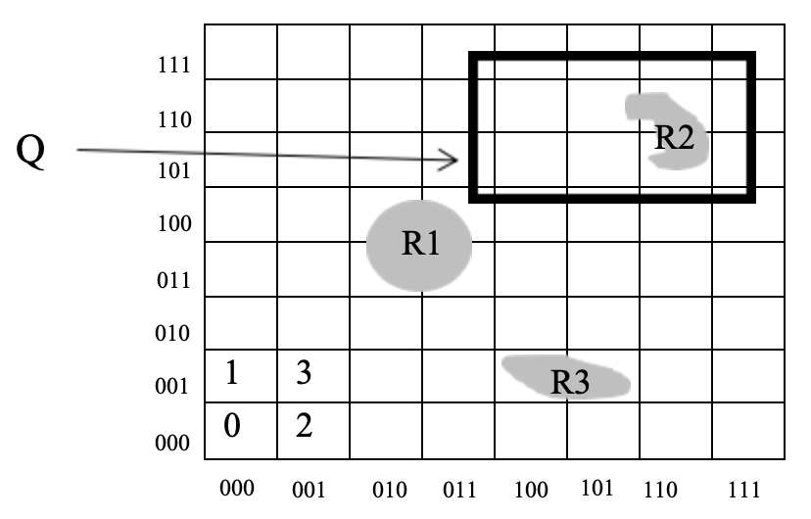

Let’s use base 5 Z-values with the entire space represented as 1. If no more than two Z-values can be used to index one object, which set of Z-values below is correct for R1?

|  |  |  |
| --- | --- | --- |
|  | a. | {112, 103} |
|  | b. | {114, 123} |
|  | c. | {11, 12} |
|  | d. | {103, 112} |

There are three spatial objects R1, R2 and R3 in the space. In order to index spatial objects using Z-values, the space has been recursively decomposed and the resolution (i.e. the maximum level of decomposition) is 3.

 Which sets of z-values for objects R1, R2, R3 are **incorrect?**

|  |  |  |
| --- | --- | --- |
|  | a. | The base 10 Z-values for the objects are: R1(13, 15, 24, 26); R2(54, 57, 60); R3(33, 35). |
|  | b. | The base 4 Z-values for the objects are:  R1(120, 122, 031, 033); R2(312, 330, 321); R3(201, 203) |
|  | c. | The base 2 Z-values for the objects are:  R1(001111, 011010, 001110, 011000); R2(110110, 111100, 111001); R3(100001, 100011) |
|  | d. | The base 2 Z-values for the objects are:  R1(001101, 011000, 001111, 011010); R2(110110, 111100, 111001); R3(100001, 100011) |

Which of the following can form a layer of spatial data?

|  |  |  |
| --- | --- | --- |
|  | a. | A set of polygons of same size |
|  | b. | A set of polygons that form a partition of the space |
|  | c. | A set of polygons that form a cover of the space |
|  | d. | A set of polygons representing the same type of data |

There are seven spatial objects A, B, C, D, E, F and G in the space indexed using the R-tree shown below. Each node can hold a maximum of 3 data entries.

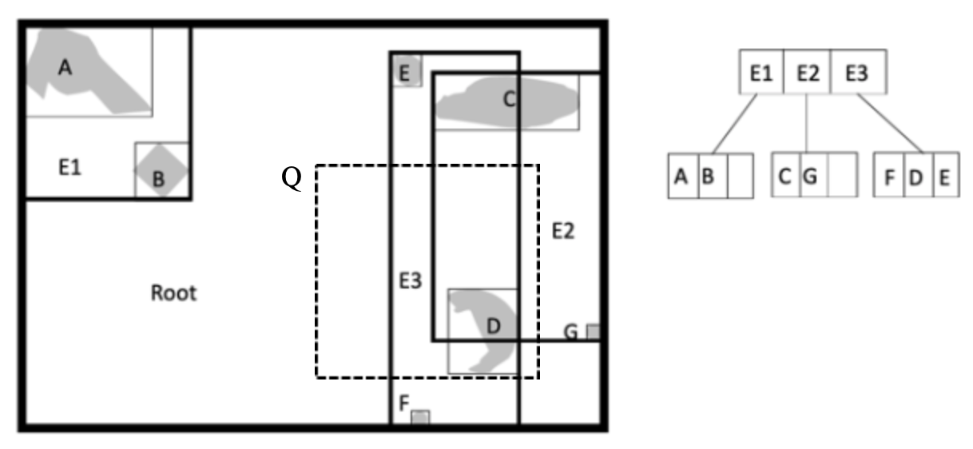

Why this R-tree is not efficient?

|  |  |  |
| --- | --- | --- |
|  | a. | E1 is too far away from E2, E3. |
|  | b. | There are three objects in E3. |
|  | c. | E2 and E3 overlaps too much. |
|  | d. | E3 cuts through object C. |

There are seven spatial objects A, B, C, D, E, F and G in the space indexed using the R-tree shown below. Each node can hold a maximum of 3 data entries.

To use the R-tree above perform the window query for Q, which R-tree nodes will be visited?

|  |  |  |
| --- | --- | --- |
|  | a. | Root, E1, E2, E3 |
|  | b. | Root, E2, E3 |
|  | c. | Root, E2 |
|  | d. | Root, E3 |

When using spatial hashing to perform polygon

for polygon datasets R and S, which statement below is correct?

|  |  |  |
| --- | --- | --- |
|  | a. | If each polygon is mapped into all cells it overlaps with, the objects in one cell in R only need to be joined with the objects in its counterpart cell in S |
|  | b. | If each polygon is mapped into all cells it overlaps with, the objects in one cell in R still need to be joined with the objects from multiple cells in S |
|  | c. | If each polygon is mapped into one cell, the objects in one cell in R only need to be joined with the objects in its counterpart cell in S |
|  | d. | None of the above statements is correct |

The definition of the 9-intersection matrix for two simple polygons A and B is given below: 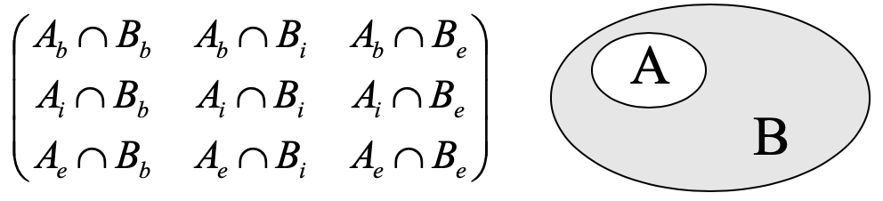

Which is the correct 9-intersection matrix that describes the INSIDE relationship as shown above? 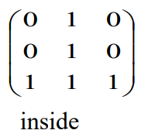

Which statement below is correct?

|  |  |  |
| --- | --- | --- |
|  | a. | When a R-tree is used to process a point query, it always needs to search more than one subtree at the same level |
|  | b. | When a R+-tree is used to process a point query, it always needs to search more than one subtree at the same level |
|  | c. | When a R-tree is used to process a point query, it is not possible to search more than one subtree at the same level |
|  | d. | When a R+-tree is used to process a point query, it is not possible to search more than one subtree at the same level |

Which statement below is correct?

|  |  |  |
| --- | --- | --- |
|  | a. | R-trees are more suitable to manage polygon data while the quadtrees is more suitable to manage point data |
|  | b. | A good R-tree should minimize the overlapping of MBRs at the same level |
|  | c. | A good R-tree should minimize the overlapping of any MBRs in the tree |
|  | d. | A good R-tree should minimize the overlapping of the MBR in a node with all MBRs in its children nodes |

When we use the end-point mapping method to transform a rectangle in a 2-dimensional space, which statement below is correct?

|  |  |  |
| --- | --- | --- |
|  | a. | It can be mapped into a point in a space of *4* dimensions |
|  | b. | It can be mapped into a point in a space of *3* dimensions |
|  | c. | It can be mapped into a point in a space of *1* dimension |
|  | d. | It cannot be mapped into a point in a space of any dimension |

Which statement below is correct?

|  |  |  |
| --- | --- | --- |
|  | a. | Spatial DBMS is a DBMS that is designed to manage any non-relational data |
|  | b. | Spatial DBMS is a DBMS that is designed to manage any data with location attributes |
|  | c. | Spatial DBMS is designed to manage datasets that are stored in different geographical locations |
|  | d. | Spatial DBMS is a kind of Geographical Information System |

What is the purpose of space-filling curve?

|  |  |  |
| --- | --- | --- |
|  | a. | Link spatial objects together into a list |
|  | b. | Map the partitioned cells of a space in a one-dimensional list |
|  | c. | Indicate the browsing order of spatial objects when these objects are required by a query |
|  | d. | Rank the spatial objects based on their distances to the origin of the space |

A rectangle R is represented using the coordinates of its lower-left and upper-right corners (xlow, ylow, xhigh, yhigh).  Which of the following is the correct condition that returns TRUE if and only if two rectangles R(xlow, ylow, xhigh, yhigh) and R’(x’low, y’low, x’high, y’high) overlap? Two rectangles are also considered to be overlap if their boundaries touch each other.

|  |  |  |
| --- | --- | --- |
|  | a. | xlow <= x’low and xhigh <= x’high and ylow <= y’low and yhigh <= y'high |
|  | b. | x’low <= xhigh <= x’high and y’low <= yhigh <= y'high |
|  | c. | xlow <= x’high and xhigh >= x’low  and ylow <= y’high and yhigh >= y’low |
|  | d. | xlow <= x’high <= xhigh and ylow <= y’high <= yhigh |

Why is the filter-and-refine strategy necessary in spatial database query processing?

|  |  |  |
| --- | --- | --- |
|  | a. | Spatial operations are expensive in terms of both CPU and I/O costs |
|  | b. | Spatial operations have uncertain semantics |
|  | c. | This is the only way to make sure the query results are correct |
|  | d. | Spatial operations are often used together with non-spatial operations |