**ENGG1300 (Flexible Enrolment)**

**Audio Filter Design Report**

**(Due 2pm, Thursday 13th of May, AEST)**

Bosheng Zhang

45004830

This assessment should be completed individually. All students must complete the theory and design part of this assignment individually; and the written report must be entirely your own work.

You ***are*** permitted to work together in the laboratory to experimentally evaluate your circuits with 1-2 other students who share your lab station. *However, it is expected that each of you have completed your theory and design of your circuits prior to this. The data you present in your report* ***must*** *be the data associated with the circuit you designed.*

If you worked with other students to experimentally evaluate your circuits, include their names and student numbers in the table below:

|  |  |
| --- | --- |
| **Other students you worked with in the Lab (if any)** | |
| **Name** | **Student ID** |
| Calum Philips | 46478205 |
| Thomas Chen | 45051423 |

**1. Selection of Filter Type**

Low-pass filter is applied. High-frequency noise is due to components of a signal varying faster than the signal of interest. Removing high-frequency noise allows the signal of interest to be more compactly represented and enables more accurate analysis. A low-pass filter is a common technique for removing high-frequency noise in a signal – the low pass filter only allows low frequency signals from 0Hz to its cut-off frequency, ƒc point to pass while blocking those any higher.

**2. Selection of Cut-off Frequency**

Cut-off frequency is a frequency which makes the gain to be $\frac{1}{\sqrt{2}}$. Here we select it as 3.5 kHz. According to the report description, the frequency of the original signal is mainly below 3 kHz, and the noise frequency is 12.5 kHz. We want the cut-off frequency to be close to 3kHz but leave a small value to preserve the original signal as much as possible and filter as much noise as possible.

**3. Circuit Design Details**

In low frequency applications (up to 100kHz), passive filters are generally constructed using simple RC (Resistor-Capacitor) networks. Also, our signal is of low power then RC is often the best, as it’s the cheapest and smallest in many cases. The key to analysing them by inspection is to remember the behaviour of capacitors. Remember that capacitors pass high frequencies and block low frequencies. Thus, the following circuits implement lowpass filters, passing low-frequency signals and killing high-frequency ones.

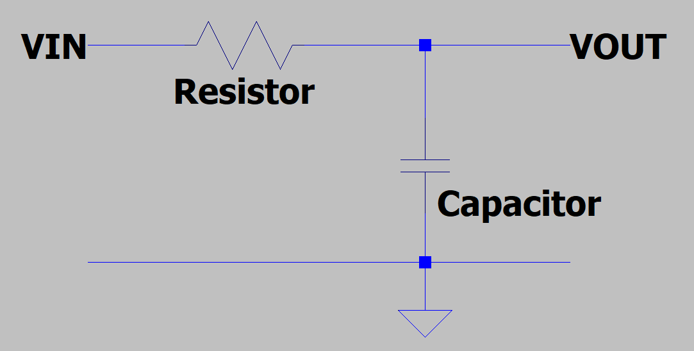

Figure 1. RC simulation circuit from LTspice

One can easily derive the transfer functions for the above filter. If we define the cut-off frequency fc for

each circuit such that

$$f_{c}= \frac{1}{2πRC}$$

, and the representation of R

$$R= \frac{1}{2πf_{c}C}$$

The transfer function is

$$H\left(jω\right)= \frac{V_{out}}{V_{in}}= \frac{Z_{C}}{Z_{R} + Z_{C}}= \frac{1}{jωRC+1}$$

We fix the capacitance values at three given capacitances and select cut-off frequencies into the R formula to calculate the component values:

|  |  |
| --- | --- |
| Capacity | Resistor |
| 0.1μF | 455Ω |
| 0.22μF | 206Ω |
| 0.47μF | 96Ω |

Table 1. Paired component values

**4. Theoretical and Experimental Magnitude Bode Plots**

The Bode magnitude plot for the transfer function is shown below. Note that the magnitude plot confirms what we already knew that low frequencies below fc are largely unaffected, while the magnitude decreases dramatically at −3 dB/dec for frequencies above fc.

I did expect there will be slightly different between the theoretical and experimental plots, because of the measurement error. By putting the two plots together, there is only minor ups and downs. I think this is due to not placing the measurement lines properly or instrumental error.

Figure 2. Theoretical and experimental magnitude bode plot

**5. Discussion**

To test my filter result I connected the breadboard with my RC filter to a microphone, the result was quite effective just as my expectation. The original signal is largely preserved because its frequency is mainly below 3kHz, and our cut-off frequency is 0.5 kHz higher than this value. Therefore, the original signal sounds almost the same among all audio files. When we tested the ‘noisy_1%.wav’ file, we could hardly hear any noise. Then when testing ‘noisy_10%.wav’ file, we can still hear some noise, but it is obviously not as large as before filtering. Finally, we tested ‘noisy_50%.wav’ file. By comparing the filtered and unfiltered versions, we can hear that the filter still filtered most of the noise, not as harsh as the previous one. Most of the noise at 12,5 kHz has been eliminated.