Assignment 2 Documentation

Team Member:

c1zhangu, c2tengfe

**Program operation procedure**

When user enters the website, click on “go to search movie page” to enter the next step. On the next page, user select a date ( only the next 14 days will be shown, and not including today).

Then, he will be automatically directed to the next page, where he will choose the movie or the venue he prefer.

When either option is clicked, the website will show the list of available showtimes from the database.

The user chooses a showtime, then will be directed to make a seat selection. According to the requirement of the assignment, all theatres have only three seats in each room, and are arranged in the way the website shows. White seats are available, Green is the one user chooses, and Yellow are seats been taken. The user can click on different seats as many times as he wants, until he makes his mind, and then click on “set seat”.

The user will be directed to the next page, where he enters his payment information ( but the payment is not placed yet. All information will be checked for correctness.

On the next page, a sum up of the user’s choice of showtime, and information of payment will be shown. At this point no further changes can be made. The user can either confirm the info and the payment will be placed, or click the “back” on the top of the page to start over. Also, the user can print this page.

After confirm, the website goes back to its index page.

On admin page, the three functionality are shown clearly on the page, no need for further explanation.

**Deployability**

All of the redirection and link in our program are relative, that means they does not depend on any specific port or address.

And the pictures are stored on an online image server. We choose to implement it this simply for a safety concern. If we implement it using local url, it has a potential risk that when source image is damaged or removed, the website will no longer display those images. On another hand, since this assignment assumes will always have internet connection, uploading the source images online seems a better option to us.

**Validation**

For safety concerns, the validation of the user inputs and other necessary information are validated twice, once on both client side and server side.

The client side validation is completed by two implementations.

First, all procedures of selecting movies are done in drop-down form. The available choices are provided correspond to the database, therefore user will never be able to enter anything invalid during selecting movies.

Second, when user type in payment information, the data is checked in javascript to ensure its validation.

The server side validation is also completed by two implementations. However, the difference is, because the existence of server side validation is to protect the data when client side validation is compromised, or hacked, therefore, server side validation must be more secure than client side validation. The solution we take is to perform validation after all POST operations and no further changes can be made to the “session”, where all the necessary data are stored.

First, right before the summary page shows up, the first half of the server-side validation will be booted. I Implemented using the “form_validation” functionality provided in code igniter’s library. The payment informations will be checked at here.

Second, after the user confirms the information on the summary page, and right before the payment is placed and ticket is issued, the second half of the server-side validation will be performed. This part of validation is to check the selecting information including which movie, theater and showtime, etc. Since for this assignment we are not required to deal with concurrency (which however can be handled by this part of validation), thus this part of the validation is only to protect the data from potential hackers, provide a much higher security for the website.

**Handling ' in the database**

When populating the database, please make sure the name of the movies or theaters don't have the character ' . If they do, please change ' to %, or other proper characters. Since the character ' can mess up the input during the insert and search operations in the database, and change it to other character can simply avoid that.

**For Any Readers**

In order to run this website, you need to prepare a apache running environment, and a mysql database constructed in the following scheme:

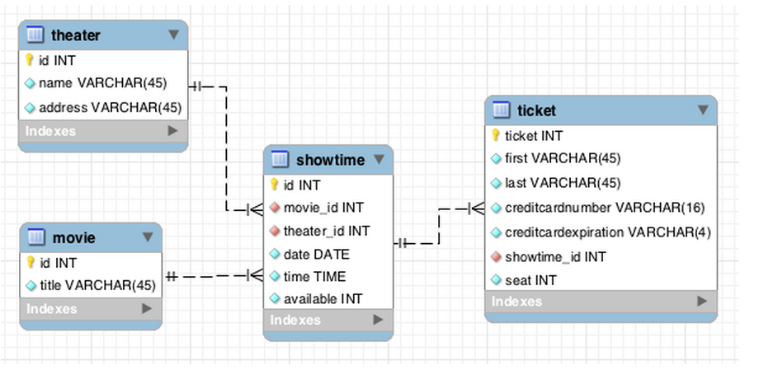

Database connection can be set up in “uofttheater\application\config\database.php”.

The website contains two interface, one for users, one for admins. The user interface is by default.

If you want to enter the admin interface, please change the last part of URL “index.php” to “admin.php”. The user interface if for purchasing tickets, and admin interface has administrator functionalities like populate the database, delete tickets, etc.