**Nama : Febrian Dani Ritonga**

**Role : Fullstack Intern**

Link repository :<https://github.com/daniertg/test-fullstack-intern>

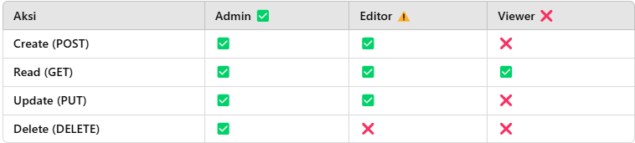

1. **Test user login**

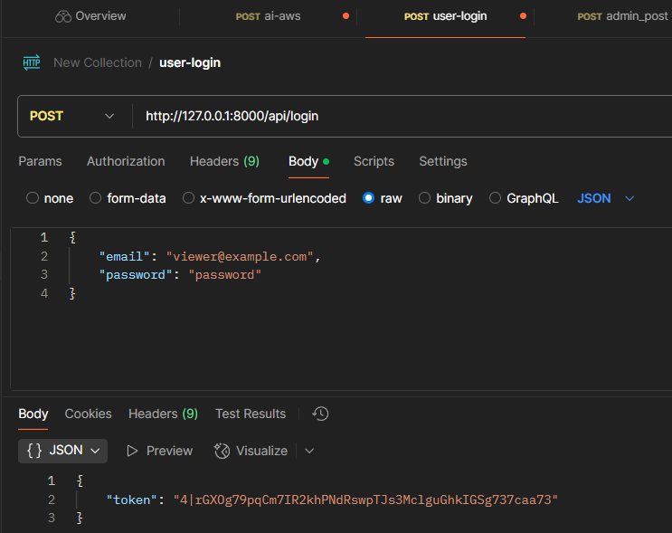

1. **Test user post buku**

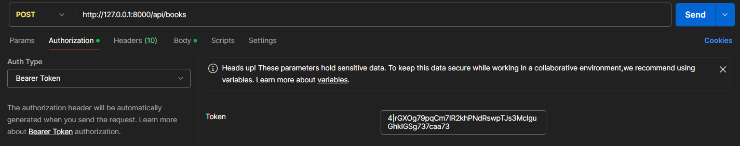

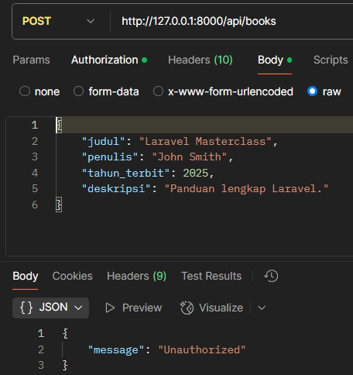

1. **Test user liat buku**

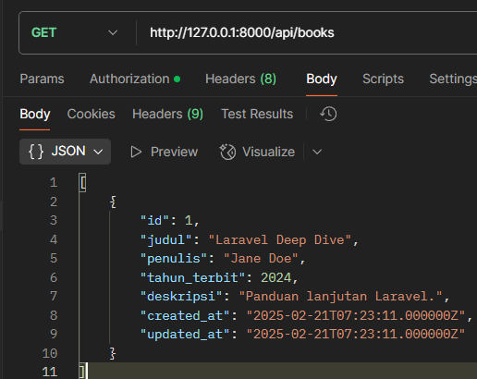

1. **Admin post buku  
   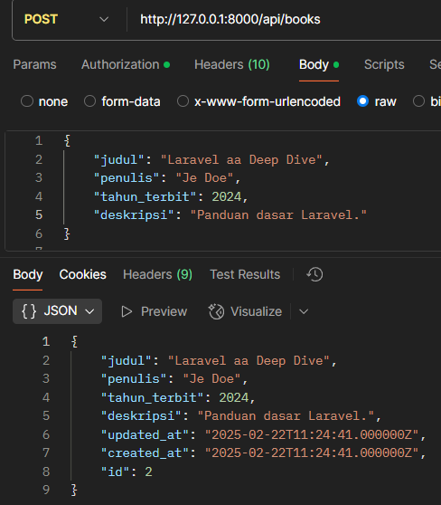**
2. **Editor delete**

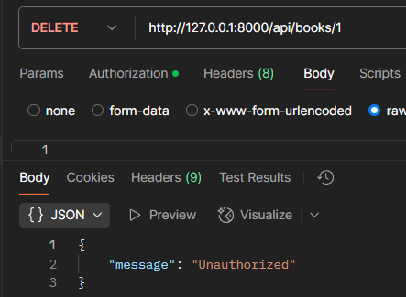

1. **Editor PUT**

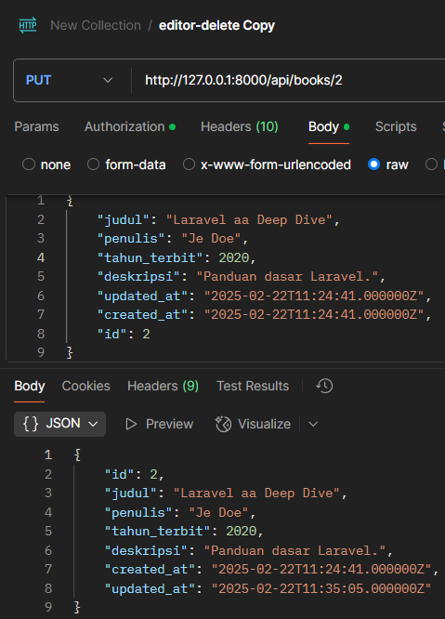

1. **Admin delete**

