Contents

Purpose of YouTube Database Application
First Example
Logging In to Application
Creating a New LINKS Table or Updating Existing LINKS Table
Searching LINKS Table--Basic Search
Updating Records in LINKS Table
Deleting Records from LINKS Table
Printing Records from LINKS Table to File
Second Example - Updating LINKS Table and Doing Advanced Search
Updating LINKS Table
Searching LINKS Table--Advanced Search
Signing Out and Automatic Database Backup

Purpose of YouTube Database Application

This application allows a user to create a database table to save the results of the user's searches of YouTube. This LINKS table contains urls of videos found on YouTube as well as descriptions of the videos. Each user has his or her own LINKS table containing results of his or her YouTube searches. The user can save these results with a predefined or user-defined category for ease of later retrieval.

This LINKS table can then be searched by the user. Basic and advanced search functions are included. The LINKS table can also be customized. The user can delete records from LINKS table, update the category of specified records, or print records to file.

TOP

First Example

For this example, the application has been started on a Windows computer where it has not yet created a database; and the log file is empty.

TOP

Logging In to Application

The first screen you will see if a Login screen.

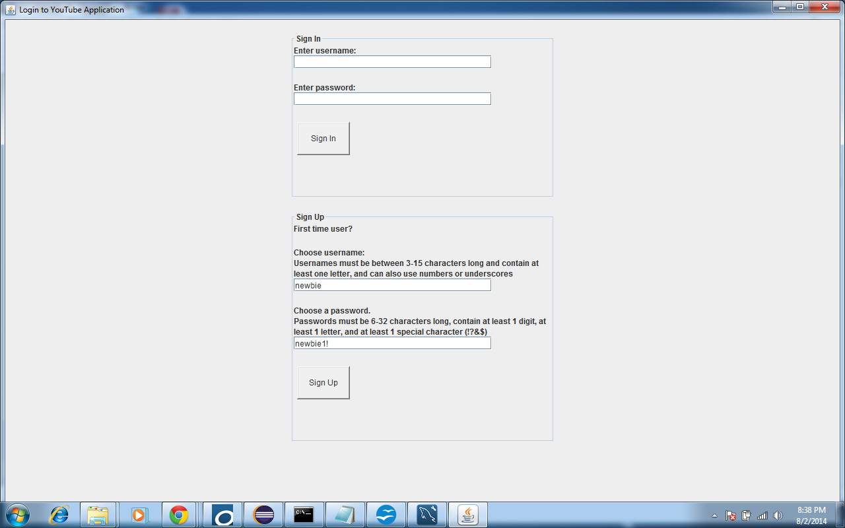

Existing users should go to Sign In section, in the upper half of the screen.

First time users should go to Sign Up section, in the lower half of the screen.

Since this is the first time we are using this application we go to Sign Up. On screen the you are given the rules for creating new username and password.

TOP

Creating a New LINKS Table or Updating Existing LINKS Table

If the user has not created a LINKS table, the first thing the user must do is to go to the Construct menu and then choose the Create New You Tube Links Table.

Existing users who have previously created a LINKS table can use this option to create a new LINKS table which will overwrite their previous LINKS table. This option deletes previous LINKS table!

To update an existing LINKS table, choose Update Your Existing Links Table. This will add new video links found on YouTube to your existing database.

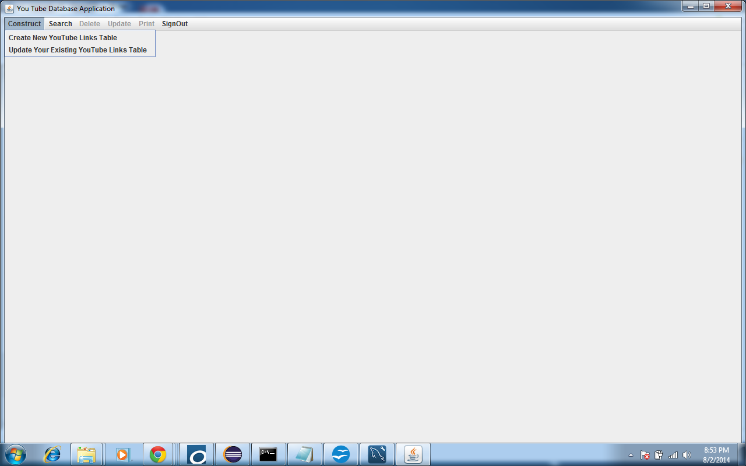

A screen opens to search YouTube. We have chosen to search for videos about wombats, so in the text field underneath "Enter your search words:" type wombats.

We want to save the list of videos in the category animals. In the category drop-down list we do not see that category in the list of pre-defined choices. So in the box underneath the text "Select the category in which the results will be saved, or type new category" type animals.

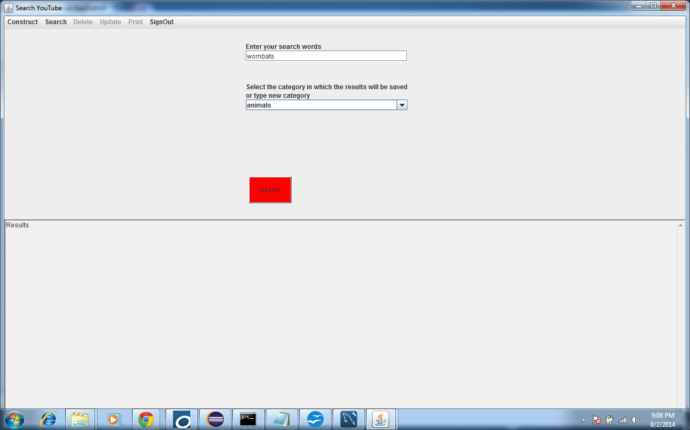

Note: Do not type in a new category that includes any characters other than letters and spaces. For example 60’s Music would not be a valid user-defined category, but Classic Music would be.

Then click the Search button.

The application searches for videos on YouTube related to wombats. In the lower half of the screen it returns the url for the video and a brief description of the video. It creates a LINKS database table for the current user and saves these links to videos found on YouTube in the table.

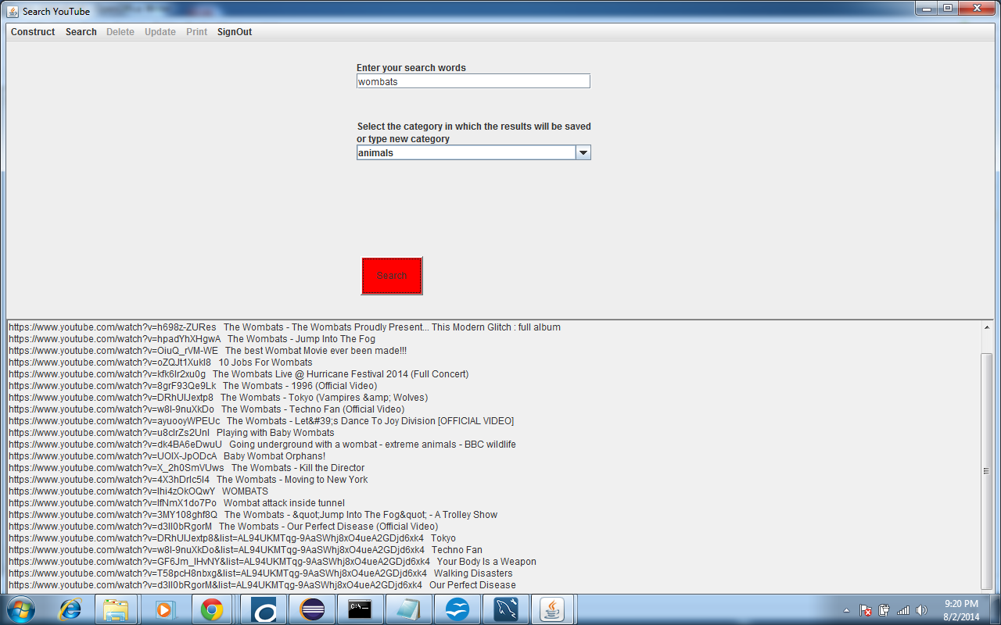

TOP

Searching LINKS table--Basic

We see that this search returns results of albums by the band The Wombats. We had wanted results about wombats, the animal, so we would like to search these results for the words album, so that we can change or delete them.

We click on the Search menu and choose Basic Database Search.

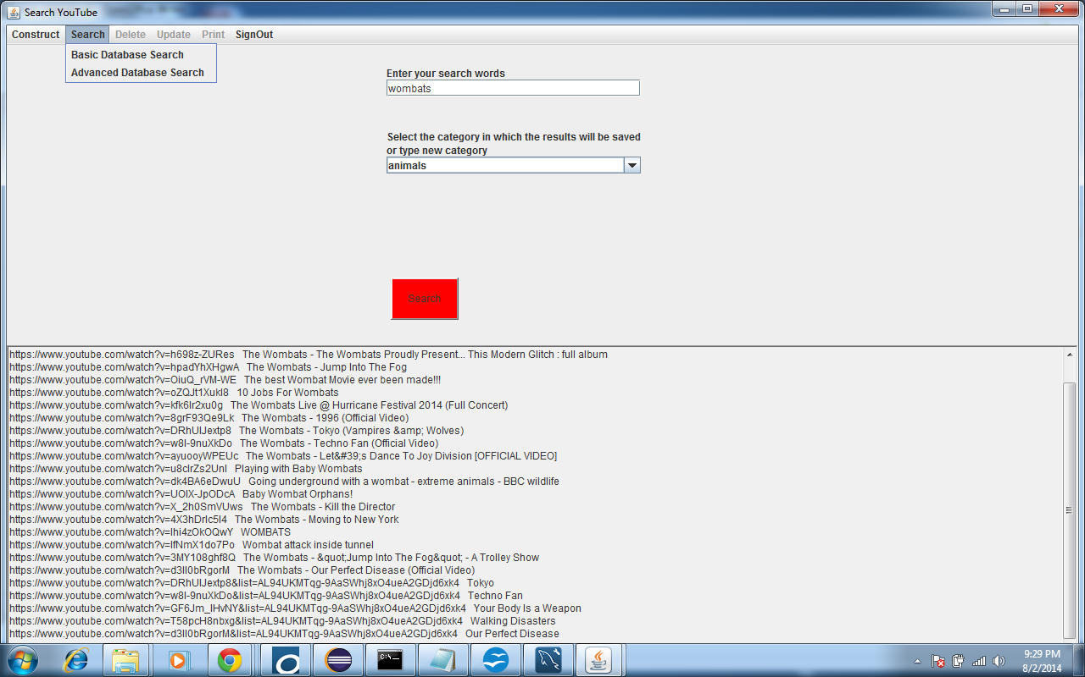

The GUI to do a basic search of the LINKS database opens. In the keyword text field type album.

Hit Search button.

This searches your LINKS database (which is comprised of the links to videos related to wombats) and chooses out of these links, which have the word album in the description. There are 2 results.

The GUI displays the ID number of the record, the url of the video, the description of the video and the category.

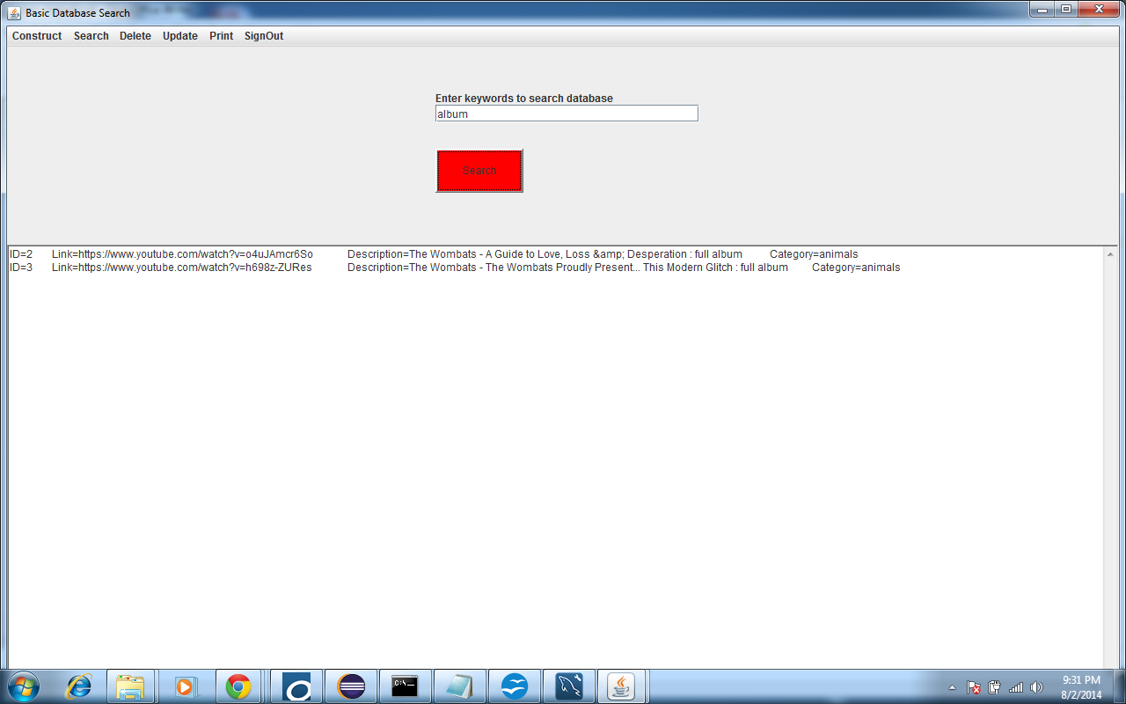

***Note: If the keyword field is empty when you hit Search button, the application will print an exception and stack trace to console, but will not end the application. The application will continue normally when a non-empty search term is entered, or another valid choice is made.

TOP

Updating Records in LINKS Table

Go to Update menu and choose Update Category.

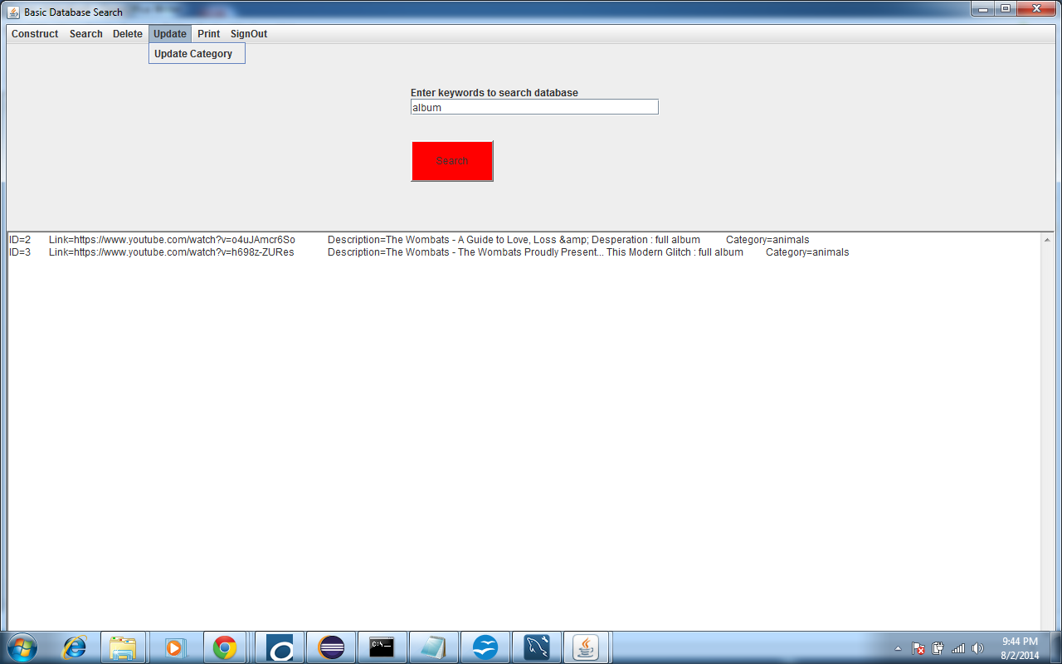

***Note: Update, delete, or print works with the results from the last search of the LINKS table. In order to perform these actions, a search must have previously been done of the LINKS table. Otherwise you will see a message stating that there are no search results.
Update window opens.

Next to the text "Enter the ID number of the record to be deleted" there is a drop-down list which contains the IDs for the records just retrieved. (In this case it is the ID number of the records we just found from searching for album in LINKS table.)

In this example we choose ID number 3.

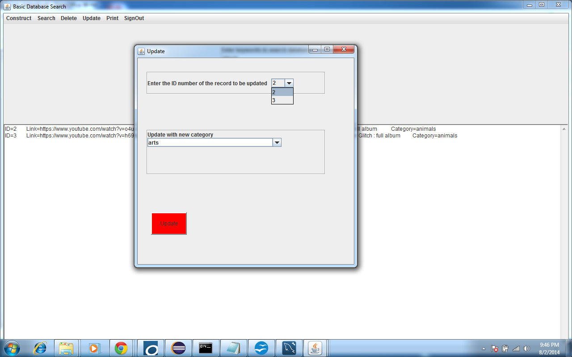

Use the drop-down list to choose a new category to tag the chosen record. In this example, we choose music.

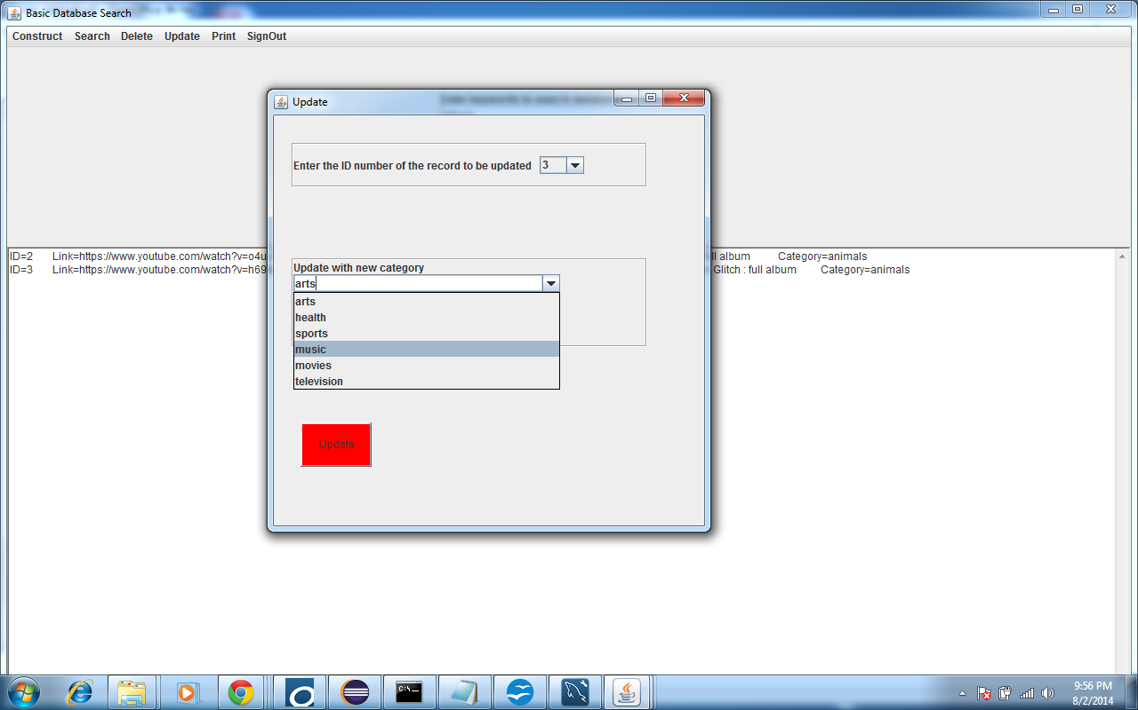

Then hit Update button.

This changes the category of record 3 to music. To check this was done successfully, click Search button again. Now you see that the category of record 3 is listed as music.

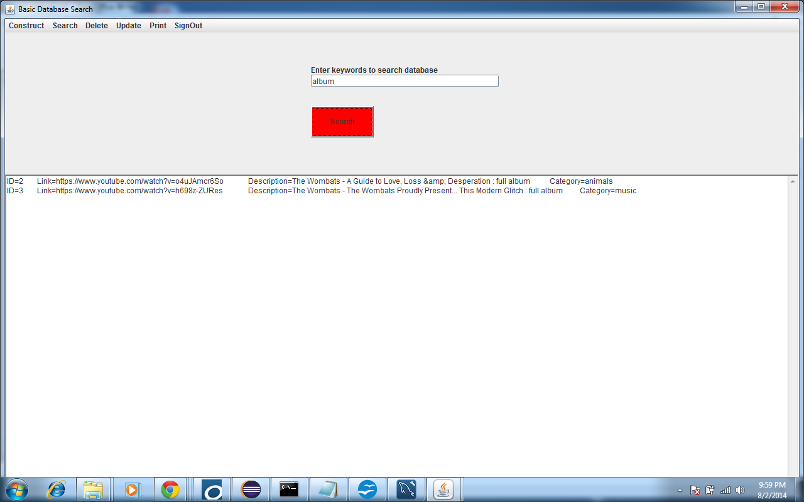

TOP

Deleting Records from LINKS table

Suppose we decide to delete one or both of these records form our LINKS table. Go to the Delete menu and click on the Delete menu item. This opens a GUI to delete records.

Select from drop-down list the record number to be deleted. This displays all the records in the last search of the LINKS table. In this example it finds records 2 and 3 from our basic search for album. To delete selected record after choosing record from drop-down list, hit Delete Selected button.

Or hit Delete All to delete all records in the last search. This would delete both records 2 and 3.

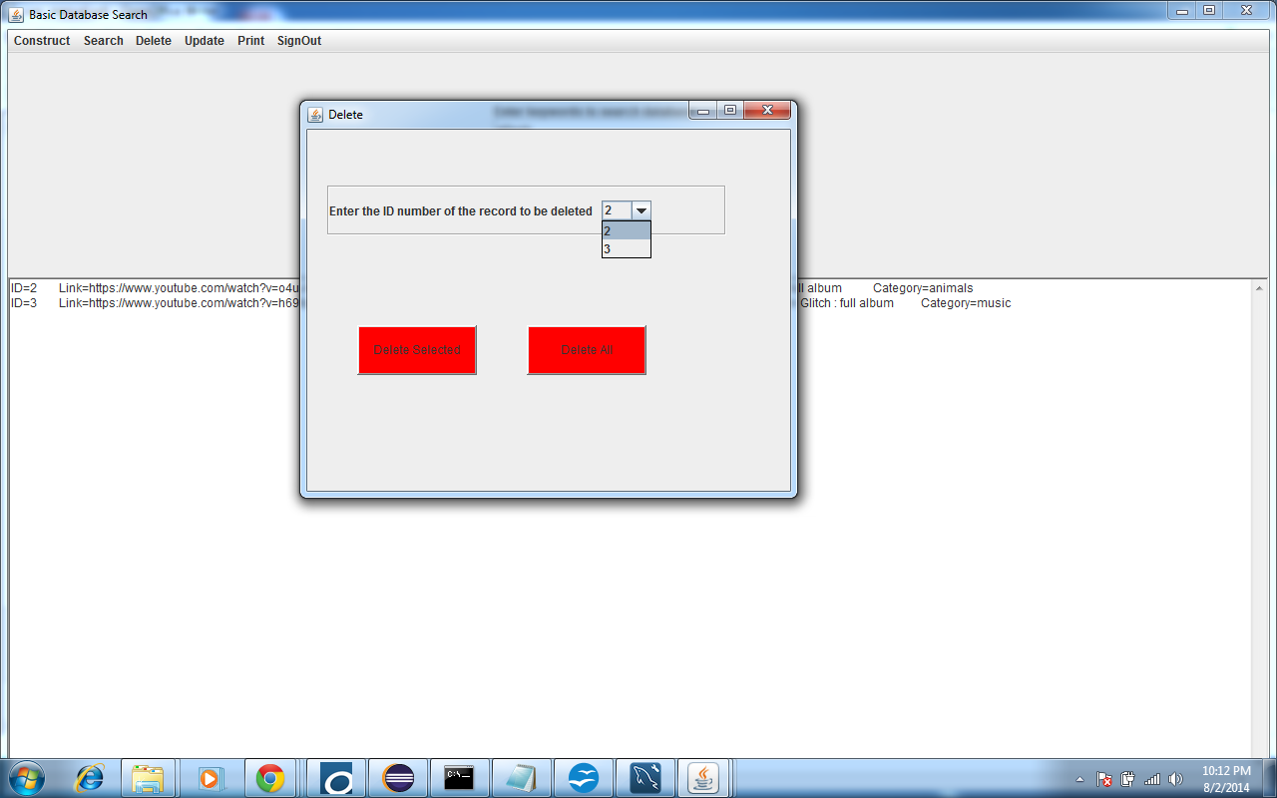

Choose record number 2 and click Delete Selected.

***Note: Update, delete, or print works with the results from the last search of the LINKS table. In order to perform these actions, a search must have previously been done of the LINKS table. Otherwise you will see a message stating that there are no search results.

Clicking on the Search button again shows that record number 2 no longer exists.

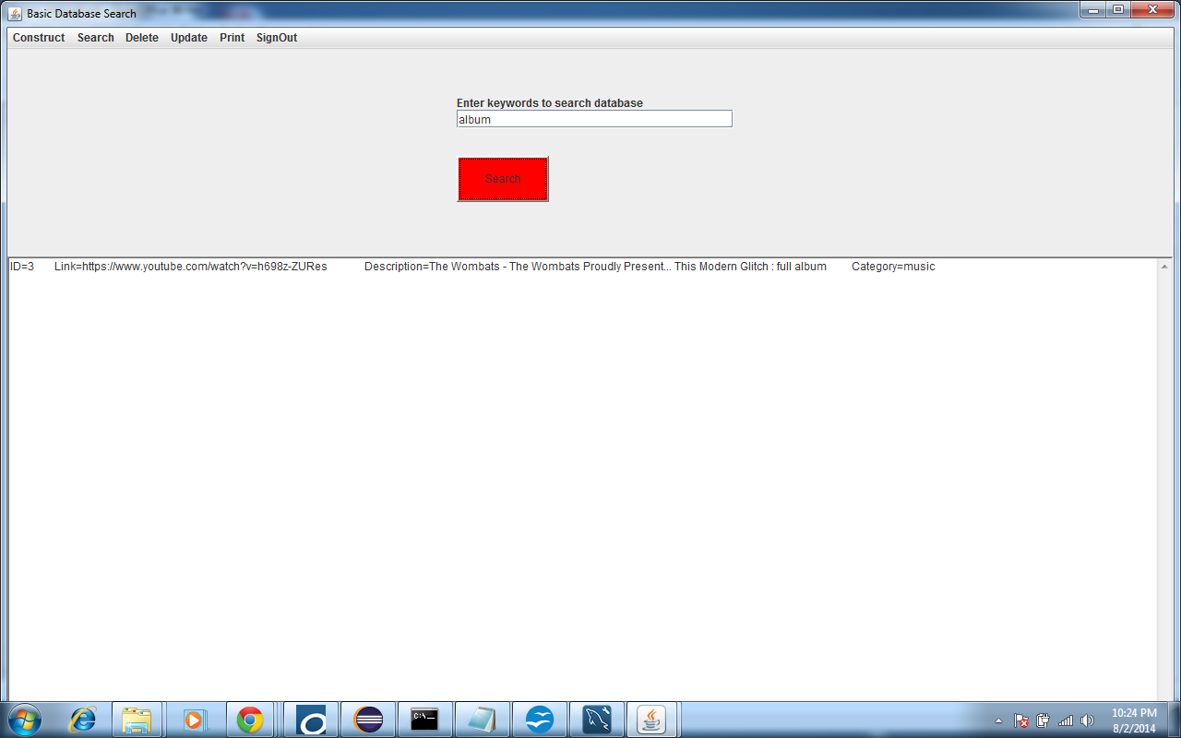

TOP

Printing Records from LINKS Table to File

Suppose at this point you want to print all records with the phrase The Wombats to file. Go to Search menu, choose Basic Database Search, type in "the wombats" (including quotes searches for entire phrase) in keyword field, and click Search.

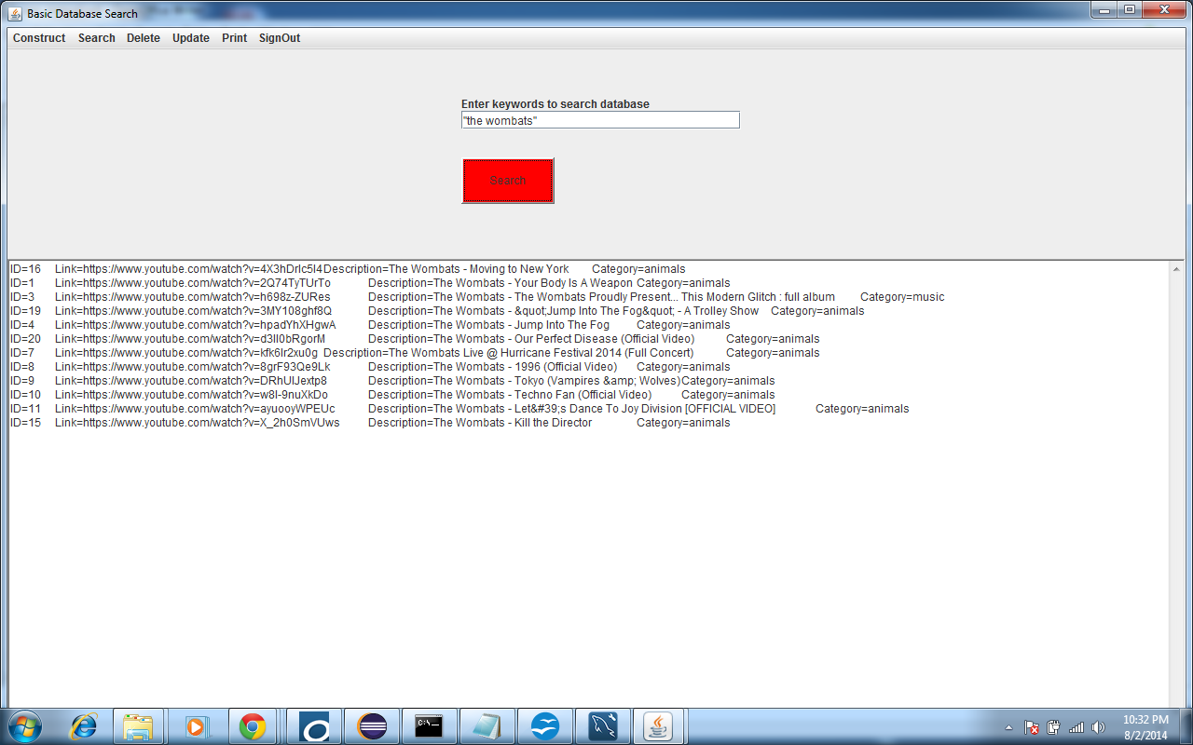

Notice that the category of result 3 has been changed to music. (These should all be changed to music, but for purposes of example we just changed one result.)

Notice also that record 2 no longer exists, as it was deleted.

To print these records to file, choose Print menu and click on Print Results to File. This prints the above results to a file results.txt.

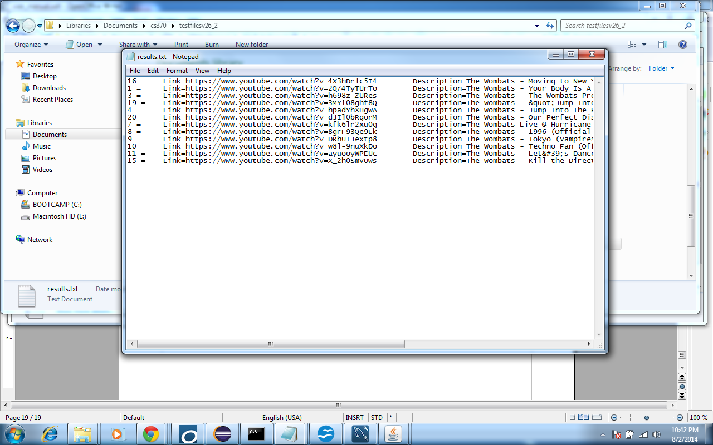

***Note: Update, delete, or print works with the results from the last search of the LINKS table. In order to perform these actions, a search must have previously been done of the LINKS table. Otherwise you will see a message stating that there are no search results.

TOP

Second Example - Updating LINKS Table and Doing Advanced Search

Updating LINKS Table

TOP

Say you want to add to your LINKS table by doing a second search of YouTube for the phrase The Doors.

Go to the Construct menu and choose Update Your Existing Links Table.

In the keyword search text field type "the doors" (including quotes) and in category drop-down list choose music to save the results from this search in the music category.

Hit Search button. This adds these results to the your LINKS table.

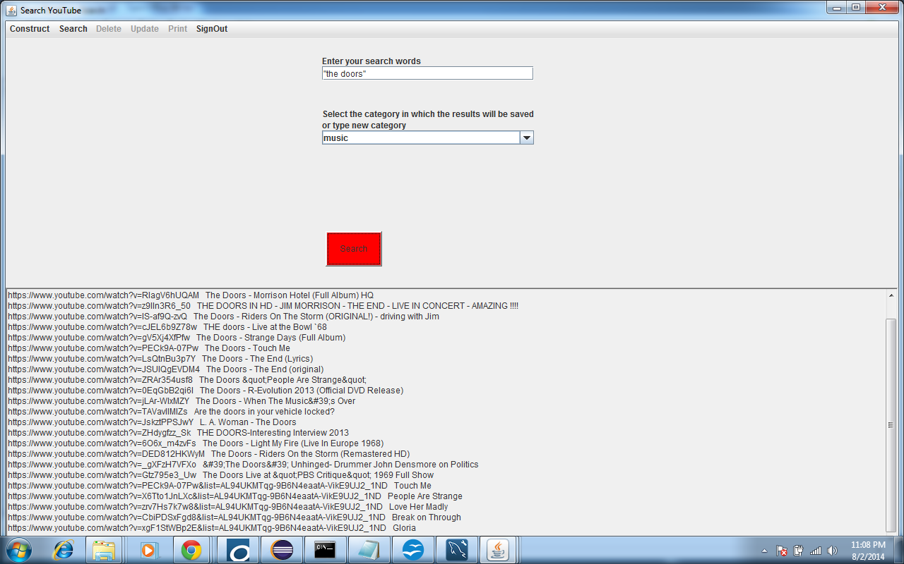

TOP

Searching LINKS Table--Advanced Search

To search your LINKS table by keyword and/or category, choose Search menu and click on Advanced Database Search.

Choose the category music from the category list and enter the phrase "the wombats" (including quotes searches for entire phrase) in the keyword text field. Leave the and/or drop down menu between the category and keyword as and.

Hit Search button. This return the 1 result which is the record from the previous result set for “the wombats” search that we tagged with the music category.

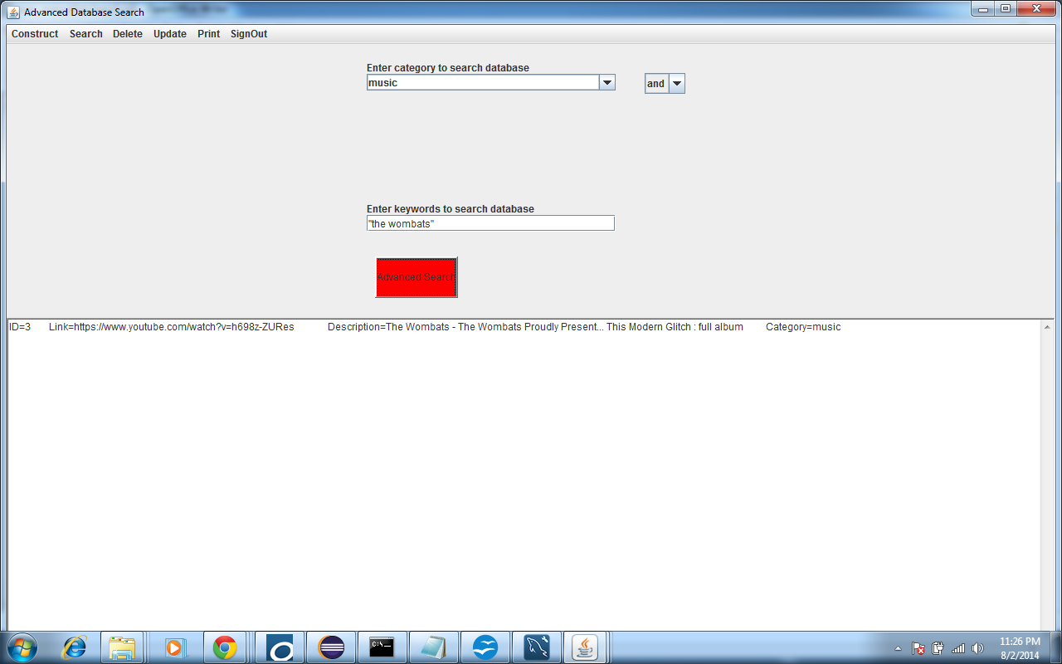

Try changing the and/or drop down to or. This searches for results in the LINKS table which include the phrase the wombats or the category music. This returns the results below:

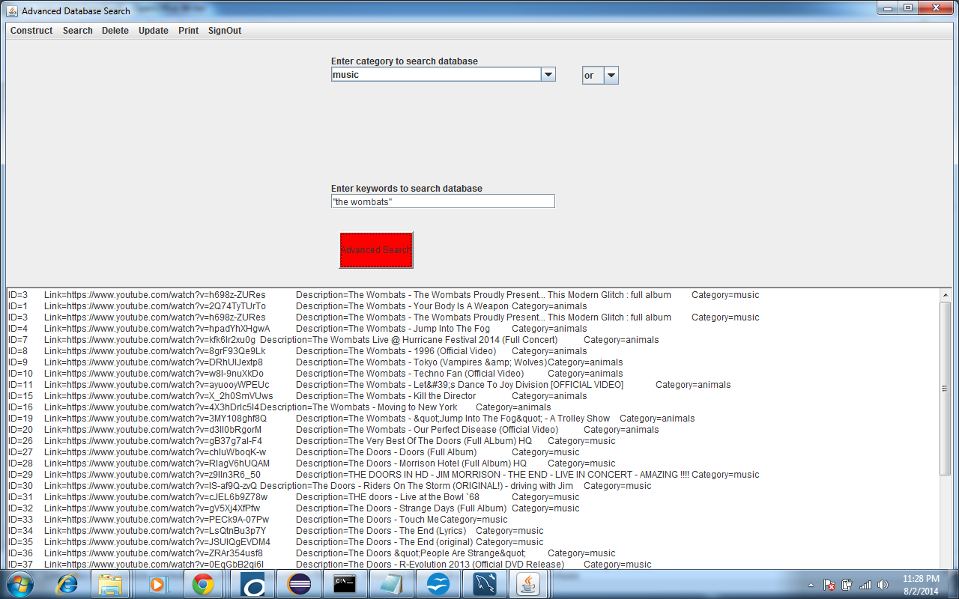

Searches can also be created by using multiple search words and phrases. This is a search for category music and keyword "the doors" best "full album":

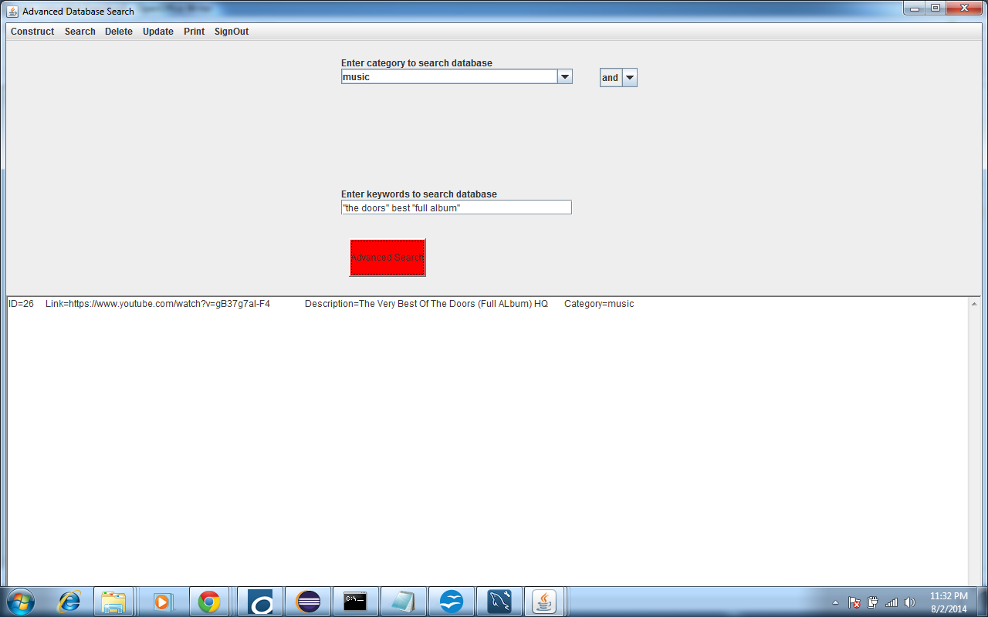

***Note: If the keyword and category fields are both empty when you hit Search button, the application will print an exception and stack trace to console, but will not end the application. The application will continue normally when a non-empty search term is entered, or another valid choice is made.

TOP

Signing Out and Automatic Database Backup

When you are done using the application choose the SignOut menu and click on the Sign Out menu item. This logs the user out and exits the application. The next time the application is run, a user must sign in with an existing username and password, or a new user can create a new user name and password. No user has access to another user’s LINKS table of search results.

Sign Out has another purpose which is to ensure that all commands that have been entered during the session which create or alter the database have been saved to the log.txt file. In the case that the database is destroyed, upon opening, the application will automatically rebuild the database from the log.txt file.

TOP

