Daniel Gutiérrez Restrepo

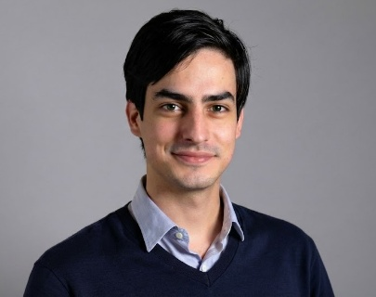  Area:  AI & Data – Strategy & Advanced Analytics  Education:  B.S. Applied Mathematics – ITAM  Language:  English – Native  Spanish – Native  Tel: +52 56 2007 6714  Email: dangutierrez@deloittemx.com | Summary  Applied Mathematics graduate and Deloitte senior consultant with hands-on experience building AI agents, machine learning models, and data-driven solutions across Latin America. Focused on AI engineering and delivering production-ready systems that bridge technical depth with business impact.  Education  Instituto Tecnológico Autónomo de México (ITAM) – B.S. Applied Mathematics, 2019–2024  Key Areas of Expertise  AI Engineering, Agentic Systems, Machine Learning, Neural Networks, Regression, Clustering, PCA, Random Forests, Time Series Analysis, Statistical Modeling, Numerical Optimization  Professional Experience & Projects  Deloitte – AI & Data, Strategy & Advanced Analytics, Mexico City | Senior Consultant | May 2024 – Present Developed analytical models, software tools, financial projections, and strategic deliverables that informed C-suite decision-making. Leveraged data science expertise and business/strategy know-how to deliver analytics-driven solutions tailored to client needs.  - Developed a PoC for an AWS partner hackathon (3rd place): an AI agent for commerce built with AWS AgentCore and Strands that matches shopping lists to store catalog products and leverages a recommendation engine to propose complementary items.  - Built a full-stack MVP for an AI agent solution that automates regulatory financial report generation for a bank, streamlining compliance workflows and reducing manual effort.  - Automated enterprise risk assessment processes through GenAI implementation on AWS, delivering a scalable solution that standardized evaluation methodology.  - Built a machine learning land valuation model based on relevant appraisals and features, then created an optimal land-use allocation strategy using an optimization algorithm.  - Developed a Python tool to automate vehicle sales validation across 200+ dealerships of six brands, reducing process time by 75% and eliminating human error, generating annual savings of $1M+ MXN.  - Designed a 10-year growth plan for a hotel group valued at $1B+ USD, including financial valuation and strategic initiatives, capturing an additional present value of $100M+ USD.  - Gained cross-industry experience in energy, hospitality, real estate, and auditing sectors across Latin America.  Certifications  AWS Solutions Architect Associate (2026)  Tools & Skills  Python (numpy, pandas, scikit-learn, pytorch), Claude Code (MCPs, Skills, context engineering), Git, AWS, SQL, R, Excel | Strategic thinking, quantitative analysis, executive communication, leadership  Tenure at Firm  2 years (May 2024 – Present)  Years of Industry Experience  Energy, Hospitality, Real Estate, Auditing, Financial Services – 2 years

