**LAPORAN PRAKTIKUM PEMROGRAMAN WEB  
Program Studi Sistem Informasi Fakultas Sains dan Teknologi  
Universitas Islam Negeri Sultan Syarif Kasim Riau**

**Nama Lengkap : Dani Harmade**

**No. Induk Mahasiswa : 12250310356**

**Semester/Lokal : 3/B**

**Pertemuan Ke : 10**

**Materi : PHP (2)**

**LAPORAN PRAKTIKUM:**

**Buat Database Melalui CLI :**

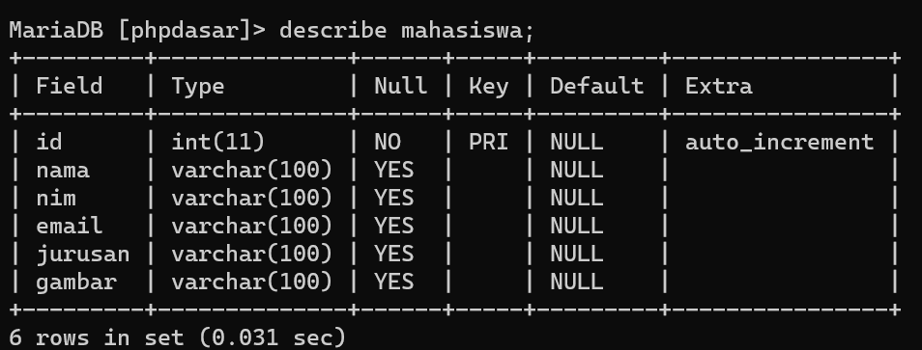

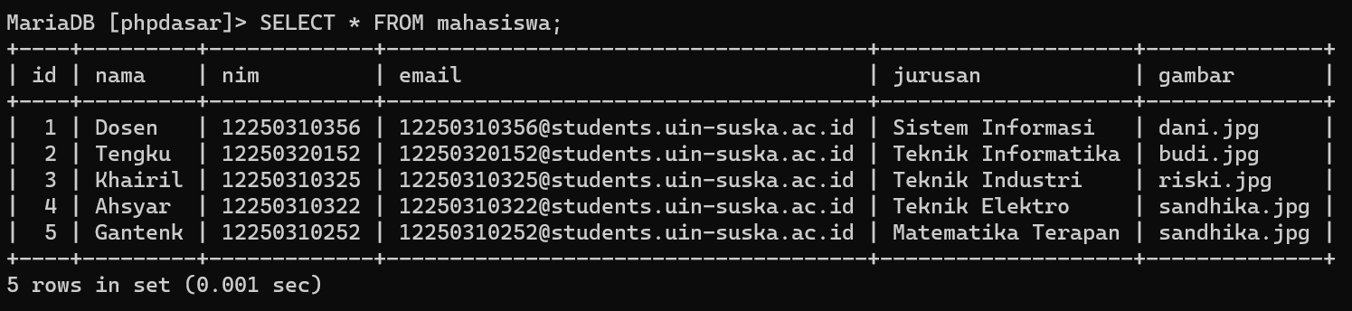

**Buat Database Melalui GUI :**

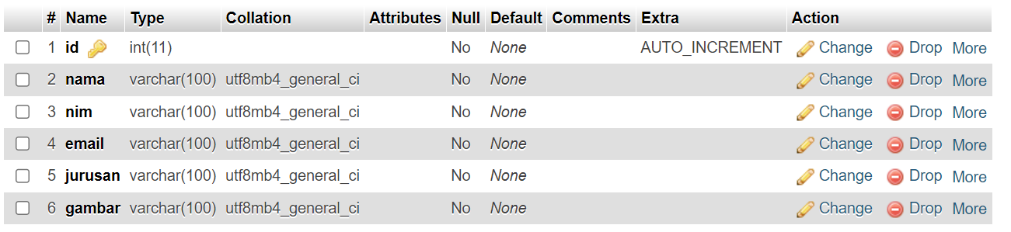

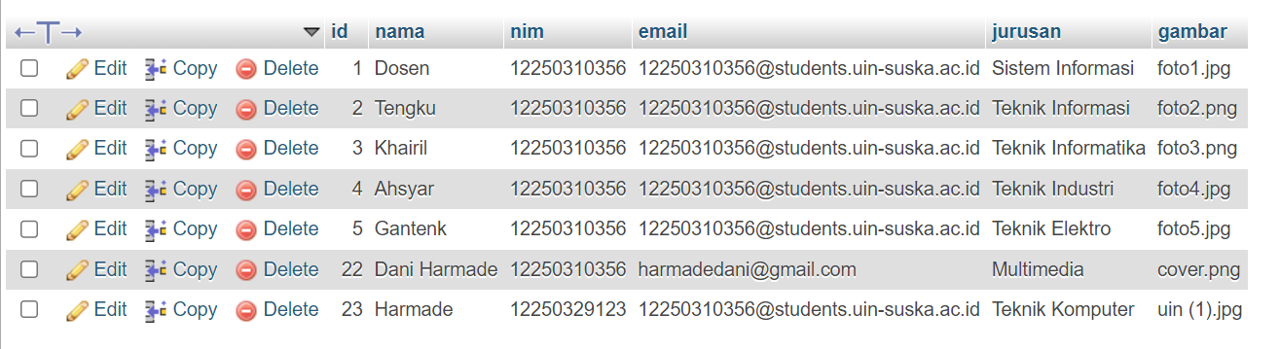

**Nama File:** index.php

**Script:**

<?php

require 'functions.php';

$mahasiswa = query("SELECT * FROM mahasiswa");

// Tombol cari ditekan

if (isset($_POST["cari"])) {

$mahasiswa = cari($_POST["keyword"]);

}

?>

<!DOCTYPE html>

<html lang="en">

<head>

<meta charset="UTF-8">

<meta name="viewport" content="width=device-width, initial-scale=1.0">

<title>Halaman Admin</title>

<style>

* {

margin: 0;

padding: 0;

box-sizing: border-box;

}

body {

background-color: #f9b600;

height: 180vh;

}

.content-table,

h1 {

margin: 0 auto;

width: 80%;

text-align: center;

border-collapse: collapse;

font-family: Arial, sans-serif;

margin-top: 2%;

}

.content-table th {

background-color: #1b1c2d;

color: #f9b600;

font-weight: bold;

padding: 12px;

}

.content-table td {

padding: 5px;

border-bottom: 1px solid #ccc;

}

.content-table tr:nth-child(even) {

background-color: #f2f2f2;

}

.content-table a {

color: #007bff;

text-decoration: none;

font-weight: bold;

}

.action-btn a {

display: inline-block;

padding: 5px 10px;

margin: 5px;

border: 1px solid transparent;

text-decoration: none;

font-weight: bold;

border-radius: 4px;

transition: background-color 0.3s;

}

.action-btn a.edit {

background-color: #007bff;

color: #fff;

}

.tambah-btn a {

margin-top: 2%;

display: inline-block;

padding: 5px 10px;

margin-left: 10%;

border: 1px solid transparent;

text-decoration: none;

font-weight: bold;

border-radius: 4px;

transition: background-color 0.3s;

/* position: absolute; */

}

.tambah-btn a.edit {

background-color: #007bff;

color: #fff;

}

.action-btn a.delete {

background-color: #ff0000;

color: #fff;

}

.action-btn a:hover {

transform: scale(1.1);

}

.tambah-btn a:hover {

transform: scale(1.1);

}

/* Reset gaya default formulir */

.search {

margin: 0;

padding: 0;

border: 0;

font-size: 100%;

font: inherit;

vertical-align: baseline;

}

/* Gaya umum untuk formulir */

.search {

/* float: left; */

margin-left: 57%;

display: flex;

align-items: center;

}

/* Gaya untuk input teks */

.search input[type="text"] {

padding: 10px;

border: 1px solid #ccc;

border-radius: 5px;

font-size: 16px;

}

/* Gaya untuk tombol cari */

.search button {

background-color: #4CAF50;

color: white;

padding: 10px 20px;

border: none;

border-radius: 5px;

cursor: pointer;

font-size: 16px;

margin-left: 10px;

}

/* Efek hover pada tombol cari */

.search button:hover {

background-color: #45a049;

}

/* Stil placeholder */

.search input[type="text"]::placeholder {

color: #aaa;

}

/* Autofokus pada input teks */

.search input[type="text"]:focus {

outline: none;

border-color: #1b1c2d;

box-shadow: 0 0 5px rgba(27, 28, 45, 0.8);

}

</style>

</head>

<body>

<h1>Daftar Mahasiswa UIN Suska Riau</h1>

<span class="tambah-btn">

<a href="tambah.php" class="edit">Tambah Mahasiswa</a>

</span>

<br>

<form action="" method="post" class="search">

<input type="text" name="keyword" id="" size="35" autofocus placeholder="masukkan keyword pencarian..." autocomplete="off">

<button type="submit" name="cari">Cari</button>

</form>

<table border="3" cellpadding="10" cellspacing="0" class="content-table">

<tr>

<th>No</th>

<th>Aksi</th>

<th>Gambar</th>

<th>NIM</th>

<th>Nama</th>

<th>Email</th>

<th>Jurusan</th>

</tr>

<?php $i = 1; ?>

<?php foreach ($mahasiswa as $row) : ?>

<tr>

<td><?= $i++ ?></td>

<td>

<span class="action-btn">

<a href="ubah.php?id=<?= $row["id"]; ?>" class="edit">Ubah</a>

<a href="hapus.php?id=<?= $row["id"]; ?>" onclick="return confirm('Apakah Anda Yakin Ingin Menghapus Data?');" class="delete">Hapus</a>

</span>

</td>

<td><img src="img/<?= $row["gambar"]; ?>" alt="" width="50"></td>

<td><?= $row["nim"]; ?></td>

<td><?= $row["nama"]; ?></td>

<td><?= $row["email"]; ?></td>

<td><?= $row["jurusan"]; ?></td>

</tr>

<?php endforeach; ?>

</table>

</body>

</html>

**Nama File: functions.php**

**Script:**

<?php

### Koneksi ke database

$conn = mysqli_connect("localhost", "root", "", "phpdasar");

function query($query)

{

global $conn;

$result = mysqli_query($conn, $query);

$rows = [];

while ($row = mysqli_fetch_assoc($result)) {

$rows[] = $row;

}

return $rows;

}

function tambah($data)

{

global $conn;

$nama = htmlspecialchars($data["nama"]);

$nim = htmlspecialchars($data["nim"]);

$email = htmlspecialchars($data["email"]);

$jurusan = htmlspecialchars($data["jurusan"]);

// upload gambar

$gambar = upload();

if (!$gambar) {

return false;

}

// Query insert data

$query = "INSERT INTO mahasiswa VALUES

('', '$nama', '$nim', '$email', '$jurusan', '$gambar')

";

mysqli_query($conn, $query);

return mysqli_affected_rows($conn);

}

function upload()

{

$namaFile = $_FILES['gambar']['name'];

$ukuranFile = $_FILES['gambar']['size'];

$error = $_FILES['gambar']['error'];

$tmpName = $_FILES['gambar']['tmp_name'];

// cek apakah tidak ada gambar yang diupload

if ($error === 4) {

echo "

<script>

alert('Pilih Gambar Terlebih Dahulu!');

</script>

";

return false;

}

// cek apakah yang diupload adalah gambar

$ekstensiGambarValid = ['jpg', 'jpeg', 'png'];

$ekstensiGambar = explode('.', $namaFile);

$ekstensiGambar = strtolower(end($ekstensiGambar));

if (!in_array($ekstensiGambar, $ekstensiGambarValid)) {

echo "

<script>

alert('Yang Anda Upload Bukan Gambar!');

</script>

";

}

// cek jika ukurannya terlalu besar

if ($ukuranFile > 1000000) {

echo "

<script>

alert('Ukuran Gambar Terlalu Besar');

</script>

";

}

// lolos pengecekan, gambar siap di upload

// generate nama baru

$namaFileBaru = uniqid();

$namaFileBaru .= '.';

$namaFileBaru .= $ekstensiGambar;

move_uploaded_file($tmpName, 'img/' . $namaFileBaru);

return $namaFileBaru;

}

function hapus($id)

{

global $conn;

mysqli_query($conn, "DELETE FROM mahasiswa where id = $id");

return mysqli_affected_rows($conn);

}

function ubah($data)

{

global $conn;

$id = $data["id"];

$nama = htmlspecialchars($data["nama"]);

$nim = htmlspecialchars($data["nim"]);

$email = htmlspecialchars($data["email"]);

$jurusan = htmlspecialchars($data["jurusan"]);

$gambarLama = htmlspecialchars($data["gambarLama"]);

// cek apakah gambar baru atau tidak

if ($_FILES['gambar']['error'] === 4) {

$gambar = $gambarLama;

} else {

$gambar = upload();

}

// Query insert data

$query = "UPDATE mahasiswa SET

nama = '$nama',

nim = '$nim',

email = '$email',

jurusan = '$jurusan',

gambar = '$gambar'

WHERE id = $id;

";

mysqli_query($conn, $query);

return mysqli_affected_rows($conn);

}

function cari($keyword)

{

$query = "SELECT * FROM mahasiswa WHERE

nama LIKE '%$keyword%' OR

nim LIKE '%$keyword%' OR

email LIKE '%$keyword%' OR

jurusan LIKE '%$keyword%'

";

return query($query);

}

**Nama File: hapus.php**

**Script:**

<?php

require "functions.php";

$id = $_GET["id"];

if (hapus($id) > 0) {

echo "

<script>

alert('Data Berhasil Dihapus!');

document.location.href = 'index.php';

</script>

";

} else {

echo "

<script>

alert('Data Gagal Dihapus!');

document.location.href = 'index.php';

</script>

";

}

**Nama File: tambah.php**

**Script:**

<?php

require "functions.php";

// Cek apakah tombol submit sudah ditekan atau belum

if (isset($_POST["submit"])) {

// cek apakah data berhasil ditambahkan atau tidak

if (tambah($_POST) > 0) {

echo "

<script>

alert('Data Berhasil Ditambahkan!');

document.location.href = 'index.php';

</script>

";

} else {

echo "

<script>

alert('Data Gagal Ditambahkan!');

</script>

";

}

}

?>

<!DOCTYPE html>

<html lang="en">

<head>

<meta charset="UTF-8">

<meta name="viewport" content="width=device-width, initial-scale=1.0">

<title>Tambah Data Mahasiswa</title>

<style>

body {

font-family: 'Arial', sans-serif;

background-color: #f9b600;

margin: 0;

padding: 0;

}

form {

background-color: #1b1c2d;

padding: 20px;

border-radius: 8px;

box-shadow: 0 0 10px rgba(0, 0, 0, 0.1);

margin-left: 40%;

width: 19%;

}

ul li label {

color: #ccc;

}

h1 {

text-align: center;

color: #333;

}

ul {

list-style: none;

padding: 0;

}

li {

margin-bottom: 15px;

}

label {

display: block;

font-weight: bold;

margin-bottom: 5px;

}

input {

width: 100%;

padding: 8px;

box-sizing: border-box;

border: 1px solid #ccc;

border-radius: 4px;

}

button {

background-color: #4caf50;

color: #fff;

padding: 10px 15px;

border: none;

border-radius: 4px;

cursor: pointer;

}

button:hover {

background-color: #45a049;

}

.gambar input {

background-color: #ccc;

cursor: pointer;

}

.gambar p {

color: #ccc;

font-size: 10px;

}

</style>

</head>

<body>

<h1>Tambah Data Mahasiswa</h1>

<form action="" method="post" enctype="multipart/form-data">

<ul>

<li>

<label for="nama">Nama : </label>

<input type="text" name="nama" id="nama" required>

</li>

<li>

<label for="nim">NIM : </label>

<input type="text" name="nim" id="nim" required>

</li>

<li>

<label for="email">Email : </label>

<input type="email" name="email" id="email" required>

</li>

<li>

<label for="jurusan">Jurusan : </label>

<input type="text" name="jurusan" id="jurusan" required>

</li>

<li class="gambar">

<label for="gambar" class="input">Gambar : </label>

<input type="file" name="gambar" id="gambar" required>

<p>Size Maksimal 1MB</p>

</li>

<li>

<button type="submit" name="submit">Tambah Data!</button>

</li>

</ul>

</form>

</body>

</html>

**Nama File: ubah.php**

**Script:**

<?php

require "functions.php";

// ambil data di URL

$id = $_GET["id"];

// query data mahasiswa berdasarkan id

$mhs = query("SELECT * FROM mahasiswa where id=$id")[0];

// Cek apakah tombol submit sudah ditekan atau belum

if (isset($_POST["submit"])) {

// cek apakah data berhasil diubah atau tidak

if (ubah($_POST) > 0) {

echo "

<script>

alert('Data Berhasil Diubah!');

document.location.href = 'index.php';

</script>

";

} else {

echo "

<script>

alert('Data Gagal Diubah!');

</script>

";

}

}

?>

<!DOCTYPE html>

<html lang="en">

<head>

<meta charset="UTF-8">

<meta name="viewport" content="width=device-width, initial-scale=1.0">

<title>Edit Data Mahasiswa</title>

<style>

body {

font-family: 'Arial', sans-serif;

background-color: #f9b600;

margin: 0;

padding: 0;

}

form {

background-color: #1b1c2d;

padding: 20px;

border-radius: 8px;

box-shadow: 0 0 10px rgba(0, 0, 0, 0.1);

margin-left: 40%;

width: 19%;

}

ul li label {

color: #ccc;

}

h1 {

text-align: center;

color: #333;

}

ul {

list-style: none;

padding: 0;

}

li {

margin-bottom: 15px;

}

label {

display: block;

font-weight: bold;

margin-bottom: 5px;

}

input {

width: 100%;

padding: 8px;

box-sizing: border-box;

border: 1px solid #ccc;

border-radius: 4px;

}

button {

background-color: #4caf50;

color: #fff;

padding: 10px 15px;

border: none;

border-radius: 4px;

cursor: pointer;

margin-left: 63%;

}

button:hover {

background-color: #45a049;

}

.gambar input {

background-color: #ccc;

cursor: pointer;

}

.gambar p {

color: #ccc;

font-size: 10px;

}

</style>

</head>

<body>

<h1>Edit Data Mahasiswa</h1>

<form action="" method="post" enctype="multipart/form-data">

<input type="hidden" name="id" value="<?= $mhs["id"]; ?>">

<input type="hidden" name="gambarLama" value="<?= $mhs["gambar"]; ?>">

<ul>

<li>

<label for="nama">Nama : </label>

<input type="text" name="nama" id="nama" required value="<?= $mhs["nama"] ?>">

</li>

<li>

<label for="nim">NIM : </label>

<input type="text" name="nim" id="nim" required value="<?= $mhs["nim"] ?>">

</li>

<li>

<label for="email">Email : </label>

<input type="email" name="email" id="email" required value="<?= $mhs["email"] ?>">

</li>

<li>

<label for="jurusan">Jurusan : </label>

<input type="text" name="jurusan" id="jurusan" required value="<?= $mhs["jurusan"] ?>">

</li>

<li class="gambar">

<label for="gambar">Gambar : </label>

<img src="img/<?= $mhs["gambar"]; ?>" width="50"> <br>

<input type="file" name="gambar" id="gambar">

<p>Size Maksimal 1MB</p>

</li>

<li>

<button type="submit" name="submit">Edit Data!</button>

</li>

</ul>

</form>

</body>

</html>

**Output:**

**Halaman Admin**

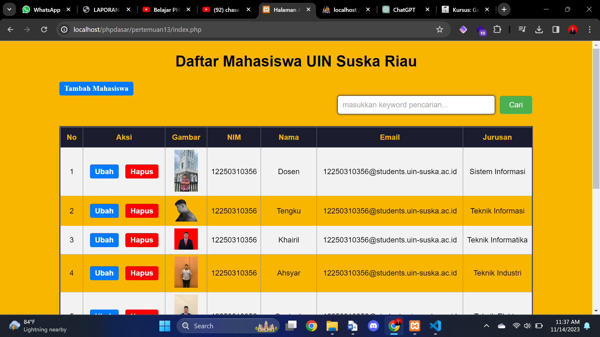

**Halaman Tambah Mahasiswa**

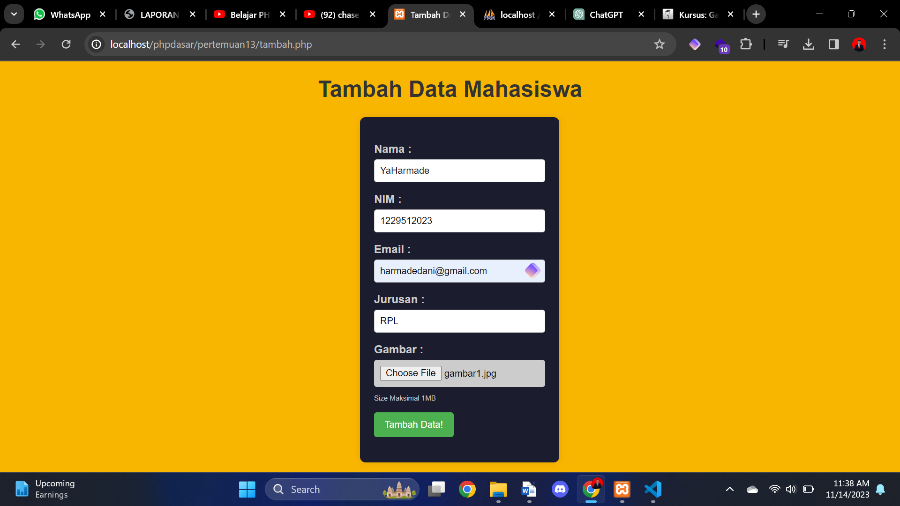

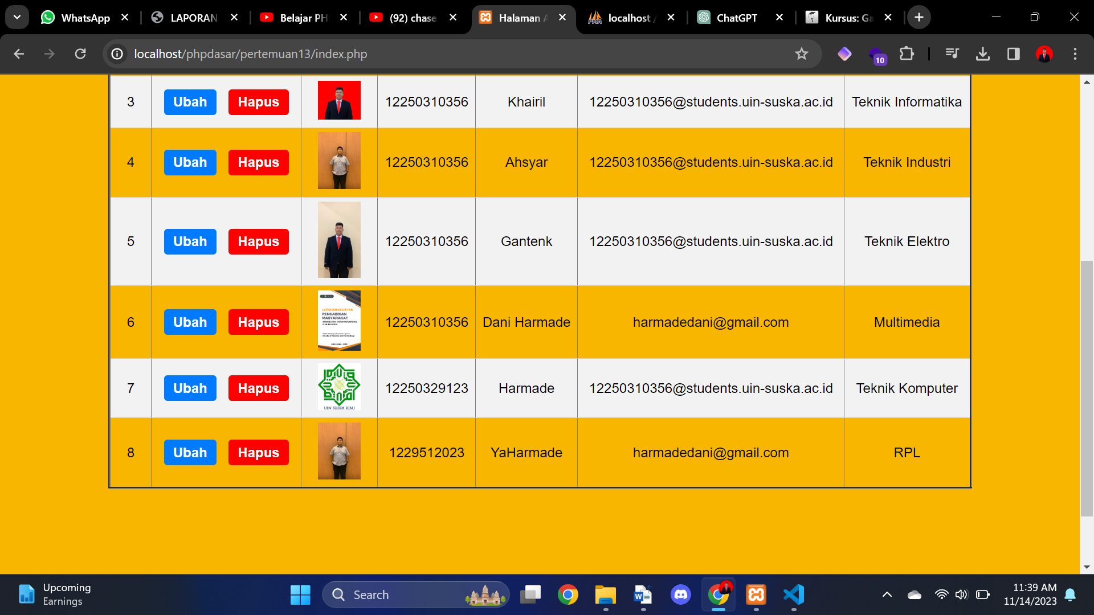

**Aksi Hapus**

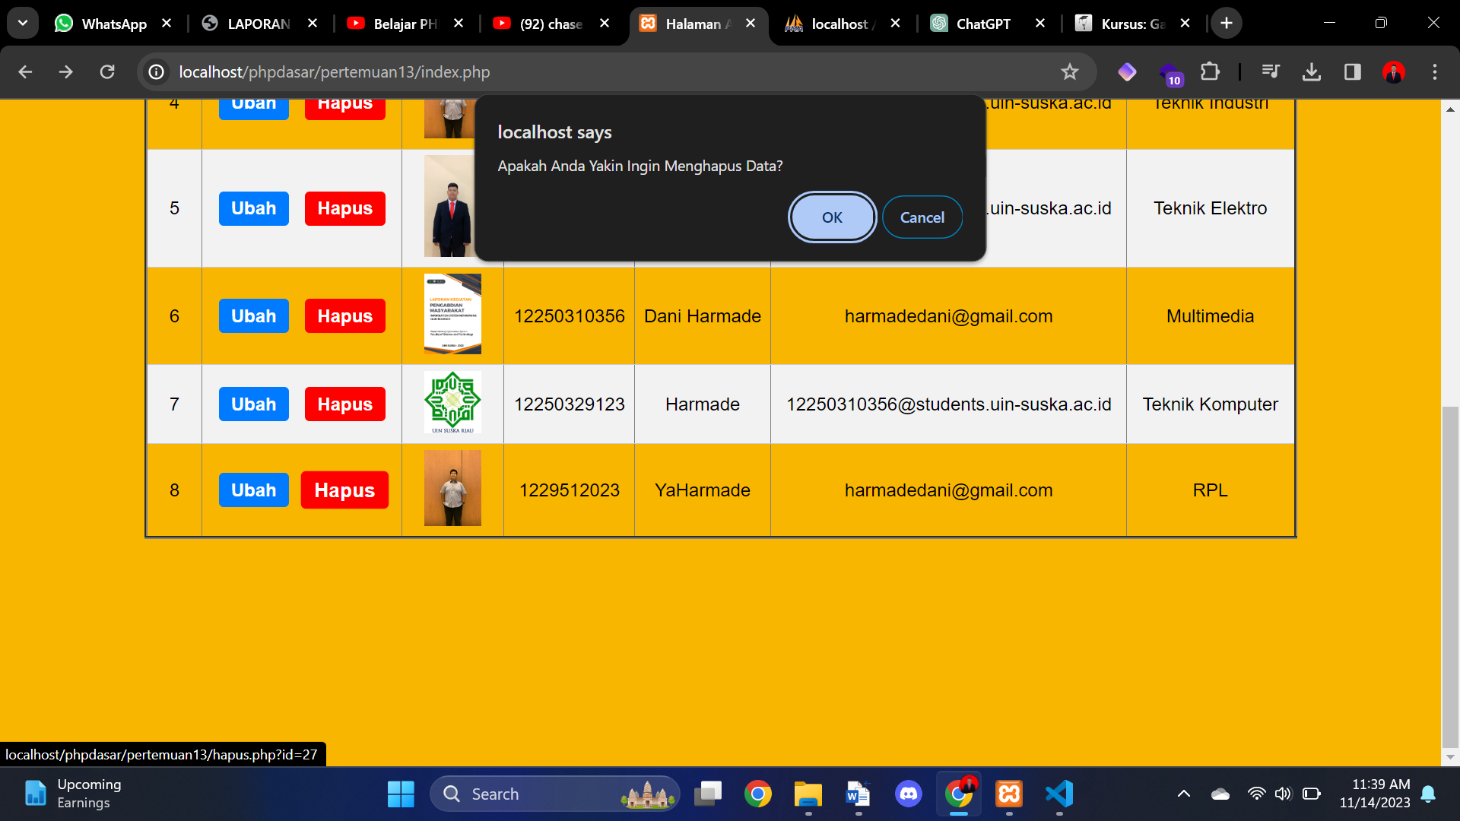

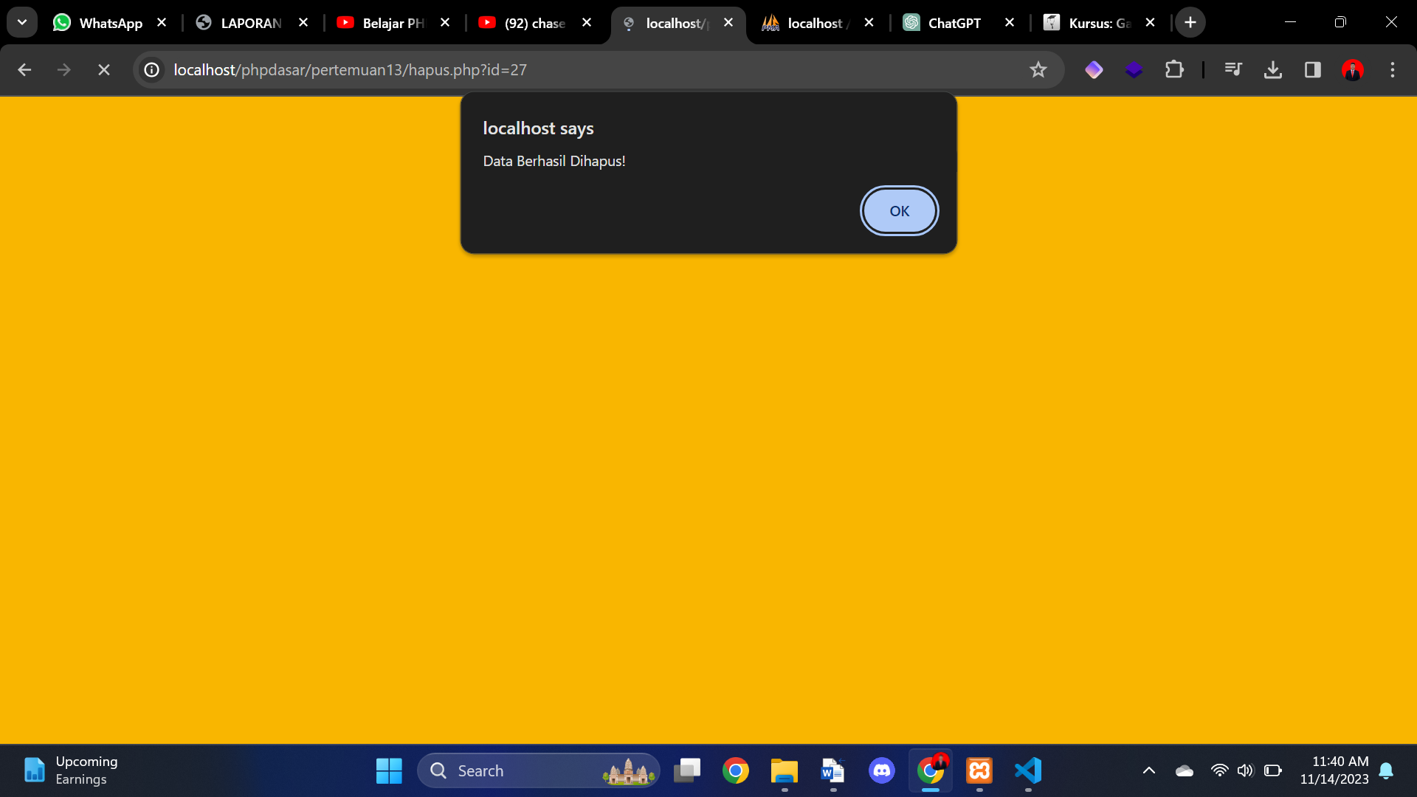

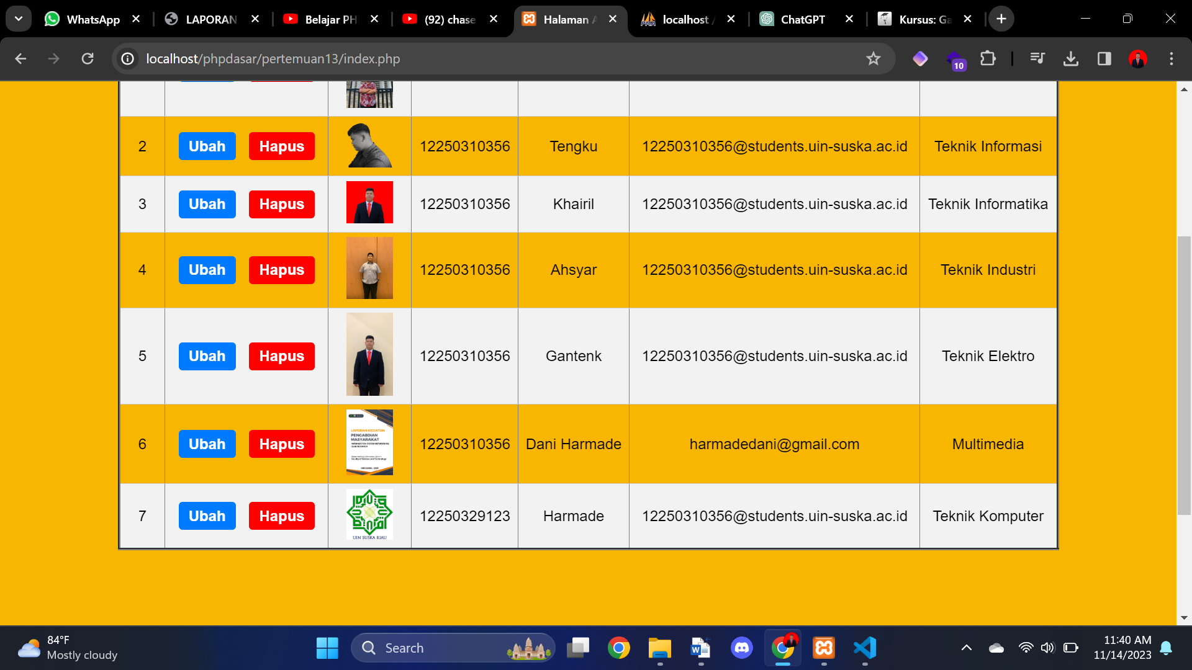

**Aksi Ubah**

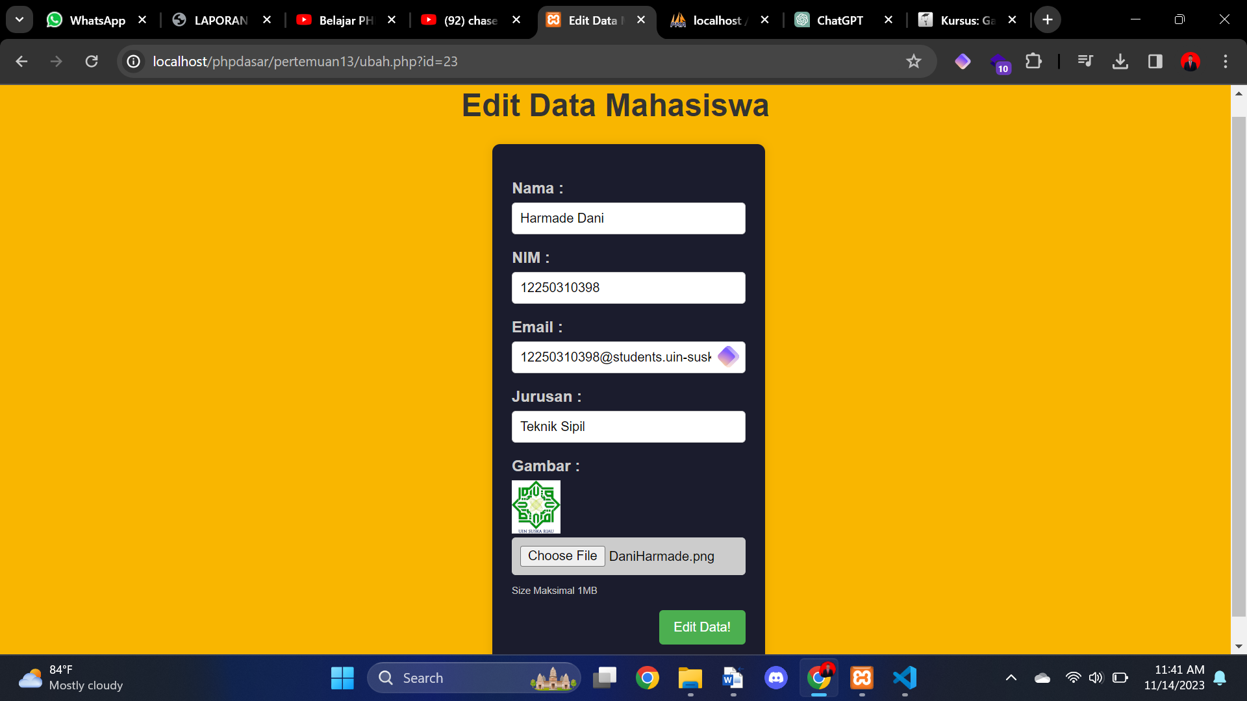

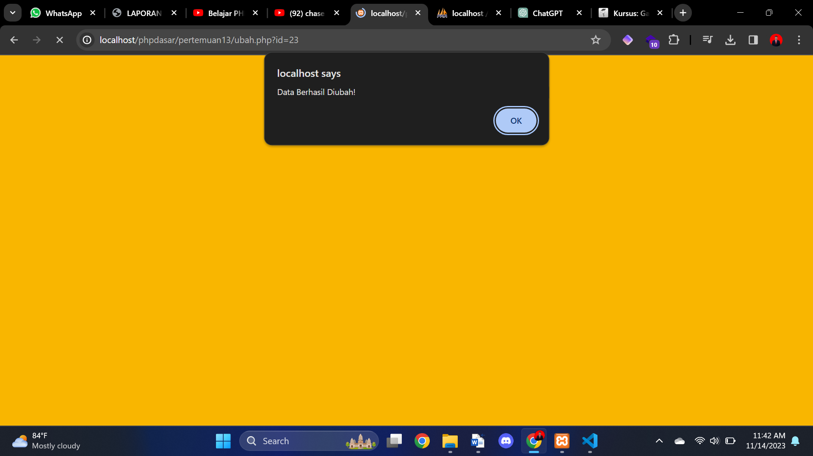

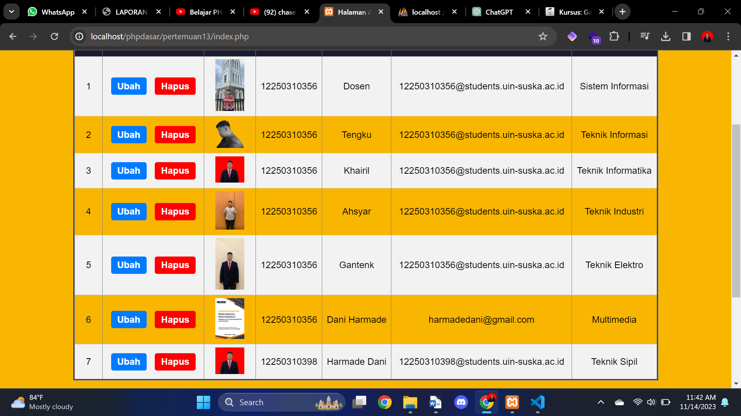

**Menu Search**

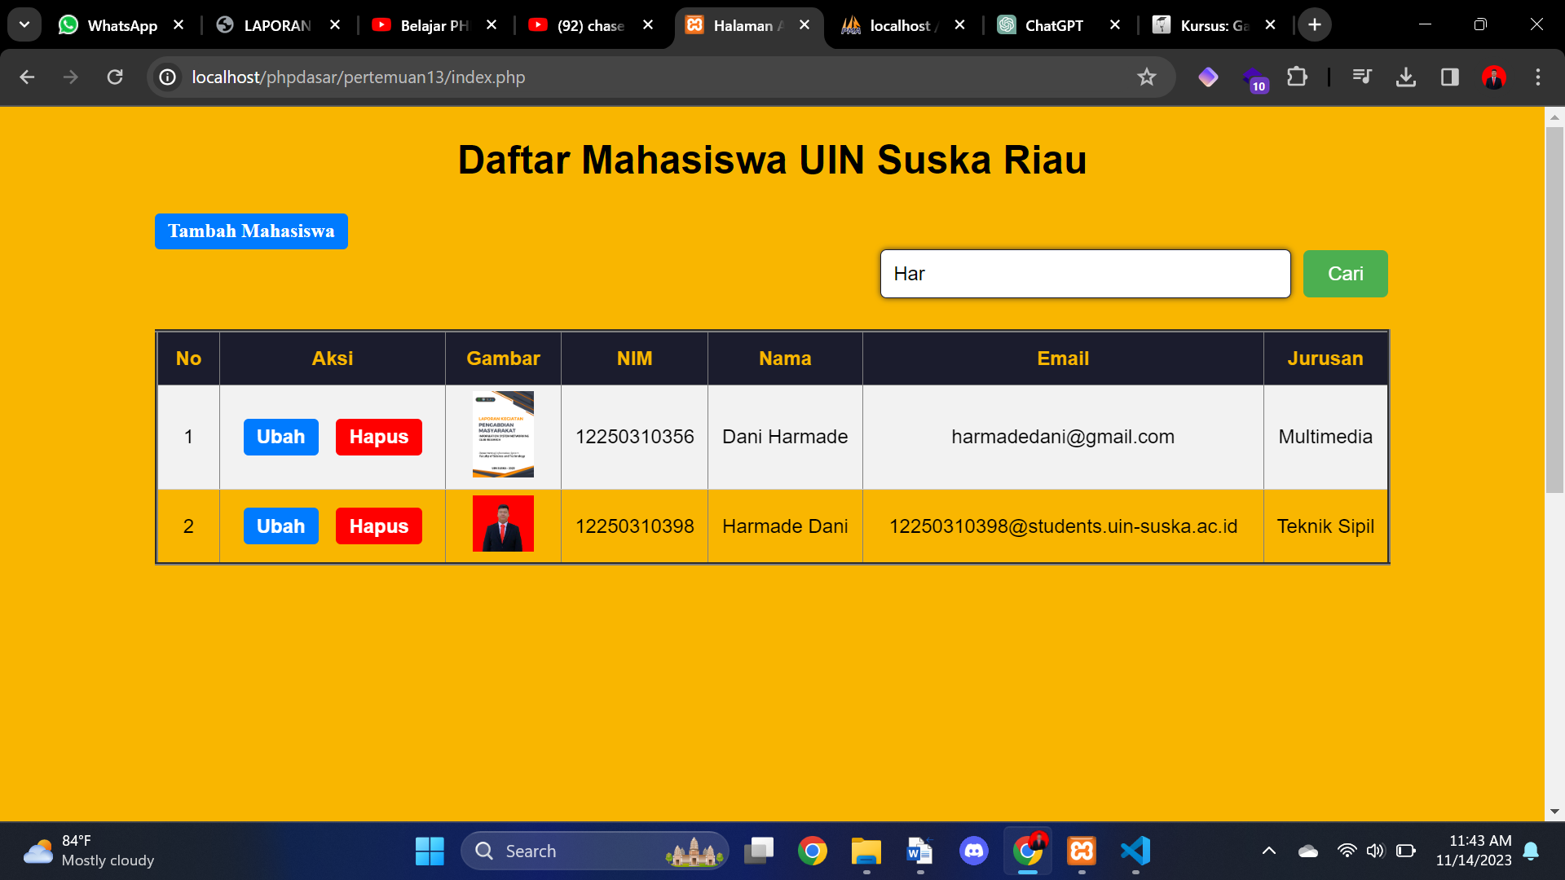

|  |  |
| --- | --- |
| **Telah diperiksa tanggal:** | **../../20..** |
| **Mengetahui:**  **Dosen Pembimbing/Asisten**  **T. Khairil Ahsyar, S.Kom,. M.Kom**  **NIP. 198505202023211020** | **Nilai Praktikum:** |
| **Catatan:** |