Danielle Hooven

IST269-225

Cyril Keiffer

02 May 2020

**Final Project: Harry Potter Trivia App**

**Techniques from Each Chapter…**

* Specify the use of the layout in the user interface (Ch. 1)
  + Relative Layout
* Create multiple Android Activities (Ch. 2)
  + Each question is a new activity
* Develop a user interface using a Spinner control (Ch. 3)
  + Question with dropdown list to select answer
  + Uses a string-array to store list items.
* Use an Android Theme (Ch. 3)
  + Customized black background with red title bar
* Place a RadioGroup and RadioButtons in Android applications (Ch. 4)
  + Question with RadioButtons to select answer
* Write code using the Switch decision structure (Ch. 5)
  + Case 4: 100% Ravenclaw
  + Case 3: 75% Gryffindor
  + Case 2: 50% Hufflepuff
  + Case 1: 25% Slytherin
  + Case 0: 0% Slytherin
* Create an Android project using a splash screen (Ch. 6)
  + “Calculating Results”
* Display a custom toast message (Ch. 7)
  + Message pops up if an answer is not selected.
* Display a DatePicker Control (Ch. 8)
  + When is Harry Potter’s birthday?
* Display a custom layout…a table layout (Ch. 9)
  + Final screen with picture and results
* Create an Android application with Frame animation (Ch. 10)
  + Animated image on splash screen
* Write data using a SharedPrefence object. (Ch. 11)
  + Correct answer gets 1 point, wrong answer gets 0.
  + Store the point, use it for running total.
  + Stored data is used to decide result page display.
* Target various languages (Ch. 12)
  + Spanish alternative.

**Mock-Up Design with Notes…**

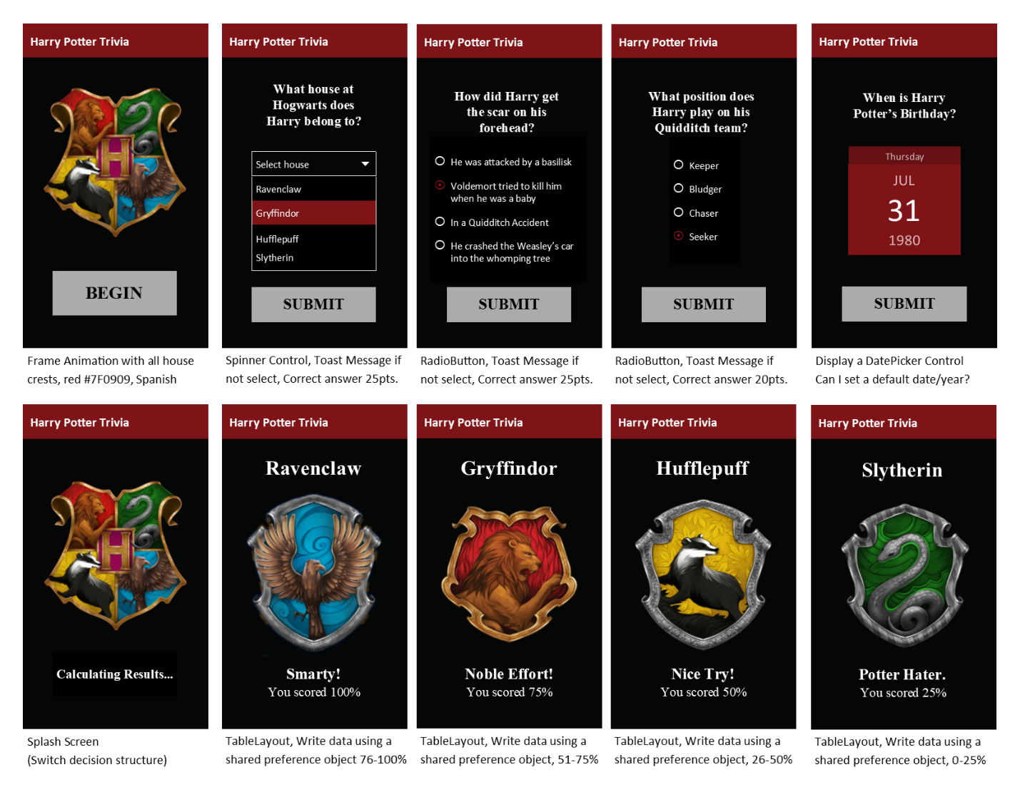

**Psuedo-Code**

1. Opening
   1. On open, Start Frame Animation reveals animated house crests frame-by-frame for 5 seconds. How do I start Frame Animation without hitting a button to start activity?
      1. When user taps begin, the first question is opened in a new activity.
2. Question One
   1. Display a text field with the question and spinner control. The options in the spinner are each of the Hogwarts houses.
      1. When the user taps submit
         1. The point value for the selected answer are added to the total. How do I store value in sharedPreferences?
         2. The second question is opened in a new activity.
         3. If no selection is made, display custom toast message.
3. Question Two
   1. Display a text field with the question, RadioGroup and RadioButtons. The user selects a RadioButton to answer.
      1. When the user taps submit
         1. The point value for the selected answer are added to the total. How do I store value in SharedPreferences?
         2. The third question is opened in a new activity.
         3. If no selection is made, display custom toast message.
4. Question Three
   1. Display a text field with the question, RadioGroup and RadioButtons. The user selects a RadioButton to answer.
      1. When the user taps submit
         1. The point value for the selected answer are added to the total. How do I store value in sharedPreferences?
         2. The third question is opened in a new activity.
         3. If no selection is made, display custom toast message.
5. Question Four
   1. Display a text field with the question and button to select date. Do I have to use the button to select date or can I display the DatePicker in the layout?
   2. When the user taps the select date button, a DatePicker is displayed in a dialog box. The dialog box allows the user to select the date to attend the year-long festival.
      1. When the user taps submit
         1. The point value for the selected date are added to the total. How do I store value in sharedPreferences?
         2. The splash screen is opened in a new activity.
         3. If no selection is made, display custom toast message.
6. Calculate Results
   1. A splash screen opens and displays the Hogwarts crest image with the text “Calculating Results” for two seconds.
      1. Total point value is saved in persistent data using SharedPreferences. Open and retrieve saved values.
7. Results
   1. Use swtich decision structure
      1. Case 0: Total = 4 pts (Ravenclaw)
         1. Display 4 table rows within a table layout with a house title, image, phrase, and results.
      2. Case 1: Total = 3 pts (Gryffindor)
         1. Display 4 table rows within a table layout with a house title, image, phrase, and results.
      3. Case 2: Total = 2pts (Hufflepuff)
         1. Display 4 table rows within a table layout with a house title, image, phrase, and results.
      4. Case 3: Total = 1 (Slytherin)
         1. Display 4 table rows within a table layout with a house title, image, phrase, and results.
      5. Case 4: Total = 0 (Muggle)
         1. Display 4 table rows within a table layout with a house title, image, phrase, and results.