**ITEC 136 Lab 3 Name: ___Danielle Hooveny______**

## Assignment

Write a program that will create a histogram of the number of times each character occurs in a file. Check <https://en.wikipedia.org/wiki/Histogram> and <http://interactivepython.org/runestone/static/thinkcspy/Functions/ATurtleBarChart.html> for help. Your program will read any input text file and print the histogram. If you have a huge file you should have a graph similar to:

Note the y-axis shows the percentage of each letter. The height of each bar is percentage of that letter. You program must show the graph with percentage marks on y-axis and letters on the x-axis as shown in the graph below.

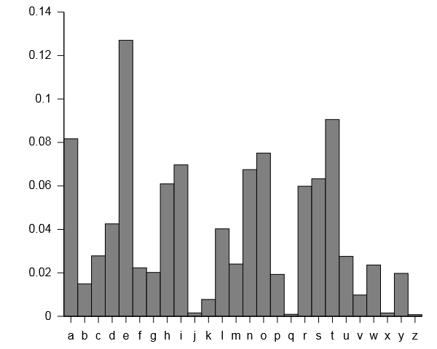

<https://en.wikipedia.org/wiki/Letter_frequency>

## Grading Criteria

* Quality of the solution: 0 – 50 points
  + Documentation (internal comments) (0 – 5 points)
    - It is not uncommon for industry to impose a way of documenting software that is uniform across all programmers. Documentation standards are outlined in the same document referenced in the style bullet below.
  + Style (formatting, naming conventions and appearance of solution code) (0 – 5 points)
    - As listed in the action items of the course web page lab assignment, ensure that your solution code meets the documentation and style guidelines for this course. The documentation and style requirements Word document titled "DocumentationAndStyleGuidelines.doc” exists as a link on the lab assignment page. Review your code against this document.
  + Correctness (how the program works under test) (0 – 40 points)
    - The program should work, and be seen to work. The code should be robust.
* Note that grammar, spelling, and writing mechanics do not contribute to the total points for this assignment; however, improper grammar, poor spelling, or poor writing mechanics may result in significant point deductions.