**Object Oriented**

**Programming**

**( Lab )**

**Smart Healthcare Assistant**

**Submitted To: Mam Samra Mehboob**

**__________________________________________________________________________**

**Student Name: Danish Hussain,**

**__________________________________________________________________________**

**Reg. Number:, 2312426,**

***Code:***

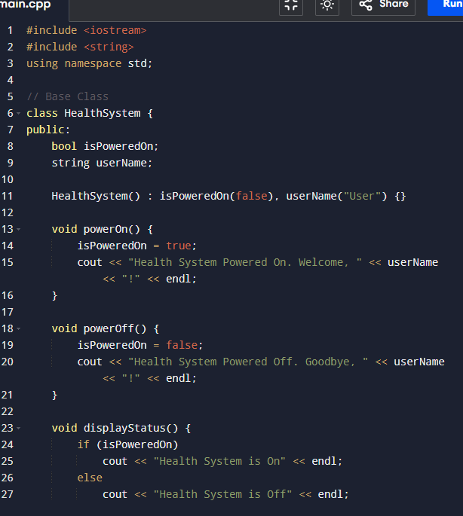

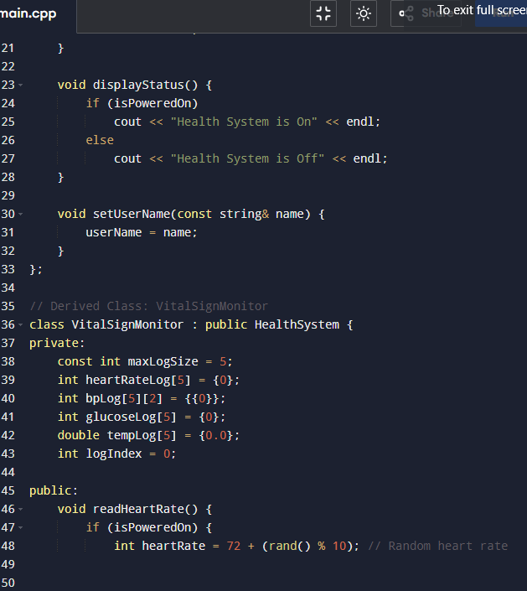

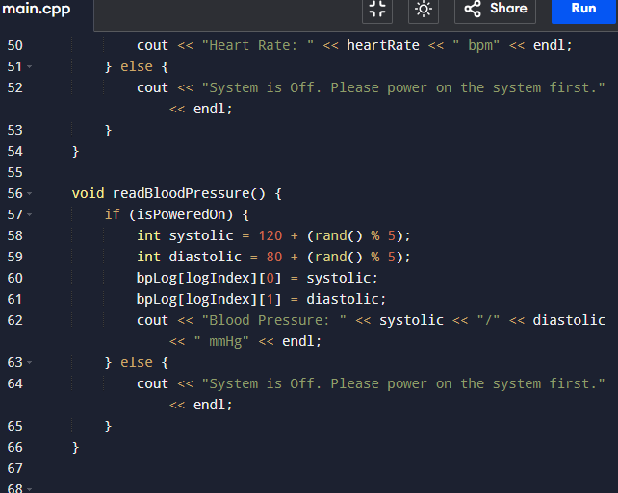

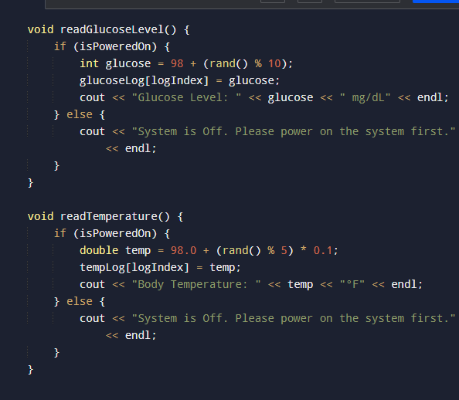

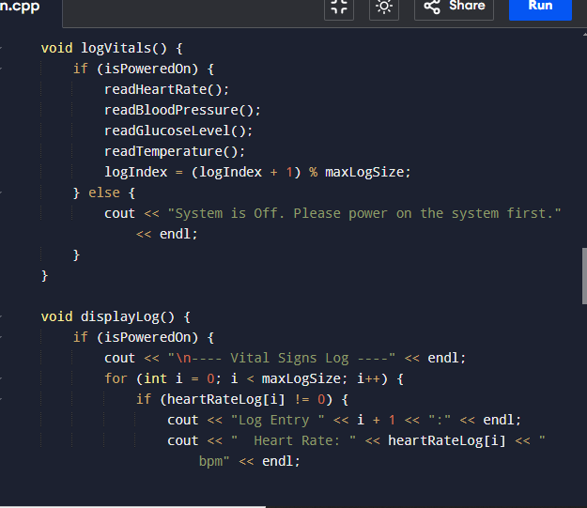

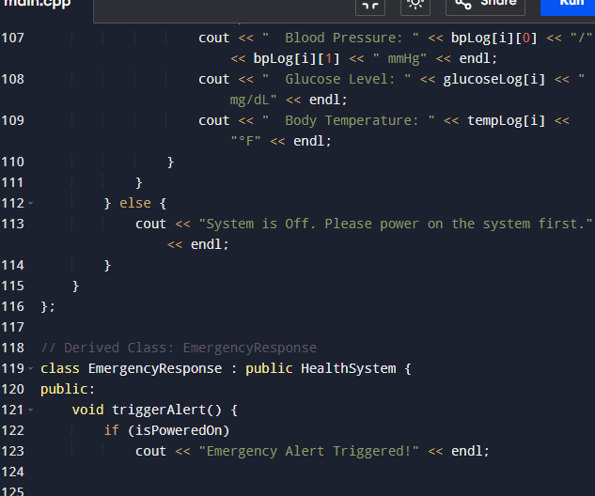

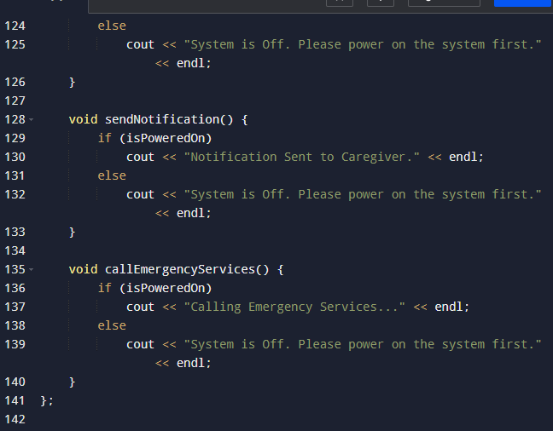

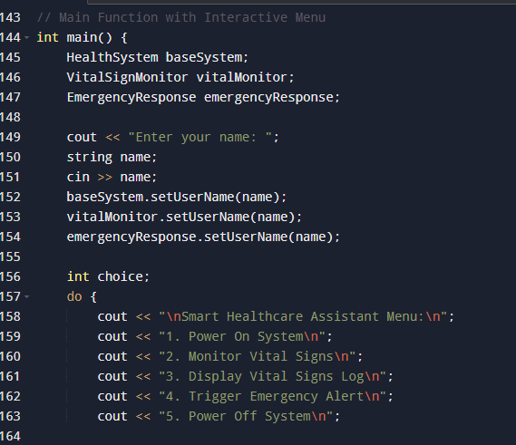

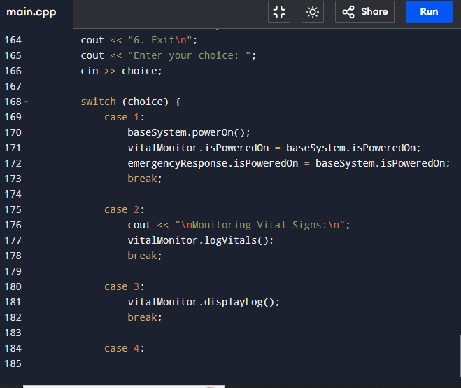

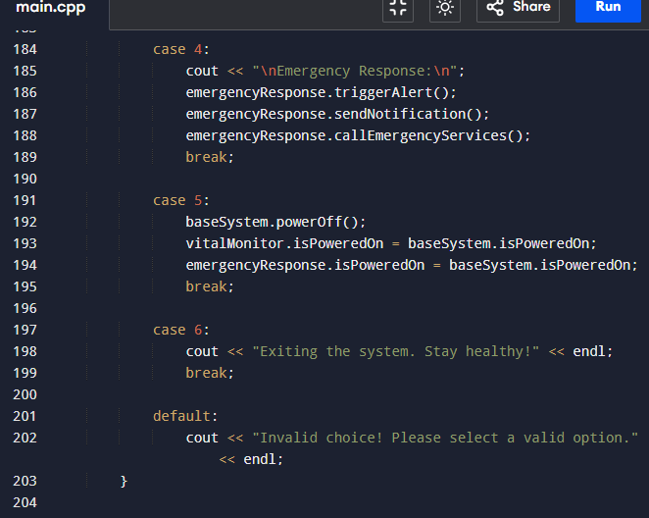

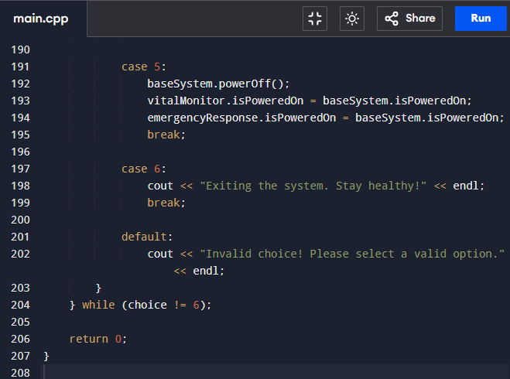

***Output:***

***Menu 1 output***

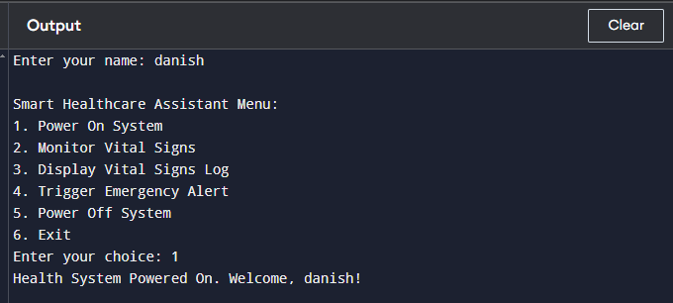

***Menu 2 output***

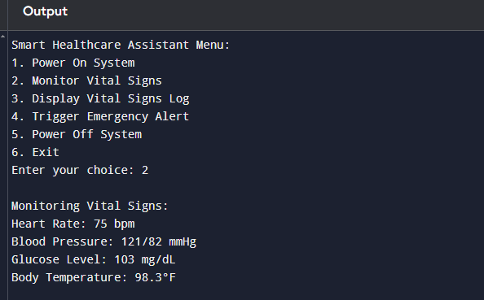

***Menu output***

