Date: Saturday, November 27, 2021

OnlyBugs Inc.

Version 2.0

SOftware solution for student housing

Contents

Introduction 3

Who is to benefit from this software solution? 3

Problems in student housing and which of them we aim to solve 4

Functionalities which we implemented to solve the problems 4

Student 4

Agency 5

Timeline of the implementation of the functionalities 6

External factors which might slow down the work on the project 6

Constraints- language, tools, etc… 7

Deliverables 7

# Introduction

This software solution for student housing is made for the sake of easing the communication between tenants and their roommates and between tenants and property managers. There can be tenant and agency/admin accounts which have different accessibility to the application’s functionalities.

On the tenants’ side the application includes a calendar with the possibility to create events/etc. or check existing ones. The home tab displays any upcoming events/tasks with the option to show only personal ones for the logged in tenant. Tenants can read rules made by the property manager in the rules tab and they have the option to send anonymous complaints to their roommates or directly to the manager.

On the property manager’s side, we have a complaints tab which displays all the complaints sent by tenants. The property manager can add/delete rules in the rules tab, and they can send announcements to the tenants through the announcements tab. Accounts can be created or deleted from the accounts tab.

# Who is to benefit from this software solution?

The software solution’s main end users are the students who live in student housing. Its purpose is to make the process of communication, organization and making complaints easier. The secondary user of the solution will be the person/agency responsible for the management of the property. The implementation of the solution makes the collection of complaints by the agency fast and simple. They can also edit the list of the rules, send messages to the tenants if necessary and add and delete tenant's accounts.

# Problems in student housing and which of them we aim to solve

It may not seem at first glance but there are several responsibilities connected with offering student housing. The Agency should know what is going on in the house, provide some cleaning services and basically maintain the house. To be able to do all these things, the agency needs to hire people who then get paid. With our software, the information flow and maintenance will be easier and faster.

The student house and agency face a lot of problems every single day. Problems starting with taking out the rubbish to buying house supplies. These problems should be fairly divided between all house members. The most common problems are taking out the rubbish, leaving dishes in a sink, leaving dried dishes in dish tray, not announcing when something is broken or out of stock (e.g., toilet paper, baking paper, soap, etc.). Another particularly crucial point is that students host parties very often and sometimes other tenants have no idea about some events.

Therefore, our group came up with a solution for most of the problems. We are creating simple designed software, where students can submit their complaints to the agency and send messages to the other tenants living in the house. They can see all the upcoming events and the tasks that they have been assigned to or the whole list of the tasks of all tenants. They can add or delete an event from the implemented calendar. Our software also has a log in page where the logged in person is recognized and whether the person is tenant or agency.

# Functionalities which we implemented to solve the problems

## Student

Each of these functionalities will be easily accessible through the Tab Control tool from the toolbox in Visual Studio. They will be categorized into four categories.

The first category is Home. Here tenants can see all tasks and events and also messages from agency (inbox). There is a possibility to filter tasks and events to show only the ones that are for the logged in tenant. The logged in tenant can also delete the events he/she has created.

The second category is called Calendar. Here tenants can click on a date and see events listed for this exact day. Tenants can also add events into the calendar from here.

The third category is Rules. Here all the house rules will be listed, such as when the bins are collected and how to behave in the house.

The fourth and last category is Complaints. This tab lists all the complaints from tenants. Tenants can send a complaint so other tenants see it, or he/she can send a direct complaint to the agency.

## Agency

After logging in, the page layout will contain a Tab Control with four tabs. The first tab is called Complaints, the second is called Rules, third one is called Accounts and the fourth is called Send message.

In the Complaints tab the admin can find all the complaints that were sent by tenants. This way he has access to everything that was said and immediately interacts.

In Rules tab, admin will be able to add and delete rules.

In the third tab, admin can add or delete user accounts of those who came new or do not live there anymore.

In the last tab admin can send messages to tenants. These messages will be listed on a home page of student in an Inbox list box.

## CRUD

Admin, in our case agency can see/do:

* all complaints sent by students,
* edit rules (i.e. add rules or delete rules),
* accounts (i.e. add account or delete account),
* send messages to tenants

Tenants, in our case students can see/do:

* tasks, events and messages from the agency (can filter tasks and events to see only his/hers)
* calendar with all events listed, add own event
* all listed rules by agency
* all complaints from students, add own complaint (send to students or directly to agency)

# Timeline of the implementation of the functionalities

* Login page with username and password – 04/12 – 06/12
* Student account
  + Calendar tab – 05/12
    - Events and Tasks are shown in a list box for the selected date
    - Adding an event for the selected date
  + Announcements tab – 07/12 – 09/12
    - All tasks are shown in the Tasks list box
    - All events are shown in the Events list box
    - Adding filters for showing only My Tasks and My events
    - Adding list box for showing all the messages sent from students - Log
  + Rules tab – 04/12 – 07/12
    - A list box showing all the rules set by the agency
  + Complaints tab – 07/12 – 09/12
    - Adding a textbox for writing the message and two buttons – one for sending a message to the agency and second for sending a message to the other roommates. Message is going to be shown in the Log.
* Agency account
  + Complaints tab– 09/12
    - A list of all the complaints sent from the students in the past month.
  + Rules – 04/12 – 07/12
    - A list of all the rules and two buttons for adding a new rule and deleting a rule.

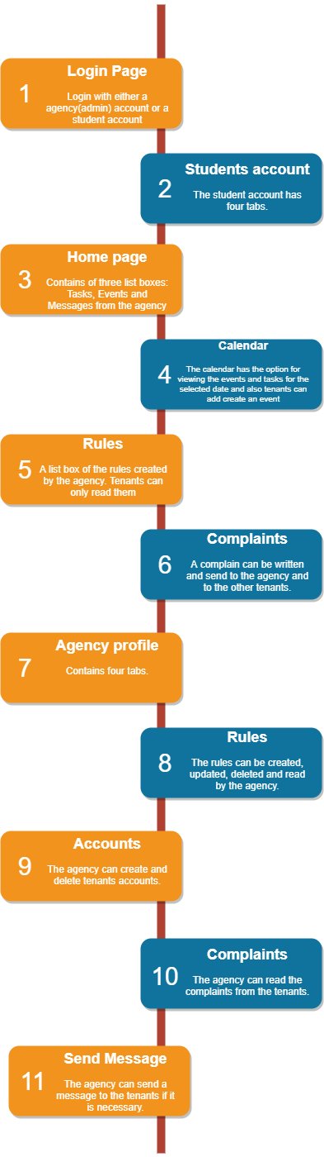

# External factors which might slow down the work on the project

* Everyone from the group should stick to the plan, because if someone is late with finishing a certain task this is going to cause a delay with the implementation of the next features.
* If someone gets sick this is going to cause a delay
* Clients running out of business
* If the team has any issues with their laptops.

# Constraints- language, tools, etc…

Our software housing project is built on the coding language C# in Visual Studio and it is based on the Windows Forms App (.NET Framework) template. We use GitHub as a version control system. Microsoft Teams, WhatsApp, Outlook as forms of communication. Draw.io was used for the creation of the diagram in the document.

# Deliverables

* Project analysis + basic functionalities
* Class diagram
* Prototype of the design
* A login screen for students and agency
* Calendar tab
* Announcements tab

Announcements can be made by students

* Rules Tab

Agency can add rules, students can only read rules

* Complaints tab

Students can add complaints, agency can only read them

* Solution in Git
* Report
* Presentation

Flow chart of the functionalities

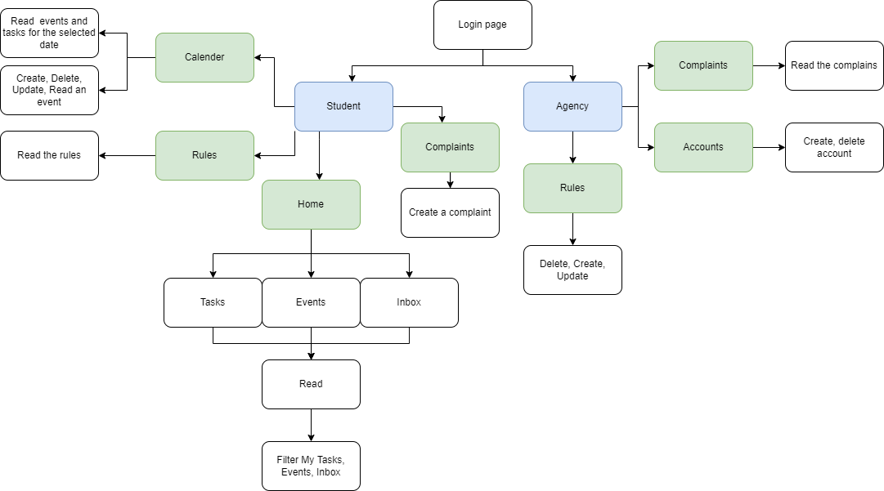

UML of the classes in our project

Showcase of the UI

