Семинар

<https://gb.ru/lessons/386945/homework>

Задача1

<https://autotest.gb.ru/problems/50?lesson_id=386945&_ga=2.29953919.1367847346.1703276949-1084979555.1684681893>

DROP TABLE IF EXISTS itresume113284.mobile_phones;

CREATE TABLE itresume113284.mobile_phones (

id SERIAL PRIMARY KEY,

product_name VARCHAR,

manufacturer VARCHAR,

product_count VARCHAR,

price INT

);

INSERT INTO itresume113284.mobile_phones (product_name, manufacturer, product_count, price)

VALUES

('iPhone X', 'Apple', 156, 76000),

('iPhone 8', 'Apple', 180, 51000),

('Galaxy S9', 'Samsung', 21, 56000),

('Galaxy S8', 'Samsung', 124, 41000),

('P20 Pro', 'Huawei', 341, 36000);

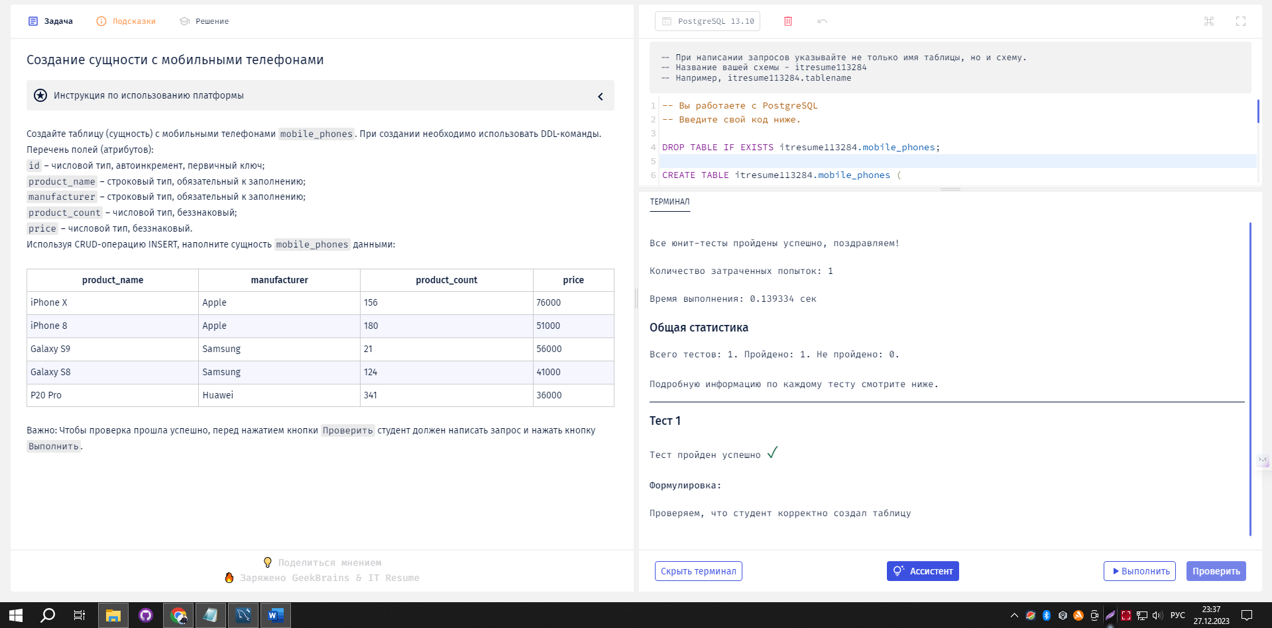

Успех

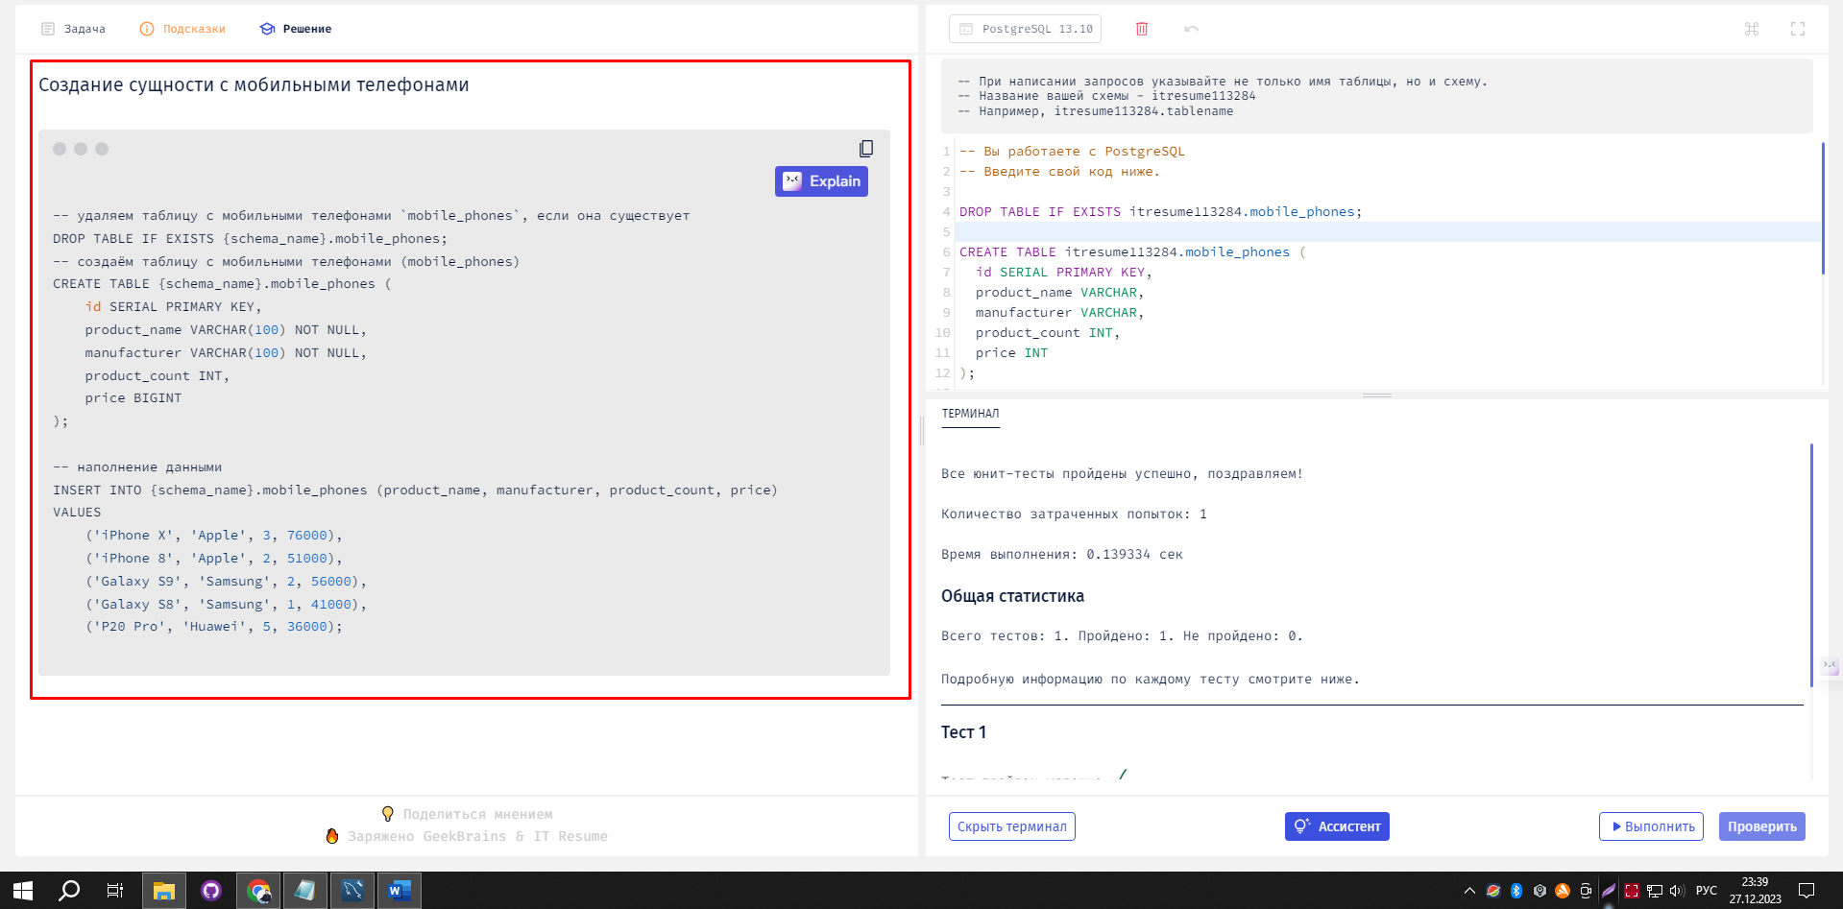

SELECT product_name, manufacturer, price FROM mobile_phones WHERE product_count >2;

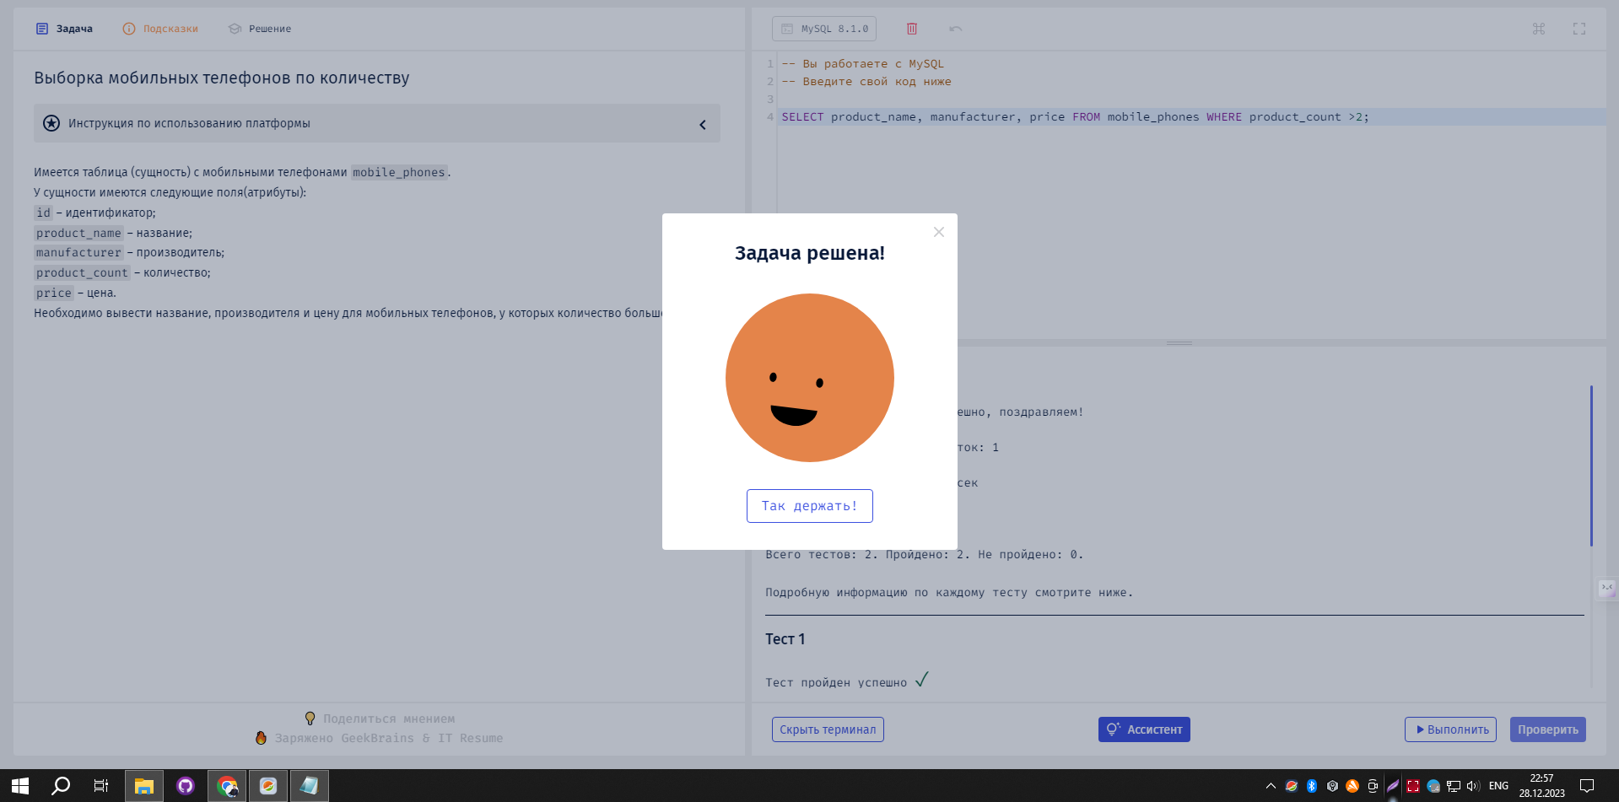

SELECT id, product_name, manufacturer, product_count, price FROM mobile_phones WHERE manufacturer = 'Samsung';

