-- Вы работаете с PostgreSQL

-- Введите свой код ниже

DROP TABLE IF EXISTS itresume113284.manufacturer;

CREATE TABLE itresume113284.manufacturer (

id SERIAL PRIMARY KEY,

name VARCHAR

);

INSERT INTO itresume113284.manufacturer

(name)

VALUES

('Apple'),

('Apple'),

('Samsung'),

('Samsung'),

('Huawei');

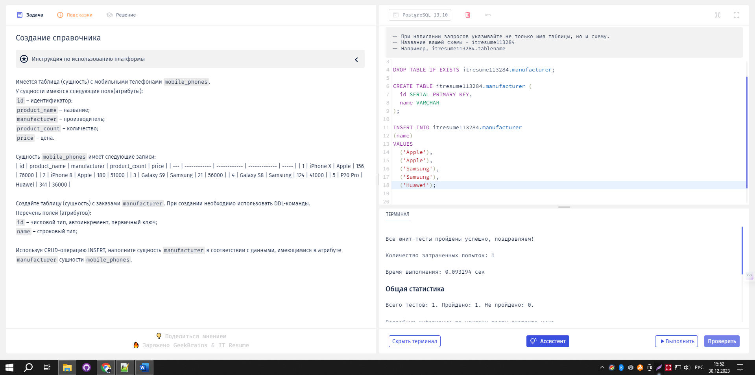

|  |
| --- |
| Их терминал это не смог обработать |
| -- select * from mobile_phones;  SELECT  id AS 'номер',  product_name AS 'товар',  manufacturer AS "завод",  product_count AS "кол-во"  price AS "цена",  CASE  WHEN product_count < 100 THEN 'little'  WHEN product_count BETWEEN 100 AND 300 THEN 'many'  WHEN product_count > 300 THEN 'lots'  ELSE 'непонятно'  END AS 'статус'  FROM mobile_phones ; |

Успех SELECT id, product_name, manufacturer, product_count, price FROM mobile_phones;

Их рабочий ответ

SELECT

`product_name`,

`manufacturer`,

CASE

WHEN product_count<100 THEN 'little'

WHEN product_count between 100 AND 300 THEN 'many'

WHEN product_count>300 THEN ' lots'

ELSE 'unspecified'

END AS `status_count`

FROM `mobile_phones`;

