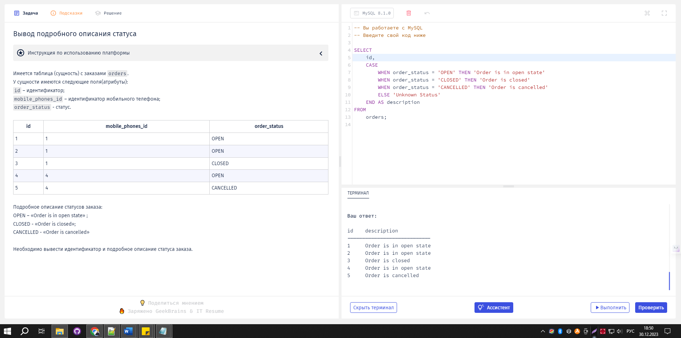

-- Вы работаете с MySQL

-- Введите свой код ниже

SELECT

id,

CASE

WHEN order_status = 'OPEN' THEN 'Order is in open state'

WHEN order_status = 'CLOSED' THEN 'Order is closed'

WHEN order_status = 'CANCELLED' THEN 'Order is cancelled'

ELSE 'Unknown Status'

END AS description

FROM

orders;