<https://gb.ru/lessons/386947/homework>

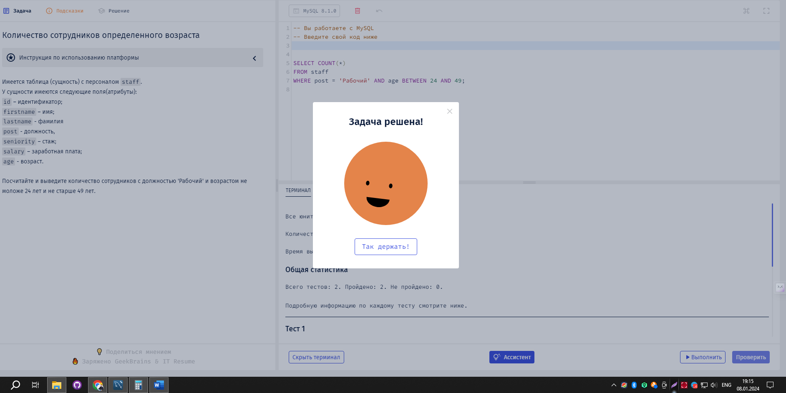

SELECT COUNT(\*)

FROM staff

WHERE post = 'Рабочий' AND age BETWEEN 24 AND 49;

