<https://gb.ru/lessons/386947/homework>

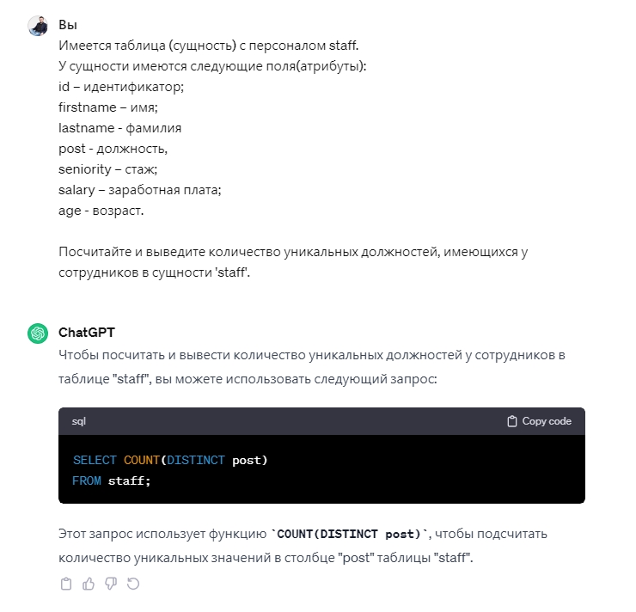

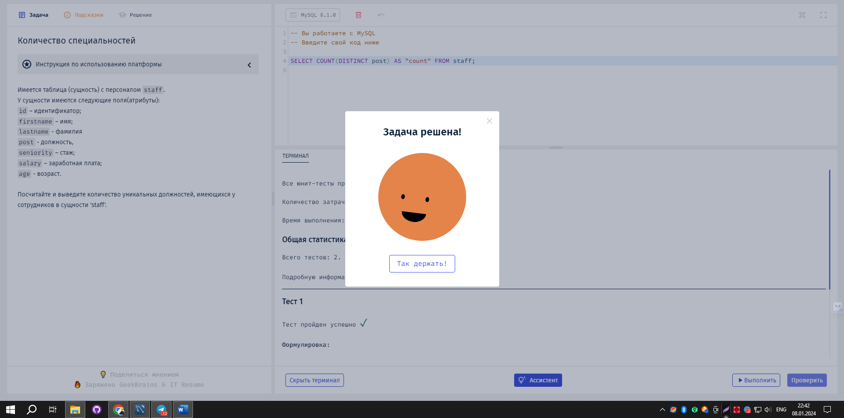

SELECT COUNT(DISTINCT post) FROM staff;