<https://gb.ru/lessons/386947/homework>

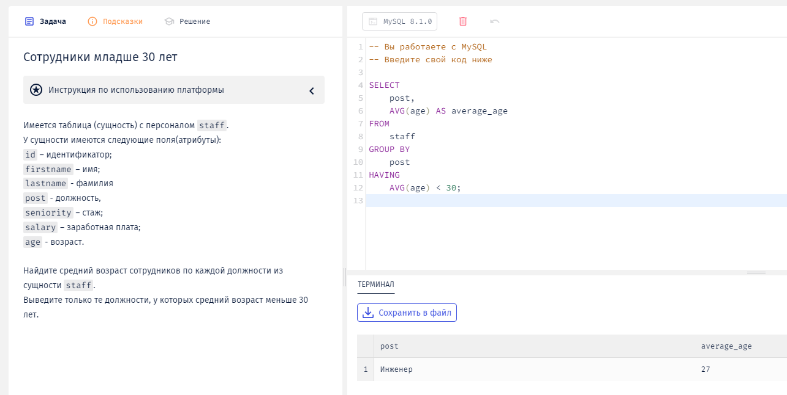

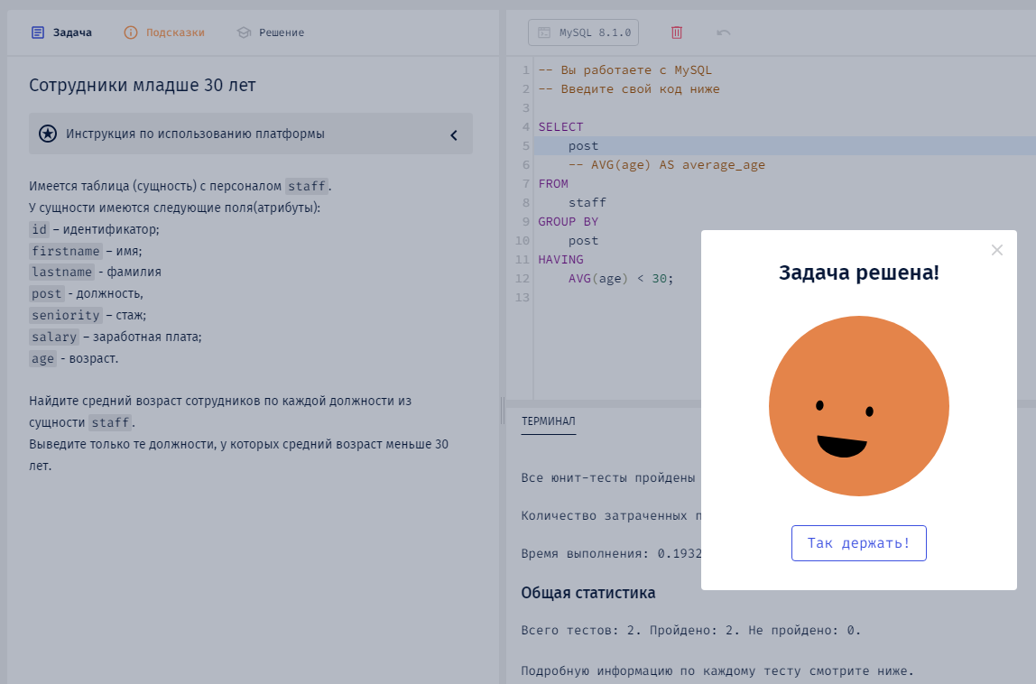

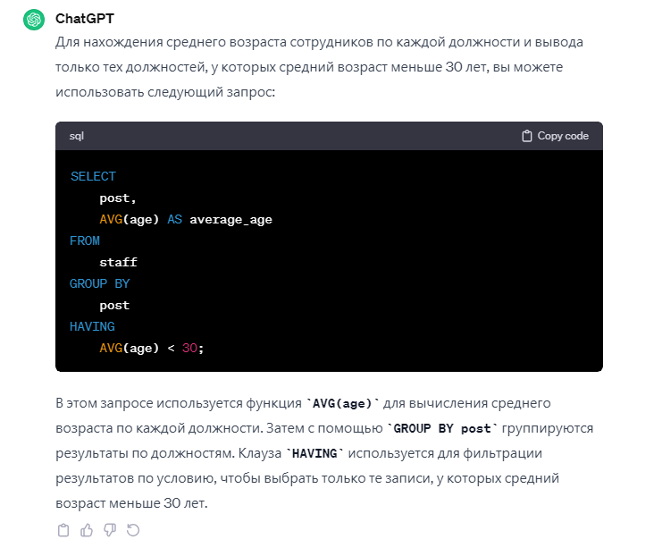

|  |
| --- |
| SELECT  post,  AVG(age) AS average_age  FROM  staff  GROUP BY  post  HAVING  AVG(age) < 30; |
|  |
| SELECT  post  -- AVG(age) AS average_age  FROM  staff  GROUP BY  post  HAVING  AVG(age) < 30; |
|  |
|  |