UDC 004.85

MACHINE LEARNING-BASED VIBRATION ANALYSIS FOR SYSTEM-AGNOSTIC FAULT DETECTION

Sanzharov D. R. – Bachelor's degree student in Computer Science, State University of Trade and Economics, Kyiv, Ukraine.
Filimonova T. O. – Candidate of Physical and Mathematical Sciences, Associate Professor of Computer Science and Information Systems Department, State University of Trade and Economics, Kyiv, Ukraine.

ABSTRACT
Context. Traditional maintenance strategies for complex machinery rely on fixed schedules or run-to-failure approaches, which can be inefficient and potentially unsafe. Modern computational capabilities and vibration analysis offer opportunities for more sophisticated predictive maintenance solutions, but processing raw vibration signals for effective fault detection remains challenging.
Objective. This research aims to develop and validate a system-agnostic methodology for automatic fault detection in mechanical systems using vibration signal analysis, without requiring prior knowledge of system-specific parameters or sampling rates.
Method. The study implements a comprehensive signal processing pipeline combining detrending, Hann windowing, and Fast Fourier Transformation for feature extraction. Principal Component Analysis reduces dimensionality while preserving 95% variance. A Random Forest classifier performs the final fault detection. The methodology was validated using 1158 vibration signals with known fault classifications through 5-fold cross-validation.
Results. The developed methodology achieved near-perfect classification accuracy across all validation folds, with a mean cross-validation score of 0.9983. The approach successfully identified distinctive frequency ranges for fault detection without requiring specific mechanical knowledge. The preprocessing pipeline significantly enhanced signal clarity, particularly in the frequency range of 0.75 to 1.75, enabling clear differentiation between operational and defective states.
Conclusions. The research presents several novel contributions: a system-agnostic approach combining signal processing and machine learning that achieves reliable fault detection without mechanical expertise; an improved signal processing pipeline enhancing fault-indicating frequencies through automated feature selection; and advanced dimensionality reduction techniques maintaining discriminative power. The methodology's practical significance lies in enabling condition-based maintenance strategies across various industrial applications, reducing unnecessary maintenance interventions, minimizing expertise requirements, and supporting real-time monitoring capabilities. These advancements represent a substantial contribution to industrial maintenance practices, particularly valuable for complex systems where traditional approaches may be suboptimal.
KEYWORDS: predictive maintenance, vibration analysis, signal processing, machine learning, fault detection, Fast Fourier Transform, Random Forest classification, condition monitoring, frequency domain analysis, feature extraction, dimensionality reduction, industrial maintenance, automated diagnostics, mechanical systems, signal detrending

ABBREVIATIONS
FFT is Fast Fourie Transformation;
ML is machine learning;
PdM is predictive maintenance;
PCA is a Principal Component Analysis.

NOMENCLATURE
a_{im} is a data point of vibration recording;
f (s) is a classification function;
l_{n} is a classification label;
S is a set of vibration signals;
s_{i} is an array of data points in time of vibration signal;
ŷ is a predicted label;

INTRODUCTION
Maintenance is a critical yet often overlooked aspect of any hardware-based economic activity, particularly for complex machinery with numerous moving parts. Regular maintenance ensures equipment functions as designed and operates safely. However, determining the optimal time for maintenance—when to pause operations and invest valuable time and resources in replacements and inspections—presents a significant challenge.
Traditionally, maintenance follows a periodic schedule based on elapsed time or operational hours. While this approach works well for simple tasks like engine oil replacement, where performance depends on consumable resources, it falls short for complex systems without easily calculable failure timelines, such as internal combustion engines in automobiles or aircraft. For non-critical equipment, a run-to-failure approach may suffice, but this strategy is unacceptable for crucial or safety-critical systems. Preemptive maintenance, while ensuring safety, can waste resources if the machinery remains in good condition.
Modern computational capabilities offer a more sophisticated solution. By recording and processing vibration data from strategically placed sensors, we can detect early signs of failure before catastrophic breakdowns occur. Leveraging machine learning algorithms, these signals can be classified as indicative of healthy or faulty conditions. Although more complex, this approach enables targeted repairs and early detection of issues that might elude human operators, thereby enhancing safety and reducing unnecessary expenditures.
The object of this study is the process of analyzing and refining raw vibration signal data for use in machine learning classification algorithms. Raw signals typically require several stages of processing—analysis, transformation, feature selection, and dimensionality reduction—to become suitable inputs for machine learning models.
The subject of study encompasses digital signal refinement and analysis methods, including Fourier Transformation, statistical analysis, and spectral analysis. While these methods are well-established, their effective application requires specialized knowledge to achieve our maintenance goals.
The purpose of this work is to demonstrate the practical application of digital signal processing techniques in predictive maintenance, using real-world data. By doing so, we aim to illustrate how advanced signal processing and machine learning can revolutionize maintenance strategies, leading to improved safety, efficiency, and cost-effectiveness in industrial operations.

1 PROBLEM STATEMENT
Given:
- A set of vibration signals S = {s₁, s₂, …, s_{n}}, where each signal sᵢ is a discrete time series represented as an array of amplitude values: s_{i} = [a_{i1}, a_{i2}, …, a_{im}], where m is the number of data points in each signal.
- A corresponding set of labels L = {l₁, l₂, …, l_{n}}, where: 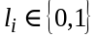 0 represents a healthy system state, 1 represents a faulty system state
- The time duration and sampling rate of the signals are unknown, so we define: t = [1,2,…,m] as an arbitrary time index for each signal.
The objective is to develop a classification function f (s) that maps an input signal s to a predicted label ŷ: 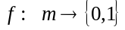, such that ŷ = f (s), where ŷ = 0 indicates a predicted healthy state and ŷ = 1 indicates a predicted faulty state.
Constraints are such that: the function f (s) must be developed without knowledge of the actual time duration or sampling rate of the input signals; the function should be generalizable to new, unseen signals with the same characteristics as the training set.
The performance of the classification function f (s) will be evaluated using the following metrics:
1. Precision: P = TP / (TP + FP)
2. Recall: R = TP / (TP + FN)
3. Score: F₁ = 2 × (P × R) / (P + R)
Where TP = True Positives (correctly identified faulty states), TN = True Negatives (correctly identified healthy states), FP = False Positives (healthy states incorrectly identified as faulty), FN = False Negatives (faulty states incorrectly identified as healthy).
The goal is to maximize F₁ score. It is crucial in classification tasks, particularly with imbalanced datasets, as it harmonically balances precision and recall, thus providing a robust measure of overall performance. Minimizing false negatives is important in our application because of safety concerns.
Additional considerations include the flexibility to incorporate various signal processing techniques and machine learning algorithms within the classification function pipeline, as well as the potential use of feature extraction and dimensionality reduction techniques to transform raw signal data into more suitable representations for classification.

2 REVIEW OF THE LITERATURE
A comprehensive review of vibration-based condition monitoring techniques, emphasizing data collection and preprocessing methods, is provided in [1] paper. It highlights the critical role of advanced accelerometers in acquiring high-quality vibration data and discusses the challenges associated with using simpler sensor technologies in industrial settings. While the study primarily focuses on hardware advancements, it also underscores the importance of coupling vibration data with analytical methods, such as spectral and time-domain analysis, to enhance fault detection accuracy. This paper serves as a foundation for understanding the role of vibration monitoring in PdM, providing context for the selection of preprocessing methods in this study.
This systematic review [2] explores machine learning methods for PdM, emphasizing the strengths and limitations of different algorithms. It evaluates approaches such as Support Vector Machines, Neural Networks, and ensemble methods for fault detection in various industrial applications. The review identifies critical factors influencing the success of PdM, including data preprocessing, feature selection, and algorithmic choice. It also highlights challenges such as overfitting and scalability in real-world settings. The insights from this paper inform the choice of Random Forests in this study, demonstrating their robustness and efficiency in handling high-dimensional vibration data.
Focusing on audio and vibration signal processing, [3] paper reviews machine learning techniques applied to anomaly detection and fault diagnosis. It discusses the effectiveness of both statistical and time-domain features in detecting faults and emphasizes the growing role of deep learning methods for automating feature extraction. While it outlines promising directions for improving fault detection accuracy, the paper also notes challenges related to data variability and noise. This work aligns closely with the objectives of the current study, particularly its focus on automated feature selection, but contrasts in its preference for time-domain features over frequency-domain analysis.
Collectively, these studies highlight the current exploration of detrending, DFA, and adaptive spectrogram-based methods as viable preprocessing steps for vibration analysis in the frequency domain, particularly under conditions where specific fault frequencies are uncertain, or signals are non-stationary. Foundational principles in frequency domain analysis, such as those described in [4], provide additional context for understanding the role of techniques like detrending and windowing in refining FFT outcomes for clearer anomaly detection in industrial applications.
An in-depth overview of PCA, a technique for reducing dimensionality in data by transforming correlated variables into orthogonal components that capture the largest variance, is provided in fundamental paper [5]. This process aids in simplifying complex datasets, improving interpretability, and serving as an essential preprocessing step in multivariate analyses. Their work also highlights PCA’s extensions, such as correspondence and multiple factor analyses, allowing for applications across various data types and research fields, reinforcing its adaptability and broad use in data analysis workflows.
Random Forests are introduced in [6] as an ensemble method that enhances the performance and stability of decision tree-based models through random sampling and aggregation. By constructing multiple trees on varied data subsets, Random Forests address overfitting and achieve high accuracy even with noisy or high-dimensional data. This method’s robust generalization capabilities make it a preferred tool for classification and regression, widely applicable across machine learning tasks where data complexity demands resilient and interpretable models.
[7] provides a comprehensive discussion on performance evaluation metrics derived from the confusion matrix, emphasizing the strengths and limitations of commonly used measures such as accuracy, sensitivity, specificity, and the F₁-score. It highlights the F₁-score's utility in imbalanced datasets due to its ability to balance precision and recall, making it particularly valuable in scenarios where correct classification of the minority class is critical. The paper also introduces alternative metrics, including Youden’s index, likelihood ratios, and Discriminant Power, which address additional classifier properties such as failure avoidance and class discrimination. However, these metrics are not directly relevant to our research focus, which prioritizes the evaluation of binary classification models using established metrics derived from the confusion matrix.

3 MATERIALS AND METHODS
The methodology of this research consists of several sequential steps designed to process vibration signals and develop a reliable classification model. Each step was chosen to address specific challenges in signal processing and ensure robust feature extraction.
The signal processing pipeline was designed to enhance the relevant frequency characteristics while minimizing noise and artifacts [4]. The first step addresses the presence of a DC component, which can mask relevant signal features and affect the frequency analysis. We apply a determining method described by formula (1):

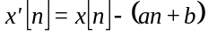 (1)

where 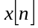 is a_{im} point in the original signal s_{i}, and (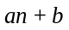) represents the linear trend.
To minimize spectral leakage in the frequency domain analysis, we apply a Hann window function. The Hann window was chosen over alternatives like the Hamming window due to its superior balance between spectral resolution and leakage protection. The window function is defined as formula (2):

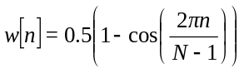 (2)

where N is the signal length. The windowed signal is obtained by (3):

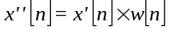 (3)

The FFT is then applied to convert the windowed time-domain signal into the frequency domain (4):

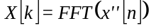 (4)

Only the positive frequency components are retained for analysis, as the negative frequencies contain redundant information due to the signal's real-valued nature. The amplitude spectrum is computed by taking the absolute values of the FFT components (5):

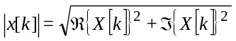 (5)

PCA [5] is applied to manage high-dimensional frequency domain features, retaining 95% of variance to balance information preservation and model complexity, with features standardized to ensure equal weighting during dimensionality reduction. However, it should be noted that different parameters should be used in the case of datasets with more subtle variations between classes.
For classification, a Random Forest model was chosen for its robustness to outliers, ability to handle high-dimensional data, feature importance estimation, and generalization properties, implemented using scikit-learn with default hyperparameters that showed satisfactory initial performance. The system's performance is evaluated through 5-fold cross-validation, dividing the dataset into five parts and rotating through all possible combinations of four training parts and one validation part to provide robust generalization estimates.

4 EXPERIMENTS
The dataset comprises 1158 vibration signals stored in MATLAB format files (T0001.mat through T1158.mat). Each file is s_{i} and they are combined into set S. Set L of labels l_{i} is stored in file key.mat. Each signal consists of amplitude measurements a_{im} recorded over time t, though the specific sampling rate was not provided.
Software was developed purposefully for this experiment using Python 3.11 programming language and Jupyter Notebook environment [8] with Miniconda 3 kernel [9]. The developed solution is heavily based on pre-existing methods implemented in NumPy 1.26.4, SciPy 1.14.1 and scikit-learn 1.5.2 modules that are available publicly [10-12].
Data was read as MATLAB proprietary files using SciPy’s IO submodule and converted in memory to a 2-D matrix using methods from NumPy. To prepare data before applying FFT were used detrending and windowing methods from SciPy’s signal submodule. The complete classification model pipeline is implemented using scikit-learn's Pipeline class to ensure reproducibility and proper handling of the training-validation split during cross-validation. This prevents data leakage and provides unbiased performance estimates.

5 RESULTS
The preprocessing methodology enhanced the clarity of our dataset significantly, thereby facilitating a discernible differentiation between operational and defective machines without the necessity for sophisticated tools. Such comparisons are illustrated in Fig. 1 and Fig. 2. Numerous characteristics within the frequency domain serve to distinguish 'acceptable' from 'unacceptable' samples. The most prominent disparity is observed in the frequency range of [0.75; 1.75].
The model achieved perfect classification accuracy across all five cross-validation folds, with individual fold scores of [1.0, 1.0, 1.0, 0.99, 1.0] and a mean cross-validation score of 0.9983. This indicates that the model correctly classified all fault conditions in each validation fold. Metrics report and confusion matrix can be observed in Table 1 and Table 2 respectively.
The dimensionality reduction step through PCA, configured to retain 95% of the variance in the frequency domain features, successfully compressed the feature space while maintaining the discriminative power of the signals.
The Random Forest classifier, trained on these transformed features, demonstrated consistent performance across most data splits, suggesting robust learning of the underlying patterns distinguishing faulty from healthy states. These results satisfy our primary objective of developing a classification function f (s) that accurately maps vibration signals to their corresponding system states (0 for healthy, 1 for faulty).

Table 1 – Classification report
 | Precision | Recall | F₁ Score | Support
0 | 1.00 | 1.00 | 1.00 | 865
1 | 1.00 | 1.00 | 1.00 | 293
Accuracy |  |  | 1.00 | 1158
Macro Avg. | 1.00 | 1.00 | 1.00 | 1158
Weighted Avg. | 1.00 | 1.00 | 1.00 | 1158

Table 2 – Confusion matrix
 |  | Predicted
 |  | 0 | 1
True | 0 | 865 | 0
True | 1 | 0 | 293

6 DISCUSSION
This study integrates established signal processing and machine learning techniques to develop a system-agnostic methodology for fault detection in mechanical systems. While these methods are not entirely novel, their application in this context represents a meaningful step forward in tailoring advanced computational approaches to the challenges of PdM.
The high classification accuracy achieved (mean cross-validation score of 0.9983) highlights the effectiveness of combining preprocessing techniques such as detrending and Hann windowing with Principal Component Analysis (PCA) and Random Forest classifiers. Unlike studies that rely heavily on system-specific expertise or manually engineered features, this approach demonstrates the potential of automating feature extraction and classification, thus broadening its applicability to diverse mechanical systems.
Compared to [1], which reviews a wide range of vibration analysis methods and tools, this study focuses on a specific, systematic implementation of preprocessing and classification techniques. While [1] underscores the importance of deep learning for future feature extraction, this research demonstrates that simpler methods, such as PCA and Random Forests, can achieve excellent results when preprocessing is carefully designed.
Similarly, [2] highlights the importance of selecting appropriate machine learning algorithms for predictive maintenance but emphasizes deep learning approaches such as Support Vector Machines and Neural Networks. This study, in contrast, illustrates the effectiveness of ensemble methods like Random Forests, particularly for high-dimensional vibration data, where interpretability and computational efficiency remain critical.
In comparison with [3], which discusses applications of machine learning in vibration and audio signal processing, this study aligns closely with the goal of automating fault detection but adopts a different focus. While paper suggests leveraging time-domain statistical features, this work emphasizes frequency-domain analysis, making it particularly well-suited for identifying faults in systems where signal properties are less stationary.
The practical significance of this research lies in adapting and integrating existing methods for fault detection in mechanical systems. By emphasizing a system-agnostic approach, this study demonstrates how established techniques can be applied to address real-world challenges without requiring detailed knowledge of specific system parameters. This adaptability positions the methodology as a valuable contribution to condition-based maintenance strategies.
At the same time, it is important to acknowledge the incremental nature of this contribution. As with [1] and [2], this research faces limitations in handling non-stationary signals, environmental noise, and sensor variability. While the current approach achieves excellent results in controlled conditions, future work should focus on extending the methodology to more variable and challenging environments. Integrating advanced techniques such as wavelet transforms or deep learning, as discussed in [3], could enhance robustness and scalability.
In summary, this study applies well-established signal processing and machine learning methods in a new context, adapting them to the specific demands of vibration-based PdM. While it builds upon the foundational work outlined in [1-3], its contributions are incremental, offering a practical and adaptable framework that bridges the gap between theoretical methods and their application in industrial settings.

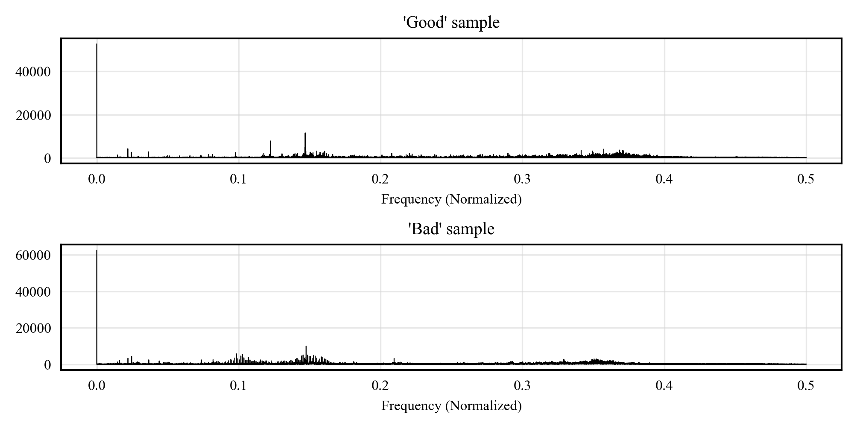
Figure 1 – Frequency domain before processing
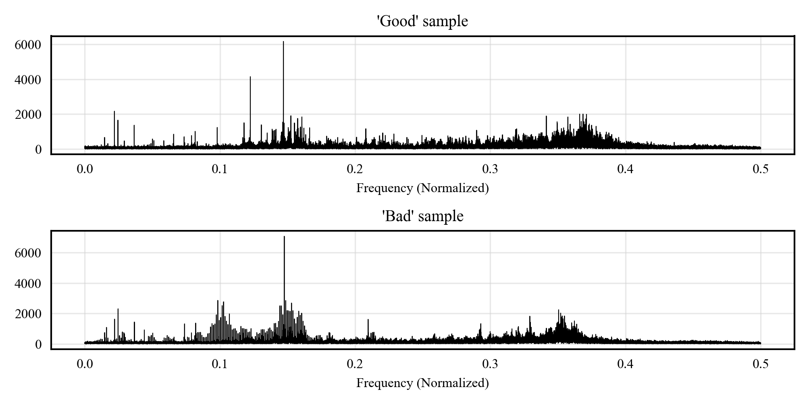
Figure 2 – Frequency domain after processing

CONCLUSIONS
This research successfully developed and validated a methodology for automated fault detection in mechanical systems using vibration signal analysis, addressing the critical challenge of optimizing maintenance timing without relying on fixed schedules or system-specific expertise.
This work is an incremental contribution to the field of PdM using existing methods to achieve the goal. The study presents a demonstration of a system-agnostic approach combining detrending, windowing, and ML that achieves reliable fault detection without requiring knowledge of the system's mechanical properties or sampling parameters. The research has developed a signal processing pipeline, enhancing the visibility of fault-indicating frequencies through automated feature selection, advancing beyond traditional approaches that rely on predetermined frequency bands.
The practical significance of the developed methodology enables implementation of condition-based maintenance strategies across various industrial applications. This approach eliminates unnecessary maintenance interventions while ensuring timely fault detection, reduces the requirement for system-specific expertise in deployment and operation, and enables real-time monitoring and early warning capabilities without expensive hardware. These benefits translate directly into cost reduction through optimized maintenance scheduling and enhanced safety through reliable fault detection.
Future research directions should focus on several key areas. The methodology should be adapted to varying environmental conditions and operational parameters, with particular attention to integration with multi-sensor systems for comprehensive system monitoring. Development of transfer learning approaches could accelerate deployment across different mechanical systems. Additional investigation into minimal signal requirements for reliable classification would optimize system performance. Furthermore, extending the methodology to predict the remaining useful life of components represents a crucial next step in advancing PdM capabilities.

ACKNOWLEDGMENTS
Acknowledgments go to GPMS Inc. owner Prof. Dr. Eric Bechhoefer for providing the dataset.

REFERENCES
- Mohamad Hazwan Mohd Ghazali, W. Rahiman. Vibration Analysis for Machine Monitoring and Diagnosis: A Systematic Review / M. H. M. Ghazali, W. Rahiman // Shock and Vibration. – 2021. – DOI: 10.1155/2021/9469318.
- T. Carvalho, Fabrízzio Soares, Roberto Vita, R. Francisco, João P. Basto, S. G. Alcalá. A Systematic Literature Review of Machine Learning Methods Applied to Predictive Maintenance / T. Carvalho, F. Soares, R. Vita, et al. // Comput. Ind. Eng. – 2019. – Vol. 137. DOI: 10.1016/j.cie.2019.106024.
- Rommel Prieto, Diego Bravo. Machine Learning and Audio Signal Processing for Predictive Maintenance: A Review / R. Prieto, D. Bravo // 2023 IEEE 6th Colombian Conference on Automatic Control (CCAC). – 2023. – P. 1–6. DOI: 10.1109/CCAC58200.2023.10333661.
- Oppenheim A. V., Schafer R. W. Discrete-Time Signal Processing / A. V. Oppenheim, R. W. Schafer. – 3rd ed. – Upper Saddle River, NJ: Prentice Hall, 2010. – ISBN 978-0-13-198842-2.
- Abdi H., Williams L. J. Principal Component Analysis / H. Abdi, L. J. Williams // Wiley Interdisciplinary Reviews: Computational Statistics. – 2010. – Vol. 2, № 4. – P. 433-459. DOI: 10.1002/WICS.101.
- Breiman L. Random Forests / L. Breiman // Machine Learning. – 2001. – Vol. 45, № 1. – P. 5-32. DOI: 10.1023/A:1010933404324.
- Sokolova M., Japkowicz N., Szpakowicz S. Beyond Accuracy, F-Score and ROC: A Family of Discriminant Measures for Performance Evaluation / M. Sokolova, N. Japkowicz, S. Szpakowicz // AI 2006: Advances in Artificial Intelligence, Sattar A., Kang Bh. (eds). – Lecture Notes in Computer Science. – Berlin, Heidelberg: Springer, 2006. – Vol. 4304. – DOI: 10.1007/11941439_114.
- Project Jupyter. URL: https://jupyter.org (accessed: 07.11.2024).
- Anaconda Miniconda Documentation. URL: https://docs.anaconda.com/miniconda/ (accessed: 07.11.2024).
- NumPy. URL: https://numpy.org (accessed: 07.11.2024).
- SciPy. URL: https://scipy.org (accessed: 07.11.2024).
- Scikit-Learn Documentation. URL: https://scikit-learn.org/stable/index.html (accessed: 07.11.2024).

УДК 004.85

АГНОСТИЧНЕ ВИЯВЛЕННЯ НЕСПРАВНОСТЕЙ МАШИННИМ НАВЧАННЯМ НА ОСНОВІ АНАЛІЗУ ВІБРАЦІЇ

Санжаров Д. Р. – студент-бакалавр спеціальності «Комп'ютерні науки», Державний торговельно-економічний університет, м. Київ, Україна.
Філімонова Т. О. – канд. фіз.-мат. наук, Доцент кафедри комп'ютерних наук та інформаційних систем ДТЕУ, м. Київ, Україна.

AНОТАЦІЯ
Контекст. Традиційні стратегії обслуговування складного обладнання базуються на фіксованих графіках або підходах експлуатації до відмови, що може бути неефективним і потенційно небезпечним. Сучасні обчислювальні можливості та аналіз вібрації відкривають можливості для більш досконалих рішень з прогнозного обслуговування, але обробка необроблених вібраційних сигналів для ефективного виявлення несправностей залишається складною.
Мета. Це дослідження спрямоване на розробку та перевірку методології виявлення несправностей у механічних системах, незалежної від системи, з використанням аналізу вібраційних сигналів, без необхідності попереднього знання специфічних параметрів системи або частоти дискретизації.
Метод. Дослідження реалізує комплексний конвеєр обробки сигналів, що поєднує детрендинг, віконну функцію Ханна та швидке перетворення Фур'є для вилучення ознак. Аналіз головних компонент зменшує розмірність, зберігаючи 95% дисперсії. Класифікатор Random Forest виконує остаточне виявлення несправностей. Методологія була перевірена з використанням 1158 вібраційних сигналів з відомими класифікаціями несправностей через 5-кратну перехресну валідацію.
Результати. Розроблена методологія досягла майже ідеальної точності класифікації у всіх валідаційних вибірках, з середнім показником перехресної валідації 0,9983. Підхід успішно ідентифікував характерні частотні діапазони для виявлення несправностей без необхідності специфічних механічних знань. Конвеєр попередньої обробки значно покращив чіткість сигналу, особливо в частотному діапазоні від 0,75 до 1,75, що дозволило чітко розрізняти робочі та дефектні стани.
Висновки. Дослідження представляє кілька нових внесків: незалежний від системи підхід, що поєднує обробку сигналів та машинне навчання, який досягає надійного виявлення несправностей без механічної експертизи; вдосконалений конвеєр обробки сигналів, що посилює частоти, що вказують на несправності, через автоматизований вибір ознак; та передові методи зменшення розмірності, що зберігають дискримінаційну здатність. Практичне значення методології полягає в забезпеченні стратегій обслуговування на основі стану в різних промислових застосуваннях, зменшенні непотрібних втручань з обслуговування, мінімізації вимог до експертизи та підтримці можливостей моніторингу в реальному часі. Ці досягнення представляють суттєвий внесок у практику промислового обслуговування, особливо цінний для складних систем, де традиційні підходи можуть бути неоптимальними.
КЛЮЧОВІ СЛОВА: прогнозне обслуговування, аналіз вібрації, обробка сигналів, машинне навчання, виявлення несправностей, швидке перетворення Фур'є, класифікація Random Forest, моніторинг стану, частотний аналіз, вилучення ознак, зменшення розмірності, промислове обслуговування, автоматизована діагностика, механічні системи, детрендинг сигналів

ЛІТЕРАТУРА
- Mohamad Hazwan Mohd Ghazali, W. Rahiman. Vibration Analysis for Machine Monitoring and Diagnosis: A Systematic Review / M. H. M. Ghazali, W. Rahiman // Shock and Vibration. – 2021. – DOI: 10.1155/2021/9469318.
- T. Carvalho, Fabrízzio Soares, Roberto Vita, R. Francisco, João P. Basto, S. G. Alcalá. A Systematic Literature Review of Machine Learning Methods Applied to Predictive Maintenance / T. Carvalho, F. Soares, R. Vita, et al. // Comput. Ind. Eng. – 2019. – Vol. 137. DOI: 10.1016/j.cie.2019.106024.
- Rommel Prieto, Diego Bravo. Machine Learning and Audio Signal Processing for Predictive Maintenance: A Review / R. Prieto, D. Bravo // 2023 IEEE 6th Colombian Conference on Automatic Control (CCAC). – 2023. – P. 1–6. DOI: 10.1109/CCAC58200.2023.10333661.
- Oppenheim A. V., Schafer R. W. Discrete-Time Signal Processing / A. V. Oppenheim, R. W. Schafer. – 3rd ed. – Upper Saddle River, NJ: Prentice Hall, 2010. – ISBN 978-0-13-198842-2.
- Abdi H., Williams L. J. Principal Component Analysis / H. Abdi, L. J. Williams // Wiley Interdisciplinary Reviews: Computational Statistics. – 2010. – Vol. 2, № 4. – P. 433-459. DOI: 10.1002/WICS.101.
- Breiman L. Random Forests / L. Breiman // Machine Learning. – 2001. – Vol. 45, № 1. – P. 5-32. DOI: 10.1023/A:1010933404324.
- Sokolova M., Japkowicz N., Szpakowicz S. Beyond Accuracy, F-Score and ROC: A Family of Discriminant Measures for Performance Evaluation / M. Sokolova, N. Japkowicz, S. Szpakowicz // AI 2006: Advances in Artificial Intelligence, Sattar A., Kang Bh. (eds). – Lecture Notes in Computer Science. – Berlin, Heidelberg: Springer, 2006. – Vol. 4304. – DOI: 10.1007/11941439_114.
- Project Jupyter : вебсайт. URL: https://jupyter.org (дата звернення: 07.11.2024).
- Anaconda Miniconda Documentation : вебсайт. URL: https://docs.anaconda.com/miniconda/ (дата звернення: 07.11.2024).
- NumPy : вебсайт. URL: https://numpy.org (дата звернення: 07.11.2024).
- SciPy : вебсайт. URL: https://scipy.org (дата звернення: 07.11.2024).
- Scikit-Learn Documentation : вебсайт. URL: https://scikit-learn.org/stable/index.html (дата звернення: 07.11.2024).

