DOM

**DEADLINE:** 12/05/2020

## FOLDER STRUCTURE

|  |  |
| --- | --- |
| FL13_HW11/ [*]  ├─ task [**]  ├─ homework/ [*]  ├─ material-icons/ [*]  ├─ index.html [*]  ├─ styles.css [*]  ├─ app.js [*]  └─ .eslintrc.js | [\***]  - required**  **[**] - restricted (no need to submit)** |

TASK

* Using the standard JavaScript functions, create a file tree (see Figure 1) based on the data in structure variable.
* Requirements:
* By default all folders are closed
* When you click by left mouse button on a closed folder, folder opens. Otherwise close.
* When you click on file by left mouse button - nothing happen
* If the top-level folder closes when the subfolder is open, then after reopening the top-level folder, the subfolder remains in the same state.
* Use the appropriate icon if the folder is open or closed.
* Folder/File may be clickable out of name
* The folder / file is clickable outside the title. (It means you can open folder by clicking on row instead title directly)
* Create a custom context menu, which opens with the right-click
* Menu has two options: rename and delete item
* When context menu is open appropriate item become focused
* If context menu open outside of the item, rename and delete options are disabled
* If you rename the file, the file name without it’s extension should be selected
* If you delete the last item in the folder, the “Folder is empty” text should appear.
* Context menu can be hidden by left-click outside it’s container
* Icons, to the left of file/folder names can be found at the link - <https://material.io/icons/> (they are already included). Use icons like this

<i class="material-icons">done</i> will display icon -> 

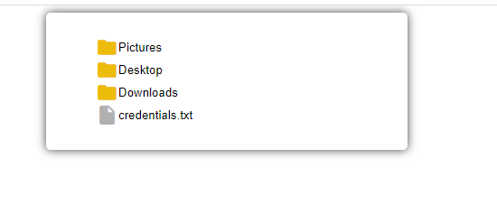

* Figure 1 - Folder tree (To see folder tree in the action, open - /animations/HM_11.gif)

RESTRICTIONS

* Editing index.html is forbidden.
* Adding **task/** folder is forbidden. Do not push it to repository. (Only **homework/** and **material-icons/** folders should be pushed)

## BEFORE SUBMIT

* Code should be clean, without comments, readable, and tested
* Make sure your GitHub folder structure meets folder structure from this document (without **task** folder)

## SUBMIT

* The **FL13_HW11** folder without **task** folder should be uploaded to github repository “**FL-13**” into **master** branch.

## USEFUL LINKS

* <https://developer.mozilla.org/uk/docs/Web/API/Document>
* <https://learn.javascript.ru/traversing-dom>