1 Новрый разде

1.1 Новый подразед
Таблица 1.1 – аыфафы
1 | 2
4афыаф | 3
Transact-SQL supports a subset of the XQuery language that is used for querying the xml data type. This XQuery implementation is aligned with the July 2004 Working Draft of XQuery. The language is under development by the World Wide Web Consortium (W3C), with the participation of all major database vendors and also Microsoft. Because the W3C specifications may undergo future revisions before becoming a W3C recommendation, this implementation may be different from the final recommendation. This topic outlines the semantics and syntax of the subset of XQuery that is supported in SQL Server.
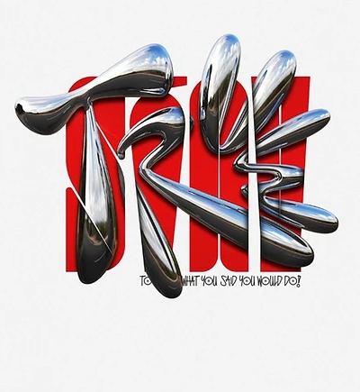
Рисунок 1.1 – афыафыа

