Methyl (E)-3-(2-(bromomethyl)phenyl)acrylate (2a)
white solid; mp 82; 0.38 (petroleum ether : ethyl acetate = 7 : 1).
¹H NMR (CDCl₃, 600 MHz) δ = 8.07 (d, J = 15.8 Hz, 1H), 7.61 - 7.55 (m, 1H), 7.40 - 7.30 (m, 3H), 6.45 (d, J = 15.8 Hz, 1H), 4.59 (s, 2H), 3.83 (s, 3H).
¹³C{¹H} NMR (CDCl₃, 150 MHz) δ = 167.1, 140.9, 136.7, 133.8, 130.8, 130.5, 129.4, 127.4, 120.7, 52.0, 30.7.

Methyl (E)-3-(2-(bromomethyl)-4-fluorophenyl)acrylate (2b)
white solid; mp 84; 0.63 (petroleum ether : ethyl acetate = 7 : 1).
¹H NMR (CDCl₃, 600 MHz) δ = 7.96 (d, J = 15.8 Hz, 1H), 7.56 (dd, J = 5.6, 8.7 Hz, 1H), 7.08 (dd, J = 2.7, 9.0 Hz, 1H), 7.02 (td, J = 2.7, 8.3 Hz, 1H), 6.37 (d, J = 15.8 Hz, 1H), 4.52 (s, 2H), 3.81 (s, 3H).
¹³C{¹H} NMR (CDCl₃, 150 MHz) δ = 167.0, 164.2, 162.6, 139.7, 139.0, 130.6, 120.5, 117.5, 116.6, 52.0, 29.6.
HRMS (ESI/Q-TOF) m/z: [M+H]+ calcd for C₁₁H₁₁BrFO₂⁺ 272.9921. Found 272.9923.

Methyl (E)-3-(2-(bromomethyl)-5-fluorophenyl)acrylate (2c)
white solid; mp 85; 0.56 (petroleum ether : ethyl acetate = 7 : 1).
¹H NMR (CDCl₃, 600 MHz) δ = 7.99 (dd, J = 1.5, 15.9 Hz, 1H), 7.36 (dd, J = 5.6, 8.5 Hz, 1H), 7.26 (dd, J = 2.7, 9.6 Hz, 1H), 7.05 (td, J = 2.7, 8.2 Hz, 1H), 6.43 (d, J = 15.8 Hz, 1H), 4.56 (s, 2H), 3.83 (s, 3H).
¹³C{¹H} NMR (CDCl₃, 150 MHz) δ = 166.8, 163.7, 162.1, 139.7, 135.9 (d, J = 8.0 Hz), 132.7 (d, J = 9.4 Hz), 121.9, 117.4 (d, J = 21.9 Hz), 114.1, 113.9, 52.1, 29.8.
HRMS (ESI/Q-TOF) m/z: [M+H]+ calcd for C₁₁H₁₁BrFO₂⁺ 272.9921. Found 272.9921.

Methyl (E)-3-(2-(bromomethyl)-5-nitrophenyl)acrylate (2d)
white solid; mp 97; 0.48 (petroleum ether : ethyl acetate = 7 : 1).
¹H NMR (CDCl₃, 600 MHz) δ = 8.42 (d, J = 2.3 Hz, 1H), 8.18 (dd, J = 2.4, 8.4 Hz, 1H), 8.00 (d, J = 15.8 Hz, 1H), 7.57 (d, J = 8.5 Hz, 1H), 6.58 (d, J = 15.8 Hz, 1H), 4.59 (s, 2H), 3.85 (s, 3H).
¹³C{¹H} NMR (CDCl₃, 150 MHz) δ = 166.2, 148.1, 142.8, 138.4, 135.2, 131.6, 124.4, 123.4, 122.2, 52.1, 28.2.
HRMS (ESI/Q-TOF) m/z: [M+H]+ calcd for C₁₁H₁₁BrNO₄⁺ 299.9866. Found 299.9866.

Methyl (E)-3-(4-bromo-2-(bromomethyl)phenyl)acrylate (2e)
Green oil; 0.55 (petroleum ether : ethyl acetate = 7 : 1).
¹H NMR (CDCl₃, 400 MHz) δ = 7.98 (s, 3H), 7.94 (d, J = 1.6 Hz, 3H), 7.53 (s, 5H), 7.53 - 7.40 (m, 12H), 6.43 (dd, J = 1.5, 15.8 Hz, 6H), 4.51 (d, J = 1.5 Hz, 12H), 3.83 (d, J = 1.5 Hz, 17H).
¹³C{¹H} NMR (CDCl₃, 100 MHz) δ = 166.6, 139.4, 138.1, 133.3, 132.2 (d, J = 18.6 Hz), 128.5, 123.9, 120.9, 51.8, 29.1.
HRMS (ESI/Q-TOF) m/z: [M+H]+ calcd for C₁₁H₁₁Br₂O₂⁺ 332.9120. Found 332.9115.

Methyl (E)-3-(2-(bromomethyl)-3-fluorophenyl)acrylate (2f)
Yellow solid; mp 98; 0.74 (petroleum ether : ethyl acetate = 7 : 1).
¹H NMR (CDCl₃, 600 MHz) δ = 7.97 (d, J = 15.8 Hz, 1H), 7.36 (dd, J = 1.2, 7.9 Hz, 1H), 7.31 (td, J = 5.5, 8.0 Hz, 1H), 7.09 (ddd, J = 1.3, 8.1, 9.4 Hz, 1H), 6.45 (d, J = 15.8 Hz, 1H), 4.61 (d, J = 1.8 Hz, 2H), 3.83 (s, 3H).
¹³C{¹H} NMR (CDCl₃, 150 MHz) δ = 166.8, 161.8, 160.2, 140.1, 139.6 (d, J = 3.5 Hz), 136.0, 130.3 (d, J = 9.3 Hz), 127.5 - 123.4 (m), 123.0 (d, J = 3.5 Hz), 122.5 - 113.8 (m), 52.1, 21.6 (d, J = 7.1 Hz).
HRMS (ESI/Q-TOF) m/z: [M+H]+ calcd for C₁₁H₁₁BrFO₂⁺ 272.9921. Found 272.9920.

Methyl (E)-3-(2-(bromomethyl)phenyl)acrylate (2a)
¹H NMR (CDCl₃, 600 MHz)
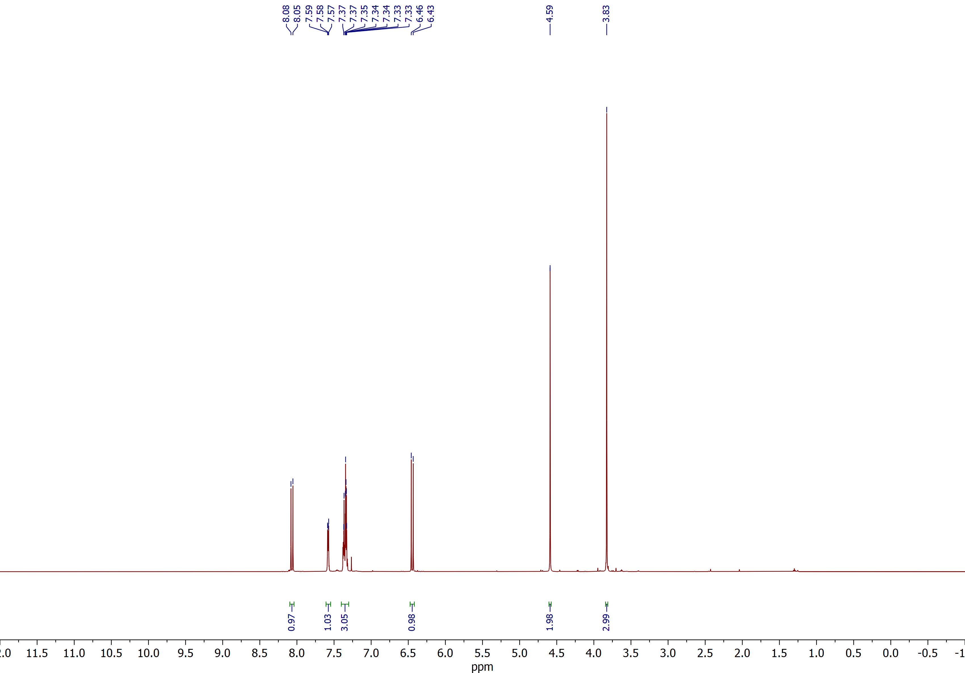

Methyl (E)-3-(2-(bromomethyl)phenyl)acrylate (2a)
¹³C{¹H} NMR (CDCl₃, 150 MHz)
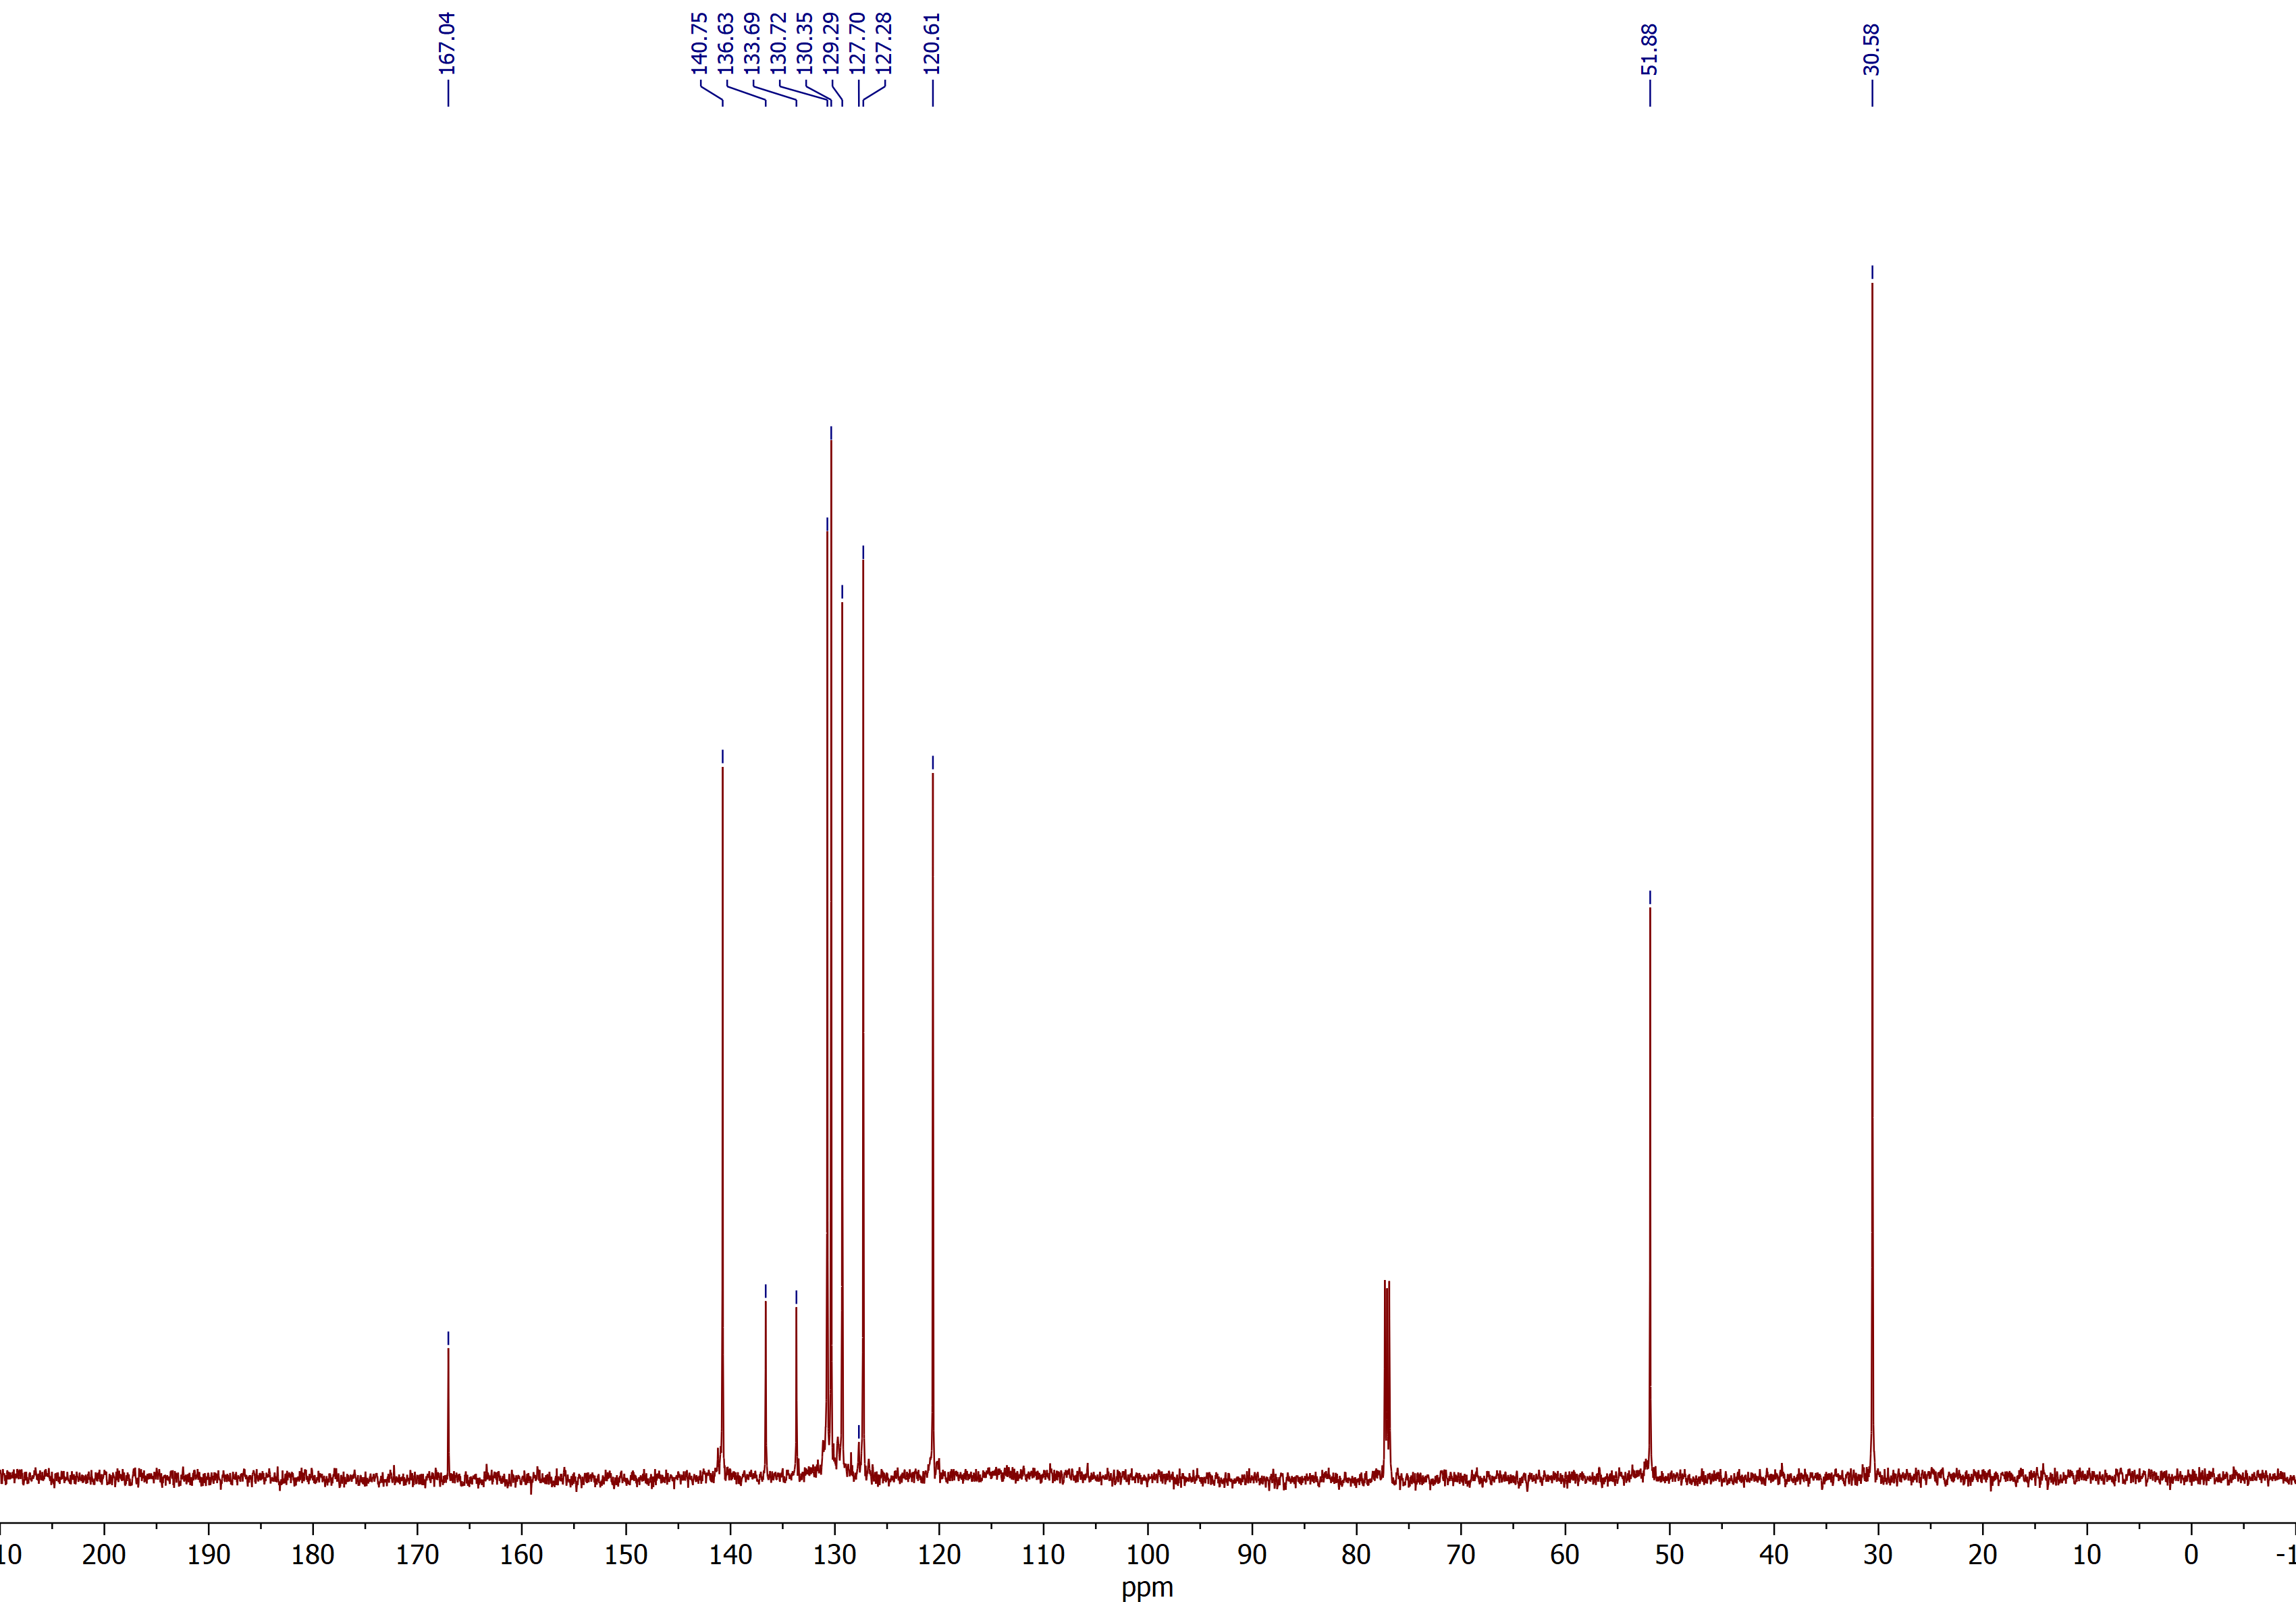

Methyl (E)-3-(2-(bromomethyl)-4-fluorophenyl)acrylate (2b)
¹H NMR (CDCl₃, 600 MHz)
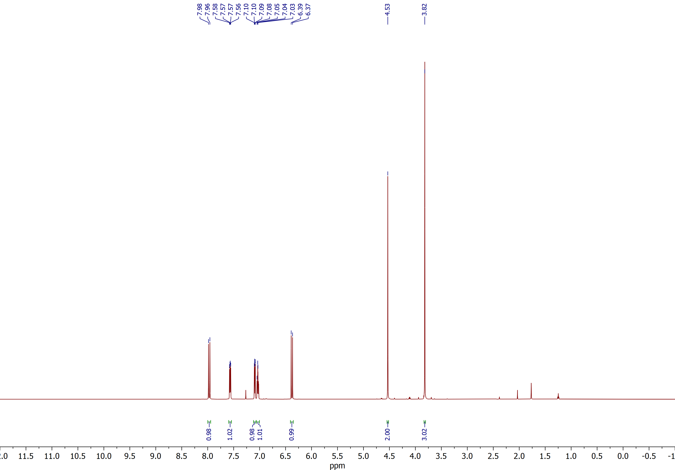

Methyl (E)-3-(2-(bromomethyl)-4-fluorophenyl)acrylate (2b)
¹³C{¹H} NMR (CDCl₃, 150 MHz)
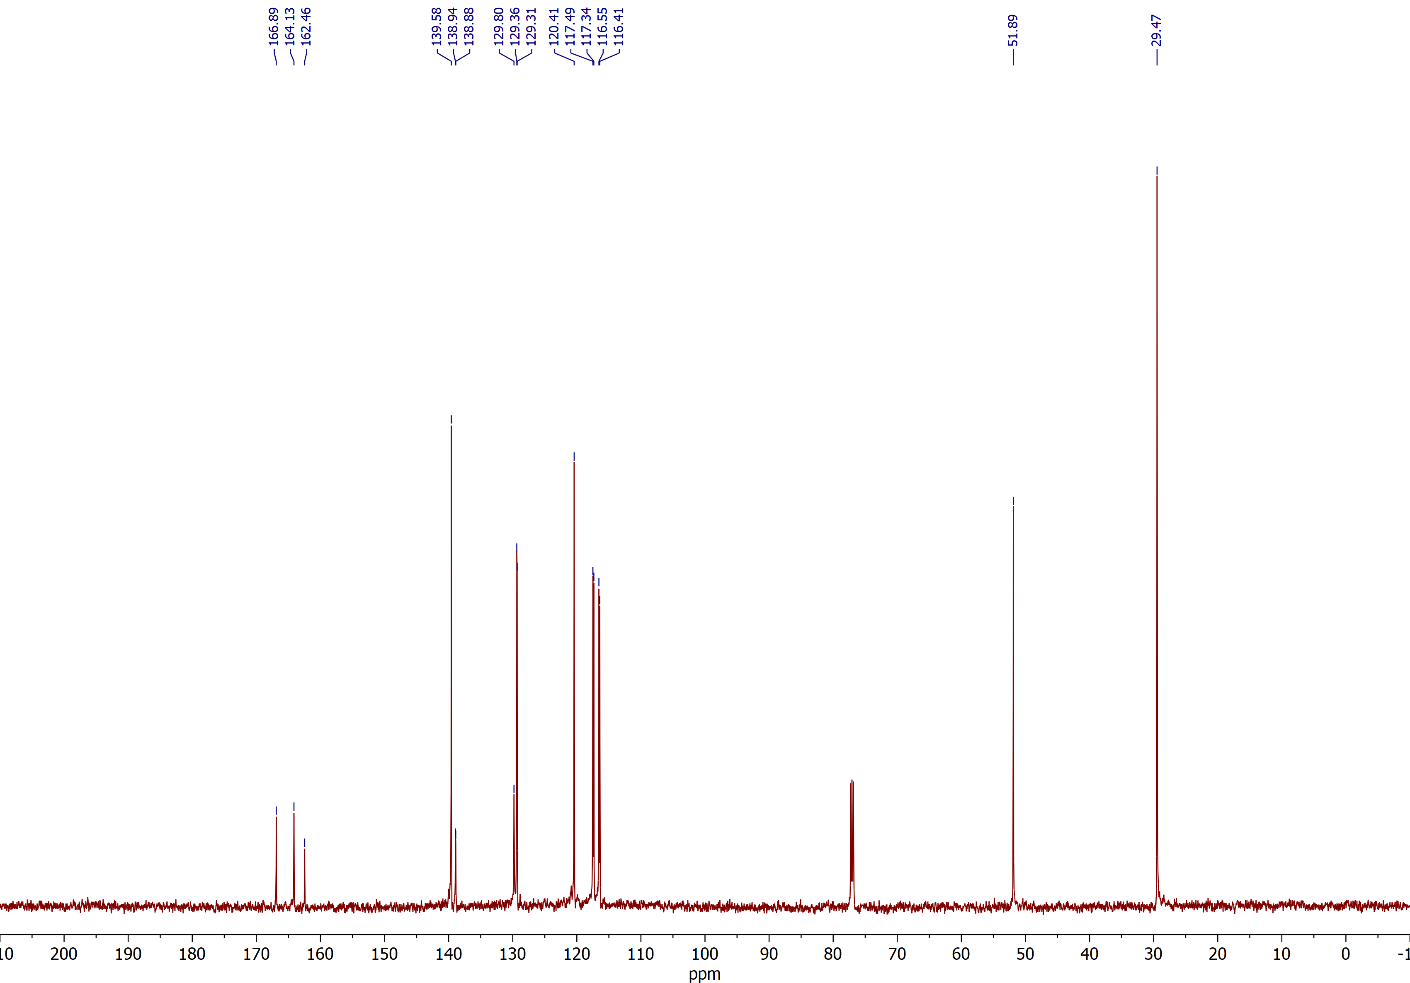

Methyl (E)-3-(2-(bromomethyl)-5-fluorophenyl)acrylate (2c)
¹H NMR (CDCl₃, 600 MHz)
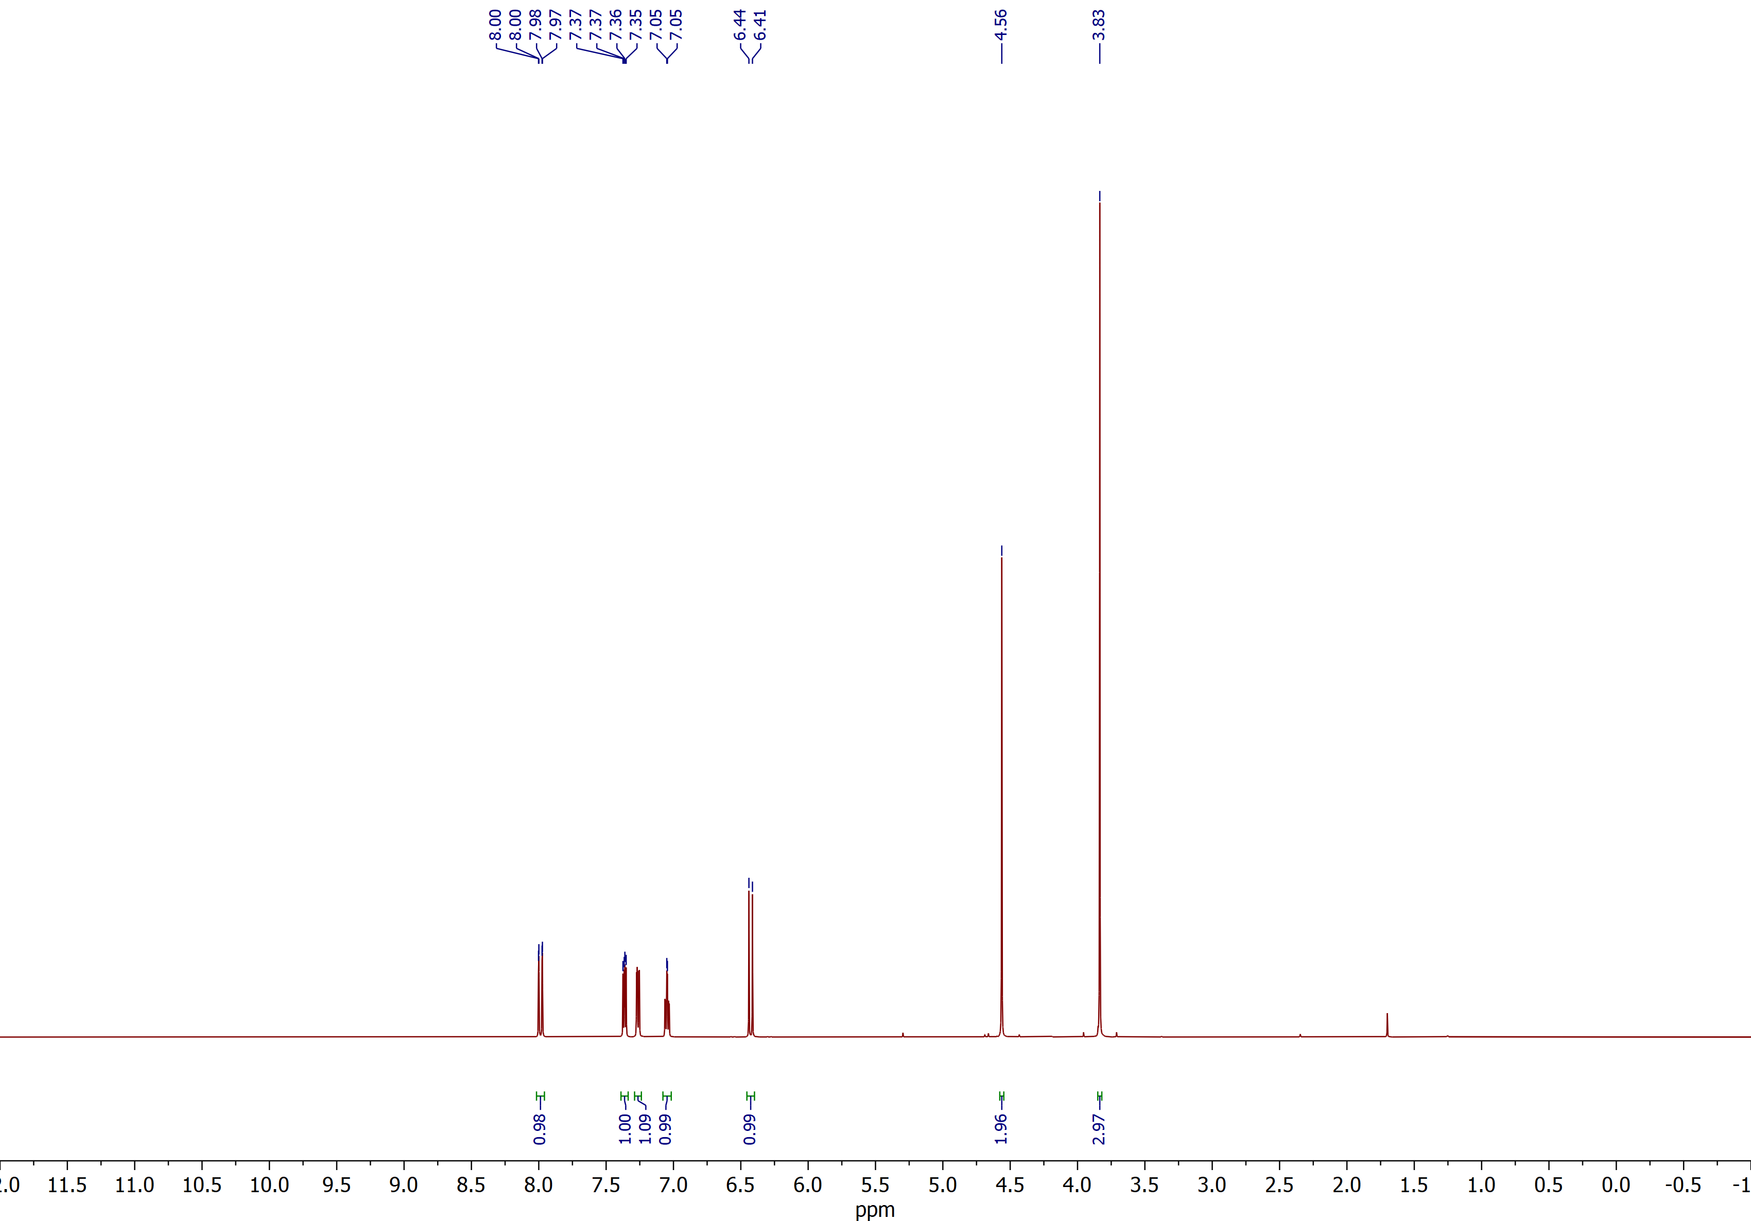

Methyl (E)-3-(2-(bromomethyl)-5-fluorophenyl)acrylate (2c)
¹³C{¹H} NMR (CDCl₃, 150 MHz)
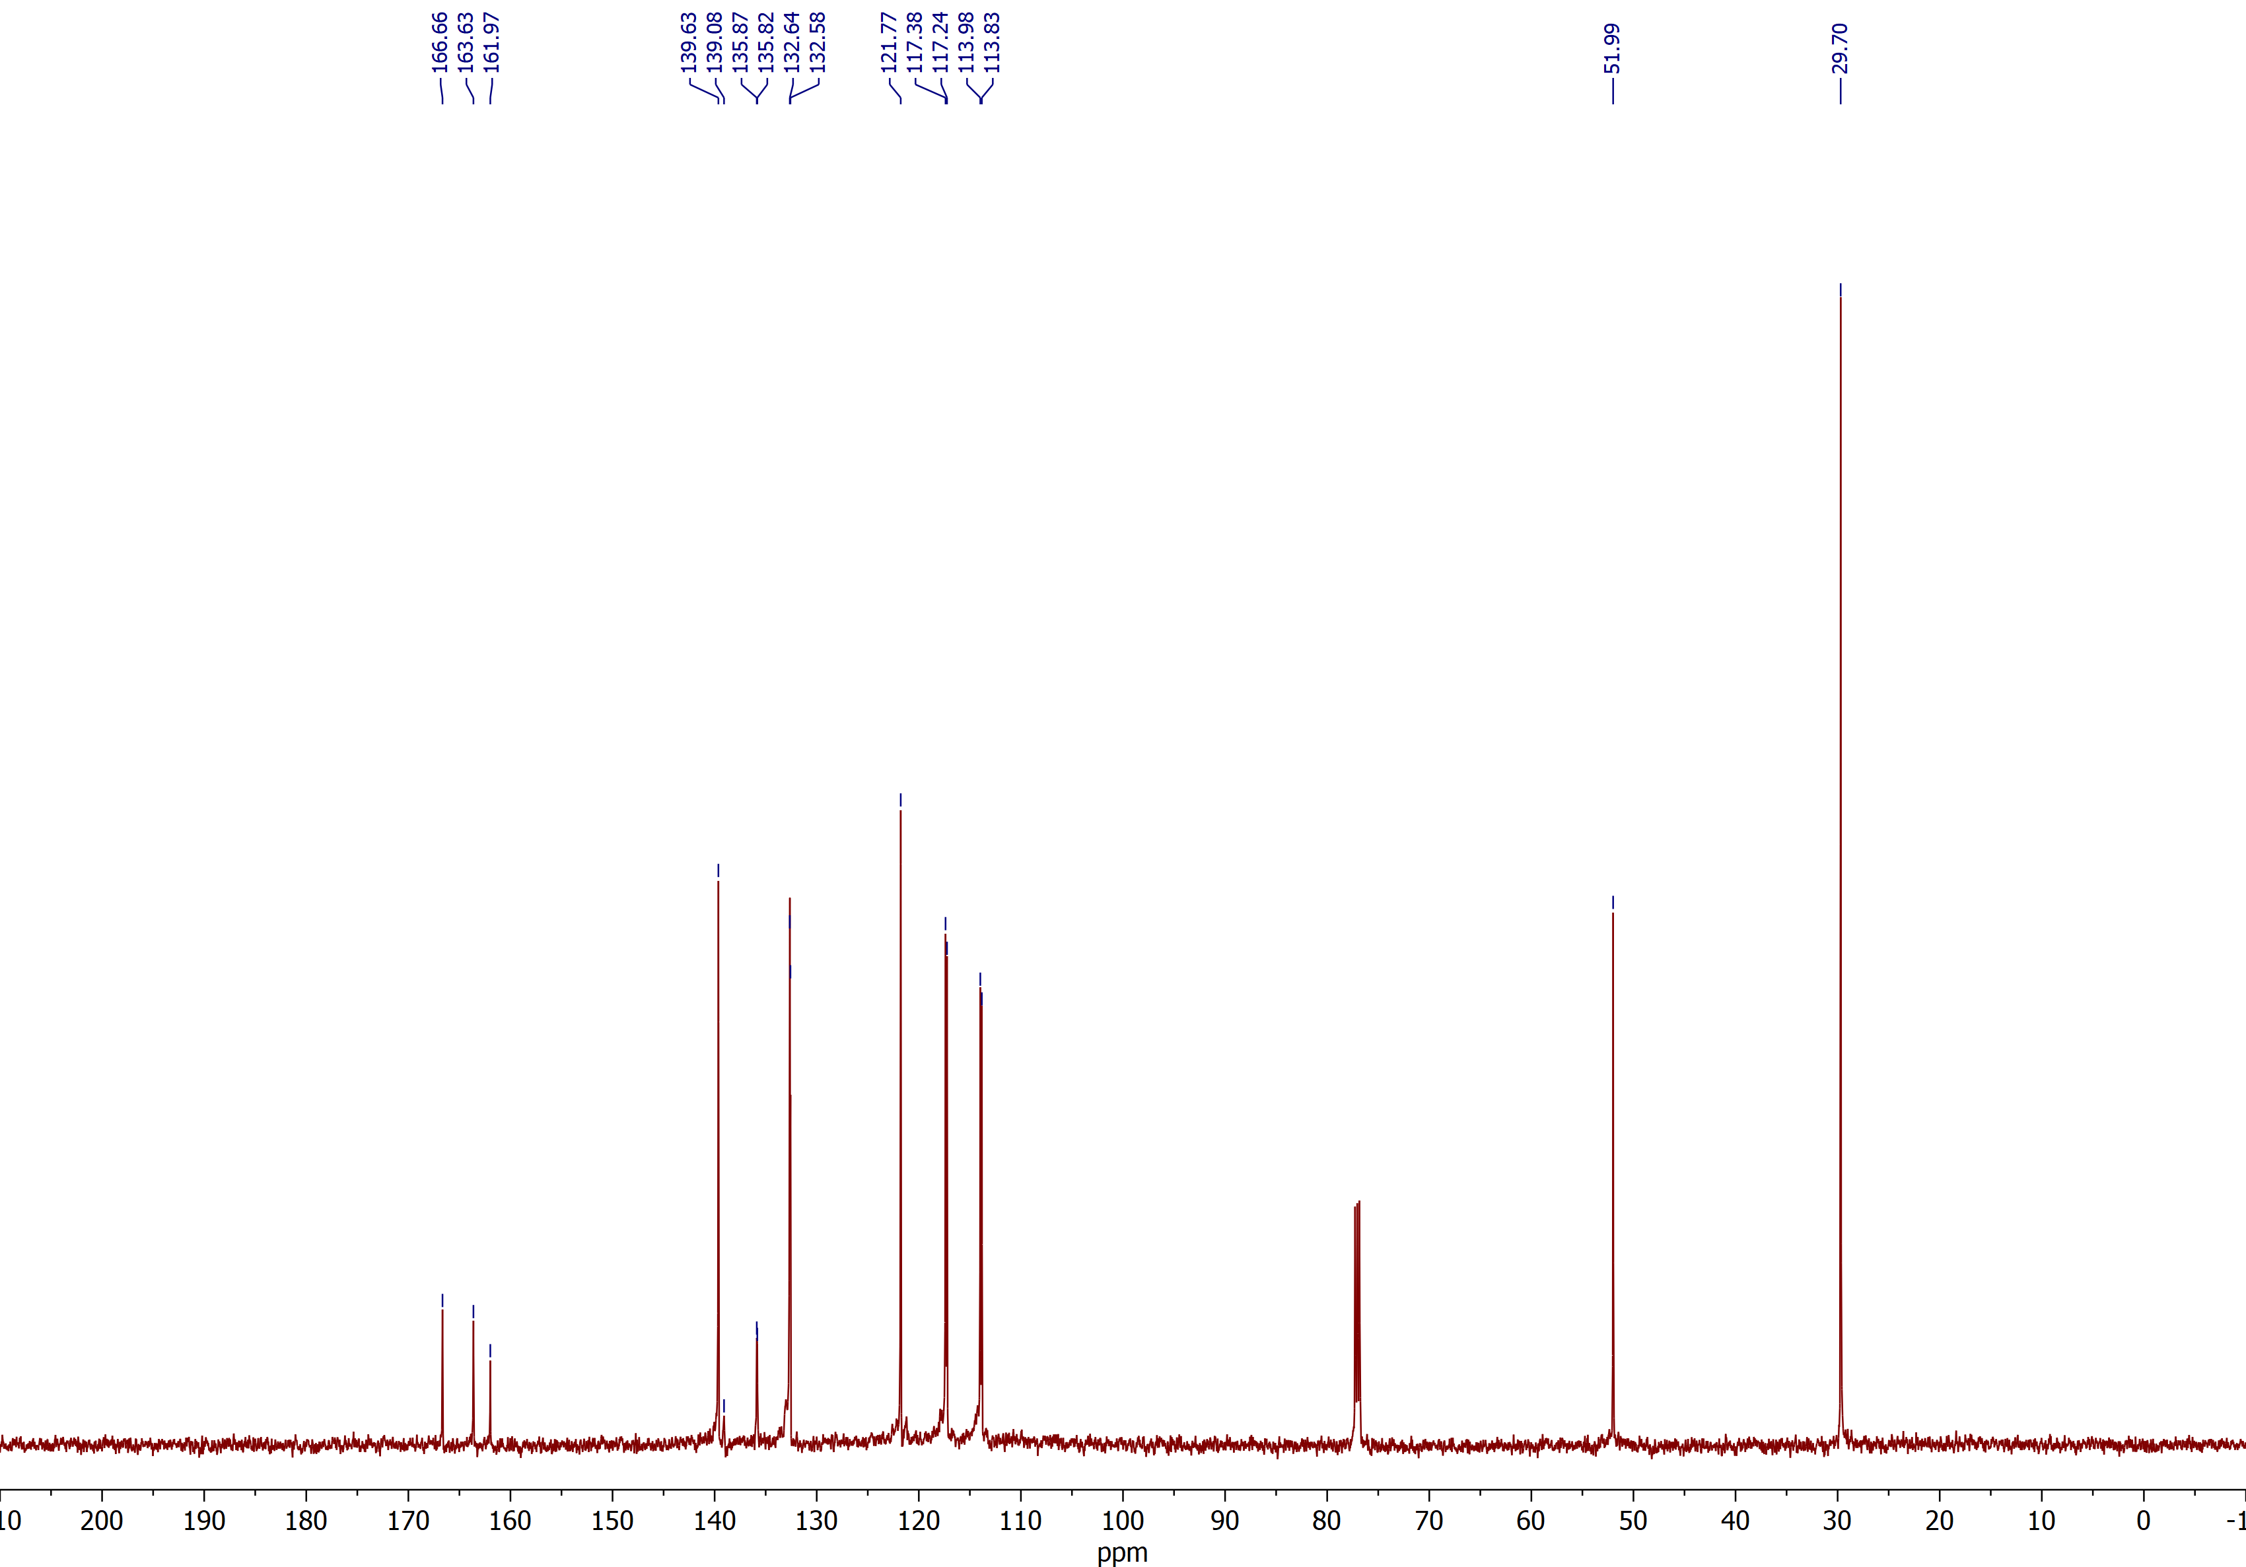

Methyl (E)-3-(2-(bromomethyl)-5-nitrophenyl)acrylate (2d)
¹H NMR (CDCl₃, 600 MHz)
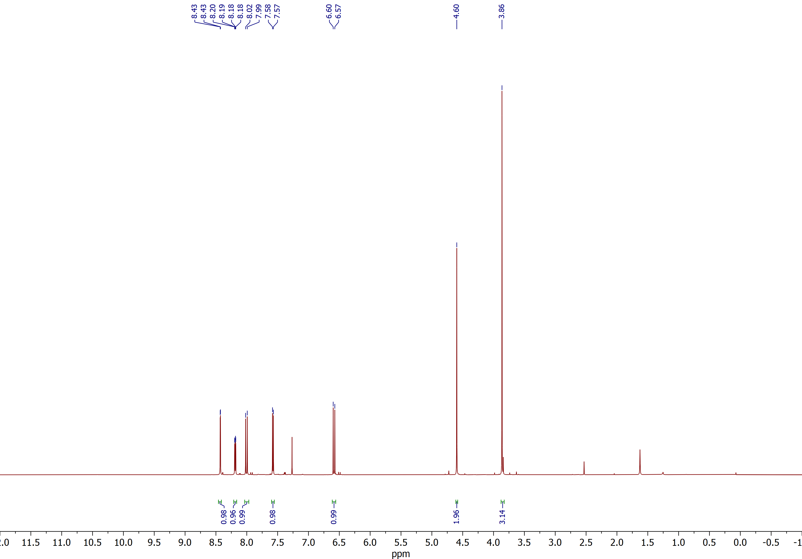

Methyl (E)-3-(2-(bromomethyl)-5-nitrophenyl)acrylate (2d)
¹³C{¹H} NMR (CDCl₃, 150 MHz)
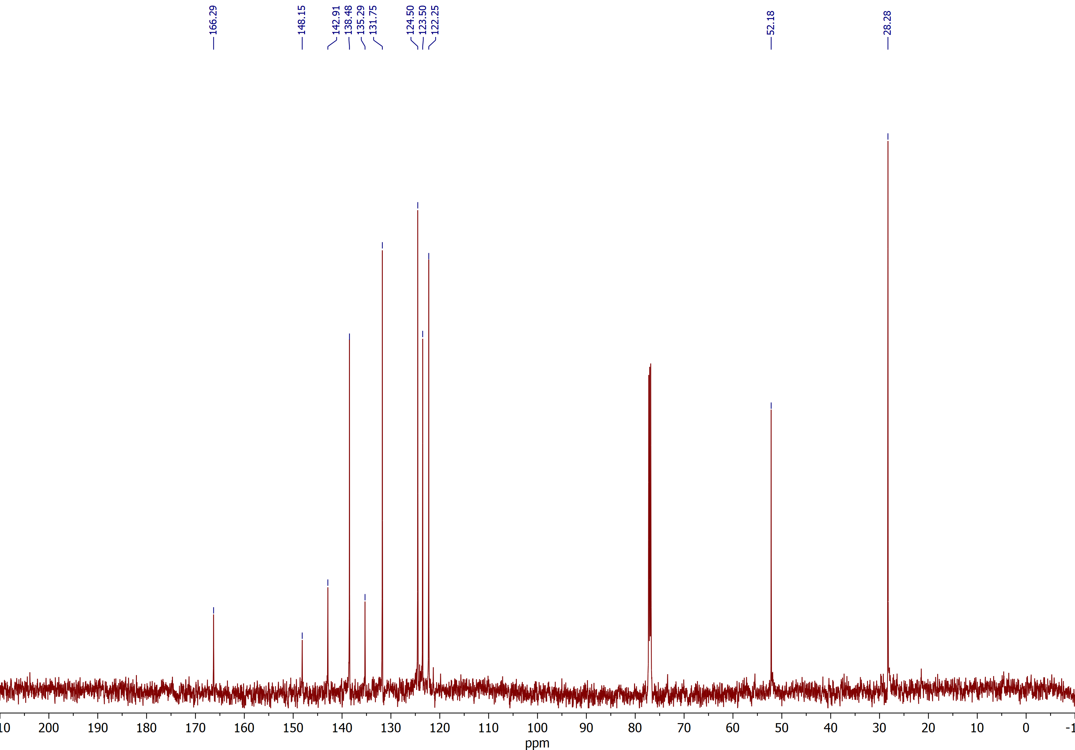

Methyl (E)-3-(4-bromo-2-(bromomethyl)phenyl)acrylate (2e)
¹H NMR (CDCl₃, 400 MHz)
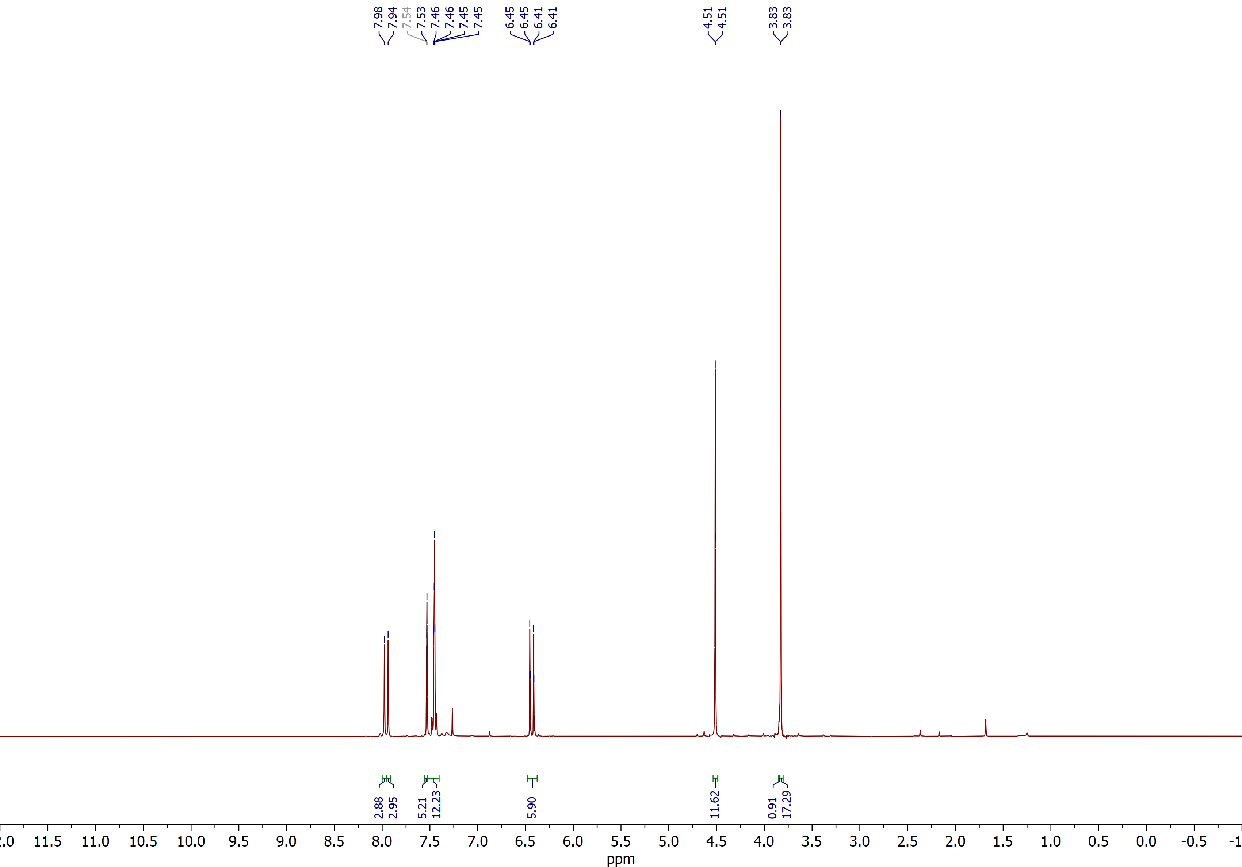

Methyl (E)-3-(4-bromo-2-(bromomethyl)phenyl)acrylate (2e)
¹³C{¹H} NMR (CDCl₃, 100 MHz)
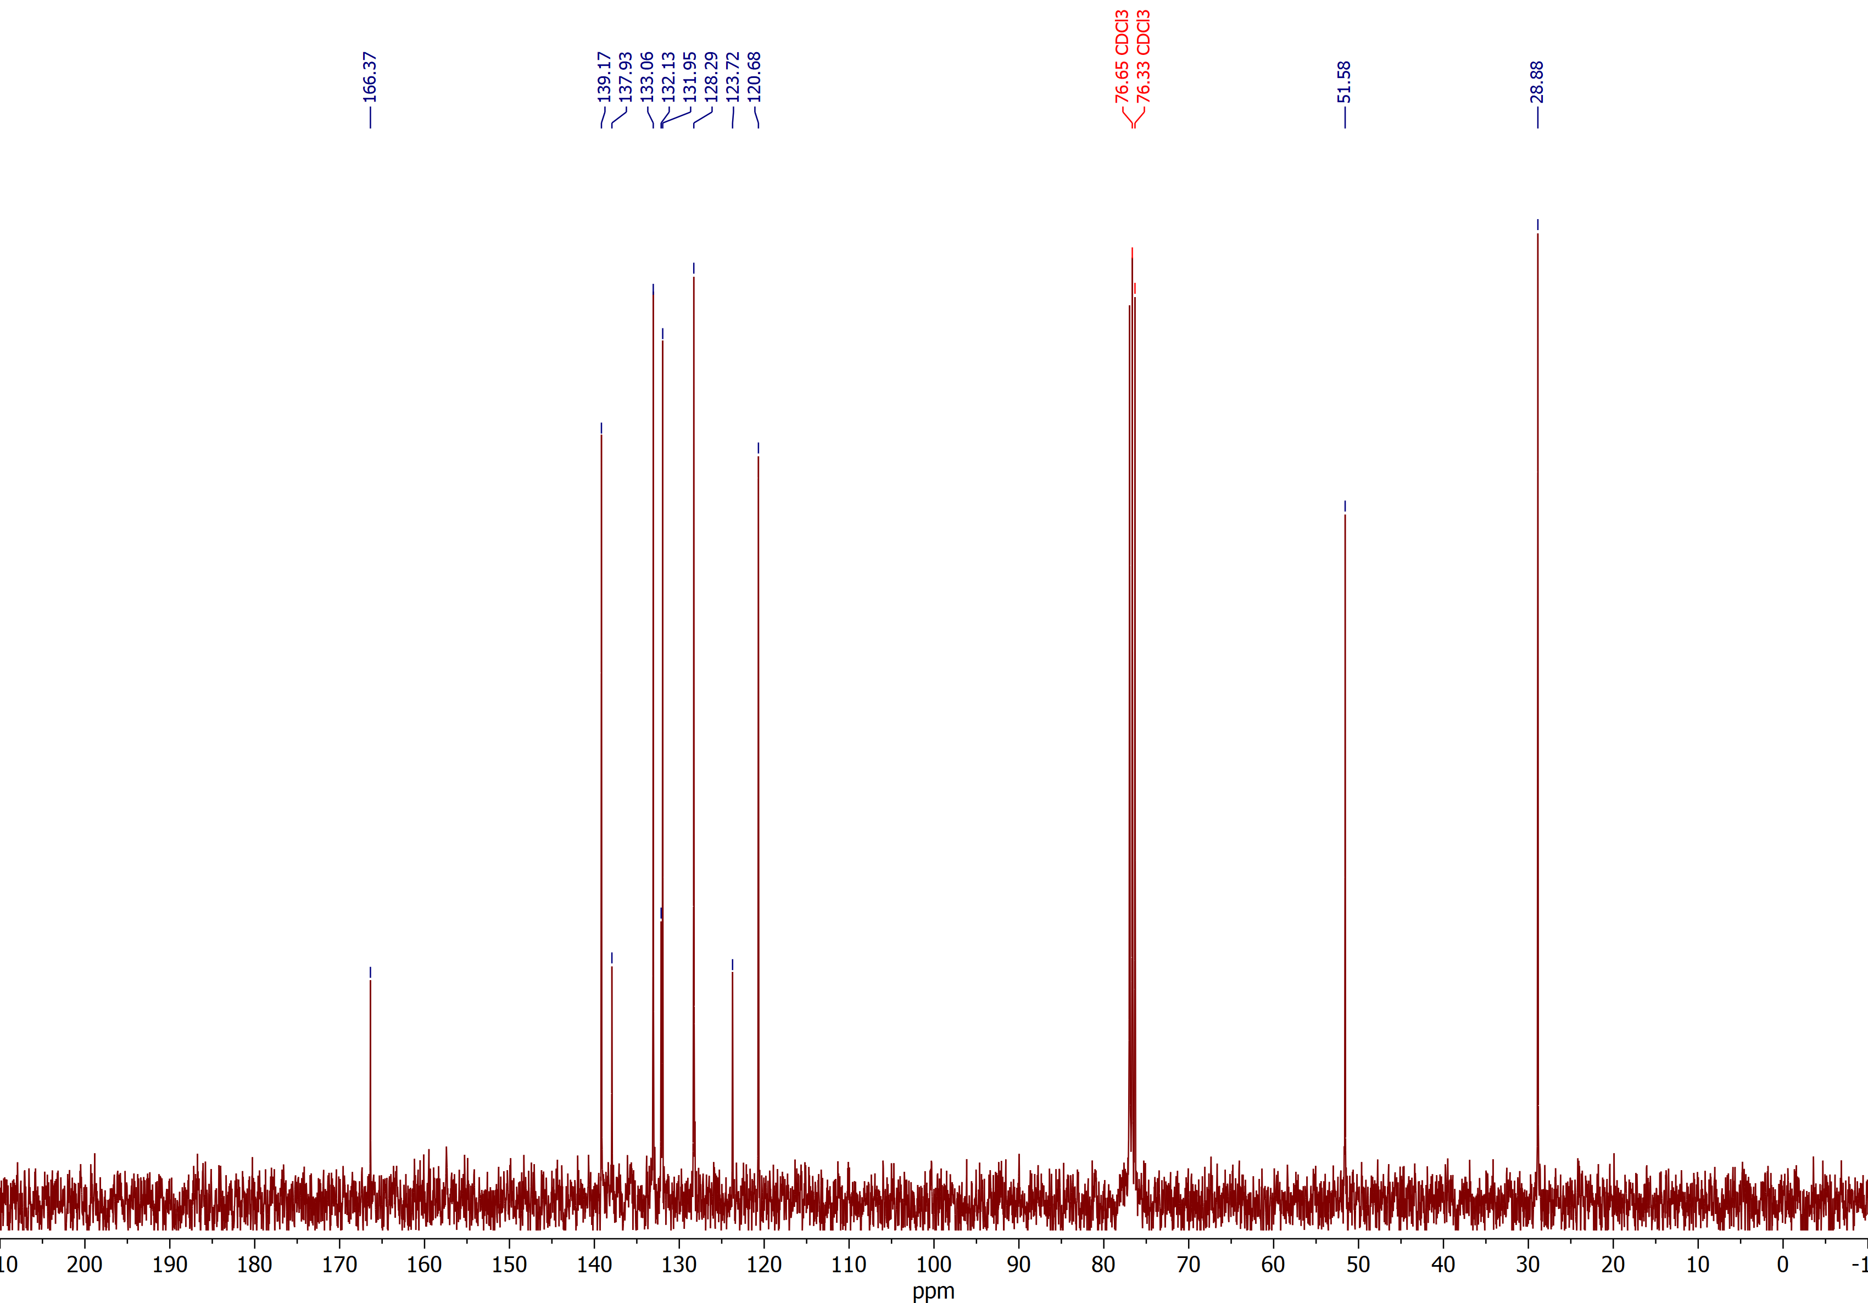

Methyl (E)-3-(2-(bromomethyl)-3-fluorophenyl)acrylate (2f)
¹H NMR (CDCl₃, 600 MHz)
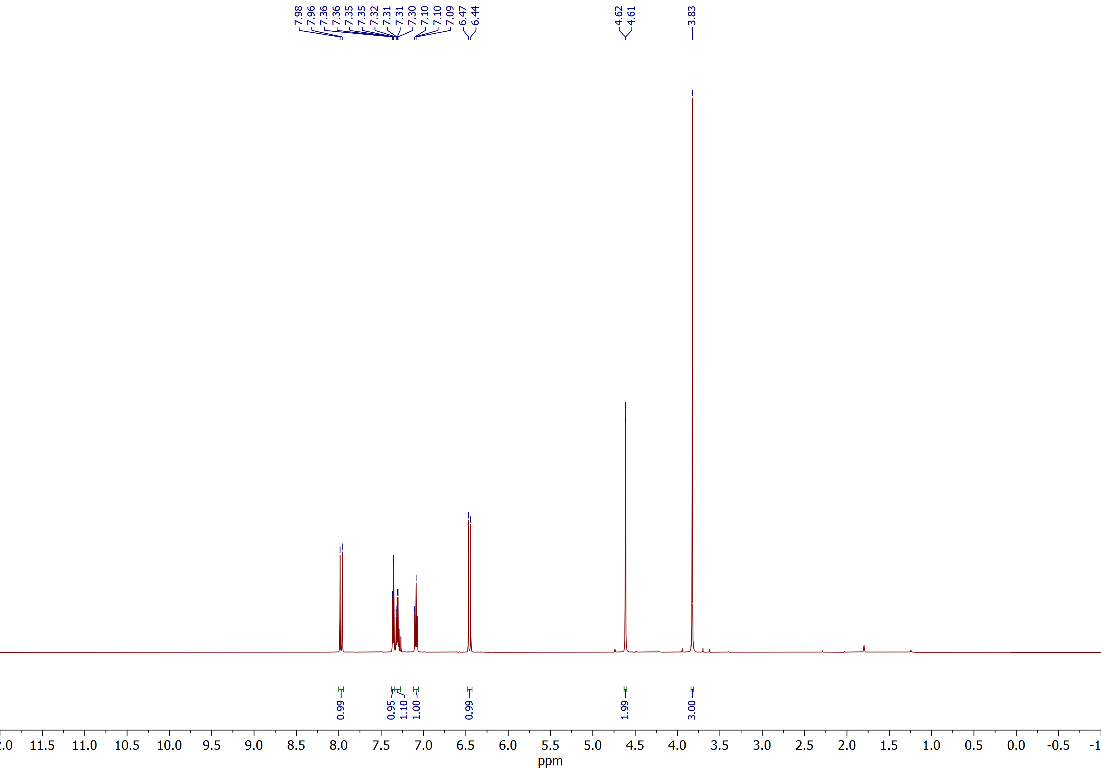

Methyl (E)-3-(2-(bromomethyl)-3-fluorophenyl)acrylate (2f)
¹³C{¹H} NMR (CDCl₃, 150 MHz)
