Compound table for the crystallography example
Original preparation and analytical data from the supplied Supporting Information. 3a deliberately has no CIF. Raw NMR spectra are supplied separately.
Number | Structure | Name | Preparation | HRMS [M+H]+ | Anal
3a | 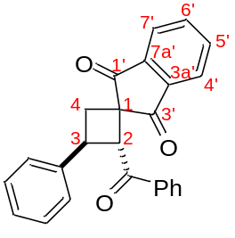 | (2RS,3SR)-2-Benzoyl-3-phenylspiro[cyclobutane-1,2'-indene]-1',3'-dione | Cyclobutane 3a was obtained from cyclopropane 2a (230 mg, 0.9 mmol), 4a (250 mg, 1.4 mmol) in DCE (1.9 mL) according to General procedure A, 12 h. An additional portion of 4a (75 mg, 0.4 mmol) was added to the reaction mixture after 8 h, and the reaction was left for another 4 h. Yield 278 mg (82%); white solid; mp 126–127 °C; Rf=0.39 (petroleum ether – ethyl acetate, 4:1). | 367.1332. | -
3c | 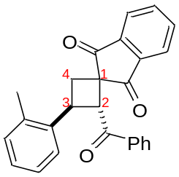 | (2RS,3SR)-2-Benzoyl-3-(o-tolyl)spiro[cyclobutane-1,2'-indene]-1',3'-dione | Cyclobutane 3c was obtained from cyclopropane 2c (150 mg, 0.6 mmol), 4a (154 mg, 0.9 mmol) in DCE (1.2 mL) according to General procedure A, 7 h. Yield 189 mg (87%); light-yellow solid; mp 181–182 °C; Rf=0.33 (petroleum ether – ethyl acetate, 6:1). | 381.1483. | -
3f | 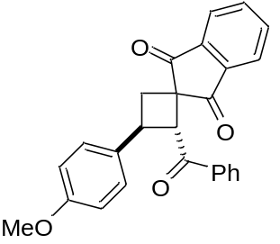 | (2RS,3SR)-2-Benzoyl-3-(4-methoxyphenyl)spiro[cyclobutane-1,2'-indene]-1',3'-dione | Cyclobutane 3f was obtained from cyclopropane 2f (200 mg,  0.7 mmol), 4a (195 mg, 1.1 mmol) in DCE (1.4 mL) according to General procedure A, 4 h. Yield 205 mg (72%); white solid;  mp 134–135 °C; Rf=0.22 (petroleum ether – ethyl acetate, 6:1). | 397.1439. | C, 78.41; H, 5.08.

