Compound table for the crystallography example
Original preparation and analytical data from the supplied Supporting Information. 3a deliberately has no CIF. Raw NMR spectra are supplied separately.
Number | Structure | Name | Preparation | HRMS [M+H]+ | Anal
3s | 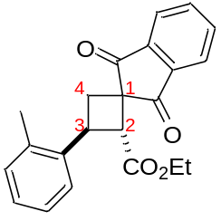 | Ethyl (2RS,3SR)-1',3'-dioxo-3-(o-tolyl)-1',3'-dihydrospiro[cyclobutane-1,2'-indene]-2-carboxylate | Cyclobutane 3s was obtained from cyclopropane 1c (200 mg, 0.8 mmol), 4g (170 mg, 1.1 mmol) in DCM (1.5 mL) according to General procedure B, 4 h. Yield 220 mg (82%); white solid; mp 136–137°C; Rf=0.38 (petroleum ether – ethyl acetate, 4:1). | 349.1439. | C, 75.81; H, 5.53.

