(2RS,3SR)-2-Benzoyl-3-phenylspiro[cyclobutane-1,2'-indene]-1',3'-dione (3a)
Cyclobutane 3a was obtained from cyclopropane 2a (230 mg, 0.9 mmol), 4a (250 mg, 1.4 mmol) in DCE (1.9 mL) according to General procedure A, 12 h. An additional portion of 4a (75 mg, 0.4 mmol) was added to the reaction mixture after 8 h, and the reaction was left for another 4 h. Yield 278 mg (82%); white solid; mp 126–127 °C; R_{f}=0.39 (petroleum ether – ethyl acetate, 4:1).
¹H NMR (CDCl₃, 600 MHz) δ = 8.02 - 7.91 (m, 2H), 7.84 - 7.77 (m, 2H), 7.52 - 7.47 (m, 2H), 7.43 - 7.36 (m, 4H), 7.35 - 7.28 (m, 2H), 7.09 (t, J = 7.8 Hz, 2H), 4.57 (d, J = 10.1 Hz, 1H), 4.32 (q, J = 9.8 Hz, 1H), 2.72 (t, J = 10.5 Hz, 1H), 2.61 (dd, J = 8.9, 10.9 Hz, 1H).
¹³C NMR (CDCl₃, 150 MHz) δ = 201.7, 201.0, 197.2, 142.8, 142.3, 141.0, 136.5, 136.0, 135.4, 134.9, 134.7, 133.7, 132.7, 129.4, 129.4, 129.0, 128.8, 128.8, 128.3, 128.3, 127.9, 127.7, 127.7, 127.2, 126.9, 123.8, 122.7, 57.7, 56.8, 38.9, 38.0, 33.4, 32.5, 31.5.
HRMS (ESI/Q-TOF) m/z: [M+H]⁺ calcd for C₂₅H₁₉O₃⁺ 367.1329. Found 367.1332.
(Support check: C signals expected 18 after aromatic symmetry correction (25 C atoms in formula), found 34)

(2RS,3SR)-2-Benzoyl-3-(o-tolyl)spiro[cyclobutane-1,2'-indene]-1',3'-dione (3c)
Cyclobutane 3c was obtained from cyclopropane 2c (150 mg, 0.6 mmol), 4a (154 mg, 0.9 mmol) in DCE (1.2 mL) according to General procedure A, 7 h. Yield 189 mg (87%); light-yellow solid; mp 181–182 °C; R_{f}=0.33 (petroleum ether – ethyl acetate, 6:1).
¹H NMR (CDCl₃, 600 MHz) δ = 8.02 - 7.92 (m, 2H), 7.85 - 7.78 (m, 3H), 7.40 (t, J = 7.2 Hz, 3H), 7.33 (t, J = 7.4 Hz, 1H), 7.22 (t, J = 7.4 Hz, 1H), 7.15 - 7.08 (m, 3H), 4.64 (d, J = 10.2 Hz, 1H), 4.54 (q, J = 9.7 Hz, 1H), 2.70 - 2.59 (m, 2H), 2.16 (s, 3H).
¹³C NMR (CDCl₃, 150 MHz) δ = 201.7, 201.0, 197.3, 142.7, 140.9, 140.3, 136.7, 135.8, 135.3, 134.7, 133.1, 130.2, 128.4, 128.2, 128.1, 127.1, 126.8, 126.2, 123.2, 123.1, 57.1, 52.9, 34.0, 32.8, 29.6, 19.6.
HRMS (ESI/Q-TOF) m/z: [M+H]⁺ calcd for C₂₆H₂₁O₃⁺ 381.1485. Found 381.1483.
(Support check: C signals expected 21 after aromatic symmetry correction (26 C atoms in formula), found 26)
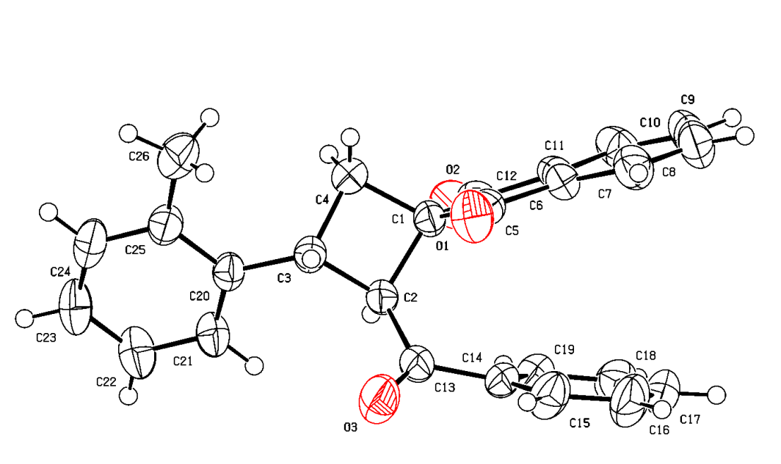
Crystal structure of 3c. ORTEP drawing with thermal ellipsoids at the 50% probability level. Deposition: 2383313.

(2RS,3SR)-2-Benzoyl-3-(4-methoxyphenyl)spiro[cyclobutane-1,2'-indene]-1',3'-dione (3f)
Cyclobutane 3f was obtained from cyclopropane 2f (200 mg,
0.7 mmol), 4a (195 mg, 1.1 mmol) in DCE (1.4 mL) according to General procedure A, 4 h. Yield 205 mg (72%); white solid;
mp 134–135 °C; R_{f}=0.22 (petroleum ether – ethyl acetate, 6:1).
¹H NMR (CDCl₃, 600 MHz) δ = 8.00 - 7.91 (m, 2H), 7.83 - 7.76 (m, 2H), 7.40 (ddd, J = 1.7, 7.5, 13.9 Hz, 4H), 7.32 (tt, J = 1.3, 7.4 Hz, 1H), 7.13 - 7.08 (m, 2H), 6.97 - 6.91 (m, 2H), 4.52 (d, J = 10.1 Hz, 1H), 4.24 (q, J = 9.8 Hz, 1H), 3.83 (s, 3H), 2.66 (t, J = 10.5 Hz, 1H), 2.58 (dd, J = 8.9, 10.9 Hz, 1H).
¹³C NMR (CDCl₃, 150 MHz) δ = 201.9, 201.0, 197.3, 159.0, 142.8, 141.0, 135.9, 135.4, 134.7, 134.4, 133.2, 128.8, 128.5, 128.2, 123.2, 123.1, 114.2, 57.9, 55.4, 52.9, 38.1, 32.7.
HRMS (ESI/Q-TOF) m/z: [M+H]⁺ calcd for C₂₆H₂₁O₄⁺ 397.1434. Found 397.1439.
Anal. Calcd for C₂₆H₂₀O₄: C, 78.77; H, 5.09. Found: C, 78.41; H, 5.08.
(Support check: C signals expected 19 after aromatic symmetry correction (26 C atoms in formula), found 22)
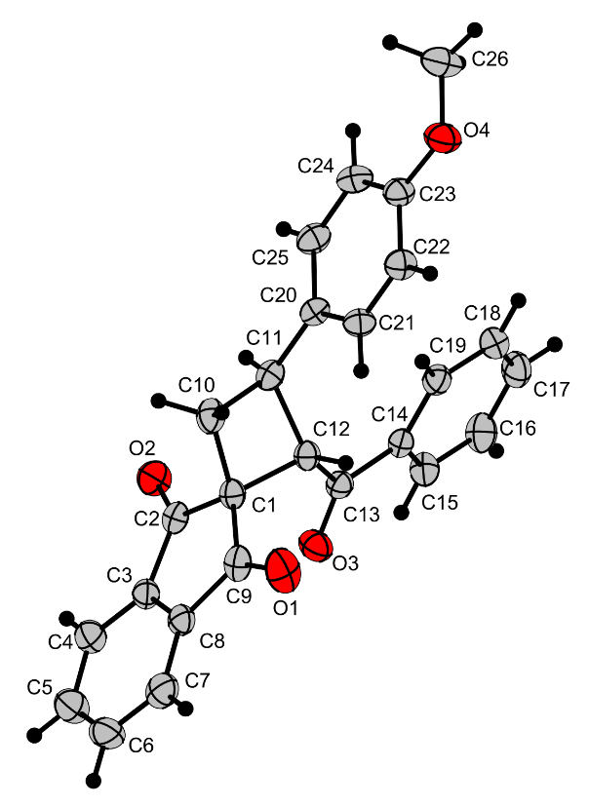
Crystal structure of 3f. ORTEP drawing with thermal ellipsoids at the 50% probability level. Deposition: 2432441.

Ethyl (2RS,3SR)-1',3'-dioxo-3-(o-tolyl)-1',3'-dihydrospiro[cyclobutane-1,2'-indene]-2-carboxylate (3s)
Cyclobutane 3s was obtained from cyclopropane 1c (200 mg, 0.8 mmol), 4g (170 mg, 1.1 mmol) in DCM (1.5 mL) according to General procedure B, 4 h. Yield 220 mg (82%); white solid; mp 136–137°C; R_{f}=0.38 (petroleum ether – ethyl acetate, 4:1).
¹H NMR (CDCl₃, 600 MHz) δ = 8.03 (tt, J = 4.9, 7.2 Hz, 2H), 7.90 - 7.83 (m, 2H), 7.52 (d, J = 7.6 Hz, 1H), 7.20 - 7.14 (m, 2H), 4.45 (q, J = 9.9 Hz, 1H), 4.06 - 3.89 (m, 3H), 2.63 (dd, J = 9.2, 10.6 Hz, 1H), 2.44 - 2.36 (m, 4H), 0.98 (t, J = 7.1 Hz, 3H).
¹³C NMR (CDCl₃, 150 MHz) δ = 201.7, 200.2, 170.6, 142.6, 141.6, 140.3, 136.3, 136.0, 135.8, 130.3, 127.0, 126.9, 126.4, 126.0, 123.7, 123.4, 123.3, 61.0, 52.9, 48.8, 34.6, 33.0, 19.9, 14.2, 14.0.
HRMS (ESI/Q-TOF) m/z: [M+H]⁺ calcd for C₂²H₂₁O₄⁺ 349.1434. Found 349.1439.
Anal. Calcd for C₂²H₂₀O₄: C, 75.84; H, 5.79. Found: C, 75.81; H, 5.53.
(Support check: H expected 20, found 19; C signals expected 19 after aromatic symmetry correction (22 C atoms in formula), found 25)
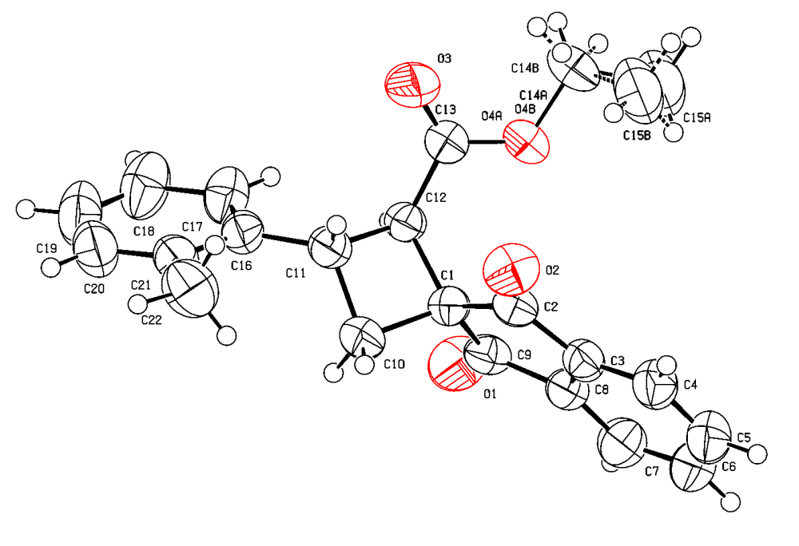
Crystal structure of 3s. ORTEP drawing with thermal ellipsoids at the 50% probability level. Deposition: 2364657.

X-ray crystallography
Crystallographic data for 3c
Single crystals of 3c were obtained through slow evaporation of its solution in a petroleum ether – ethyl acetate mixture at room temperature.
Single-crystal X-ray diffraction data were collected using stoe with Mo Kα (λ = 0.71073) at 295 K.
Structure refinement: SHELXL-2014/7 (Sheldrick, 2014).
Hydrogen-atom treatment: refall.
Crystallographic deposition: 2383313.
Crystal data and structure refinement | 3c
Empirical formula | C26 H20 O3
Formula weight | 380.42
Temperature / K | 295
Crystal system | monoclinic
Space group | P 21/n
a / Å | 7.1934(5)
b / Å | 13.3744(7)
c / Å | 20.4230(10)
α / ° | 90
β / ° | 97.997(6)
γ / ° | 90
V / Å³ | 1945.7(2)
Z | 4
Calculated density / Mg m⁻³ | 1.299
Absorption coefficient / mm⁻¹ | 0.084
F(000) | 800
Crystal size / mm | .33 × .23 × .21
Radiation (wavelength / Å) | Mo Kα (λ = 0.71073)
Diffractometer | stoe
θ range for data collection / ° | 2.525–28.097
Index ranges | -9 ≤ h ≤ 9; -17 ≤ k ≤ 15; -26 ≤ l ≤ 23
Reflections collected / independent / observed | 25442 / 4625 / 1998
Rint | 0.0945
Data / restraints / parameters | 4625 / 0 / 266
Goodness-of-fit on F² | 0.771
Final R indices [I > 2σ(I)] | R1 = 0.0433, wR2 = 0.0832
R indices (all data) | R1 = 0.1228, wR2 = 0.1018
Largest diff. peak and hole / e Å⁻³ | 0.169 / -0.160

Crystallographic data for 3f
Single crystals of 3f were obtained through slow evaporation of its solution in a petroleum ether – ethyl acetate mixture at room temperature.
Single-crystal X-ray diffraction data were collected using stoe with Mo Kα (λ = 0.71073) at 295 K.
Structure refinement: SHELXL-2014/7 (Sheldrick, 2014).
Hydrogen-atom treatment: constr.
Crystallographic deposition: 2432441.
Crystal data and structure refinement | 3f
Empirical formula | C26 H20 O4
Formula weight | 396.42
Temperature / K | 295
Crystal system | triclinic
Space group | P -1
a / Å | 8.0347(4)
b / Å | 11.0896(5)
c / Å | 12.6007(7)
α / ° | 65.645(5)
β / ° | 81.056(6)
γ / ° | 82.727(6)
V / Å³ | 1007.95(10)
Z | 2
Calculated density / Mg m⁻³ | 1.306
Absorption coefficient / mm⁻¹ | 0.088
F(000) | 416
Crystal size / mm | .26 × .23 × .14
Radiation (wavelength / Å) | Mo Kα (λ = 0.71073)
Diffractometer | stoe
θ range for data collection / ° | 2.572–27.350
Index ranges | -10 ≤ h ≤ 10; -14 ≤ k ≤ 14; -16 ≤ l ≤ 16
Reflections collected / independent / observed | 27081 / 4414 / 2055
Rint | 0.0476
Data / restraints / parameters | 4414 / 0 / 273
Goodness-of-fit on F² | 0.783
Final R indices [I > 2σ(I)] | R1 = 0.0357, wR2 = 0.0599
R indices (all data) | R1 = 0.1024, wR2 = 0.0709
Largest diff. peak and hole / e Å⁻³ | 0.132 / -0.136

Crystallographic data for 3s
Single crystals of 3s were obtained through slow evaporation of its solution in a petroleum ether – ethyl acetate mixture at room temperature.
Single-crystal X-ray diffraction data were collected using STOE with Cu Kα (λ = 1.54186) at 295 K.
Structure refinement: SHELXL-2014/7 (Sheldrick, 2014).
Hydrogen-atom treatment: constr.
Crystallographic deposition: 2364657.
Crystal data and structure refinement | 3s
Empirical formula | C22 H20 O4
Formula weight | 348.38
Temperature / K | 295
Crystal system | orthorhombic
Space group | P b c a
a / Å | 11.9328(5)
b / Å | 20.0357(7)
c / Å | 15.4091(5)
α / ° | 90
β / ° | 90
γ / ° | 90
V / Å³ | 3684.0(2)
Z | 8
Calculated density / Mg m⁻³ | 1.256
Absorption coefficient / mm⁻¹ | 0.696
F(000) | 1472
Crystal size / mm | .19 × .15 × .13
Radiation (wavelength / Å) | Cu Kα (λ = 1.54186)
Diffractometer | STOE
θ range for data collection / ° | 4.414–66.950
Index ranges | -7 ≤ h ≤ 14; -23 ≤ k ≤ 23; -16 ≤ l ≤ 18
Reflections collected / independent / observed | 23227 / 3255 / 1753
Rint | 0.0641
Data / restraints / parameters | 3255 / 2 / 243
Goodness-of-fit on F² | 0.864
Final R indices [I > 2σ(I)] | R1 = 0.0401, wR2 = 0.0881
R indices (all data) | R1 = 0.0856, wR2 = 0.0988
Largest diff. peak and hole / e Å⁻³ | 0.200 / -0.163

(2RS,3SR)-2-Benzoyl-3-phenylspiro[cyclobutane-1,2'-indene]-1',3'-dione (3a)
¹H NMR (CDCl₃, 600 MHz)
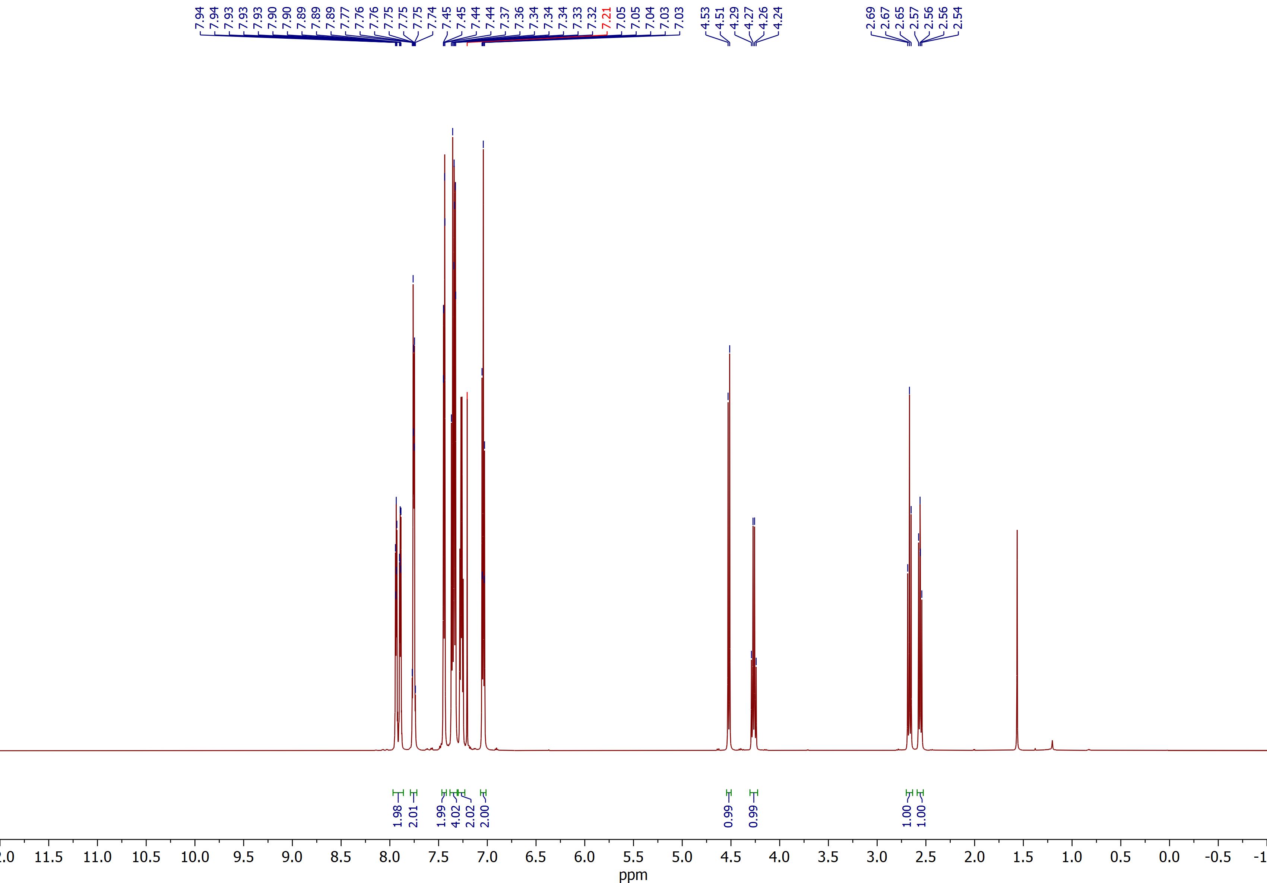

(2RS,3SR)-2-Benzoyl-3-phenylspiro[cyclobutane-1,2'-indene]-1',3'-dione (3a)
¹³C NMR (CDCl₃, 150 MHz)
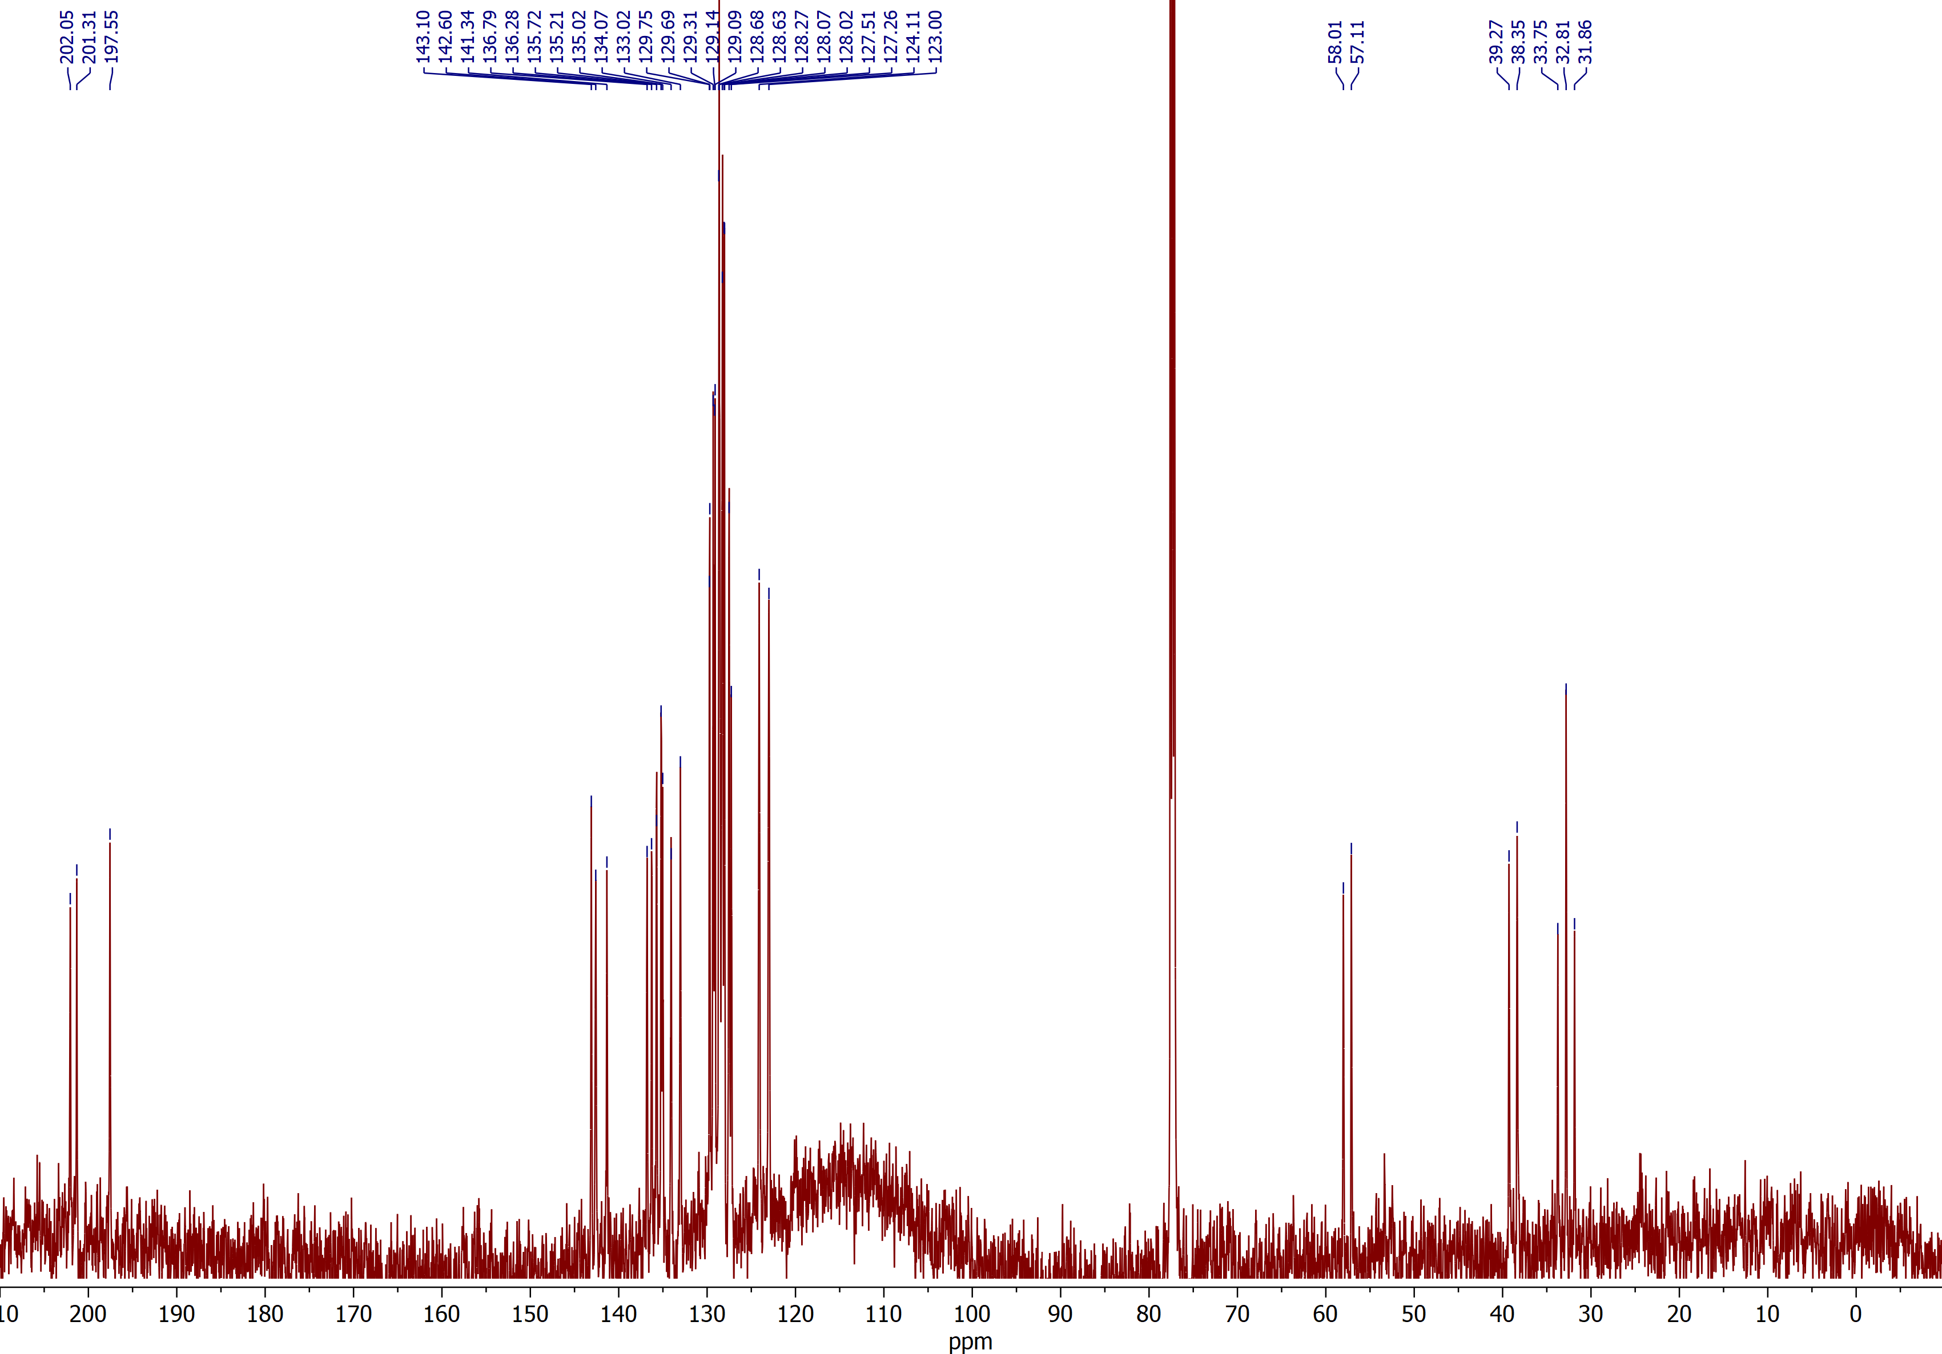

(2RS,3SR)-2-Benzoyl-3-(o-tolyl)spiro[cyclobutane-1,2'-indene]-1',3'-dione (3c)
¹H NMR (CDCl₃, 600 MHz)
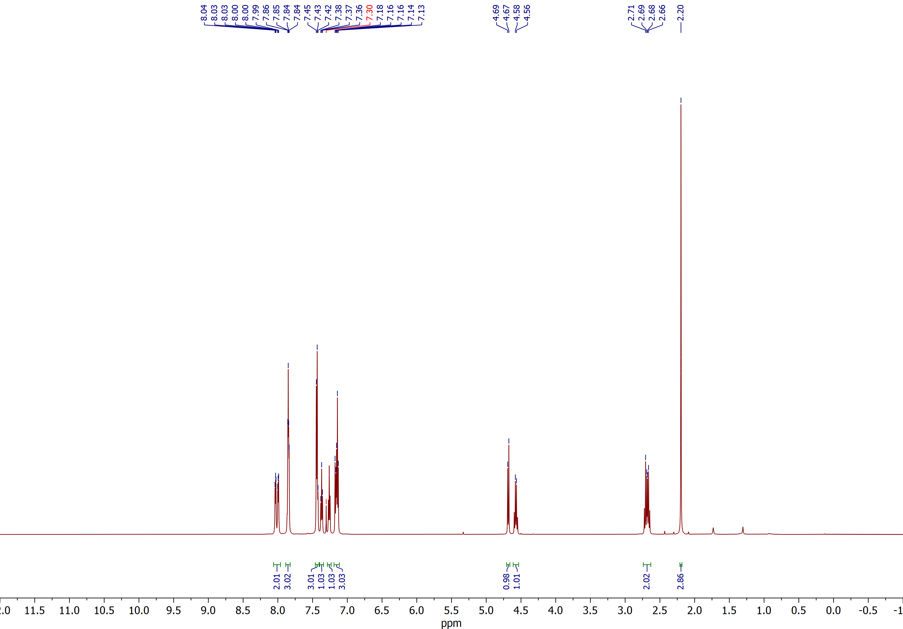

(2RS,3SR)-2-Benzoyl-3-(o-tolyl)spiro[cyclobutane-1,2'-indene]-1',3'-dione (3c)
¹³C NMR (CDCl₃, 150 MHz)
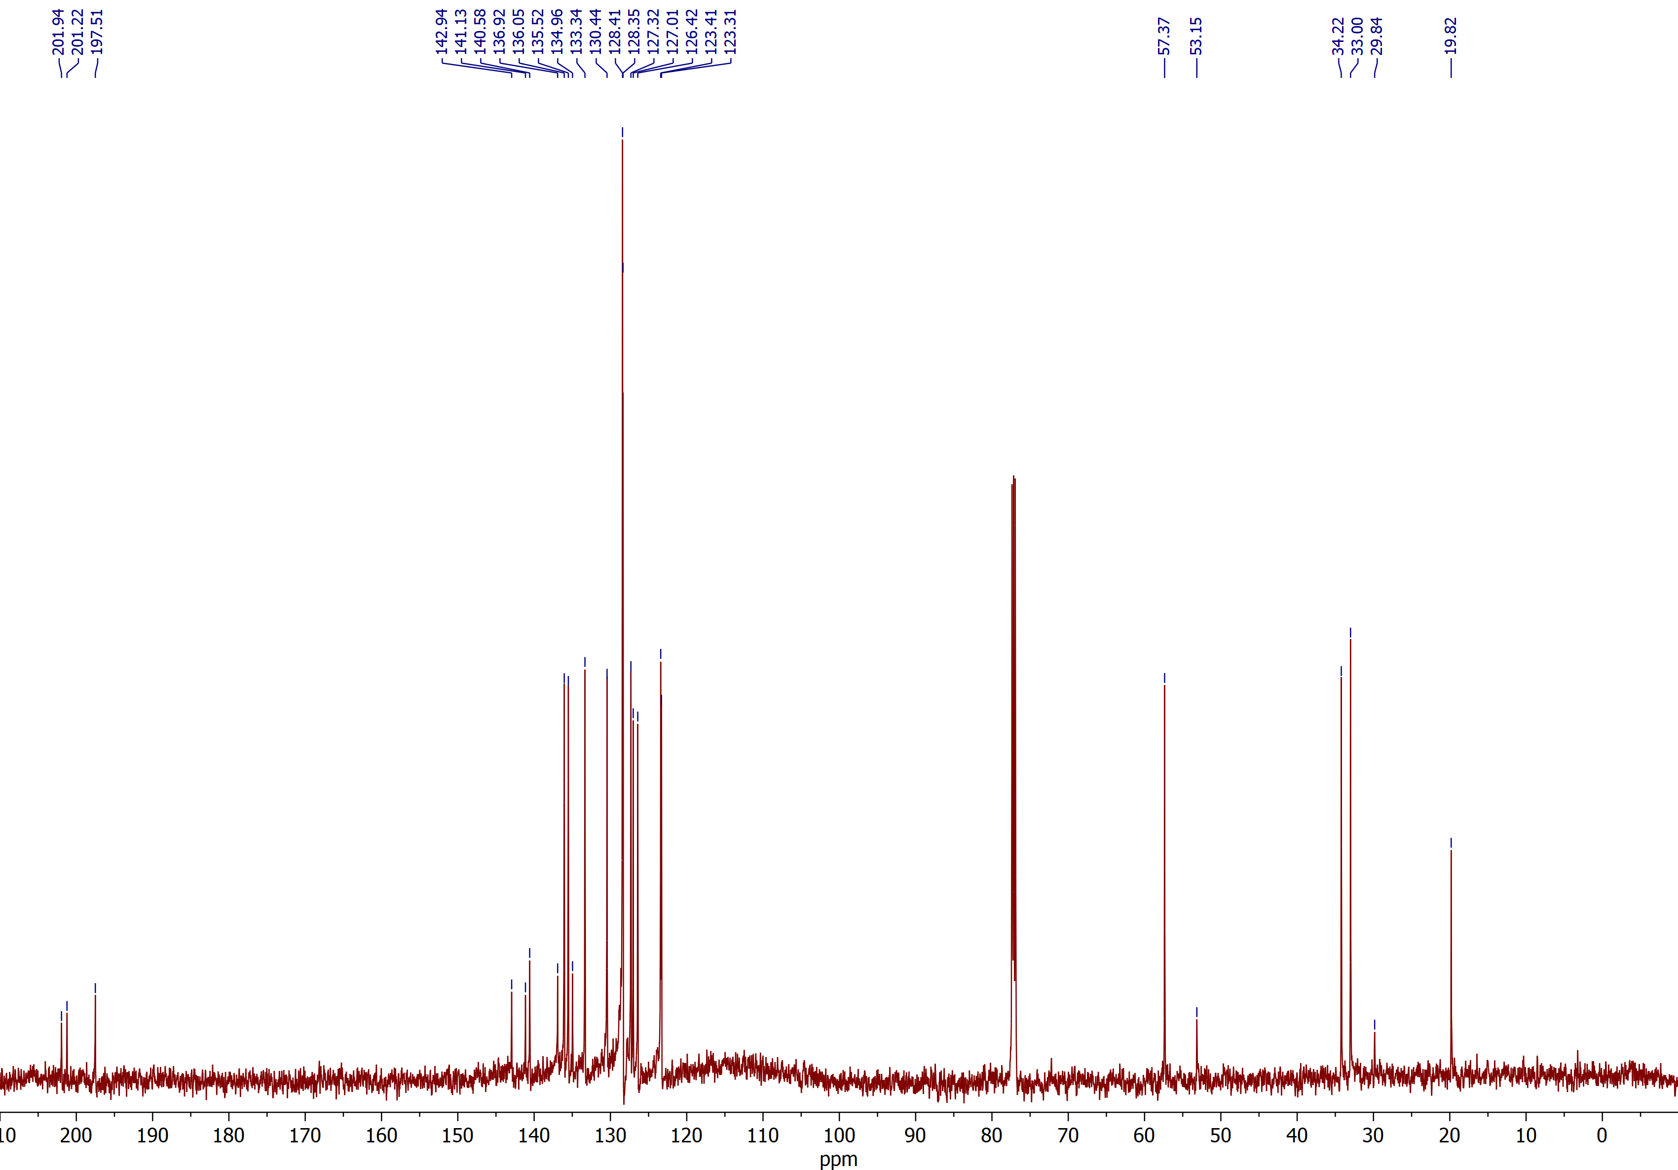

(2RS,3SR)-2-Benzoyl-3-(4-methoxyphenyl)spiro[cyclobutane-1,2'-indene]-1',3'-dione (3f)
¹H NMR (CDCl₃, 600 MHz)
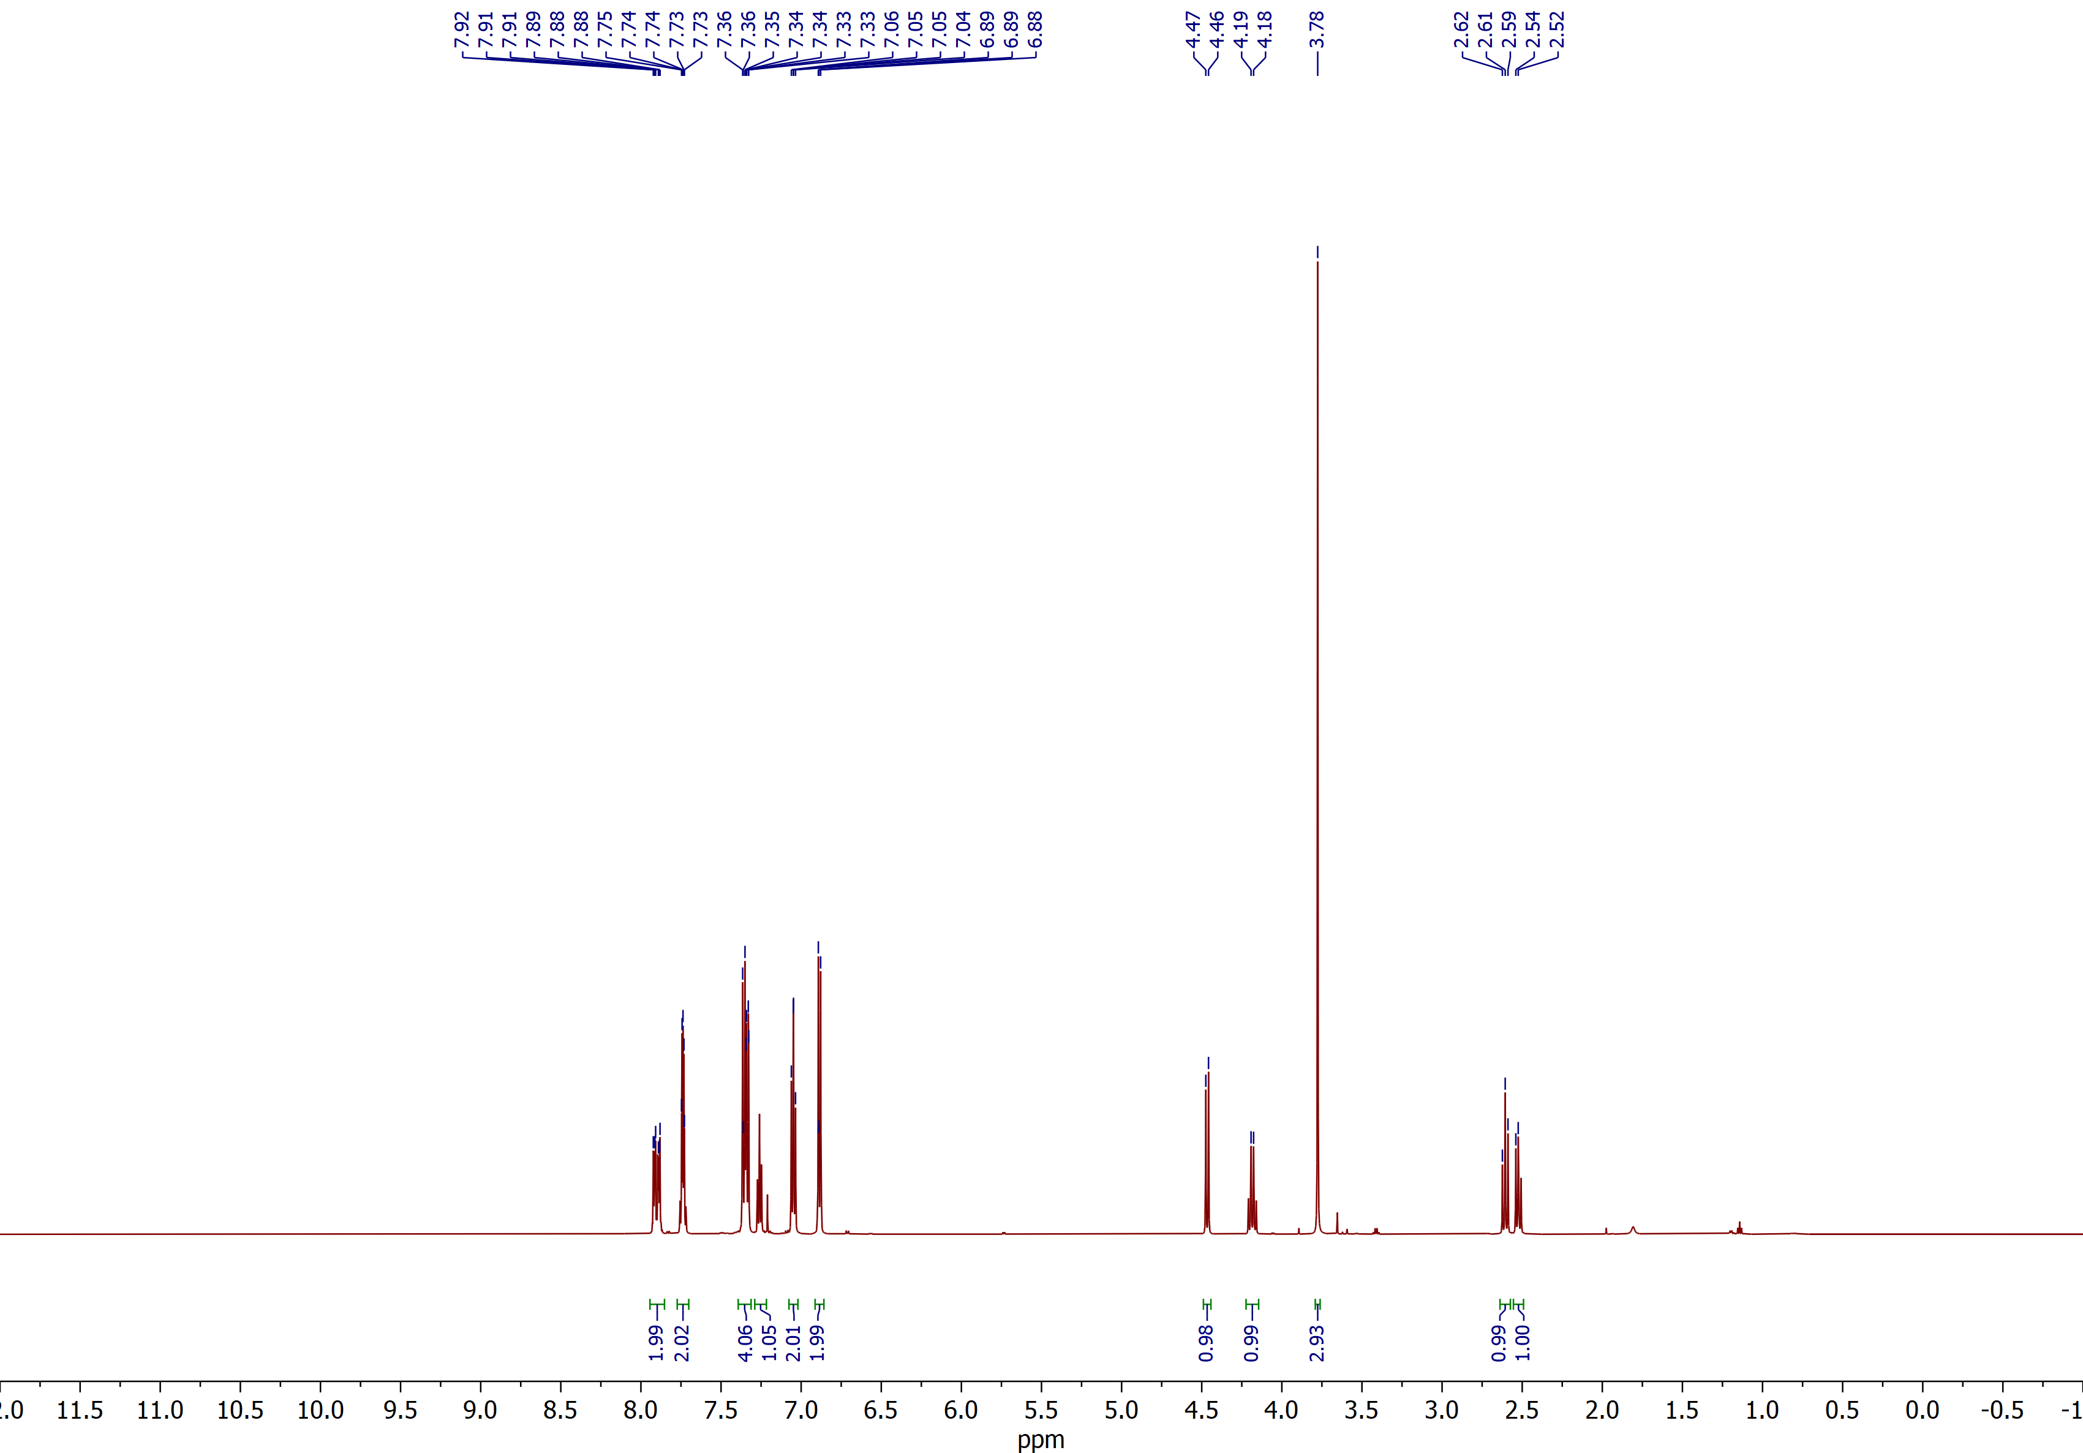

(2RS,3SR)-2-Benzoyl-3-(4-methoxyphenyl)spiro[cyclobutane-1,2'-indene]-1',3'-dione (3f)
¹³C NMR (CDCl₃, 150 MHz)
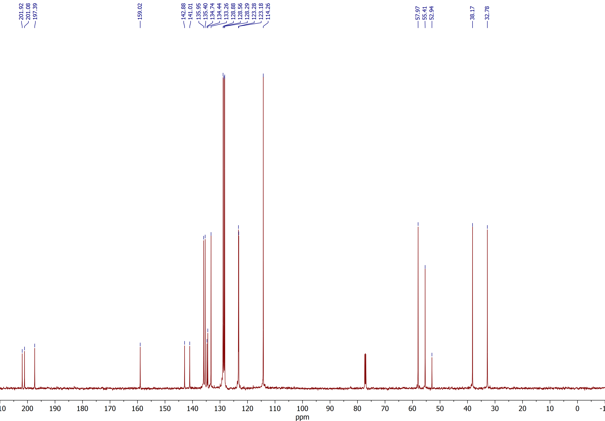

Ethyl (2RS,3SR)-1',3'-dioxo-3-(o-tolyl)-1',3'-dihydrospiro[cyclobutane-1,2'-indene]-2-carboxylate (3s)
¹H NMR (CDCl₃, 600 MHz)
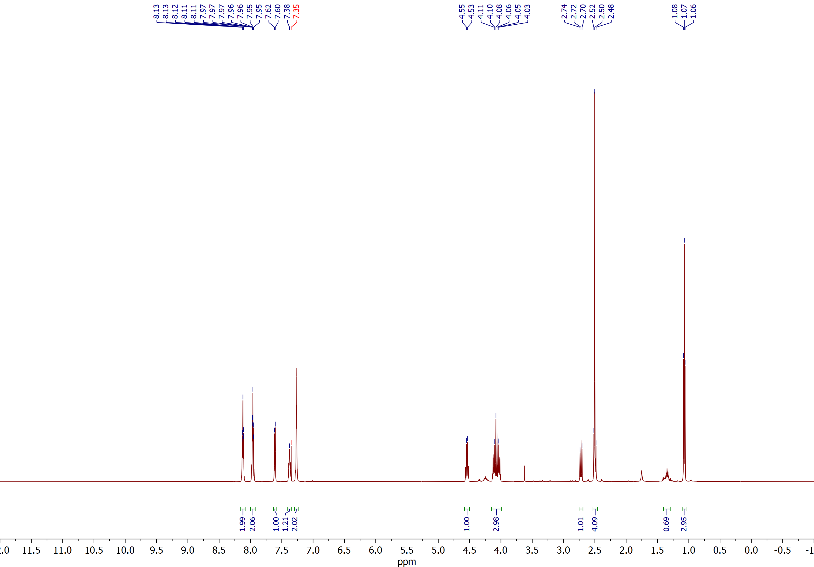

Ethyl (2RS,3SR)-1',3'-dioxo-3-(o-tolyl)-1',3'-dihydrospiro[cyclobutane-1,2'-indene]-2-carboxylate (3s)
¹³C NMR (CDCl₃, 150 MHz)
