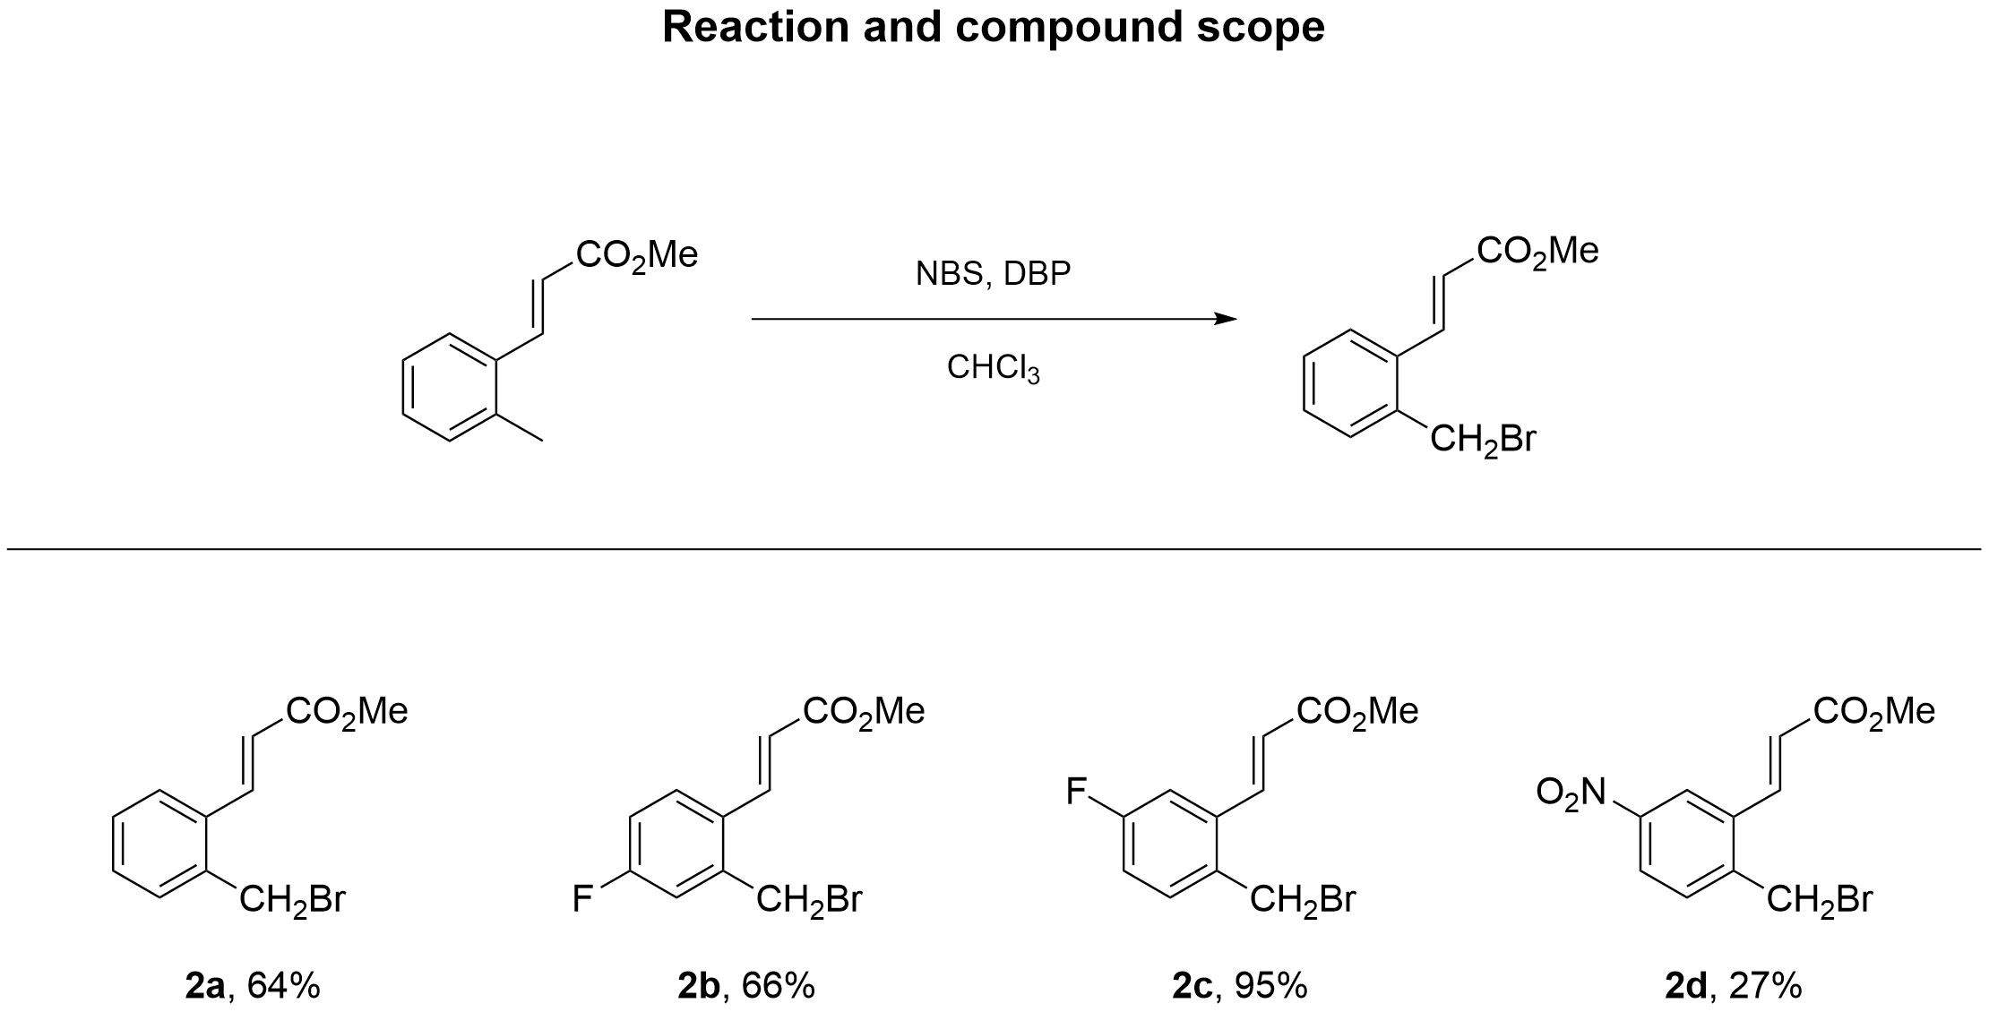

Methyl (E)-3-(2-(bromomethyl)phenyl)acrylate (2a)
Bromide 2a was obtained from methyl (E)-3-(o-tolyl)acrylate (600 mg, 3.4 mmol), NBS (606 mg, 3.4 mmol), DBP (41.2 mg, 0.17 mmol) and CHCl₃ (45.4 mL) according to GP1. Yield 560 mg (64%); white solid; mp 82 °C. R_{f} = 0.38 (petroleum ether : ethyl acetate = 7 : 1).
¹H NMR (CDCl₃, 600 MHz) δ = 8.07 (d, J = 15.8 Hz, 1H), 7.61 - 7.55 (m, 1H), 7.40 - 7.30 (m, 3H), 6.45 (d, J = 15.8 Hz, 1H), 4.59 (s, 2H), 3.83 (s, 3H).
¹³C NMR (CDCl₃, 150 MHz) δ = 167.1, 140.9, 136.7, 133.8, 130.8, 130.5, 129.4, 127.4, 120.7, 52.0, 30.7.
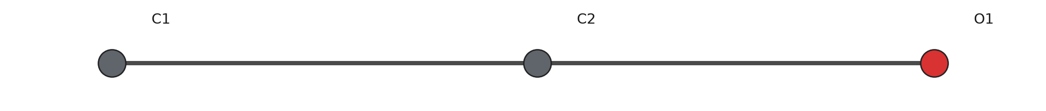
Crystal structure of 2a. Coordinate-derived ball-and-stick view of the asymmetric unit; hydrogen atoms omitted. Not a thermal-ellipsoid plot; review inferred connectivity and supply an ORTEP plot for submission.

Methyl (E)-3-(2-(bromomethyl)-4-fluorophenyl)acrylate (2b)
Bromide 2b was obtained from methyl (E)-3-(4-fluoro-2-methylphenyl)acrylate (500 mg, 2.57 mmol), NBS (458 mg, 2.57 mmol), DBP (31.2 mg, 0.13 mmol) and CHCl₃ (34.33 mL) according to GP1. Yield 467 mg (66%); white solid; mp 84 °C. R_{f} = 0.63 (petroleum ether : ethyl acetate = 7 : 1).
¹H NMR (CDCl₃, 600 MHz) δ = 7.96 (d, J = 15.8 Hz, 1H), 7.56 (dd, J = 5.6, 8.7 Hz, 1H), 7.08 (dd, J = 2.7, 9.0 Hz, 1H), 7.02 (td, J = 2.7, 8.3 Hz, 1H), 6.37 (d, J = 15.8 Hz, 1H), 4.52 (s, 2H), 3.81 (s, 3H).
¹³C NMR (CDCl₃, 150 MHz) δ = 167.0, 164.2, 162.6, 139.7, 139.0, 139.0, 129.9, 129.5, 129.4, 120.5, 117.6, 117.4, 116.7, 116.5, 52.0, 29.6.
HRMS (ESI/Q-TOF) m/z: [M+H]⁺ calcd for C₁₁H₁₁⁷⁹BrFO₂⁺ 272.9921. Found 272.9923.
Anal. Calcd for C₁₁H₁₀BrFO₂: C, 48.38; H, 3.69; Br, 29.26; F, 6.96; O, 11.72. Found: C, 48.38; H, 3.69; Br, 29.26; F, 6.96; O, 11.72.

Methyl (E)-3-(2-(bromomethyl)-5-fluorophenyl)acrylate (2c)
Bromide 2c was obtained from methyl (E)-3-(5-fluoro-2-methylphenyl)acrylate (400 mg, 2.06 mmol), NBS (367 mg, 2.06 mmol), DBP (24.9 mg, 0.1 mmol) and CHCl₃ (27.46 mL) according to GP1. Yield 534 mg (95%); white solid; mp 85 °C. R_{f} = 0.56 (petroleum ether : ethyl acetate = 7 : 1).
¹H NMR (CDCl₃, 600 MHz) δ = 7.99 (dd, J = 1.5, 15.9 Hz, 1H), 7.36 (dd, J = 5.6, 8.5 Hz, 1H), 7.05 (td, J = 2.7, 8.2 Hz, 1H), 6.43 (d, J = 15.8 Hz, 1H), 4.56 (s, 2H), 3.83 (s, 3H).
¹³C NMR (CDCl₃, 150 MHz) δ = 166.8, 163.7, 162.1, 139.7, 136.0, 135.9, 132.7, 132.7, 121.9, 117.5, 117.3, 114.1, 113.9, 52.1, 29.8.
HRMS (ESI/Q-TOF) m/z: [M+H]⁺ calcd for C₁₁H₁₁⁷⁹BrFO₂⁺ 272.9921. Found 272.9921.
Anal. Calcd for C₁₁H₁₀BrFO₂: C, 48.38; H, 3.69; Br, 29.26; F, 6.96; O, 11.72. Found: C, 48.38; H, 3.69; Br, 29.26; F, 6.96; O, 11.72.
(Support check: H expected 10, found 9)

Methyl (E)-3-(2-(bromomethyl)-5-nitrophenyl)acrylate (2d)
Bromide 2d was obtained from methyl (E)-3-(2-methyl-5-nitrophenyl)acrylate (350 mg, 1.58 mmol), NBS (282 mg, 1.58 mmol), DBP (19.2 mg, 0.08 mmol) and CHCl₃ (21.1 mL) according to GP1. Yield 127 mg (27%); white solid; mp 97 °C. R_{f} = 0.48 (petroleum ether : ethyl acetate = 7 : 1).
¹H NMR (CDCl₃, 600 MHz) δ = 8.42 (d, J = 2.3 Hz, 1H), 8.18 (dd, J = 2.4, 8.4 Hz, 1H), 8.00 (d, J = 15.8 Hz, 1H), 7.57 (d, J = 8.5 Hz, 1H), 6.58 (d, J = 15.8 Hz, 1H), 4.59 (s, 2H), 3.85 (s, 3H).
¹³C NMR (CDCl₃, 150 MHz) δ = 166.2, 148.1, 142.8, 138.4, 135.2, 131.6, 124.4, 123.4, 122.2, 52.1, 28.2.
HRMS (ESI/Q-TOF) m/z: [M+H]⁺ calcd for C₁₁H₁₁⁷⁹BrNO₄⁺ 299.9866. Found 299.9866.
Anal. Calcd for C₁₁H₁₀BrNO₄: C, 44.02; H, 3.36; N, 4.67; Br, 26.63; O, 21.32. Found: C, 44.02; H, 3.36; N, 4.67; Br, 26.63; O, 21.32.

X-ray crystallography
Methyl (E)-3-(2-(bromomethyl)phenyl)acrylate (2a)
Single-crystal X-ray diffraction data were collected with MoKα (λ = 0.71073) at 100(2) K.
Table S1. Crystal data and structure refinement for compound 2a.
Identification code | demo
Empirical formula | C₂ H₄ O₂
Formula weight | 60.05
Temperature / K | 100(2)
Crystal system | monoclinic
Space group | P 21/c
a / Å | 5.000(2)
b / Å | 6.000(2)
c / Å | 7.000(2)
α / ° | 90
β / ° | 100.000(3)
γ / ° | 90
V / Å³ | 206.81(12)
Z | 2
Calculated density / Mg m⁻³ | 1.200
Absorption coefficient / mm⁻¹ | 0.10
F(000) | 64
Crystal size / mm | 0.20 × 0.15 × 0.10
Radiation (wavelength / Å) | MoKα (λ = 0.71073)
θ range for data collection / ° | 2.0–30.0
Index ranges | -6 ≤ h ≤ 6; -7 ≤ k ≤ 7; -8 ≤ l ≤ 8
Reflections collected / independent / observed | 1000 / 500 / 450
Rint | 0.030
Data / restraints / parameters | 500 / 0 / 40
Goodness-of-fit on F² | 1.02
Final R indices (observed data) | R1 = 0.035, wR2 = 0.090
R indices (all data) | R1 = 0.040, wR2 = 0.095
Largest diff. peak and hole / e Å⁻³ | 0.20 / -0.18

Methyl (E)-3-(2-(bromomethyl)phenyl)acrylate (2a)
¹H NMR (CDCl₃, 600 MHz)
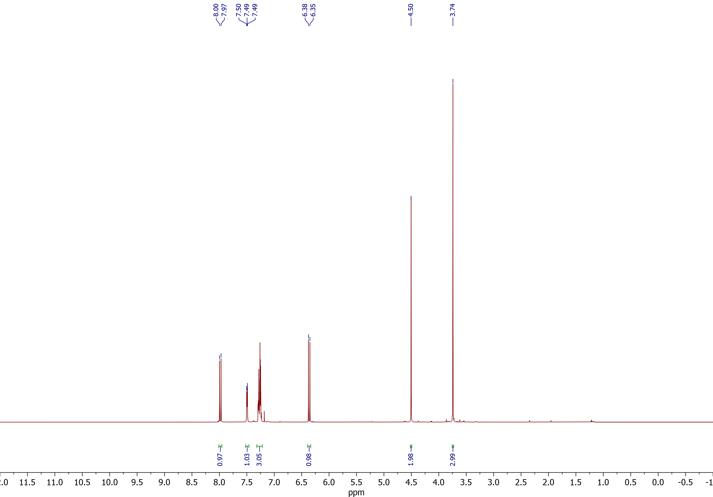

Methyl (E)-3-(2-(bromomethyl)phenyl)acrylate (2a)
¹³C NMR (CDCl₃, 150 MHz)
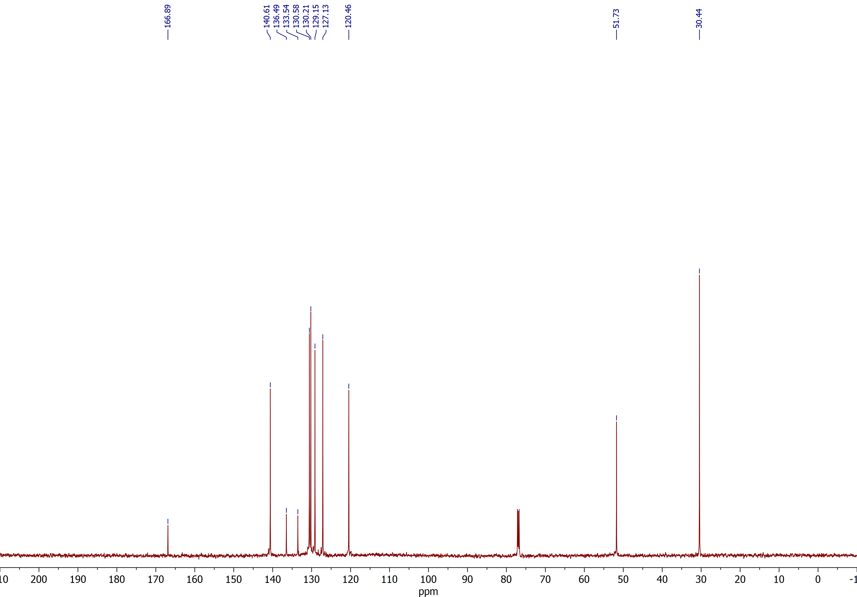

Methyl (E)-3-(2-(bromomethyl)phenyl)acrylate (2a)
HMBC ¹H–¹³C NMR (CDCl₃)
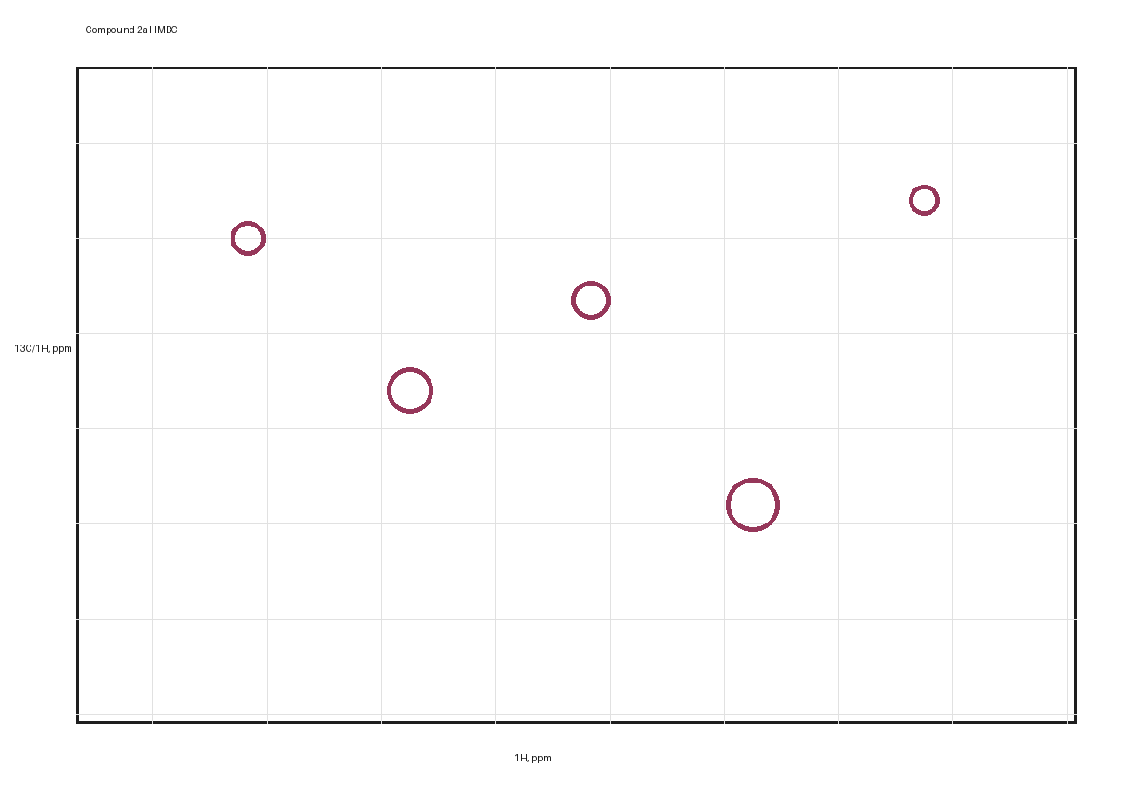

Methyl (E)-3-(2-(bromomethyl)phenyl)acrylate (2a)
HSQC ¹H–¹³C NMR (CDCl₃)
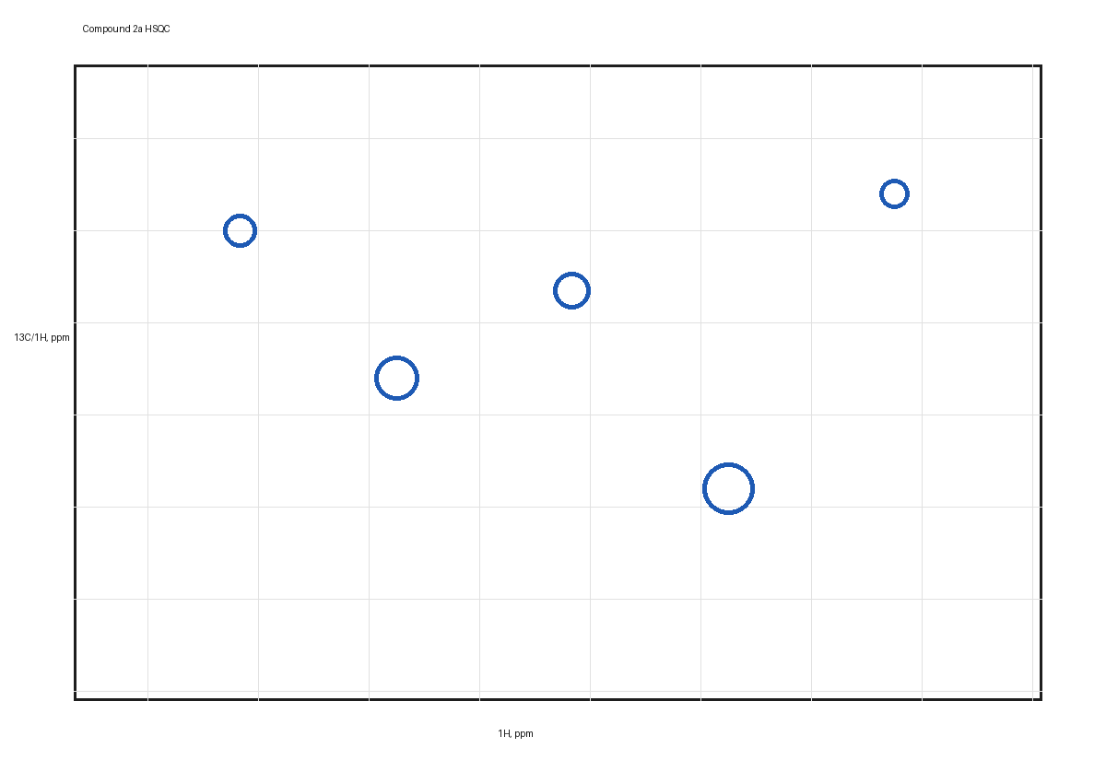

Methyl (E)-3-(2-(bromomethyl)phenyl)acrylate (2a)
NOESY ¹H–¹H NMR (CDCl₃)
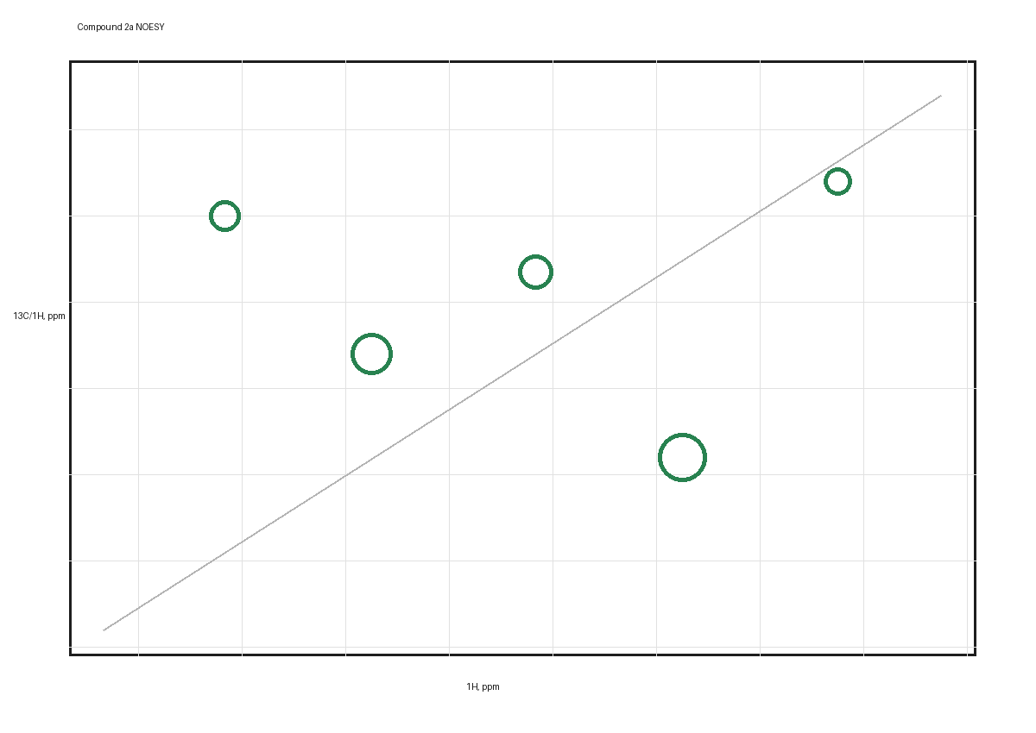

Methyl (E)-3-(2-(bromomethyl)-4-fluorophenyl)acrylate (2b)
¹H NMR (CDCl₃, 600 MHz)
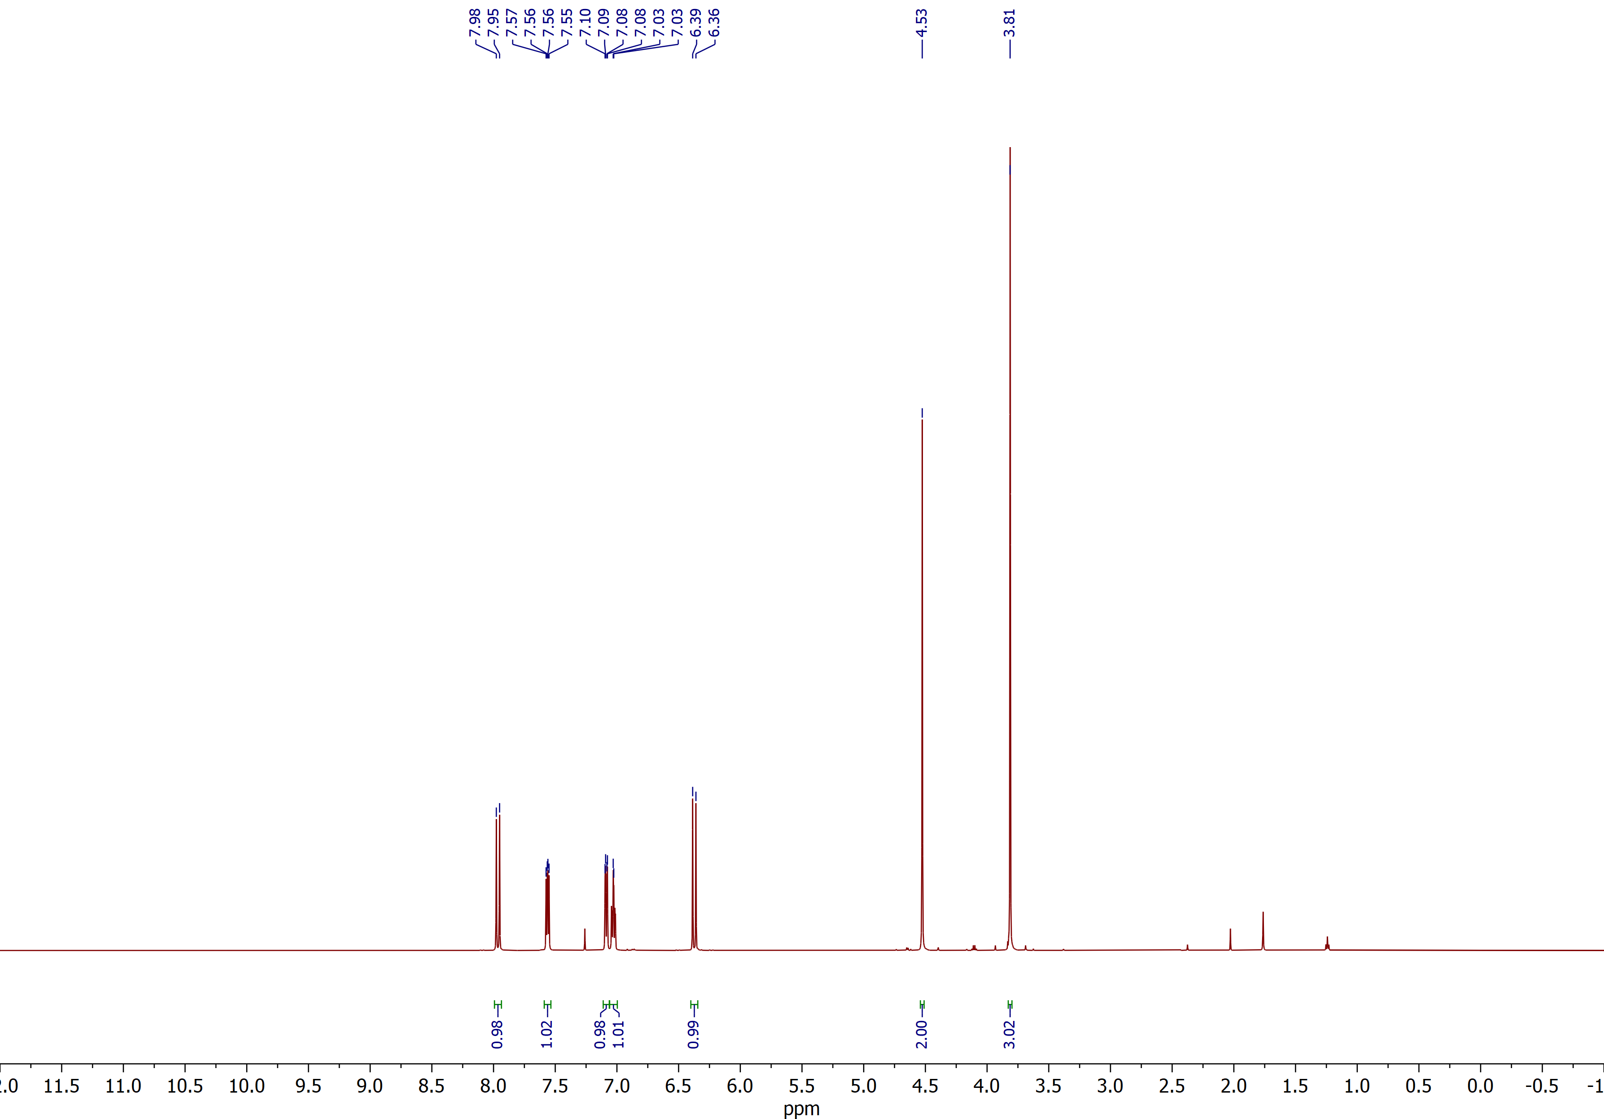

Methyl (E)-3-(2-(bromomethyl)-4-fluorophenyl)acrylate (2b)
¹³C NMR (CDCl₃, 150 MHz)
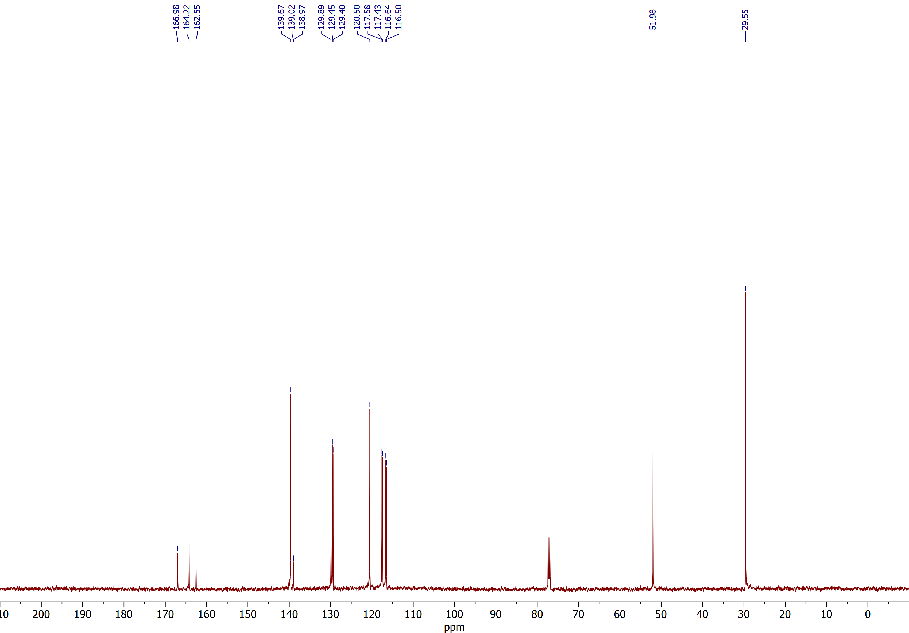

Methyl (E)-3-(2-(bromomethyl)-5-fluorophenyl)acrylate (2c)
¹H NMR (CDCl₃, 600 MHz)
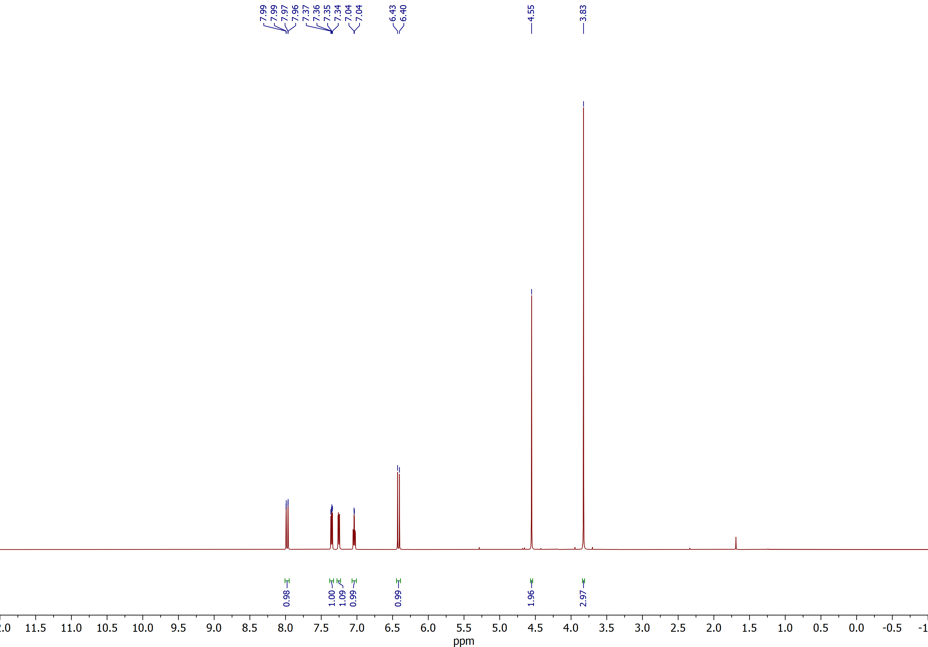

Methyl (E)-3-(2-(bromomethyl)-5-fluorophenyl)acrylate (2c)
¹³C NMR (CDCl₃, 150 MHz)
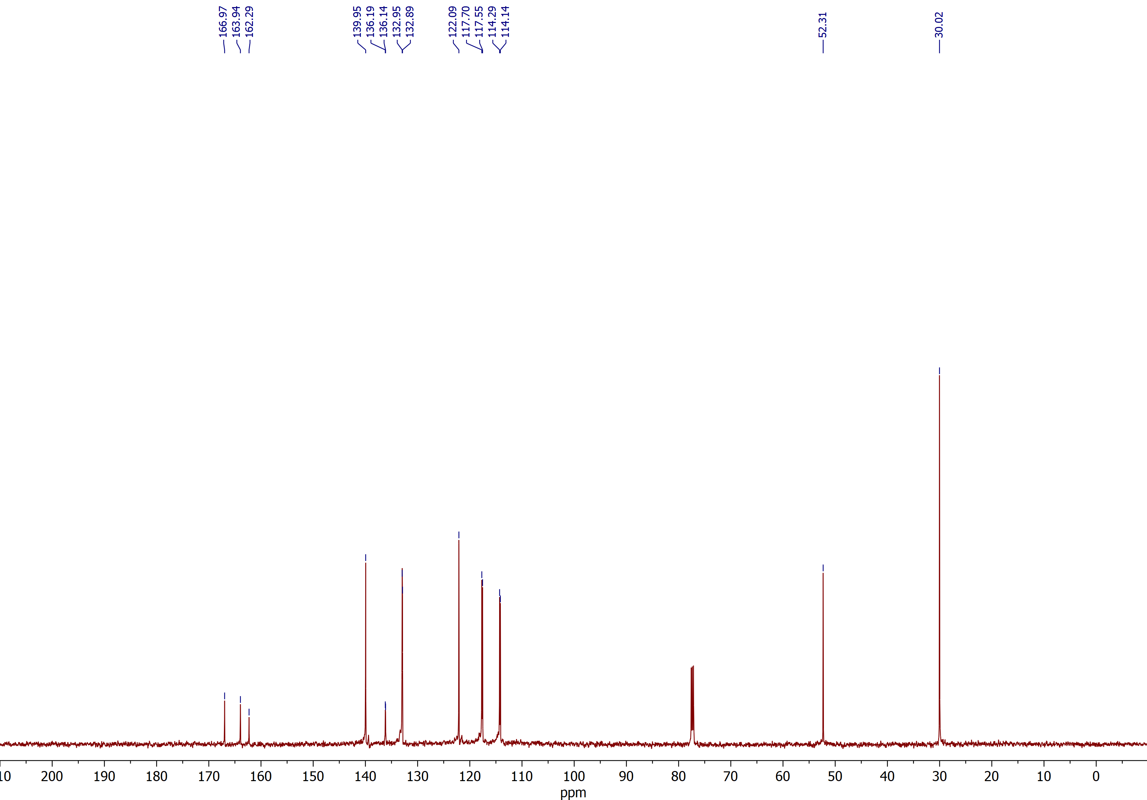

Methyl (E)-3-(2-(bromomethyl)-5-nitrophenyl)acrylate (2d)
¹H NMR (CDCl₃, 600 MHz)
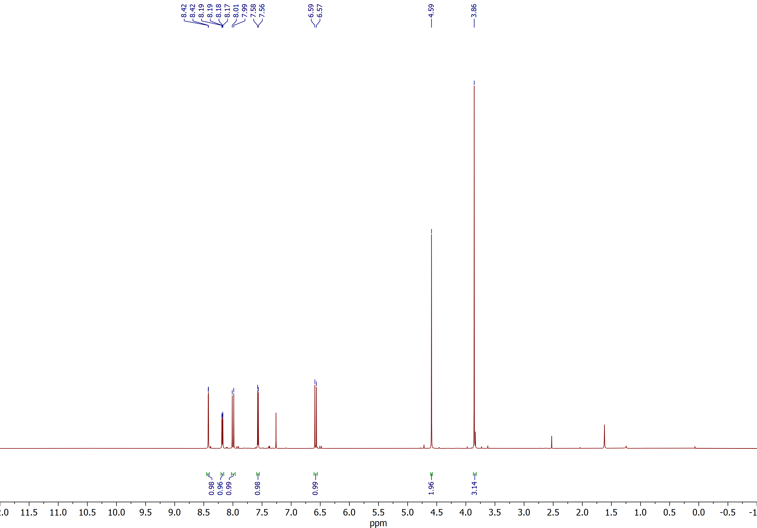

Methyl (E)-3-(2-(bromomethyl)-5-nitrophenyl)acrylate (2d)
¹³C NMR (CDCl₃, 150 MHz)
