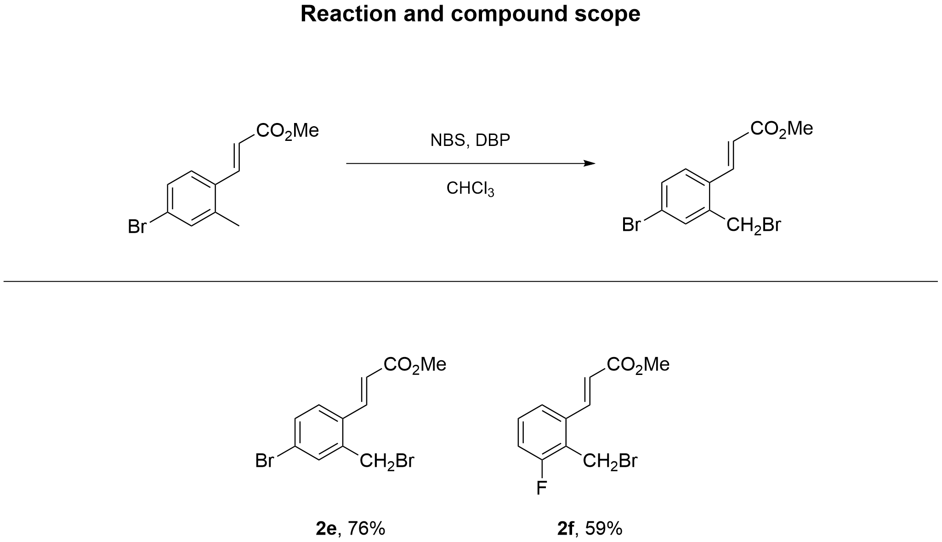

Methyl (E)-3-(4-bromo-2-(bromomethyl)phenyl)acrylate (2e)
Bromide 2e was obtained from methyl (E)-3-(4-bromo-2-methylphenyl)acrylate (600 mg, 2.35 mmol), NBS (419 mg, 2.35 mmol), DBP (28.5 mg, 0.12 mmol) and CHCl₃ (31.36 mL) according to GP1. Yield 600 mg (76%); Green oil. R_{f} = 0.55 (petroleum ether : ethyl acetate = 7 : 1).
¹H NMR (CDCl₃, 400 MHz) δ = 7.98 (s, 3H), 7.94 (d, J = 1.6 Hz, 3H), 7.53 (s, 5H), 7.53 - 7.40 (m, 12H), 6.43 (dd, J = 1.5, 15.8 Hz, 6H), 4.51 (d, J = 1.5 Hz, 12H), 3.83 (d, J = 1.5 Hz, 17H).
¹³C NMR (CDCl₃, 100 MHz) δ = 166.6, 139.4, 138.1, 133.3, 132.3, 132.2, 128.5, 123.9, 120.9, 51.8, 29.1.
HRMS (ESI/Q-TOF) m/z: [M+H]⁺ calcd for C₁₁H₁₁⁷⁹Br₂O₂⁺ 332.9120. Found 332.9115.
Anal. Calcd for C₁₁H₁₀Br₂O₂: C, 39.56; H, 3.02; Br, 47.85; O, 9.58. Found: C, 39.56; H, 3.02; Br, 47.85; O, 9.58.
(Support check: H expected 10, found 58)

Methyl (E)-3-(2-(bromomethyl)-3-fluorophenyl)acrylate (2f)
Bromide 2f was obtained from methyl (E)-3-(3-fluoro-2-methylphenyl)acrylate (400 mg, 2.06 mmol), NBS (367 mg, 2.06 mmol), DBP (24.9 mg, 0.1 mmol) and CHCl₃ (27.46 mL) according to GP1. Yield 333 mg (59%); Yellow solid; mp 98 °C. R_{f} = 0.74 (petroleum ether : ethyl acetate = 7 : 1).
¹H NMR (CDCl₃, 600 MHz) δ = 7.97 (d, J = 15.8 Hz, 1H), 7.36 (dd, J = 1.2, 7.9 Hz, 1H), 7.31 (td, J = 5.5, 8.0 Hz, 1H), 7.09 (ddd, J = 1.3, 8.1, 9.4 Hz, 1H), 6.45 (d, J = 15.8 Hz, 1H), 4.61 (d, J = 1.8 Hz, 2H), 3.83 (s, 3H).
¹³C NMR (CDCl₃, 150 MHz) δ = 166.8, 161.8, 160.2, 139.7, 139.6, 136.0, 130.4, 130.3, 124.4, 124.3, 123.0, 123.0, 122.2, 117.0, 116.9, 52.1, 21.6, 21.6.
HRMS (ESI/Q-TOF) m/z: [M+H]⁺ calcd for C₁₁H₁₁⁷⁹BrFO₂⁺ 272.9921. Found 272.9920.
Anal. Calcd for C₁₁H₁₀BrFO₂: C, 48.38; H, 3.69; Br, 29.26; F, 6.96; O, 11.72. Found: C, 48.38; H, 3.69; Br, 29.26; F, 6.96; O, 11.72.

Methyl (E)-3-(4-bromo-2-(bromomethyl)phenyl)acrylate (2e)
¹H NMR (CDCl₃, 400 MHz)
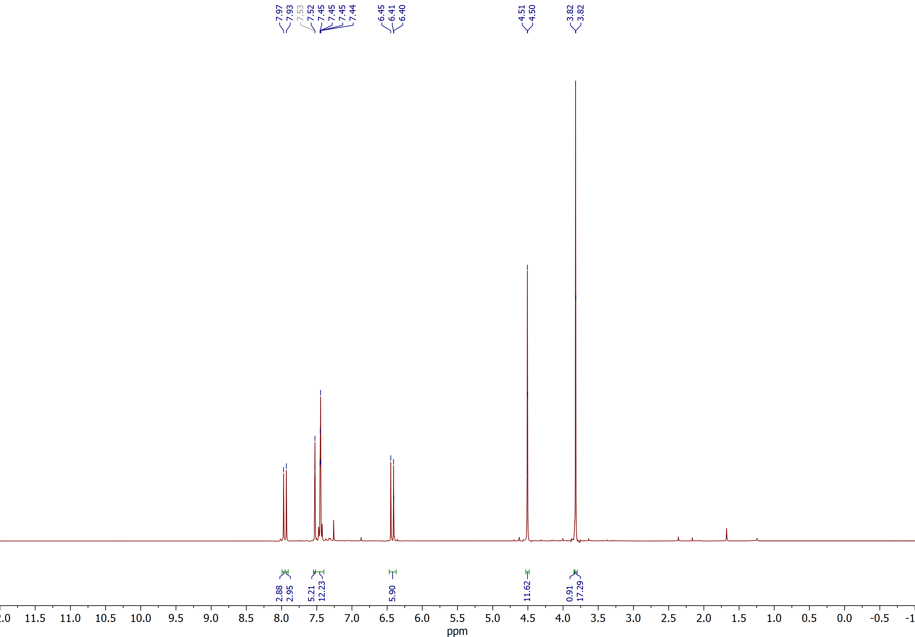

Methyl (E)-3-(4-bromo-2-(bromomethyl)phenyl)acrylate (2e)
¹³C NMR (CDCl₃, 100 MHz)
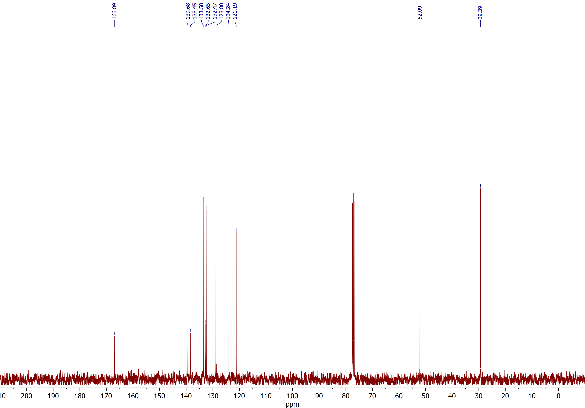

Methyl (E)-3-(2-(bromomethyl)-3-fluorophenyl)acrylate (2f)
¹H NMR (CDCl₃, 600 MHz)
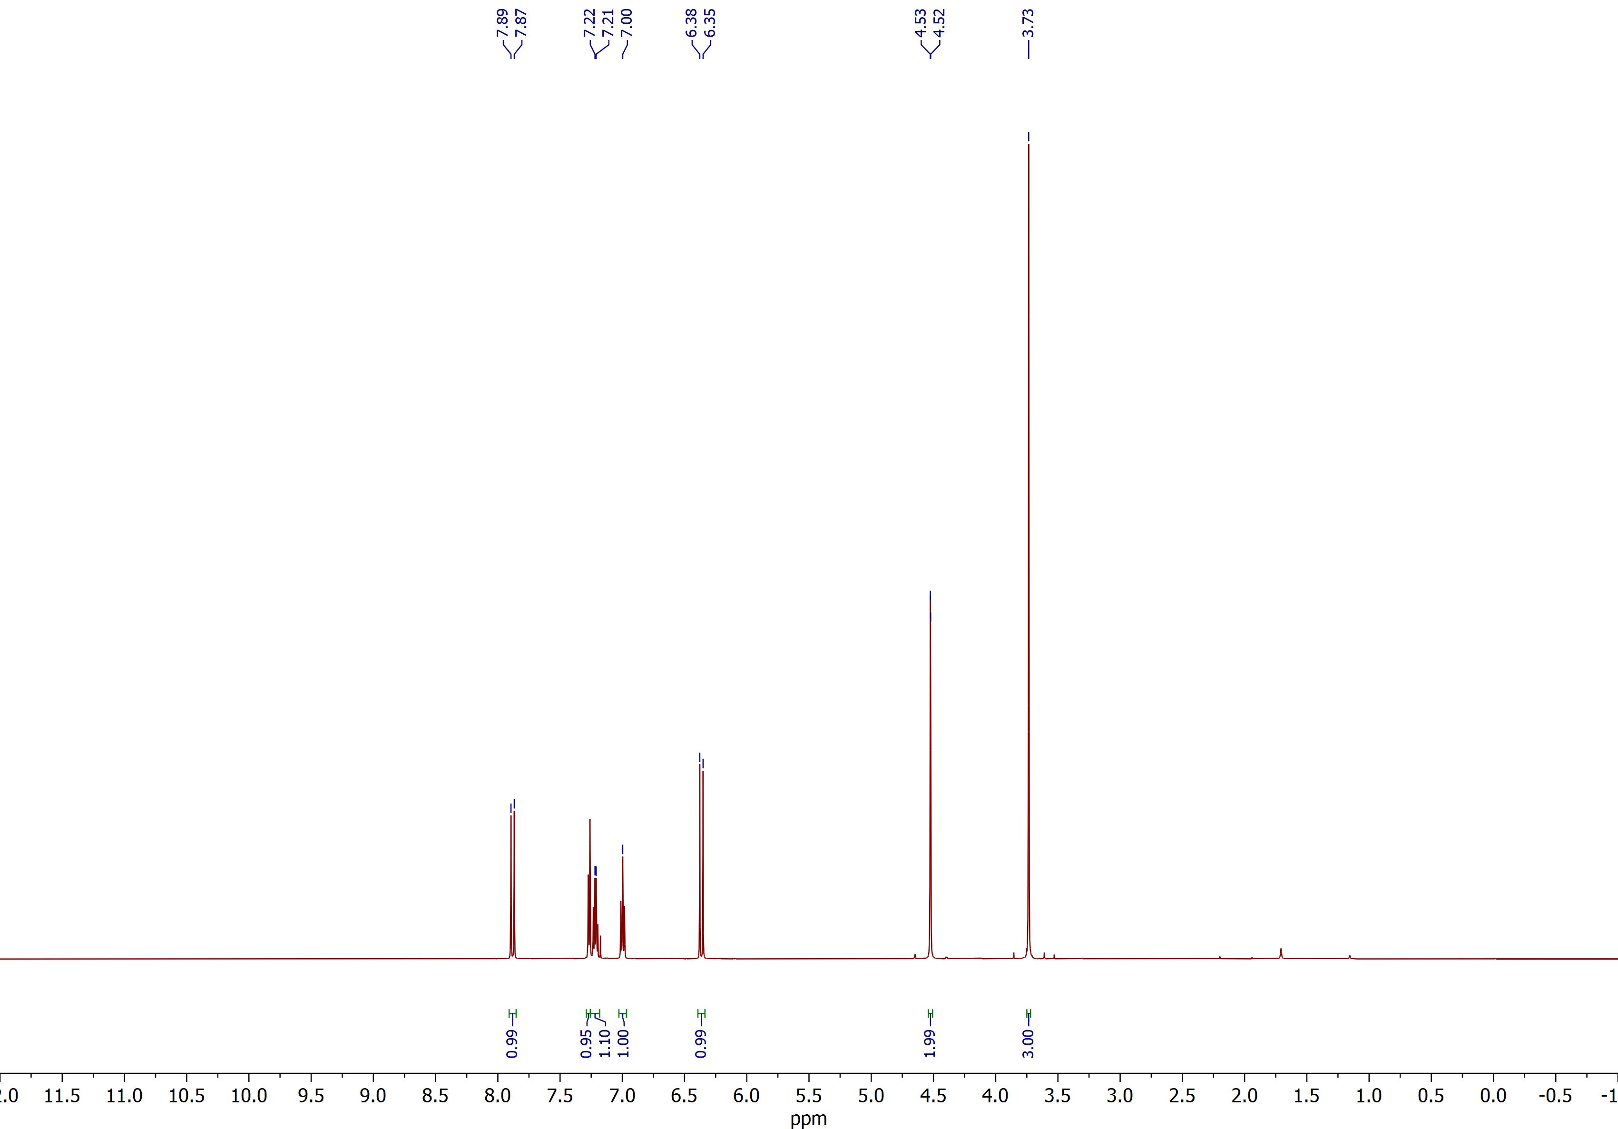

Methyl (E)-3-(2-(bromomethyl)-3-fluorophenyl)acrylate (2f)
¹³C NMR (CDCl₃, 150 MHz)
