Auto Support Generator - all-in-one input
Edit the tables and template below. Keep the section labels unchanged. Reaction schema, Scope, SI template and Crystallography template are optional.
[AUTO SI: COMPOUND TABLE]
Complete NMR and crystallography example
All available preparation and analytical data are retained from the supplied Supporting Information. The primary 1H and 13C NMR reports and appendix images are generated from Spectra_source.zip. CIF data are attached only to compounds for which an author-provided structure is available.
Number | Structure | Name | Formula | Preparation | HRMS (ESI-TOF) m/z | HRMS adduct | IR | Anal | Extra NMR
2g | 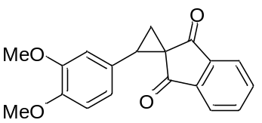 | 2-(3,4-Dimethoxyphenyl)spiro(cyclopropane-1,2'-indene)-1',3'-dione | C19H16O4 | Cyclopropane 2g was obtained according to the general procedure from alkene 1g (1.00 g, 3.4 mmol), trimethylsulfoxonium iodide (0.82 g, 3.7 mmol) and NaH (149 mg, 3.7 mmol) in DMF (34 mL). Yield 715 mg (69%); yellow solid; mp 175–176 °C; Rf=0.56 (petroleum ether – ethyl acetate, 2:1). | 309.1123. | [M+H]+ | IR (KBr, сm-1): 3082, 2965, 2942, 2842, 1738, 1694, 1600, 1589, 1518, 1467, 1445, 1367, 1329, 1315, 1295, 1255, 1239, 1216, 1167, 1142, 1110, 1077, 1048, 1036, 1023, 1011. | -
2h | 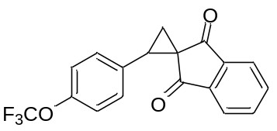 | 2-[4-(Trifluoromethoxy)phenyl]spiro[cyclopropane-1,2'-indene]-1',3'-dione | C18H11F3O3 | Cyclopropane 2h was obtained according to the general procedure from alkene 1h (1.00 g, 3.1 mmol), trimethylsulfoxonium iodide (0.76 g, 3.4 mmol) and NaH (138 mg, 3.4 mmol) in DMF (29 mL). Yield 400 mg (38%); light-yellow solid; mp 89–90 °C; Rf=0.53 (petroleum ether – ethyl acetate, 4:1). | 333.0737. | [M+H]+ | IR (KBr, сm-1): 3421, 3079, 2469, 1732, 1700, 1593, 1513, 1447, 1415, 1383, 1353, 1337, 1310, 1289, 1259, 1211, 1191, 1173, 1144, 1123, 1099, 1066, 1041, 1021, 1008. | - | 19F{1H} NMR (CDCl3, 376 MHz): –57.9 (OCF3).
2k | 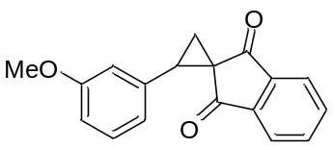 | 2-(3-Methoxyphenyl)spiro(cyclopropane-1,2'-indene)-1',3'-dione | C18H14O3 | Cyclopropane 2k was obtained according to the general procedure from alkene 1k (1.00 g, 3.8 mmol), trimethylsulfoxonium iodide (1.08 g, 4.9 mmol) and NaH (166 mg, 4.2 mmol) in DMF (19 mL). Yield 582 mg (55%); pale-yellow solid; mp 103–105 °C; Rf=0.38 (petroleum ether – ethyl acetate, 4:1). | 279.1018. | [M+H]+ | IR (KBr, сm-1): 3422, 3074, 3011, 2966, 2944, 2843, 1739, 1700, 1675, 1600, 1591, 1489, 1466, 1448, 1422, 1373, 1347, 1328, 1315, 1297, 1288, 1250, 1215, 1174, 1160, 1152, 1115, 1082, 1074, 1035, 1010. | -
3a | 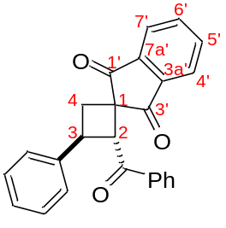 | (2RS,3SR)-2-Benzoyl-3-phenylspiro[cyclobutane-1,2'-indene]-1',3'-dione | C25H18O3 | Cyclobutane 3a was obtained from cyclopropane 2a (230 mg, 0.9 mmol), 4a (250 mg, 1.4 mmol) in DCE (1.9 mL) according to General procedure A, 12 h. An additional portion of 4a (75 mg, 0.4 mmol) was added to the reaction mixture after 8 h, and the reaction was left for another 4 h. Yield 278 mg (82%); white solid; mp 126–127 °C; Rf=0.39 (petroleum ether – ethyl acetate, 4:1).  One-pot synthesis: alkene 1a (200 mg, 0.85 mmol), trimethylsulfoxonium chloride (143 mg, 1.1 mmol), NaH (60%, 38 mg, 0.94 mmol), 4a (1.02 g, 5.6 mmol) in DMF (4.3 mL) according to General procedure C, 3 h. Yield 218 mg (70%). | 367.1332. | [M+H]+ | IR (KBr, сm-1): 3424, 3061, 3032, 2989, 2940, 2895, 2849, 1736, 1699, 1683, 1672, 1593, 1578, 1496, 1447, 1355, 1332, 1303, 1285, 1269, 1239, 1194, 1178, 1151, 1114, 1091, 1057, 1038, 1026, 1002. | - | 13C NMR (CDCl3, 150 MHz): 201.8 (s, C(1’)=O), 201.1 (s, C(3’)=O), 197.3 (s, C=O), 142.8 (s, C(7a’)), 142.4 (s, C, Ph), 141.1 (s, C(3a’)), 136.0 (dd, 1JС–Н = 164 Hz, 1JС–Н = 6 Hz, C(6’)H), 135.5 (dd, 1JС–Н = 162 Hz, 2JС–Н = 7 Hz, C(5’)H), 134.8 (s, C, Ph), 133.3(ddd, 1JС–Н = 160 Hz, 2JС–Н = 14 Hz, 2JС–Н = 7 Hz, CH, Ph), 128.9 (d, 1JС–Н = 161 Hz, 2 × CH, Ph), 128.6 (d, 1JС–Н = 160 Hz, 2 × CH, Ph), 128.4 (d, 1JС–Н = 162 Hz, 2 × CH, Ph), 127.9 (d, 1JС–Н = 162 Hz, 2 × CH, Ph), 127.6 (d, 1JС–Н = 154 Hz, CH, Ph), 123.4 (d, 1JС–Н = 167 Hz, C(7’)H), 123.3 (d, 1JС–Н = 168 Hz, C(4’)H), 57.3 (d, 1JС–Н = 136 Hz, C(2)H), 53.1 (s, C(1)), 38.6 (d, 1JС–Н = 139 Hz, C(3)H), 32.6 (d, 1JС–Н = 144 Hz, C(4)H2).
3b | 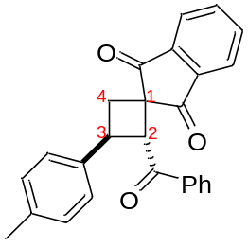 | (2RS,3SR)-2-Benzoyl-3-(p-tolyl)spiro[cyclobutane-1,2'-indene]-1',3'-dione | C26H20O3 | Cyclobutane 3b was obtained from cyclopropane 2b (300 mg, 1.1 mmol), 4a (309 mg, 1.7 mmol) in DCE (2.3 mL) according to General procedure A, 6.5 h. Yield 370 mg (85%); white solid; mp 147–148 °C; Rf=0.29 (petroleum ether – ethyl acetate, 6:1).  One-pot synthesis: alkene 1b (200 mg, 0.81 mmol), trimethylsulfoxonium chloride (135 mg, 1.05 mmol), NaH (60%, 36 mg, 0.87 mmol), 4a (960 mg, 5.3 mmol) in DMF (4.0 mL) according to General procedure C, 3 h. Yield 200 mg (65%). | 381.1481. | [M+H]+ | IR (KBr, сm-1): 3425, 3058, 3031, 2990, 2940, 2917, 2886, 2857, 1739, 1702, 1663, 1597, 1581, 1517, 1464, 1453, 1348, 1331, 1309, 1289, 1269, 1248, 1232, 1218, 1196, 1182, 1168, 1150, 1119, 1111, 1069, 1040, 1023, 1001. | C, 81.93; H, 5.22.
3c | 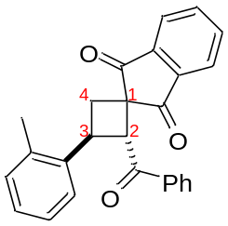 | (2RS,3SR)-2-Benzoyl-3-(o-tolyl)spiro[cyclobutane-1,2'-indene]-1',3'-dione | C26H20O3 | Cyclobutane 3c was obtained from cyclopropane 2c (150 mg, 0.6 mmol), 4a (154 mg, 0.9 mmol) in DCE (1.2 mL) according to General procedure A, 7 h. Yield 189 mg (87%); light-yellow solid; mp 181–182 °C; Rf=0.33 (petroleum ether – ethyl acetate, 6:1). | 381.1483. | [M+H]+ | IR (KBr, сm-1): 3415, 3080, 3057, 2967, 2949, 2922, 2852, 1736, 1695, 1687, 1595, 1579, 1558, 1486, 1456, 1448, 1379, 1358, 1332, 1296, 1268, 1235, 1223, 1191, 1182, 1154, 1115, 1073, 1051, 1027, 1014, 1001. | -
3d | 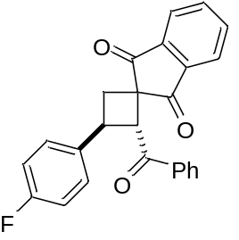 | (2RS,3SR)-2-Benzoyl-3-(4-fluorophenyl)spiro[cyclobutane-1,2'-indene]-1',3'-dione | C25H17FO3 | Cyclobutane 3d was obtained from cyclopropane 2d (200 mg, 0.8 mmol), 4a (203 mg, 1.1 mmol) in DCE (1.5 mL) according to General procedure A, 6.5 h. Yield 231 mg (80%); white solid; mp 147–148 °C; Rf=0.36 (petroleum ether – ethyl acetate, 4:1). | 385.1235. | [M+H]+ | IR (KBr, сm-1): 3419, 3088, 3066, 2987, 2940, 2899, 1733, 1698, 1682, 1591, 1510, 1489, 1447, 1434, 1408, 1361, 1335, 1310, 1298, 1269, 1239, 1217, 1191, 1173, 1163, 1158, 1149, 1117, 1103, 1074, 1047, 1024, 1016, 1003. | - | 19F{1H} NMR (CDCl3, 376 MHz): –114.9 (CF).
3e | 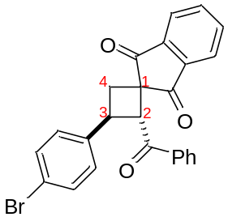 | (2RS,3SR)-2-Benzoyl-3-(4-bromophenyl)spiro[cyclobutane-1,2'-indene]-1',3'-dione | C25H17BrO3 | Cyclobutane 3e was obtained from cyclopropane 2e (150 mg, 0.5 mmol), 4a (125 mg, 0.7 mmol) in DCE (0.9 mL) according to General procedure A, 7 h. Yield 155 mg (76%); pale-orange solid; mp 150–152 °C; Rf=0.35 (petroleum ether – ethyl acetate, 4:1).  Gram-scale synthesis: cyclopropane 2e (1.50 g, 5 mmol), 4a (1.24 g, 7 mmol) in DCE (9.2 mL) according to General procedure A, 7 h. The crude product was purified by recrystallization from ethanol. Yield 1.60 g (78%). | 445.0431. | [M+H]+ | IR (KBr, сm-1): 3416, 3086, 3057, 3028, 3009, 2950, 2910, 1733, 1696, 1670, 1596, 1581, 1488, 1450, 1408, 1349, 1333, 1299, 1281, 1265, 1251, 1230, 1206, 1181, 1162, 1123, 1072, 1039, 1027, 1006. | -
3f | 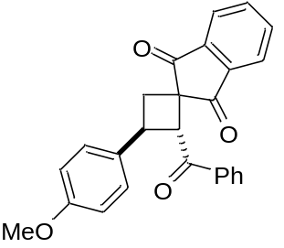 | (2RS,3SR)-2-Benzoyl-3-(4-methoxyphenyl)spiro[cyclobutane-1,2'-indene]-1',3'-dione | C26H20O4 | Cyclobutane 3f was obtained from cyclopropane 2f (200 mg, 0.7 mmol), 4a (195 mg, 1.1 mmol) in DCE (1.4 mL) according to General procedure A, 4 h. Yield 205 mg (72%); white solid; mp 134–135 °C; Rf=0.22 (petroleum ether – ethyl acetate, 6:1). | 397.1439. | [M+H]+ | IR (KBr, сm-1): 3420, 3062, 3034, 2996, 2955, 2932, 2898, 2833, 1735, 1700, 1662, 1607, 1594, 1579, 1512, 1460, 1450, 1442, 1356, 1333, 1324, 1305, 1299, 1272, 1245, 1237, 1207, 1195, 1179, 1166, 1115, 1070, 1035, 1024, 1003. | C, 78.41; H, 5.08.
3g | 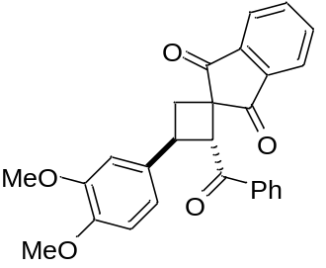 | (2RS,3SR)-2-Benzoyl-3-(3,4-dimethoxyphenyl)spiro[cyclobutane-1,2'-indene]-1',3'-dione | C27H22O5 | Cyclobutane 3g was obtained from cyclopropane 2g (235 mg, 0.76 mmol), 4a (206 mg, 1.1 mmol) in DCE (1.5 mL) according to General procedure A, 4 h. The crude product duct was purified by recrystallization from ethanol. Yield 245 mg (75%); light-yellow solid; mp 210–212 °C; Rf=0.24 (petroleum ether – ethyl acetate, 3:1). | 449.1359. | [M+Na]+ | IR (KBr, сm-1): 3060, 3004, 2970, 2958, 2939, 2931, 2831, 1737, 1700, 1670, 1596, 1590, 1578, 1515, 1456, 1447, 1435, 1419, 1346, 1328, 1315, 1305, 1290, 1272, 1257, 1236, 1212, 1199, 1176, 1163, 1140, 1114, 1080, 1044, 1033, 1021, 1004. | -
3h | 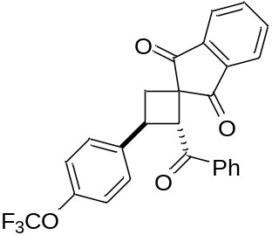 | (2RS,3SR)-2-Benzoyl-3-[4-(trifluoromethoxy)phenyl]spiro[cyclobutane-1,2'-indene]-1',3'-dione | C26H17F3O4 | Cyclobutane 3h was obtained from cyclopropane 2h (200 mg, 0.6 mmol), 4a (163 mg, 0.9 mmol) in DCE (1.2 mL) according to General procedure A, 7.5 h. Yield 217 mg (80%); white solid; mp 139–141 °C; Rf=0.36 (petroleum ether – ethyl acetate, 4:1. | 451.1151. | [M+H]+ | IR (KBr, сm-1): 3419, 3070, 3020, 2989, 2940, 2918, 2904, 1734, 1700, 1685, 1595, 1507, 1448, 1360, 1333, 1316, 1259, 1219, 1201, 1168, 1151, 1117, 1075, 1049, 1020, 1005. | C, 69.46; H, 3.94. | 19F{1H} NMR (CDCl3, 376 MHz): –57.8 (OCF3).
3i | 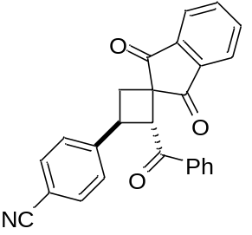 | (2RS,3SR)-2-Benzoyl-3-(4-cyanophenyl)spiro[cyclobutane-1,2'-indene]-1',3'-dione | C26H17NO3 | Cyclobutane 3i was obtained from cyclopropane 2i (304 mg, 1.1 mmol), 4a (301 mg, 1.7 mmol) in DCE (2.2 mL) according to General procedure A, 15.5 h. An additional portion of 4a (100 mg, 0.6 mmol) was added to the reaction mixture after 8 h, and the reaction was left for another 7.5 h. Yield 357 mg (82%); white solid; mp 157–159 °C; Rf=0.16 (petroleum ether – ethyl acetate, 6:1). | 392.1281. | [M+H]+ | IR (KBr, сm-1): 3427, 3097, 2996, 2952, 2930, 2226, 1738, 1699, 1695, 1597, 1578, 1504, 1444, 1434, 1416, 1369, 1347, 1328, 1317, 1291, 1279, 1263, 1227, 1178, 1147, 1125, 1111, 1082, 1074, 1039, 1026, 1018, 1001. | C, 79.39; H, 4.42; N, 3.37.
3j | 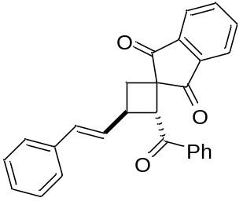 | (2RS,3SR)-2-Benzoyl-3-((E)-styryl)spiro[cyclobutane-1,2'-indene]-1',3'-dione | C27H20O3 | Cyclobutane 3j was obtained according to modified General procedure A. To a solution of cyclopropane 2j (213 mg, 0.7 mmol) in dry DMF (3.7 mL, 0.2 M) in a microwave vial was added 4a (150 mg, 0.8 mmol, 1.2 equiv.) in one portion at room temperature under an argon atmosphere. The resulting mixture was placed in a microwave reactor and stirred at 50 °C for 30 minutes. Then an additional portion of 4a (150 mg, 0.8 mmol, 1.2 equiv.) was added, and the reaction mixture was stirred in a microwave reactor at 50 °C for 30 minutes. After completion, the mixture was diluted with water and extracted with ethyl acetate (3 × 15 mL). The combined organic fractions were washed with brine (7 × 10 mL), dried with Na2SO4, and concentrated in vacuo. The residue was purified by column chromatography on silica gel (eluting with a petroleum ether – ethyl acetate mixture) to obtain the 3j. Yield 35 mg (12%); white solid; mp 160–161 °C; Rf=0.4 (petroleum ether – ethyl acetate, 4:1). | 393.1490. | [M+H]+ | IR (KBr, сm-1): 2918, 1738, 1697, 1673, 1596, 1450, 1325, 1275, 1235, 972. | -
3k | 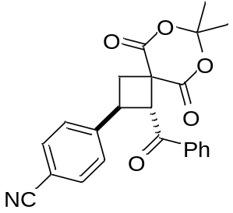 | 4-((1RS,2SR)-1-Benzoyl-7,7-dimethyl-5,9-dioxo-6,8-dioxaspiro[3.5]nonan-2-yl)benzonitrile | C23H19NO5 | Cyclobutane 3k was obtained from cyclopropane 2m (271 mg, 1.0 mmol), 4a (270 mg, 1.5 mmol) in DCE (2.0 mL) according to General procedure A, 4.0 h. Yield 239 mg (63%); white solid; mp 150–153 °C; Rf=0.51 (petroleum ether – ethyl acetate, 2:1). | 390.1336. | [M+H]+ | IR (KBr, сm-1): 3065, 3003, 2949, 2229, 1768, 1733, 1686, 1608, 1598, 1580, 1506, 1448, 1431, 1417, 1394, 1382, 1373, 1325, 1297, 1287, 1240, 1229, 1200, 1179, 1139, 1121, 1094, 1077, 1057, 1039, 1020, 1002. | -
3l | 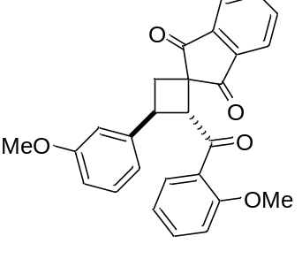 | (2RS,3SR)-3-(3-Methoxyphenyl)-2-(2-methoxybenzoyl)spiro[cyclobutane-1,2'-indene]-1',3'-dione | C27H22O5 | Cyclobutane 3l was obtained from cyclopropane 2k (180 mg, 0.65 mmol), 4b (204 mg, 0.97 mmol) in DCE (1.3 mL) according to General procedure A, 8 h. Yield 232 mg (84%); light-yellow solid; mp 123–125 °C; Rf=0.42 (petroleum ether – ethyl acetate, 1:2). | 427.1543. | [M+H]+ | IR (KBr, сm-1): 3091, 3069, 3004, 2995, 2959, 2946, 2835, 1742, 1706, 1668, 1594, 1496, 1483, 1464, 1434, 1363, 1335, 1302, 1292, 1273, 1266, 1247, 1221, 1194, 1175, 1159, 1150, 1126, 1107, 1088, 1064, 1036, 1012. | -
3m | 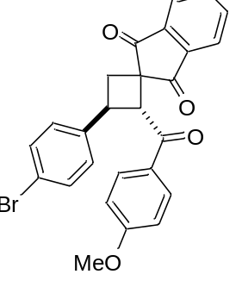 | (2RS,3SR)-3-(4-Bromophenyl)-2-(4-methoxybenzoyl)spiro[cyclobutane-1,2'-indene]-1',3'-dione | C26H19BrO4 | Cyclobutane 3m was obtained from cyclopropane 2e (200 mg, 0.42 mmol), 4c (133 mg, 0.63 mmol) in DCE (0.84 mL) according to General procedure A, 8 h. Yield 175 mg (60%); white solid; mp 139–140 °C; Rf=0.48. (petroleum ether – ethyl acetate, 2:1). | 475.0543. | [M+H]+ | IR (KBr, сm-1): 3013, 2980, 2926, 2844, 1735, 1698, 1673, 1596, 1510, 1488, 1456, 1442, 1395, 1360, 1335, 1315, 1307, 1261, 1237, 1227, 1168, 1115, 1072, 1023, 1010. | -
3n | 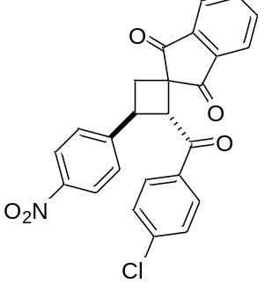 | (2RS,3SR)-2-(4-Chlorobenzoyl)-3-(4-nitrophenyl)spiro[cyclobutane-1,2'-indene]-1',3'-dione | C25H16ClNO5 | Cyclobutane 3n was obtained from cyclopropane 2l (200 mg, 0.68 mmol), 4d (220 mg, 1.02 mmol) in DCE (1.36 mL) according to General procedure A, 8 h. Yield 121 mg (40%); white solid; mp 191–192 °C; Rf=0.44. (petroleum ether – ethyl acetate, 6:1). | 468.0607. | [M+Na]+ | IR (KBr, сm-1): 3069, 2921, 2854, 1741, 1701, 1683, 1590, 1523, 1487, 1397, 1347, 1295, 1271, 1241, 1199, 1178, 1153, 1110, 1086, 1045, 1013, 1000. | -
3o | 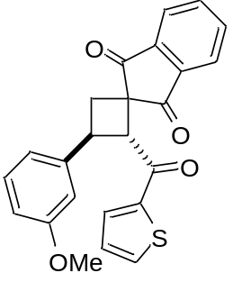 | (2RS,3SR)-3-(3-Methoxyphenyl)-2-(thiophene-2-carbonyl)spiro[cyclobutane-1,2'-indene]-1',3'-dione | C24H18O4S | Cyclobutane 3o was obtained from cyclopropane 2k (200 mg, 0.515 mmol), 4e (201 mg, 0.773 mmol) in DCE (1.5 mL) according to General procedure A, 8 h. Yield 47 mg (23%); white solid; mp 156–158 °C; Rf=0.50 (petroleum ether – ethyl acetate, 2:1). | 403.1001. | [M+H]+ | IR (KBr, сm-1): 3088, 2993, 2939, 2833, 1736, 1699, 1633, 1595, 1514, 1495, 1466, 1455, 1435, 1411, 1353, 1322, 1292, 1273, 1243, 1209, 1161, 1113, 1095, 1082, 1072, 1060, 1037. | -
3p | 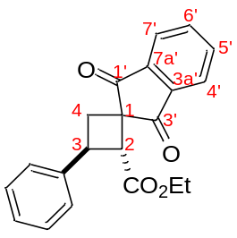 | Ethyl (2RS,3SR)-1',3'-dioxo-3-phenyl-1',3'-dihydrospiro(cyclobutane-1,2'-indene)-2-carboxylate | C21H18O4 | Cyclobutane 3p was obtained from cyclopropane 1a (130 mg, 0.5 mmol), 4g (116 mg, 0.8 mmol) in DCM (1 mL) according to General procedure B, 6 h. Yield 150 mg (85%); light-yellow solid; mp 86–89 °C; Rf=0.38 (petroleum ether – ethyl acetate, 5:1). | 335.1284. | [M+H]+ | IR (film, сm-1): 3087, 3073, 3027, 2984, 2933, 2909, 2871, 2851, 1743, 1740, 1704, 1598, 1498, 1470, 1446, 1374, 1359, 1352, 1332, 1311, 1290, 1267, 1226, 1210, 1187, 1180, 1155, 1119, 1111, 1092, 1075, 1050, 1036, 1016. | C, 75.12; H, 5.41.
3q | 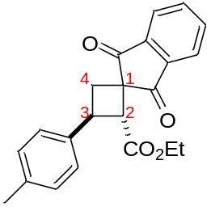 | Ethyl (2RS,3SR)-1',3'-dioxo-3-(p-tolyl)-1',3'-dihydrospiro[cyclobutane-1,2'-indene]-2-carboxylate | C22H20O4 | Cyclobutane 3q was obtained from cyclopropane 1b (236 mg, 1.0 mmol), 4g (200 mg, 1.3 mmol) in DCE (1.8 mL) according to General procedure B, 4 h. Yield 266 mg (76%); yellowish oil; Rf=0.37 (petroleum ether – ethyl acetate, 4:1). | 349.1437. | [M+H]+ | IR (film, сm-1): 2981, 2937, 1737, 1704, 1597, 1516, 1465, 1445, 1371, 1352, 1330, 1303, 1269, 1240, 1217, 1188, 1152, 1114, 1096, 1077, 1045, 1019. | -
3r | 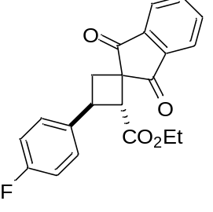 | Ethyl (2RS,3SR)-1',3'-dioxo-3-(4-fluorophenyl)-1',3'-dihydrospiro[cyclobutane-1,2'-indene]-2-carboxylate | C21H17FO4 | Cyclobutane 3r was obtained from cyclopropane 1d (200 mg, 0.8 mmol), 4g (167 mg, 1.1 mmol) in DCM (1.5 mL) according to General procedure B, 4 h. Yield 209 mg (79%); yellowish solid; mp 80–81 °C; Rf=0.33 (petroleum ether – ethyl acetate, 5:1). | 353.1175. | [M+H]+ | IR (KBr, сm-1): 3076, 3053, 2977, 2936, 2905, 2872, 1739, 1701, 1597, 1510, 1467, 1446, 1411, 1372, 1357, 1332, 1321, 1290, 1269, 1217, 1186, 1159, 1119, 1100, 1085, 1049, 1013. | - | 19F{1H} NMR (CDCl3, 376 MHz): –115.8
3s | 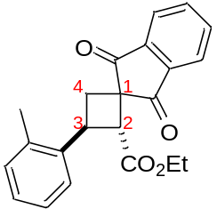 | Ethyl (2RS,3SR)-1',3'-dioxo-3-(o-tolyl)-1',3'-dihydrospiro[cyclobutane-1,2'-indene]-2-carboxylate | C22H20O4 | Cyclobutane 3s was obtained from cyclopropane 1c (200 mg, 0.8 mmol), 4g (170 mg, 1.1 mmol) in DCM (1.5 mL) according to General procedure B, 4 h. Yield 220 mg (82%); white solid; mp 136–137°C; Rf=0.38 (petroleum ether – ethyl acetate, 4:1). | 349.1439. | [M+H]+ | IR (KBr, сm-1): 2989, 2975, 2937, 1730, 1702, 1597, 1494, 1463, 1453, 1389, 1373, 1351, 1331, 1315, 1293, 1284, 1267, 1227, 1195, 1151, 1123, 1097, 1049, 1034, 1007. | C, 75.81; H, 5.53.
3t | 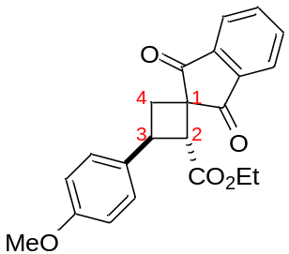 | Ethyl (2RS,3SR)-1',3'-dioxo-3-(4-methoxyphenyl)-1',3'-dihydrospiro[cyclobutane-1,2'-indene]-2-carboxylate | C22H20O5 | Cyclobutane 3t was obtained from cyclopropane 1f (200 mg, 0.72 mmol), 4g (160 mg, 1.1 mmol) in DCM (1.5 mL) according to General procedure B, 4 h. Yield 158 mg (60%); white solid; m.p. 102–104 °C; Rf=0.45 (petroleum ether – ethyl acetate, 3:1). | 365.1389. | [M+H]+ | IR (KBr, сm-1): 3076, 3016, 2978, 2963, 2935, 2914, 2897, 2849, 2837, 1741, 1703, 1610, 1597, 1514, 1462, 1373, 1350, 1331, 1317, 1295, 1284, 1271, 1243, 1230, 1211, 1201, 1176, 1149, 1118, 1098, 1071, 1031, 1018. | -
3u | 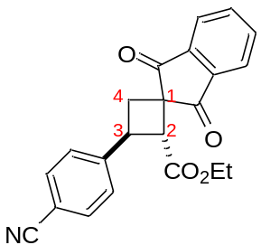 | Ethyl (2RS,3SR)-1',3'-dioxo-3-(4-cyanoxyphenyl)-1',3'-dihydrospiro[cyclobutane-1,2'-indene]-2-carboxylate | C22H17NO4 | Cyclobutane 3u was obtained from cyclopropane 1i (150 mg, 0.55 mmol), 4g (122 mg, 0.82 mmol) in DCM (1.1 mL) according to General procedure B, 16 h. An additional portion of 4g (100 mg, 0.67 mmol) was added to the reaction mixture after 9 h, and the reaction was left for another 7 h. Yield 99 mg (50%); white solid; m.p. 106–108 °C; Rf=0.32 (petroleum ether – ethyl acetate, 3:1). | 360.1233. | [M+H]+ | IR (KBr, сm-1): 2980, 2954, 2919, 2848, 2227, 1731, 1704, 1645, 1631, 1607, 1597, 1506, 1489, 1444, 1418, 1371, 1354, 1331, 1270, 1216, 1192, 1154, 1115, 1095, 1078, 1046, 1018. | -
3v | 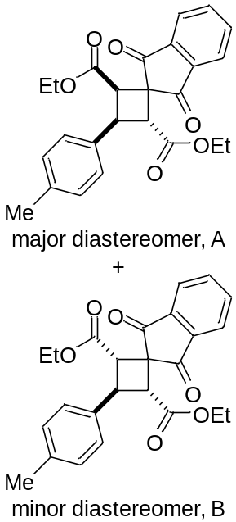 | Diethyl (2RS,3SR,4RS)- and (2RS,3SR,4SR)-1',3'-dioxo-3-(p-tolyl)-1',3'-dihydrospiro[cyclobutane-1,2'-indene]-2,4-dicarboxylate | C25H24O6 | Cyclobutane 3v was obtained according to General procedure D from alkene 1b (248 mg, 1.0 mmol), 4g (370 mg, 2.5 mmol) in DCM (2.0 mL), 8 h. The final product was purified by recrystallization from an Et2O–PE mixture (1:1). Yield 282 mg (73%); mixture of diastereomers (dr 59:41, A:B); white solid; mp 145–146 °C; Rf=0.45 (petroleum ether – ethyl acetate, 4:1). | 438.1911. | [M+NH4]+ | IR (KBr, сm-1): 2981, 2936, 2919, 2872, 1742, 1704, 1592, 1516, 1468, 1447, 1422, 1385, 1377, 1365, 1357, 1334, 1325, 1307, 1293, 1271, 1211, 1196, 1152, 1125, 1116, 1097, 1075, 1049, 1026, 1010. | - | 1H NMR (CDCl3, 600 MHz), minor diastereomer: δ 8.07–8.02 (m, 2H, CH), 7.91–7.87 (m, 2H, CH), 7.43 (d, 3J = 7.9 Hz, 2H, CH), 7.21 (d, 3J = 7.9 Hz, 2H, CH), 4.49 (t, 3J = 10.4 Hz, 1H, C(3)H), 4.07–4.02 (m, 2H, CH2CH3), 3.97–3.93 (m, 2H, CH2CH3), 3.63 (d, 3J = 10.3 Hz, 2H, C(2)H+C(4)H), 2.37 (s, 3H, CH3), 0.98 (t, 3J = 7.1 Hz, 6H, 2 × CH2CH3).  13C{1H} NMR (CDCl3, 150 MHz), minor diastereomer: δ 199.6 (C=O), 198.7 (C=O), 170.0 (2 × C=O), 143.4 (C), 141.6 (C), 137.7 (C), 137.0 (C), 136.1 (CH), 135.7 (CH), 129.4 (2 × CH), 127.0 (2 × CH), 123.9 (CH), 123.0 (CH), 61.2 (2 × CH2CH3), 55.9 (C(1)), 46.6 (C(2)H+C(4)H), 41.0 (C(3)H), 21.2 (CH3), 13.9 (2 × CH2CH3).
3w | 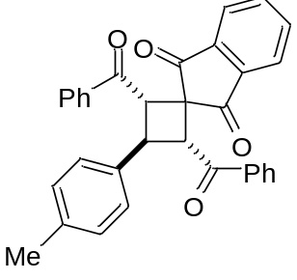 | (2RS,3SR,4SR)-2,4-Dibenzoyl-3-phenylspiro[cyclobutane-1,2'-indene]-1',3'-dione | C33H24O4 | Cyclobutane 3w was obtained according to General procedure D from alkene 1b (248 mg, 1.0 mmol), 4a (450 mg, 2.5 mmol) in DCE (2.0 mL). An additional portion of 4a (90 mg, 0.5 mmol) was added to the reaction mixture after 6 h, and the reaction was left for another 6 h. The final product was purified by recrystallization from ethanol. Yield 315 mg (65%), diastereoisomeric mixture 95:5; white solid; mp 244–245 °C; Rf=0.40 (petroleum ether – ethyl acetate, 3:1). The compound is poorly soluble in DMSO, methanol, and acetonitrile; it has limited solubility in CHCl3 and is soluble in DCM and DCE. | 485.1747. | [M+H]+ | IR (KBr, сm-1): 3060, 2918, 1698, 1667, 1597, 1447, 1271, 1241, 975, 931, 817, 755, 736, 720. | -
5 | 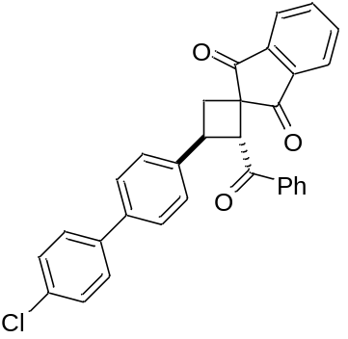 | (2RS,3SR) 2-benzoyl-3-[4'-chloro-(1,1'-biphenyl)- 4-yl]spiro(cyclobutane-1,2'-indene)-1',3'-dione | C31H21ClO3 | A 4 mL vial was charged with (4-chlorophenyl)boronic acid (56 mg, 0.36 mmol), cyclobutane 3e (134 mg, 0.30 mmol), Na2CO3 (95 mg, 0.90 mmol), dioxane (300 μL) and water (300 μL). Then Pd(dppf)Cl2 (4.4 mg, 6 μmol) was added under a stream of Ar. The resulting reaction mixture was placed in a preheated oil bath (100 °C), stirred for 5 h, poured into cold water (10 ml), and extracted with DCM (3 × 7 ml). Combined organic fractions were dried with Na2SO4 and concentrated in vacuo. Dark brown residue was purified by flash column chromatography on silica (petroleum ether – ethyl acetate, 10:1 → 5:1) to obtain pure 5. Yield 56 mg (39%); white solid; mp = 159–161 °C; Rf = 0.26 (petroleum ether – ethyl acetate, 5 : 1). | 477.1253. | [M+H]+ | IR (KBr, сm-1): 2949, 2917, 1702, 1686, 1595, 1484, 1270, 1235, 1093, 994, 914, 813, 760, 729. | -
6 | 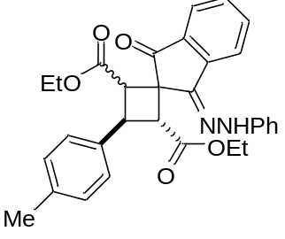 | diethyl (2RS,3SR,E)-1'-oxo-3'-(2-phenylhydrazineylidene)-3- (p-tolyl)-1',3'-dihydrospiro[cyclobutane-1,2'-indene]-2,4-dicarboxylate | C31H30N2O5 | To a solution of cyclobutane 3v (163 mg, 0.39 mmol) in absolute ethanol (1.3 ml), phenylhydrazine (46 mg, 0.43 mmol) and acetic acid (8 mg, 0.13 mmol) were added. The reaction mixture was refluxed under an argon atmosphere for 4 h. Then the reaction mixture was diluted with DCM, concentrated in vacuo, washed with cold ethyl acetate and dried in vacuo yielding 178 mg (90%) of a yellow solid product as a mixture of two pairs of diastereoisomers (62:38). Subsequent recrystallization from methanol led to the predominant precipitation of one pair of diastereoisomers (88:12); m.p = 223–226 °C; Rf=0.40 and 0.19 (petroleum ether – ethyl acetate 4:1). | 511.2230. | [M+H]+ | IR (KBr, сm-1): 3354, 3047, 3018, 2975, 2929, 2902, 2869, 1722, 1705, 1616, 1601, 1587, 1506, 1497, 1488, 1472, 1444, 1432, 1392, 1380, 1367, 1340, 1321, 1299, 1275, 1250, 1239, 1201, 1174, 1167, 1133, 1095, 1083, 1063, 1050, 1034, 1024. | -

[AUTO SI: REACTION SCHEMA]
Reaction schema
Reagents | equiv. | MW, g/mol | Density, g/ml | Concentration, M
Reagent_1 | 1
[AUTO SI: SCOPE]

Compound scope
Reagent_1 | Mass of Reagent_1, mg | Product | Product_number | Mass of product, mg
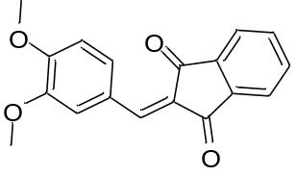 | 1000 |  | 2g | 715
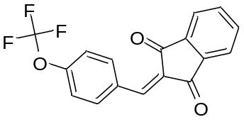 | 1000 |  | 2h | 400
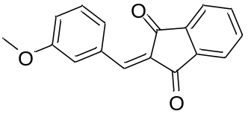 | 1000 |  | 2k | 582
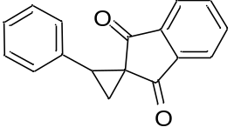 | 230 |  | 3a | 278
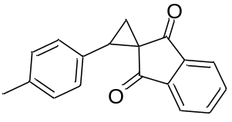 | 300 |  | 3b | 370
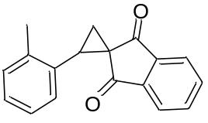 | 150 |  | 3c | 189
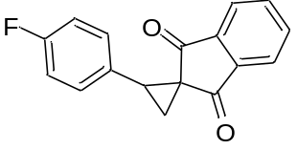 | 200 |  | 3d | 231
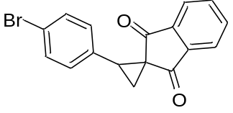 | 150 |  | 3e | 155
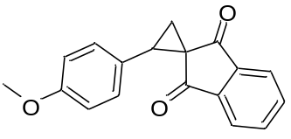 | 200 |  | 3f | 205
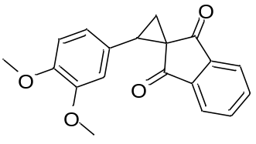 | 235 |  | 3g | 245
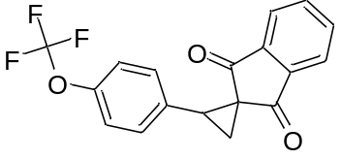 | 200 |  | 3h | 217
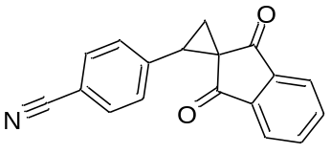 | 304 |  | 3i | 357
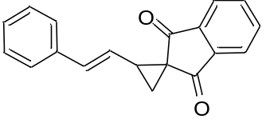 | 213 |  | 3j | 35
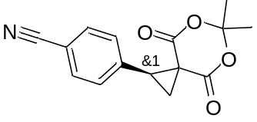 | 271 |  | 3k | 239
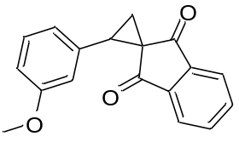 | 180 |  | 3l | 232
 | 200 |  | 3m | 175
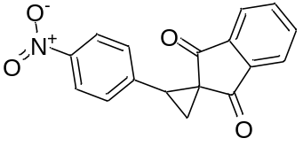 | 200 |  | 3n | 121
 | 200 |  | 3o | 47
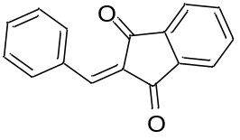 | 130 |  | 3p | 150
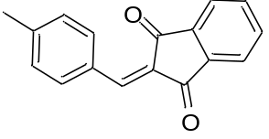 | 236 |  | 3q | 266
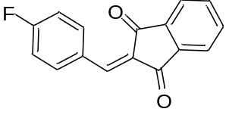 | 200 |  | 3r | 209
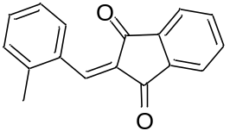 | 200 |  | 3s | 220
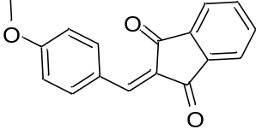 | 200 |  | 3t | 158
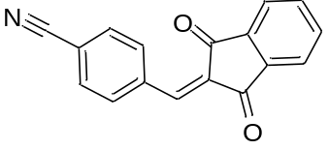 | 150 |  | 3u | 99
 | 248 | 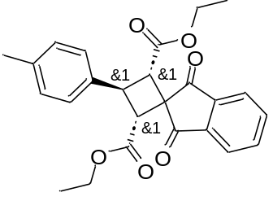 | 3v | 282
 | 248 |  | 3w | 315
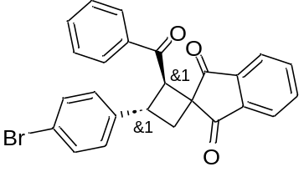 | 134 |  | 5 | 56
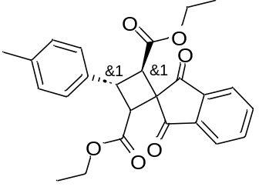 | 163 |  | 6 | 178

[AUTO SI: SI TEMPLATE]
{Product.name} ({Product.number})
{Product.structure}
{Product.preparation}
[{nmr.1h.label}] ({nmr.1h.conditions}) δ = {nmr.1h.peaks}.
[{nmr.13c.label}] ({nmr.13c.conditions}) δ = {nmr.13c.peaks}.
{nmr.extra}
[{hrms.label}]: {hrms.adduct} calcd for {hrms.formula} {hrms.calculated}. Found {hrms.found}.
[{anal.label}] Calcd for {anal.formula}: {anal.calculated}. Found: {anal.found}.
[{ir.label}] ({ir.method}, cm-1): {ir.peaks}.
{Product.support.warning}

{Product.name} ({Product.number})
[{spectrum.label}] ({spectrum.conditions})
{Product.structure}
{Product.nmr.1h.picture}

{Product.name} ({Product.number})
[{spectrum.label}] ({spectrum.conditions})
{Product.structure}
{Product.nmr.13c.picture}
[AUTO SI: CRYSTALLOGRAPHY TEMPLATE]
{Product.name} ({Product.number})
{Crystal.description}
{Crystal.table}
{Crystal.geometry}
[AUTO SI: END]

