Auto Support Generator - all-in-one input
Edit the tables and template below. Keep the section labels unchanged. Reaction schema, Scope, SI template and Crystallography template are optional.
[AUTO SI: COMPOUND TABLE]
number | structure | color | mp | R_{f} | HRMS
3a | 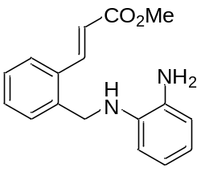 | white solid | 82 | 0.38 (petroleum ether : ethyl acetate = 7 : 1) | -
3b | 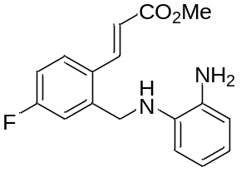 | white solid | 84 | 0.63 (petroleum ether : ethyl acetate = 7 : 1) | 272.9923
3c | 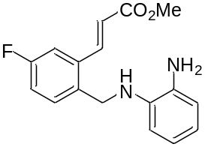 | white solid | 85 | 0.56 (petroleum ether : ethyl acetate = 7 : 1) | 272.9921
3d | 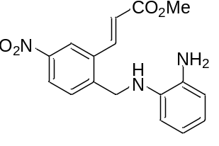 | white solid | 97 | 0.48 (petroleum ether : ethyl acetate = 7 : 1) | 299.9866
3i | 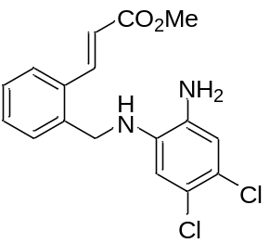 | Green oil | 98 | 0.55 (petroleum ether : ethyl acetate = 7 : 1) | 332.9115

[AUTO SI: REACTION SCHEMA]
Reagents | equiv. | MW, g/mol | Density, g/ml | Concentration, M
Reagent 1 | 1
Reagent 2 | 3
K₂CO₃ | 1 | 138.21
Solvent_MeCN |  |  |  | 0.75
AcOH | 5 | 60.05 | 1.049

[AUTO SI: SCOPE]
Reagent_1 | Mass of reagent 1, mg | Reagent_2 | Product | Product_number | Mass of product, mg
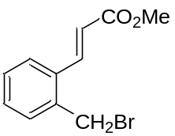 | 400 | 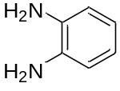 |  | 3a | 304
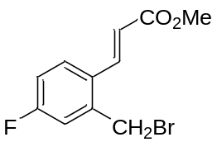 | 200 |  |  | 3b | 173
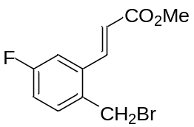 | 200 |  |  | 3c | 176
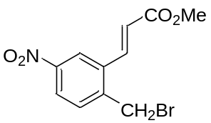 | 88 |  |  | 3d | 83
 | 200 | 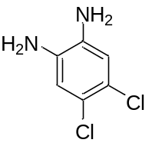 |  | 3i | 217

[AUTO SI: SI TEMPLATE]
{Product.name} ({Product.number})
{Product.structure}
{Product.preparation}
{reaction.loadings}
Alkene {Product.number} was obtained from bromide {Reagent_1.number} ({Reagent_1.mg} mg, {Reagent_1.mmol} mmol), {Reagent_2.name} ({Reagent_2.mg} mg, {Reagent_2.mmol} mmol), K₂CO₃ ({K2CO3.mg} mg, {K2CO3.mmol} mmol), AcOH ({AcOH.mcl} µL, {AcOH.mmol} mmol) and MeCN ({Solvent_MeCN.ml} mL) according to GP2. Yield {Product.mg} mg ({Product.yield.percent}); {Product.appearance}; mp {Product.mp} °C. R_{f} = {Product.rf.value} ({Product.rf.system}).
[{nmr.1h.label}] ({nmr.1h.conditions}) δ = {nmr.1h.peaks}.
[{nmr.13c.label}] ({nmr.13c.conditions}) δ = {nmr.13c.peaks}.
{nmr.extra}
[{hrms.label}]: {hrms.adduct} calcd for {hrms.formula} {hrms.calculated}. Found {hrms.found}.
[{anal.label}] Calcd for {anal.formula}: {anal.calculated}. Found: {anal.found}.
[{ir.label}] ({ir.method}, cm-1): {ir.peaks}.
{Product.support.warning}

{Product.name} ({Product.number})
[{spectrum.label}] ({spectrum.conditions})
{Product.structure}
{Product.nmr.1h.picture}

{Product.name} ({Product.number})
[{spectrum.label}] ({spectrum.conditions})
{Product.structure}
{Product.nmr.13c.picture}
[AUTO SI: END]

