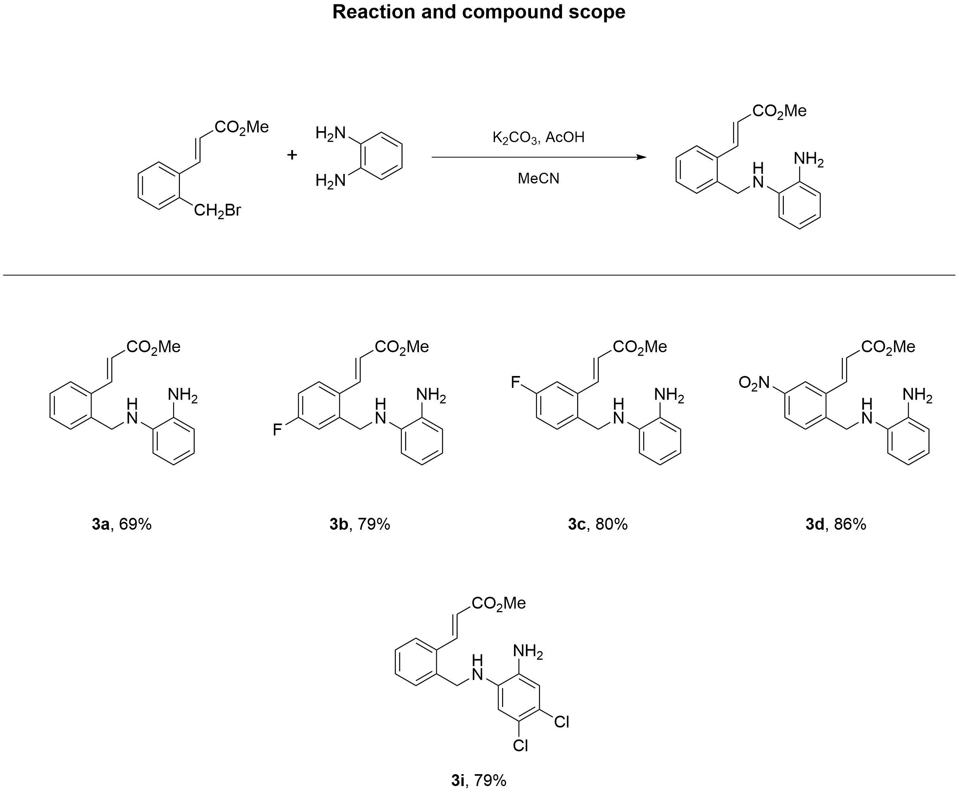

Methyl (E)-3-(2-(((2-aminophenyl)amino)methyl)phenyl)acrylate (3a)
Alkene 3a was obtained from bromide 2a (400 mg, 1.57 mmol), benzene-1,2-diamine (509 mg, 4.7 mmol), K₂CO₃ (217 mg, 1.57 mmol), AcOH (449 µL, 7.84 mmol) and MeCN (2.09 mL) according to GP2. Yield 304 mg (69%); white solid; mp 82 °C. R_{f} = 0.38 (petroleum ether : ethyl acetate = 7 : 1).
¹H NMR (CDCl₃, 600 MHz) δ = 8.13 (d, J = 15.8 Hz, 1H), 7.63 (dd, J = 1.8, 7.3 Hz, 1H), 7.42 (dd, J = 1.8, 7.3 Hz, 1H), 7.36 (dtd, J = 1.7, 7.3, 16.0 Hz, 3H), 6.84 (ddd, J = 3.7, 5.5, 8.2 Hz, 1H), 6.78 - 6.72 (m, 2H), 6.69 (d, J = 7.8 Hz, 1H), 6.44 (d, J = 15.9 Hz, 1H), 4.40 (s, 2H), 3.80 (s, 4H).
¹³C NMR (CDCl₃, 150 MHz) δ = 167.2, 141.7, 138.2, 137.3, 134.5, 133.4, 130.2, 129.4, 127.9, 126.8, 120.5, 119.7, 119.1, 116.5, 112.2, 51.7, 46.4.
Anal. Calcd for C₁₇H₁₈N₂O₂: C, 72.32; H, 6.43; N, 9.92.
(Support check: H expected 18, found 17)

Methyl (E)-3-(2-(((2-aminophenyl)amino)methyl)-4-fluorophenyl)acrylate (3b)
Alkene 3b was obtained from bromide 2b (200 mg, 0.73 mmol), benzene-1,2-diamine (238 mg, 2.2 mmol), K₂CO₃ (101 mg, 0.73 mmol), AcOH (210 µL, 3.66 mmol) and MeCN (0.98 mL) according to GP2. Yield 173 mg (79%); white solid; mp 84 °C. R_{f} = 0.63 (petroleum ether : ethyl acetate = 7 : 1).
¹H NMR (CDCl₃, 600 MHz) δ = 8.01 (d, J = 15.8 Hz, 1H), 7.58 (dd, J = 5.6, 8.7 Hz, 1H), 7.16 (dd, J = 2.7, 9.6 Hz, 1H), 7.00 (td, J = 2.7, 8.3 Hz, 1H), 6.80 (td, J = 2.0, 7.3 Hz, 1H), 6.78 - 6.70 (m, 2H), 6.57 (dd, J = 1.3, 7.8 Hz, 1H), 6.35 (d, J = 15.8 Hz, 1H), 4.39 (s, 2H), 3.79 (s, 4H).
¹³C NMR (CDCl₃, 150 MHz) δ = 167.2, 164.8, 163.1, 141.3, 141.2, 140.5, 137.0, 134.5, 129.3, 129.0, 128.9, 120.7, 119.5, 119.5, 116.8, 115.8, 115.7, 114.9, 114.8, 112.3, 51.8, 46.0.
HRMS (ESI/Q-TOF) m/z: [M+H]⁺ calcd for C₁₇H₁₈FN₂O₂⁺ 301.1347. Found 272.9923.
Anal. Calcd for C₁₇H₁₇FN₂O₂: C, 67.99; H, 5.71; N, 9.33.
(Support check: H expected 17, found 15; HRMS calcd 301.1347, found 272.9923 (error 93454.5 ppm; limit 5 ppm))

Methyl (E)-3-(2-(((2-aminophenyl)amino)methyl)-5-fluorophenyl)acrylate (3c)
Alkene 3c was obtained from bromide 2c (200 mg, 0.73 mmol), benzene-1,2-diamine (238 mg, 2.2 mmol), K₂CO₃ (101 mg, 0.73 mmol), AcOH (210 µL, 3.66 mmol) and MeCN (0.98 mL) according to GP2. Yield 176 mg (80%); white solid; mp 85 °C. R_{f} = 0.56 (petroleum ether : ethyl acetate = 7 : 1).
¹H NMR (CDCl₃, 600 MHz) δ = 8.04 (dd, J = 1.5, 15.8 Hz, 1H), 7.40 (dd, J = 5.7, 8.5 Hz, 1H), 7.32 (dd, J = 2.7, 9.7 Hz, 1H), 7.07 (td, J = 2.7, 8.3 Hz, 1H), 6.79 - 6.72 (m, 2H), 6.67 (d, J = 7.7 Hz, 1H), 6.41 (d, J = 15.8 Hz, 1H), 4.37 (s, 3H), 3.81 (s, 4H).
¹³C NMR (CDCl₃, 150 MHz) δ = 167.0, 163.1, 161.5, 140.7, 137.3, 135.6, 135.5, 134.7, 134.1, 131.4, 131.4, 121.0, 120.8, 120.2, 119.6, 117.2, 117.0, 116.8, 113.6, 113.4, 112.5, 52.0, 46.0.
HRMS (ESI/Q-TOF) m/z: [M+H]⁺ calcd for C₁₇H₁₈FN₂O₂⁺ 301.1347. Found 272.9921.
Anal. Calcd for C₁₇H₁₇FN₂O₂: C, 67.99; H, 5.71; N, 9.33.
(Support check: H expected 17, found 15; HRMS calcd 301.1347, found 272.9921 (error 93455.2 ppm; limit 5 ppm))

Methyl (E)-3-(2-(((2-aminophenyl)amino)methyl)-5-nitrophenyl)acrylate (3d)
Alkene 3d was obtained from bromide 2d (88 mg, 0.29 mmol), benzene-1,2-diamine (95.1 mg, 0.88 mmol), K₂CO₃ (40.5 mg, 0.29 mmol), AcOH (84 µL, 1.47 mmol) and MeCN (0.39 mL) according to GP2. Yield 83 mg (86%); white solid; mp 97 °C. R_{f} = 0.48 (petroleum ether : ethyl acetate = 7 : 1).
¹H NMR (CDCl₃, 600 MHz) δ = 8.41 (d, J = 2.4 Hz, 1H), 8.14 (dd, J = 2.3, 8.5 Hz, 1H), 8.05 (d, J = 15.8 Hz, 1H), 7.62 (d, J = 8.5 Hz, 1H), 6.80 - 6.74 (m, 3H), 6.74 - 6.67 (m, 1H), 6.55 - 6.49 (m, 2H), 4.51 (s, 2H), 3.84 (s, 4H).
¹³C NMR (CDCl₃, 150 MHz) δ = 166.4, 147.6, 145.2, 139.2, 136.6, 134.8, 134.7, 129.6, 124.2, 122.8, 121.8, 120.8, 120.0, 117.2, 112.7, 51.9, 46.1.
HRMS (ESI/Q-TOF) m/z: [M+H]⁺ calcd for C₁₇H₁₈N₃O₄⁺ 328.1292. Found 299.9866.
Anal. Calcd for C₁₇H₁₇N₃O₄: C, 62.38; H, 5.23; N, 12.84.
(Support check: H expected 17, found 16; HRMS calcd 328.1292, found 299.9866 (error 85766.8 ppm; limit 5 ppm))

Methyl (E)-3-(2-(((2-amino-4,5-dichlorophenyl)amino)methyl)phenyl)acrylate (3i)
Alkene 3i was obtained from bromide 2i (200 mg, 0.78 mmol), 4,5-dichlorobenzene-1,2-diamine (416 mg, 2.35 mmol), K₂CO₃ (108 mg, 0.78 mmol), AcOH (224 µL, 3.92 mmol) and MeCN (1.05 mL) according to GP2. Yield 217 mg (79%); Green oil; mp 98 °C. R_{f} = 0.55 (petroleum ether : ethyl acetate = 7 : 1).
¹H NMR (CDCl₃, 600 MHz) δ = 8.01 (d, J = 15.8 Hz, 1H), 7.62 (d, J = 7.0 Hz, 1H), 7.41 - 7.31 (m, J = 2.4 Hz, 3H), 6.76 (s, 1H), 6.68 (s, 1H), 6.39 (d, J = 15.9 Hz, 1H), 4.35 - 4.31 (m, 2H), 3.78 (s, 3H), 3.35 (s, 1H).
¹³C NMR (CDCl₃, 150 MHz) δ = 167.1, 141.4, 137.0, 136.9, 134.1, 133.6, 130.2, 129.5, 128.3, 127.0, 122.9, 121.2, 119.9, 117.3, 113.1, 51.7, 46.4.
HRMS (ESI/Q-TOF) m/z: [M+H]⁺ calcd for C₁₇H₁₇³⁵Cl₂N₂O₂⁺ 351.0662. Found 332.9115.
Anal. Calcd for C₁₇H₁₆Cl₂N₂O₂: C, 58.14; H, 4.59; N, 7.98.
(Support check: H expected 16, found 14; HRMS calcd 351.0662, found 332.9115 (error 51713.0 ppm; limit 5 ppm))

Methyl (E)-3-(2-(((2-aminophenyl)amino)methyl)phenyl)acrylate (3a)
¹H NMR (CDCl₃, 600 MHz)
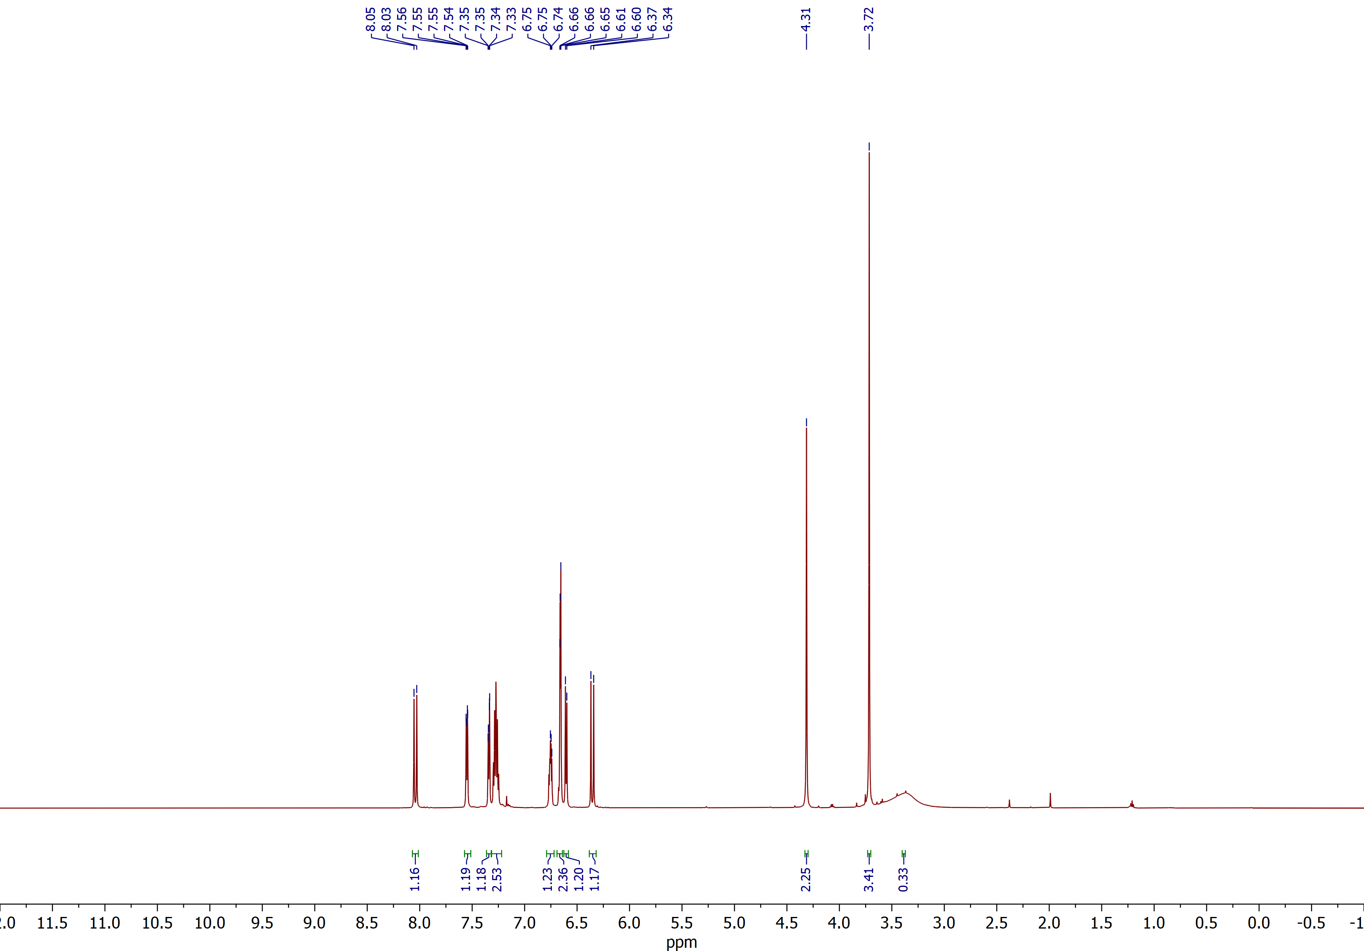

Methyl (E)-3-(2-(((2-aminophenyl)amino)methyl)phenyl)acrylate (3a)
¹³C NMR (CDCl₃, 150 MHz)
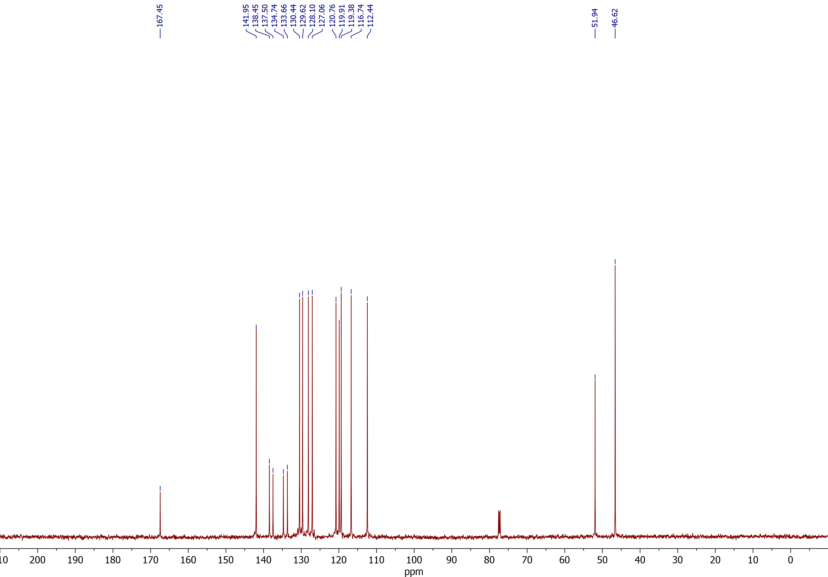

Methyl (E)-3-(2-(((2-aminophenyl)amino)methyl)-4-fluorophenyl)acrylate (3b)
¹H NMR (CDCl₃, 600 MHz)
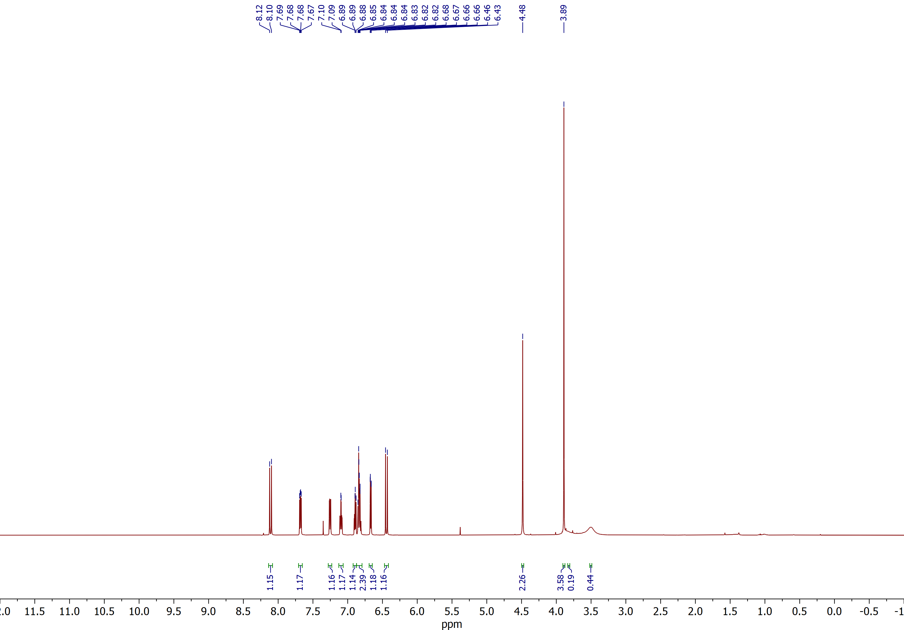

Methyl (E)-3-(2-(((2-aminophenyl)amino)methyl)-4-fluorophenyl)acrylate (3b)
¹³C NMR (CDCl₃, 150 MHz)
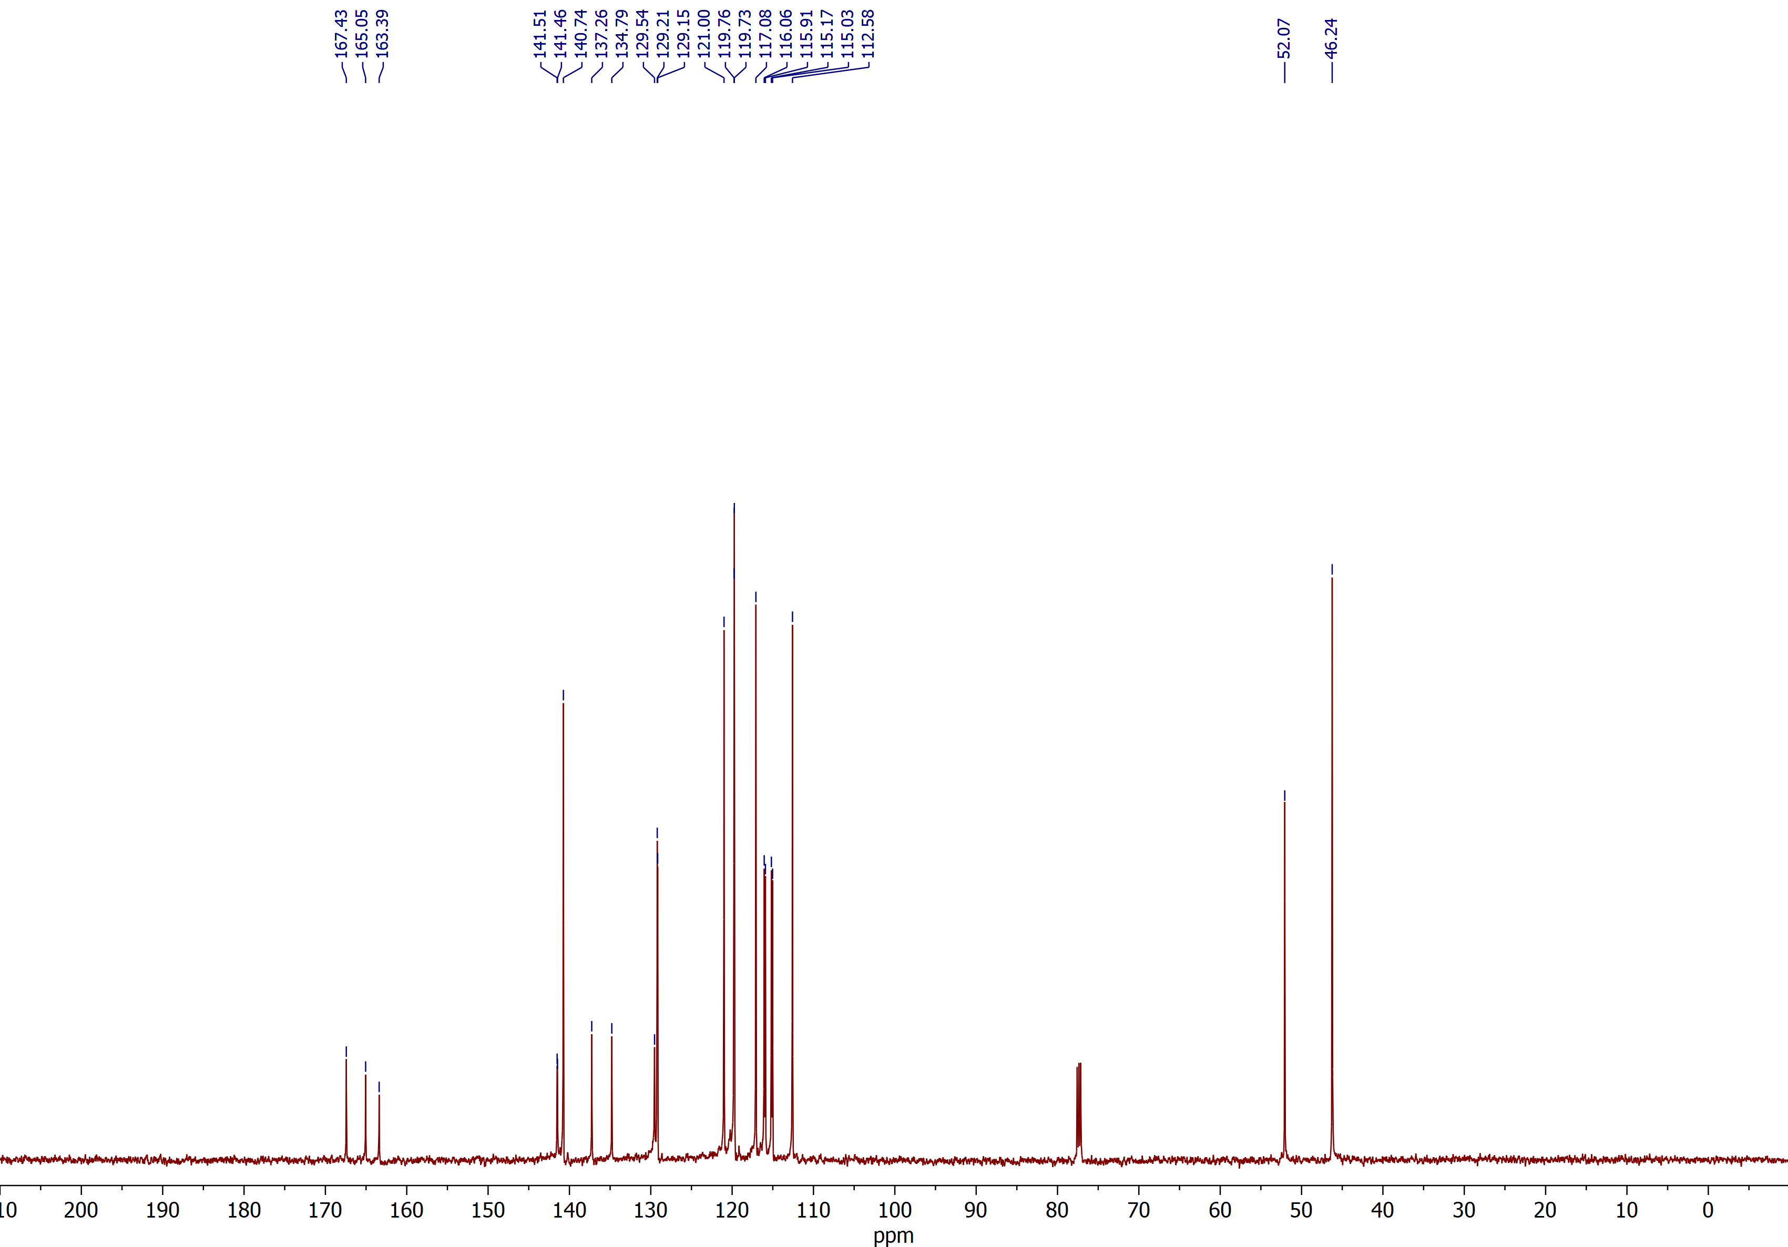

Methyl (E)-3-(2-(((2-aminophenyl)amino)methyl)-5-fluorophenyl)acrylate (3c)
¹H NMR (CDCl₃, 600 MHz)
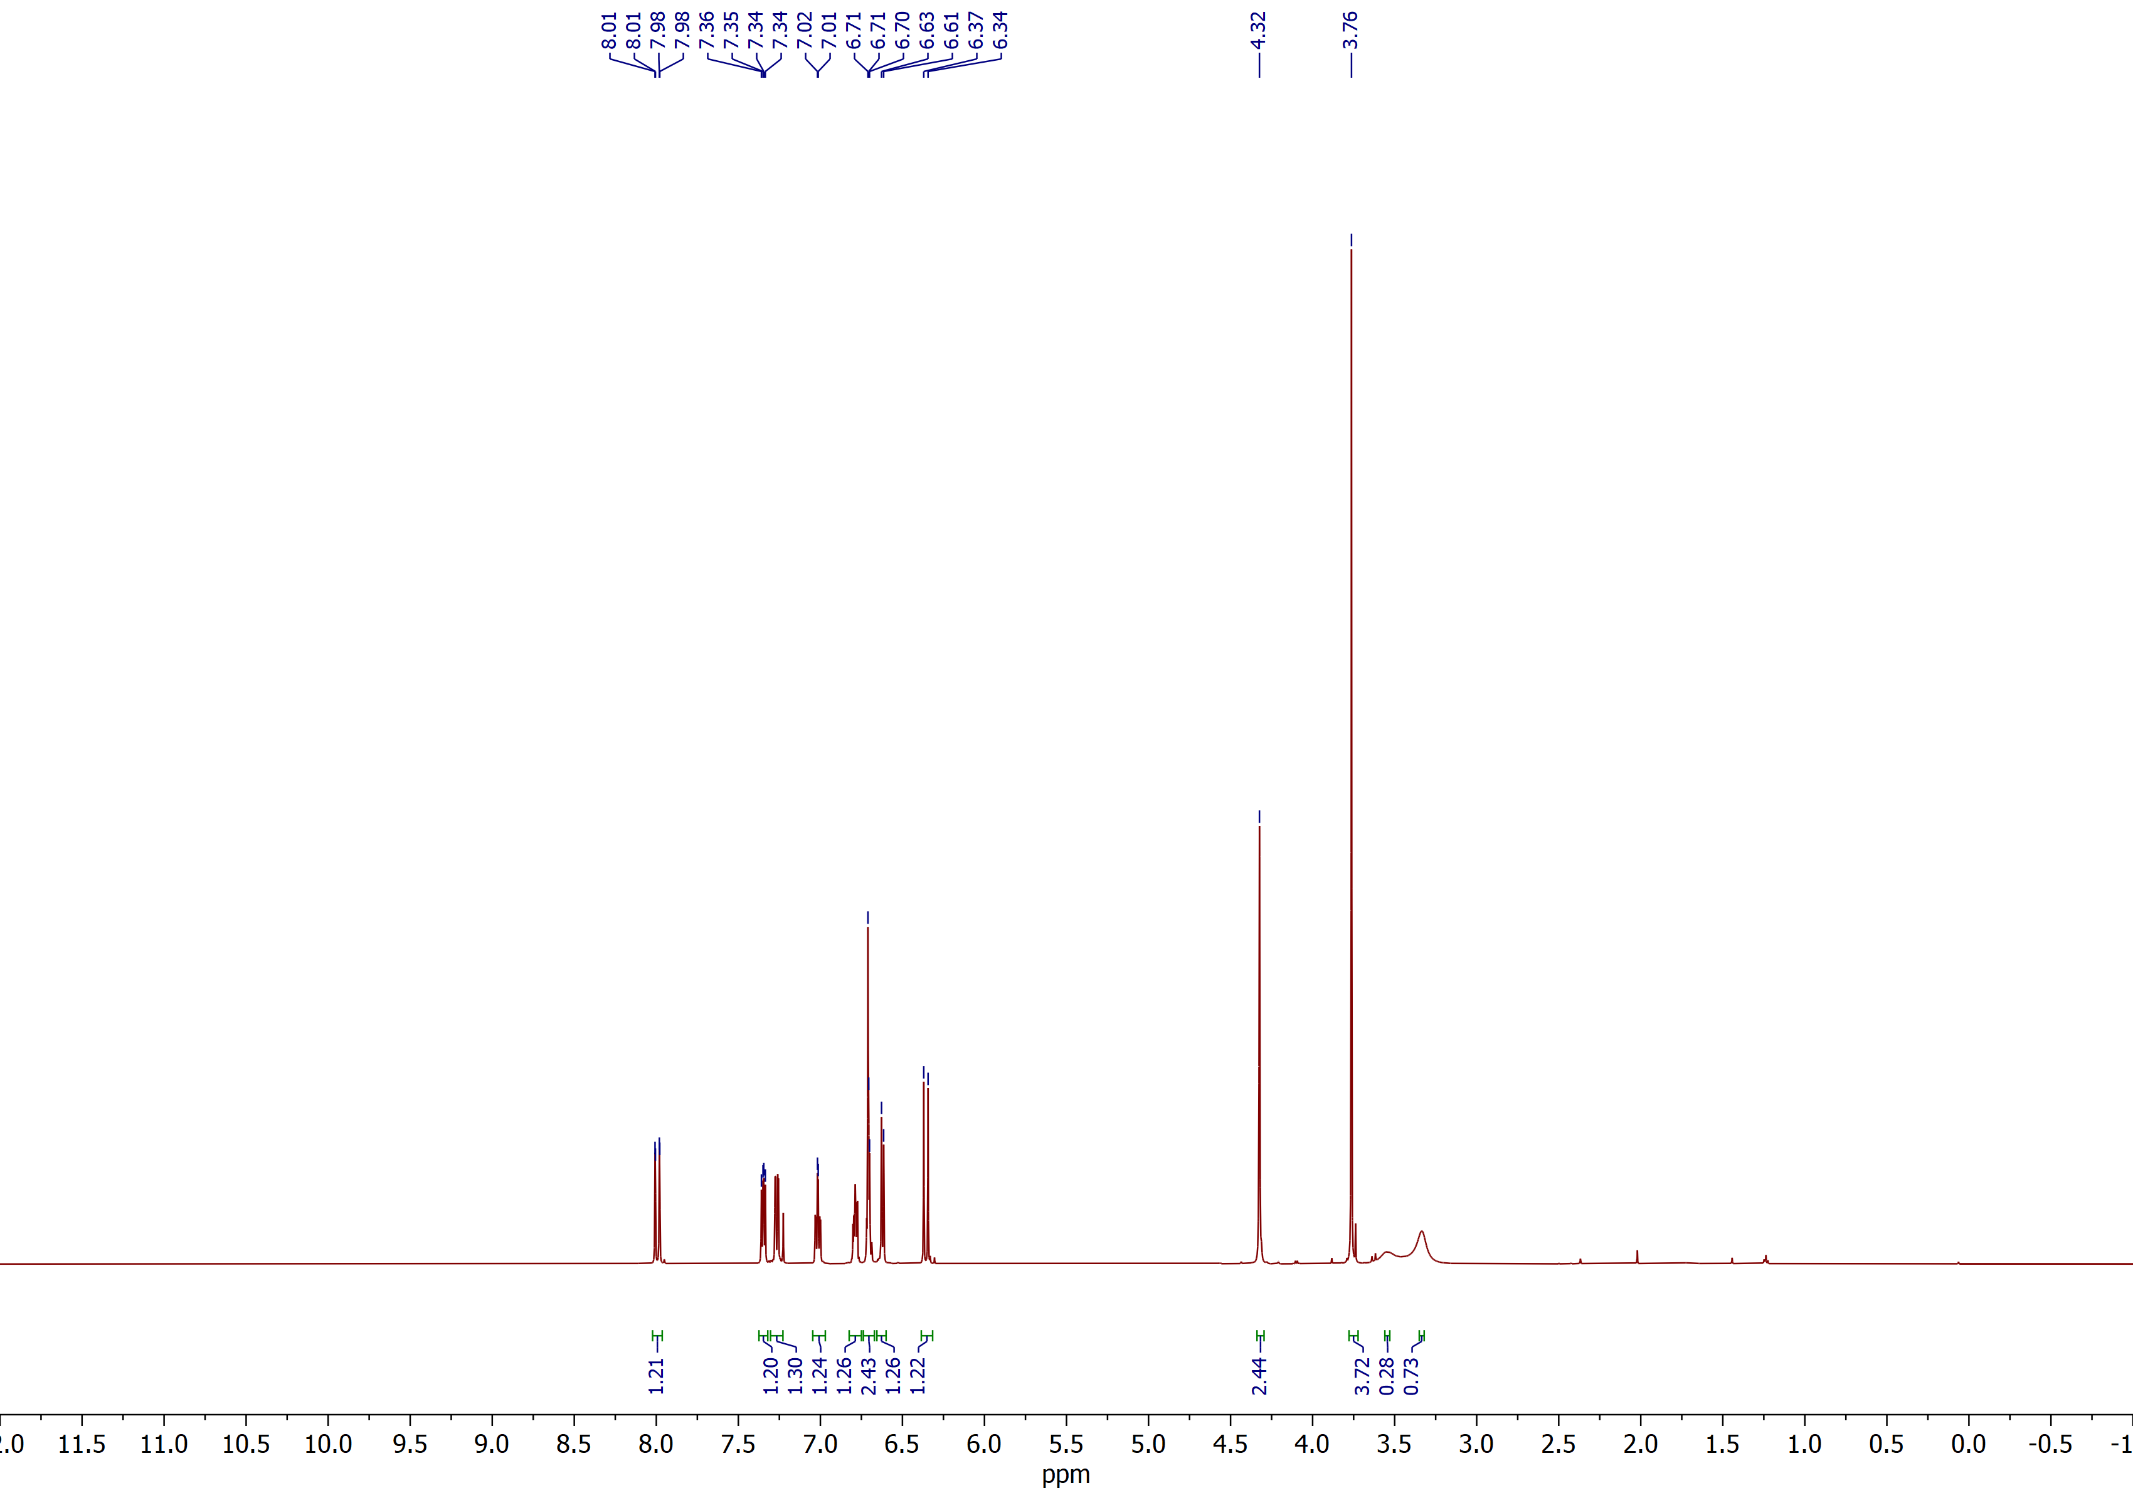

Methyl (E)-3-(2-(((2-aminophenyl)amino)methyl)-5-fluorophenyl)acrylate (3c)
¹³C NMR (CDCl₃, 150 MHz)
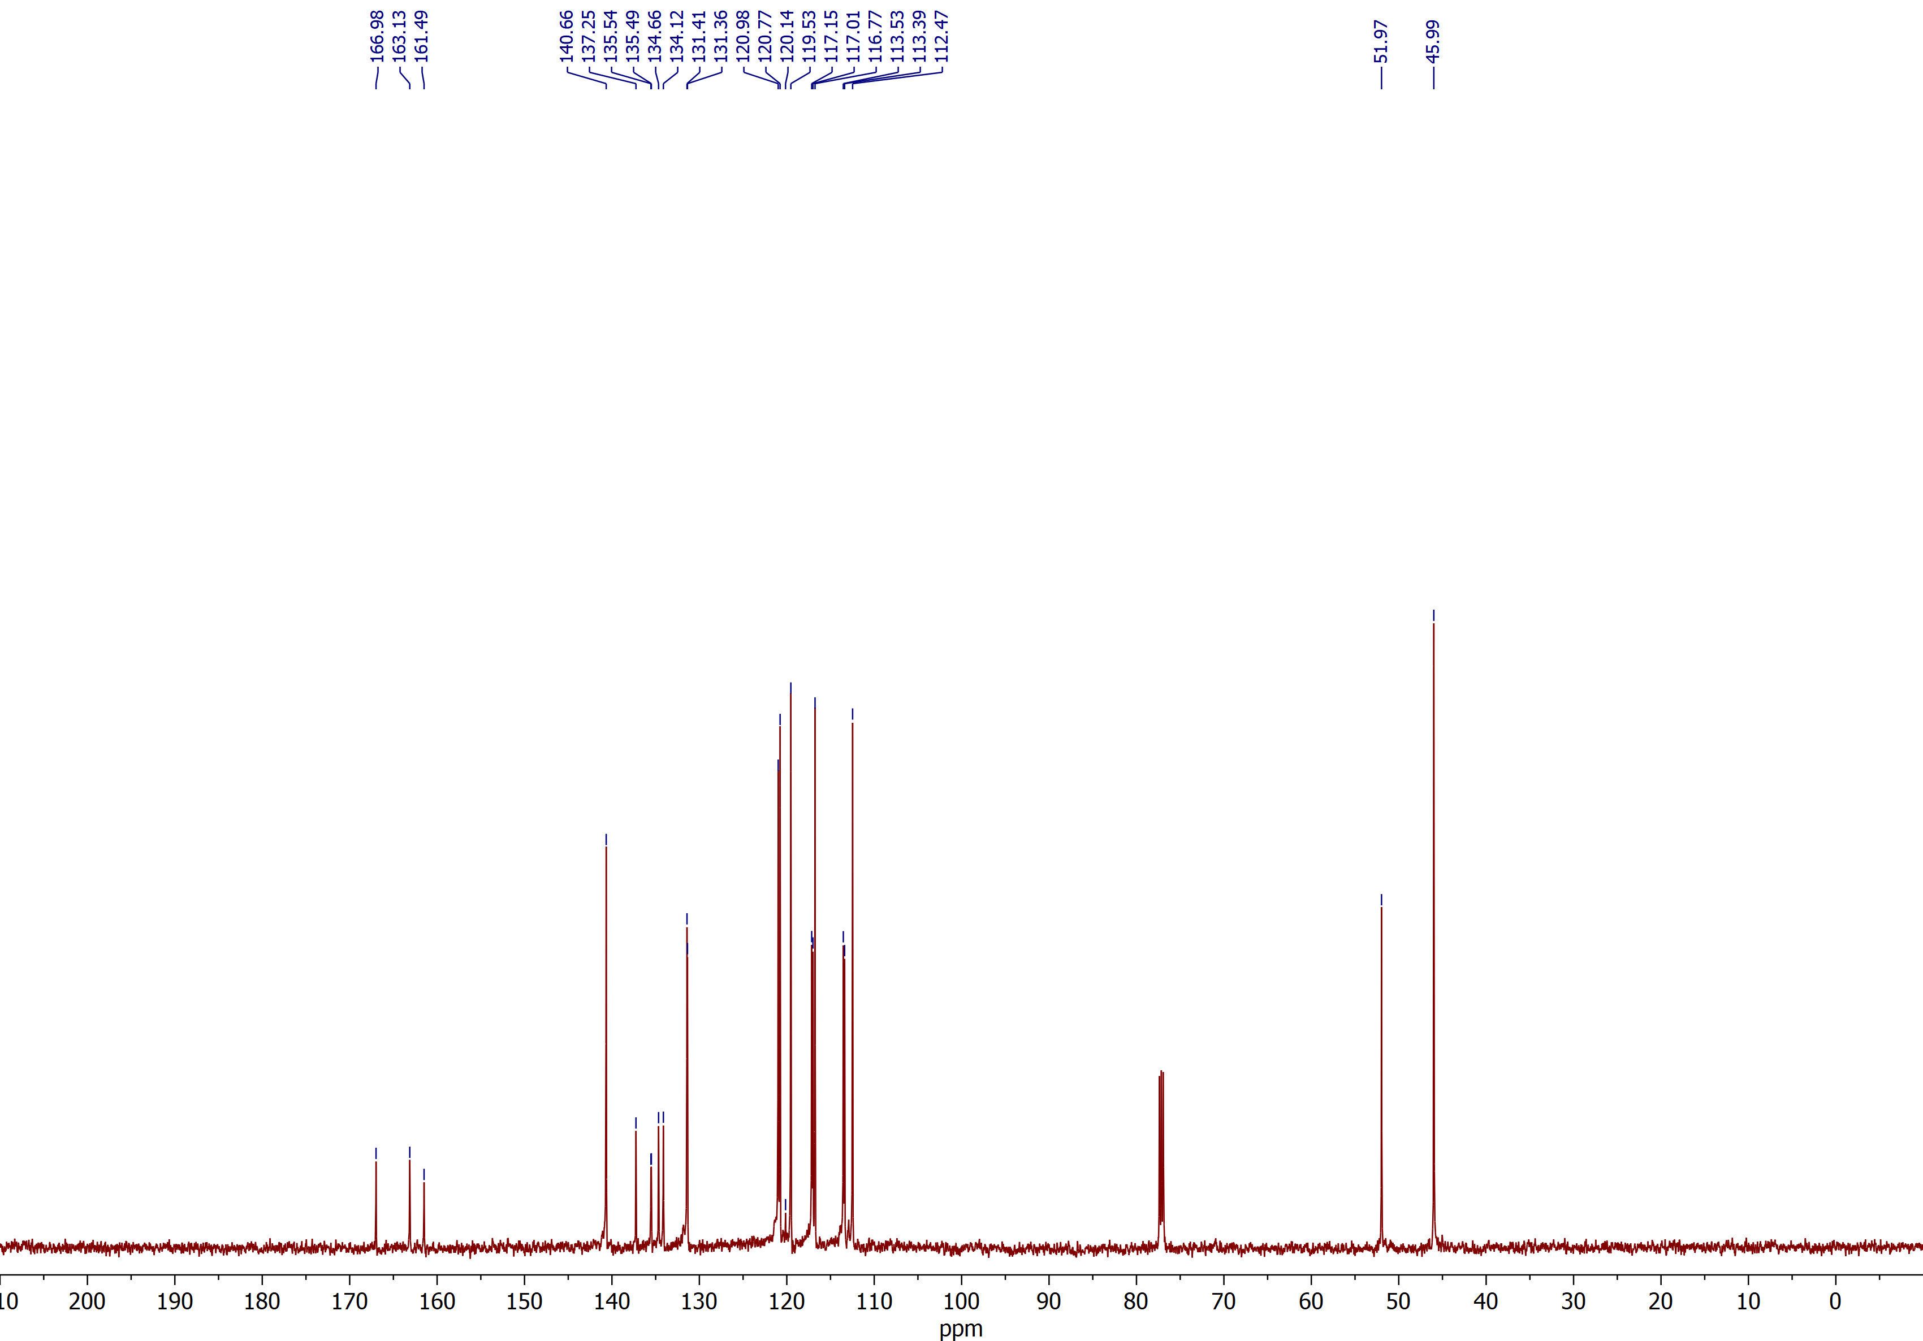

Methyl (E)-3-(2-(((2-aminophenyl)amino)methyl)-5-nitrophenyl)acrylate (3d)
¹H NMR (CDCl₃, 600 MHz)
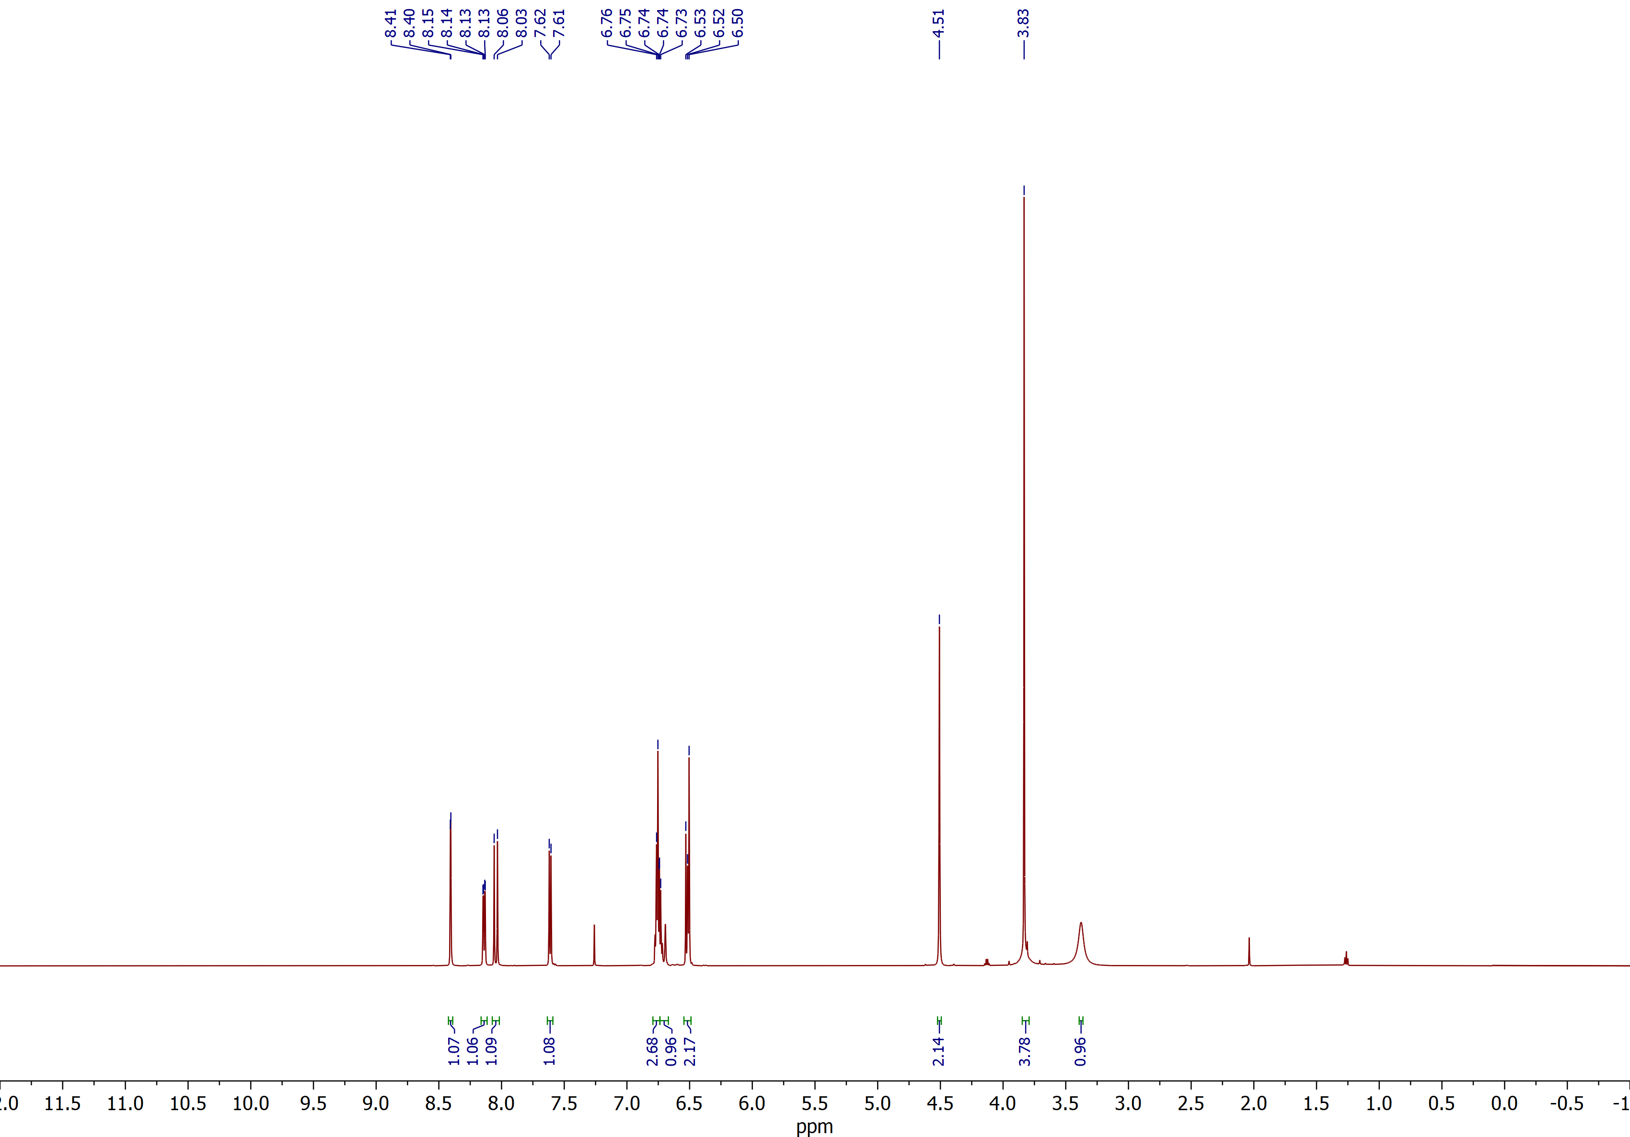

Methyl (E)-3-(2-(((2-aminophenyl)amino)methyl)-5-nitrophenyl)acrylate (3d)
¹³C NMR (CDCl₃, 150 MHz)
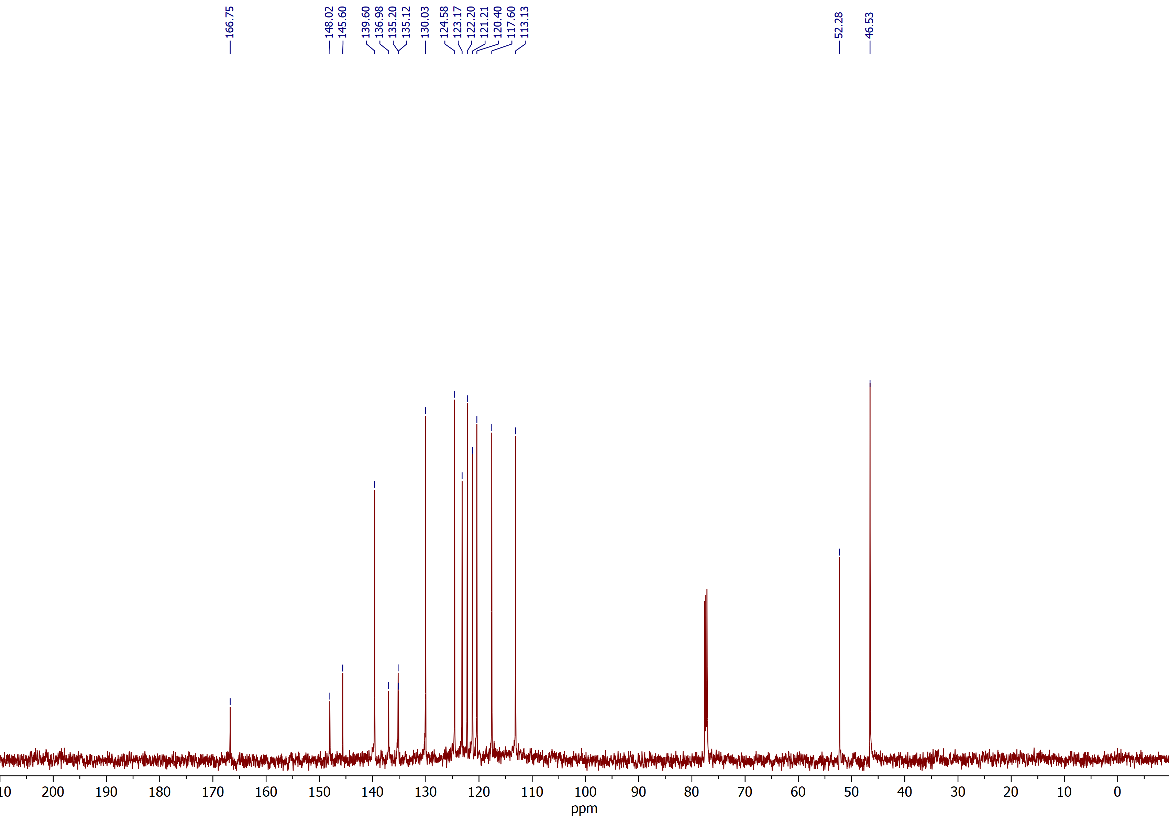

Methyl (E)-3-(2-(((2-amino-4,5-dichlorophenyl)amino)methyl)phenyl)acrylate (3i)
¹H NMR (CDCl₃, 600 MHz)
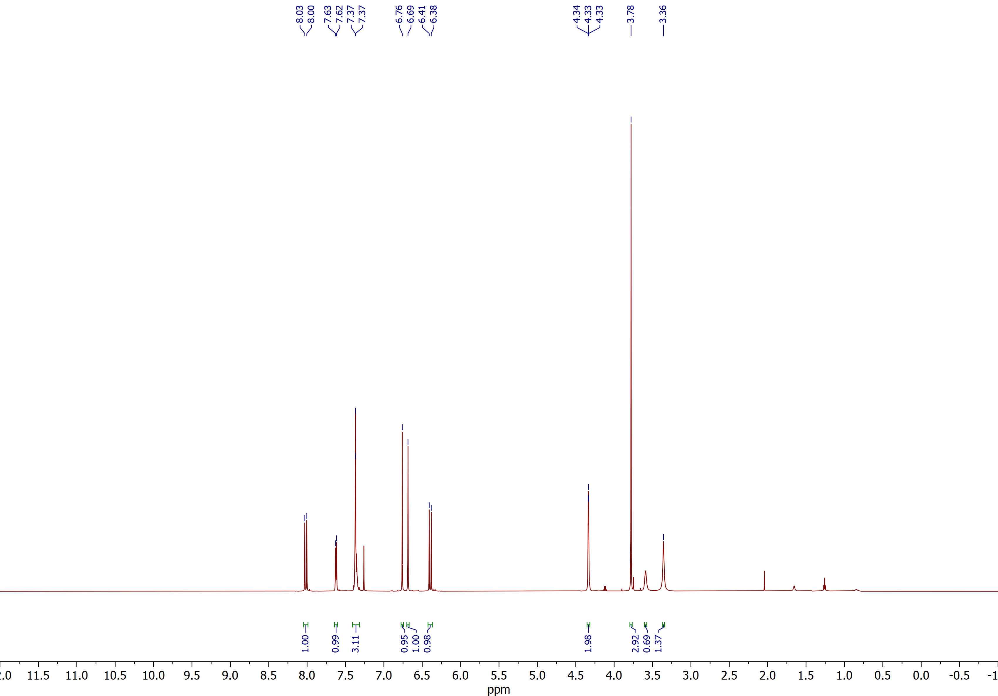

Methyl (E)-3-(2-(((2-amino-4,5-dichlorophenyl)amino)methyl)phenyl)acrylate (3i)
¹³C NMR (CDCl₃, 150 MHz)
