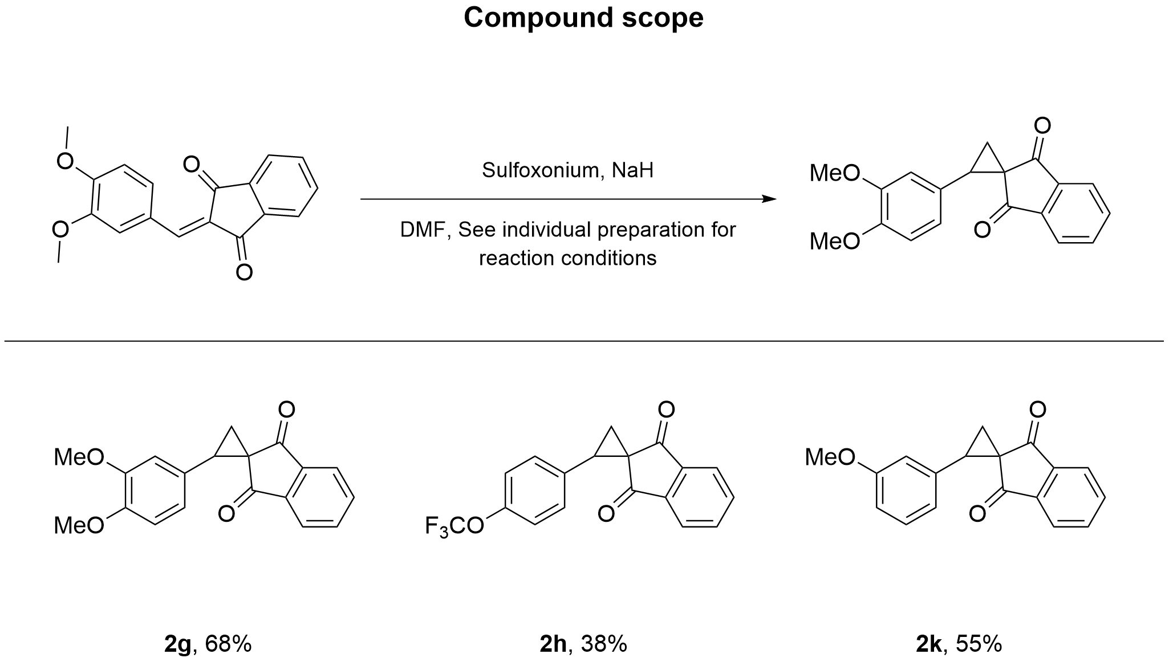

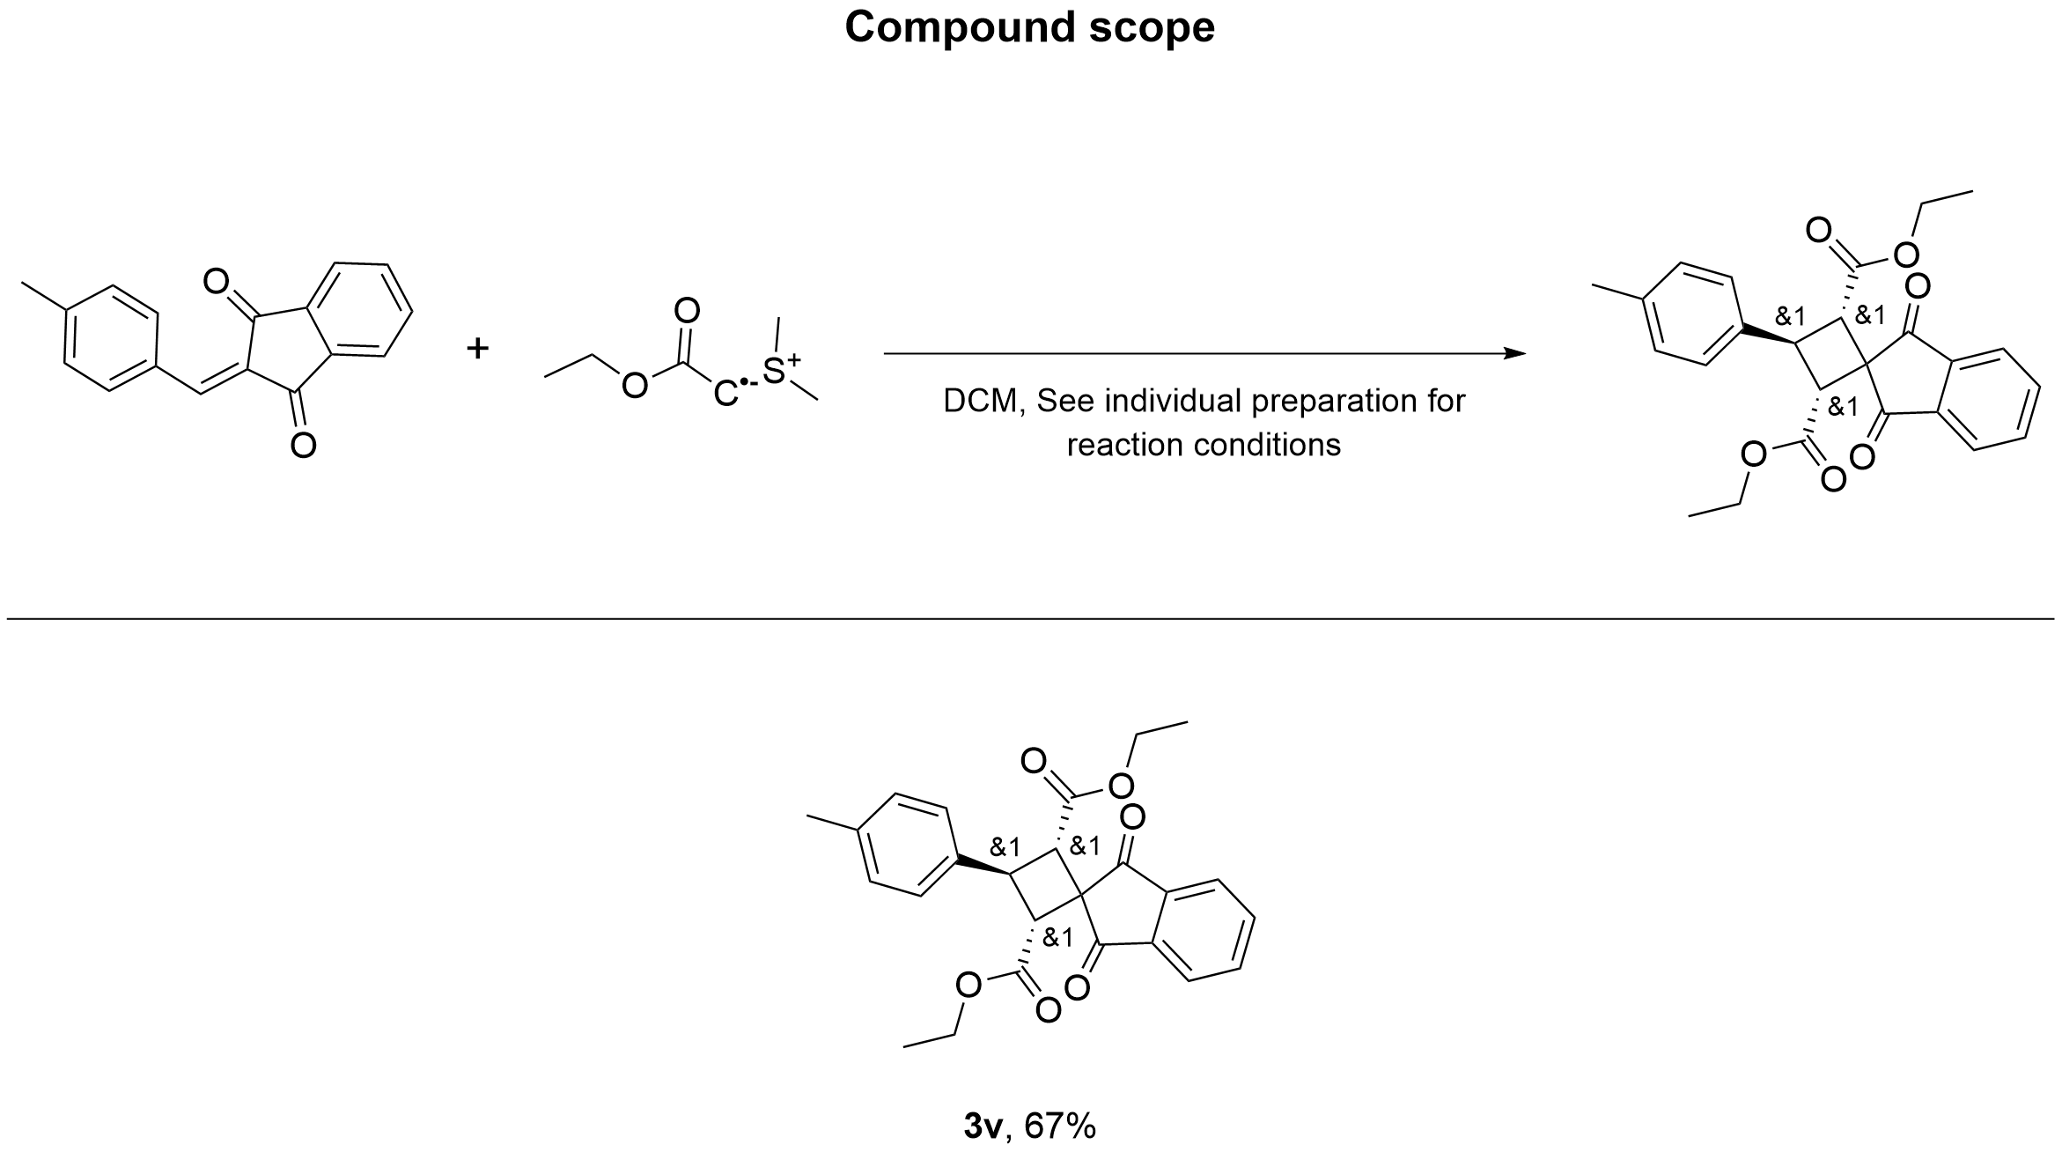

2-(3,4-Dimethoxyphenyl)spiro[cyclopropane-1,2'-indene]-1',3'-dione (2g)
¹H NMR (CDCl₃, 600 MHz) δ = 7.97 - 7.92 (m, 1H), 7.82 - 7.76 (m, 1H), 7.76 - 7.70 (m, 2H), 6.86 (dd, J = 2.1, 8.2 Hz, 1H), 6.82 - 6.76 (m, 2H), 3.83 (d, J = 1.2 Hz, 6H), 3.39 (t, J = 9.0 Hz, 1H), 2.44 (dd, J = 4.3, 8.8 Hz, 1H), 2.29 (dd, J = 4.3, 9.1 Hz, 1H).
¹³C NMR (CDCl₃, 150 MHz) δ = 198.2, 196.0, 148.8, 148.6, 142.8, 141.7, 134.9, 134.7, 126.1, 122.5, 121.6, 112.4, 110.7, 56.0, 55.9, 43.2, 41.8, 22.7.
HRMS (ESI/Q-TOF) m/z: [M+H]⁺ calcd for C₁₉H₁₇O₄⁺ 309.1121. Found 309.1123.
(Support check: C expected 19, found 18)

2-(4-(Trifluoromethoxy)phenyl)spiro[cyclopropane-1,2'-indene]-1',3'-dione (2h)
¹H NMR (CDCl₃, 600 MHz) δ = 7.98 (dd, J = 1.2, 7.5 Hz, 1H), 7.85 - 7.74 (m, 3H), 7.35 - 7.30 (m, 2H), 7.16 - 7.12 (m, 2H), 3.40 (t, J = 8.9 Hz, 1H), 2.42 (ddd, J = 1.3, 4.4, 8.7 Hz, 1H), 2.31 (ddd, J = 1.3, 4.5, 9.1 Hz, 1H).
¹³C NMR (CDCl₃, 150 MHz) δ = 197.7, 195.6, 148.5, 142.5, 141.5, 134.9, 134.7, 132.2, 130.5, 122.5, 120.4, 42.3, 39.7, 22.2.
HRMS (ESI/Q-TOF) m/z: [M+H]⁺ calcd for C₁₈H₁₂F₃O₃⁺ 333.0733. Found 333.0737.
(Support check: C signals expected 16 after phenyl-ring symmetry correction (18 C atoms in formula), found 14)

2-(3-Methoxyphenyl)spiro[cyclopropane-1,2'-indene]-1',3'-dione (2k)
¹H NMR (CDCl₃, 600 MHz) δ = 7.96 (dt, J = 1.0, 7.6 Hz, 1H), 7.83 - 7.71 (m, 3H), 7.21 (t, J = 7.9 Hz, 1H), 6.90 - 6.77 (m, 3H), 3.77 (s, 3H), 3.41 (t, J = 8.9 Hz, 1H), 2.45 (dd, J = 4.3, 8.8 Hz, 1H), 2.28 (dd, J = 4.3, 9.1 Hz, 1H).
¹³C NMR (CDCl₃, 150 MHz) δ = 198.3, 195.8, 159.4, 142.8, 141.7, 135.3, 135.0, 134.7, 129.2, 122.6, 122.6, 121.7, 115.2, 113.3, 55.3, 42.8, 41.2, 22.4.
HRMS (ESI/Q-TOF) m/z: [M+H]⁺ calcd for C₁₈H₁₅O₃⁺ 279.1016. Found 279.1018.

(2R,3S)-2-benzoyl-3-phenylspiro[cyclobutane-1,2'-indene]-1',3'-dione (3a)
¹H NMR (CDCl₃, 600 MHz) δ = 8.02 - 7.91 (m, 2H), 7.84 - 7.77 (m, 2H), 7.52 - 7.47 (m, 2H), 7.43 - 7.36 (m, 4H), 7.35 - 7.28 (m, 2H), 7.09 (t, J = 7.8 Hz, 2H), 4.57 (d, J = 10.1 Hz, 1H), 4.32 (q, J = 9.8 Hz, 1H), 2.72 (t, J = 10.5 Hz, 1H), 2.61 (dd, J = 8.9, 10.9 Hz, 1H).
¹³C NMR (CDCl₃, 150 MHz) δ = 201.8, 201.1, 197.3, 142.9, 142.4, 141.1, 136.0, 135.5, 134.8, 133.3, 129.0, 128.5, 128.4, 127.8, 127.6, 123.4, 123.3, 57.3, 53.1, 38.6, 32.6.
HRMS (ESI/Q-TOF) m/z: [M+H]⁺ calcd for C₂₅H₁₉O₃⁺ 367.1329. Found 367.1332.

(2R,3S)-2-benzoyl-3-(p-tolyl)spiro[cyclobutane-1,2'-indene]-1',3'-dione (3b)
¹H NMR (CDCl₃, 600 MHz) δ = 8.03 - 7.93 (m, 2H), 7.82 (td, J = 3.4, 5.9 Hz, 2H), 7.40 (dd, J = 6.2, 7.9 Hz, 4H), 7.33 (t, J = 7.4 Hz, 1H), 7.22 (d, J = 7.7 Hz, 2H), 7.11 (t, J = 7.7 Hz, 2H), 4.56 (d, J = 10.1 Hz, 1H), 4.28 (q, J = 9.7 Hz, 1H), 2.69 (t, J = 10.5 Hz, 1H), 2.59 (dd, J = 8.9, 10.8 Hz, 1H), 2.39 (s, 3H).
¹³C NMR (CDCl₃, 150 MHz) δ = 201.9, 201.1, 197.4, 142.9, 141.1, 139.4, 137.2, 136.0, 135.5, 134.8, 133.7, 133.3, 129.6, 129.0, 128.8, 128.6, 128.3, 127.7, 123.3, 123.3, 57.6, 53.1, 38.4, 36.5, 32.7, 21.3.
HRMS (ESI/Q-TOF) m/z: [M+H]⁺ calcd for C₂₆H₂₁O₃⁺ 381.1485. Found 381.1481.
Anal. Calcd for C₂₆H₂₀O₃: C, 82.08; H, 5.30. Found: C, 81.93; H, 5.22.
(Support check: C signals expected 22 after phenyl-ring symmetry correction (26 C atoms in formula), found 26)

(2R,3S)-2-benzoyl-3-(o-tolyl)spiro[cyclobutane-1,2'-indene]-1',3'-dione (3c)
¹H NMR (CDCl₃, 600 MHz) δ = 8.02 - 7.92 (m, 2H), 7.85 - 7.78 (m, 3H), 7.40 (t, J = 7.2 Hz, 3H), 7.33 (t, J = 7.4 Hz, 1H), 7.22 (t, J = 7.4 Hz, 1H), 7.15 - 7.08 (m, 3H), 4.64 (d, J = 10.2 Hz, 1H), 4.54 (q, J = 9.7 Hz, 1H), 2.70 - 2.59 (m, 2H), 2.16 (s, 3H).
¹³C NMR (CDCl₃, 150 MHz) δ = 201.7, 201.0, 197.3, 142.7, 140.9, 140.3, 136.7, 135.8, 135.3, 134.7, 133.1, 130.2, 128.4, 128.2, 128.1, 127.1, 126.8, 126.2, 123.2, 123.1, 57.1, 52.9, 34.0, 32.8, 29.6, 19.6.
HRMS (ESI/Q-TOF) m/z: [M+H]⁺ calcd for C₂₆H₂₁O₃⁺ 381.1485. Found 381.1483.
(Support check: C signals expected 24 after phenyl-ring symmetry correction (26 C atoms in formula), found 26)
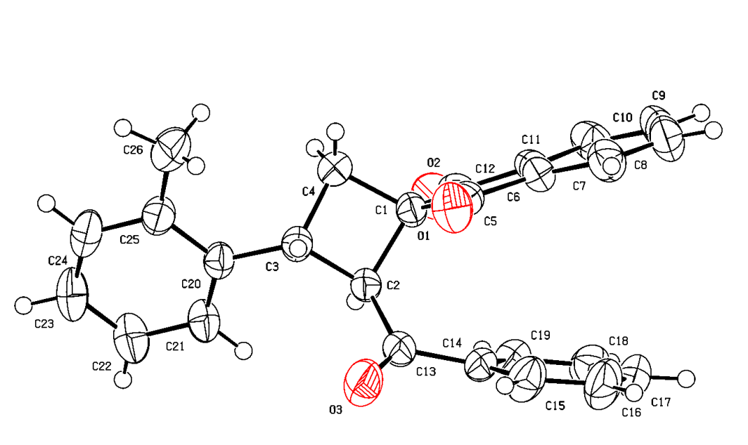
Crystal structure of 3c. ORTEP drawing with thermal ellipsoids at the 50% probability level. Deposition: 2383313.

(2R,3S)-2-benzoyl-3-(4-fluorophenyl)spiro[cyclobutane-1,2'-indene]-1',3'-dione (3d)
¹H NMR (CDCl₃, 400 MHz) δ = 8.02 - 7.94 (m, 1H), 7.94 - 7.87 (m, 1H), 7.80 (dd, J = 3.1, 5.7 Hz, 2H), 7.50 - 7.41 (m, 2H), 7.41 - 7.35 (m, 2H), 7.35 - 7.27 (m, 1H), 7.10 (q, J = 8.5 Hz, 4H), 4.50 (d, J = 10.1 Hz, 1H), 4.31 (q, J = 9.7 Hz, 1H), 2.72 - 2.55 (m, 2H).
¹³C NMR (CDCl₃, 150 MHz) δ = 201.3, 200.8, 197.0, 162.8, 142.6, 140.9, 138.0, 135.9, 135.4, 134.6, 133.2, 129.2, 129.1, 128.2, 123.2, 123.1, 115.6, 115.5, 57.1, 52.9, 37.5, 32.5.
HRMS (ESI/Q-TOF) m/z: [M+H]⁺ calcd for C₂₅H₁₈FO₃⁺ 385.1234. Found 385.1235.

(2R,3S)-2-benzoyl-3-(4-bromophenyl)spiro[cyclobutane-1,2'-indene]-1',3'-dione (3e)
¹H NMR (CDCl₃, 600 MHz) δ = 8.01 - 7.95 (m, 1H), 7.93 - 7.87 (m, 1H), 7.83 - 7.76 (m, 2H), 7.52 (d, J = 8.0 Hz, 2H), 7.37 (dd, J = 7.9, 12.9 Hz, 4H), 7.34 - 7.29 (m, 1H), 7.11 (t, J = 7.8 Hz, 2H), 4.49 (d, J = 10.0 Hz, 1H), 4.30 (q, J = 9.7 Hz, 1H), 2.66 (t, J = 10.5 Hz, 1H), 2.60 (dd, J = 8.9, 11.0 Hz, 1H).
¹³C NMR (CDCl₃, 150 MHz) δ = 201.2, 200.7, 196.9, 142.5, 141.2, 140.9, 135.9, 135.4, 134.6, 133.2, 131.8, 129.3, 128.3, 128.2, 123.2, 123.1, 121.1, 56.5, 53.0, 37.4, 32.2.
HRMS (ESI/Q-TOF) m/z: [M+H]⁺ calcd for C₂₅H₁₈⁷⁹BrO₃⁺ 445.0434. Found 445.0431.
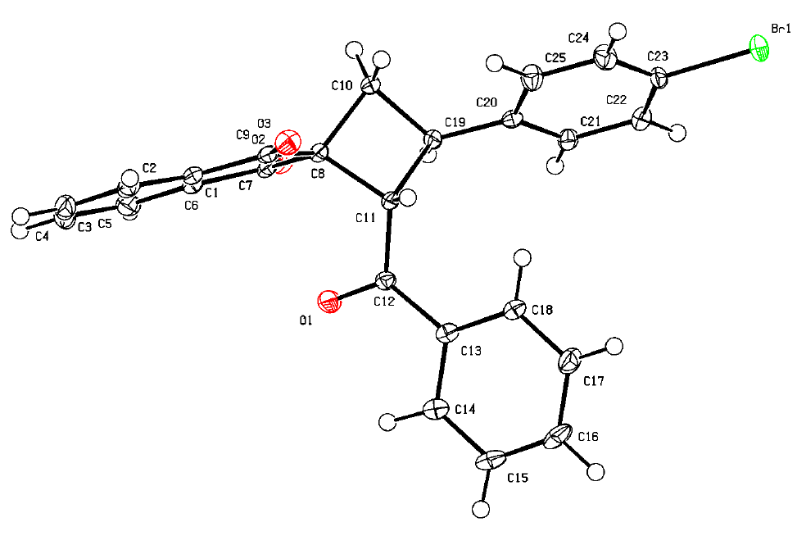
Crystal structure of 3e. ORTEP drawing with thermal ellipsoids at the 50% probability level. Deposition: 2535885.

(2R,3S)-2-benzoyl-3-(4-methoxyphenyl)spiro[cyclobutane-1,2'-indene]-1',3'-dione (3f)
¹H NMR (CDCl₃, 600 MHz) δ = 8.00 - 7.91 (m, 2H), 7.83 - 7.76 (m, 2H), 7.40 (ddd, J = 1.7, 7.5, 13.9 Hz, 4H), 7.32 (tt, J = 1.3, 7.4 Hz, 1H), 7.13 - 7.08 (m, 2H), 6.97 - 6.91 (m, 2H), 4.52 (d, J = 10.1 Hz, 1H), 4.24 (q, J = 9.8 Hz, 1H), 3.83 (s, 3H), 2.66 (t, J = 10.5 Hz, 1H), 2.58 (dd, J = 8.9, 10.9 Hz, 1H).
¹³C NMR (CDCl₃, 150 MHz) δ = 201.9, 201.0, 197.3, 159.0, 142.8, 141.0, 135.9, 135.4, 134.7, 134.4, 133.2, 128.8, 128.5, 128.2, 123.2, 123.1, 114.2, 57.9, 55.4, 52.9, 38.1, 32.7.
HRMS (ESI/Q-TOF) m/z: [M+H]⁺ calcd for C₂₆H₂₁O₄⁺ 397.1434. Found 397.1439.
Anal. Calcd for C₂₆H₂₀O₄: C, 78.77; H, 5.09. Found: C, 78.41; H, 5.08.
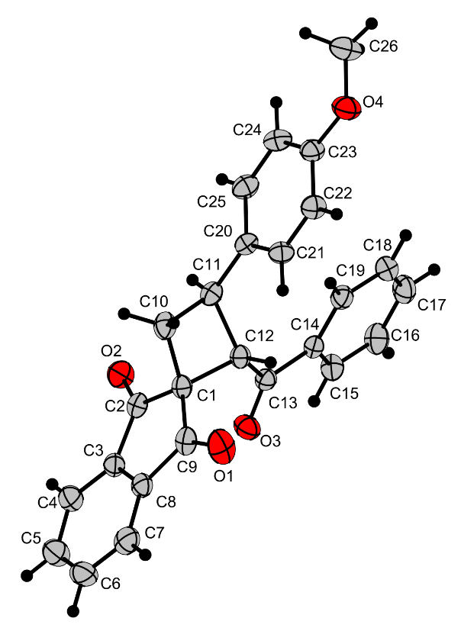
Crystal structure of 3f. ORTEP drawing with thermal ellipsoids at the 50% probability level. Deposition: 2432441.

(2R,3S)-2-benzoyl-3-(3,4-dimethoxyphenyl)spiro[cyclobutane-1,2'-indene]-1',3'-dione (3g)
¹H NMR (CDCl₃, 600 MHz) δ = 8.02 - 7.98 (m, 1H), 7.98 - 7.94 (m, 1H), 7.81 (td, J = 3.9, 6.7 Hz, 2H), 7.40 (d, J = 7.8 Hz, 2H), 7.33 (t, J = 7.3 Hz, 1H), 7.12 (t, J = 7.7 Hz, 2H), 7.06 (dd, J = 2.2, 8.2 Hz, 1H), 6.98 (d, J = 2.2 Hz, 1H), 6.92 (d, J = 8.2 Hz, 1H), 4.51 (d, J = 10.0 Hz, 1H), 4.22 (q, J = 9.7 Hz, 1H), 3.90 (d, J = 15.1 Hz, 6H), 2.68 (t, J = 10.5 Hz, 1H), 2.59 (t, J = 9.9 Hz, 1H).
¹³C NMR (CD₂Cl₂, 100 MHz) δ = 201.4, 200.6, 197.3, 148.8, 148.0, 142.2, 140.6, 135.6, 135.1, 134.5, 134.4, 132.8, 127.9, 127.8, 122.7, 122.4, 119.1, 111.2, 110.7, 56.9, 55.4, 55.3, 53.5, 53.3, 53.0, 52.7, 52.6, 52.5, 48.9, 48.7, 48.4, 48.2, 48.0, 37.7, 32.1.
HRMS (ESI/Q-TOF) m/z: [M+Na]⁺ calcd for C₂₇H₂₂O₅Na⁺ 449.1359. Found 449.1359.
(Support check: C signals expected 25 after phenyl-ring symmetry correction (27 C atoms in formula), found 35)
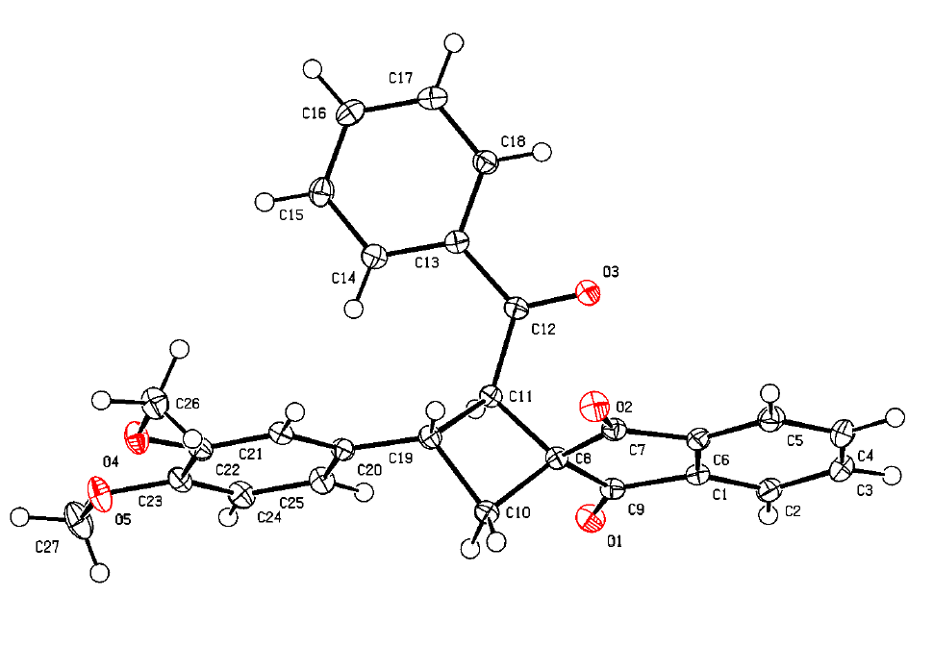
Crystal structure of 3g. ORTEP drawing with thermal ellipsoids at the 50% probability level. Deposition: 2535886.

(2R,3S)-2-benzoyl-3-(4-(trifluoromethoxy)phenyl)spiro[cyclobutane-1,2'-indene]-1',3'-dione (3h)
¹H NMR (CDCl₃, 600 MHz) δ = 8.02 - 7.96 (m, 1H), 7.93 - 7.86 (m, 1H), 7.84 - 7.76 (m, 2H), 7.54 - 7.49 (m, 2H), 7.40 - 7.35 (m, 2H), 7.31 (tt, J = 1.3, 7.3 Hz, 1H), 7.13 - 7.07 (m, 2H), 4.51 (d, J = 10.0 Hz, 1H), 4.37 (q, J = 9.7 Hz, 1H), 2.70 (t, J = 10.5 Hz, 1H), 2.62 (dd, J = 8.9, 10.9 Hz, 1H).
¹³C NMR (CDCl₃, 150 MHz) δ = 201.1, 200.7, 196.8, 148.3, 142.4, 141.0, 140.9, 135.9, 135.4, 134.6, 133.2, 128.9, 128.4, 128.2, 128.1, 123.2, 123.1, 121.2, 56.5, 53.0, 37.2, 32.2.
HRMS (ESI/Q-TOF) m/z: [M+H]⁺ calcd for C₂₆H₁₈F₃O₄⁺ 451.1152. Found 451.1151.
Anal. Calcd for C₂₆H₁₇F₃O₄: C, 69.33; H, 3.80. Found: C, 69.46; H, 3.94.
(Support check: H expected 17, found 15)
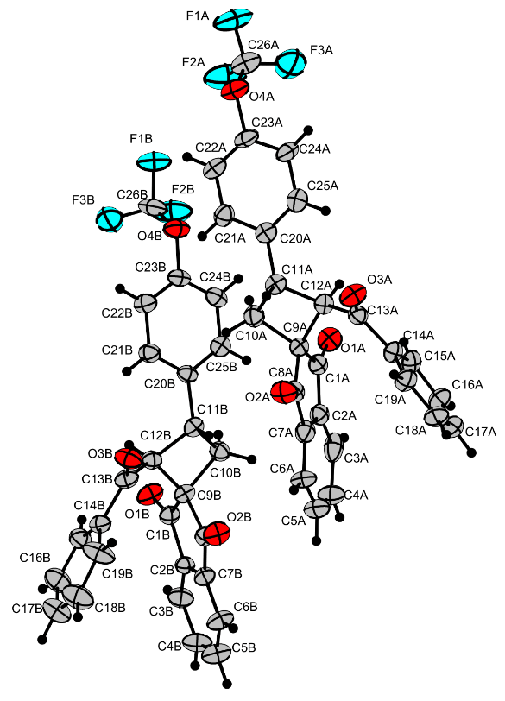
Crystal structure of 3h. ORTEP drawing with thermal ellipsoids at the 50% probability level. Deposition: 2432443.

4-((2R,3S)-2-benzoyl-1',3'-dioxo-1',3'-dihydrospiro[cyclobutane-1,2'-inden]-3-yl)benzonitrile (3i)
¹H NMR (CDCl₃, 600 MHz) δ = 7.96 (dt, J = 1.1, 7.5 Hz, 1H), 7.82 - 7.77 (m, 2H), 7.77 - 7.72 (m, 1H), 7.69 - 7.64 (m, 2H), 7.57 (d, J = 8.2 Hz, 2H), 7.38 - 7.33 (m, 2H), 7.11 - 7.05 (m, 2H), 4.49 (d, J = 9.9 Hz, 1H), 4.44 (q, J = 9.4 Hz, 1H), 2.68 (dd, J = 9.7, 11.0 Hz, 1H), 2.61 (dd, J = 8.6, 11.0 Hz, 1H).
¹³C NMR (CDCl₃, 150 MHz) δ = 200.6, 196.7, 147.9, 142.4, 141.2, 136.2, 135.8, 134.8, 133.5, 132.7, 128.5, 128.4, 128.1, 123.4, 123.4, 118.9, 111.1, 55.4, 53.4, 37.2, 32.0.
HRMS (ESI/Q-TOF) m/z: [M+H]⁺ calcd for C₂₆H₁₈NO₃⁺ 392.1281. Found 392.1281.
Anal. Calcd for C₂₆H₁₇NO₃: C, 79.78; H, 4.38; N, 3.58. Found: C, 79.39; H, 4.42; N, 3.37.
(Support check: H expected 17, found 16; C signals expected 22 after phenyl-ring symmetry correction (26 C atoms in formula), found 21)
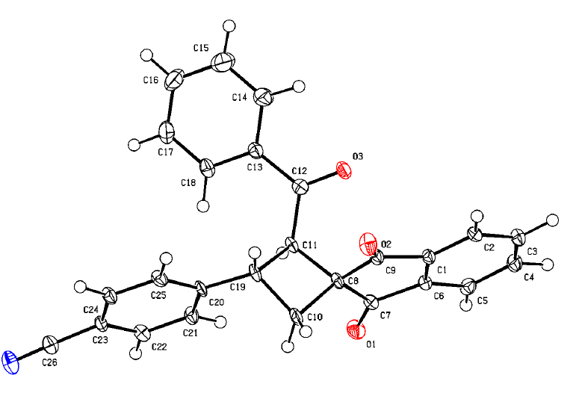
Crystal structure of 3i. ORTEP drawing with thermal ellipsoids at the 50% probability level. Deposition: 2535884.

(2R,3R)-2-benzoyl-3-((E)-styryl)spiro[cyclobutane-1,2'-indene]-1',3'-dione (3j)
¹H NMR (CDCl₃, 600 MHz) δ = 8.01 - 7.95 (m, 2H), 7.82 (pd, J = 1.5, 7.2 Hz, 3H), 7.70 (dd, J = 1.4, 8.1 Hz, 2H), 7.45 - 7.32 (m, 6H), 7.31 - 7.22 (m, 5H), 6.52 (d, J = 15.8 Hz, 1H), 6.47 (dd, J = 8.0, 15.8 Hz, 1H), 4.38 (d, J = 9.9 Hz, 1H), 3.94 (p, J = 9.2 Hz, 1H), 2.49 - 2.45 (m, 2H), 1.26 (d, J = 2.6 Hz, 1H).
¹³C NMR (CDCl₃, 150 MHz) δ = 201.7, 200.7, 197.1, 142.8, 140.8, 136.7, 135.8, 135.2, 134.8, 133.3, 132.6, 131.2, 128.7, 128.6, 128.2, 127.7, 126.3, 123.2, 123.1, 56.1, 37.3, 31.2.
HRMS (ESI/Q-TOF) m/z: [M+H]⁺ calcd for C₂₇H₂₁O₃⁺ 393.1485. Found 393.1490.
(Support check: H expected 20, found 25; C signals expected 23 after phenyl-ring symmetry correction (27 C atoms in formula), found 22)

4-((1R,2S)-1-benzoyl-7,7-dimethyl-5,9-dioxo-6,8-dioxaspiro[3.5]nonan-2-yl)benzonitrile (3k)
¹H NMR (CDCl₃, 400 MHz) δ = 7.71 - 7.64 (m, 2H), 7.60 - 7.53 (m, 2H), 7.53 - 7.47 (m, 1H), 7.47 - 7.42 (m, 2H), 7.31 (td, J = 1.6, 8.0 Hz, 2H), 4.79 (d, J = 9.9 Hz, 1H), 4.42 (q, J = 9.7 Hz, 1H), 2.99 - 2.84 (m, 2H), 1.68 (d, J = 15.4 Hz, 6H).
¹³C NMR (D₂O, 100 MHz) δ = 196.1, 169.5, 167.4, 146.8, 134.3, 133.5, 132.5, 128.6, 128.2, 127.7, 118.4, 111.2, 105.8, 76.9, 76.6, 55.6, 46.6, 37.7, 37.0, 29.0, 27.7.
HRMS (ESI/Q-TOF) m/z: [M+H]⁺ calcd for C₂₃H₂₀NO₅⁺ 390.1336. Found 390.1336.
(Support check: C signals expected 19 after phenyl-ring symmetry correction (23 C atoms in formula), found 21)

(2R,3S)-2-(2-methoxybenzoyl)-3-(3-methoxyphenyl)spiro[cyclobutane-1,2'-indene]-1',3'-dione (3l)
¹H NMR (CDCl₃, 600 MHz) δ = 7.94 (dt, J = 1.0, 7.7 Hz, 1H), 7.76 (td, J = 1.6, 7.1 Hz, 1H), 7.71 - 7.63 (m, 2H), 7.48 (dd, J = 1.8, 7.6 Hz, 1H), 6.96 (t, J = 2.1 Hz, 1H), 6.85 (td, J = 1.0, 7.5 Hz, 1H), 6.26 (d, J = 8.3 Hz, 1H), 4.54 (dd, J = 1.0, 9.8 Hz, 1H), 4.22 (q, J = 9.7 Hz, 1H), 3.81 (s, 3H), 3.29 (s, 3H), 2.69 (dd, J = 10.1, 11.0 Hz, 1H).
¹³C NMR (CDCl₃, 150 MHz) δ = 201.8, 200.4, 199.2, 159.6, 157.1, 144.9, 142.0, 141.3, 135.2, 135.1, 133.3, 130.7, 129.3, 126.6, 122.8, 122.5, 120.6, 119.5, 112.8, 112.3, 109.6, 59.7, 55.1, 53.9, 53.5, 37.6, 30.7.
HRMS (ESI/Q-TOF) m/z: [M+H]⁺ calcd for C₂₇H₂₃O₅⁺ 427.1540. Found 427.1543.
(Support check: H expected 22, found 17)

(2R,3S)-3-(4-bromophenyl)-2-(4-methoxybenzoyl)spiro[cyclobutane-1,2'-indene]-1',3'-dione (3m)
¹H NMR (CDCl₃, 600 MHz) δ = 8.00 - 7.95 (m, 1H), 7.93 (dt, J = 3.1, 4.9 Hz, 1H), 7.83 - 7.75 (m, 2H), 7.54 - 7.49 (m, 2H), 7.39 - 7.33 (m, 4H), 6.61 - 6.56 (m, 2H), 4.46 (d, J = 10.1 Hz, 1H), 4.29 (q, J = 9.8 Hz, 1H), 3.71 (s, 3H), 2.66 - 2.55 (m, 2H).
¹³C NMR (CDCl₃, 150 MHz) δ = 201.6, 201.1, 195.2, 163.8, 142.9, 141.6, 141.0, 136.1, 135.5, 132.0, 130.8, 129.5, 127.5, 123.4, 123.3, 121.3, 113.7, 57.0, 55.5, 53.1, 37.9, 32.3.
HRMS (ESI/Q-TOF) m/z: [M+H]⁺ calcd for C₂₆H₂₀⁷⁹BrO₄⁺ 475.0539. Found 475.0543.

(2R,3S)-2-(4-chlorobenzoyl)-3-(4-nitrophenyl)spiro[cyclobutane-1,2'-indene]-1',3'-dione (3n)
¹H NMR (CDCl₃, 600 MHz) δ = 8.29 - 8.24 (m, 2H), 8.00 (dt, J = 1.1, 7.3 Hz, 1H), 7.88 - 7.82 (m, 3H), 7.81 (dd, J = 1.3, 7.3 Hz, 1H), 7.66 - 7.62 (m, 2H), 7.37 - 7.30 (m, 2H), 7.13 - 7.06 (m, 2H), 4.53 (q, J = 9.5 Hz, 1H), 4.48 (d, J = 9.9 Hz, 1H), 2.73 (dd, J = 9.8, 11.0 Hz, 1H), 2.67 (dd, J = 8.8, 11.0 Hz, 1H).
¹³C NMR (CDCl₃, 150 MHz) δ = 200.2, 200.2, 195.2, 149.5, 147.1, 142.0, 140.9, 139.9, 136.3, 135.9, 132.9, 129.2, 128.8, 128.3, 124.0, 123.3, 123.3, 54.8, 53.3, 36.6, 32.1.
HRMS (ESI/Q-TOF) m/z: [M+Na]⁺ calcd for C₂₅H₁₆³⁵ClNO₅Na⁺ 468.0609. Found 468.0607.
(Support check: H expected 16, found 17)

(2R,3S)-3-(3-methoxyphenyl)-2-(thiophene-2-carbonyl)spiro[cyclobutane-1,2'-indene]-1',3'-dione (3o)
¹H NMR (CDCl₃, 600 MHz) δ = 8.05 - 7.97 (m, 2H), 7.83 (dtd, J = 1.3, 7.3, 17.2 Hz, 2H), 7.50 - 7.46 (m, 1H), 7.35 (t, J = 7.9 Hz, 1H), 7.15 - 7.11 (m, 1H), 7.07 - 7.03 (m, 1H), 6.92 - 6.85 (m, 2H), 6.79 - 6.74 (m, 1H), 4.49 (dd, J = 2.3, 10.2 Hz, 1H), 4.36 (q, J = 9.7 Hz, 1H), 3.85 (d, J = 2.3 Hz, 2H), 2.69 - 2.59 (m, 2H).
¹³C NMR (CDCl₃, 150 MHz) δ = 201.4, 200.5, 189.1, 160.0, 143.6, 142.9, 140.8, 135.9, 135.3, 134.3, 132.7, 129.9, 127.8, 123.2, 119.8, 113.2, 113.0, 57.2, 55.2, 52.6, 38.9, 32.7.
HRMS (ESI/Q-TOF) m/z: [M+H]⁺ calcd for C₂₄H₁₉O₄S⁺ 403.0999. Found 403.1001.
(Support check: H expected 18, found 17; C expected 24, found 22)

Ethyl (2R,3S)-1',3'-dioxo-3-phenyl-1',3'-dihydrospiro[cyclobutane-1,2'-indene]-2-carboxylate (3p)
¹H NMR (CDCl₃, 600 MHz) δ = 8.05 - 7.98 (m, 2H), 7.91 - 7.82 (m, 2H), 7.46 (d, J = 7.6 Hz, 2H), 7.37 (t, J = 7.5 Hz, 2H), 4.29 (q, J = 9.8 Hz, 1H), 4.03 (dq, J = 7.1, 10.5 Hz, 1H), 3.94 (dq, J = 7.1, 10.7 Hz, 1H), 3.78 (d, J = 10.2 Hz, 1H), 2.58 (d, J = 9.7 Hz, 2H), 0.98 (t, J = 7.1 Hz, 3H).
¹³C NMR (CDCl₃, 150 MHz) δ = 201.5, 199.9, 170.5, 142.5, 142.3, 141.5, 136.2, 135.9, 135.7, 128.6, 127.0, 126.9, 126.8, 123.6, 123.2, 60.9, 52.7, 49.9, 37.5, 31.6, 13.9.
HRMS (ESI/Q-TOF) m/z: [M+H]⁺ calcd for C₂₁H₁₉O₄⁺ 335.1278. Found 335.1284.
Anal. Calcd for C₂₁H₁₈O₄: C, 75.43; H, 5.43. Found: C, 75.12; H, 5.41.
(Support check: H expected 18, found 17; C signals expected 19 after phenyl-ring symmetry correction (21 C atoms in formula), found 21)

Ethyl (2R,3S)-1',3'-dioxo-3-(p-tolyl)-1',3'-dihydrospiro[cyclobutane-1,2'-indene]-2-carboxylate (3q)
¹H NMR (CDCl₃, 600 MHz) δ = 8.02 (ddd, J = 2.2, 5.7, 7.3 Hz, 2H), 7.90 - 7.82 (m, 2H), 7.35 (d, J = 7.8 Hz, 2H), 7.18 (d, J = 7.8 Hz, 2H), 4.24 (q, J = 9.8 Hz, 1H), 4.02 (dq, J = 7.1, 10.9 Hz, 1H), 3.94 (dq, J = 7.1, 10.8 Hz, 1H), 3.75 (d, J = 10.2 Hz, 1H), 2.55 (d, J = 9.7 Hz, 2H), 2.35 (s, 3H), 0.98 (t, J = 7.1 Hz, 3H).
¹³C NMR (CDCl₃, 150 MHz) δ = 201.7, 200.1, 170.7, 142.6, 141.6, 139.4, 136.7, 136.0, 135.8, 129.4, 127.0, 123.6, 123.3, 61.0, 52.8, 50.2, 37.4, 31.9, 21.2, 14.0.
HRMS (ESI/Q-TOF) m/z: [M+H]⁺ calcd for C₂₂H₂₁O₄⁺ 349.1434. Found 349.1437.

Ethyl (2R,3S)-3-(4-fluorophenyl)-1',3'-dioxo-1',3'-dihydrospiro[cyclobutane-1,2'-indene]-2-carboxylate (3r)
¹H NMR (CDCl₃, 600 MHz) δ = 8.06 - 8.00 (m, 2H), 7.91 - 7.83 (m, 2H), 7.45 - 7.39 (m, 2H), 7.06 (t, J = 8.7 Hz, 2H), 4.26 (q, J = 9.9 Hz, 1H), 4.08 - 3.99 (m, 1H), 3.94 (dq, J = 7.0, 10.7 Hz, 1H), 3.72 (d, J = 10.2 Hz, 1H), 2.55 (p, J = 10.7 Hz, 2H), 1.32 - 1.16 (m, 1H), 0.97 (td, J = 1.3, 7.2 Hz, 3H).
¹³C NMR (CDCl₃, 150 MHz) δ = 201.3, 199.8, 170.3, 162.6, 161.0, 142.4, 141.3, 137.9, 135.8, 135.7, 128.4, 128.4, 123.5, 123.1, 115.3, 115.2, 60.9, 52.5, 50.0, 36.8, 31.6, 13.7.
HRMS (ESI/Q-TOF) m/z: [M+H]⁺ calcd for C₂₁H₁₈FO₄⁺ 353.1184. Found 353.1175.
(Support check: H expected 17, found 18)

Ethyl (2R,3S)-1',3'-dioxo-3-(o-tolyl)-1',3'-dihydrospiro[cyclobutane-1,2'-indene]-2-carboxylate (3s)
¹H NMR (CDCl₃, 600 MHz) δ = 8.03 (tt, J = 4.9, 7.2 Hz, 2H), 7.90 - 7.83 (m, 2H), 7.52 (d, J = 7.6 Hz, 1H), 7.20 - 7.14 (m, 2H), 4.45 (q, J = 9.9 Hz, 1H), 4.06 - 3.89 (m, 3H), 2.63 (dd, J = 9.2, 10.6 Hz, 1H), 2.44 - 2.36 (m, 4H), 0.98 (t, J = 7.1 Hz, 3H).
¹³C NMR (CDCl₃, 150 MHz) δ = 201.7, 200.2, 170.6, 142.6, 141.6, 140.3, 136.3, 136.0, 135.8, 130.3, 127.0, 126.9, 126.4, 126.0, 123.7, 123.4, 123.3, 61.0, 52.9, 48.8, 34.6, 33.0, 19.9, 14.2, 14.0.
HRMS (ESI/Q-TOF) m/z: [M+H]⁺ calcd for C₂₂H₂₁O₄⁺ 349.1434. Found 349.1439.
Anal. Calcd for C₂₂H₂₀O₄: C, 75.84; H, 5.79. Found: C, 75.81; H, 5.53.
(Support check: H expected 20, found 19; C expected 22, found 25)
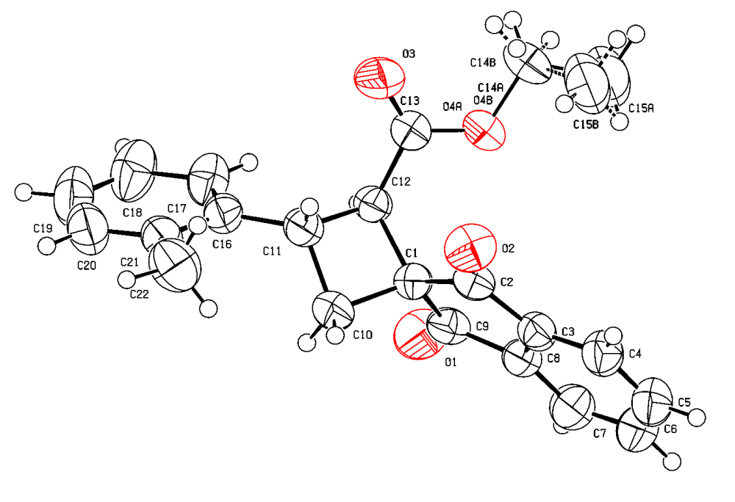
Crystal structure of 3s. ORTEP drawing with thermal ellipsoids at the 50% probability level. Deposition: 2364657.

Ethyl (2R,3S)-3-(4-methoxyphenyl)-1',3'-dioxo-1',3'-dihydrospiro[cyclobutane-1,2'-indene]-2-carboxylate (3t)
¹H NMR (CDCl₃, 600 MHz) δ = 8.05 - 7.97 (m, 2H), 7.89 - 7.81 (m, 2H), 7.41 - 7.35 (m, 2H), 6.94 - 6.87 (m, 2H), 4.21 (q, J = 9.8 Hz, 1H), 4.01 (dq, J = 7.1, 10.8 Hz, 1H), 3.93 (dq, J = 7.1, 10.7 Hz, 1H), 3.81 (s, 3H), 3.71 (d, J = 10.2 Hz, 1H), 2.53 (d, J = 9.6 Hz, 2H), 0.97 (t, J = 7.1 Hz, 3H).
¹³C NMR (CDCl₃, 150 MHz) δ = 201.5, 200.0, 170.5, 158.5, 142.4, 141.4, 135.8, 135.6, 134.3, 128.0, 123.4, 123.1, 113.9, 60.7, 55.2, 52.6, 50.2, 36.9, 31.8, 13.8.
HRMS (ESI/Q-TOF) m/z: [M+H]⁺ calcd for C₂₂H₂₁O₅⁺ 365.1384. Found 365.1389.

Ethyl (2R,3S)-3-(4-cyanophenyl)-1',3'-dioxo-1',3'-dihydrospiro[cyclobutane-1,2'-indene]-2-carboxylate (3u)
¹H NMR (CDCl₃, 600 MHz) δ = 8.03 (ddt, J = 2.2, 4.2, 5.6 Hz, 2H), 7.89 (td, J = 3.9, 6.8 Hz, 2H), 7.69 - 7.62 (m, 2H), 7.55 (d, J = 8.0 Hz, 2H), 4.34 (q, J = 9.9 Hz, 1H), 4.05 (dq, J = 7.1, 10.7 Hz, 1H), 3.93 (dq, J = 7.1, 10.8 Hz, 1H), 3.73 (d, J = 10.2 Hz, 1H), 2.64 - 2.52 (m, 2H), 0.97 (t, J = 7.1 Hz, 3H).
¹³C NMR (CDCl₃, 150 MHz) δ = 200.9, 199.4, 169.9, 147.4, 142.3, 141.3, 136.0, 135.8, 135.3, 132.3, 130.6, 128.1, 127.6, 127.4, 124.9, 123.6, 123.2, 118.7, 110.8, 61.8, 61.1, 60.0, 52.3, 49.3, 47.5, 37.3, 36.2, 31.5, 30.9, 14.0, 13.7.
HRMS (ESI/Q-TOF) m/z: [M+H]⁺ calcd for C₂₂H₁₈NO₄⁺ 360.1230. Found 360.1233.
(Support check: C signals expected 20 after phenyl-ring symmetry correction (22 C atoms in formula), found 31)

Diethyl (2R,3s,4S)-1',3'-dioxo-3-(p-tolyl)-1',3'-dihydrospiro[cyclobutane-1,2'-indene]-2,4-dicarboxylate (3v)
¹H NMR (CDCl₃, 600 MHz) δ = 8.07 - 7.99 (m, 2H), 7.91 - 7.84 (m, 2H), 7.41 (d, J = 7.8 Hz, 1H), 7.31 (d, J = 7.8 Hz, 1H), 7.19 (d, J = 7.9 Hz, 1H), 7.15 (d, J = 7.8 Hz, 1H), 4.58 (t, J = 10.1 Hz, 1H), 4.35 (d, J = 10.0 Hz, 1H), 4.10 - 3.89 (m, 3H), 3.89 - 3.78 (m, 1H), 3.61 (d, J = 10.4 Hz, 1H), 2.34 (d, J = 12.8 Hz, 3H), 0.98 (dt, J = 7.1, 16.9 Hz, 4H), 0.85 (t, J = 7.1 Hz, 2H).
¹³C NMR (CDCl₃, 150 MHz) δ = 199.7, 199.6, 198.7, 170.4, 170.0, 168.3, 143.4, 142.4, 141.6, 137.7, 137.0, 136.4, 136.3, 136.1, 135.9, 135.8, 135.7, 129.4, 129.0, 127.4, 127.0, 123.9, 123.8, 123.5, 123.0, 61.2, 60.9, 55.9, 47.6, 46.6, 45.9, 41.0, 39.7, 21.2, 14.0, 13.9, 13.7.
HRMS (ESI/Q-TOF) m/z: [M+NH4]⁺ calcd for C₂₅H₂₈O₆N⁺ 438.1911. Found 438.1911.
(Support check: C signals expected 23 after phenyl-ring symmetry correction (25 C atoms in formula), found 37)
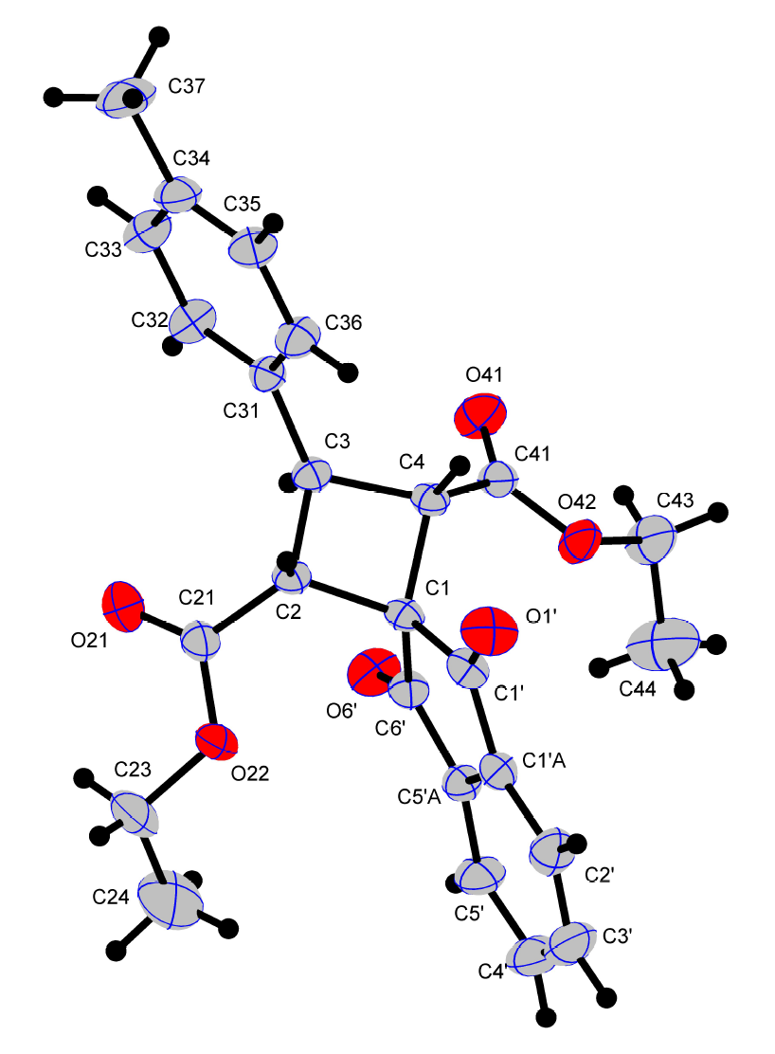
Crystal structure of 3v. Minor diastereomer B. ORTEP drawing with thermal ellipsoids at the 50% probability level. Deposition: 2117516.

(2R,3s,4S)-2,4-dibenzoyl-3-(p-tolyl)spiro[cyclobutane-1,2'-indene]-1',3'-dione (3w)
¹H NMR (CD₂Cl₂, 600 MHz) δ = 8.01 (dd, J = 7.6, 13.9 Hz, 2H), 7.79 (t, J = 7.4 Hz, 1H), 7.72 (t, J = 7.4 Hz, 1H), 7.66 (d, J = 7.6 Hz, 1H), 7.50 (d, J = 7.7 Hz, 3H), 7.41 (d, J = 7.7 Hz, 5H), 7.36 - 7.28 (m, 5H), 7.13 (t, J = 7.6 Hz, 5H), 4.62 (t, J = 10.2 Hz, 1H), 4.52 (d, J = 10.0 Hz, 2H), 2.43 (s, 3H).
¹³C NMR (CD₂Cl₂, 150 MHz) δ = 200.3, 196.7, 143.3, 140.9, 137.9, 137.7, 136.0, 135.3, 135.1, 133.2, 129.7, 128.3, 128.1, 127.9, 123.0, 122.5, 53.8, 53.6, 53.4, 53.2, 53.1, 41.3, 20.9.
HRMS (ESI/Q-TOF) m/z: [M+H]⁺ calcd for C₃₃H₂₅O₄⁺ 485.1747. Found 485.1747.
(Support check: H expected 24, found 29; C signals expected 27 after phenyl-ring symmetry correction (33 C atoms in formula), found 23)

(2R,3S)-2-benzoyl-3-(4'-chloro-[1,1'-biphenyl]-4-yl)spiro[cyclobutane-1,2'-indene]-1',3'-dione (5)
¹H NMR (CDCl₃, 600 MHz) δ = 7.99 (dd, J = 2.8, 5.9 Hz, 1H), 7.93 (dd, J = 2.8, 5.9 Hz, 1H), 7.84 - 7.77 (m, 2H), 7.60 (d, J = 8.0 Hz, 2H), 7.57 (d, J = 7.9 Hz, 3H), 7.55 (s, 1H), 7.45 - 7.40 (m, 4H), 7.31 (t, J = 7.4 Hz, 1H), 7.10 (t, J = 7.7 Hz, 2H), 4.59 (d, J = 10.0 Hz, 1H), 4.38 (q, J = 9.7 Hz, 1H), 2.74 (t, J = 10.5 Hz, 1H), 2.63 (dd, J = 8.9, 10.9 Hz, 1H).
¹³C NMR (CDCl₃, 150 MHz) δ = 201.4, 200.8, 197.0, 142.6, 141.7, 140.9, 139.1, 139.0, 135.9, 135.4, 134.7, 133.4, 133.1, 128.9, 128.3, 128.2, 128.1, 127.2, 123.2, 123.1, 56.8, 53.1, 37.8, 32.4.
HRMS (ESI/Q-TOF) m/z: [M+H]⁺ calcd for C₃₁H₂₂³⁵ClO₃⁺ 477.1252. Found 477.1253.
(Support check: C signals expected 25 after phenyl-ring symmetry correction (31 C atoms in formula), found 24)

Diethyl (2R,3S,E)-1'-oxo-3'-(2-phenylhydrazineylidene)-3-(p-tolyl)-1',3'-dihydrospiro[cyclobutane-1,2'-indene]-2,4-dicarboxylate (6)
¹H NMR (DMSO, 600 MHz) δ = 10.10 (d, J = 3.2 Hz, 1H), 8.55 (d, J = 7.9 Hz, 1H), 7.95 (t, J = 7.9 Hz, 1H), 7.88 (d, J = 7.6 Hz, 1H), 7.70 (t, J = 7.5 Hz, 1H), 7.44 - 7.39 (m, 2H), 7.37 (d, J = 8.0 Hz, 2H), 7.30 (t, J = 7.8 Hz, 2H), 7.22 (d, J = 7.7 Hz, 2H), 6.89 (t, J = 7.2 Hz, 1H), 4.20 (t, J = 10.2 Hz, 1H), 3.93 (dt, J = 7.0, 14.1 Hz, 2H), 3.83 - 3.72 (m, 3H), 3.72 (s, 1H), 2.33 (s, 3H), 0.83 (t, J = 7.1 Hz, 6H).
¹³C NMR (DMSO, 150 MHz) δ = 202.3, 170.7, 146.7, 143.4, 140.0, 139.0, 137.9, 136.5, 136.2, 131.1, 129.6, 129.4, 127.3, 126.8, 123.5, 121.0, 114.3, 60.6, 56.3, 49.4, 40.4, 40.3, 21.1, 14.1.
HRMS (ESI/Q-TOF) m/z: [M+H]⁺ calcd for C₃₁H₃₁N₂O₅⁺ 511.2227. Found 511.2230.
(Support check: C signals expected 27 after phenyl-ring symmetry correction (31 C atoms in formula), found 24)

X-ray crystallography
(2R,3S)-2-benzoyl-3-(o-tolyl)spiro[cyclobutane-1,2'-indene]-1',3'-dione (3c)
Single crystals of 3c were obtained through slow evaporation of its solution in a petroleum ether – ethyl acetate mixture at room temperature.
Single-crystal X-ray diffraction data were collected using stoe with Mo Kα (λ = 0.71073) at 295 K.
Structure refinement: SHELXL-2014/7 (Sheldrick, 2014).
Hydrogen-atom treatment: refall.
Crystallographic deposition: 2383313.
Table S1. Crystal data and structure refinement for compound 3c.
Identification code | CCDC 2383313
Empirical formula | C₂₆ H₂₀ O₃
Formula weight | 380.42
Temperature / K | 295
Crystal system | monoclinic
Space group | P 21/n
a / Å | 7.1934(5)
b / Å | 13.3744(7)
c / Å | 20.4230(10)
α / ° | 90
β / ° | 97.997(6)
γ / ° | 90
V / Å³ | 1945.7(2)
Z | 4
Calculated density / Mg m⁻³ | 1.299
Absorption coefficient / mm⁻¹ | 0.084
F(000) | 800
Crystal size / mm | .33 × .23 × .21
Radiation (wavelength / Å) | Mo Kα (λ = 0.71073)
Diffractometer | stoe
θ range for data collection / ° | 2.525–28.097
Index ranges | -9 ≤ h ≤ 9; -17 ≤ k ≤ 15; -26 ≤ l ≤ 23
Reflections collected / independent / observed | 25442 / 4625 / 1998
Rint | 0.0945
Data / restraints / parameters | 4625 / 0 / 266
Goodness-of-fit on F² | 0.771
Final R indices [I > 2σ(I)] | R1 = 0.0433, wR2 = 0.0832
R indices (all data) | R1 = 0.1228, wR2 = 0.1018
Largest diff. peak and hole / e Å⁻³ | 0.169 / -0.160

(2R,3S)-2-benzoyl-3-(4-bromophenyl)spiro[cyclobutane-1,2'-indene]-1',3'-dione (3e)
Single crystals of 3e were obtained through slow evaporation of its solution in a petroleum ether – ethyl acetate mixture at room temperature.
Single-crystal X-ray diffraction data were collected using XtaLAB Pro: Kappa single with MoKα (λ = 0.71073) at 100(2) K.
Structure solution: SHELXT 2018/2 (Sheldrick, 2018).
Structure refinement: SHELXL-2019/2 (Sheldrick, 2019).
Hydrogen-atom treatment: refxyz.
Crystallographic deposition: 2535885.
Table S2. Crystal data and structure refinement for compound 3e.
Identification code | CCDC 2535885
Empirical formula | C₂₅ H₁₇ Br O₃
Formula weight | 445.29
Temperature / K | 100(2)
Crystal system | monoclinic
Space group | P 21/c
a / Å | 12.6839(12)
b / Å | 7.1871(3)
c / Å | 26.734(3)
α / ° | 90
β / ° | 128.548(15)
γ / ° | 90
V / Å³ | 1906.0(4)
Z | 4
Calculated density / Mg m⁻³ | 1.552
Absorption coefficient / mm⁻¹ | 2.182
F(000) | 904
Crystal size / mm | 0.741 × 0.565 × 0.364
Radiation (wavelength / Å) | MoKα (λ = 0.71073)
Diffractometer | XtaLAB Pro: Kappa single
θ range for data collection / ° | 2.997–30.507
Index ranges | -16 ≤ h ≤ 17; -10 ≤ k ≤ 10; -38 ≤ l ≤ 33
Reflections collected / independent / observed | 16732 / 5741 / 4729
Rint | 0.0407
Data / restraints / parameters | 5741 / 0 / 313
Goodness-of-fit on F² | 1.064
Final R indices [I > 2σ(I)] | R1 = 0.0344, wR2 = 0.0829
R indices (all data) | R1 = 0.0472, wR2 = 0.0870
Largest diff. peak and hole / e Å⁻³ | 0.605 / -0.810

(2R,3S)-2-benzoyl-3-(4-methoxyphenyl)spiro[cyclobutane-1,2'-indene]-1',3'-dione (3f)
Single crystals of 3f were obtained through slow evaporation of its solution in a petroleum ether – ethyl acetate mixture at room temperature.
Single-crystal X-ray diffraction data were collected using stoe with Mo Kα (λ = 0.71073) at 295 K.
Structure refinement: SHELXL-2014/7 (Sheldrick, 2014).
Hydrogen-atom treatment: constr.
Crystallographic deposition: 2432441.
Table S3. Crystal data and structure refinement for compound 3f.
Identification code | CCDC 2432441
Empirical formula | C₂₆ H₂₀ O₄
Formula weight | 396.42
Temperature / K | 295
Crystal system | triclinic
Space group | P -1
a / Å | 8.0347(4)
b / Å | 11.0896(5)
c / Å | 12.6007(7)
α / ° | 65.645(5)
β / ° | 81.056(6)
γ / ° | 82.727(6)
V / Å³ | 1007.95(10)
Z | 2
Calculated density / Mg m⁻³ | 1.306
Absorption coefficient / mm⁻¹ | 0.088
F(000) | 416
Crystal size / mm | .26 × .23 × .14
Radiation (wavelength / Å) | Mo Kα (λ = 0.71073)
Diffractometer | stoe
θ range for data collection / ° | 2.572–27.350
Index ranges | -10 ≤ h ≤ 10; -14 ≤ k ≤ 14; -16 ≤ l ≤ 16
Reflections collected / independent / observed | 27081 / 4414 / 2055
Rint | 0.0476
Data / restraints / parameters | 4414 / 0 / 273
Goodness-of-fit on F² | 0.783
Final R indices [I > 2σ(I)] | R1 = 0.0357, wR2 = 0.0599
R indices (all data) | R1 = 0.1024, wR2 = 0.0709
Largest diff. peak and hole / e Å⁻³ | 0.132 / -0.136

(2R,3S)-2-benzoyl-3-(3,4-dimethoxyphenyl)spiro[cyclobutane-1,2'-indene]-1',3'-dione (3g)
Single crystals of 3g were obtained through slow evaporation of its solution in a petroleum ether – ethyl acetate mixture at room temperature.
Single-crystal X-ray diffraction data were collected using XtaLAB Pro: Kappa single with MoKα (λ = 0.71073) at 100(2) K.
Structure refinement: SHELXL-2019/2 (Sheldrick, 2019).
Hydrogen-atom treatment: refxyz.
Crystallographic deposition: 2535886.
Table S4. Crystal data and structure refinement for compound 3g.
Identification code | CCDC 2535886
Empirical formula | C₂₇ H₂₂ O₅
Formula weight | 426.44
Temperature / K | 100(2)
Crystal system | monoclinic
Space group | P 21/c
a / Å | 9.2211(3)
b / Å | 16.0471(5)
c / Å | 14.6220(5)
α / ° | 90
β / ° | 107.623(4)
γ / ° | 90
V / Å³ | 2062.09(12)
Z | 4
Calculated density / Mg m⁻³ | 1.374
Absorption coefficient / mm⁻¹ | 0.094
F(000) | 896
Crystal size / mm | 0.566 × 0.486 × 0.427
Radiation (wavelength / Å) | MoKα (λ = 0.71073)
Diffractometer | XtaLAB Pro: Kappa single
θ range for data collection / ° | 2.929–30.505
Index ranges | -13 ≤ h ≤ 11; -22 ≤ k ≤ 17; -15 ≤ l ≤ 20
Reflections collected / independent / observed | 19451 / 6190 / 5363
Rint | 0.0238
Data / restraints / parameters | 6190 / 0 / 355
Goodness-of-fit on F² | 1.051
Final R indices [I > 2σ(I)] | R1 = 0.0406, wR2 = 0.1114
R indices (all data) | R1 = 0.0467, wR2 = 0.1149
Largest diff. peak and hole / e Å⁻³ | 0.457 / -0.249

(2R,3S)-2-benzoyl-3-(4-(trifluoromethoxy)phenyl)spiro[cyclobutane-1,2'-indene]-1',3'-dione (3h)
Single crystals of 3h were obtained through slow evaporation of its solution in a petroleum ether – ethyl acetate mixture at room temperature. It was found that the lattice of cyclobutane 3h contains two independent molecules.
Single-crystal X-ray diffraction data were collected using stoe with Mo Kα (λ = 0.71073) at 295 K.
Structure refinement: SHELXL-2014/7 (Sheldrick, 2014).
Hydrogen-atom treatment: constr.
Crystallographic deposition: 2432443.
Table S5. Crystal data and structure refinement for compound 3h.
Identification code | CCDC 2432443
Empirical formula | C₂₆ H₁₇ F₃ O₄
Formula weight | 450.39
Temperature / K | 295
Crystal system | orthorhombic
Space group | P 21 21 21
a / Å | 9.7324(6)
b / Å | 16.6860(10)
c / Å | 26.4640(10)
α / ° | 90
β / ° | 90
γ / ° | 90
V / Å³ | 4297.6(4)
Z | 8
Calculated density / Mg m⁻³ | 1.392
Absorption coefficient / mm⁻¹ | 0.111
F(000) | 1856
Crystal size / mm | .24 × .18 × .12
Radiation (wavelength / Å) | Mo Kα (λ = 0.71073)
Diffractometer | stoe
θ range for data collection / ° | 1.964–26.950
Index ranges | -8 ≤ h ≤ 12; -21 ≤ k ≤ 20; -33 ≤ l ≤ 33
Reflections collected / independent / observed | 33117 / 8932 / 2173
Rint | 0.1142
Data / restraints / parameters | 8932 / 0 / 595
Goodness-of-fit on F² | 0.626
Final R indices [I > 2σ(I)] | R1 = 0.0575, wR2 = 0.1421
R indices (all data) | R1 = 0.2254, wR2 = 0.1970
Largest diff. peak and hole / e Å⁻³ | 0.343 / -0.292
Absolute-structure parameter | 1.8(10)

4-((2R,3S)-2-benzoyl-1',3'-dioxo-1',3'-dihydrospiro[cyclobutane-1,2'-inden]-3-yl)benzonitrile (3i)
Single crystals of 3i were obtained through slow evaporation of its solution in a petroleum ether – ethyl acetate mixture at room temperature.
Single-crystal X-ray diffraction data were collected using XtaLAB Pro: Kappa single with MoKα (λ = 0.71073) at 100(2) K.
Structure solution: SHELXT 2018/2 (Sheldrick, 2018).
Structure refinement: SHELXL-2019/2 (Sheldrick, 2019).
Hydrogen-atom treatment: refxyz.
Crystallographic deposition: 2535884.
Table S6. Crystal data and structure refinement for compound 3i.
Identification code | CCDC 2535884
Empirical formula | C₂₆ H₁₇ N O₃
Formula weight | 391.40
Temperature / K | 100(2)
Crystal system | orthorhombic
Space group | P b c a
a / Å | 9.9050(2)
b / Å | 33.5101(8)
c / Å | 12.1902(3)
α / ° | 90
β / ° | 90
γ / ° | 90
V / Å³ | 4046.14(16)
Z | 8
Calculated density / Mg m⁻³ | 1.285
Absorption coefficient / mm⁻¹ | 0.084
F(000) | 1632
Crystal size / mm | 0.655 × 0.576 × 0.224
Radiation (wavelength / Å) | MoKα (λ = 0.71073)
Diffractometer | XtaLAB Pro: Kappa single
θ range for data collection / ° | 2.718–28.282
Index ranges | -13 ≤ h ≤ 13; -44 ≤ k ≤ 44; -16 ≤ l ≤ 16
Reflections collected / independent / observed | 149296 / 5011 / 4765
Rint | 0.1033
Data / restraints / parameters | 5011 / 0 / 322
Goodness-of-fit on F² | 1.352
Final R indices [I > 2σ(I)] | R1 = 0.1039, wR2 = 0.1967
R indices (all data) | R1 = 0.1067, wR2 = 0.1977
Largest diff. peak and hole / e Å⁻³ | 0.415 / -0.324

Ethyl (2R,3S)-1',3'-dioxo-3-(o-tolyl)-1',3'-dihydrospiro[cyclobutane-1,2'-indene]-2-carboxylate (3s)
Single crystals of 3s were obtained through slow evaporation of its solution in a petroleum ether – ethyl acetate mixture at room temperature.
Single-crystal X-ray diffraction data were collected using STOE with Cu Kα (λ = 1.54186) at 295 K.
Structure refinement: SHELXL-2014/7 (Sheldrick, 2014).
Hydrogen-atom treatment: constr.
Crystallographic deposition: 2364657.
Table S7. Crystal data and structure refinement for compound 3s.
Identification code | CCDC 2364657
Empirical formula | C₂₂ H₂₀ O₄
Formula weight | 348.38
Temperature / K | 295
Crystal system | orthorhombic
Space group | P b c a
a / Å | 11.9328(5)
b / Å | 20.0357(7)
c / Å | 15.4091(5)
α / ° | 90
β / ° | 90
γ / ° | 90
V / Å³ | 3684.0(2)
Z | 8
Calculated density / Mg m⁻³ | 1.256
Absorption coefficient / mm⁻¹ | 0.696
F(000) | 1472
Crystal size / mm | .19 × .15 × .13
Radiation (wavelength / Å) | Cu Kα (λ = 1.54186)
Diffractometer | STOE
θ range for data collection / ° | 4.414–66.950
Index ranges | -7 ≤ h ≤ 14; -23 ≤ k ≤ 23; -16 ≤ l ≤ 18
Reflections collected / independent / observed | 23227 / 3255 / 1753
Rint | 0.0641
Data / restraints / parameters | 3255 / 2 / 243
Goodness-of-fit on F² | 0.864
Final R indices [I > 2σ(I)] | R1 = 0.0401, wR2 = 0.0881
R indices (all data) | R1 = 0.0856, wR2 = 0.0988
Largest diff. peak and hole / e Å⁻³ | 0.200 / -0.163

Diethyl (2R,3s,4S)-1',3'-dioxo-3-(p-tolyl)-1',3'-dihydrospiro[cyclobutane-1,2'-indene]-2,4-dicarboxylate--diethyl (2R,4R)-1',3'-dioxo-3-(p-tolyl)-1',3'-dihydrospiro[cyclobutane-1,2'-indene]-2,4-dicarboxylate (1/1) (3v)
Single crystals of the 3v minor diastereomer were obtained through slow evaporation of its solution in a petroleum ether – ethyl acetate mixture at room temperature.
Single-crystal X-ray diffraction data were collected using Stoe STADI VARI with Cu Kα (λ = 1.54186) at 295(2) K.
Structure refinement: SHELXL-2014/7 (Sheldrick, 2014).
Hydrogen-atom treatment: constr.
Crystallographic deposition: 2117516.
Table S8. Crystal data and structure refinement for compound 3v.
Identification code | CCDC 2117516
Empirical formula | C₂₅ H₂₄ O₆
Formula weight | 420.44
Temperature / K | 295(2)
Crystal system | monoclinic
Space group | P 21/n
a / Å | 8.0322(3)
b / Å | 14.8648(4)
c / Å | 19.0366(8)
α / ° | 90
β / ° | 101.184(3)
γ / ° | 90
V / Å³ | 2229.75(14)
Z | 4
Calculated density / Mg m⁻³ | 1.253
Absorption coefficient / mm⁻¹ | 0.733
F(000) | 888
Crystal size / mm | 0.200 × 0.200 × 0.200
Radiation (wavelength / Å) | Cu Kα (λ = 1.54186)
Diffractometer | Stoe STADI VARI
θ range for data collection / ° | 3.801–72.874
Index ranges | -9 ≤ h ≤ 7; -18 ≤ k ≤ 17; -17 ≤ l ≤ 23
Reflections collected / independent / observed | 15826 / 4357 / 3470
Rint | 0.0855
Data / restraints / parameters | 4357 / 0 / 259
Goodness-of-fit on F² | 1.065
Final R indices [I > 2σ(I)] | R1 = 0.0553, wR2 = 0.1539
R indices (all data) | R1 = 0.0657, wR2 = 0.1609
Largest diff. peak and hole / e Å⁻³ | 0.291 / -0.252

2-(3,4-Dimethoxyphenyl)spiro[cyclopropane-1,2'-indene]-1',3'-dione (2g)
¹H NMR (CDCl₃, 600 MHz)
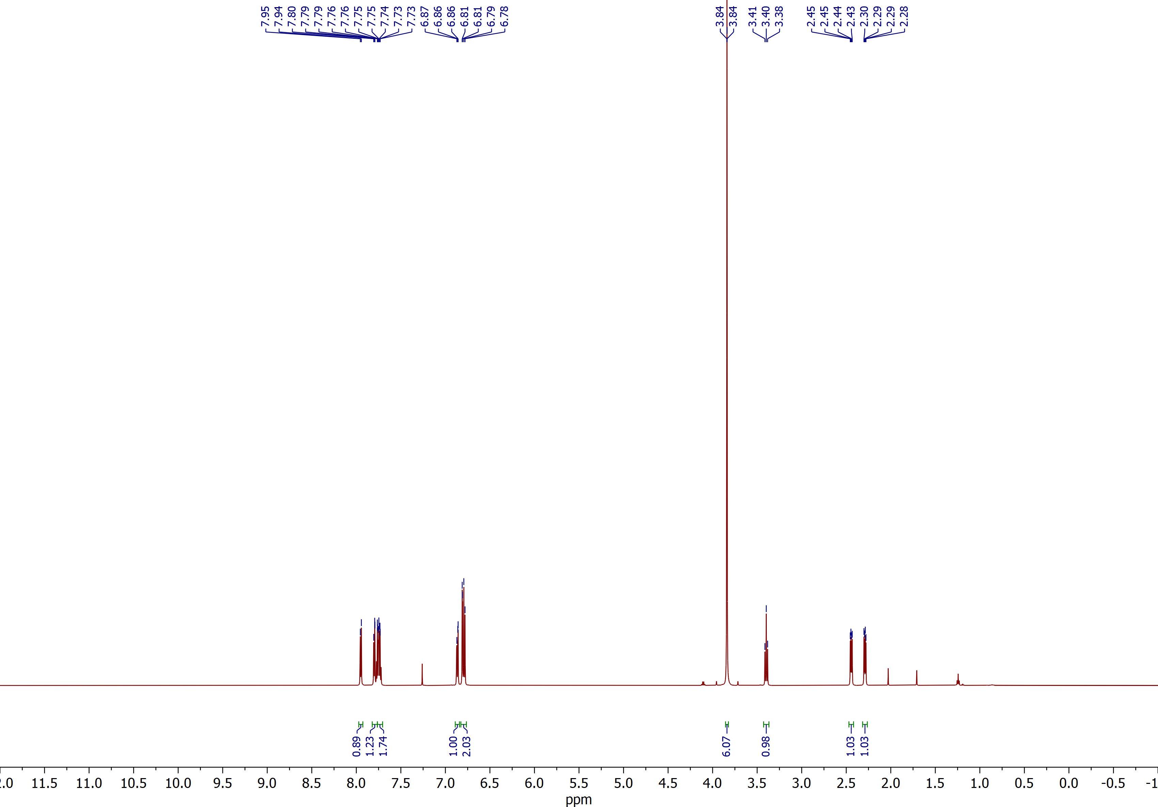

2-(3,4-Dimethoxyphenyl)spiro[cyclopropane-1,2'-indene]-1',3'-dione (2g)
¹³C NMR (CDCl₃, 150 MHz)
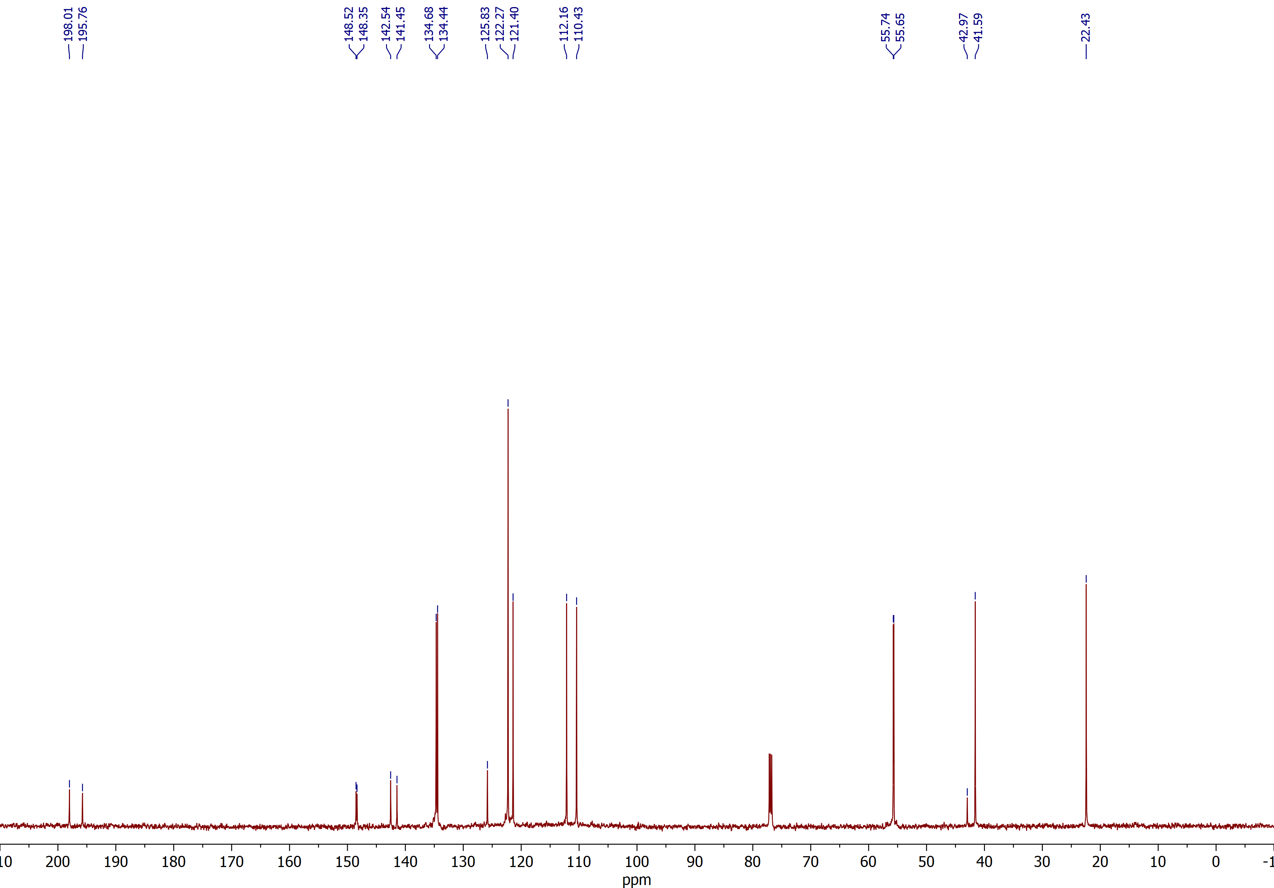

2-(4-(Trifluoromethoxy)phenyl)spiro[cyclopropane-1,2'-indene]-1',3'-dione (2h)
¹H NMR (CDCl₃, 600 MHz)
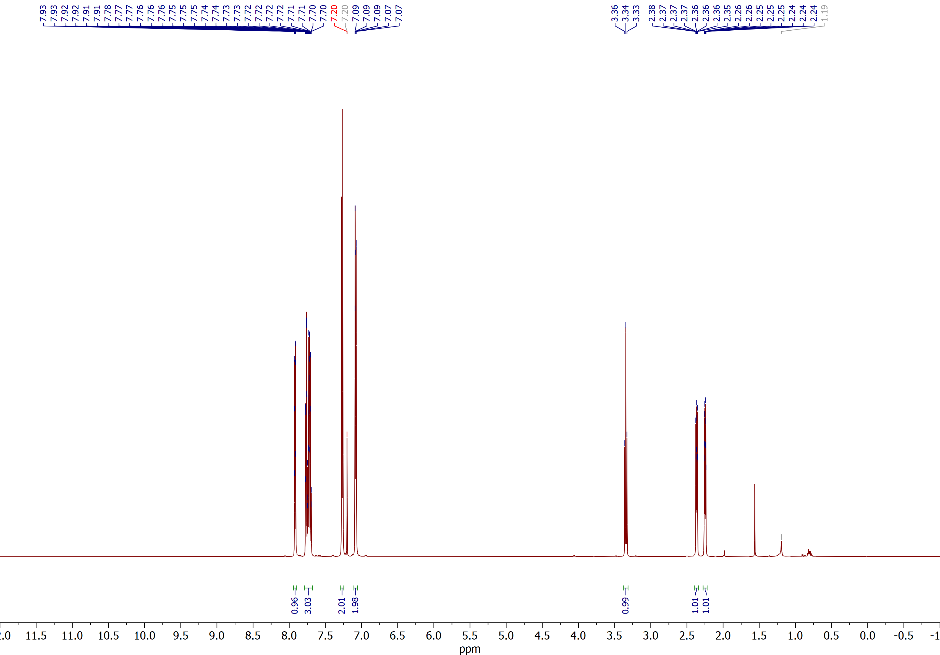

2-(4-(Trifluoromethoxy)phenyl)spiro[cyclopropane-1,2'-indene]-1',3'-dione (2h)
¹³C NMR (CDCl₃, 150 MHz)
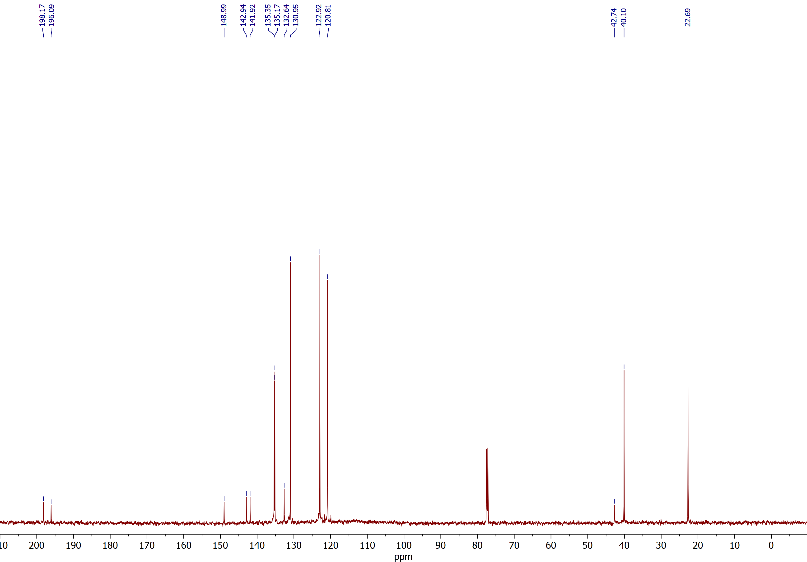

2-(3-Methoxyphenyl)spiro[cyclopropane-1,2'-indene]-1',3'-dione (2k)
¹H NMR (CDCl₃, 600 MHz)
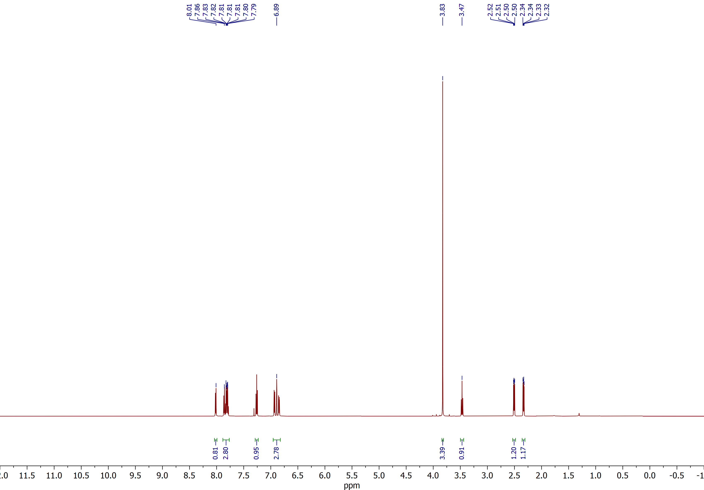

2-(3-Methoxyphenyl)spiro[cyclopropane-1,2'-indene]-1',3'-dione (2k)
¹³C NMR (CDCl₃, 150 MHz)
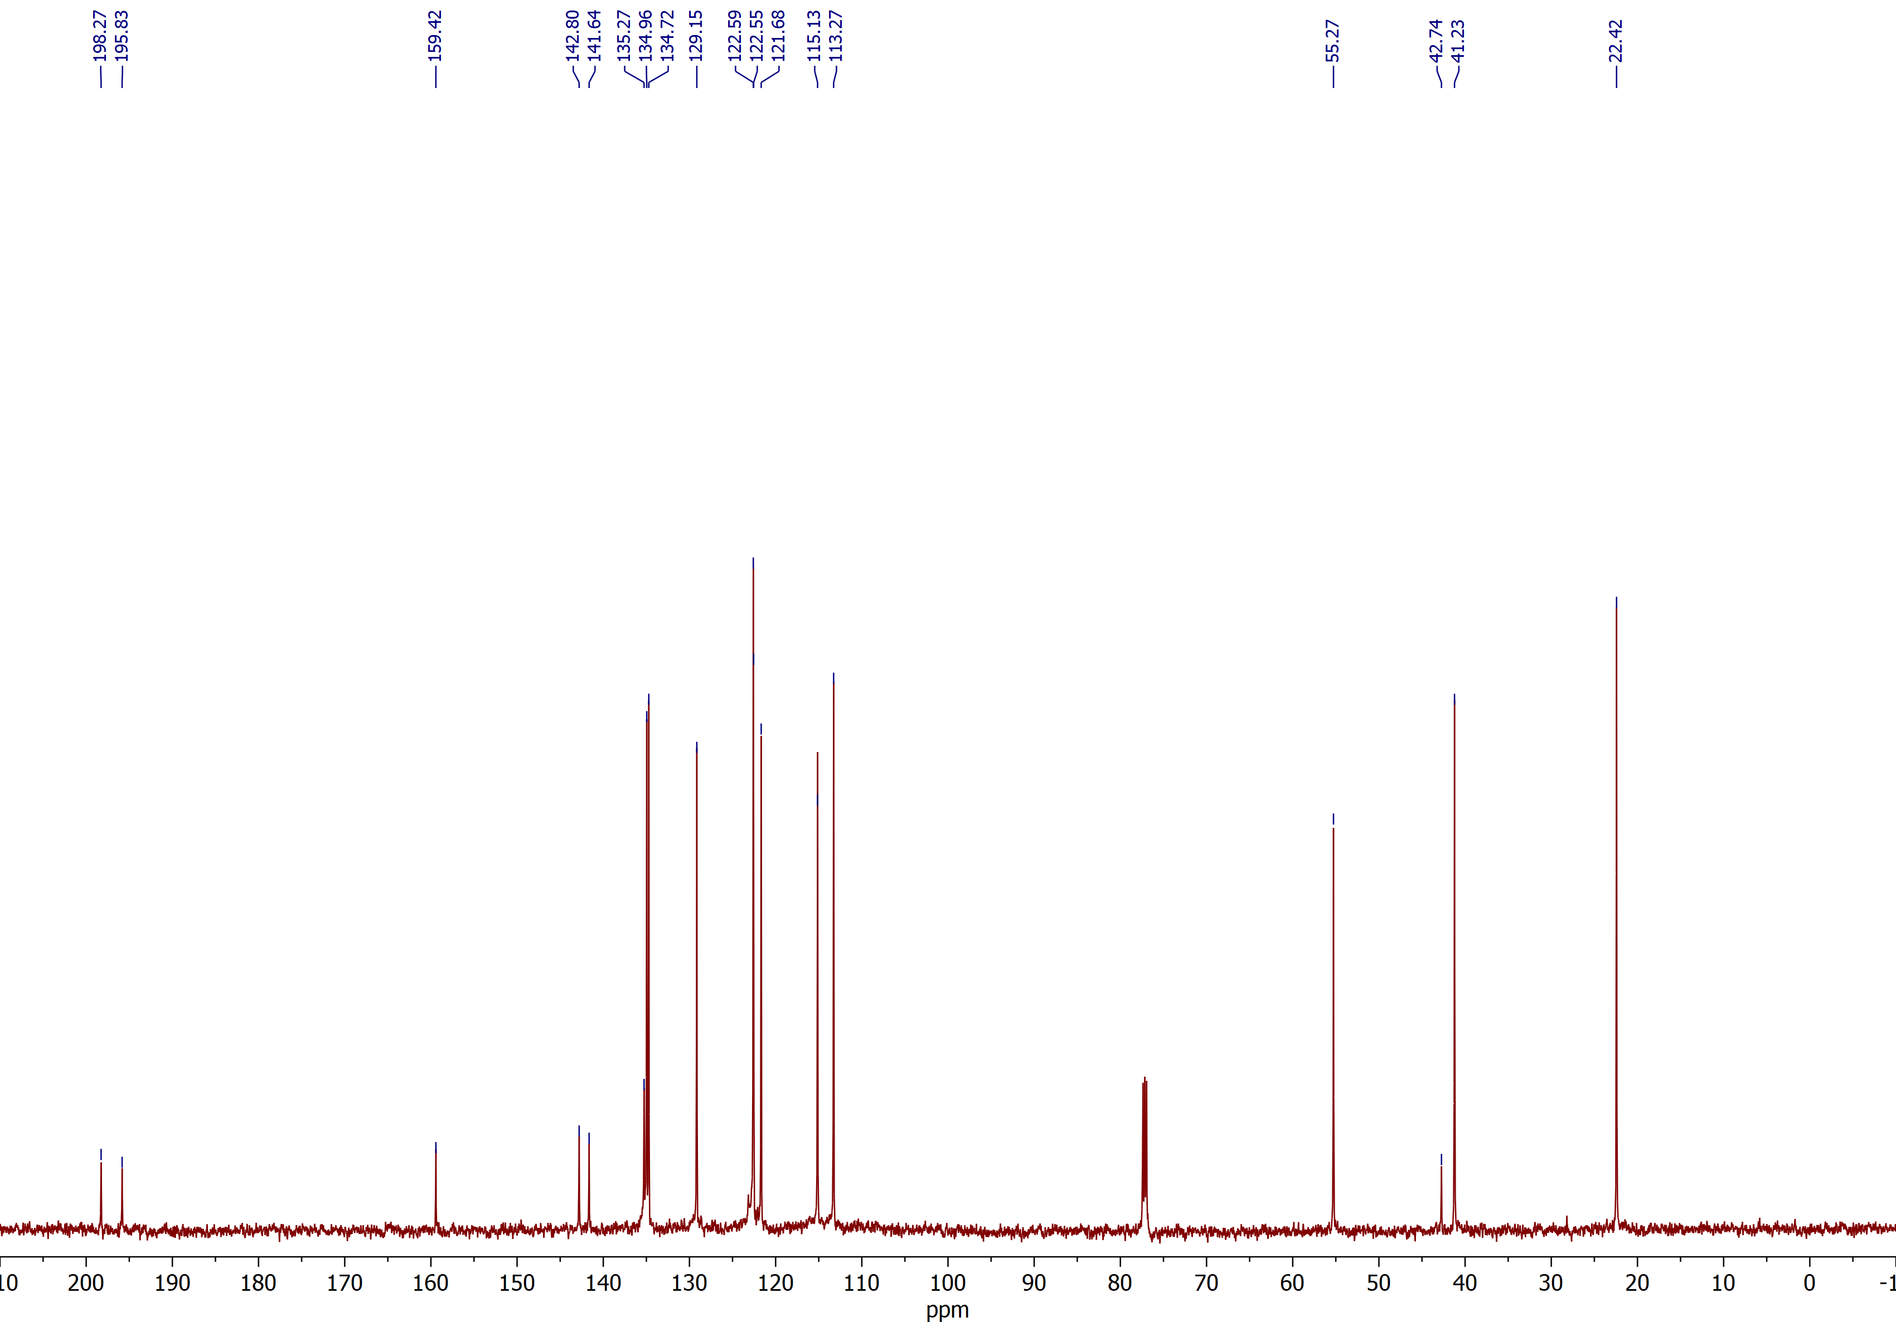

(2R,3S)-2-benzoyl-3-phenylspiro[cyclobutane-1,2'-indene]-1',3'-dione (3a)
¹H NMR (CDCl₃, 600 MHz)
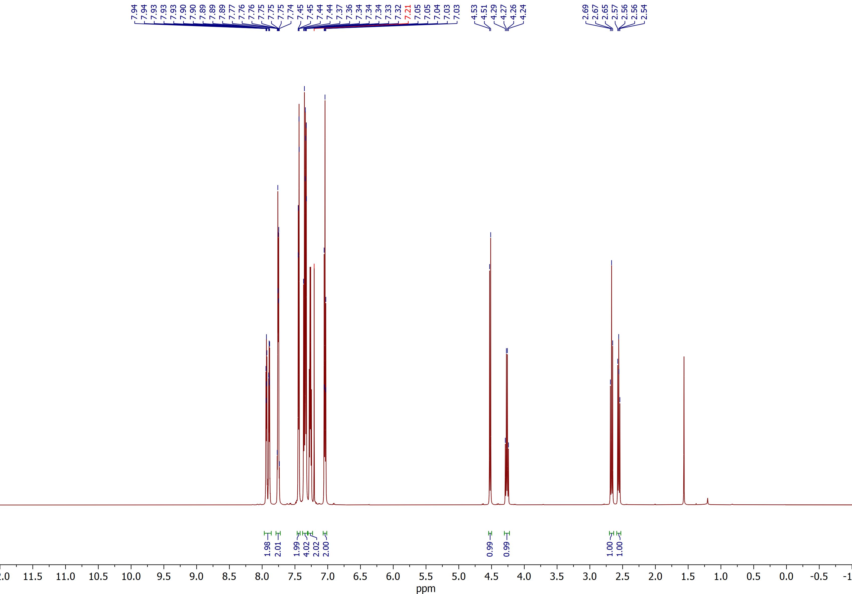

(2R,3S)-2-benzoyl-3-phenylspiro[cyclobutane-1,2'-indene]-1',3'-dione (3a)
¹³C NMR (CDCl₃, 150 MHz)
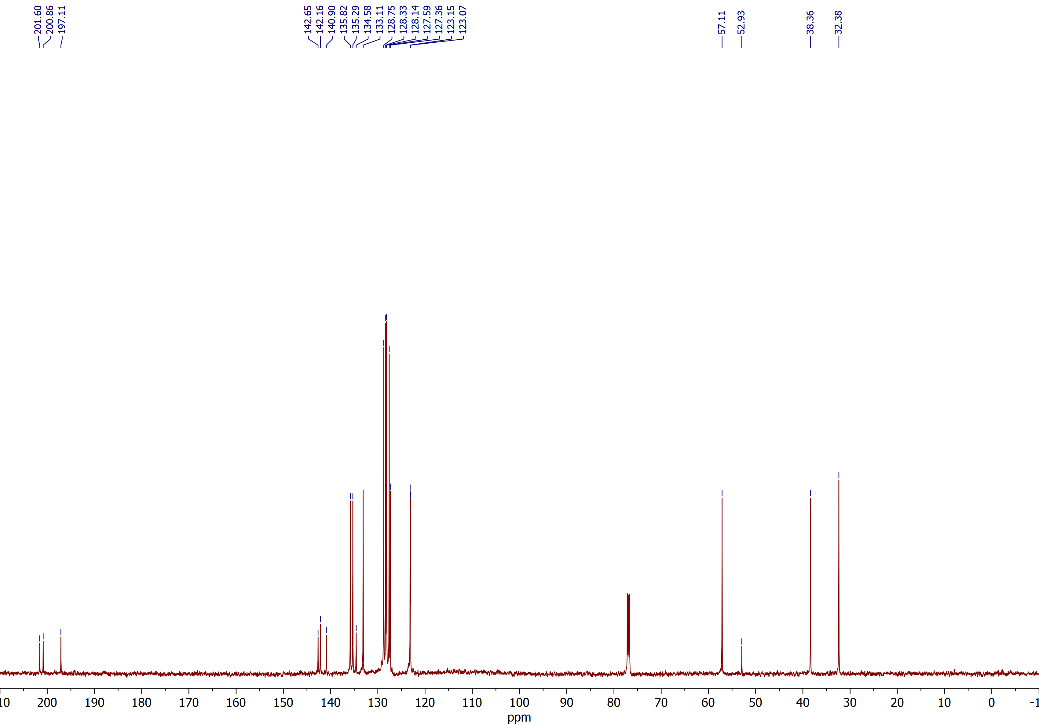

(2R,3S)-2-benzoyl-3-(p-tolyl)spiro[cyclobutane-1,2'-indene]-1',3'-dione (3b)
¹H NMR (CDCl₃, 600 MHz)
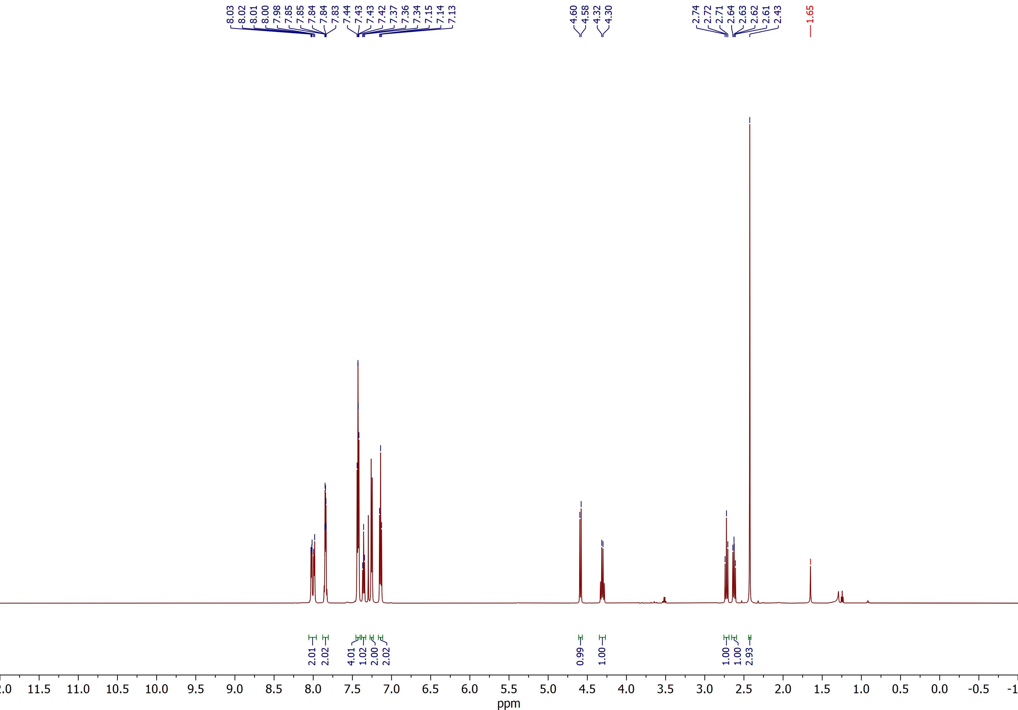

(2R,3S)-2-benzoyl-3-(p-tolyl)spiro[cyclobutane-1,2'-indene]-1',3'-dione (3b)
¹³C NMR (CDCl₃, 150 MHz)
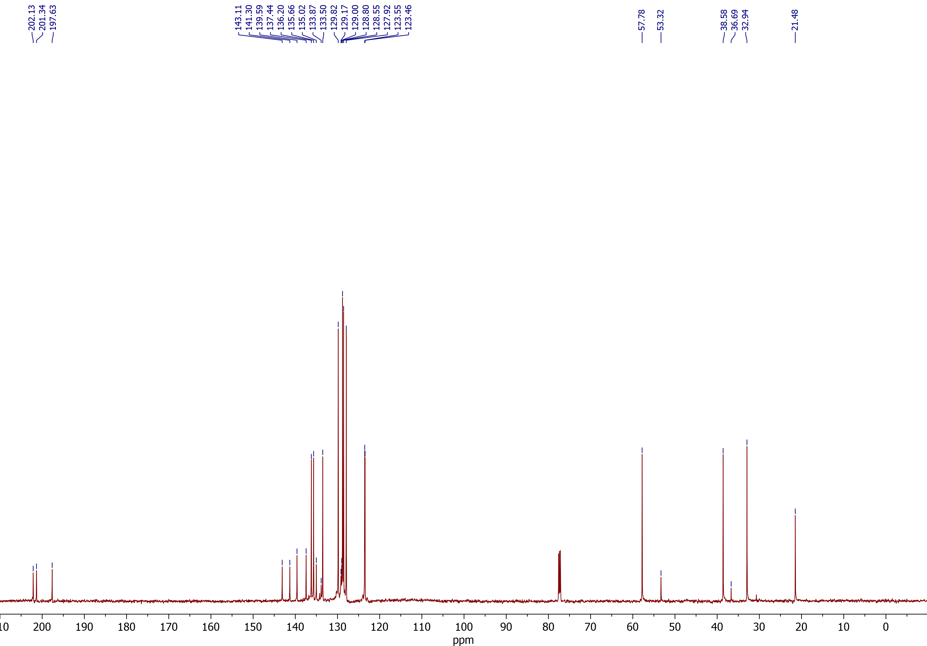

(2R,3S)-2-benzoyl-3-(o-tolyl)spiro[cyclobutane-1,2'-indene]-1',3'-dione (3c)
¹H NMR (CDCl₃, 600 MHz)
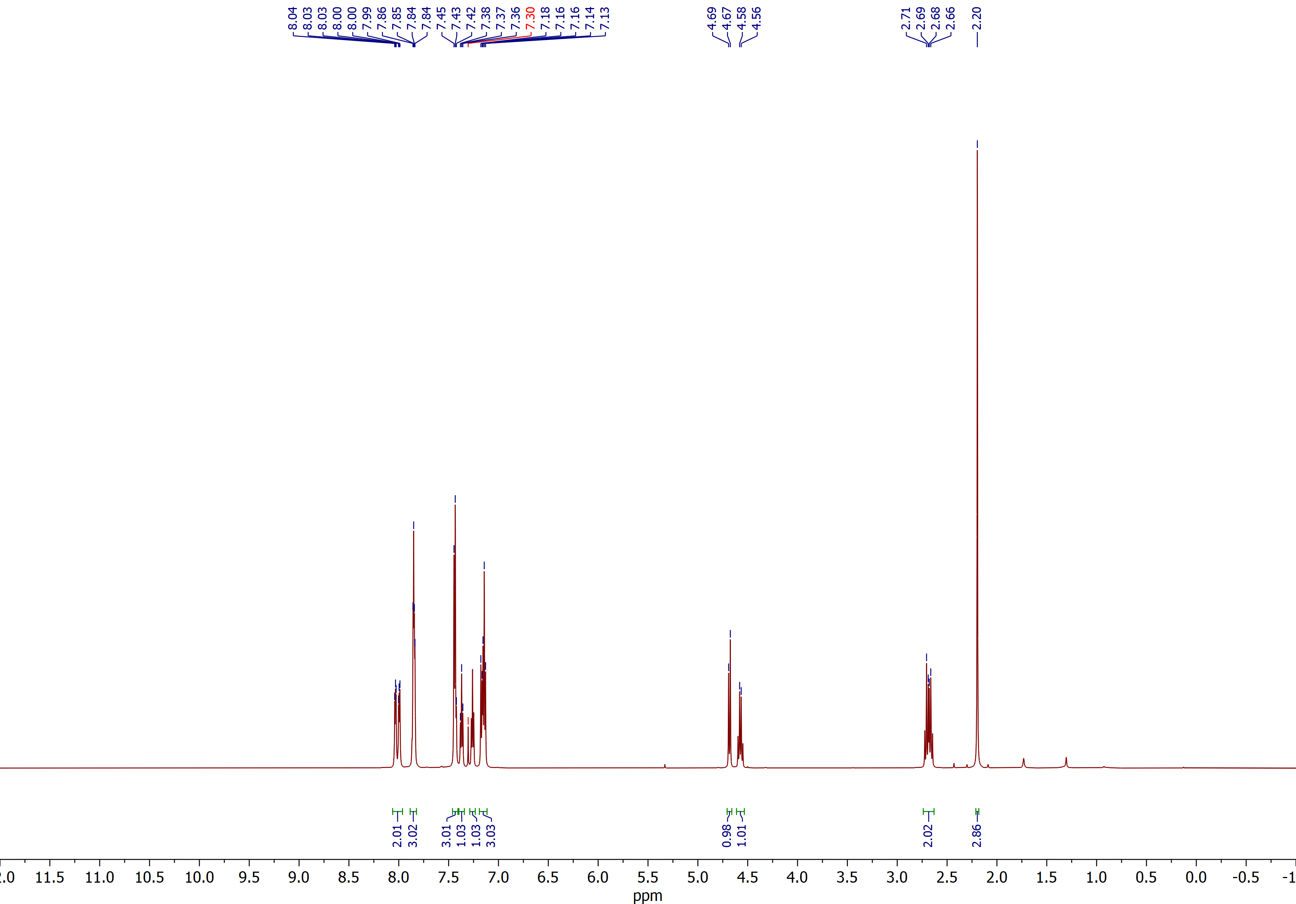

(2R,3S)-2-benzoyl-3-(o-tolyl)spiro[cyclobutane-1,2'-indene]-1',3'-dione (3c)
¹³C NMR (CDCl₃, 150 MHz)
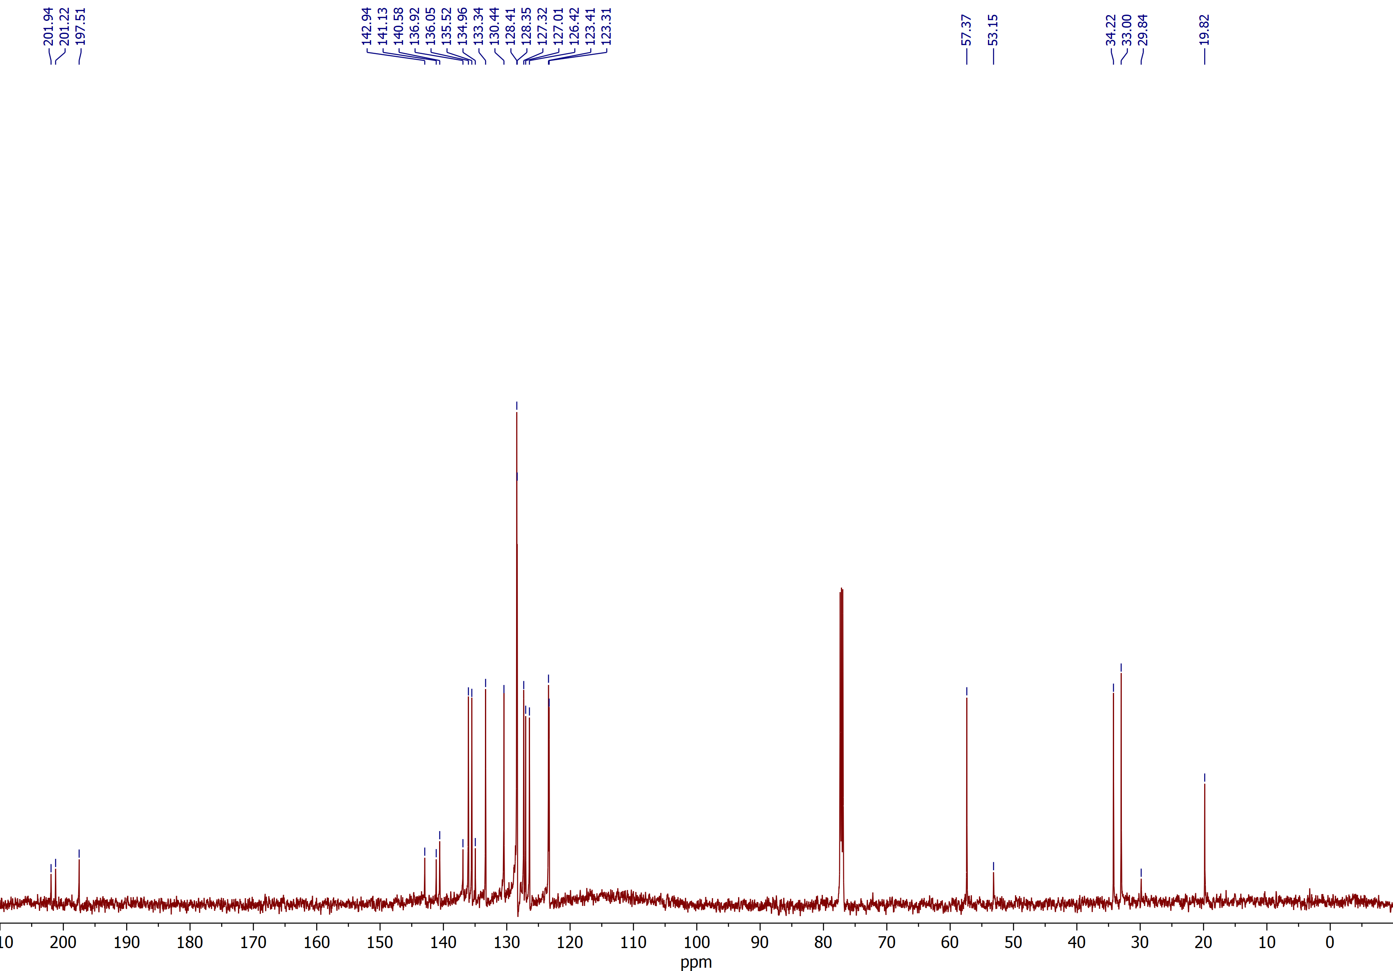

(2R,3S)-2-benzoyl-3-(4-fluorophenyl)spiro[cyclobutane-1,2'-indene]-1',3'-dione (3d)
¹H NMR (CDCl₃, 400 MHz)
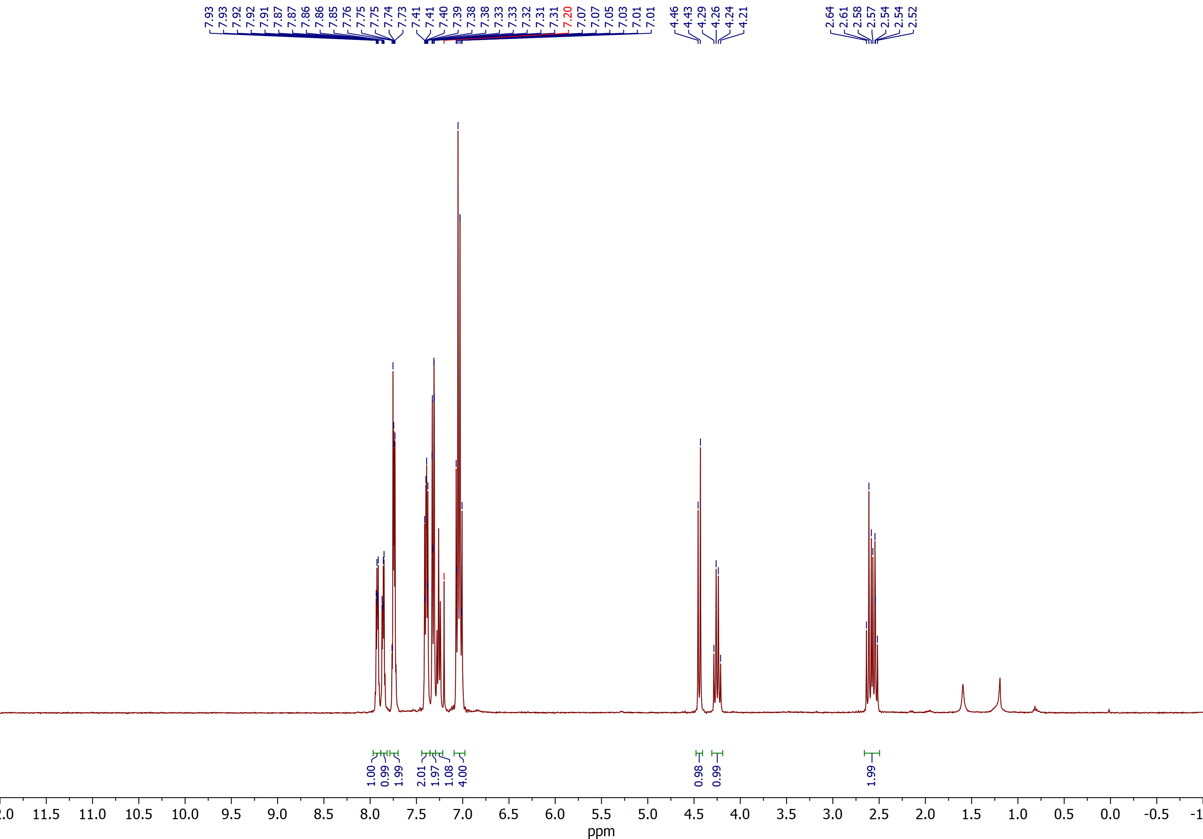

(2R,3S)-2-benzoyl-3-(4-fluorophenyl)spiro[cyclobutane-1,2'-indene]-1',3'-dione (3d)
¹³C NMR (CDCl₃, 150 MHz)
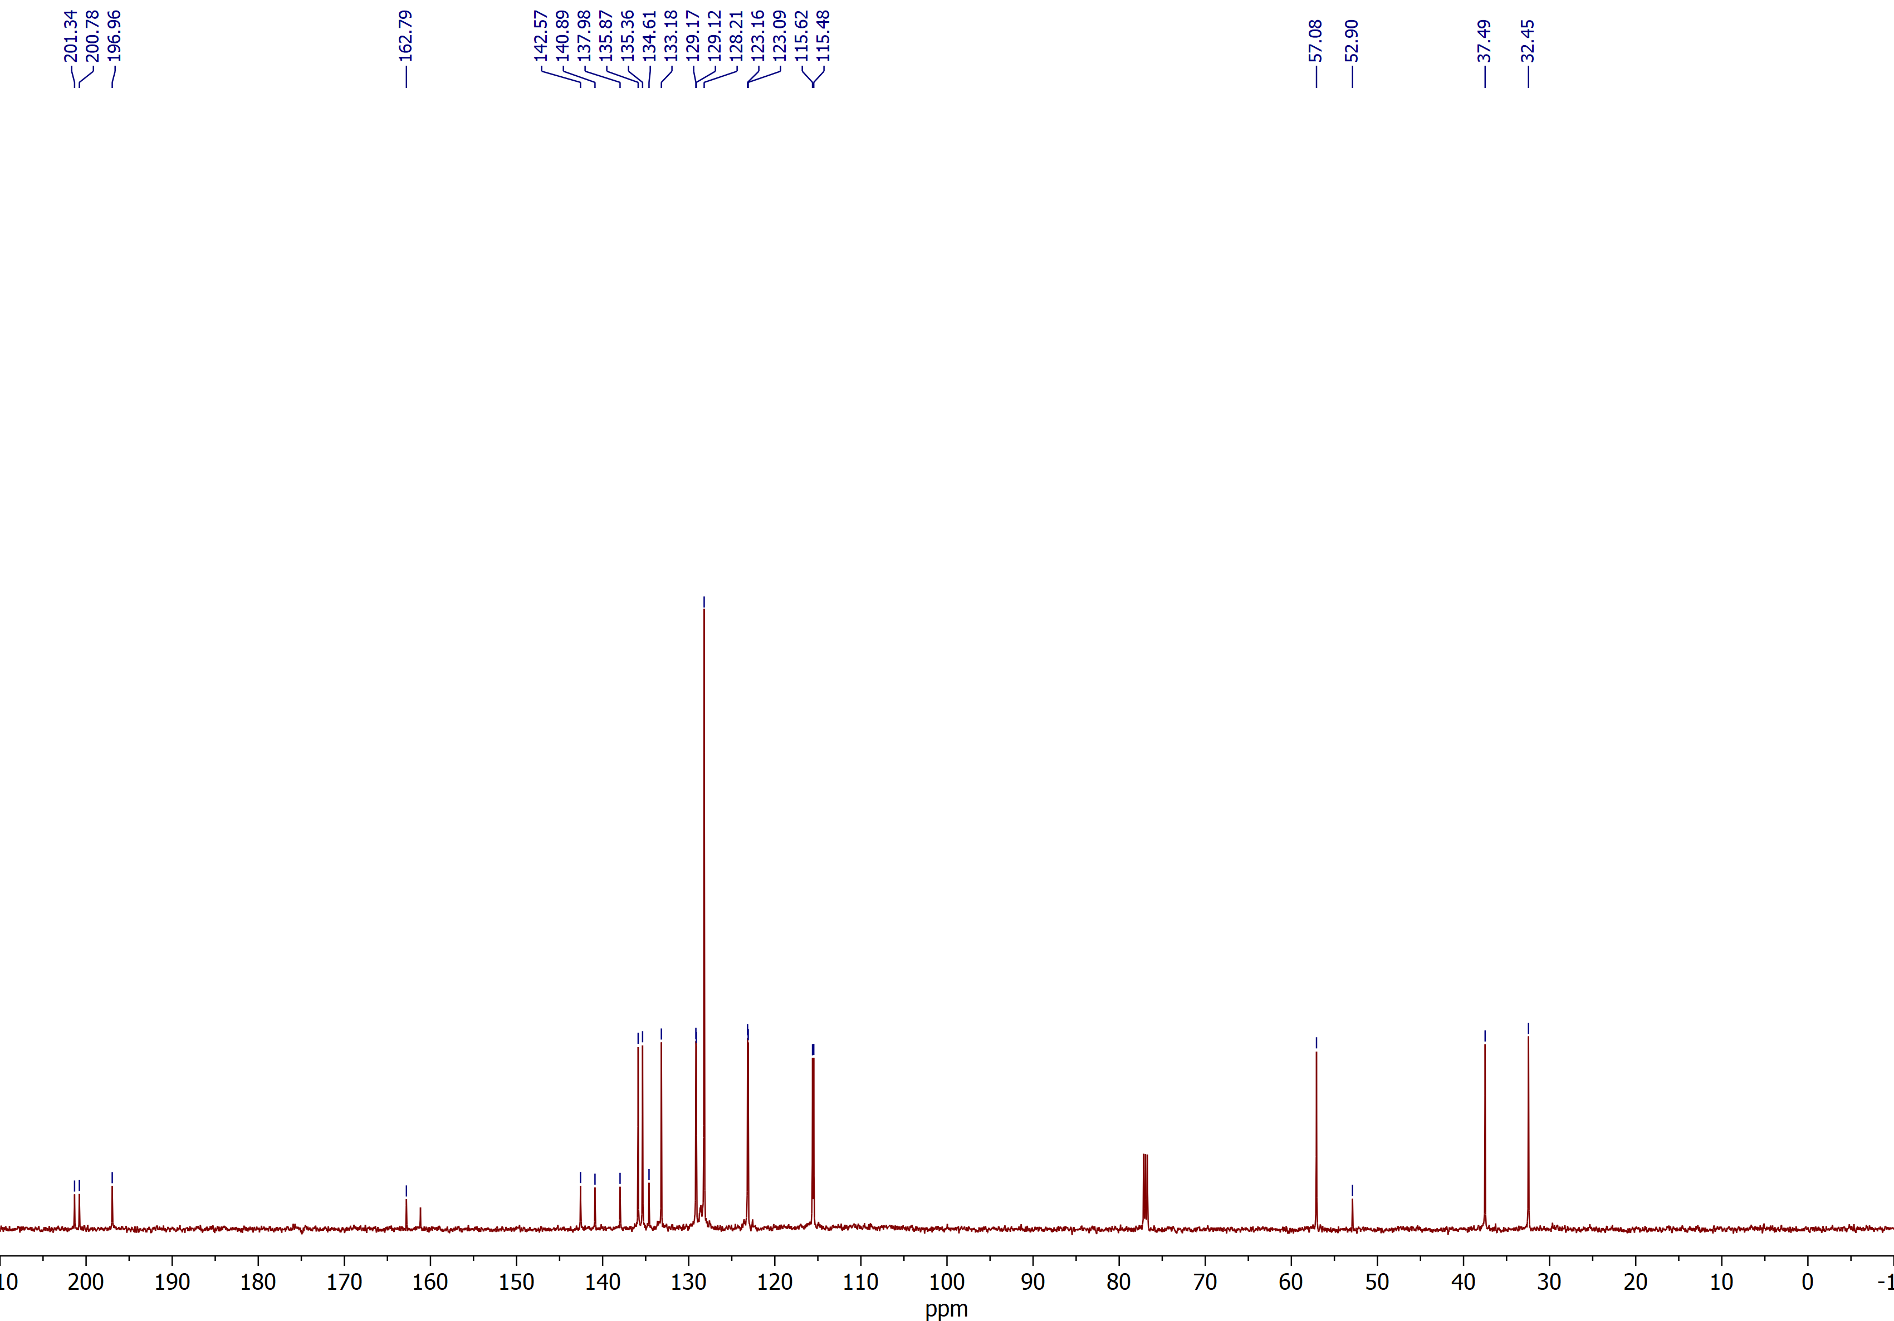

(2R,3S)-2-benzoyl-3-(4-bromophenyl)spiro[cyclobutane-1,2'-indene]-1',3'-dione (3e)
¹H NMR (CDCl₃, 600 MHz)
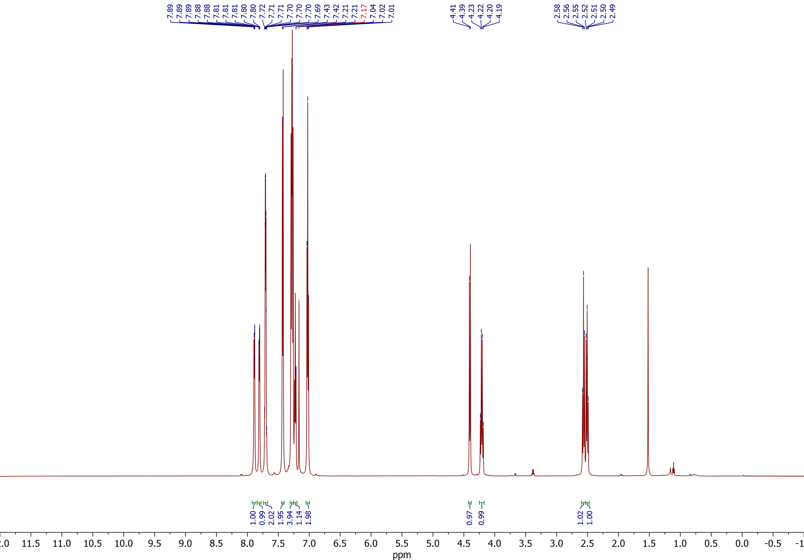

(2R,3S)-2-benzoyl-3-(4-bromophenyl)spiro[cyclobutane-1,2'-indene]-1',3'-dione (3e)
¹³C NMR (CDCl₃, 150 MHz)
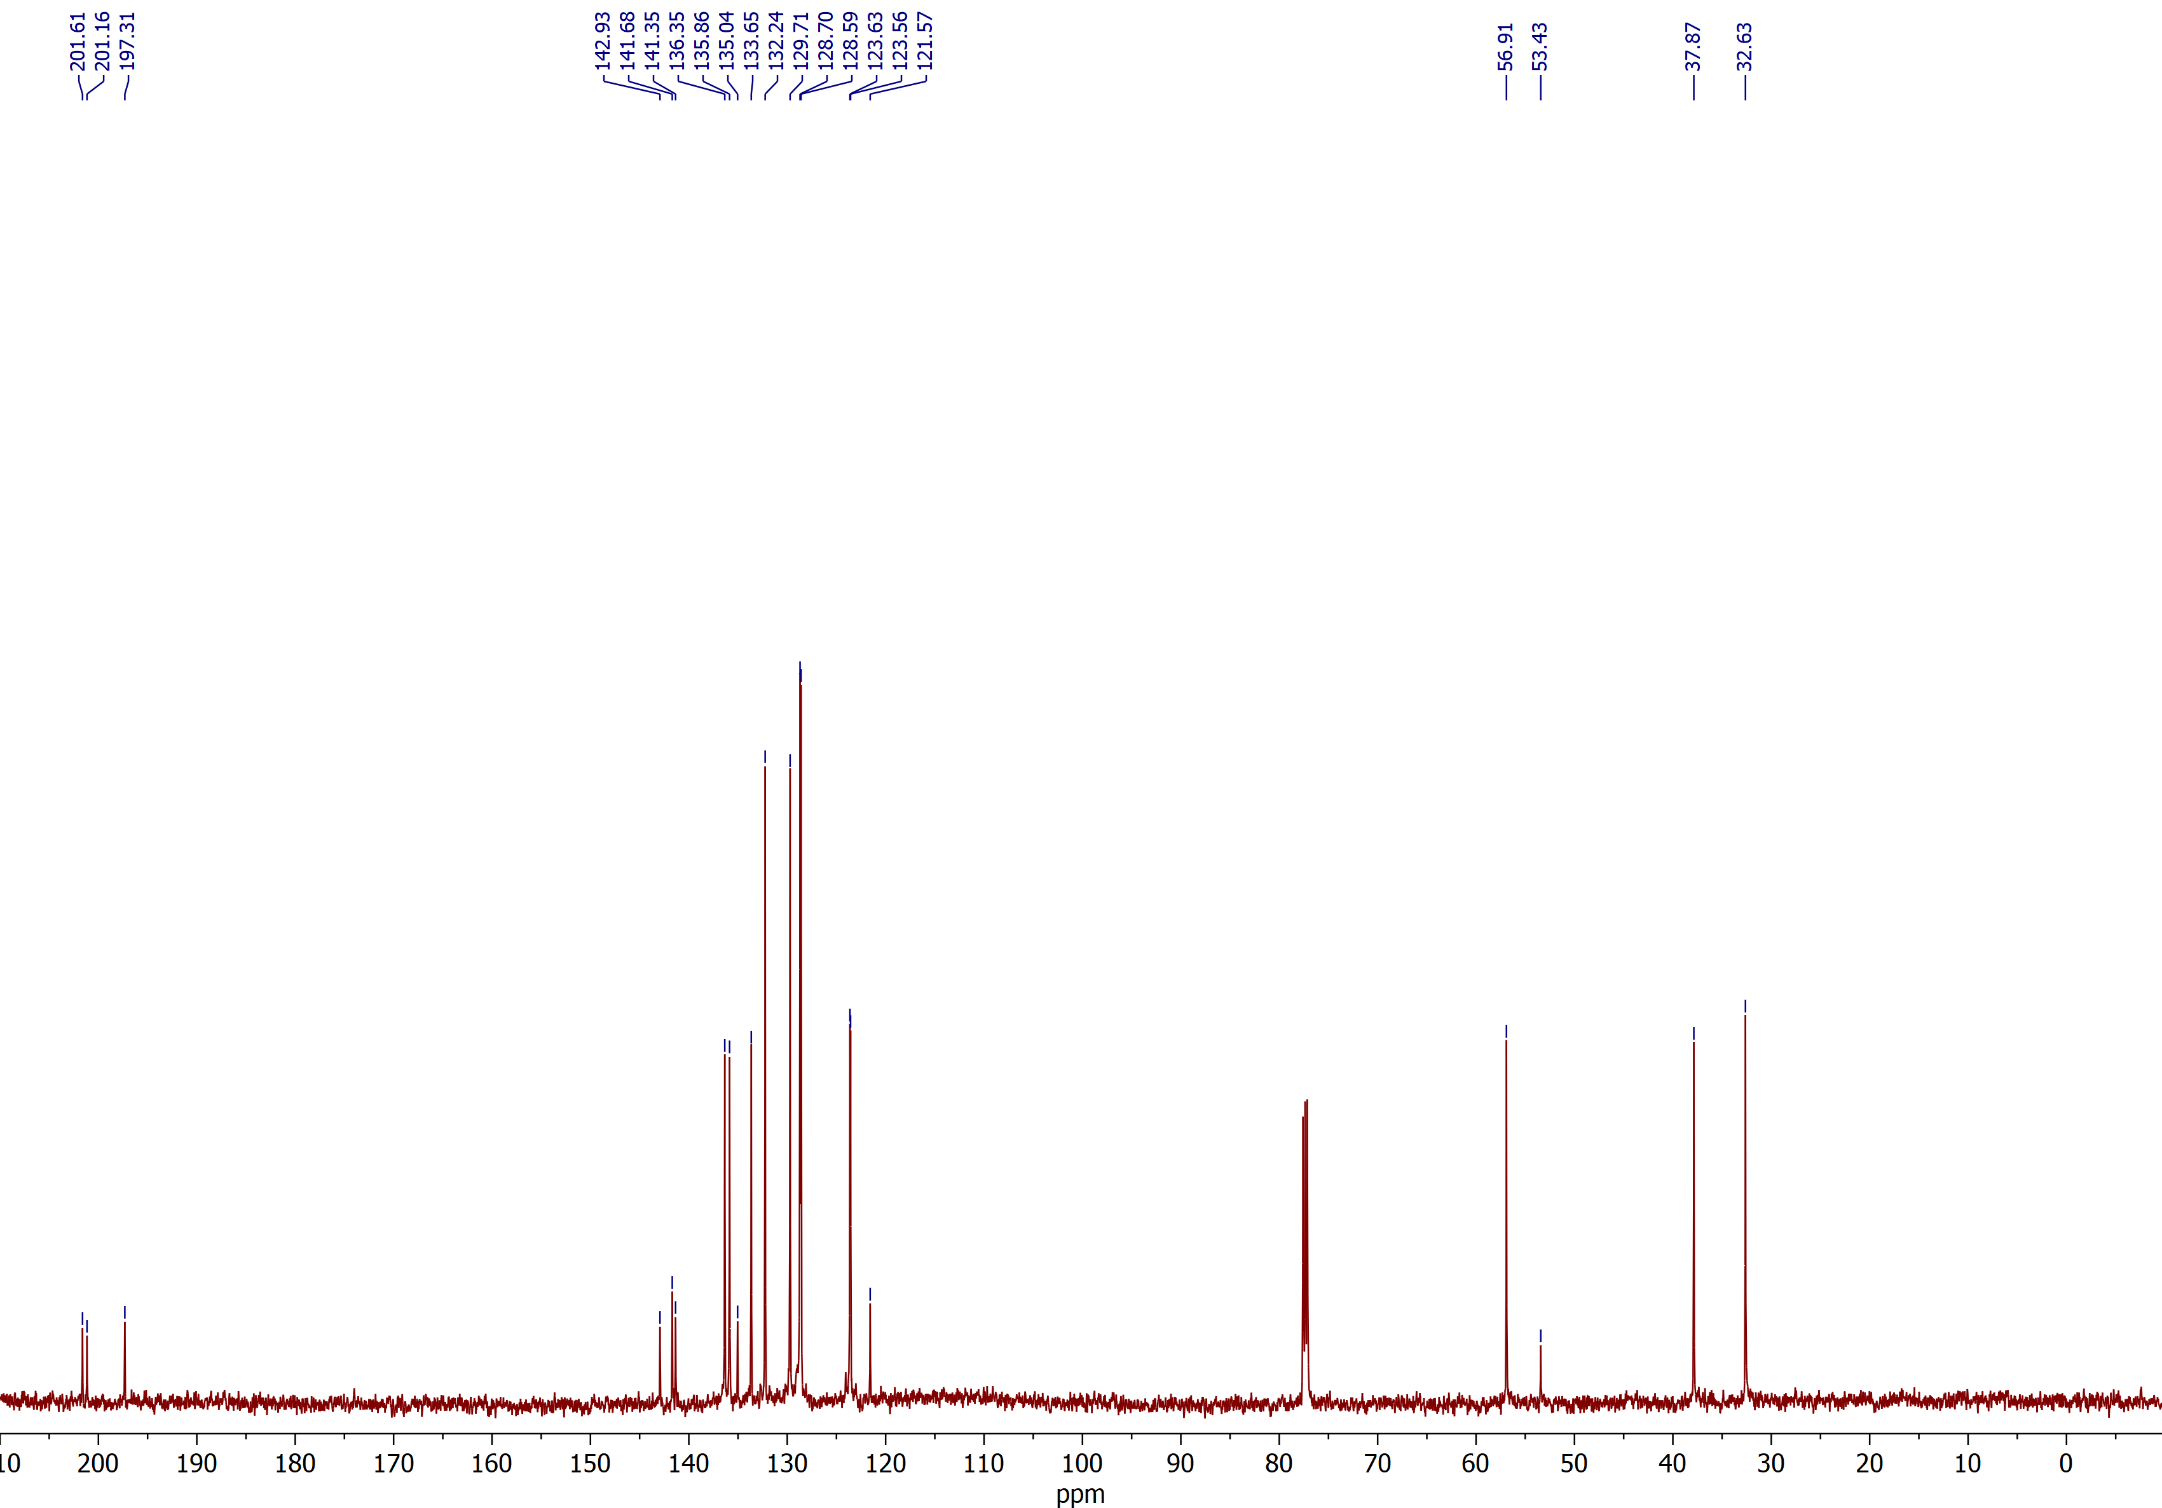

(2R,3S)-2-benzoyl-3-(4-methoxyphenyl)spiro[cyclobutane-1,2'-indene]-1',3'-dione (3f)
¹H NMR (CDCl₃, 600 MHz)
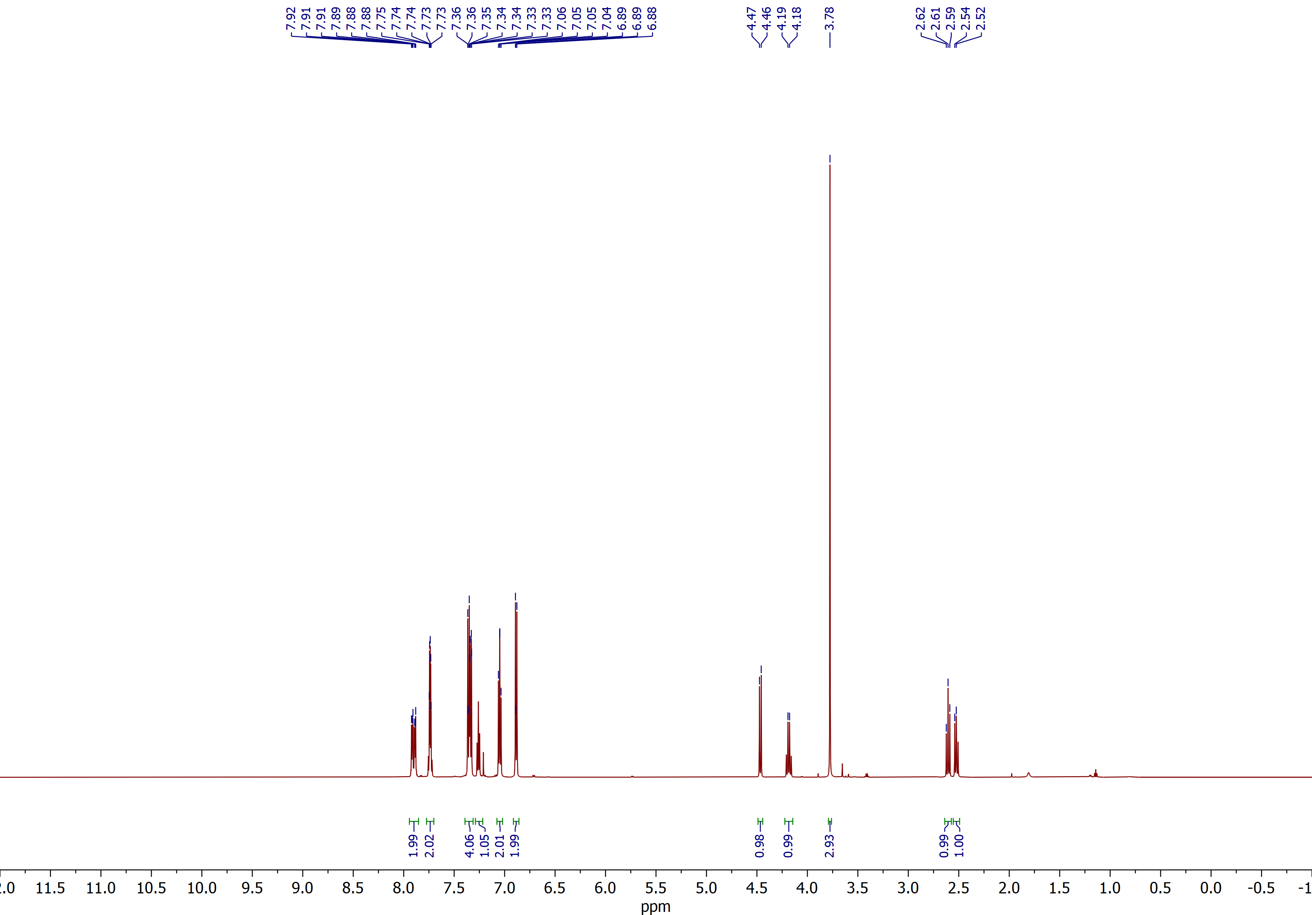

(2R,3S)-2-benzoyl-3-(4-methoxyphenyl)spiro[cyclobutane-1,2'-indene]-1',3'-dione (3f)
¹³C NMR (CDCl₃, 150 MHz)
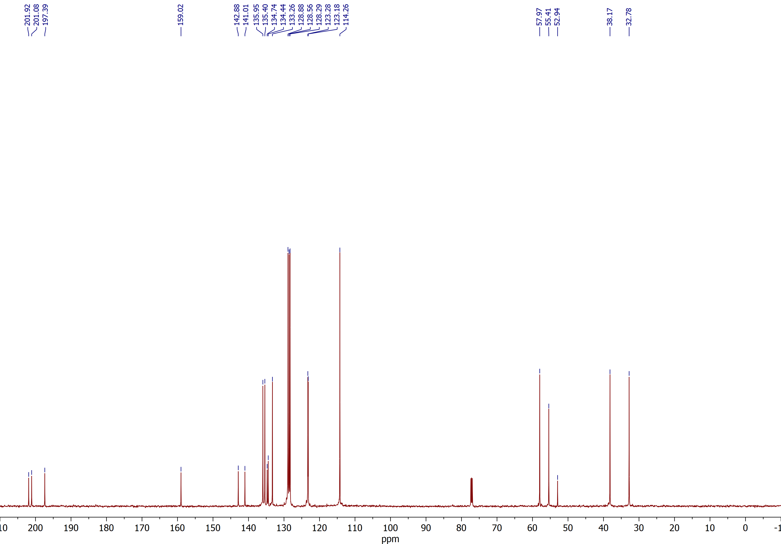

(2R,3S)-2-benzoyl-3-(3,4-dimethoxyphenyl)spiro[cyclobutane-1,2'-indene]-1',3'-dione (3g)
¹H NMR (CDCl₃, 600 MHz)
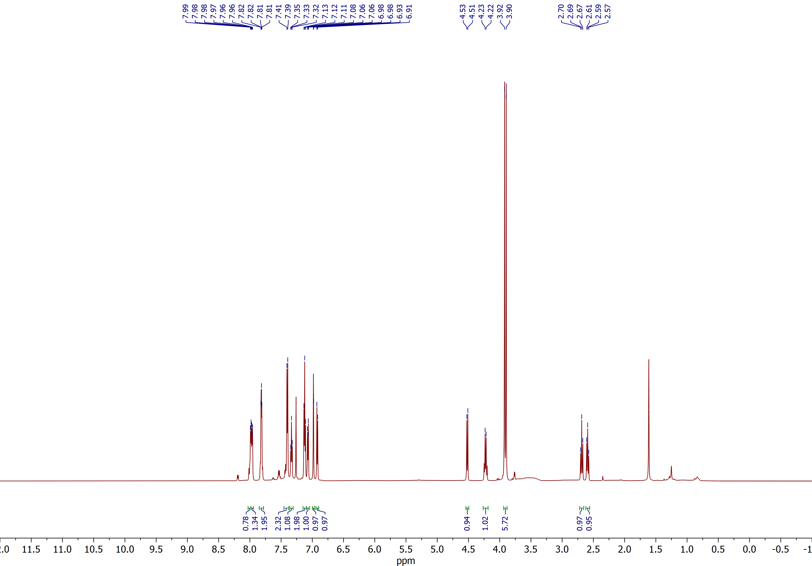

(2R,3S)-2-benzoyl-3-(3,4-dimethoxyphenyl)spiro[cyclobutane-1,2'-indene]-1',3'-dione (3g)
¹³C NMR (CD₂Cl₂, 100 MHz)
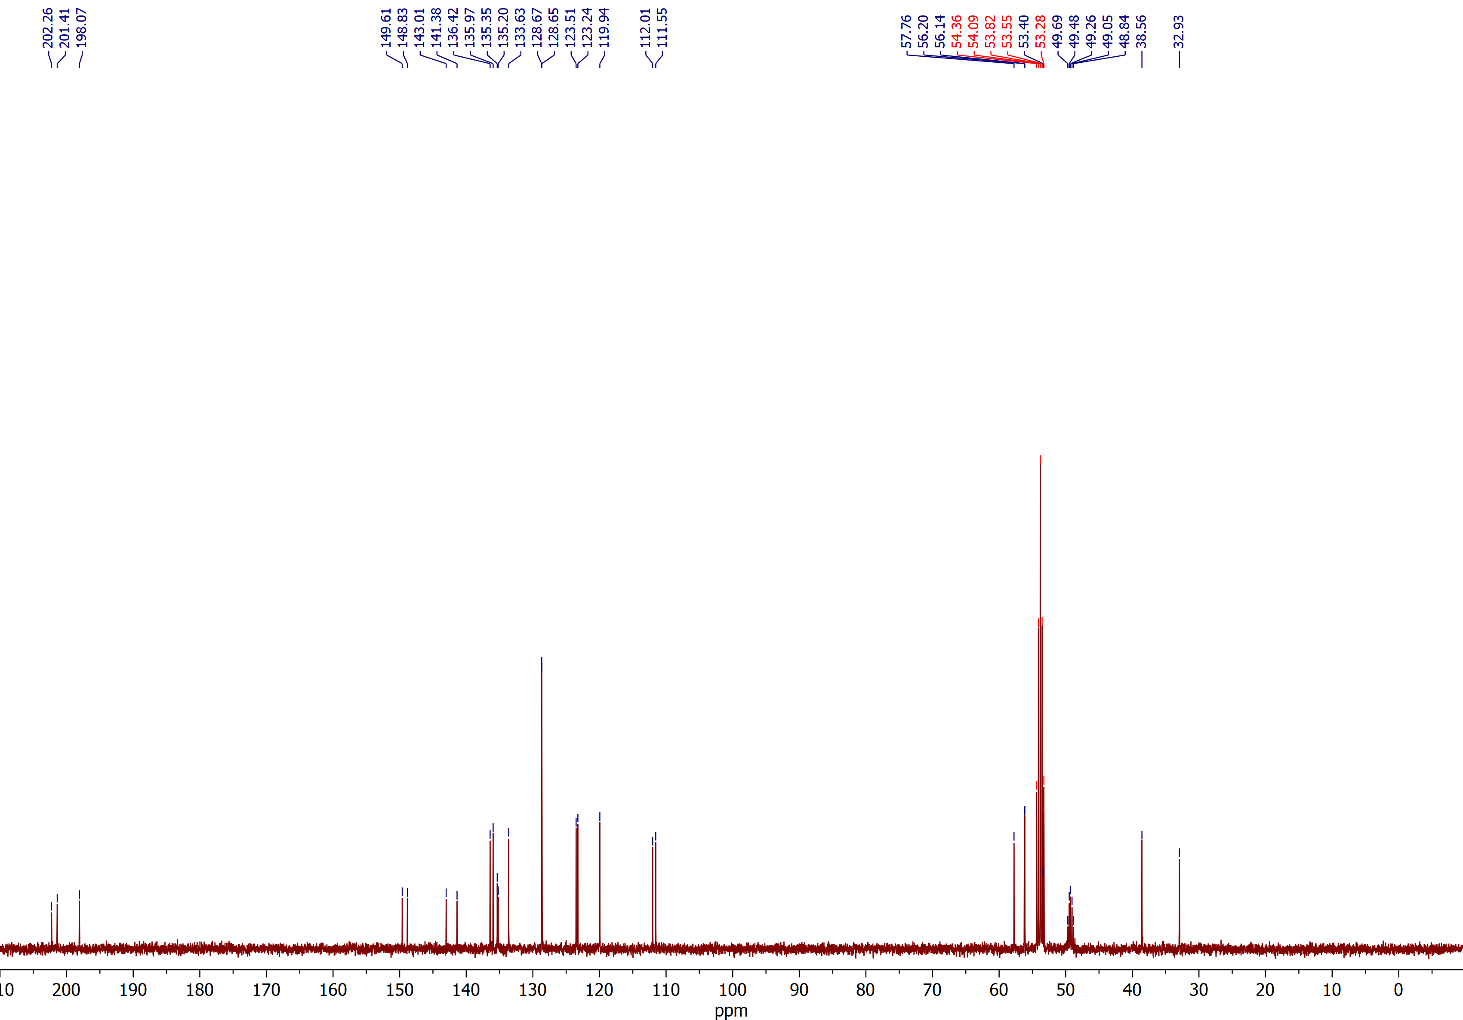

(2R,3S)-2-benzoyl-3-(4-(trifluoromethoxy)phenyl)spiro[cyclobutane-1,2'-indene]-1',3'-dione (3h)
¹H NMR (CDCl₃, 600 MHz)
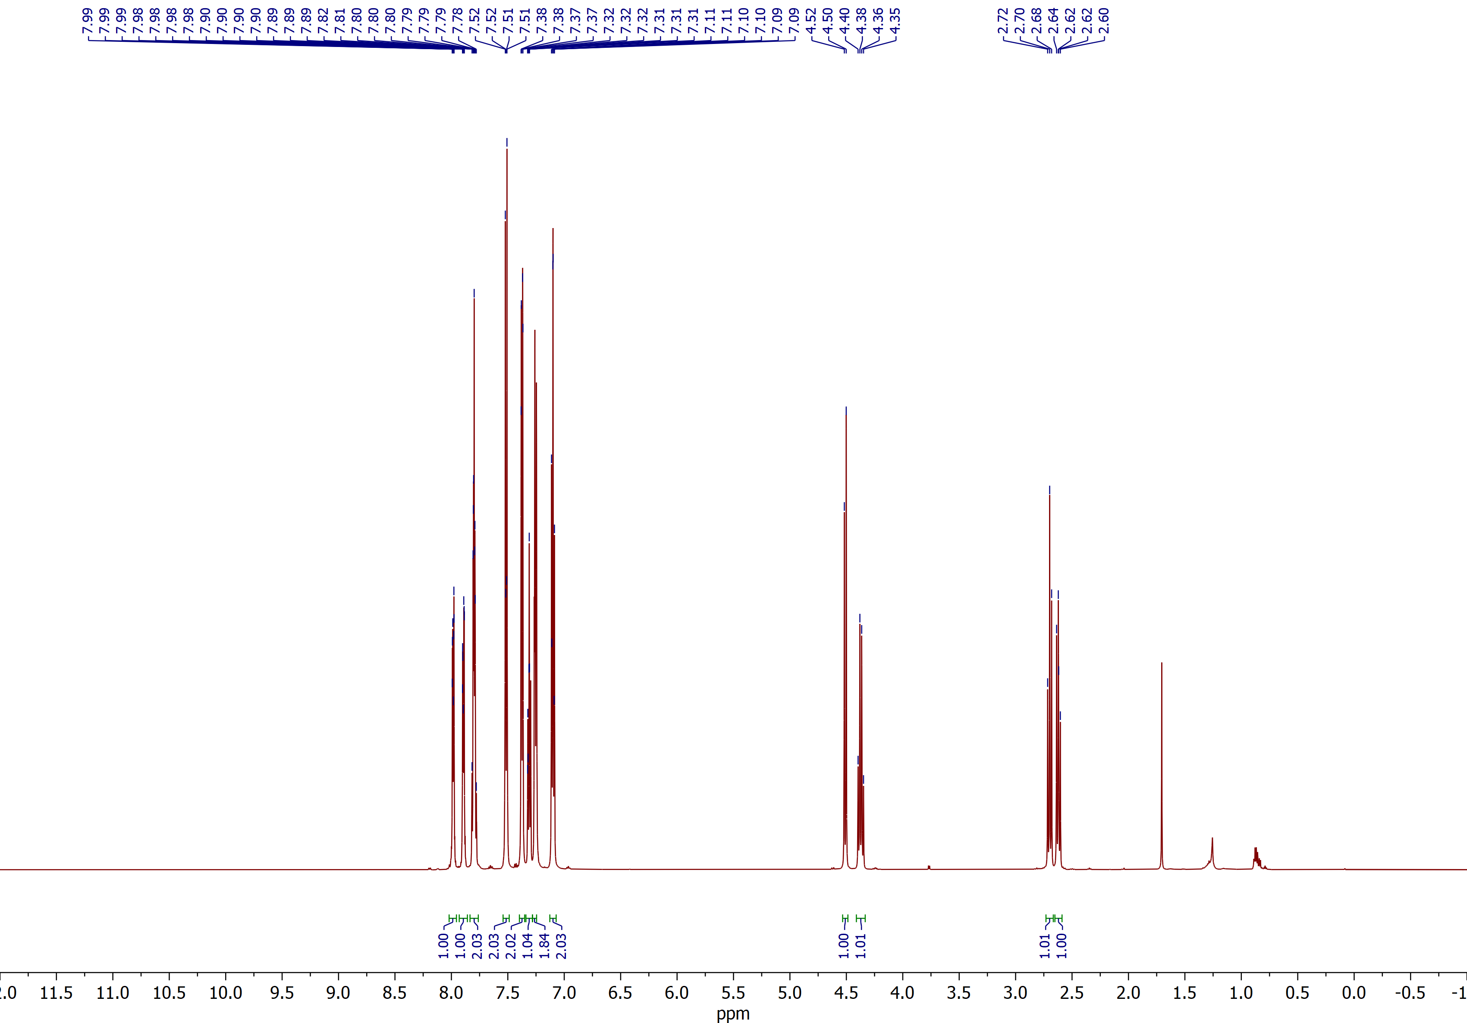

(2R,3S)-2-benzoyl-3-(4-(trifluoromethoxy)phenyl)spiro[cyclobutane-1,2'-indene]-1',3'-dione (3h)
¹³C NMR (CDCl₃, 150 MHz)
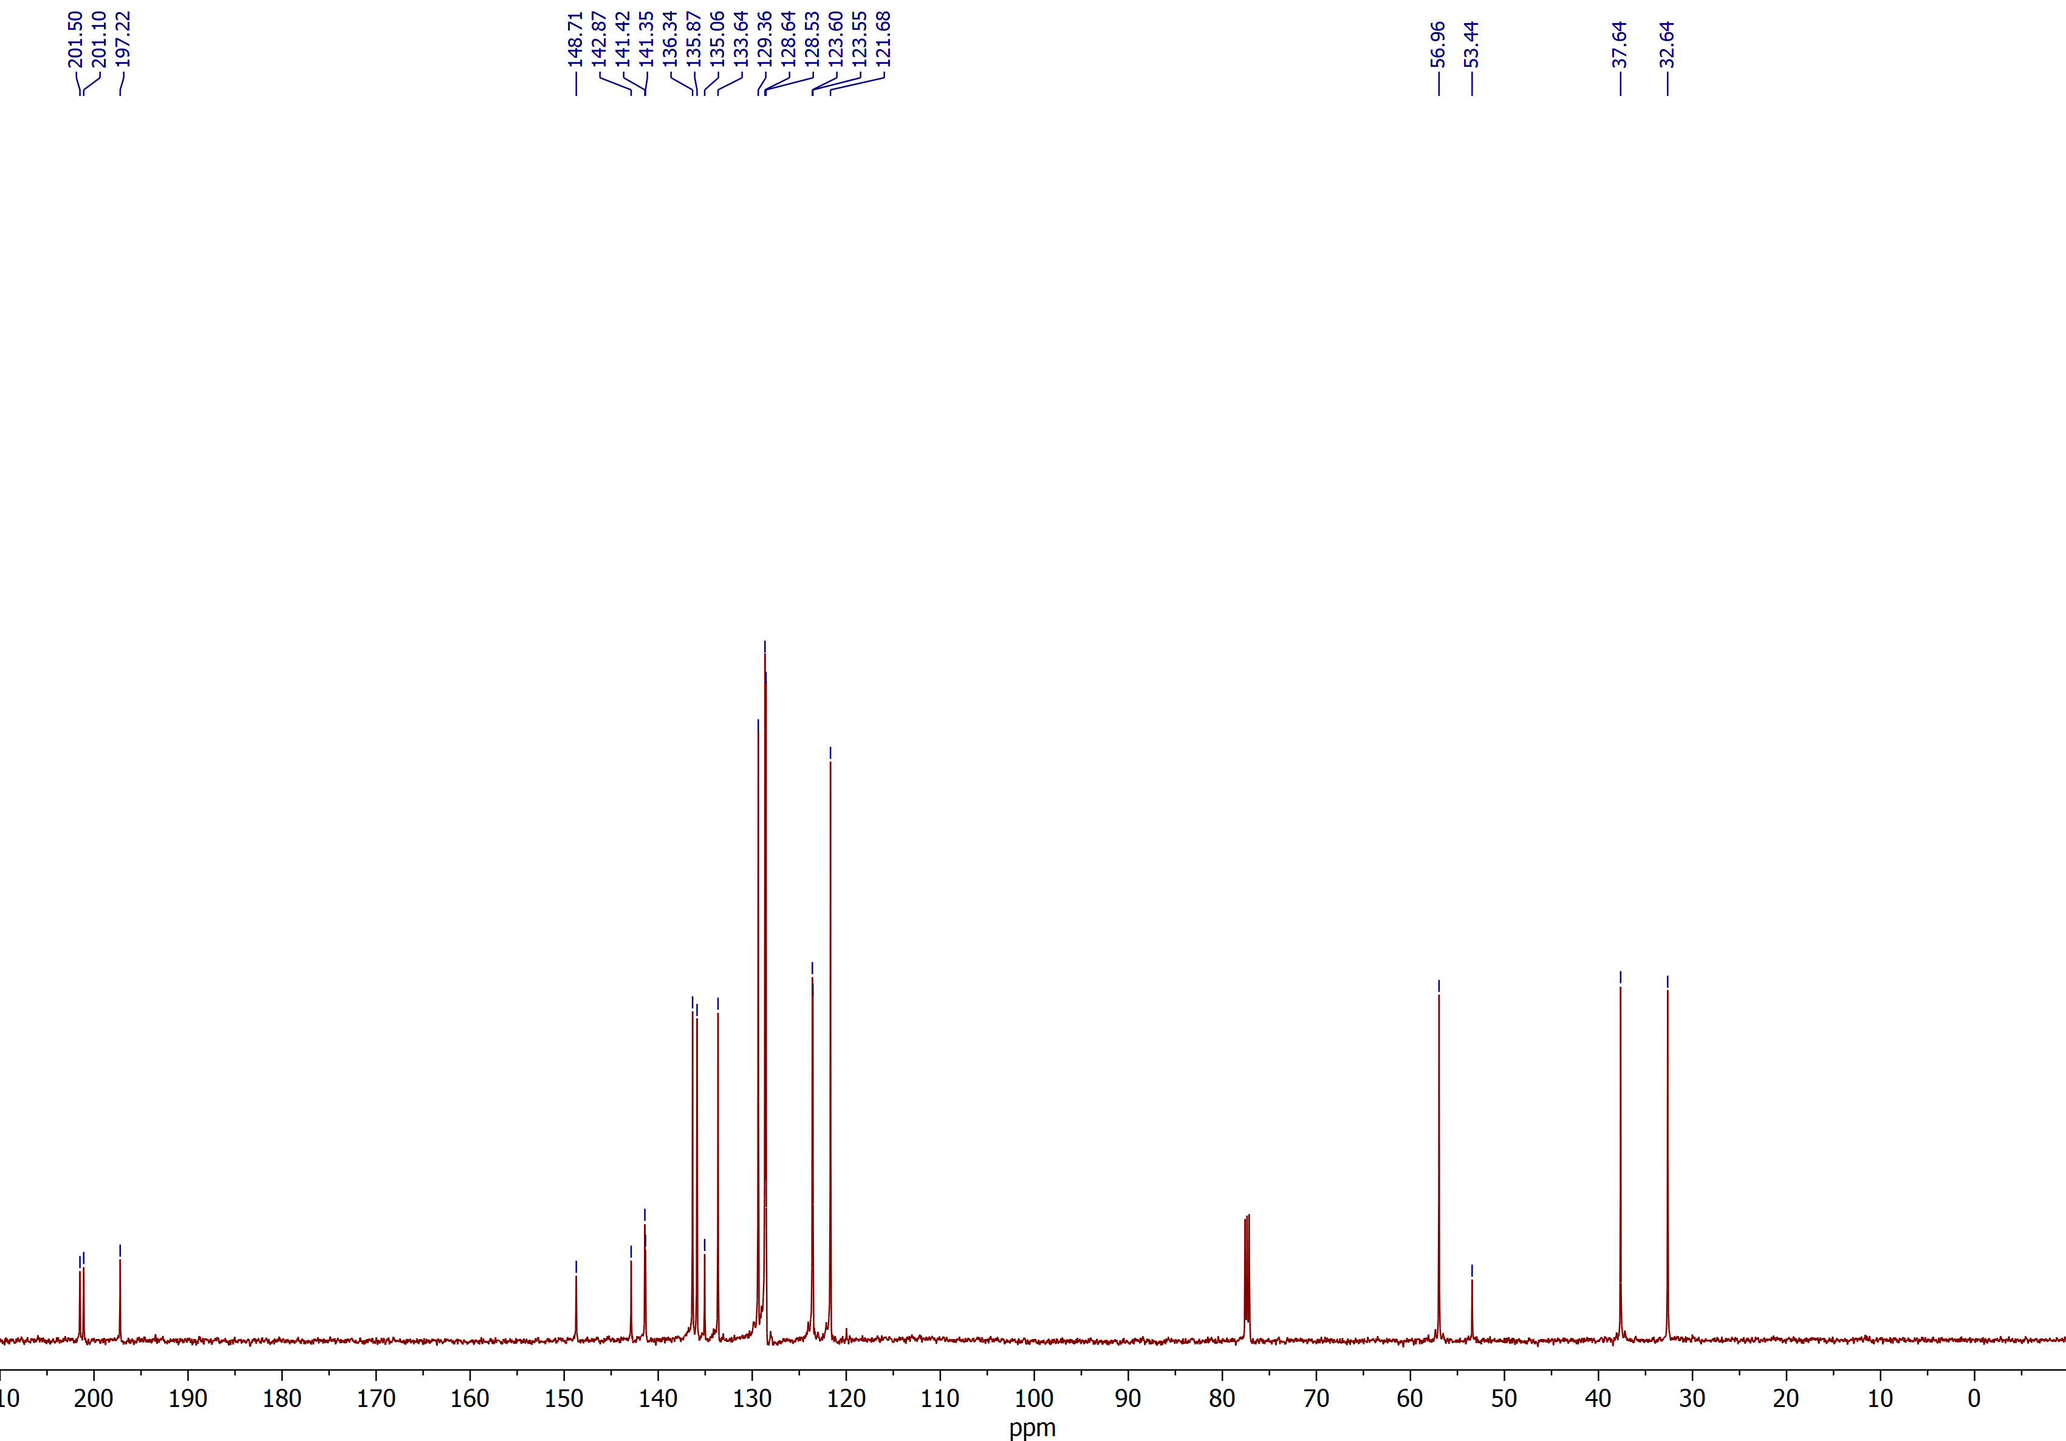

4-((2R,3S)-2-benzoyl-1',3'-dioxo-1',3'-dihydrospiro[cyclobutane-1,2'-inden]-3-yl)benzonitrile (3i)
¹H NMR (CDCl₃, 600 MHz)
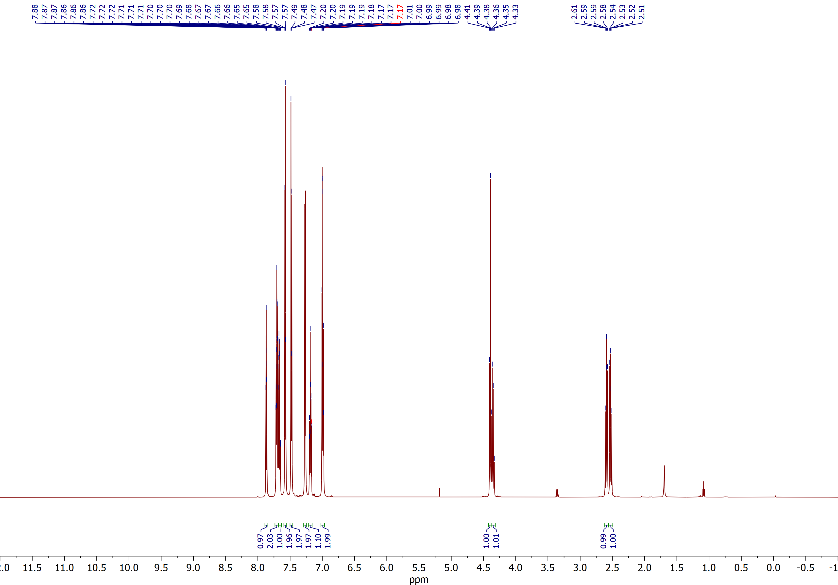

4-((2R,3S)-2-benzoyl-1',3'-dioxo-1',3'-dihydrospiro[cyclobutane-1,2'-inden]-3-yl)benzonitrile (3i)
¹³C NMR (CDCl₃, 150 MHz)
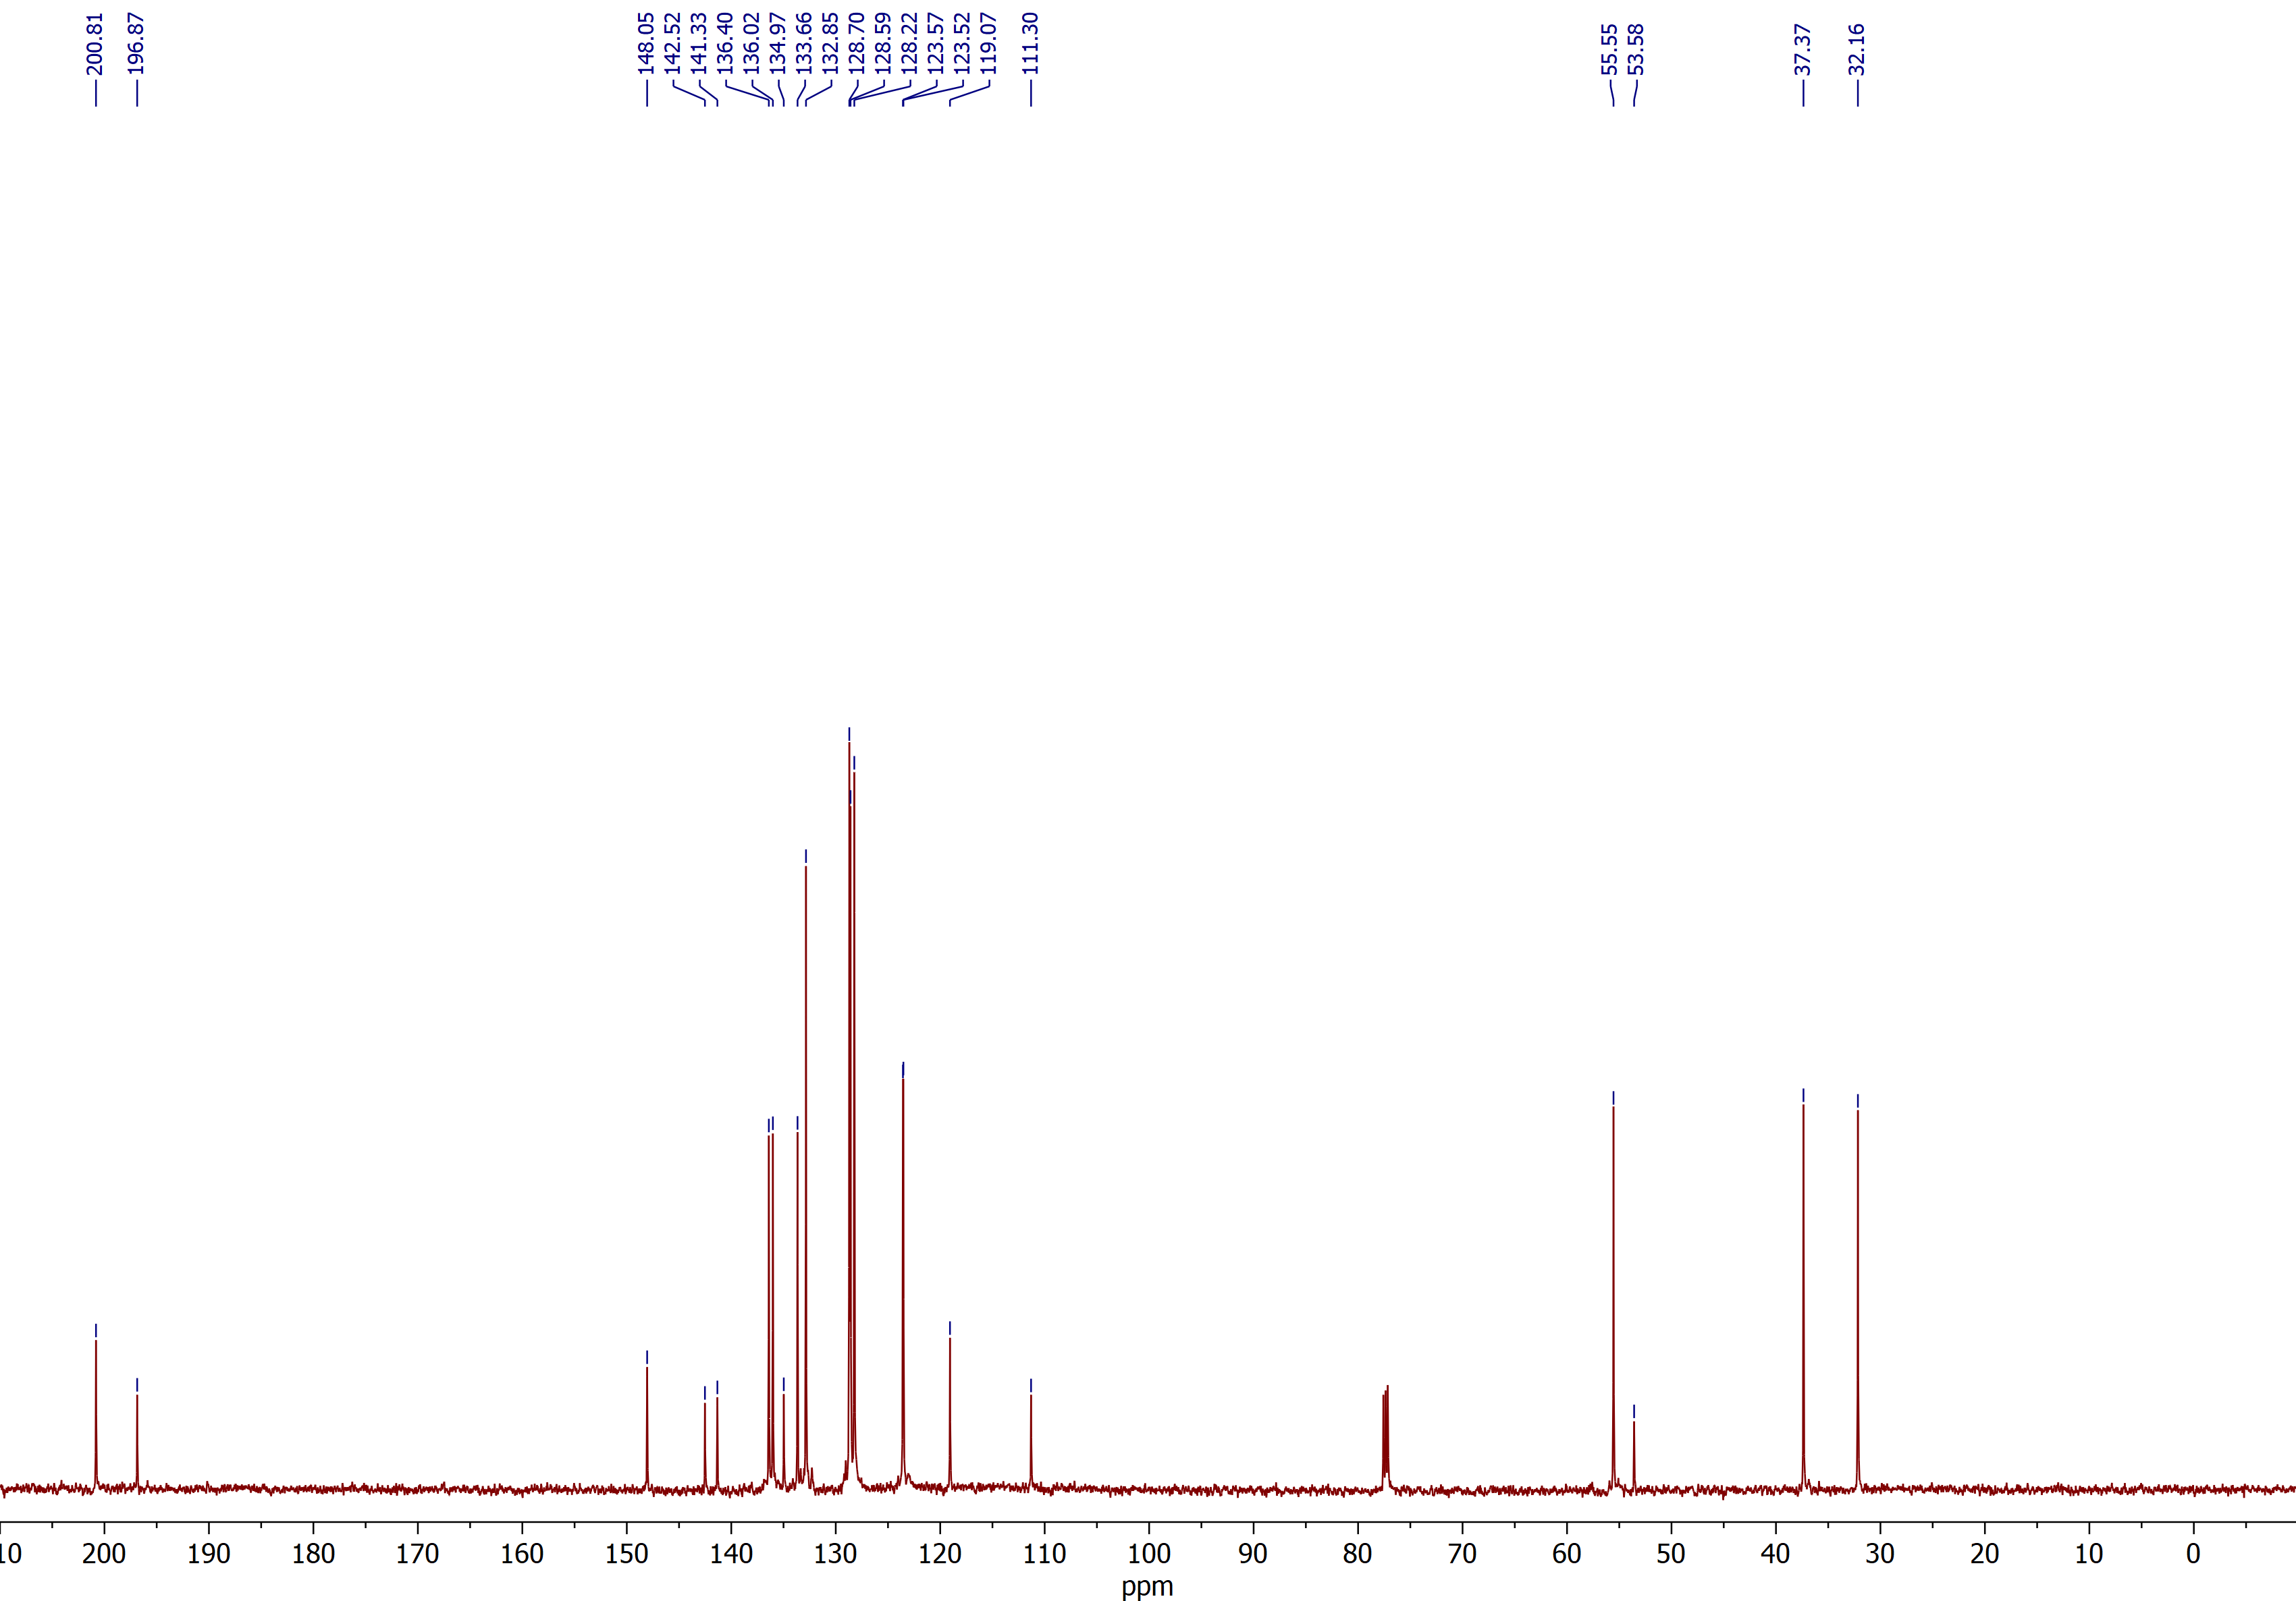

(2R,3R)-2-benzoyl-3-((E)-styryl)spiro[cyclobutane-1,2'-indene]-1',3'-dione (3j)
¹H NMR (CDCl₃, 600 MHz)
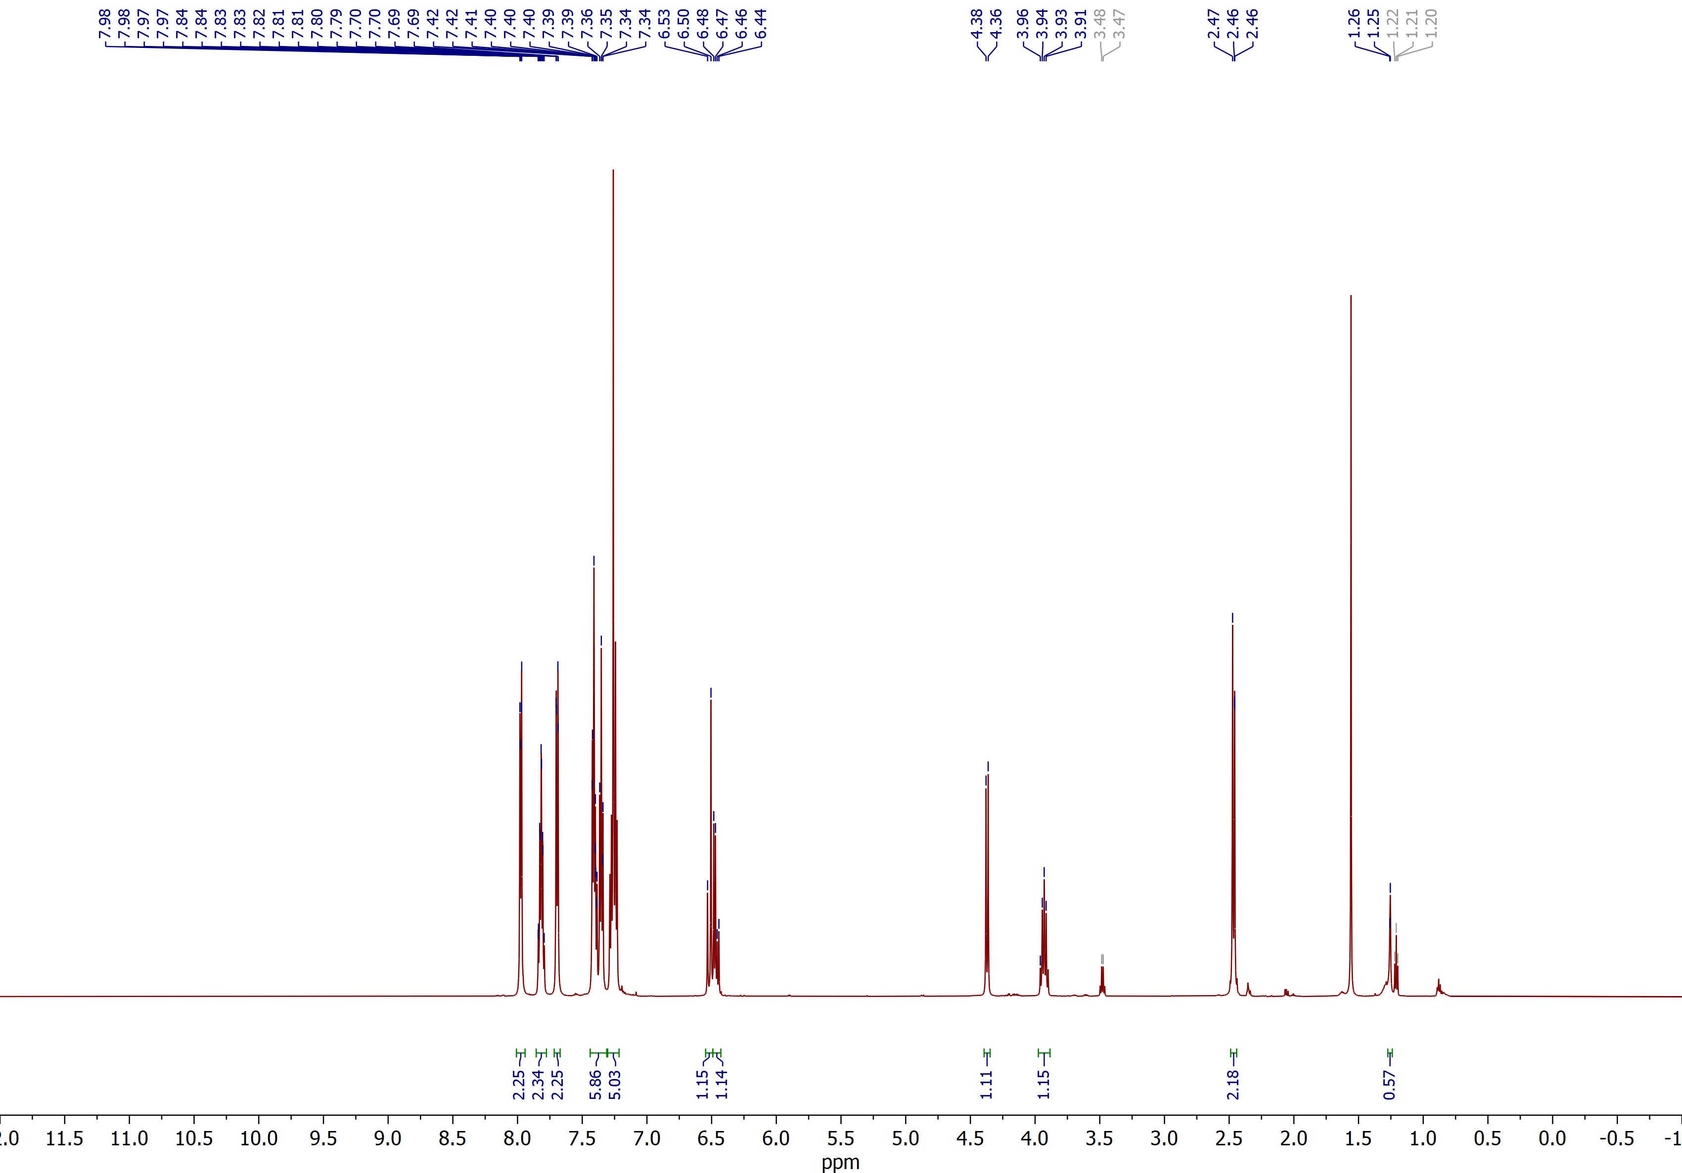

(2R,3R)-2-benzoyl-3-((E)-styryl)spiro[cyclobutane-1,2'-indene]-1',3'-dione (3j)
¹³C NMR (CDCl₃, 150 MHz)
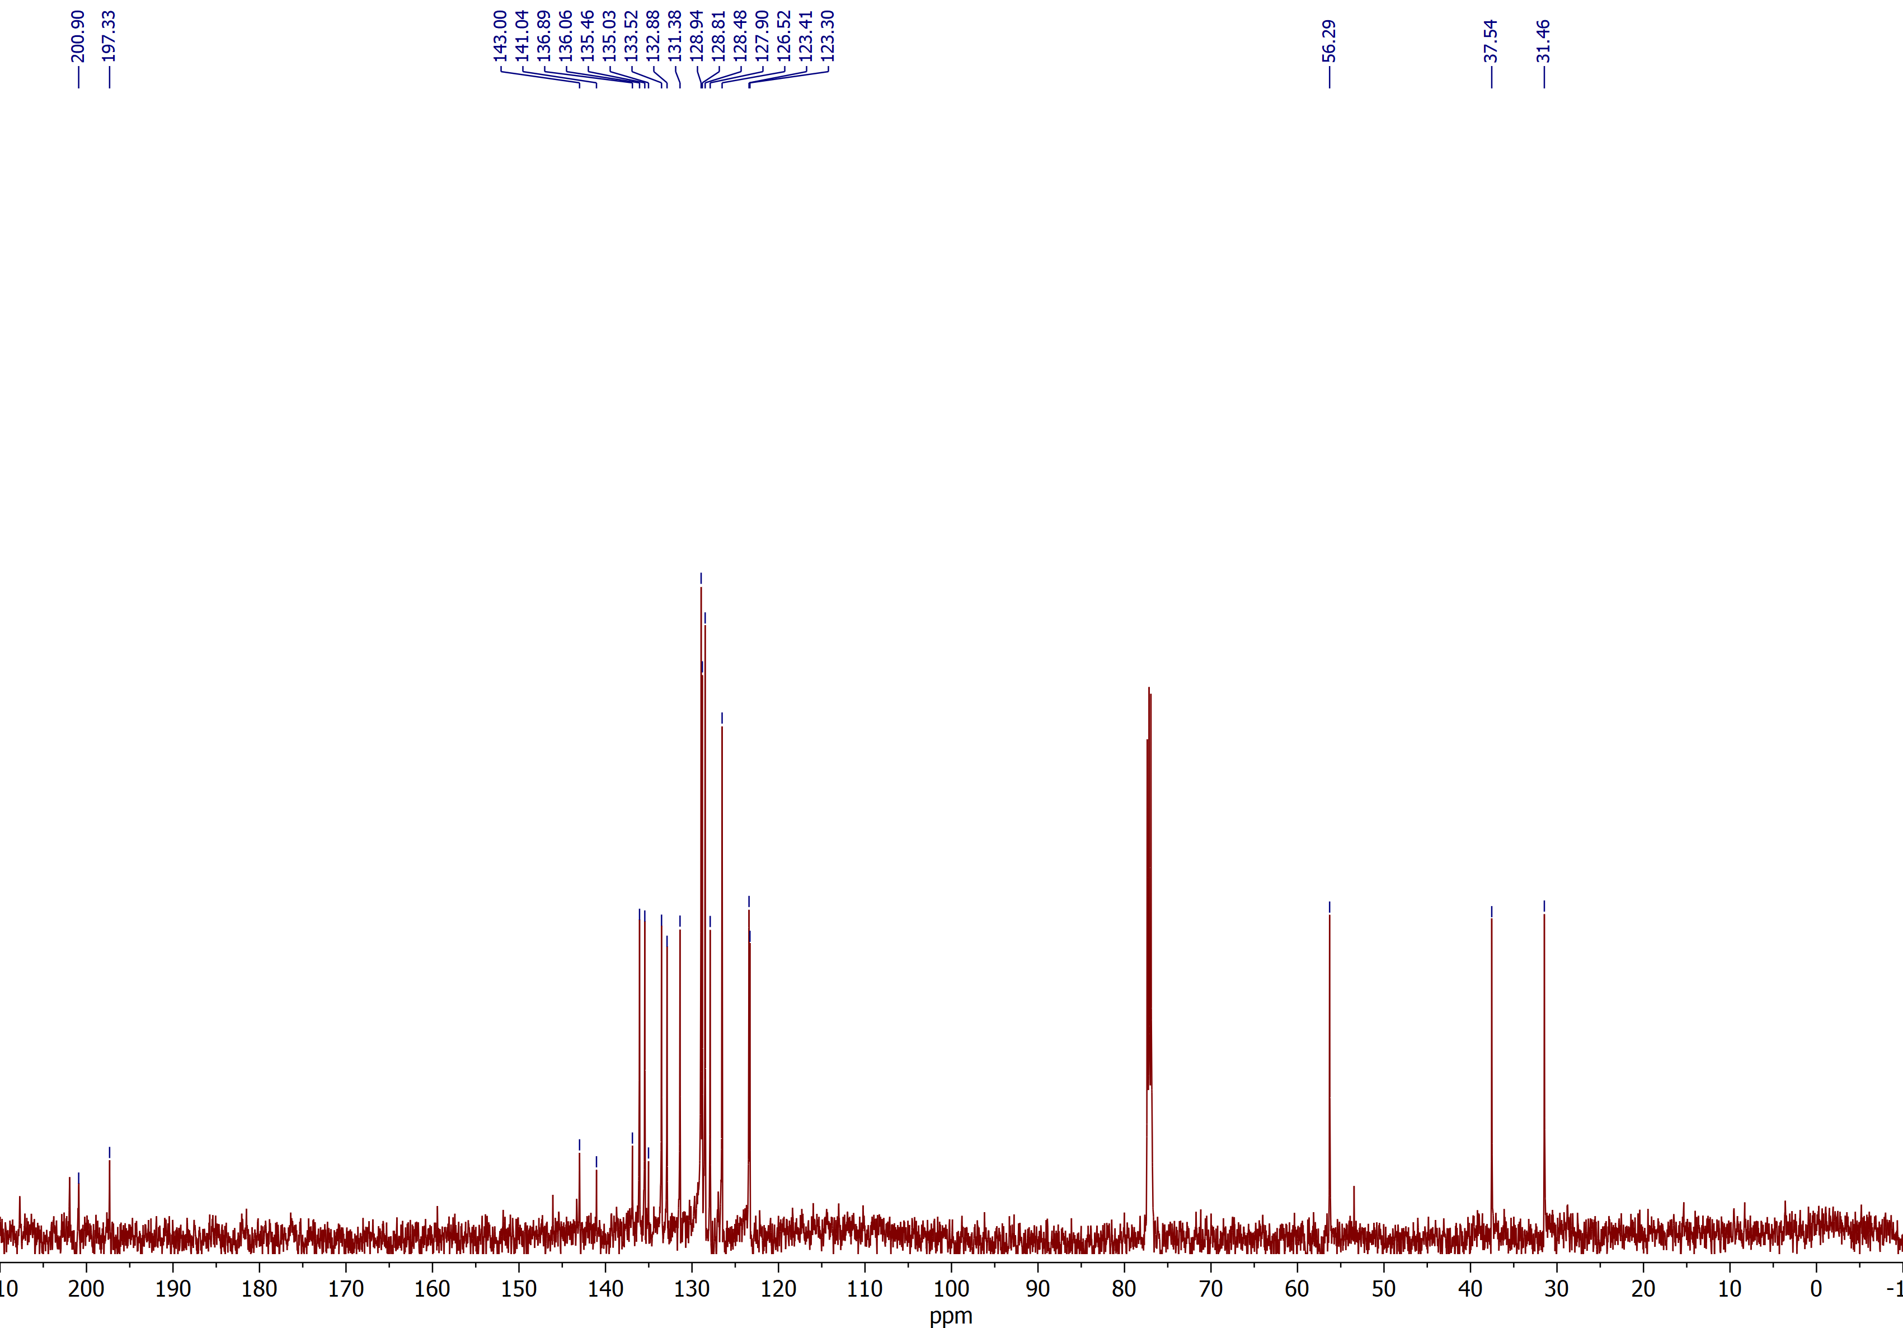

4-((1R,2S)-1-benzoyl-7,7-dimethyl-5,9-dioxo-6,8-dioxaspiro[3.5]nonan-2-yl)benzonitrile (3k)
¹H NMR (CDCl₃, 400 MHz)

4-((1R,2S)-1-benzoyl-7,7-dimethyl-5,9-dioxo-6,8-dioxaspiro[3.5]nonan-2-yl)benzonitrile (3k)
¹³C NMR (D₂O, 100 MHz)

(2R,3S)-2-(2-methoxybenzoyl)-3-(3-methoxyphenyl)spiro[cyclobutane-1,2'-indene]-1',3'-dione (3l)
¹H NMR (CDCl₃, 600 MHz)

(2R,3S)-2-(2-methoxybenzoyl)-3-(3-methoxyphenyl)spiro[cyclobutane-1,2'-indene]-1',3'-dione (3l)
¹³C NMR (CDCl₃, 150 MHz)

(2R,3S)-3-(4-bromophenyl)-2-(4-methoxybenzoyl)spiro[cyclobutane-1,2'-indene]-1',3'-dione (3m)
¹H NMR (CDCl₃, 600 MHz)

(2R,3S)-3-(4-bromophenyl)-2-(4-methoxybenzoyl)spiro[cyclobutane-1,2'-indene]-1',3'-dione (3m)
¹³C NMR (CDCl₃, 150 MHz)

(2R,3S)-2-(4-chlorobenzoyl)-3-(4-nitrophenyl)spiro[cyclobutane-1,2'-indene]-1',3'-dione (3n)
¹H NMR (CDCl₃, 600 MHz)

(2R,3S)-2-(4-chlorobenzoyl)-3-(4-nitrophenyl)spiro[cyclobutane-1,2'-indene]-1',3'-dione (3n)
¹³C NMR (CDCl₃, 150 MHz)

(2R,3S)-3-(3-methoxyphenyl)-2-(thiophene-2-carbonyl)spiro[cyclobutane-1,2'-indene]-1',3'-dione (3o)
¹H NMR (CDCl₃, 600 MHz)

(2R,3S)-3-(3-methoxyphenyl)-2-(thiophene-2-carbonyl)spiro[cyclobutane-1,2'-indene]-1',3'-dione (3o)
¹³C NMR (CDCl₃, 150 MHz)

Ethyl (2R,3S)-1',3'-dioxo-3-phenyl-1',3'-dihydrospiro[cyclobutane-1,2'-indene]-2-carboxylate (3p)
¹H NMR (CDCl₃, 600 MHz)

Ethyl (2R,3S)-1',3'-dioxo-3-phenyl-1',3'-dihydrospiro[cyclobutane-1,2'-indene]-2-carboxylate (3p)
¹³C NMR (CDCl₃, 150 MHz)

Ethyl (2R,3S)-1',3'-dioxo-3-(p-tolyl)-1',3'-dihydrospiro[cyclobutane-1,2'-indene]-2-carboxylate (3q)
¹H NMR (CDCl₃, 600 MHz)

Ethyl (2R,3S)-1',3'-dioxo-3-(p-tolyl)-1',3'-dihydrospiro[cyclobutane-1,2'-indene]-2-carboxylate (3q)
¹³C NMR (CDCl₃, 150 MHz)

Ethyl (2R,3S)-3-(4-fluorophenyl)-1',3'-dioxo-1',3'-dihydrospiro[cyclobutane-1,2'-indene]-2-carboxylate (3r)
¹H NMR (CDCl₃, 600 MHz)

Ethyl (2R,3S)-3-(4-fluorophenyl)-1',3'-dioxo-1',3'-dihydrospiro[cyclobutane-1,2'-indene]-2-carboxylate (3r)
¹³C NMR (CDCl₃, 150 MHz)

Ethyl (2R,3S)-1',3'-dioxo-3-(o-tolyl)-1',3'-dihydrospiro[cyclobutane-1,2'-indene]-2-carboxylate (3s)
¹H NMR (CDCl₃, 600 MHz)

Ethyl (2R,3S)-1',3'-dioxo-3-(o-tolyl)-1',3'-dihydrospiro[cyclobutane-1,2'-indene]-2-carboxylate (3s)
¹³C NMR (CDCl₃, 150 MHz)

Ethyl (2R,3S)-3-(4-methoxyphenyl)-1',3'-dioxo-1',3'-dihydrospiro[cyclobutane-1,2'-indene]-2-carboxylate (3t)
¹H NMR (CDCl₃, 600 MHz)

Ethyl (2R,3S)-3-(4-methoxyphenyl)-1',3'-dioxo-1',3'-dihydrospiro[cyclobutane-1,2'-indene]-2-carboxylate (3t)
¹³C NMR (CDCl₃, 150 MHz)

Ethyl (2R,3S)-3-(4-cyanophenyl)-1',3'-dioxo-1',3'-dihydrospiro[cyclobutane-1,2'-indene]-2-carboxylate (3u)
¹H NMR (CDCl₃, 600 MHz)

Ethyl (2R,3S)-3-(4-cyanophenyl)-1',3'-dioxo-1',3'-dihydrospiro[cyclobutane-1,2'-indene]-2-carboxylate (3u)
¹³C NMR (CDCl₃, 150 MHz)

Diethyl (2R,3s,4S)-1',3'-dioxo-3-(p-tolyl)-1',3'-dihydrospiro[cyclobutane-1,2'-indene]-2,4-dicarboxylate (3v)
¹H NMR (CDCl₃, 600 MHz)

Diethyl (2R,3s,4S)-1',3'-dioxo-3-(p-tolyl)-1',3'-dihydrospiro[cyclobutane-1,2'-indene]-2,4-dicarboxylate (3v)
¹³C NMR (CDCl₃, 150 MHz)

(2R,3s,4S)-2,4-dibenzoyl-3-(p-tolyl)spiro[cyclobutane-1,2'-indene]-1',3'-dione (3w)
¹H NMR (CD₂Cl₂, 600 MHz)

(2R,3s,4S)-2,4-dibenzoyl-3-(p-tolyl)spiro[cyclobutane-1,2'-indene]-1',3'-dione (3w)
¹³C NMR (CD₂Cl₂, 150 MHz)

(2R,3S)-2-benzoyl-3-(4'-chloro-[1,1'-biphenyl]-4-yl)spiro[cyclobutane-1,2'-indene]-1',3'-dione (5)
¹H NMR (CDCl₃, 600 MHz)

(2R,3S)-2-benzoyl-3-(4'-chloro-[1,1'-biphenyl]-4-yl)spiro[cyclobutane-1,2'-indene]-1',3'-dione (5)
¹³C NMR (CDCl₃, 150 MHz)

Diethyl (2R,3S,E)-1'-oxo-3'-(2-phenylhydrazineylidene)-3-(p-tolyl)-1',3'-dihydrospiro[cyclobutane-1,2'-indene]-2,4-dicarboxylate (6)
¹H NMR (DMSO, 600 MHz)

Diethyl (2R,3S,E)-1'-oxo-3'-(2-phenylhydrazineylidene)-3-(p-tolyl)-1',3'-dihydrospiro[cyclobutane-1,2'-indene]-2,4-dicarboxylate (6)
¹³C NMR (DMSO, 150 MHz)

