Auto Support Generator - all-in-one input
Edit the tables and template below. Keep the section labels unchanged. Reaction schema, Scope, SI template and Crystallography template are optional.
[AUTO SI: COMPOUND TABLE]
number | structure | color | mp | Rf | HRMS | Elemental_analysis
4a | 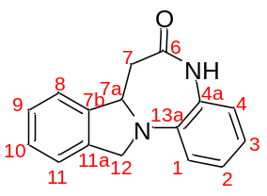 | white solid | 222-223 | 0.56 (petroleum ether : ethyl acetate = 1 : 1) | [M+H]+ 251.1183 | -
4b | 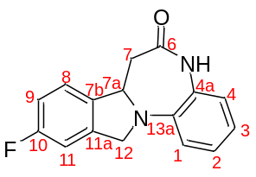 | off-white solid | 239-240 | 0.40 (petroleum ether : ethyl acetate = 1 : 1) | [M+H]+ 269.1088 | -
4c | 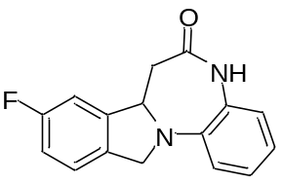 | off-white solid | 222-223 | 0.56 (petroleum ether : ethyl acetate = 1 : 1) | [M+H]+ 269.1088 | -
4d | 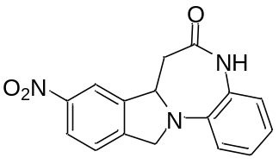 | off-white solid | 262-263 | 0.39 (petroleum ether : ethyl acetate = 1 : 1) | [M+H]+ 296.1030 | -
4e | 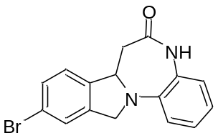 | off-white solid | 233-234 | 0.39 (petroleum ether : ethyl acetate = 1 : 1) | [M+H]+ 329.0287 | -

[AUTO SI: REACTION SCHEMA]
[AUTO SI: REACTION 4a-4e]
Reagents | equiv. | MW, g/mol | Density, g/ml | Concentration, M
Reagent_1 | 1
Phenylenediamine | 3 | 108.14
AcOH | 5 | 60.05 | 1.049
[AUTO SI: SCOPE]
Reagent_1 | Mass of Reagent_1, mg | Product | Product_number | Mass of product, mg
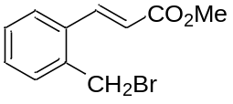 | 100 |  | 4a | 69
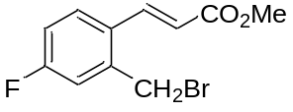 | 100 |  | 4b | 62
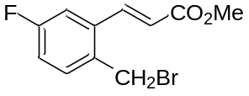 | 100 |  | 4c | 59
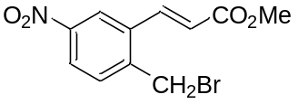 | 100 |  | 4d | 54
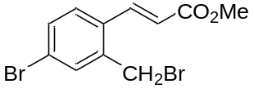 | 100 |  | 4e | 66
[AUTO SI: SI TEMPLATE]
[AUTO SI: METHOD 4a-4e]
Benzodiazepinone {Product.number} was obtained from {Reagent_1.name} ({Reagent_1.mg} mg, {Reagent_1.mmol} mmol), o-phenylenediamine ({Phenylenediamine.mg} mg, {Phenylenediamine.mmol} mmol) and AcOH ({AcOH.mcl} µL) according to GP3. Yield {Product.mg} mg ({Product.yield.percent}); {Product.appearance}; mp {Product.mp} °C. Rf = {Product.rf.value} ({Product.rf.system}).
[AUTO SI: COMPOUND TEMPLATE]
{Product.name} ({Product.number})
{Product.structure}
{Product.preparation}
[{nmr.1h.label}] ({nmr.1h.conditions}) δ = {nmr.1h.peaks}.
[{nmr.13c.label}] ({nmr.13c.conditions}) δ = {nmr.13c.peaks}.
{nmr.extra}
[{hrms.label}]: {hrms.adduct} calcd for {hrms.formula} {hrms.calculated}. Found {hrms.found}.
[{anal.label}] Calcd for {anal.formula}: {anal.calculated}. Found: {anal.found}.
[{ir.label}] ({ir.method}, cm-1): {ir.peaks}.
{Product.support.warning}

{Product.name} ({Product.number})
[{spectrum.label}] ({spectrum.conditions})
{Product.structure}
{Product.nmr.1h.picture}

{Product.name} ({Product.number})
[{spectrum.label}] ({spectrum.conditions})
{Product.structure}
{Product.nmr.13c.picture}
[AUTO SI: CRYSTALLOGRAPHY TEMPLATE]
{Product.name} ({Product.number})
{Crystal.description}
{Crystal.table}
{Crystal.geometry}
[AUTO SI: END]

