number | structure | color | mp | Rf | HRMS | Elemental_analysis
4a | 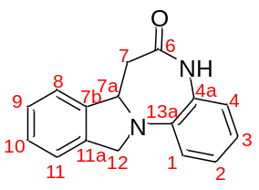 | white solid | 222-223 | 0.56 (petroleum ether : ethyl acetate = 1 : 1) | [M+H]+ 251.1183 | -
4b | 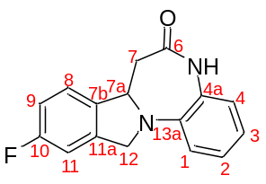 | off-white solid | 239-240 | 0.40 (petroleum ether : ethyl acetate = 1 : 1) | [M+H]+ 269.1088 | -
4c | 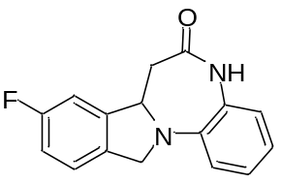 | off-white solid | 222-223 | 0.56 (petroleum ether : ethyl acetate = 1 : 1) | [M+H]+ 269.1088 | -
4d | 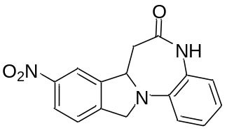 | off-white solid | 262-263 | 0.39 (petroleum ether : ethyl acetate = 1 : 1) | [M+H]+ 296.1030 | -
4e | 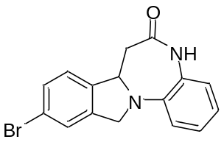 | off-white solid | 233-234 | 0.39 (petroleum ether : ethyl acetate = 1 : 1) | [M+H]+ 329.0287 | -

