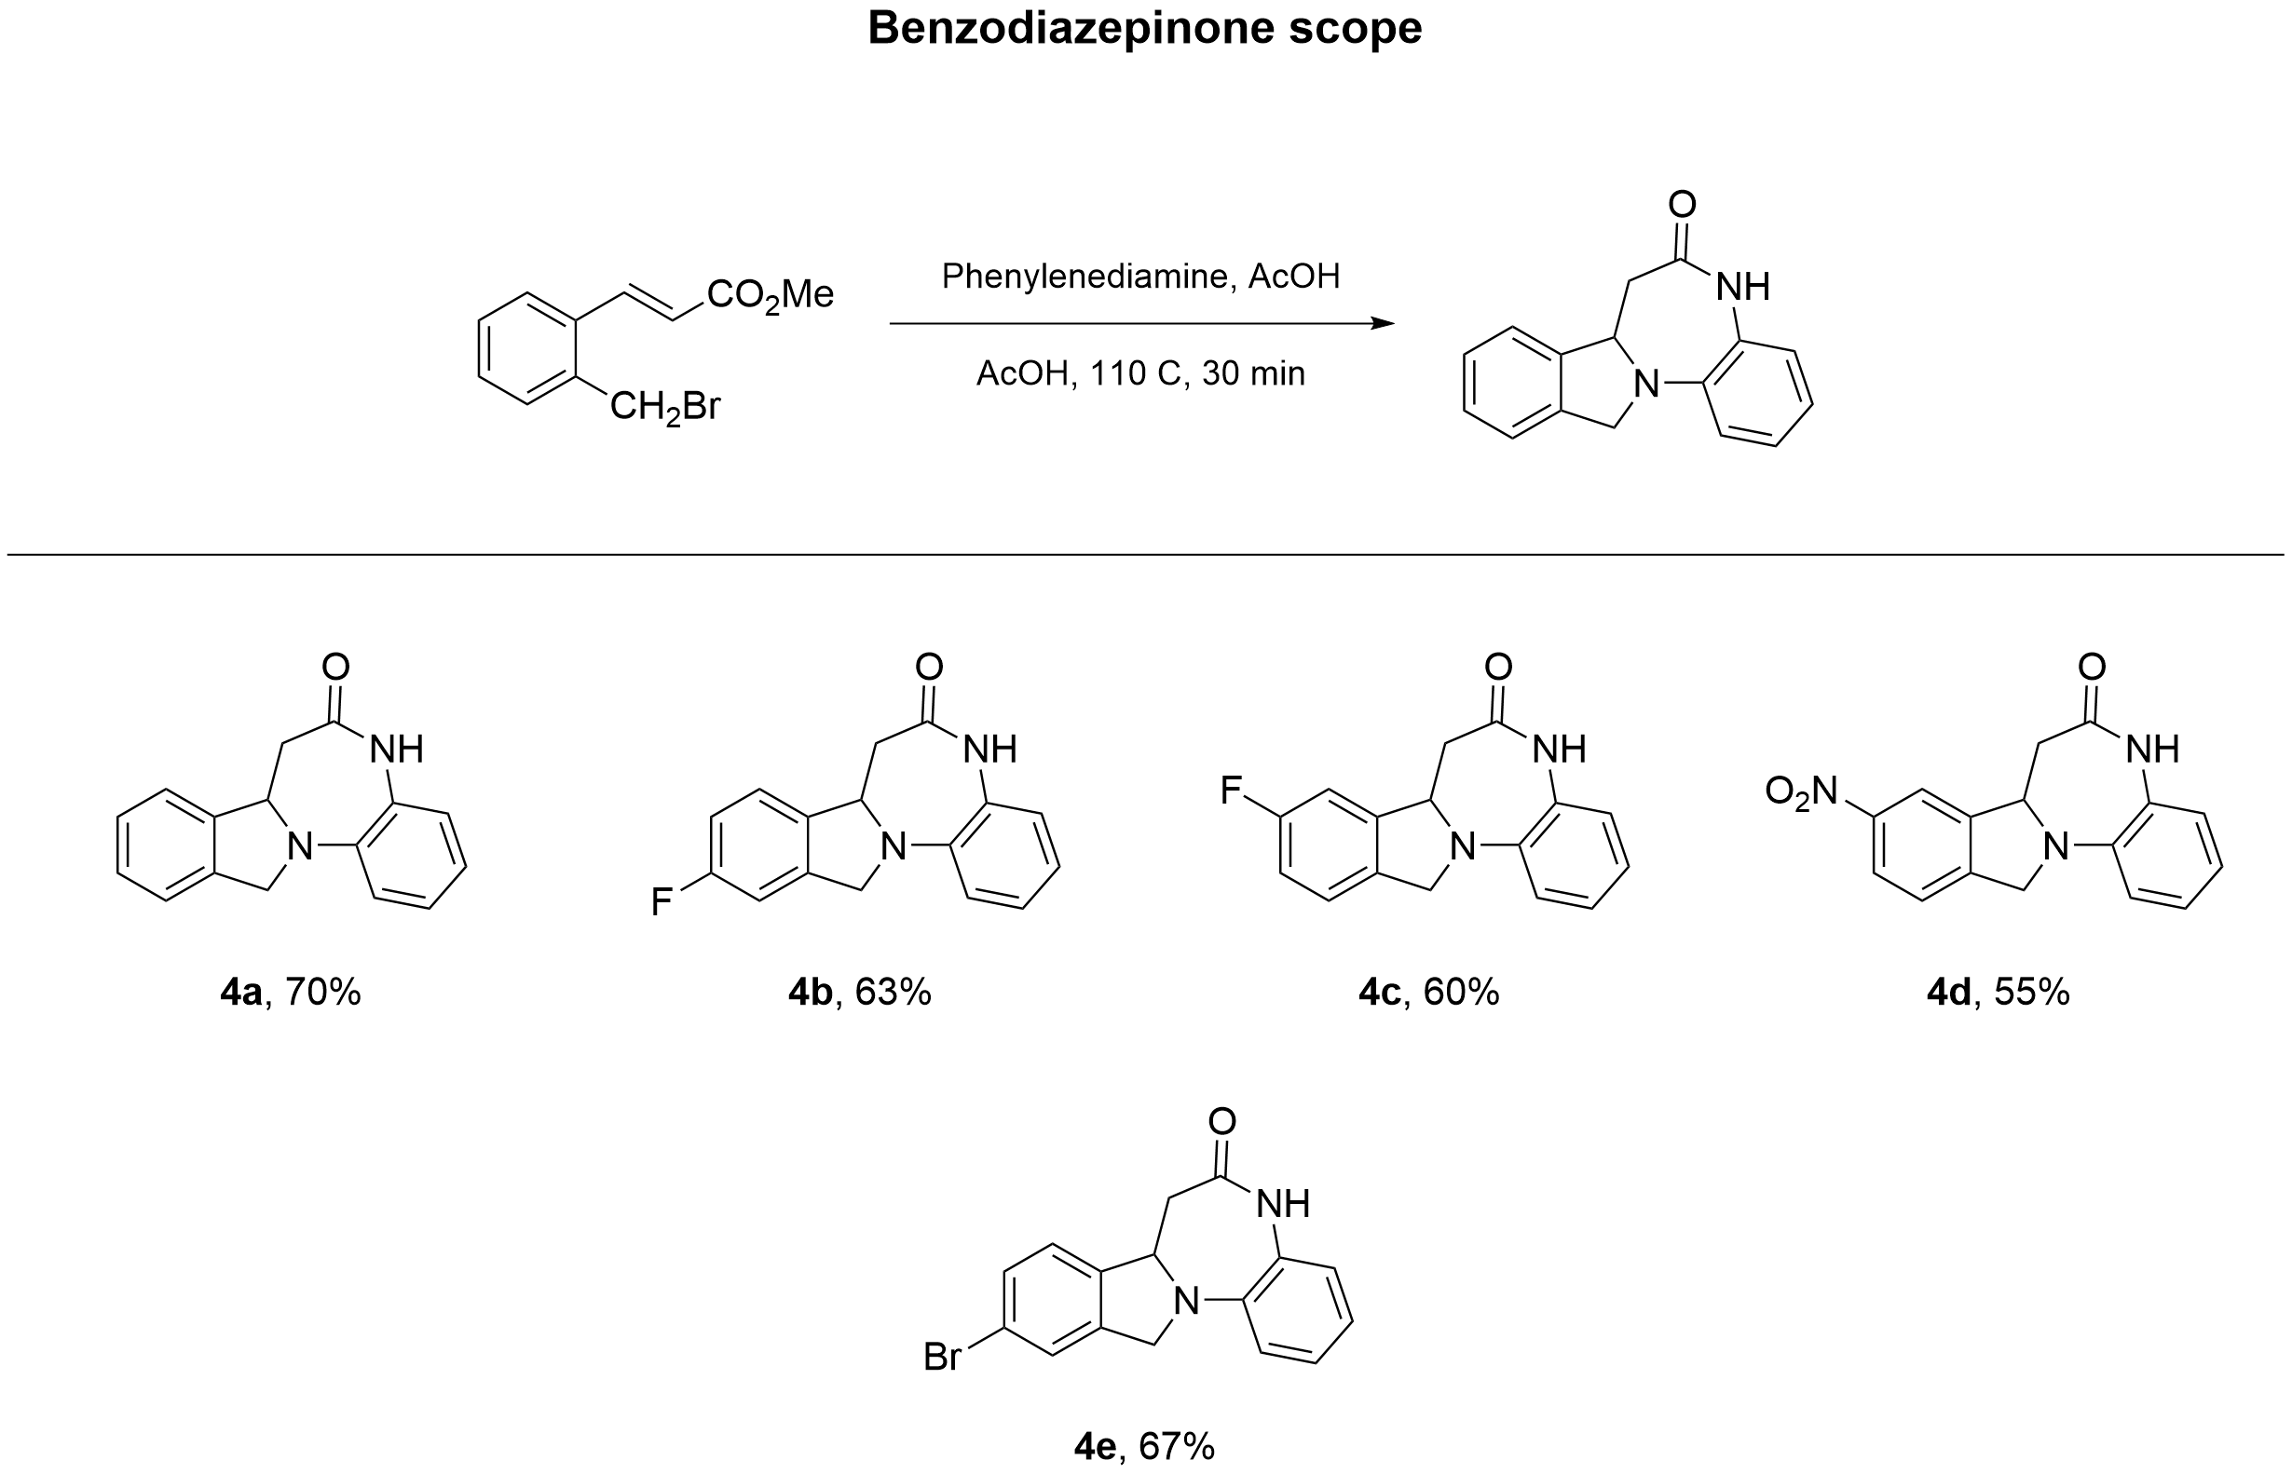

7A,12-dihydro-5H-benzo[2,3][1,4]diazepino[7,1-a]isoindol-6(7H)-one (4a)
¹H NMR (DMSO, 600 MHz) δ = 9.68 (s, 1H), 7.39 (dt, J = 3.1, 5.7 Hz, 2H), 7.36 - 7.30 (m, 2H), 7.06 (dd, J = 1.5, 7.9 Hz, 1H), 6.99 - 6.93 (m, 1H), 6.78 (d, J = 8.2 Hz, 1H), 6.69 - 6.64 (m, 1H), 5.01 (d, J = 9.4 Hz, 1H), 4.67 - 4.62 (m, 2H), 3.09 - 3.03 (m, 1H), 2.81 (dd, J = 9.5, 15.8 Hz, 1H).
¹³C NMR (DMSO, 150 MHz) δ = 171.6, 141.0, 136.8, 136.4, 128.0, 127.7, 124.7, 124.4, 122.7, 122.5, 121.9, 117.8, 115.8, 60.7, 55.3, 45.5, 40.1.
HRMS (ESI/Q-TOF) m/z: [M+H]⁺ calcd for C₁₆H₁₅N₂O⁺ 251.1179. Found 251.1183.
(Support check: C expected 16, found 17)

10-Fluoro-7a,12-dihydro-5H-benzo[2,3][1,4]diazepino[7,1-a]isoindol-6(7H)-one (4b)
¹H NMR (DMSO, 600 MHz) δ = 9.67 (s, 1H), 7.44 (dd, J = 4.9, 8.4 Hz, 1H), 7.24 (dd, J = 2.5, 8.9 Hz, 1H), 7.18 - 7.10 (m, 1H), 7.05 (dd, J = 1.6, 7.9 Hz, 1H), 6.96 (ddd, J = 1.6, 7.2, 8.5 Hz, 1H), 6.76 (dd, J = 1.4, 8.4 Hz, 1H), 6.70 - 6.65 (m, 1H), 4.98 (d, J = 9.4 Hz, 1H), 4.70 - 4.61 (m, 2H), 3.06 (dt, J = 1.6, 15.9 Hz, 1H), 2.81 (dd, J = 9.5, 15.9 Hz, 1H).
¹³C NMR (DMSO, 150 MHz) δ = 171.7, 163.3, 161.7, 139.1, 139.0, 137.2, 136.9, 125.0, 124.8, 124.7, 124.6, 122.1, 118.2, 116.0, 115.0, 114.9, 110.0, 109.8, 60.5, 55.3, 45.6, 40.4, 40.2.
HRMS (ESI/Q-TOF) m/z: [M+H]⁺ calcd for C₁₆H₁₄FN₂O⁺ 269.1085. Found 269.1088.

9-Fluoro-7a,12-dihydro-5H-benzo[2,3][1,4]diazepino[7,1-a]isoindol-6(7H)-one (4c)
¹H NMR (DMSO, 600 MHz) δ = 9.66 - 9.63 (m, 1H), 7.41 (dd, J = 5.0, 8.3 Hz, 1H), 7.31 (dd, J = 2.5, 9.1 Hz, 1H), 7.15 (td, J = 2.5, 8.9 Hz, 1H), 7.06 (dd, J = 1.6, 7.9 Hz, 1H), 6.96 (ddd, J = 1.6, 7.1, 8.4 Hz, 1H), 6.77 (dd, J = 1.3, 8.3 Hz, 1H), 6.68 (td, J = 1.3, 7.5 Hz, 1H), 5.01 (d, J = 9.4 Hz, 1H), 4.67 - 4.58 (m, 2H), 3.11 (dt, J = 1.6, 15.9 Hz, 1H), 2.82 (dd, J = 9.6, 15.9 Hz, 1H).
¹³C NMR (DMSO, 150 MHz) δ = 171.5, 163.1, 161.5, 143.5, 143.4, 136.9, 132.5, 125.0, 124.5, 124.3, 124.3, 121.9, 118.2, 116.0, 115.2, 115.1, 110.2, 110.1, 60.9, 54.8, 45.1, 40.3, 40.2.
HRMS (ESI/Q-TOF) m/z: [M+H]⁺ calcd for C₁₆H₁₄FN₂O⁺ 269.1085. Found 269.1088.

9-Nitro-7a,12-dihydro-5H-benzo[2,3][1,4]diazepino[7,1-a]isoindol-6(7H)-one (4d)
¹H NMR (DMSO, 600 MHz) δ = 9.71 (s, 1H), 8.30 (d, J = 2.1 Hz, 1H), 8.21 (dd, J = 2.1, 8.2 Hz, 1H), 7.67 (d, J = 8.3 Hz, 1H), 7.07 (dd, J = 1.6, 7.9 Hz, 1H), 7.01 - 6.95 (m, 1H), 6.80 (d, J = 8.1 Hz, 1H), 6.74 - 6.68 (m, 1H), 5.11 (d, J = 9.4 Hz, 1H), 4.81 - 4.72 (m, 2H), 3.20 (dt, J = 1.7, 15.8 Hz, 1H), 2.87 (dd, J = 9.5, 16.0 Hz, 1H).
¹³C NMR (DMSO, 150 MHz) δ = 171.5, 148.0, 144.7, 143.2, 136.8, 125.5, 124.6, 124.1, 123.9, 122.0, 118.7, 118.6, 116.3, 60.9, 55.3, 45.0, 40.4, 40.3.
HRMS (ESI/Q-TOF) m/z: [M+H]⁺ calcd for C₁₆H₁₄N₃O₃⁺ 296.1030. Found 296.1030.
(Support check: C expected 16, found 18)

10-Bromo-7a,12-dihydro-5H-benzo[2,3][1,4]diazepino[7,1-a]isoindol-6(7H)-one (4e)
¹H NMR (DMSO, 600 MHz) δ = 9.66 - 9.63 (m, 1H), 7.61 (d, J = 1.9 Hz, 1H), 7.50 (dd, J = 1.9, 8.2 Hz, 1H), 7.38 (dd, J = 0.9, 8.1 Hz, 1H), 7.05 (dd, J = 1.6, 7.9 Hz, 1H), 6.97 (ddd, J = 1.6, 7.2, 8.5 Hz, 1H), 6.75 (dd, J = 1.3, 8.3 Hz, 1H), 6.68 (ddd, J = 1.3, 7.1, 7.9 Hz, 1H), 4.98 (dq, J = 1.8, 10.0 Hz, 1H), 4.71 - 4.61 (m, 2H), 3.04 (dt, J = 1.6, 15.8 Hz, 1H), 2.82 (dd, J = 9.5, 15.9 Hz, 1H).
¹³C NMR (DMSO, 150 MHz) δ = 171.5, 140.6, 139.4, 136.8, 130.6, 125.7, 125.0, 124.5, 122.0, 121.1, 118.2, 116.0, 60.6, 55.0, 45.2, 40.3, 40.2.
HRMS (ESI/Q-TOF) m/z: [M+H]⁺ calcd for C₁₆H₁₄⁷⁹BrN₂O⁺ 329.0284. Found 329.0287.
(Support check: C expected 16, found 17)

7A,12-dihydro-5H-benzo[2,3][1,4]diazepino[7,1-a]isoindol-6(7H)-one (4a)
¹H NMR (DMSO, 600 MHz)
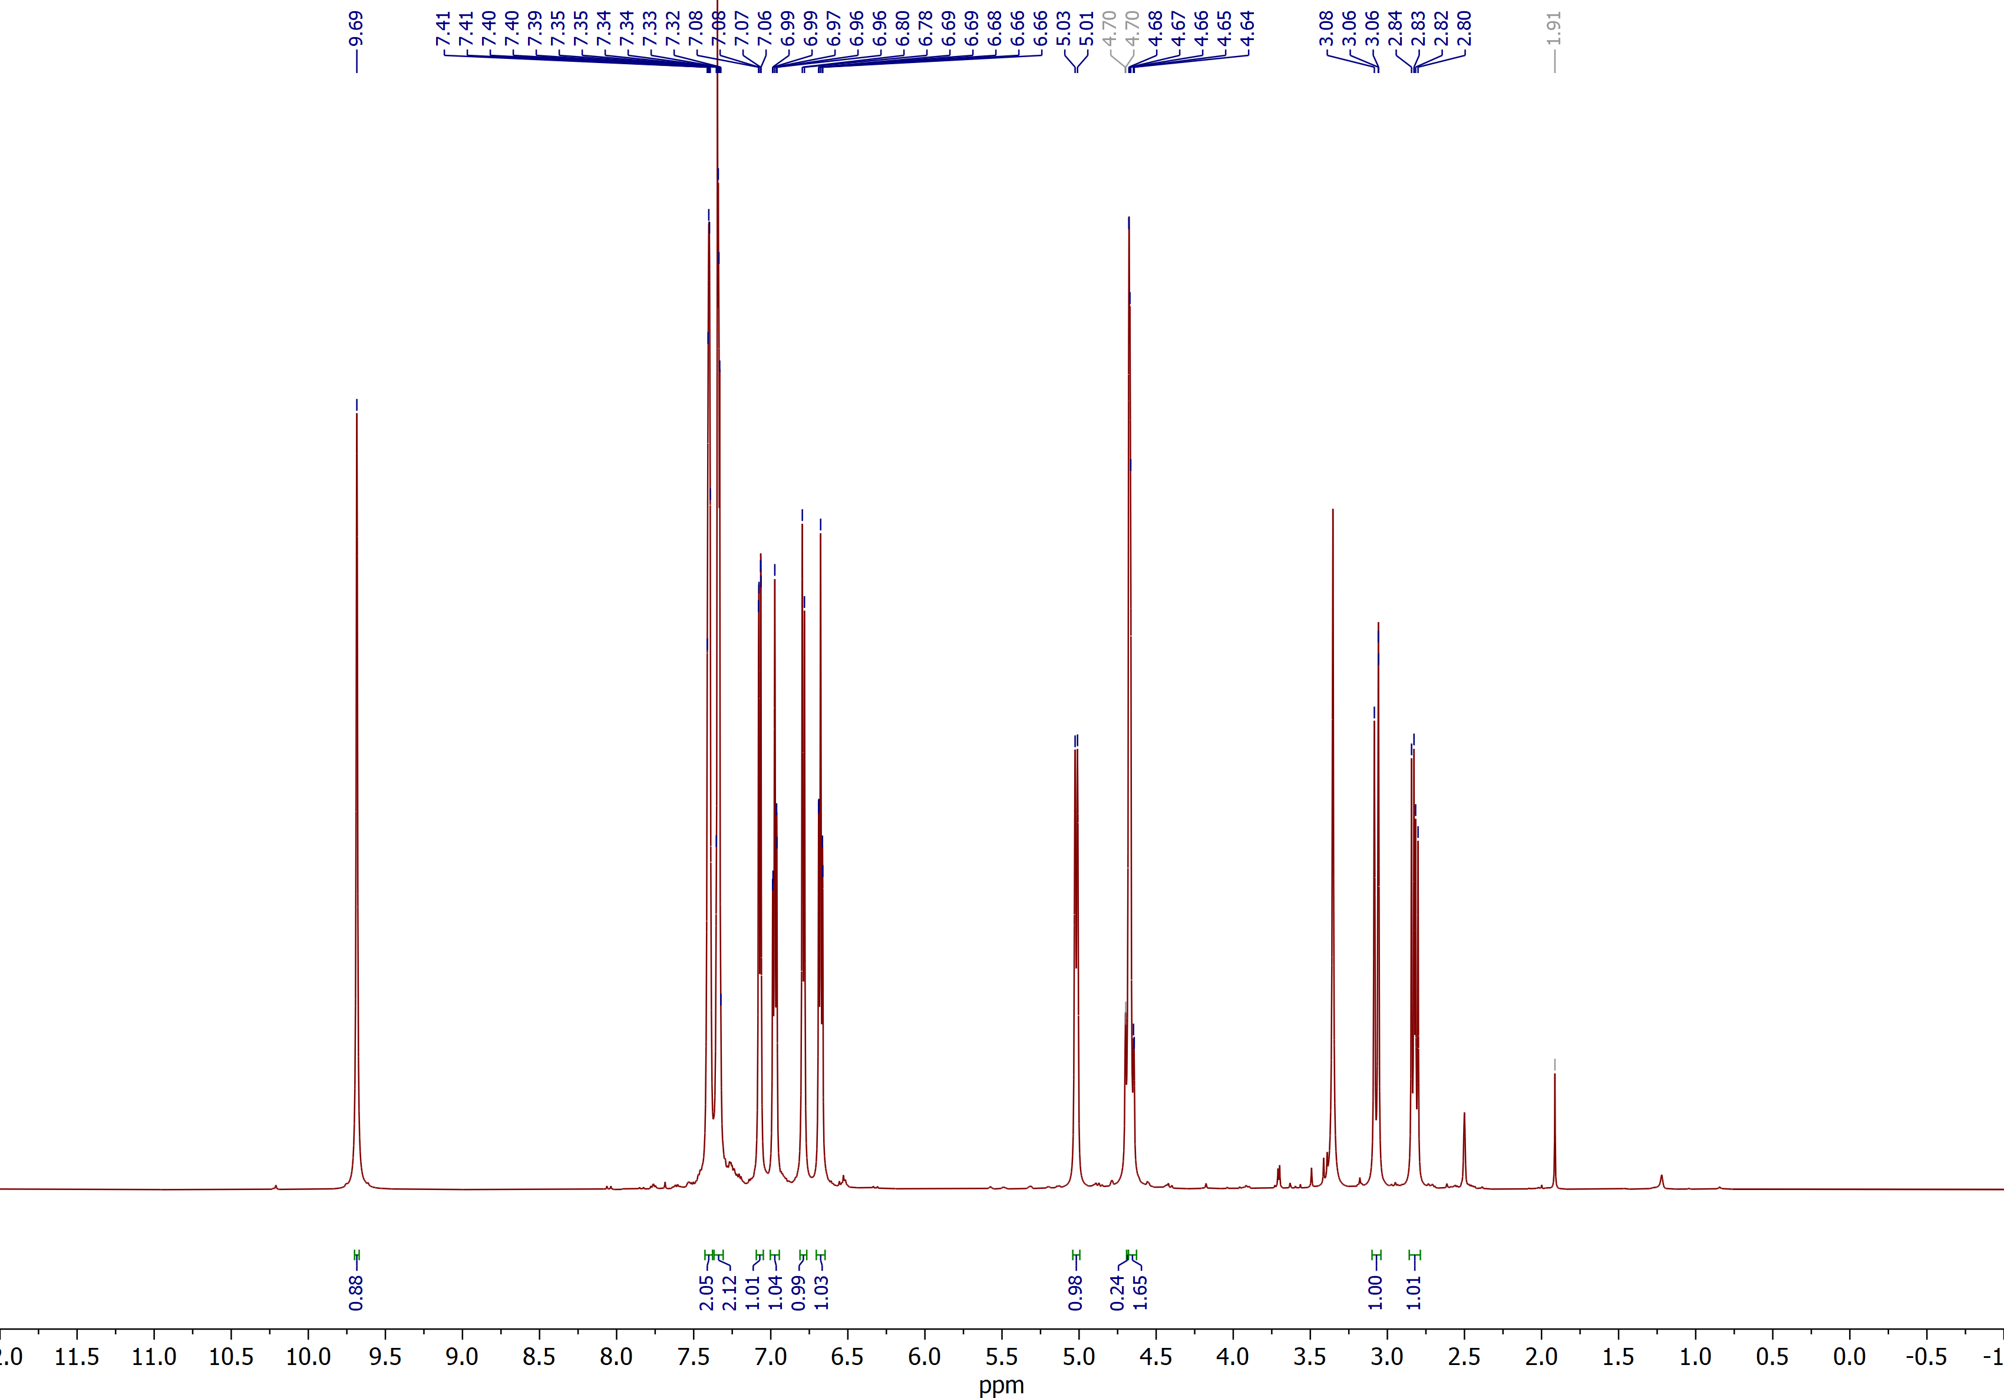

7A,12-dihydro-5H-benzo[2,3][1,4]diazepino[7,1-a]isoindol-6(7H)-one (4a)
¹³C NMR (DMSO, 150 MHz)
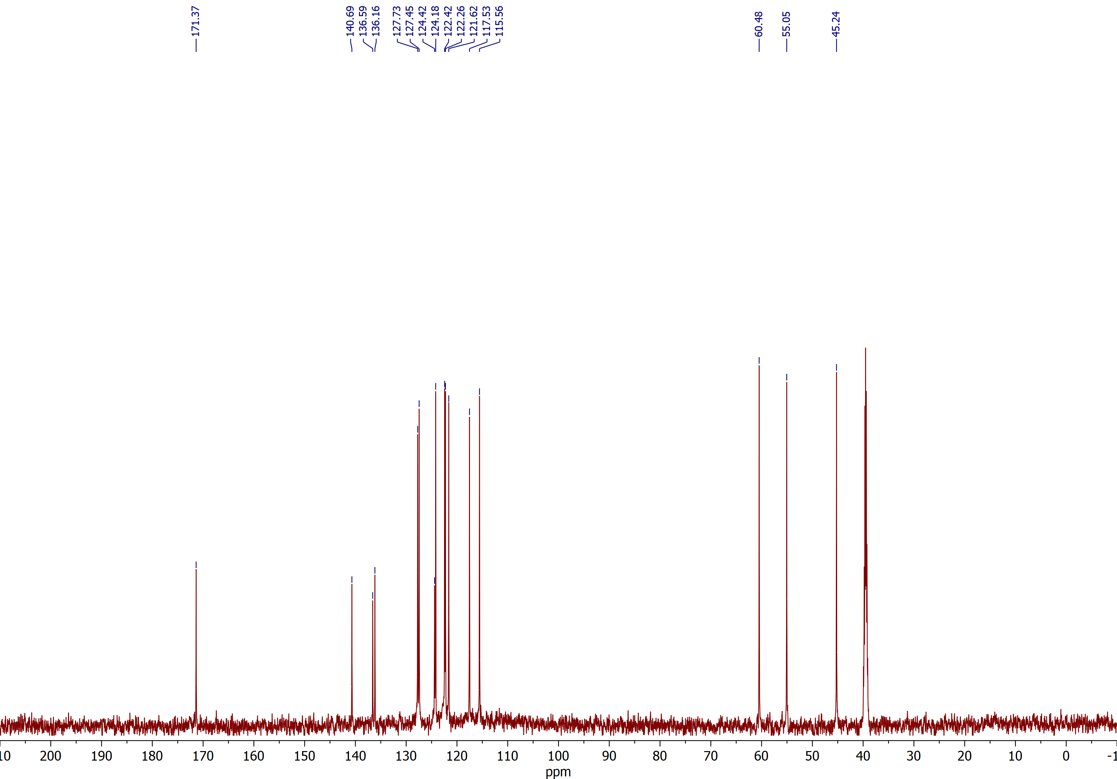

7A,12-dihydro-5H-benzo[2,3][1,4]diazepino[7,1-a]isoindol-6(7H)-one (4a)
HSQC ¹H–¹³C NMR (DMSO)
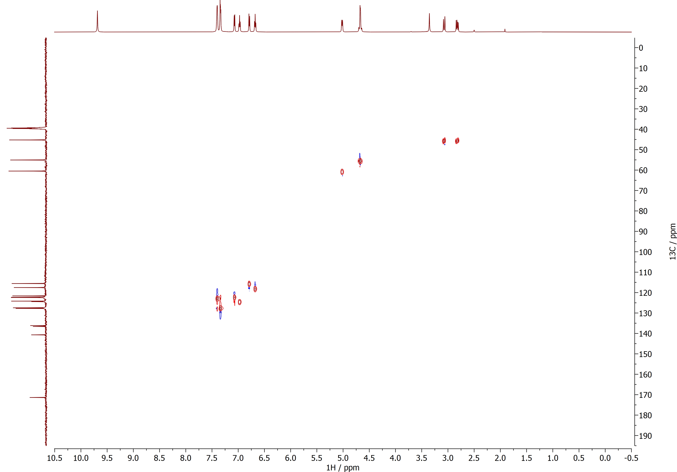

7A,12-dihydro-5H-benzo[2,3][1,4]diazepino[7,1-a]isoindol-6(7H)-one (4a)
HMBC ¹H–¹³C NMR (DMSO)
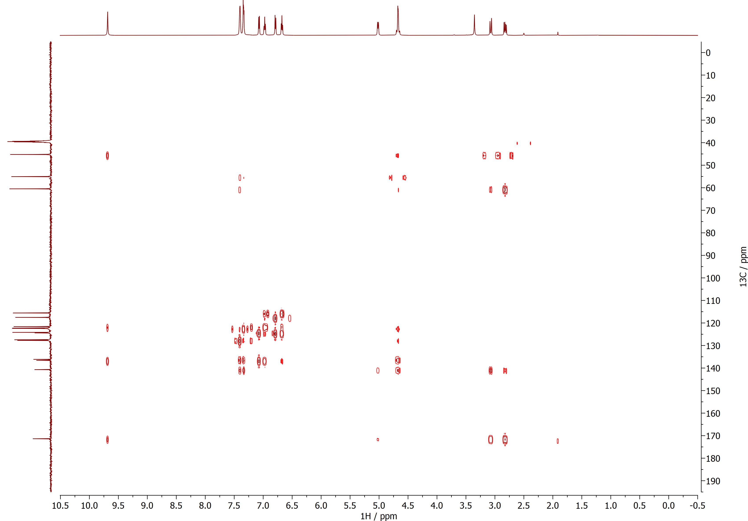

10-Fluoro-7a,12-dihydro-5H-benzo[2,3][1,4]diazepino[7,1-a]isoindol-6(7H)-one (4b)
¹H NMR (DMSO, 600 MHz)
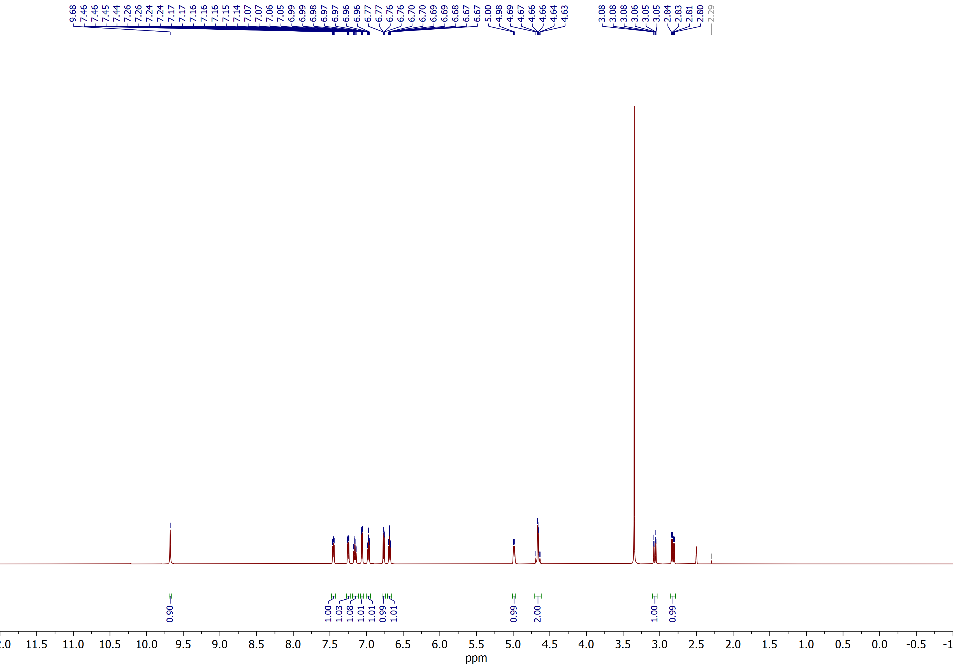

10-Fluoro-7a,12-dihydro-5H-benzo[2,3][1,4]diazepino[7,1-a]isoindol-6(7H)-one (4b)
¹³C NMR (DMSO, 150 MHz)
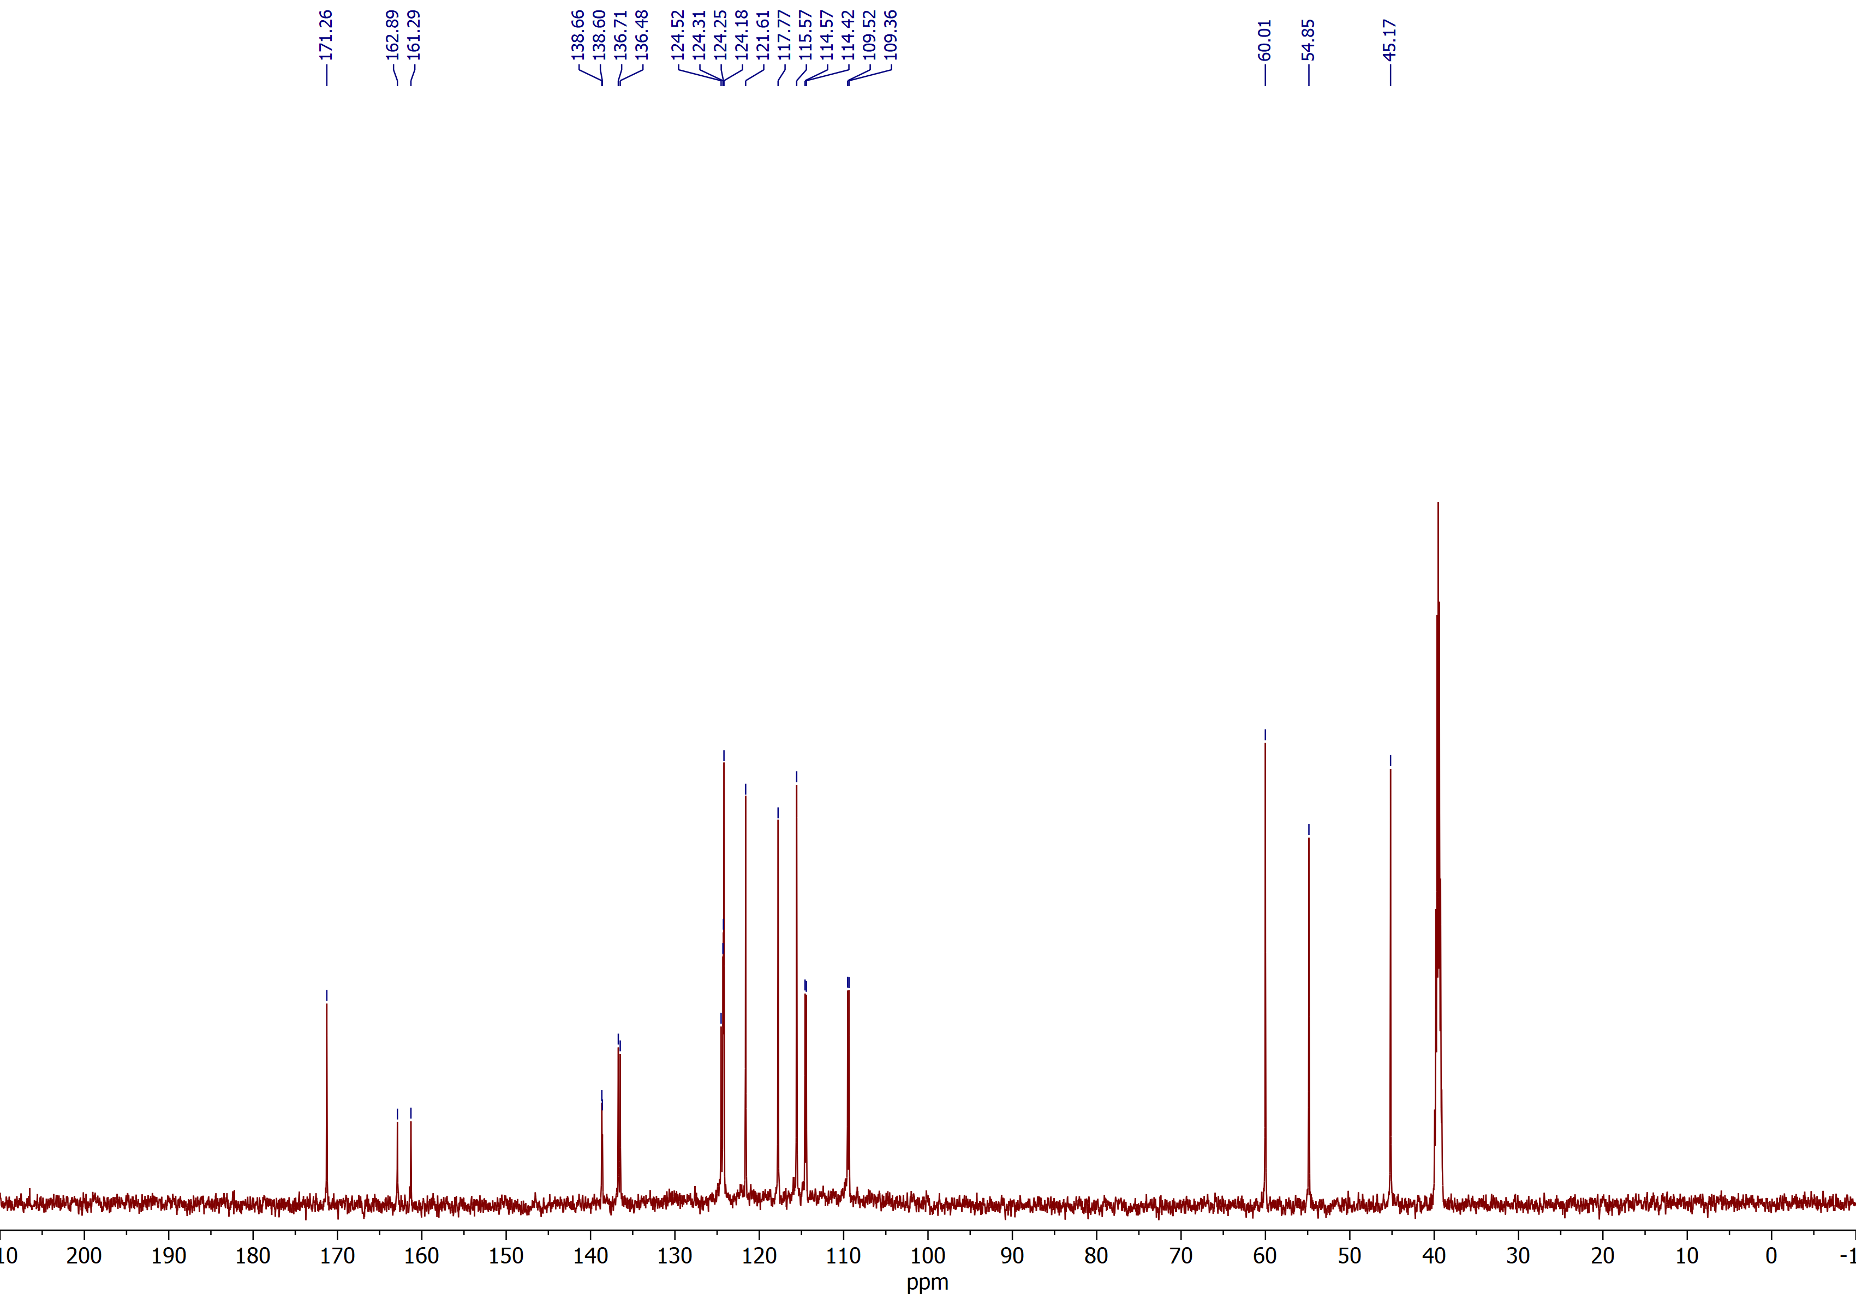

10-Fluoro-7a,12-dihydro-5H-benzo[2,3][1,4]diazepino[7,1-a]isoindol-6(7H)-one (4b)
HSQC ¹H–¹³C NMR (DMSO)
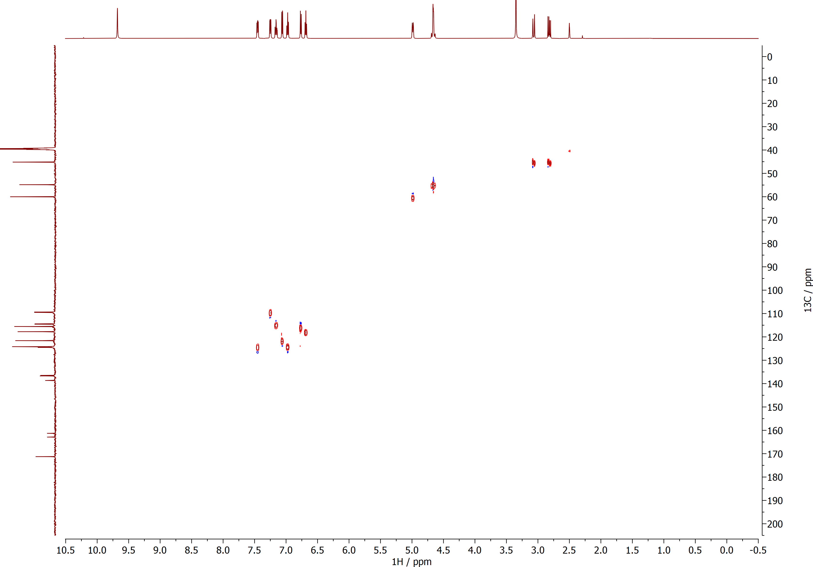

10-Fluoro-7a,12-dihydro-5H-benzo[2,3][1,4]diazepino[7,1-a]isoindol-6(7H)-one (4b)
HMBC ¹H–¹³C NMR (DMSO)
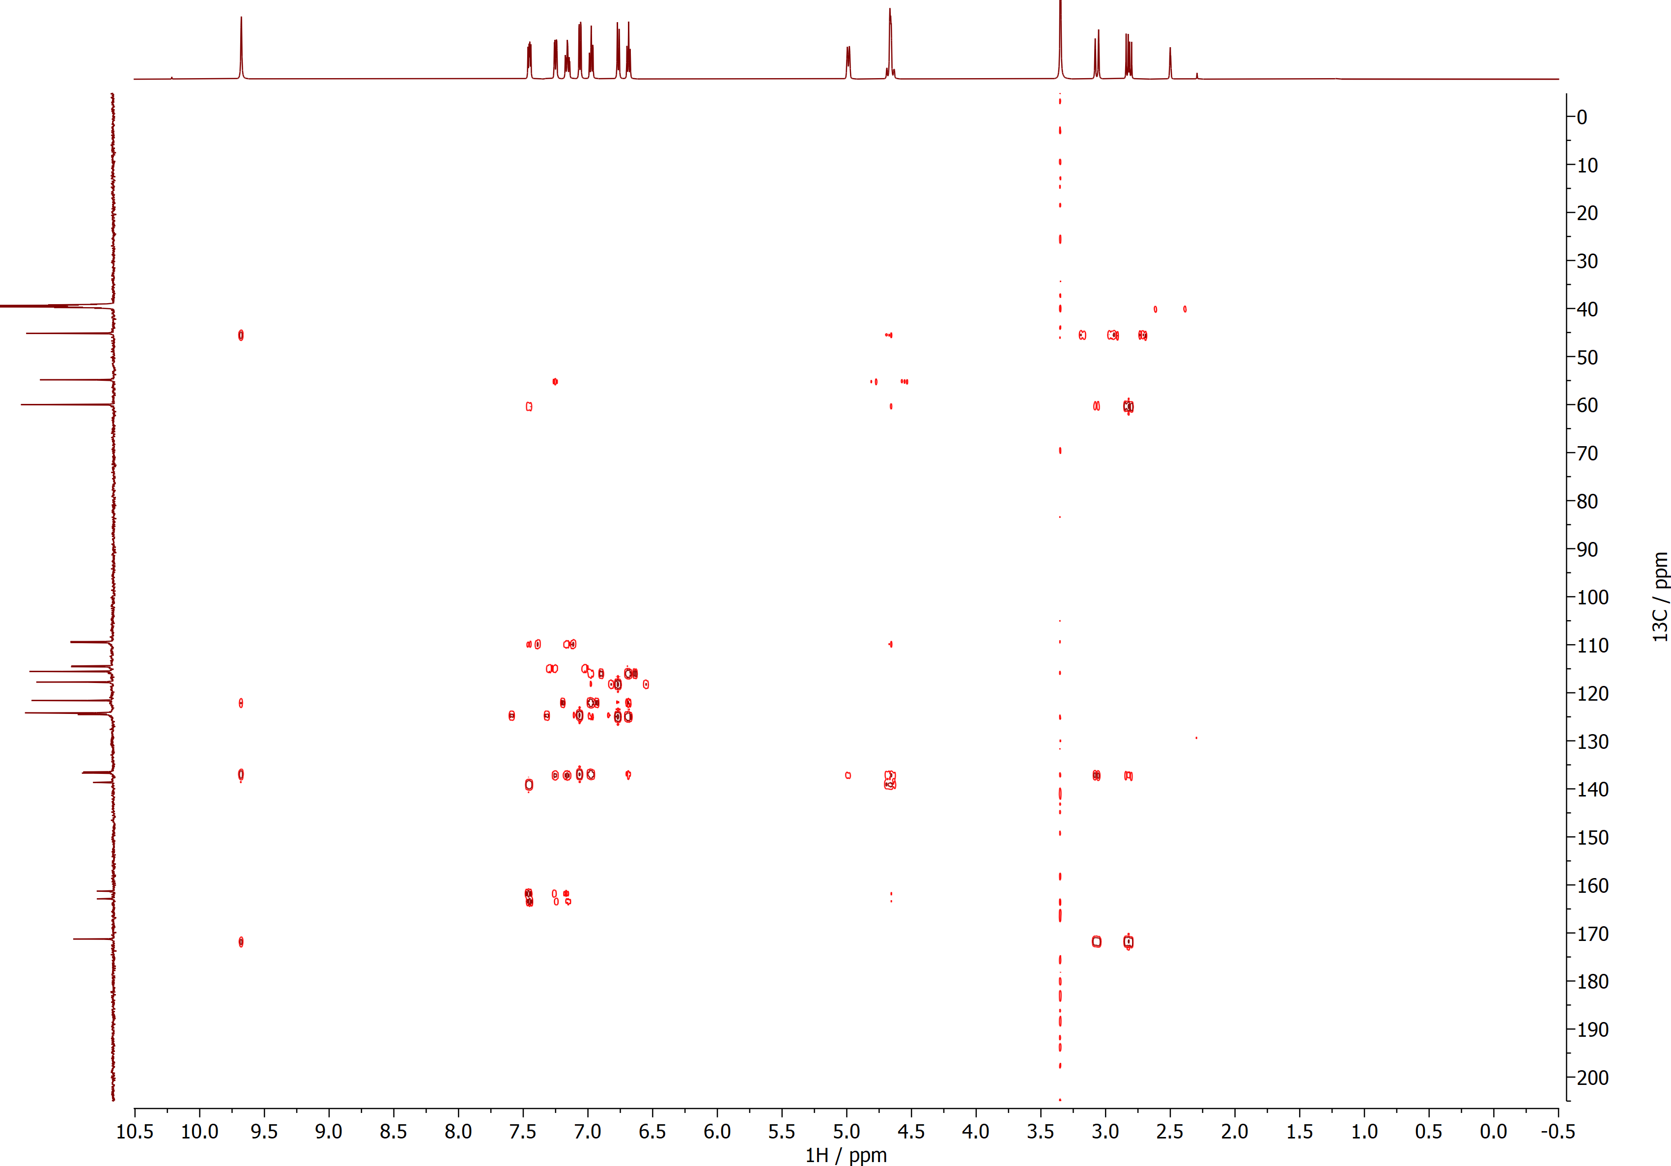

9-Fluoro-7a,12-dihydro-5H-benzo[2,3][1,4]diazepino[7,1-a]isoindol-6(7H)-one (4c)
¹H NMR (DMSO, 600 MHz)
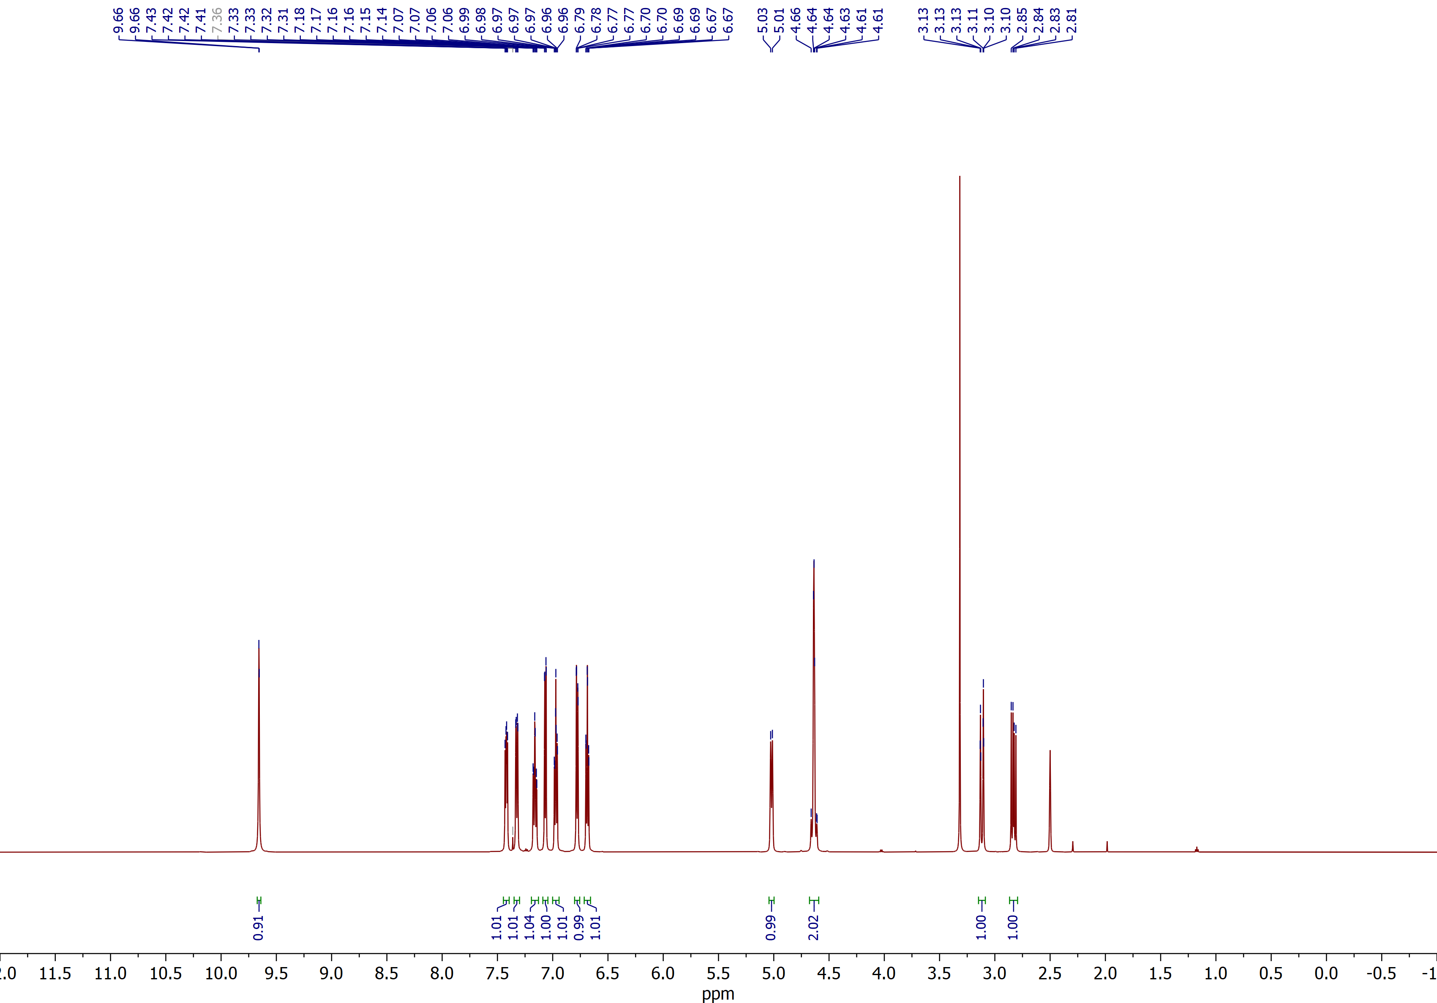

9-Fluoro-7a,12-dihydro-5H-benzo[2,3][1,4]diazepino[7,1-a]isoindol-6(7H)-one (4c)
¹³C NMR (DMSO, 150 MHz)
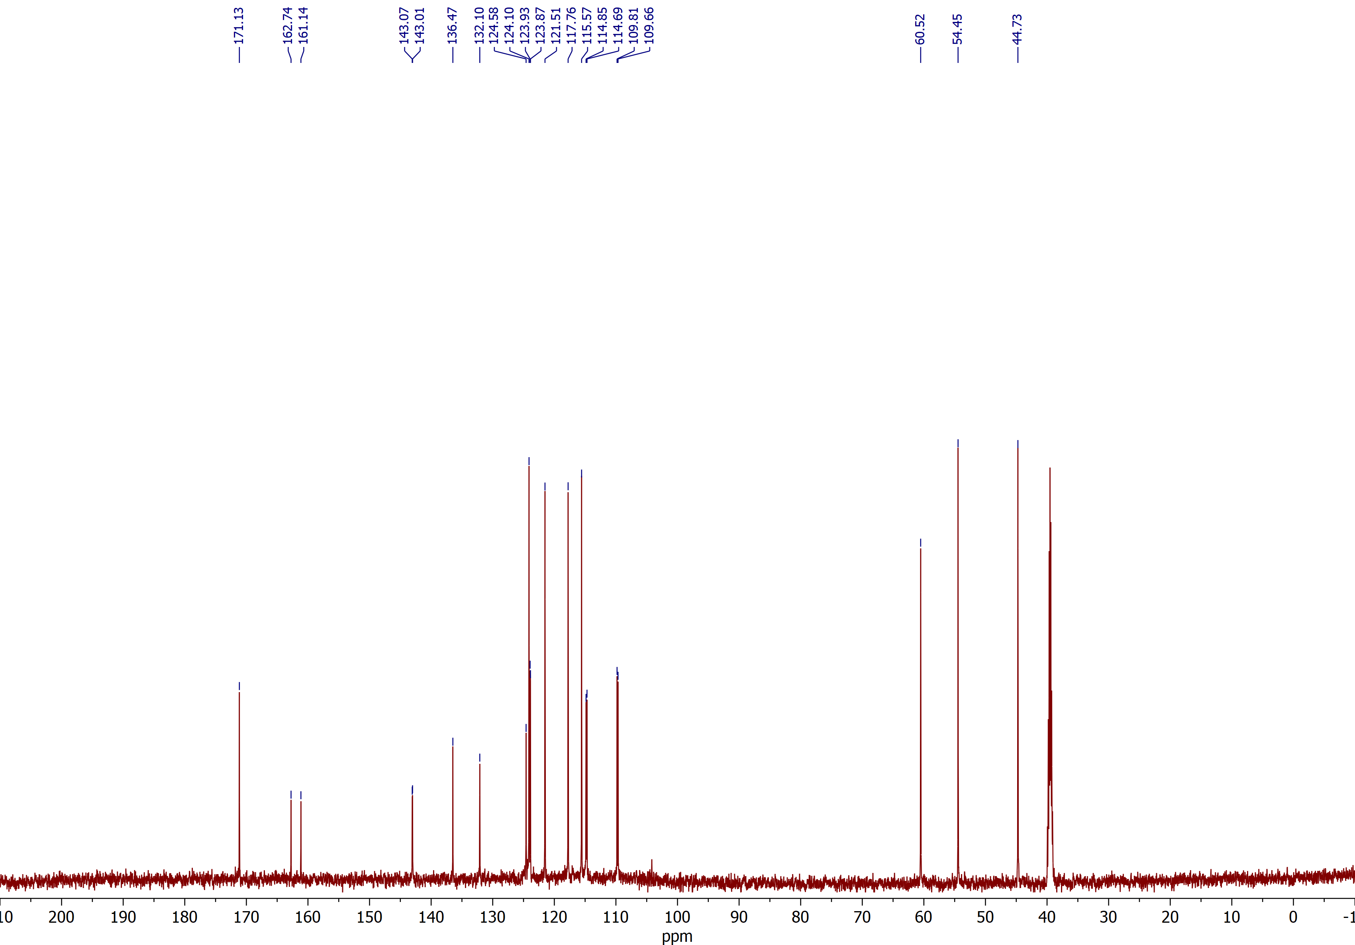

9-Nitro-7a,12-dihydro-5H-benzo[2,3][1,4]diazepino[7,1-a]isoindol-6(7H)-one (4d)
¹H NMR (DMSO, 600 MHz)
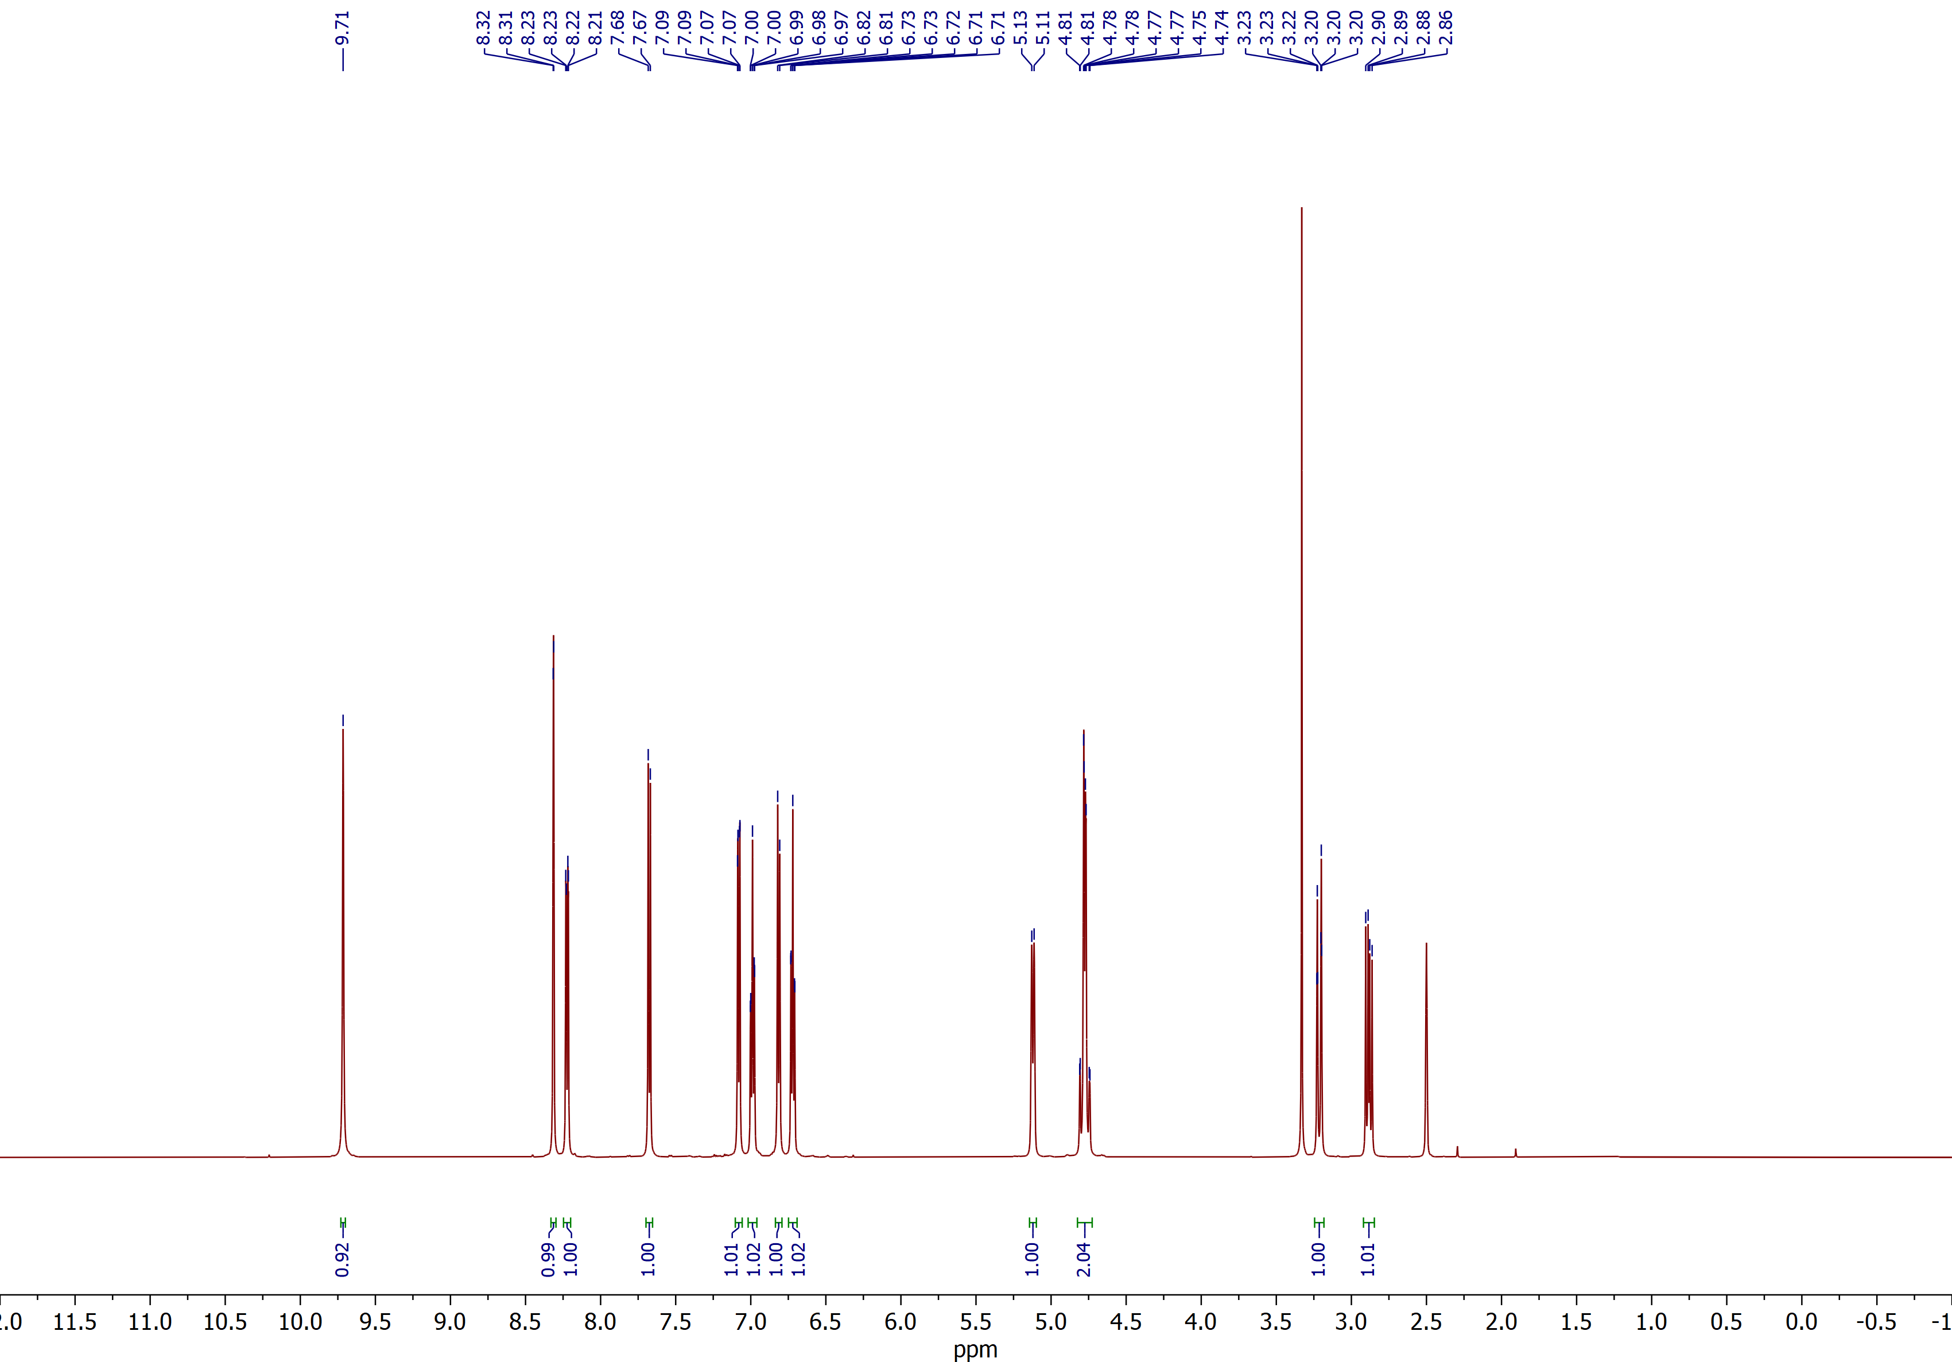

9-Nitro-7a,12-dihydro-5H-benzo[2,3][1,4]diazepino[7,1-a]isoindol-6(7H)-one (4d)
¹³C NMR (DMSO, 150 MHz)
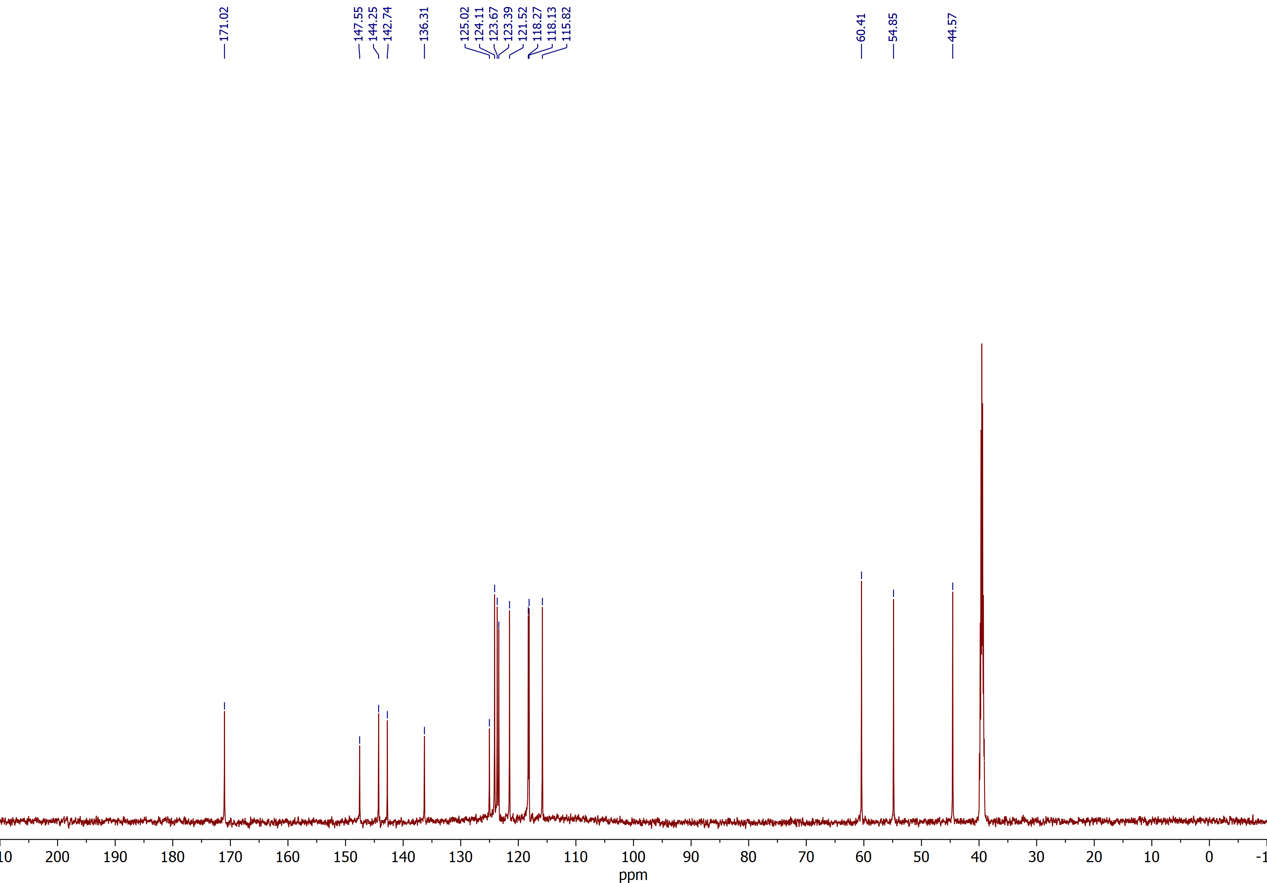

10-Bromo-7a,12-dihydro-5H-benzo[2,3][1,4]diazepino[7,1-a]isoindol-6(7H)-one (4e)
¹H NMR (DMSO, 600 MHz)
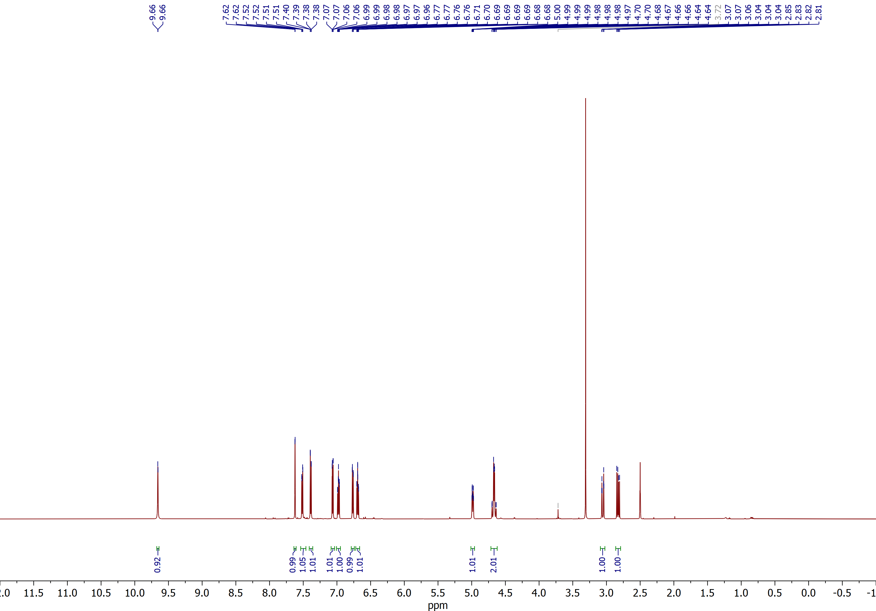

10-Bromo-7a,12-dihydro-5H-benzo[2,3][1,4]diazepino[7,1-a]isoindol-6(7H)-one (4e)
¹³C NMR (DMSO, 150 MHz)
