(2RS,3SR)-2-Benzoyl-3-(o-tolyl)spiro[cyclobutane-1,2'-indene]-1',3'-dione (3c)
Cyclobutane 3c was obtained from cyclopropane 2c (150 mg, 0.6 mmol), 4a (154 mg, 0.9 mmol) in DCE (1.2 mL) according to General procedure A, 7 h. Yield 189 mg (87%); light-yellow solid; mp 181–182 °C; R_{f}=0.33 (petroleum ether – ethyl acetate, 6:1).
General procedure A. To a solution of cyclopropane 2 in dry 1,2-dichloroethane (0.5 M) was added ylide 4 (1.5 equiv.) in one portion at room temperature under an argon atmosphere. The resulting mixture was placed in a preheated oil bath and stirred at 70 °C (internal temperature) for several hours. The progress of the reaction was monitored by TLC or ¹H NMR spectra. After completion, the mixture was diluted with DCM, and the solvent was evaporated under reduced pressure. The residue was purified by column chromatography on silica gel to obtain the target cyclobutane 3.
¹H NMR (CDCl₃, 600 MHz) δ = 8.02 - 7.92 (m, 2H), 7.85 - 7.78 (m, 3H), 7.40 (t, J = 7.2 Hz, 3H), 7.33 (t, J = 7.4 Hz, 1H), 7.22 (t, J = 7.4 Hz, 1H), 7.15 - 7.08 (m, 3H), 4.64 (d, J = 10.2 Hz, 1H), 4.54 (q, J = 9.7 Hz, 1H), 2.70 - 2.59 (m, 2H), 2.16 (s, 3H).
¹³C NMR (CDCl₃, 150 MHz) δ = 201.7, 201.0, 197.3, 142.7, 140.9, 140.3, 136.7, 135.8, 135.3, 134.7, 133.1, 130.2, 128.4, 128.2, 128.1, 127.1, 126.8, 126.2, 123.2, 123.1, 57.1, 52.9, 34.0, 32.8, 29.6, 19.6.
HRMS (ESI-TOF) m/z: [M+H]⁺ calcd for C₂₆H₂₁O₃⁺ 381.1485. Found 381.1483.
IR (KBr, cm-1): 3415, 3080, 3057, 2967, 2949, 2922, 2852, 1736, 1695, 1687, 1595, 1579, 1558, 1486, 1456, 1448, 1379, 1358, 1332, 1296, 1268, 1235, 1223, 1191, 1182, 1154, 1115, 1073, 1051, 1027, 1014, 1001.
(Support check: C signals expected 20 after molecular symmetry correction (26 C atoms in formula), found 26)
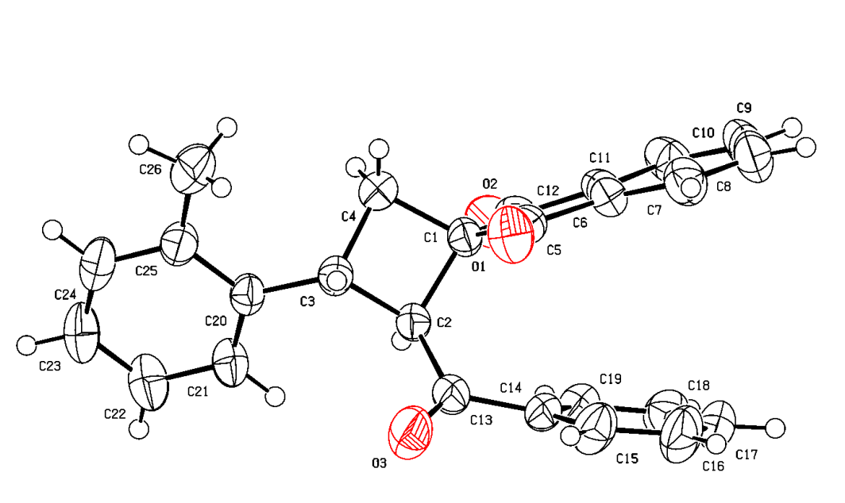
Crystal structure of 3c. ORTEP drawing with thermal ellipsoids at the 50% probability level. Deposition: 2383313.

(2RS,3SR)-2-Benzoyl-3-(4-bromophenyl)spiro[cyclobutane-1,2'-indene]-1',3'-dione (3e)
Cyclobutane 3e was obtained from cyclopropane 2e (150 mg, 0.5 mmol), 4a (125 mg, 0.7 mmol) in DCE (0.9 mL) according to General procedure A, 7 h. Yield 155 mg (76%); pale-orange solid; mp 150–152 °C; R_{f}=0.35 (petroleum ether – ethyl acetate, 4:1).
Gram-scale synthesis: cyclopropane 2e (1.50 g, 5 mmol), 4a (1.24 g, 7 mmol) in DCE (9.2 mL) according to General procedure A, 7 h. The crude product was purified by recrystallization from ethanol. Yield 1.60 g (78%).
General procedure A. To a solution of cyclopropane 2 in dry 1,2-dichloroethane (0.5 M) was added ylide 4 (1.5 equiv.) in one portion at room temperature under an argon atmosphere. The resulting mixture was placed in a preheated oil bath and stirred at 70 °C (internal temperature) for several hours. The progress of the reaction was monitored by TLC or ¹H NMR spectra. After completion, the mixture was diluted with DCM, and the solvent was evaporated under reduced pressure. The residue was purified by column chromatography on silica gel to obtain the target cyclobutane 3.
¹H NMR (CDCl₃, 600 MHz) δ = 8.01 - 7.95 (m, 1H), 7.93 - 7.87 (m, 1H), 7.83 - 7.76 (m, 2H), 7.52 (d, J = 8.0 Hz, 2H), 7.37 (dd, J = 7.9, 12.9 Hz, 4H), 7.34 - 7.29 (m, 1H), 7.11 (t, J = 7.8 Hz, 2H), 4.49 (d, J = 10.0 Hz, 1H), 4.30 (q, J = 9.7 Hz, 1H), 2.66 (t, J = 10.5 Hz, 1H), 2.60 (dd, J = 8.9, 11.0 Hz, 1H).
¹³C NMR (CDCl₃, 150 MHz) δ = 201.2, 200.7, 196.9, 142.5, 141.2, 140.9, 135.9, 135.4, 134.6, 133.2, 131.8, 129.3, 128.3, 128.2, 123.2, 123.1, 121.1, 56.5, 53.0, 37.4, 32.2.
HRMS (ESI-TOF) m/z: [M+H]⁺ calcd for C₂₅H₁₈⁷⁹BrO₃⁺ 445.0434. Found 445.0431.
IR (KBr, cm-1): 3416, 3086, 3057, 3028, 3009, 2950, 2910, 1733, 1696, 1670, 1596, 1581, 1488, 1450, 1408, 1349, 1333, 1299, 1281, 1265, 1251, 1230, 1206, 1181, 1162, 1123, 1072, 1039, 1027, 1006.
(Support check: C signals expected 17 after molecular symmetry correction (25 C atoms in formula), found 21)
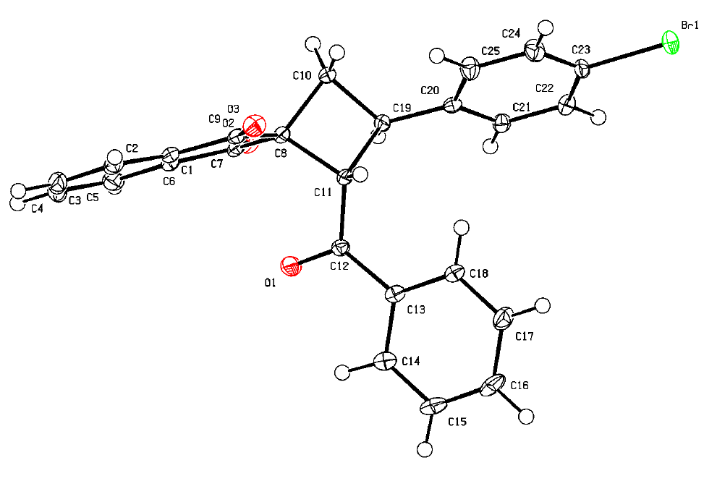
Crystal structure of 3e. ORTEP drawing with thermal ellipsoids at the 50% probability level. Deposition: 2535885.

(2RS,3SR)-2-Benzoyl-3-(4-methoxyphenyl)spiro[cyclobutane-1,2'-indene]-1',3'-dione (3f)
Cyclobutane 3f was obtained from cyclopropane 2f (200 mg, 0.7 mmol), 4a (195 mg, 1.1 mmol) in DCE (1.4 mL) according to General procedure A, 4 h. Yield 205 mg (72%); white solid; mp 134–135 °C; R_{f}=0.22 (petroleum ether – ethyl acetate, 6:1).
General procedure A. To a solution of cyclopropane 2 in dry 1,2-dichloroethane (0.5 M) was added ylide 4 (1.5 equiv.) in one portion at room temperature under an argon atmosphere. The resulting mixture was placed in a preheated oil bath and stirred at 70 °C (internal temperature) for several hours. The progress of the reaction was monitored by TLC or ¹H NMR spectra. After completion, the mixture was diluted with DCM, and the solvent was evaporated under reduced pressure. The residue was purified by column chromatography on silica gel to obtain the target cyclobutane 3.
¹H NMR (CDCl₃, 600 MHz) δ = 8.00 - 7.91 (m, 2H), 7.83 - 7.76 (m, 2H), 7.40 (ddd, J = 1.7, 7.5, 13.9 Hz, 4H), 7.32 (tt, J = 1.3, 7.4 Hz, 1H), 7.13 - 7.08 (m, 2H), 6.97 - 6.91 (m, 2H), 4.52 (d, J = 10.1 Hz, 1H), 4.24 (q, J = 9.8 Hz, 1H), 3.83 (s, 3H), 2.66 (t, J = 10.5 Hz, 1H), 2.58 (dd, J = 8.9, 10.9 Hz, 1H).
¹³C NMR (CDCl₃, 150 MHz) δ = 201.9, 201.0, 197.3, 159.0, 142.8, 141.0, 135.9, 135.4, 134.7, 134.4, 133.2, 128.8, 128.5, 128.2, 123.2, 123.1, 114.2, 57.9, 55.4, 52.9, 38.1, 32.7.
HRMS (ESI-TOF) m/z: [M+H]⁺ calcd for C₂₆H₂₁O₄⁺ 397.1434. Found 397.1439.
Anal. Calcd for C₂₆H₂₀O₄: C, 78.77; H, 5.09. Found: C, 78.41; H, 5.08.
IR (KBr, cm-1): 3420, 3062, 3034, 2996, 2955, 2932, 2898, 2833, 1735, 1700, 1662, 1607, 1594, 1579, 1512, 1460, 1450, 1442, 1356, 1333, 1324, 1305, 1299, 1272, 1245, 1237, 1207, 1195, 1179, 1166, 1115, 1070, 1035, 1024, 1003.
(Support check: C signals expected 18 after molecular symmetry correction (26 C atoms in formula), found 22)
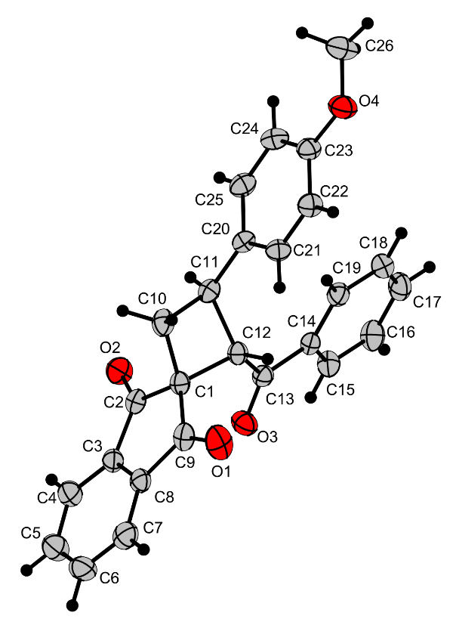
Crystal structure of 3f. ORTEP drawing with thermal ellipsoids at the 50% probability level. Deposition: 2432441.

(2RS,3SR)-2-Benzoyl-3-(3,4-dimethoxyphenyl)spiro[cyclobutane-1,2'-indene]-1',3'-dione (3g)
Cyclobutane 3g was obtained from cyclopropane 2g (235 mg, 0.76 mmol), 4a (206 mg, 1.1 mmol) in DCE (1.5 mL) according to General procedure A, 4 h. The crude product duct was purified by recrystallization from ethanol. Yield 245 mg (75%); light-yellow solid; mp 210–212 °C; R_{f}=0.24 (petroleum ether – ethyl acetate, 3:1).
General procedure A. To a solution of cyclopropane 2 in dry 1,2-dichloroethane (0.5 M) was added ylide 4 (1.5 equiv.) in one portion at room temperature under an argon atmosphere. The resulting mixture was placed in a preheated oil bath and stirred at 70 °C (internal temperature) for several hours. The progress of the reaction was monitored by TLC or ¹H NMR spectra. After completion, the mixture was diluted with DCM, and the solvent was evaporated under reduced pressure. The residue was purified by column chromatography on silica gel to obtain the target cyclobutane 3.
¹H NMR (CDCl₃, 600 MHz) δ = 8.02 - 7.98 (m, 1H), 7.98 - 7.94 (m, 1H), 7.81 (td, J = 3.9, 6.7 Hz, 2H), 7.40 (d, J = 7.8 Hz, 2H), 7.33 (t, J = 7.3 Hz, 1H), 7.12 (t, J = 7.7 Hz, 2H), 7.06 (dd, J = 2.2, 8.2 Hz, 1H), 6.98 (d, J = 2.2 Hz, 1H), 6.92 (d, J = 8.2 Hz, 1H), 4.51 (d, J = 10.0 Hz, 1H), 4.22 (q, J = 9.7 Hz, 1H), 3.90 (d, J = 15.1 Hz, 6H), 2.68 (t, J = 10.5 Hz, 1H), 2.59 (t, J = 9.9 Hz, 1H).
¹³C NMR (CD₂Cl₂, 100 MHz) δ = 201.4, 200.6, 197.3, 148.8, 148.0, 142.2, 140.6, 135.6, 135.1, 134.5, 134.4, 132.8, 127.9, 127.8, 122.7, 122.4, 119.1, 111.2, 110.7, 56.9, 55.4, 55.3, 53.5, 53.3, 53.0, 52.7, 52.6, 52.5, 48.9, 48.7, 48.4, 48.2, 48.0, 37.7, 32.1.
HRMS (ESI-TOF) m/z: [M+Na]⁺ calcd for C₂₇H₂₂O₅Na⁺ 449.1359. Found 449.1359.
IR (KBr, cm-1): 3060, 3004, 2970, 2958, 2939, 2931, 2831, 1737, 1700, 1670, 1596, 1590, 1578, 1515, 1456, 1447, 1435, 1419, 1346, 1328, 1315, 1305, 1290, 1272, 1257, 1236, 1212, 1199, 1176, 1163, 1140, 1114, 1080, 1044, 1033, 1021, 1004.
(Support check: C signals expected 21 after molecular symmetry correction (27 C atoms in formula), found 35)
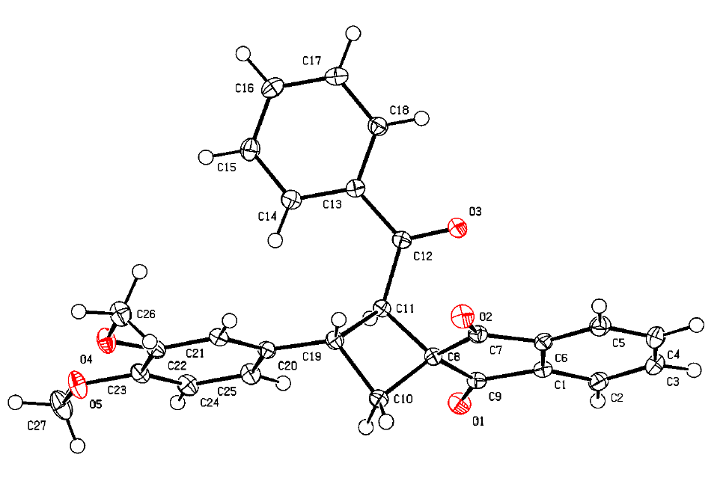
Crystal structure of 3g. ORTEP drawing with thermal ellipsoids at the 50% probability level. Deposition: 2535886.

(2RS,3SR)-2-Benzoyl-3-[4-(trifluoromethoxy)phenyl]spiro[cyclobutane-1,2'-indene]-1',3'-dione (3h)
Cyclobutane 3h was obtained from cyclopropane 2h (200 mg, 0.6 mmol), 4a (163 mg, 0.9 mmol) in DCE (1.2 mL) according to General procedure A, 7.5 h. Yield 217 mg (80%); white solid; mp 139–141 °C; R_{f}=0.36 (petroleum ether – ethyl acetate, 4:1.
General procedure A. To a solution of cyclopropane 2 in dry 1,2-dichloroethane (0.5 M) was added ylide 4 (1.5 equiv.) in one portion at room temperature under an argon atmosphere. The resulting mixture was placed in a preheated oil bath and stirred at 70 °C (internal temperature) for several hours. The progress of the reaction was monitored by TLC or ¹H NMR spectra. After completion, the mixture was diluted with DCM, and the solvent was evaporated under reduced pressure. The residue was purified by column chromatography on silica gel to obtain the target cyclobutane 3.
¹H NMR (CDCl₃, 600 MHz) δ = 8.02 - 7.96 (m, 1H), 7.93 - 7.86 (m, 1H), 7.84 - 7.76 (m, 2H), 7.54 - 7.49 (m, 2H), 7.40 - 7.35 (m, 2H), 7.31 (tt, J = 1.3, 7.3 Hz, 1H), 7.13 - 7.07 (m, 2H), 4.51 (d, J = 10.0 Hz, 1H), 4.37 (q, J = 9.7 Hz, 1H), 2.70 (t, J = 10.5 Hz, 1H), 2.62 (dd, J = 8.9, 10.9 Hz, 1H).
¹³C NMR (CDCl₃, 150 MHz) δ = 201.1, 200.7, 196.8, 148.3, 142.4, 141.0, 140.9, 135.9, 135.4, 134.6, 133.2, 128.9, 128.4, 128.2, 128.1, 123.2, 123.1, 121.2, 56.5, 53.0, 37.2, 32.2.
19F{1H} NMR (CDCl₃, 376 MHz): –57.8 (OCF₃).
HRMS (ESI-TOF) m/z: [M+H]⁺ calcd for C₂₆H₁₈F₃O₄⁺ 451.1152. Found 451.1151.
Anal. Calcd for C₂₆H₁₇F₃O₄: C, 69.33; H, 3.80. Found: C, 69.46; H, 3.94.
IR (KBr, cm-1): 3419, 3070, 3020, 2989, 2940, 2918, 2904, 1734, 1700, 1685, 1595, 1507, 1448, 1360, 1333, 1316, 1259, 1219, 1201, 1168, 1151, 1117, 1075, 1049, 1020, 1005.
(Support check: H expected 17, found 15)
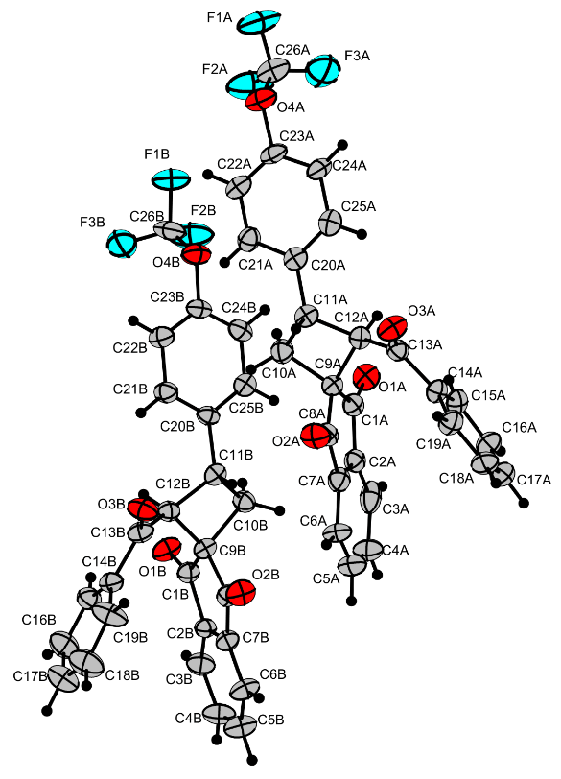
Crystal structure of 3h. ORTEP drawing with thermal ellipsoids at the 50% probability level. Deposition: 2432443.

(2RS,3SR)-2-Benzoyl-3-(4-cyanophenyl)spiro[cyclobutane-1,2'-indene]-1',3'-dione (3i)
Cyclobutane 3i was obtained from cyclopropane 2i (304 mg, 1.1 mmol), 4a (301 mg, 1.7 mmol) in DCE (2.2 mL) according to General procedure A, 15.5 h. An additional portion of 4a (100 mg, 0.6 mmol) was added to the reaction mixture after 8 h, and the reaction was left for another 7.5 h. Yield 357 mg (82%); white solid; mp 157–159 °C; R_{f}=0.16 (petroleum ether – ethyl acetate, 6:1).
General procedure A. To a solution of cyclopropane 2 in dry 1,2-dichloroethane (0.5 M) was added ylide 4 (1.5 equiv.) in one portion at room temperature under an argon atmosphere. The resulting mixture was placed in a preheated oil bath and stirred at 70 °C (internal temperature) for several hours. The progress of the reaction was monitored by TLC or ¹H NMR spectra. After completion, the mixture was diluted with DCM, and the solvent was evaporated under reduced pressure. The residue was purified by column chromatography on silica gel to obtain the target cyclobutane 3.
¹H NMR (CDCl₃, 600 MHz) δ = 7.96 (dt, J = 1.1, 7.5 Hz, 1H), 7.82 - 7.77 (m, 2H), 7.77 - 7.72 (m, 1H), 7.69 - 7.64 (m, 2H), 7.57 (d, J = 8.2 Hz, 2H), 7.38 - 7.33 (m, 2H), 7.11 - 7.05 (m, 2H), 4.49 (d, J = 9.9 Hz, 1H), 4.44 (q, J = 9.4 Hz, 1H), 2.68 (dd, J = 9.7, 11.0 Hz, 1H), 2.61 (dd, J = 8.6, 11.0 Hz, 1H).
¹³C NMR (CDCl₃, 150 MHz) δ = 200.6, 196.7, 147.9, 142.4, 141.2, 136.2, 135.8, 134.8, 133.5, 132.7, 128.5, 128.4, 128.1, 123.4, 123.4, 118.9, 111.1, 55.4, 53.4, 37.2, 32.0.
HRMS (ESI-TOF) m/z: [M+H]⁺ calcd for C₂₆H₁₈NO₃⁺ 392.1281. Found 392.1281.
Anal. Calcd for C₂₆H₁₇NO₃: C, 79.78; H, 4.38; N, 3.58. Found: C, 79.39; H, 4.42; N, 3.37.
IR (KBr, cm-1): 3427, 3097, 2996, 2952, 2930, 2226, 1738, 1699, 1695, 1597, 1578, 1504, 1444, 1434, 1416, 1369, 1347, 1328, 1317, 1291, 1279, 1263, 1227, 1178, 1147, 1125, 1111, 1082, 1074, 1039, 1026, 1018, 1001.
(Support check: H expected 17, found 16; C signals expected 18 after molecular symmetry correction (26 C atoms in formula), found 21)
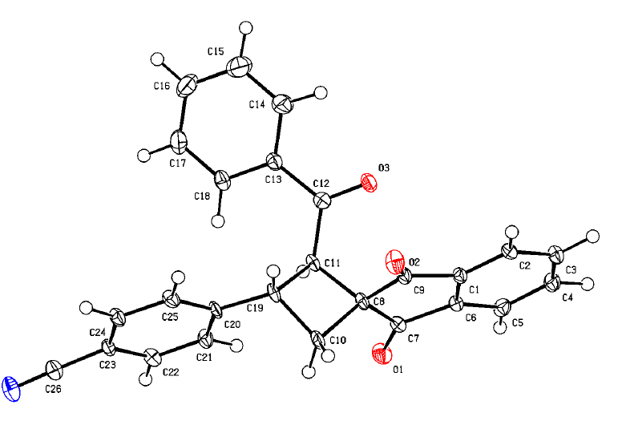
Crystal structure of 3i. ORTEP drawing with thermal ellipsoids at the 50% probability level. Deposition: 2535884.

Ethyl (2RS,3SR)-1',3'-dioxo-3-(o-tolyl)-1',3'-dihydrospiro[cyclobutane-1,2'-indene]-2-carboxylate (3s)
Cyclobutane 3s was obtained from cyclopropane 1c (200 mg, 0.8 mmol), 4g (170 mg, 1.1 mmol) in DCM (1.5 mL) according to General procedure B, 4 h. Yield 220 mg (82%); white solid; mp 136–137°C; R_{f}=0.38 (petroleum ether – ethyl acetate, 4:1).
General procedure B. To a solution of cyclopropane 2 in dry dichloromethane (0.5 M) was added 4g (1.5 equiv.) in one portion at room temperature under an argon atmosphere. The resulting mixture was stirred at room temperature for 2 h, then placed in a preheated oil bath and refluxed for 2–16 h. The progress of the reaction was monitored by TLC. After completion, the mixture was diluted with DCM, and the solvent was evaporated under reduced pressure. The residue was purified by column chromatography on silica gel to obtain the target cyclobutane 3.
¹H NMR (CDCl₃, 600 MHz) δ = 8.03 (tt, J = 4.9, 7.2 Hz, 2H), 7.90 - 7.83 (m, 2H), 7.52 (d, J = 7.6 Hz, 1H), 7.20 - 7.14 (m, 2H), 4.45 (q, J = 9.9 Hz, 1H), 4.06 - 3.89 (m, 3H), 2.63 (dd, J = 9.2, 10.6 Hz, 1H), 2.44 - 2.36 (m, 4H), 0.98 (t, J = 7.1 Hz, 3H).
¹³C NMR (CDCl₃, 150 MHz) δ = 201.7, 200.2, 170.6, 142.6, 141.6, 140.3, 136.3, 136.0, 135.8, 130.3, 127.0, 126.9, 126.4, 126.0, 123.7, 123.4, 123.3, 61.0, 52.9, 48.8, 34.6, 33.0, 19.9, 14.2, 14.0.
HRMS (ESI-TOF) m/z: [M+H]⁺ calcd for C₂₂H₂₁O₄⁺ 349.1434. Found 349.1439.
Anal. Calcd for C₂₂H₂₀O₄: C, 75.84; H, 5.79. Found: C, 75.81; H, 5.53.
IR (KBr, cm-1): 2989, 2975, 2937, 1730, 1702, 1597, 1494, 1463, 1453, 1389, 1373, 1351, 1331, 1315, 1293, 1284, 1267, 1227, 1195, 1151, 1123, 1097, 1049, 1034, 1007.
(Support check: H expected 20, found 19; C signals expected 18 after molecular symmetry correction (22 C atoms in formula), found 25)
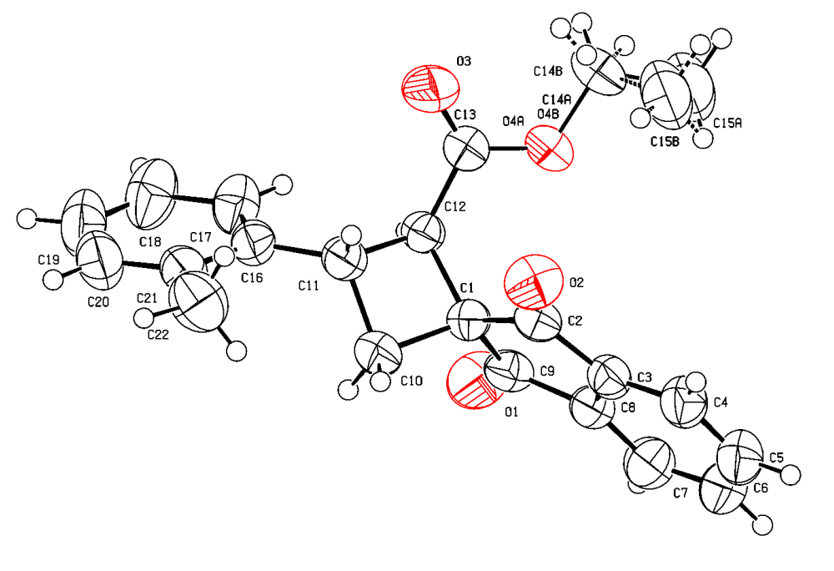
Crystal structure of 3s. ORTEP drawing with thermal ellipsoids at the 50% probability level. Deposition: 2364657.

Diethyl (2RS,3SR,4RS)- and (2RS,3SR,4SR)-1',3'-dioxo-3-(p-tolyl)-1',3'-dihydrospiro[cyclobutane-1,2'-indene]-2,4-dicarboxylate (3v)
Cyclobutane 3v was obtained according to General procedure D from alkene 1b (248 mg, 1.0 mmol), 4g (370 mg, 2.5 mmol) in DCM (2.0 mL), 8 h. The final product was purified by recrystallization from an Et₂O–PE mixture (1:1). Yield 282 mg (73%); mixture of diastereomers (dr 59:41, A:B); white solid; mp 145–146 °C; R_{f}=0.45 (petroleum ether – ethyl acetate, 4:1).
General procedure D. To a solution of alkene 1 (1 M) in dry DCM (for 4f) or DCE (for 4a) solution of 4 (1.0 equiv., 1M) was added dropwise at room temperature under an argon atmosphere [total conc. of 1 in the reaction mixture after addition of ylide – 0.5 M]. The resulting mixture was stirred at room temperature for 1 h. Then, after completion of cyclopropanation (monitored by TLC), 4 (1.5 equiv.) was added in one portion, and the reaction mixture was placed in a preheated oil bath and refluxed (for 4f) or stirred at 70 °C for 4a) for 8–12 h (monitored by TLC). After completion, the mixture was diluted with DCM, and the solvent was evaporated under reduced pressure. The residue was recrystallized from EtOH to obtain the target cyclobutane 3.
¹H NMR (CDCl₃, 600 MHz) δ = 8.07 - 7.99 (m, 3H), 7.91 - 7.84 (m, 3H), 7.41 (d, J = 7.8 Hz, 1H), 7.31 (d, J = 7.8 Hz, 2H), 7.19 (d, J = 7.9 Hz, 1H), 7.15 (d, J = 7.8 Hz, 2H), 4.58 (t, J = 10.1 Hz, 1H), 4.35 (d, J = 10.0 Hz, 1H), 4.10 - 3.89 (m, 5H), 3.89 - 3.78 (m, 3H), 3.61 (d, J = 10.4 Hz, 1H), 2.34 (d, J = 12.8 Hz, 5H), 0.98 (dt, J = 7.1, 16.9 Hz, 7H), 0.85 (t, J = 7.1 Hz, 3H).
¹³C NMR (CDCl₃, 150 MHz) δ = 199.7, 199.6, 198.7, 170.4, 170.0, 168.3, 143.4, 142.4, 141.6, 137.7, 137.0, 136.4, 136.3, 136.1, 135.9, 135.8, 135.7, 129.4, 129.0, 127.4, 127.0, 123.9, 123.8, 123.5, 123.0, 61.2, 60.9, 55.9, 47.6, 46.6, 45.9, 41.0, 39.7, 21.2, 14.0, 13.9, 13.7.
¹H NMR (CDCl₃, 600 MHz), minor diastereomer: δ 8.07–8.02 (m, 2H, CH), 7.91–7.87 (m, 2H, CH), 7.43 (d, 3J = 7.9 Hz, 2H, CH), 7.21 (d, 3J = 7.9 Hz, 2H, CH), 4.49 (t, 3J = 10.4 Hz, 1H, C(3)H), 4.07–4.02 (m, 2H, CH₂CH₃), 3.97–3.93 (m, 2H, CH₂CH₃), 3.63 (d, 3J = 10.3 Hz, 2H, C(2)H+C(4)H), 2.37 (s, 3H, CH₃), 0.98 (t, 3J = 7.1 Hz, 6H, 2 × CH₂CH₃).
¹³C{¹H} NMR (CDCl₃, 150 MHz), minor diastereomer: δ 199.6 (C=O), 198.7 (C=O), 170.0 (2 × C=O), 143.4 (C), 141.6 (C), 137.7 (C), 137.0 (C), 136.1 (CH), 135.7 (CH), 129.4 (2 × CH), 127.0 (2 × CH), 123.9 (CH), 123.0 (CH), 61.2 (2 × CH₂CH₃), 55.9 (C(1)), 46.6 (C(2)H+C(4)H), 41.0 (C(3)H), 21.2 (CH₃), 13.9 (2 × CH₂CH₃).
HRMS (ESI-TOF) m/z: [M+NH4]⁺ calcd for C₂₅H₂₈O₆N⁺ 438.1911. Found 438.1911.
IR (KBr, cm-1): 2981, 2936, 2919, 2872, 1742, 1704, 1592, 1516, 1468, 1447, 1422, 1385, 1377, 1365, 1357, 1334, 1325, 1307, 1293, 1271, 1211, 1196, 1152, 1125, 1116, 1097, 1075, 1049, 1026, 1010.
(Support check: H expected 24, found 38; C signals expected 19 after molecular symmetry correction (25 C atoms in formula), found 37)
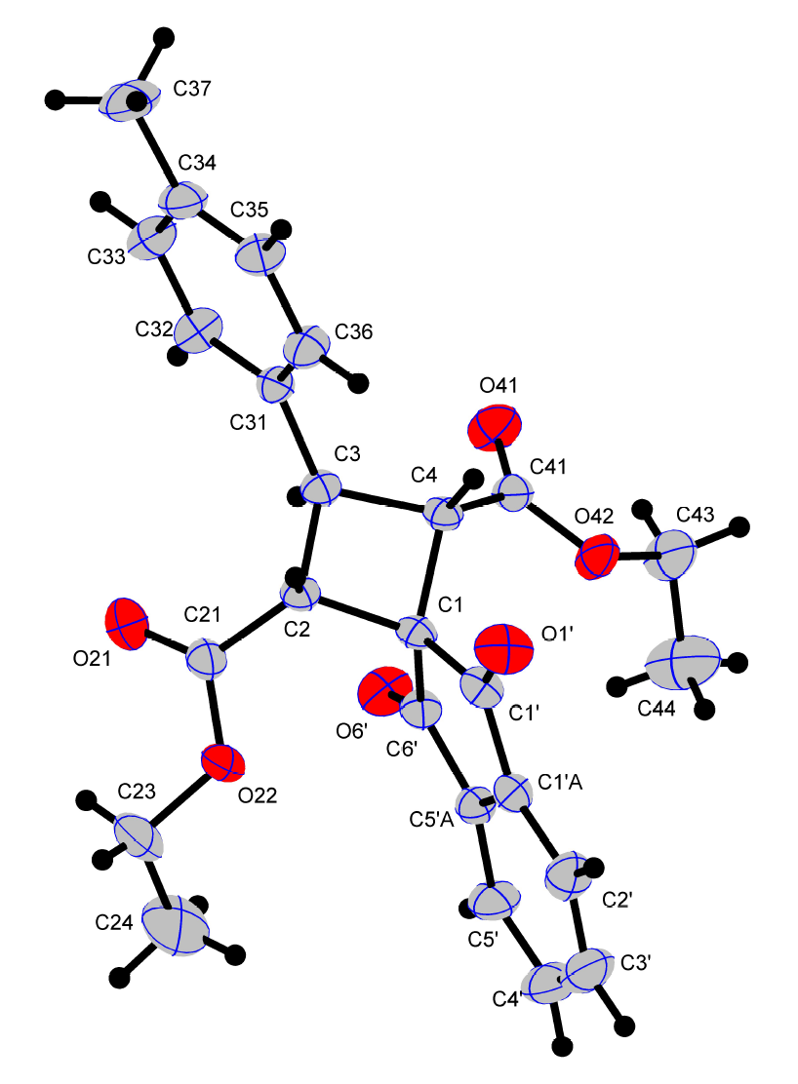
Crystal structure of 3v. Minor diastereomer B. ORTEP drawing with thermal ellipsoids at the 50% probability level. Deposition: 2117516.

X-ray crystallography
(2RS,3SR)-2-Benzoyl-3-(o-tolyl)spiro[cyclobutane-1,2'-indene]-1',3'-dione (3c)
Single crystals of 3c were obtained through slow evaporation of its solution in a petroleum ether – ethyl acetate mixture at room temperature.
Single-crystal X-ray diffraction data were collected using stoe with Mo Kα (λ = 0.71073) at 295 K.
Structure refinement: SHELXL-2014/7 (Sheldrick, 2014).
Hydrogen-atom treatment: refall.
Crystallographic deposition: 2383313.
Table S1. Crystal data and structure refinement for compound 3c.
Identification code | CCDC 2383313
Empirical formula | C₂₆ H₂₀ O₃
Formula weight | 380.42
Temperature / K | 295
Crystal system | monoclinic
Space group | P 21/n
a / Å | 7.1934(5)
b / Å | 13.3744(7)
c / Å | 20.4230(10)
α / ° | 90
β / ° | 97.997(6)
γ / ° | 90
V / Å³ | 1945.7(2)
Z | 4
Calculated density / Mg m⁻³ | 1.299
Absorption coefficient / mm⁻¹ | 0.084
F(000) | 800
Crystal size / mm | .33 × .23 × .21
Radiation (wavelength / Å) | Mo Kα (λ = 0.71073)
Diffractometer | stoe
θ range for data collection / ° | 2.525–28.097
Index ranges | -9 ≤ h ≤ 9; -17 ≤ k ≤ 15; -26 ≤ l ≤ 23
Reflections collected / independent / observed | 25442 / 4625 / 1998
Rint | 0.0945
Data / restraints / parameters | 4625 / 0 / 266
Goodness-of-fit on F² | 0.771
Final R indices [I > 2σ(I)] | R1 = 0.0433, wR2 = 0.0832
R indices (all data) | R1 = 0.1228, wR2 = 0.1018
Largest diff. peak and hole / e Å⁻³ | 0.169 / -0.160

(2RS,3SR)-2-Benzoyl-3-(4-bromophenyl)spiro[cyclobutane-1,2'-indene]-1',3'-dione (3e)
Single crystals of 3e were obtained through slow evaporation of its solution in a petroleum ether – ethyl acetate mixture at room temperature.
Single-crystal X-ray diffraction data were collected using XtaLAB Pro: Kappa single with MoKα (λ = 0.71073) at 100(2) K.
Structure solution: SHELXT 2018/2 (Sheldrick, 2018).
Structure refinement: SHELXL-2019/2 (Sheldrick, 2019).
Hydrogen-atom treatment: refxyz.
Crystallographic deposition: 2535885.
Table S2. Crystal data and structure refinement for compound 3e.
Identification code | CCDC 2535885
Empirical formula | C₂₅ H₁₇ Br O₃
Formula weight | 445.29
Temperature / K | 100(2)
Crystal system | monoclinic
Space group | P 21/c
a / Å | 12.6839(12)
b / Å | 7.1871(3)
c / Å | 26.734(3)
α / ° | 90
β / ° | 128.548(15)
γ / ° | 90
V / Å³ | 1906.0(4)
Z | 4
Calculated density / Mg m⁻³ | 1.552
Absorption coefficient / mm⁻¹ | 2.182
F(000) | 904
Crystal size / mm | 0.741 × 0.565 × 0.364
Radiation (wavelength / Å) | MoKα (λ = 0.71073)
Diffractometer | XtaLAB Pro: Kappa single
θ range for data collection / ° | 2.997–30.507
Index ranges | -16 ≤ h ≤ 17; -10 ≤ k ≤ 10; -38 ≤ l ≤ 33
Reflections collected / independent / observed | 16732 / 5741 / 4729
Rint | 0.0407
Data / restraints / parameters | 5741 / 0 / 313
Goodness-of-fit on F² | 1.064
Final R indices [I > 2σ(I)] | R1 = 0.0344, wR2 = 0.0829
R indices (all data) | R1 = 0.0472, wR2 = 0.0870
Largest diff. peak and hole / e Å⁻³ | 0.605 / -0.810

(2RS,3SR)-2-Benzoyl-3-(4-methoxyphenyl)spiro[cyclobutane-1,2'-indene]-1',3'-dione (3f)
Single crystals of 3f were obtained through slow evaporation of its solution in a petroleum ether – ethyl acetate mixture at room temperature.
Single-crystal X-ray diffraction data were collected using stoe with Mo Kα (λ = 0.71073) at 295 K.
Structure refinement: SHELXL-2014/7 (Sheldrick, 2014).
Hydrogen-atom treatment: constr.
Crystallographic deposition: 2432441.
Table S3. Crystal data and structure refinement for compound 3f.
Identification code | CCDC 2432441
Empirical formula | C₂₆ H₂₀ O₄
Formula weight | 396.42
Temperature / K | 295
Crystal system | triclinic
Space group | P -1
a / Å | 8.0347(4)
b / Å | 11.0896(5)
c / Å | 12.6007(7)
α / ° | 65.645(5)
β / ° | 81.056(6)
γ / ° | 82.727(6)
V / Å³ | 1007.95(10)
Z | 2
Calculated density / Mg m⁻³ | 1.306
Absorption coefficient / mm⁻¹ | 0.088
F(000) | 416
Crystal size / mm | .26 × .23 × .14
Radiation (wavelength / Å) | Mo Kα (λ = 0.71073)
Diffractometer | stoe
θ range for data collection / ° | 2.572–27.350
Index ranges | -10 ≤ h ≤ 10; -14 ≤ k ≤ 14; -16 ≤ l ≤ 16
Reflections collected / independent / observed | 27081 / 4414 / 2055
Rint | 0.0476
Data / restraints / parameters | 4414 / 0 / 273
Goodness-of-fit on F² | 0.783
Final R indices [I > 2σ(I)] | R1 = 0.0357, wR2 = 0.0599
R indices (all data) | R1 = 0.1024, wR2 = 0.0709
Largest diff. peak and hole / e Å⁻³ | 0.132 / -0.136

(2RS,3SR)-2-Benzoyl-3-(3,4-dimethoxyphenyl)spiro[cyclobutane-1,2'-indene]-1',3'-dione (3g)
Single crystals of 3g were obtained through slow evaporation of its solution in a petroleum ether – ethyl acetate mixture at room temperature.
Single-crystal X-ray diffraction data were collected using XtaLAB Pro: Kappa single with MoKα (λ = 0.71073) at 100(2) K.
Structure refinement: SHELXL-2019/2 (Sheldrick, 2019).
Hydrogen-atom treatment: refxyz.
Crystallographic deposition: 2535886.
Table S4. Crystal data and structure refinement for compound 3g.
Identification code | CCDC 2535886
Empirical formula | C₂₇ H₂₂ O₅
Formula weight | 426.44
Temperature / K | 100(2)
Crystal system | monoclinic
Space group | P 21/c
a / Å | 9.2211(3)
b / Å | 16.0471(5)
c / Å | 14.6220(5)
α / ° | 90
β / ° | 107.623(4)
γ / ° | 90
V / Å³ | 2062.09(12)
Z | 4
Calculated density / Mg m⁻³ | 1.374
Absorption coefficient / mm⁻¹ | 0.094
F(000) | 896
Crystal size / mm | 0.566 × 0.486 × 0.427
Radiation (wavelength / Å) | MoKα (λ = 0.71073)
Diffractometer | XtaLAB Pro: Kappa single
θ range for data collection / ° | 2.929–30.505
Index ranges | -13 ≤ h ≤ 11; -22 ≤ k ≤ 17; -15 ≤ l ≤ 20
Reflections collected / independent / observed | 19451 / 6190 / 5363
Rint | 0.0238
Data / restraints / parameters | 6190 / 0 / 355
Goodness-of-fit on F² | 1.051
Final R indices [I > 2σ(I)] | R1 = 0.0406, wR2 = 0.1114
R indices (all data) | R1 = 0.0467, wR2 = 0.1149
Largest diff. peak and hole / e Å⁻³ | 0.457 / -0.249

(2RS,3SR)-2-Benzoyl-3-[4-(trifluoromethoxy)phenyl]spiro[cyclobutane-1,2'-indene]-1',3'-dione (3h)
Single crystals of 3h were obtained through slow evaporation of its solution in a petroleum ether – ethyl acetate mixture at room temperature. It was found that the lattice of cyclobutane 3h contains two independent molecules.
Single-crystal X-ray diffraction data were collected using stoe with Mo Kα (λ = 0.71073) at 295 K.
Structure refinement: SHELXL-2014/7 (Sheldrick, 2014).
Hydrogen-atom treatment: constr.
Crystallographic deposition: 2432443.
Table S5. Crystal data and structure refinement for compound 3h.
Identification code | CCDC 2432443
Empirical formula | C₂₆ H₁₇ F₃ O₄
Formula weight | 450.39
Temperature / K | 295
Crystal system | orthorhombic
Space group | P 21 21 21
a / Å | 9.7324(6)
b / Å | 16.6860(10)
c / Å | 26.4640(10)
α / ° | 90
β / ° | 90
γ / ° | 90
V / Å³ | 4297.6(4)
Z | 8
Calculated density / Mg m⁻³ | 1.392
Absorption coefficient / mm⁻¹ | 0.111
F(000) | 1856
Crystal size / mm | .24 × .18 × .12
Radiation (wavelength / Å) | Mo Kα (λ = 0.71073)
Diffractometer | stoe
θ range for data collection / ° | 1.964–26.950
Index ranges | -8 ≤ h ≤ 12; -21 ≤ k ≤ 20; -33 ≤ l ≤ 33
Reflections collected / independent / observed | 33117 / 8932 / 2173
Rint | 0.1142
Data / restraints / parameters | 8932 / 0 / 595
Goodness-of-fit on F² | 0.626
Final R indices [I > 2σ(I)] | R1 = 0.0575, wR2 = 0.1421
R indices (all data) | R1 = 0.2254, wR2 = 0.1970
Largest diff. peak and hole / e Å⁻³ | 0.343 / -0.292
Absolute-structure parameter | 1.8(10)

(2RS,3SR)-2-Benzoyl-3-(4-cyanophenyl)spiro[cyclobutane-1,2'-indene]-1',3'-dione (3i)
Single crystals of 3i were obtained through slow evaporation of its solution in a petroleum ether – ethyl acetate mixture at room temperature.
Single-crystal X-ray diffraction data were collected using XtaLAB Pro: Kappa single with MoKα (λ = 0.71073) at 100(2) K.
Structure solution: SHELXT 2018/2 (Sheldrick, 2018).
Structure refinement: SHELXL-2019/2 (Sheldrick, 2019).
Hydrogen-atom treatment: refxyz.
Crystallographic deposition: 2535884.
Table S6. Crystal data and structure refinement for compound 3i.
Identification code | CCDC 2535884
Empirical formula | C₂₆ H₁₇ N O₃
Formula weight | 391.40
Temperature / K | 100(2)
Crystal system | orthorhombic
Space group | P b c a
a / Å | 9.9050(2)
b / Å | 33.5101(8)
c / Å | 12.1902(3)
α / ° | 90
β / ° | 90
γ / ° | 90
V / Å³ | 4046.14(16)
Z | 8
Calculated density / Mg m⁻³ | 1.285
Absorption coefficient / mm⁻¹ | 0.084
F(000) | 1632
Crystal size / mm | 0.655 × 0.576 × 0.224
Radiation (wavelength / Å) | MoKα (λ = 0.71073)
Diffractometer | XtaLAB Pro: Kappa single
θ range for data collection / ° | 2.718–28.282
Index ranges | -13 ≤ h ≤ 13; -44 ≤ k ≤ 44; -16 ≤ l ≤ 16
Reflections collected / independent / observed | 149296 / 5011 / 4765
Rint | 0.1033
Data / restraints / parameters | 5011 / 0 / 322
Goodness-of-fit on F² | 1.352
Final R indices [I > 2σ(I)] | R1 = 0.1039, wR2 = 0.1967
R indices (all data) | R1 = 0.1067, wR2 = 0.1977
Largest diff. peak and hole / e Å⁻³ | 0.415 / -0.324

Ethyl (2RS,3SR)-1',3'-dioxo-3-(o-tolyl)-1',3'-dihydrospiro[cyclobutane-1,2'-indene]-2-carboxylate (3s)
Single crystals of 3s were obtained through slow evaporation of its solution in a petroleum ether – ethyl acetate mixture at room temperature.
Single-crystal X-ray diffraction data were collected using STOE with Cu Kα (λ = 1.54186) at 295 K.
Structure refinement: SHELXL-2014/7 (Sheldrick, 2014).
Hydrogen-atom treatment: constr.
Crystallographic deposition: 2364657.
Table S7. Crystal data and structure refinement for compound 3s.
Identification code | CCDC 2364657
Empirical formula | C₂₂ H₂₀ O₄
Formula weight | 348.38
Temperature / K | 295
Crystal system | orthorhombic
Space group | P b c a
a / Å | 11.9328(5)
b / Å | 20.0357(7)
c / Å | 15.4091(5)
α / ° | 90
β / ° | 90
γ / ° | 90
V / Å³ | 3684.0(2)
Z | 8
Calculated density / Mg m⁻³ | 1.256
Absorption coefficient / mm⁻¹ | 0.696
F(000) | 1472
Crystal size / mm | .19 × .15 × .13
Radiation (wavelength / Å) | Cu Kα (λ = 1.54186)
Diffractometer | STOE
θ range for data collection / ° | 4.414–66.950
Index ranges | -7 ≤ h ≤ 14; -23 ≤ k ≤ 23; -16 ≤ l ≤ 18
Reflections collected / independent / observed | 23227 / 3255 / 1753
Rint | 0.0641
Data / restraints / parameters | 3255 / 2 / 243
Goodness-of-fit on F² | 0.864
Final R indices [I > 2σ(I)] | R1 = 0.0401, wR2 = 0.0881
R indices (all data) | R1 = 0.0856, wR2 = 0.0988
Largest diff. peak and hole / e Å⁻³ | 0.200 / -0.163

Diethyl (2RS,3SR,4RS)- and (2RS,3SR,4SR)-1',3'-dioxo-3-(p-tolyl)-1',3'-dihydrospiro[cyclobutane-1,2'-indene]-2,4-dicarboxylate (3v)
Single crystals of the 3v minor diastereomer were obtained through slow evaporation of its solution in a petroleum ether – ethyl acetate mixture at room temperature.
Single-crystal X-ray diffraction data were collected using Stoe STADI VARI with Cu Kα (λ = 1.54186) at 295(2) K.
Structure refinement: SHELXL-2014/7 (Sheldrick, 2014).
Hydrogen-atom treatment: constr.
Crystallographic deposition: 2117516.
Table S8. Crystal data and structure refinement for compound 3v.
Identification code | CCDC 2117516
Empirical formula | C₂₅ H₂₄ O₆
Formula weight | 420.44
Temperature / K | 295(2)
Crystal system | monoclinic
Space group | P 21/n
a / Å | 8.0322(3)
b / Å | 14.8648(4)
c / Å | 19.0366(8)
α / ° | 90
β / ° | 101.184(3)
γ / ° | 90
V / Å³ | 2229.75(14)
Z | 4
Calculated density / Mg m⁻³ | 1.253
Absorption coefficient / mm⁻¹ | 0.733
F(000) | 888
Crystal size / mm | 0.200 × 0.200 × 0.200
Radiation (wavelength / Å) | Cu Kα (λ = 1.54186)
Diffractometer | Stoe STADI VARI
θ range for data collection / ° | 3.801–72.874
Index ranges | -9 ≤ h ≤ 7; -18 ≤ k ≤ 17; -17 ≤ l ≤ 23
Reflections collected / independent / observed | 15826 / 4357 / 3470
Rint | 0.0855
Data / restraints / parameters | 4357 / 0 / 259
Goodness-of-fit on F² | 1.065
Final R indices [I > 2σ(I)] | R1 = 0.0553, wR2 = 0.1539
R indices (all data) | R1 = 0.0657, wR2 = 0.1609
Largest diff. peak and hole / e Å⁻³ | 0.291 / -0.252

(2RS,3SR)-2-Benzoyl-3-(o-tolyl)spiro[cyclobutane-1,2'-indene]-1',3'-dione (3c)
¹H NMR (CDCl₃, 600 MHz)
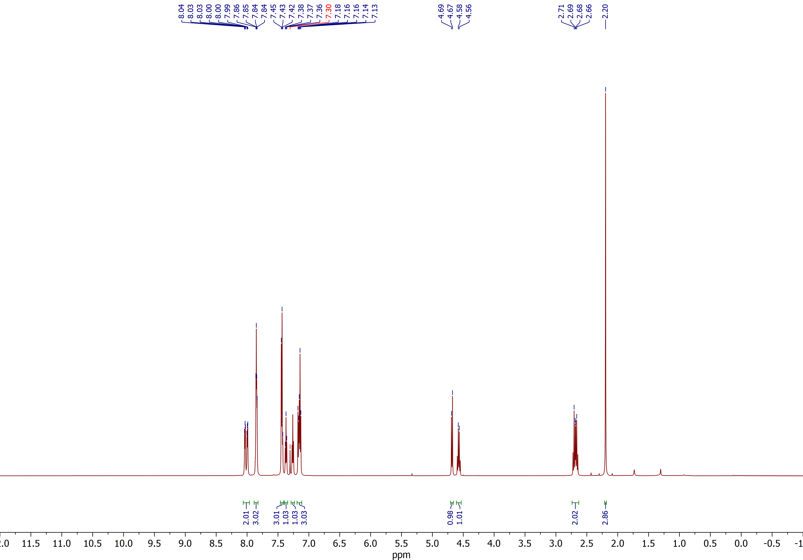

(2RS,3SR)-2-Benzoyl-3-(o-tolyl)spiro[cyclobutane-1,2'-indene]-1',3'-dione (3c)
¹³C NMR (CDCl₃, 150 MHz)
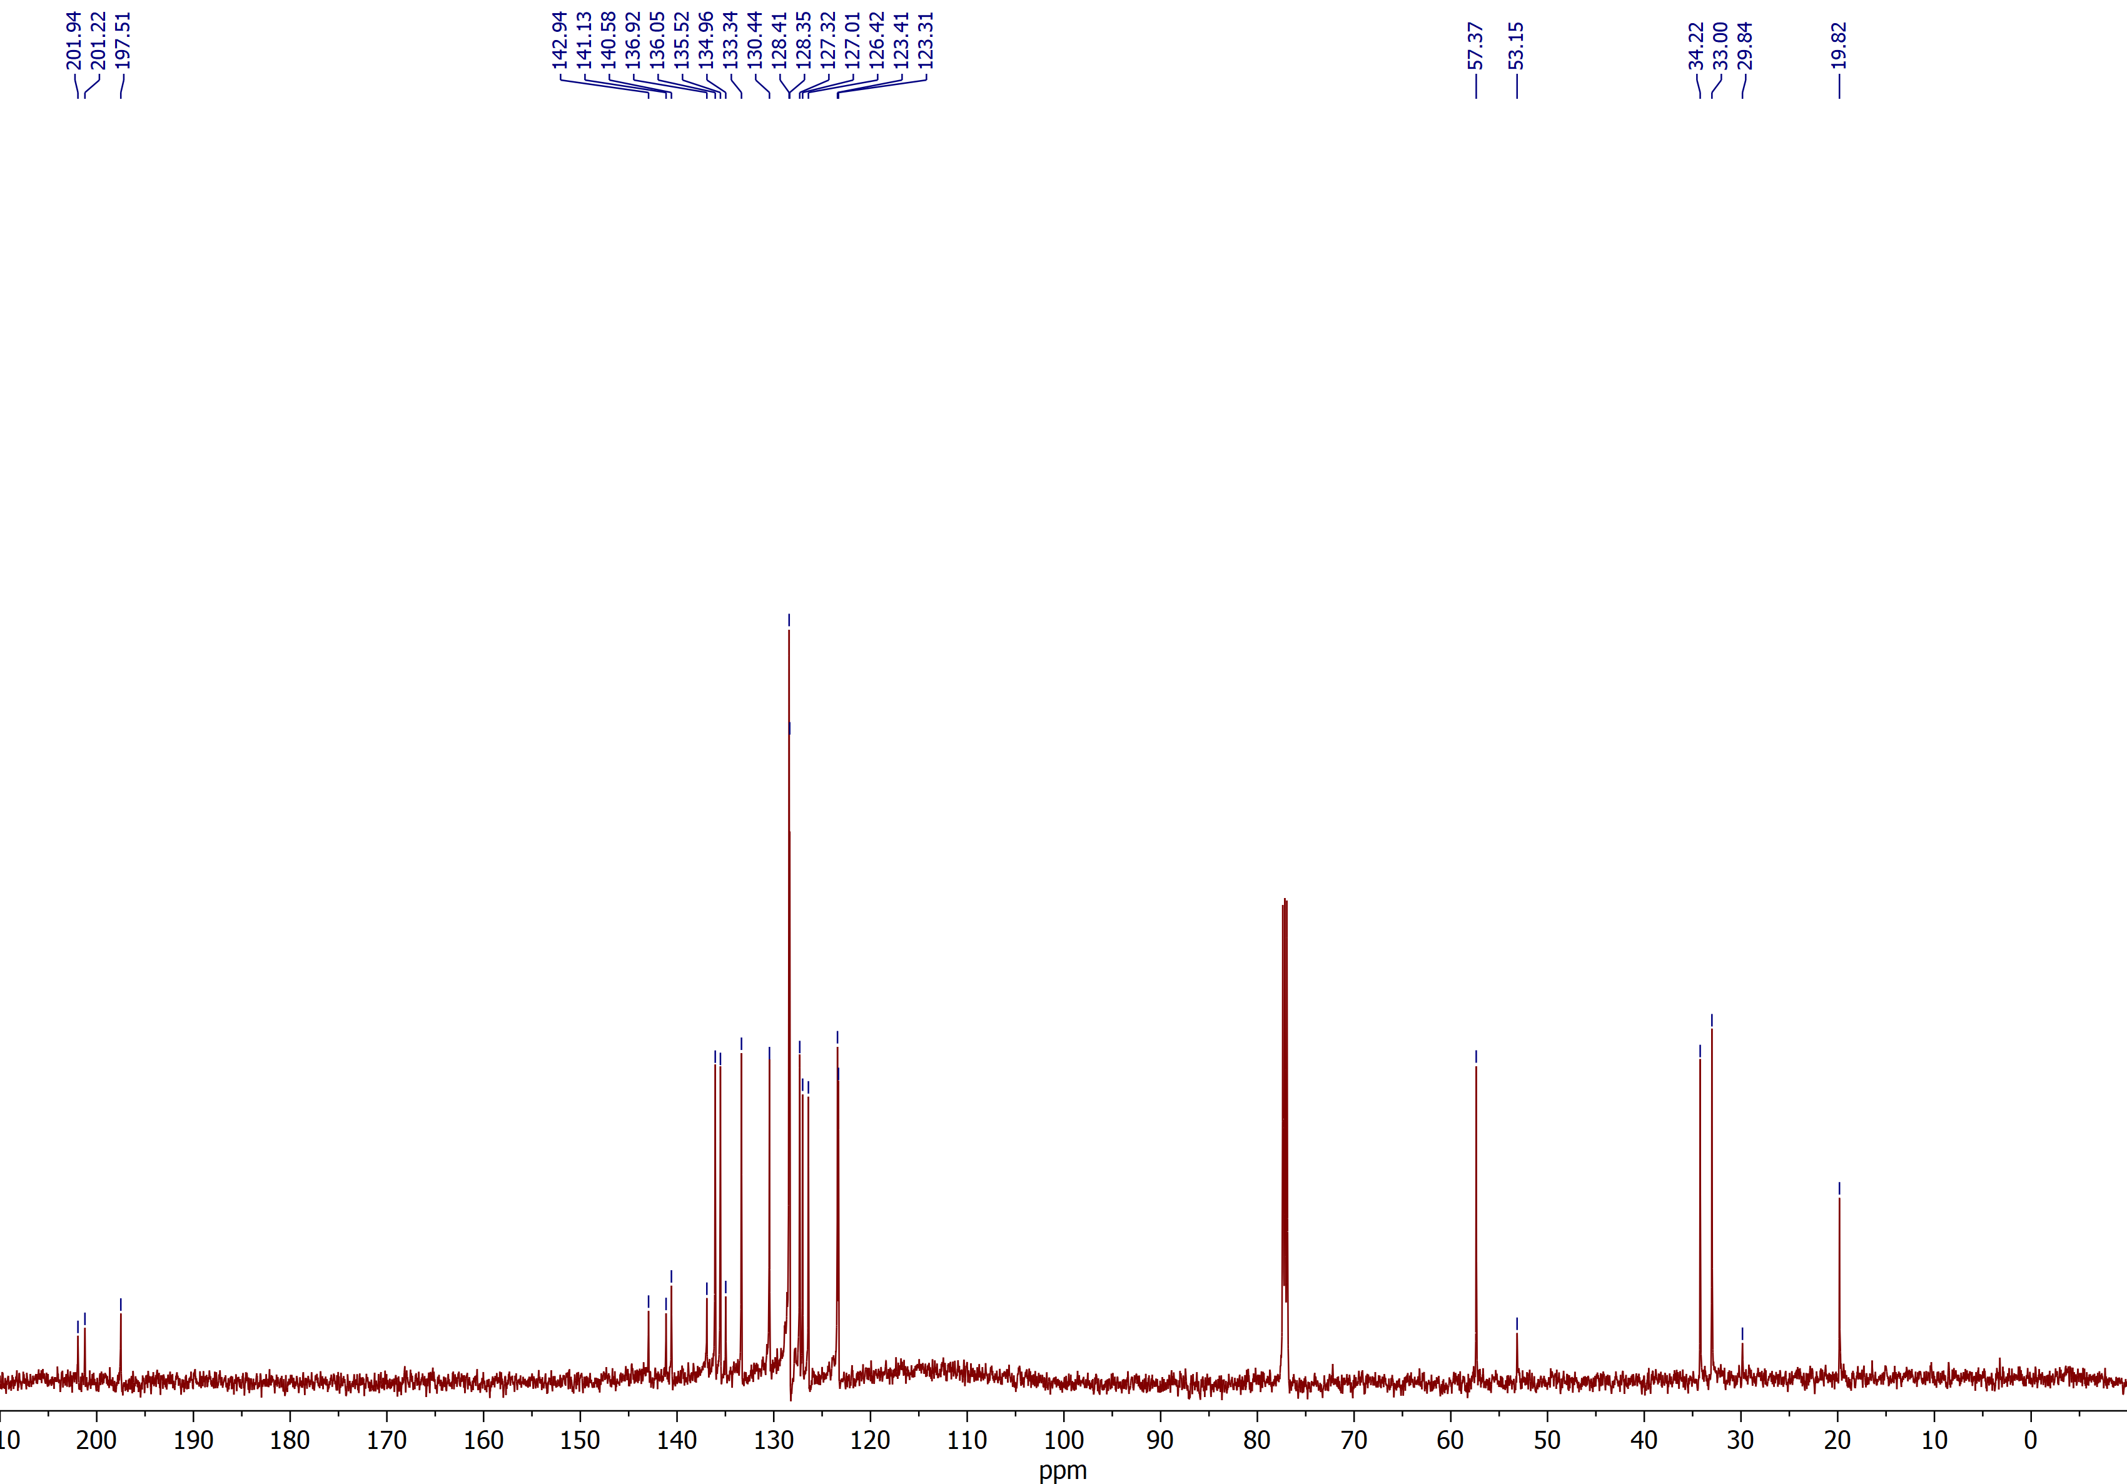

(2RS,3SR)-2-Benzoyl-3-(4-bromophenyl)spiro[cyclobutane-1,2'-indene]-1',3'-dione (3e)
¹H NMR (CDCl₃, 600 MHz)
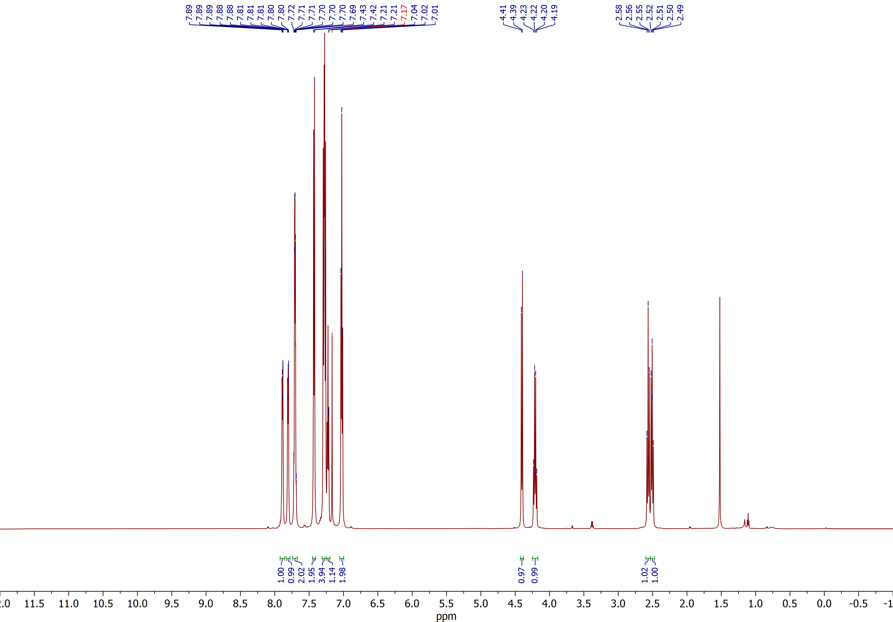

(2RS,3SR)-2-Benzoyl-3-(4-bromophenyl)spiro[cyclobutane-1,2'-indene]-1',3'-dione (3e)
¹³C NMR (CDCl₃, 150 MHz)
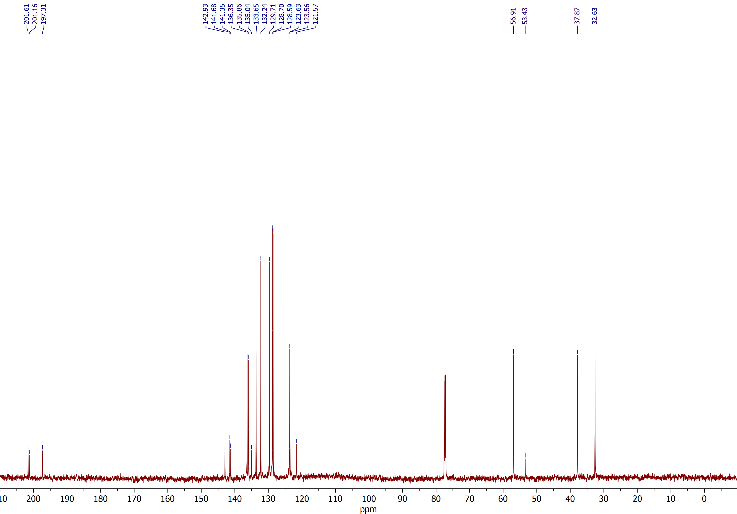

(2RS,3SR)-2-Benzoyl-3-(4-methoxyphenyl)spiro[cyclobutane-1,2'-indene]-1',3'-dione (3f)
¹H NMR (CDCl₃, 600 MHz)
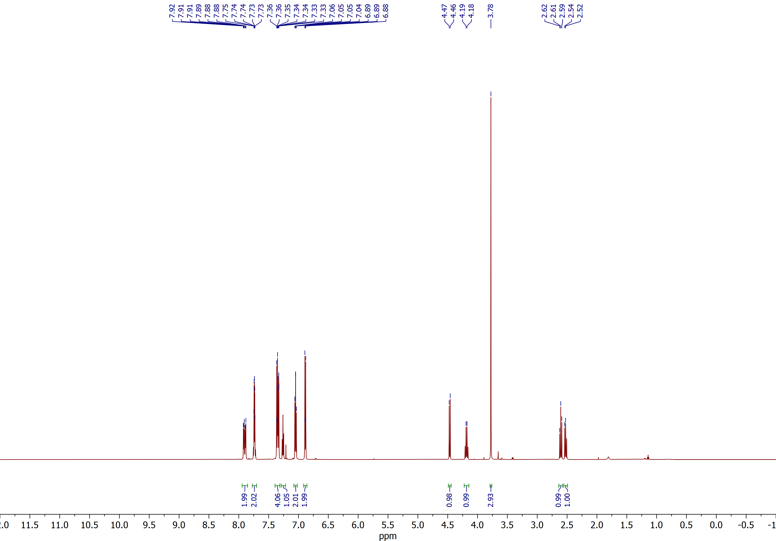

(2RS,3SR)-2-Benzoyl-3-(4-methoxyphenyl)spiro[cyclobutane-1,2'-indene]-1',3'-dione (3f)
¹³C NMR (CDCl₃, 150 MHz)
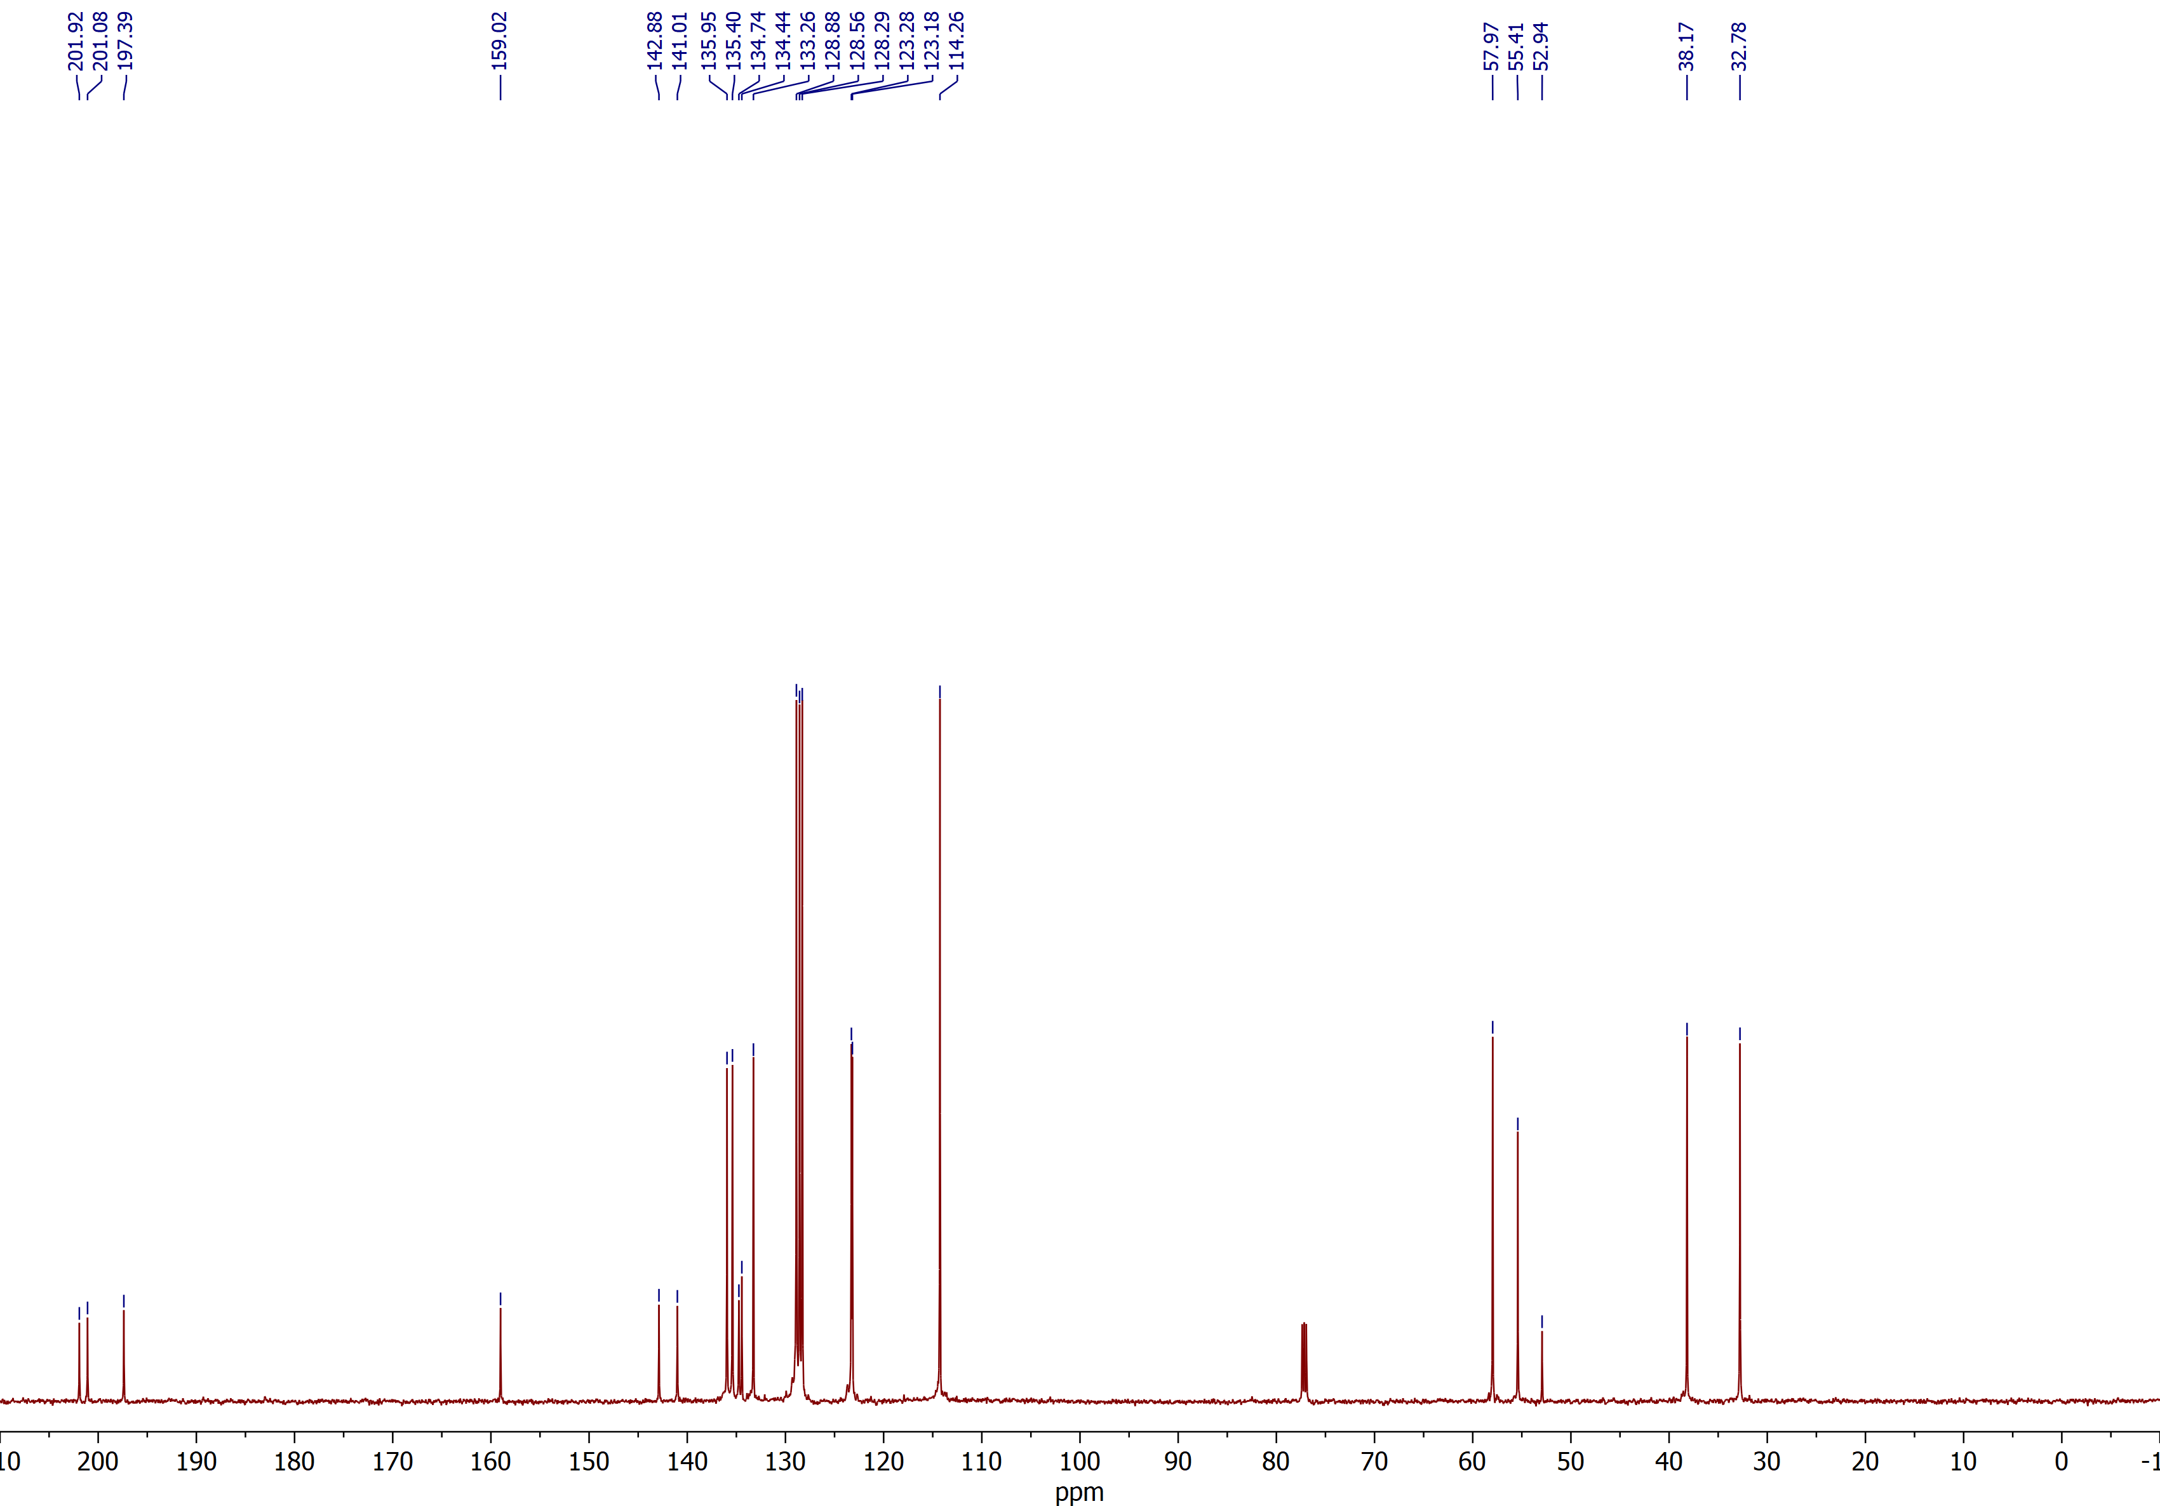

(2RS,3SR)-2-Benzoyl-3-(3,4-dimethoxyphenyl)spiro[cyclobutane-1,2'-indene]-1',3'-dione (3g)
¹H NMR (CDCl₃, 600 MHz)
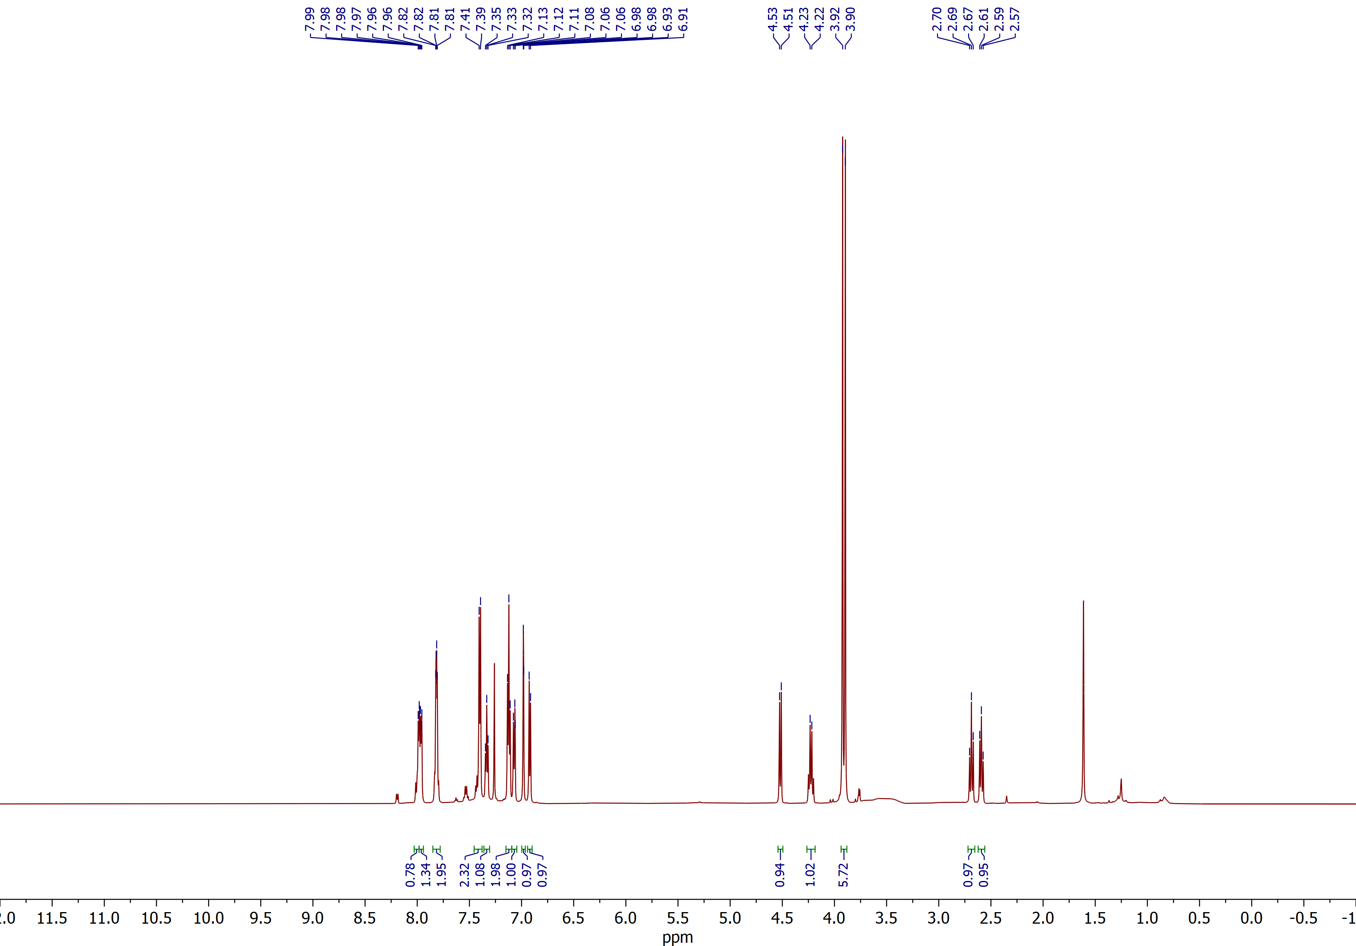

(2RS,3SR)-2-Benzoyl-3-(3,4-dimethoxyphenyl)spiro[cyclobutane-1,2'-indene]-1',3'-dione (3g)
¹³C NMR (CD₂Cl₂, 100 MHz)
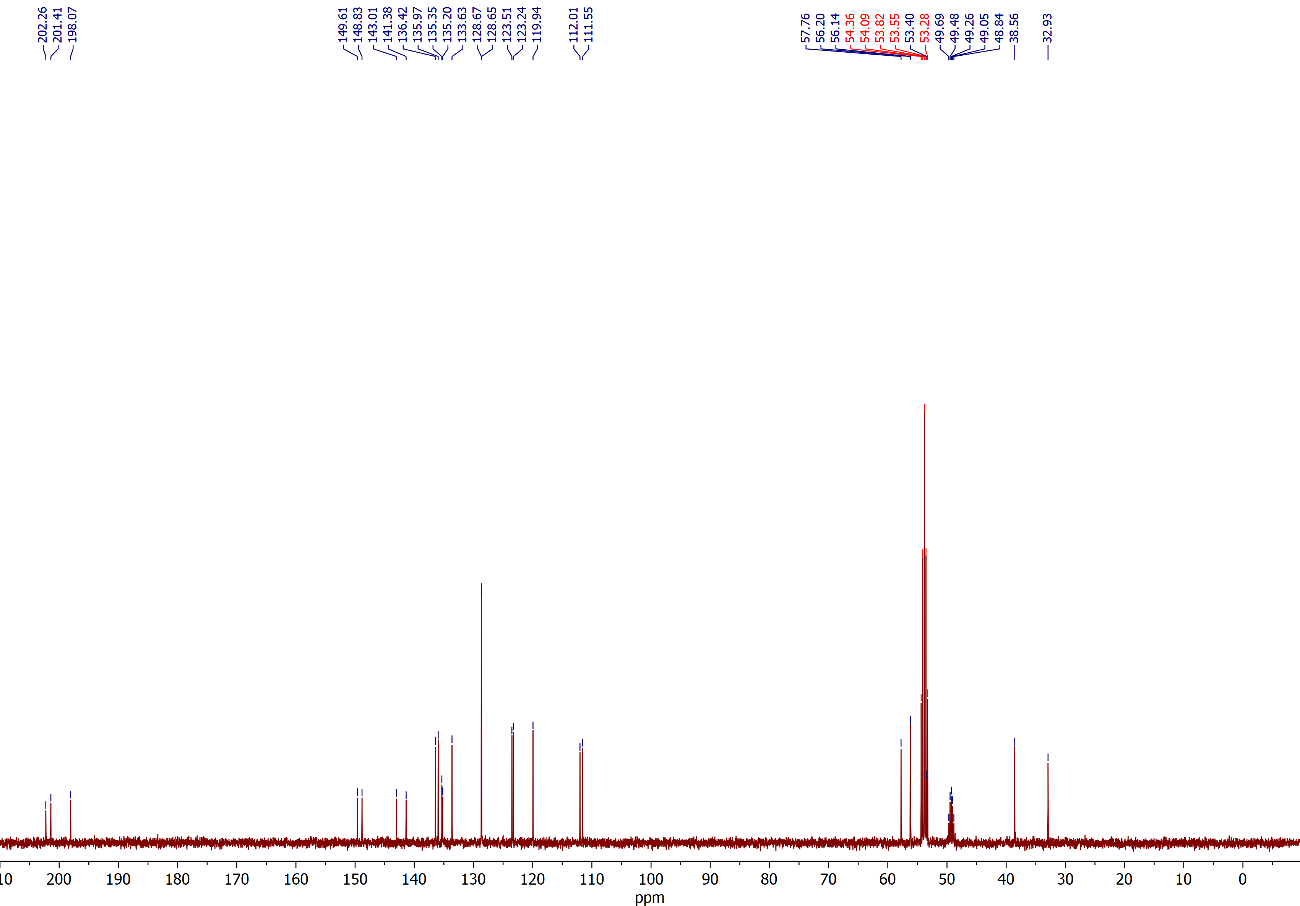

(2RS,3SR)-2-Benzoyl-3-[4-(trifluoromethoxy)phenyl]spiro[cyclobutane-1,2'-indene]-1',3'-dione (3h)
¹H NMR (CDCl₃, 600 MHz)
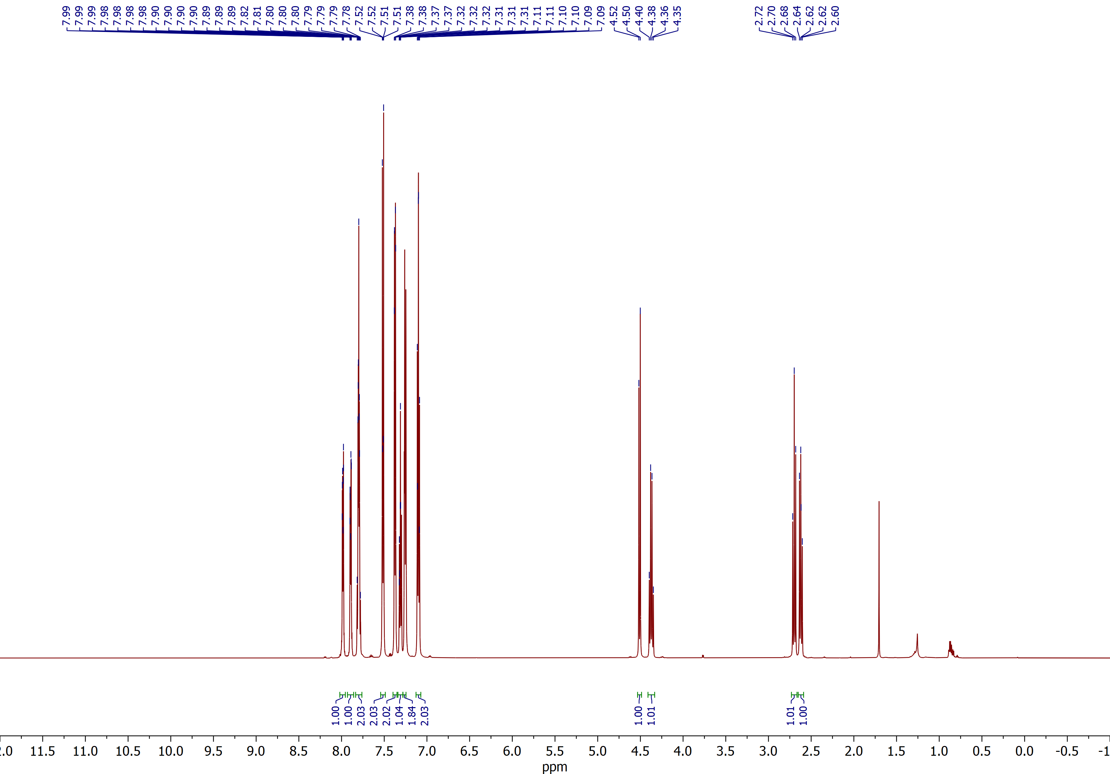

(2RS,3SR)-2-Benzoyl-3-[4-(trifluoromethoxy)phenyl]spiro[cyclobutane-1,2'-indene]-1',3'-dione (3h)
¹³C NMR (CDCl₃, 150 MHz)
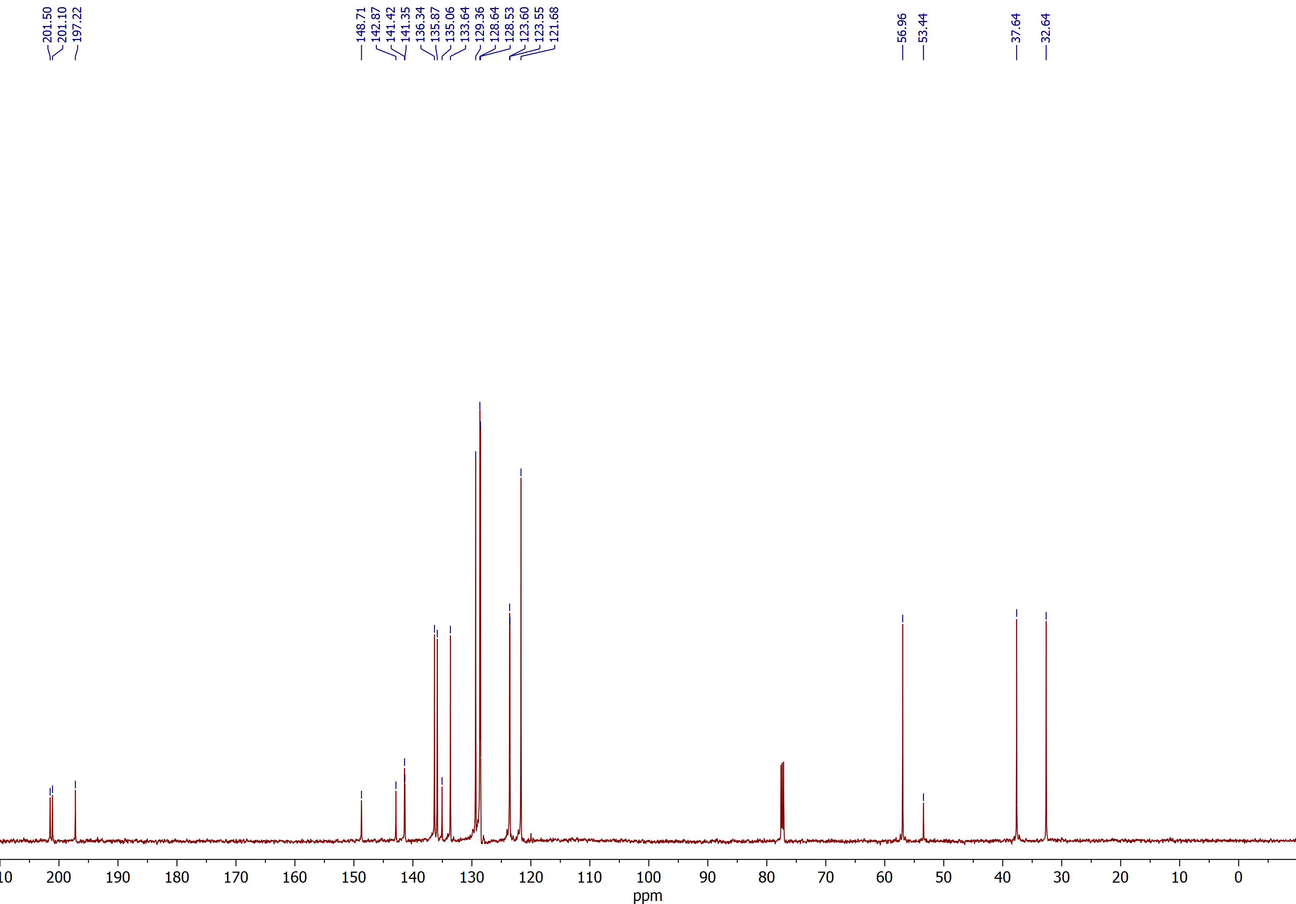

(2RS,3SR)-2-Benzoyl-3-(4-cyanophenyl)spiro[cyclobutane-1,2'-indene]-1',3'-dione (3i)
¹H NMR (CDCl₃, 600 MHz)
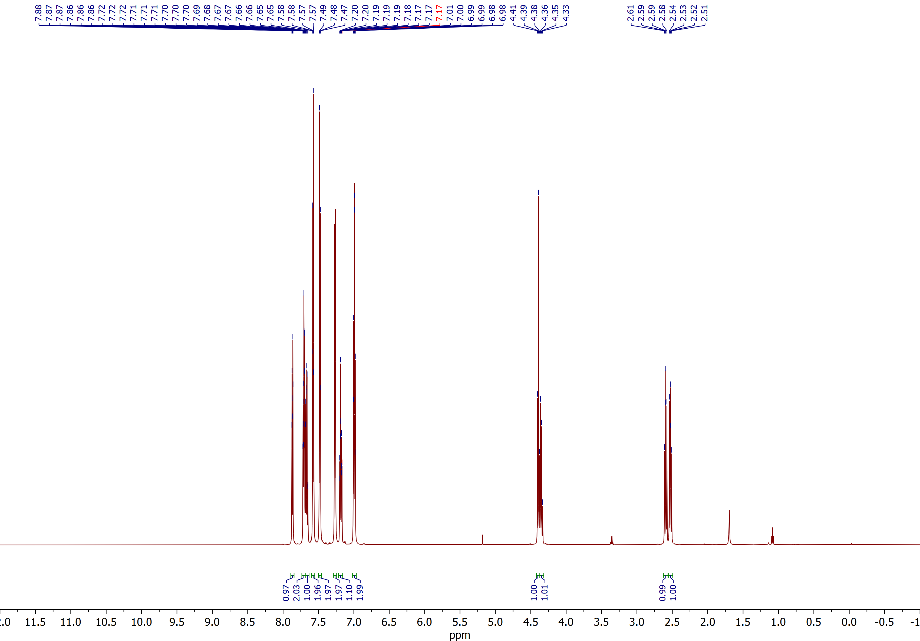

(2RS,3SR)-2-Benzoyl-3-(4-cyanophenyl)spiro[cyclobutane-1,2'-indene]-1',3'-dione (3i)
¹³C NMR (CDCl₃, 150 MHz)
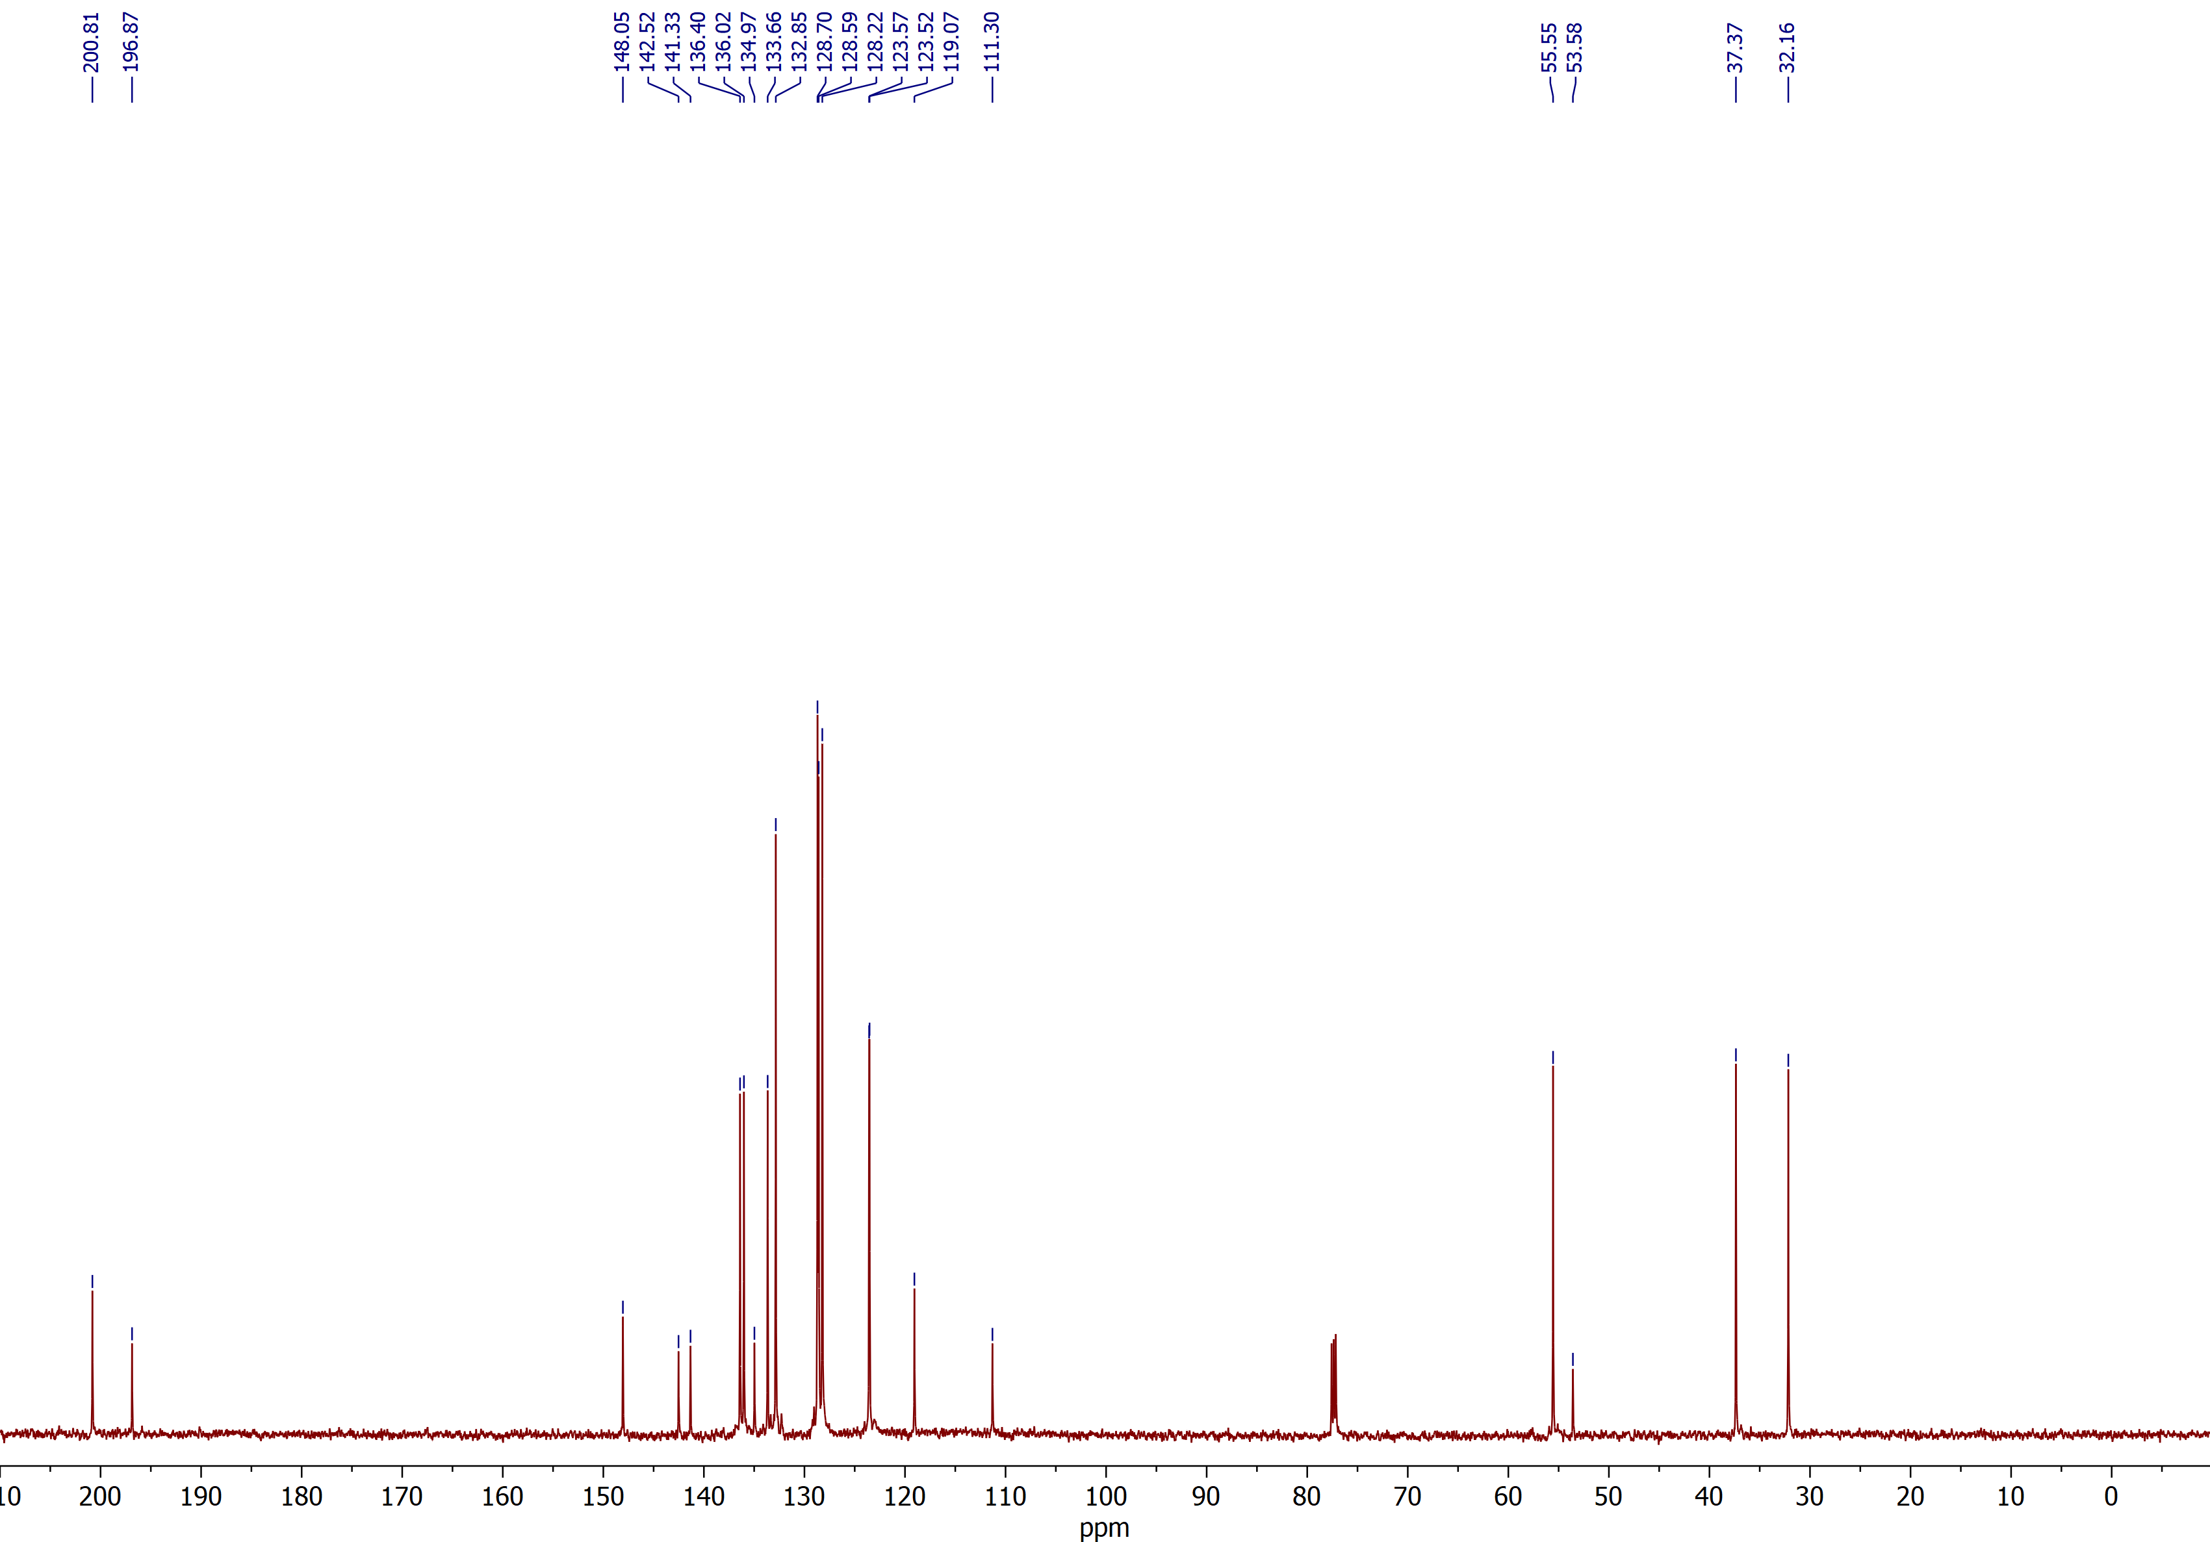

Ethyl (2RS,3SR)-1',3'-dioxo-3-(o-tolyl)-1',3'-dihydrospiro[cyclobutane-1,2'-indene]-2-carboxylate (3s)
¹H NMR (CDCl₃, 600 MHz)
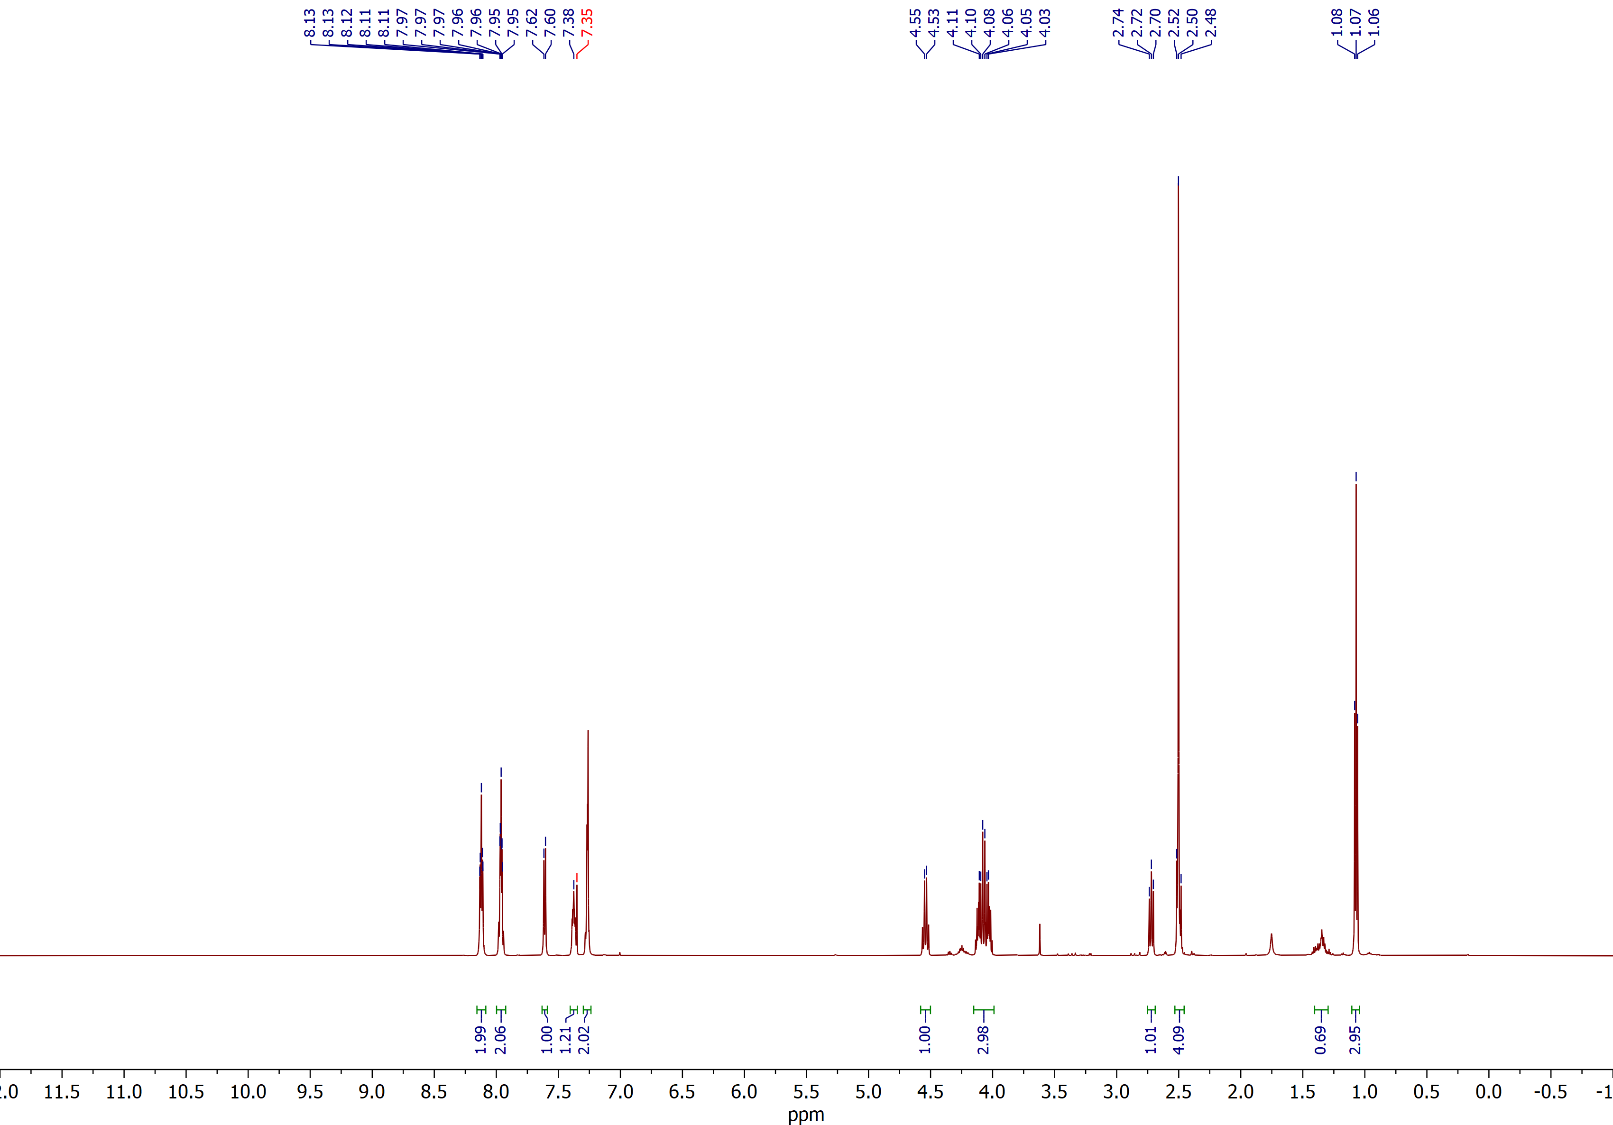

Ethyl (2RS,3SR)-1',3'-dioxo-3-(o-tolyl)-1',3'-dihydrospiro[cyclobutane-1,2'-indene]-2-carboxylate (3s)
¹³C NMR (CDCl₃, 150 MHz)
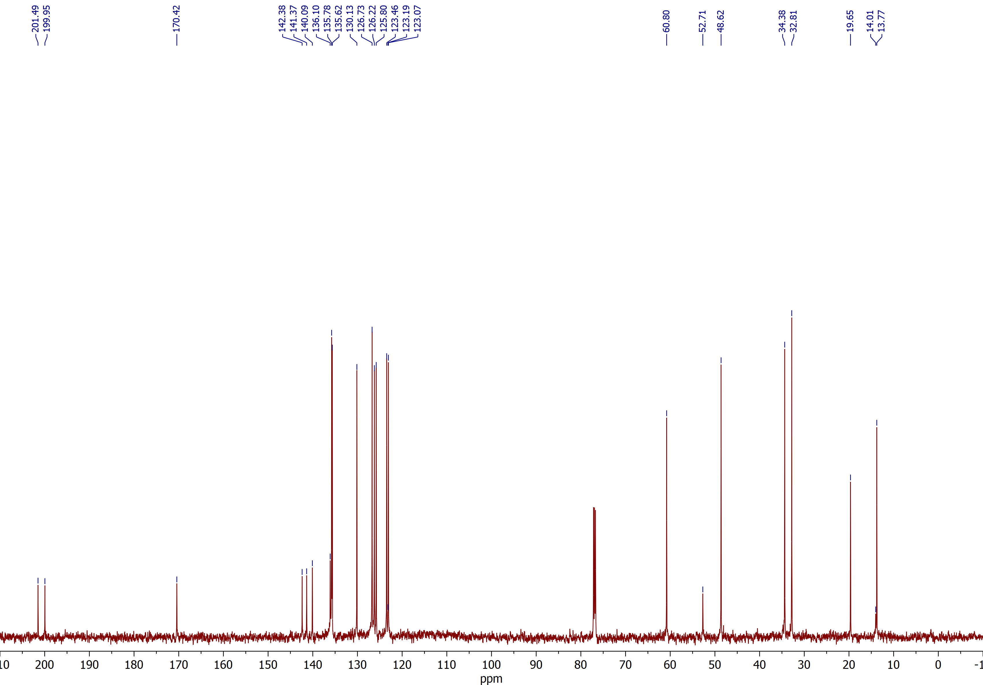

Diethyl (2RS,3SR,4RS)- and (2RS,3SR,4SR)-1',3'-dioxo-3-(p-tolyl)-1',3'-dihydrospiro[cyclobutane-1,2'-indene]-2,4-dicarboxylate (3v)
¹H NMR (CDCl₃, 600 MHz)
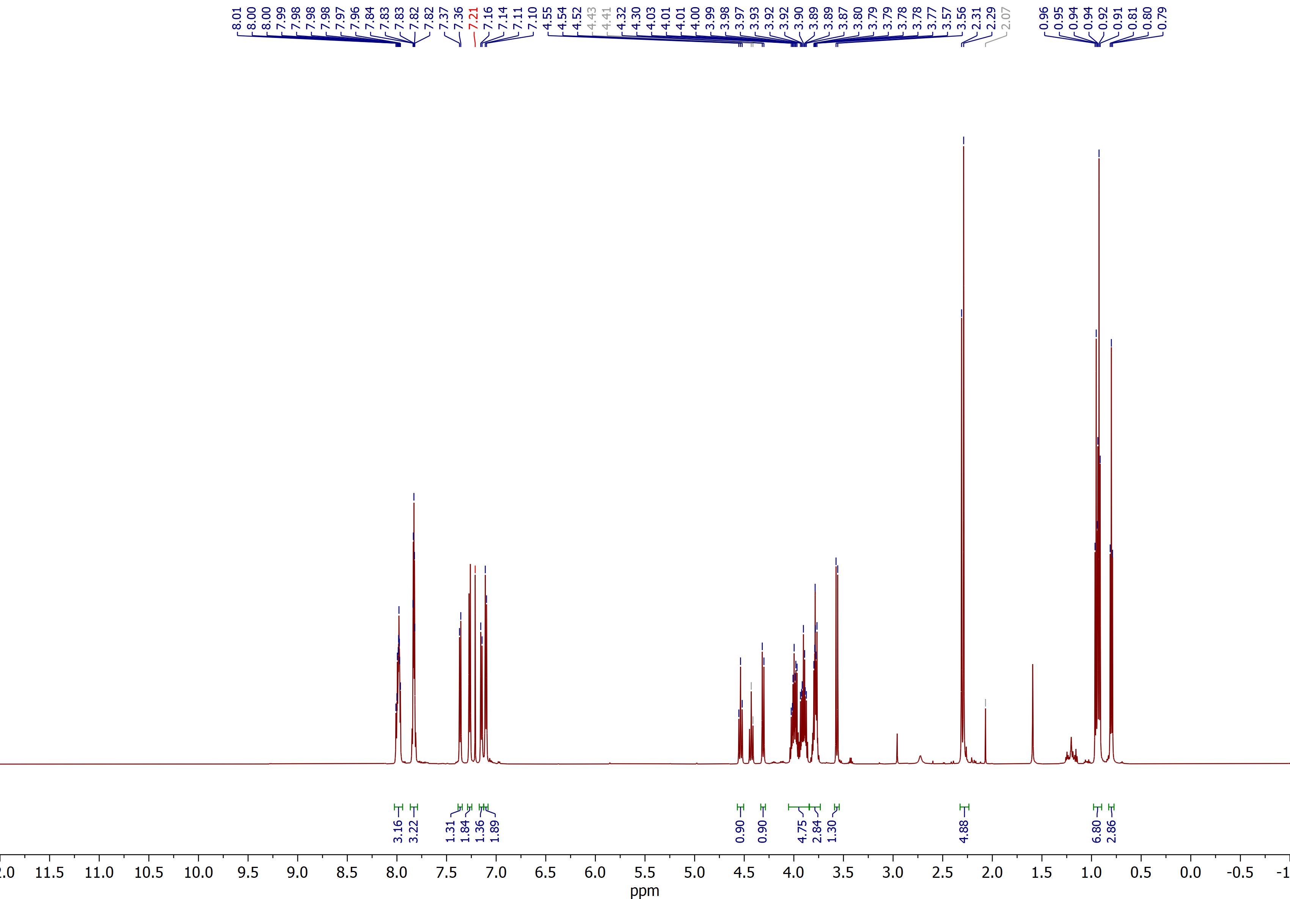

Diethyl (2RS,3SR,4RS)- and (2RS,3SR,4SR)-1',3'-dioxo-3-(p-tolyl)-1',3'-dihydrospiro[cyclobutane-1,2'-indene]-2,4-dicarboxylate (3v)
¹³C NMR (CDCl₃, 150 MHz)
