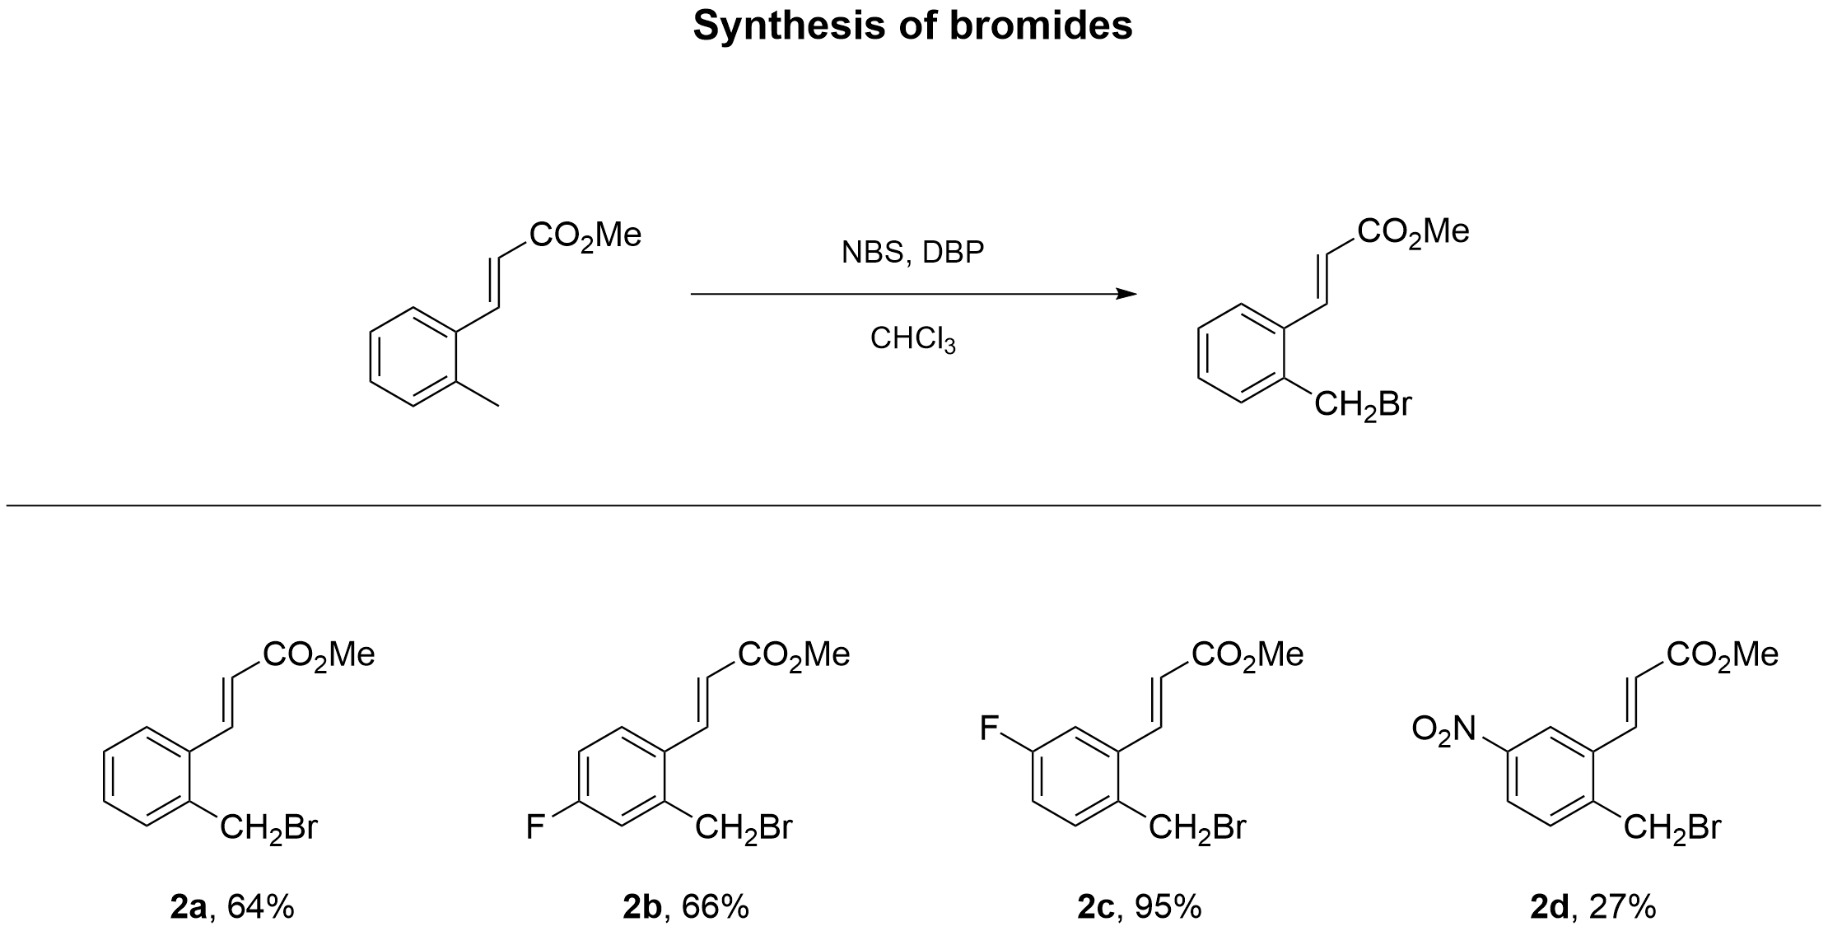

Methyl (E)-3-(2-(bromomethyl)phenyl)acrylate (2a)
Bromide 2a was obtained from methyl (E)-3-(o-tolyl)acrylate (600 mg, 3.4 mmol), NBS (606 mg, 3.4 mmol), DBP (41.2 mg, 0.17 mmol) and CHCl₃ (45.4 mL) according to GP1. Yield 560 mg (64%); white solid; mp 82 °C. R_{f} = 0.38 (petroleum ether : ethyl acetate = 7 : 1).

Methyl (E)-3-(2-(bromomethyl)-4-fluorophenyl)acrylate (2b)
Bromide 2b was obtained from methyl (E)-3-(4-fluoro-2-methylphenyl)acrylate (500 mg, 2.57 mmol), NBS (458 mg, 2.57 mmol), DBP (31.2 mg, 0.13 mmol) and CHCl₃ (34.33 mL) according to GP1. Yield 467 mg (66%); white solid; mp 84 °C. R_{f} = 0.63 (petroleum ether : ethyl acetate = 7 : 1).
HRMS (ESI/Q-TOF) m/z: [M+H]⁺ calcd for C₁₁H₁₁⁷⁹BrFO₂⁺ 272.9921. Found 272.9923.
Anal. Calcd for C₁₁H₁₀BrFO₂: C, 48.38; H, 3.69; Br, 29.26; F, 6.96; O, 11.72. Found: C, 48.38; H, 3.69; Br, 29.26; F, 6.96; O, 11.72.

Methyl (E)-3-(2-(bromomethyl)-5-fluorophenyl)acrylate (2c)
Bromide 2c was obtained from methyl (E)-3-(5-fluoro-2-methylphenyl)acrylate (400 mg, 2.06 mmol), NBS (367 mg, 2.06 mmol), DBP (24.9 mg, 0.1 mmol) and CHCl₃ (27.46 mL) according to GP1. Yield 534 mg (95%); white solid; mp 85 °C. R_{f} = 0.56 (petroleum ether : ethyl acetate = 7 : 1).
HRMS (ESI/Q-TOF) m/z: [M+H]⁺ calcd for C₁₁H₁₁⁷⁹BrFO₂⁺ 272.9921. Found 272.9921.
Anal. Calcd for C₁₁H₁₀BrFO₂: C, 48.38; H, 3.69; Br, 29.26; F, 6.96; O, 11.72. Found: C, 48.38; H, 3.69; Br, 29.26; F, 6.96; O, 11.72.

Methyl (E)-3-(2-(bromomethyl)-5-nitrophenyl)acrylate (2d)
Bromide 2d was obtained from methyl (E)-3-(2-methyl-5-nitrophenyl)acrylate (350 mg, 1.58 mmol), NBS (282 mg, 1.58 mmol), DBP (19.2 mg, 0.08 mmol) and CHCl₃ (21.1 mL) according to GP1. Yield 127 mg (27%); white solid; mp 97 °C. R_{f} = 0.48 (petroleum ether : ethyl acetate = 7 : 1).
HRMS (ESI/Q-TOF) m/z: [M+H]⁺ calcd for C₁₁H₁₁⁷⁹BrNO₄⁺ 299.9866. Found 299.9866.
Anal. Calcd for C₁₁H₁₀BrNO₄: C, 44.02; H, 3.36; N, 4.67; Br, 26.63; O, 21.32. Found: C, 44.02; H, 3.36; N, 4.67; Br, 26.63; O, 21.32.

