Auto Support Generator - all-in-one input
Edit the tables and template below. Keep the section labels unchanged. Reaction schema, Scope and SI template are optional.
[AUTO SI: COMPOUND TABLE]
number | structure | color | mp | R_{f} | HRMS | Elemental_analysis
2e | 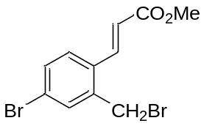 | Green oil | - | 0.55 (petroleum ether : ethyl acetate = 7 : 1) | 332.9115 | C, 39.56; H, 3.02; Br, 47.85; O, 9.58
2f | 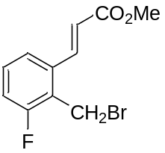 | Yellow solid | 98 | 0.74 (petroleum ether : ethyl acetate = 7 : 1) | 272.9920 | C, 48.38; H, 3.69; Br, 29.26; F, 6.96; O, 11.72

[AUTO SI: REACTION SCHEMA]
Reagents | equiv. | MW, g/mol | Density, g/ml | Concentration, M
Reagent_1 | 1
NBS | 1 | 177.98
DBP | 0.05 | 242.23
Solvent_CHCl₃ |  |  |  | 0.075

[AUTO SI: SCOPE]
Reagent_1 | Mass of Reagent_1, mg | Product | Product_number | Mass of product, mg
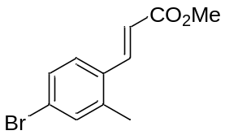 | 600 |  | 2e | 600
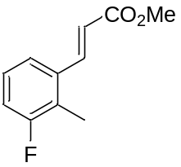 | 400 |  | 2f | 333

[AUTO SI: SI TEMPLATE]
{Product.name} ({Product.number})
{Product.structure}
{Product.preparation}
{reaction.loadings}
Bromide {Product.number} was obtained from {Reagent_1.name} ({Reagent_1.mg} mg, {Reagent_1.mmol} mmol), NBS ({NBS.mg} mg, {NBS.mmol} mmol), DBP ({DBP.mg} mg, {DBP.mmol} mmol) and CHCl₃ ({Solvent_CHCl3.ml} mL) according to GP1. Yield {Product.mg} mg ({Product.yield.percent}); {Product.appearance}; mp {Product.mp} °C. R_{f} = {Product.rf.value} ({Product.rf.system}).
[{nmr.1h.label}] ({nmr.1h.conditions}) δ = {nmr.1h.peaks}.
[{nmr.13c.label}] ({nmr.13c.conditions}) δ = {nmr.13c.peaks}.
{nmr.extra}
[{hrms.label}]: {hrms.adduct} calcd for {hrms.formula} {hrms.calculated}. Found {hrms.found}.
[{anal.label}] Calcd for {anal.formula}: {anal.calculated}. Found: {anal.found}.
[{ir.label}] ({ir.method}, cm-1): {ir.peaks}.
{Product.support.warning}

{Product.name} ({Product.number})
[{spectrum.label}] ({spectrum.conditions})
{Product.structure}
{Product.nmr.1h.picture}

{Product.name} ({Product.number})
[{spectrum.label}] ({spectrum.conditions})
{Product.structure}
{Product.nmr.13c.picture}
[AUTO SI: END]

