Лабораторная работа №7
Тема: Отладка отдельных модулей программного проекта.
Организация обработки исключений.

Цель: создать программный проект в среде Visual Studio на языке C#, реализовать организацию обработки исключений для обеспечения надежной работы приложения, а также разработать функционал для оформления предзаказов с использованием базы данных MS SQL Server.

Ход работы
Листинг кода
using System;

namespace PublishingApp.Models
{
public class Author
{
public int Id { get; set; }
public string Surname { get; set; }
public string Name { get; set; }
public string FullName => $"{Surname} {Name}";
}
}

using System;

namespace PublishingApp.Models
{
public class Book
{
public int Id { get; set; }
public string Title { get; set; }
public int AuthorId { get; set; }
public string AuthorName { get; set; }
public int ReleaseYear { get; set; }
public int Pages { get; set; }
public int Circulation { get; set; }
public decimal Price { get; set; }
}
}

using System;

namespace PublishingApp.Models
{
public class Customer
{
public int Id { get; set; }
public string Name { get; set; }
public string Address { get; set; }
public string Phone { get; set; }
public string Email { get; set; }
}
}

using System;

namespace PublishingApp.Models
{
public class Office
{
public int Id { get; set; }
public string Name { get; set; }
public string Address { get; set; }
public string Phone { get; set; }
}
}

using System;

namespace PublishingApp.Models
{
public class Order
{
public int Id { get; set; }
public string OrderName { get; set; }
public int BookId { get; set; }
public string BookTitle { get; set; }
public int OfficeId { get; set; }
public string OfficeName { get; set; }
public int CustomerId { get; set; }
public string CustomerName { get; set; }
public DateTime OrderDate { get; set; }
public DateTime? CompletionDate { get; set; }
public decimal Price { get; set; }
public int Quantity { get; set; }
}
}

using System;
using System.Data;
using System.Data.SqlClient;
using System.Collections.Generic;
using PublishingApp.Models;

namespace PublishingApp
{
public class DatabaseHelper : IDisposable
{
private string connectionString = @"Data Source=DESKTOP-3CVUA48\SQLEXPRESS;Initial Catalog=Publishing;Integrated Security=True;Connect Timeout=30";

public List<Book> GetBooks()
{
var books = new List<Book>();

try
{
using (var connection = new SqlConnection(connectionString))
{
connection.Open();
string query = @"
SELECT
p.PublicationID as id_Publication,
p.Title as Name,
p.AuthorID as Author,
a.FirstName + ' ' + a.LastName as AuthorName,
YEAR(p.PublishDate) as ReleaseYear,
300 as VolumeOfSheets,
1000 as Circulation,
p.Price
FROM Publications p
LEFT JOIN Authors a ON p.AuthorID = a.AuthorID
ORDER BY p.Title";

using (var command = new SqlCommand(query, connection))
using (var reader = command.ExecuteReader())
{
while (reader.Read())
{
books.Add(new Book
{
Id = Convert.ToInt32(reader["id_Publication"]),
Title = reader["Name"].ToString(),
AuthorId = reader["Author"] != DBNull.Value ?
Convert.ToInt32(reader["Author"]) : 0,
AuthorName = reader["AuthorName"].ToString(),
ReleaseYear = reader["ReleaseYear"] != DBNull.Value ?
Convert.ToInt32(reader["ReleaseYear"]) : DateTime.Now.Year,
Pages = 300,
Circulation = 1000,
Price = Convert.ToDecimal(reader["Price"])
});
}
}
}
}
catch (Exception ex)
{
throw new Exception($"Ошибка при загрузке книг: {ex.Message}");
}

return books;
}

public List<Office> GetOffices()
{
var offices = new List<Office>();

try
{
using (var connection = new SqlConnection(connectionString))
{
connection.Open();
string query = @"
SELECT
OfficeID as id_Office,
OfficeName as Office,
Address,
Phone
FROM Offices
ORDER BY OfficeName";

using (var command = new SqlCommand(query, connection))
using (var reader = command.ExecuteReader())
{
while (reader.Read())
{
offices.Add(new Office
{
Id = Convert.ToInt32(reader["id_Office"]),
Name = reader["Office"].ToString(),
Address = reader["Address"].ToString(),
Phone = reader["Phone"].ToString()
});
}
}
}
}
catch (Exception ex)
{
throw new Exception($"Ошибка при загрузке офисов: {ex.Message}");
}

return offices;
}

public int CreateOrder(Order order)
{
try
{
using (var connection = new SqlConnection(connectionString))
{
connection.Open();

string query = @"
INSERT INTO Orders (CustomerID, PublicationID, OrderDate, Quantity, TotalAmount, OfficeID)
VALUES (@Customer, @Publication, @DateOfAdmission, @Quantity, @Price, @Office);
SELECT SCOPE_IDENTITY();";

using (var command = new SqlCommand(query, connection))
{
command.Parameters.AddWithValue("@Customer", order.CustomerId);
command.Parameters.AddWithValue("@Publication", order.BookId);
command.Parameters.AddWithValue("@DateOfAdmission", order.OrderDate);
command.Parameters.AddWithValue("@Quantity", 1);
command.Parameters.AddWithValue("@Price", order.Price);
command.Parameters.AddWithValue("@Office", order.OfficeId);

return Convert.ToInt32(command.ExecuteScalar());
}
}
}
catch (Exception ex)
{
throw new Exception($"Ошибка при создании заказа: {ex.Message}");
}
}

public int CreateCustomer(Customer customer)
{
try
{
using (var connection = new SqlConnection(connectionString))
{
connection.Open();

string query = @"
INSERT INTO Customers (FirstName, LastName, Email, Phone, Address)
VALUES (@FirstName, @LastName, @Email, @Phone, @Address);
SELECT SCOPE_IDENTITY();";

using (var command = new SqlCommand(query, connection))
{
var names = customer.Name.Split(' ');
string firstName = names.Length > 0 ? names[0] : customer.Name;
string lastName = names.Length > 1 ? names[1] : "";

command.Parameters.AddWithValue("@FirstName", firstName);
command.Parameters.AddWithValue("@LastName", lastName);
command.Parameters.AddWithValue("@Email",
string.IsNullOrEmpty(customer.Email) ?
(object)DBNull.Value : customer.Email);
command.Parameters.AddWithValue("@Phone",
string.IsNullOrEmpty(customer.Phone) ?
(object)DBNull.Value : customer.Phone);
command.Parameters.AddWithValue("@Address",
string.IsNullOrEmpty(customer.Address) ?
(object)DBNull.Value : customer.Address);

return Convert.ToInt32(command.ExecuteScalar());
}
}
}
catch (Exception ex)
{
throw new Exception($"Ошибка при создании клиента: {ex.Message}");
}
}

public Order GetOrderDetails(int orderId)
{
try
{
using (var connection = new SqlConnection(connectionString))
{
connection.Open();

//
string query = @"
SELECT
o.OrderID as id_Order,
CONCAT('Заказ №', o.OrderID) as OrderName,
o.OrderDate as DateOfAdmission,
o.TotalAmount as Price,
p.Title as BookTitle,
CONCAT(c.FirstName, ' ', c.LastName) as CustomerName,
offic.OfficeName
FROM Orders o
LEFT JOIN Publications p ON o.PublicationID = p.PublicationID
LEFT JOIN Customers c ON o.CustomerID = c.CustomerID
LEFT JOIN Offices offic ON o.OfficeID = offic.OfficeID
WHERE o.OrderID = @OrderId";

using (var command = new SqlCommand(query, connection))
{
command.Parameters.AddWithValue("@OrderId", orderId);

using (var reader = command.ExecuteReader())
{
if (reader.Read())
{
return new Order
{
Id = Convert.ToInt32(reader["id_Order"]),
OrderName = reader["OrderName"].ToString(),
BookTitle = reader["BookTitle"].ToString(),
CustomerName = reader["CustomerName"].ToString(),
OfficeName = reader["OfficeName"].ToString(),
OrderDate = Convert.ToDateTime(reader["DateOfAdmission"]),
Price = Convert.ToDecimal(reader["Price"])
};
}
}
}
}
}
catch (Exception ex)
{
throw new Exception($"Ошибка при получении деталей заказа: {ex.Message}");
}

return null;
}

public bool TestConnection()
{
try
{
using (var connection = new SqlConnection(connectionString))
{
connection.Open();
return connection.State == ConnectionState.Open;
}
}
catch (Exception ex)
{
Console.WriteLine($"Ошибка подключения: {ex.Message}");
return false;
}
}

public void Dispose()
{
// Реализация интерфейса IDisposable
}
}
}

using System;
using System.Windows.Forms;
using PublishingApp.Models;

namespace PublishingApp
{
public partial class MainForm : Form
{
private DatabaseHelper dbHelper;
private Book selectedBook;

public MainForm()
{
InitializeComponent();
dbHelper = new DatabaseHelper();

try
{
if (!dbHelper.TestConnection())
{
MessageBox.Show("Ошибка подключения к базе данных!", "Ошибка",
MessageBoxButtons.OK, MessageBoxIcon.Error);
Environment.Exit(1);
}

LoadBooks();
}
catch (Exception ex)
{
MessageBox.Show($"Ошибка: {ex.Message}", "Ошибка",
MessageBoxButtons.OK, MessageBoxIcon.Error);
}
}

private void LoadBooks()
{
try
{
var books = dbHelper.GetBooks();
dataGridViewBooks.DataSource = books;

dataGridViewBooks.Columns["Id"].Visible = false;
dataGridViewBooks.Columns["AuthorId"].Visible = false;
dataGridViewBooks.Columns["Title"].HeaderText = "Название";
dataGridViewBooks.Columns["AuthorName"].HeaderText = "Автор";
dataGridViewBooks.Columns["ReleaseYear"].HeaderText = "Год выпуска";
dataGridViewBooks.Columns["Pages"].HeaderText = "Страниц";
dataGridViewBooks.Columns["Circulation"].HeaderText = "Тираж";
dataGridViewBooks.Columns["Price"].HeaderText = "Цена";
dataGridViewBooks.Columns["Price"].DefaultCellStyle.Format = "C2";
}
catch (Exception ex)
{
MessageBox.Show($"Ошибка при загрузке книг: {ex.Message}",
"Ошибка", MessageBoxButtons.OK, MessageBoxIcon.Error);
}
}

private void dataGridViewBooks_SelectionChanged(object sender, EventArgs e)
{
if (dataGridViewBooks.SelectedRows.Count > 0)
{
selectedBook = dataGridViewBooks.SelectedRows[0].DataBoundItem as Book;
btnOrder.Enabled = selectedBook != null;
}
}

private void btnOrder_Click(object sender, EventArgs e)
{
if (selectedBook == null)
{
MessageBox.Show("Выберите книгу для оформления предзаказа!",
"Внимание", MessageBoxButtons.OK, MessageBoxIcon.Warning);
return;
}

try
{
FormOrder orderForm = new FormOrder(selectedBook);
if (orderForm.ShowDialog() == DialogResult.OK)
{
MessageBox.Show("Предзаказ успешно оформлен!", "Успех",
MessageBoxButtons.OK, MessageBoxIcon.Information);
}
}
catch (Exception ex)
{
MessageBox.Show($"Ошибка при оформлении заказа: {ex.Message}",
"Ошибка", MessageBoxButtons.OK, MessageBoxIcon.Error);
}
}

private void btnExit_Click(object sender, EventArgs e)
{
this.Close();
}

private void MainForm_FormClosing(object sender, FormClosingEventArgs e)
{
dbHelper.Dispose();
}
}
}

using System;
using System.Drawing;
using System.Windows.Forms;
using PublishingApp.Models;

namespace PublishingApp
{
public partial class FormReceipt : Form
{
private Order order;

public FormReceipt(Order orderDetails)
{
InitializeComponent();
order = orderDetails;
DisplayReceipt();
}

private void DisplayReceipt()
{
if (order == null) return;

lblReceiptTitle.Text = $"Чек №{order.Id}";
lblOrderId.Text = order.Id.ToString();
lblOrderName.Text = order.OrderName;
lblBookTitle.Text = order.BookTitle;
lblCustomerName.Text = order.CustomerName;
lblOfficeName.Text = order.OfficeName;
lblOrderDate.Text = order.OrderDate.ToString("dd.MM.yyyy HH:mm");
lblPrice.Text = order.Price.ToString("C");

rtxtReceipt.Text = $"ЧЕК №{order.Id}\n" +
$"=============================\n" +
$"Клиент: {order.CustomerName}\n" +
$"Книга: {order.BookTitle}\n" +
$"Офис получения: {order.OfficeName}\n" +
$"Дата заказа: {order.OrderDate:dd.MM.yyyy HH:mm}\n" +
$"Сумма: {order.Price:C}\n" +
$"=============================\n" +
$"Спасибо за предзаказ!\n" +
$"Книга будет доступна в офисе через 3-5 дней.\n" +
$"Контактный телефон: +7 (495) 123-45-67";
}

private void btnPrint_Click(object sender, EventArgs e)
{
try
{
printDocument.Print();
}
catch (Exception ex)
{
MessageBox.Show($"Ошибка при печати: {ex.Message}",
"Ошибка", MessageBoxButtons.OK, MessageBoxIcon.Error);
}
}

private void btnClose_Click(object sender, EventArgs e)
{
this.Close();
}

private void printDocument_PrintPage(object sender, System.Drawing.Printing.PrintPageEventArgs e)
{
Font printFont = new Font("Courier New", 10);
float yPos = 0;
float leftMargin = e.MarginBounds.Left;
float topMargin = e.MarginBounds.Top;

string[] lines = rtxtReceipt.Text.Split('\n');

foreach (string line in lines)
{
yPos = topMargin + (printFont.GetHeight(e.Graphics) * lines.Length);
e.Graphics.DrawString(line, printFont, Brushes.Black, leftMargin, yPos, new StringFormat());
topMargin += printFont.GetHeight(e.Graphics);
}
}
}
}

using System;
using System.Windows.Forms;
using PublishingApp.Models;

namespace PublishingApp
{
public partial class FormOrder : Form
{
private Book selectedBook;
private DatabaseHelper dbHelper;

public FormOrder(Book book)
{
InitializeComponent();
selectedBook = book;
dbHelper = new DatabaseHelper();

InitializeForm();
}

private void InitializeForm()
{
lblBookTitleValue.Text = selectedBook.Title;
lblAuthorValue.Text = selectedBook.AuthorName;
lblYearValue.Text = selectedBook.ReleaseYear.ToString();
lblPriceValue.Text = selectedBook.Price.ToString("C");

try
{
var offices = dbHelper.GetOffices();
cmbOffice.DataSource = offices;
cmbOffice.DisplayMember = "Name";
cmbOffice.ValueMember = "Id";
}
catch (Exception ex)
{
MessageBox.Show($"Ошибка при загрузке офисов: {ex.Message}",
"Ошибка", MessageBoxButtons.OK, MessageBoxIcon.Error);
}
}

private void btnCancel_Click(object sender, EventArgs e)
{
this.DialogResult = DialogResult.Cancel;
this.Close();
}

private void btnSubmit_Click(object sender, EventArgs e)
{
try
{
if (string.IsNullOrWhiteSpace(txtCustomerName.Text))
{
MessageBox.Show("Введите ФИО клиента!", "Ошибка",
MessageBoxButtons.OK, MessageBoxIcon.Error);
return;
}

if (cmbOffice.SelectedItem == null)
{
MessageBox.Show("Выберите офис для получения!", "Ошибка",
MessageBoxButtons.OK, MessageBoxIcon.Error);
return;
}

var customer = new Customer
{
Name = txtCustomerName.Text,
Address = txtAddress.Text,
Phone = txtPhone.Text,
Email = txtEmail.Text
};

int customerId = dbHelper.CreateCustomer(customer);

var order = new Order
{
BookId = selectedBook.Id,
BookTitle = selectedBook.Title,
CustomerId = customerId,
CustomerName = customer.Name,
OfficeId = ((Office)cmbOffice.SelectedItem).Id,
OfficeName = ((Office)cmbOffice.SelectedItem).Name,
OrderDate = DateTime.Now,
Price = selectedBook.Price,
Quantity = 1
};

int orderId = dbHelper.CreateOrder(order);

var orderDetails = dbHelper.GetOrderDetails(orderId);

FormReceipt receiptForm = new FormReceipt(orderDetails);
receiptForm.ShowDialog();

this.DialogResult = DialogResult.OK;
this.Close();
}
catch (Exception ex)
{
MessageBox.Show($"Ошибка при оформлении заказа: {ex.Message}",
"Ошибка", MessageBoxButtons.OK, MessageBoxIcon.Error);
}
}
}
}
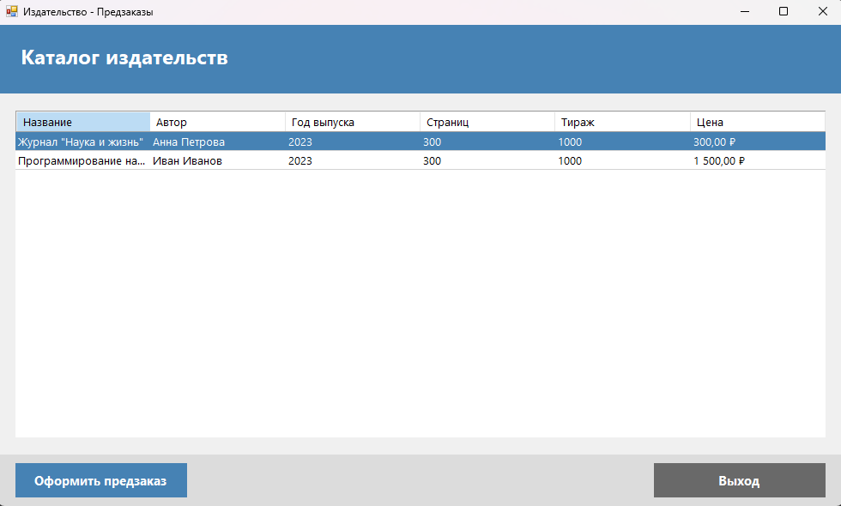
Рис.1 – Каталог издательств

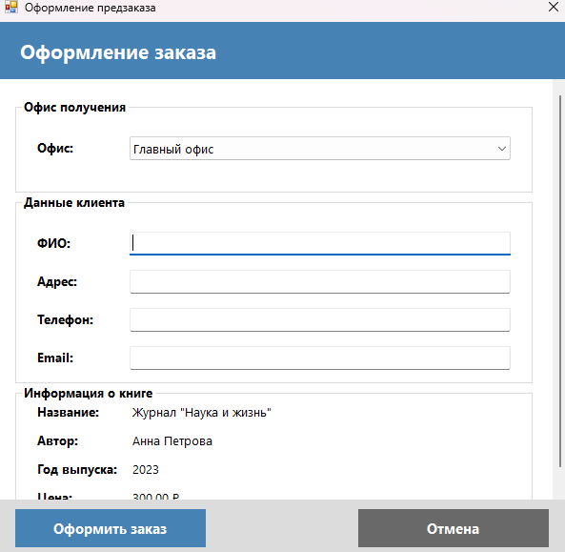
Рис.2 – оформление заказа

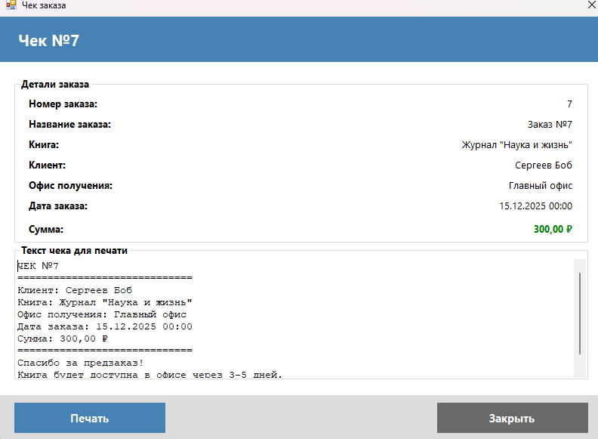
Рис.3 - чек

