DANA LITOVSKY ALCALA Machine Learning, report 2

In order to understand what factors make individuals more likely to not be able to pay debt, I will will analyze and evaluate data with the following features.

“SeriousDlqin2yrs', 'RevolvingUtilizationOfUnsecuredLines',
'age', 'NumberOfTime30-59DaysPastDueNotWorse', 'DebtRatio',
'MonthlyIncome', 'NumberOfOpenCreditLinesAndLoans',
'NumberOfTimes90DaysLate', 'NumberRealEstateLoansOrLines',
'NumberOfTime60-89DaysPastDueNotWorse', 'NumberOfDependents”

Where SeriousDlqin2yrs is 1 if an individual experienced 90 days past due delinquency, or worse, and 0 otherwise..

To better understand the data, I first look at some summary statistics.
For example, the mean of all columns:

SeriousDlqin2yrs 0.066840
RevolvingUtilizationOfUnsecuredLines 6.048438
age 52.295207
NumberOfTime30-59DaysPastDueNotWorse 0.421033
DebtRatio 353.005076
MonthlyIncome 6670.221237
NumberOfOpenCreditLinesAndLoans 8.452760
NumberOfTimes90DaysLate 0.265973
NumberRealEstateLoansOrLines 1.018240
NumberOfTime60-89DaysPastDueNotWorse 0.240387
NumberOfDependents 0.757222

And the mode:
SeriousDlqin2yrs 0 0.0
RevolvingUtilizationOfUnsecuredLines 0 0.0
age 0 49.0
NumberOfTime30-59DaysPastDueNotWorse 0 0.0
DebtRatio 0 0.0
MonthlyIncome 0 5000.0
NumberOfOpenCreditLinesAndLoans 0 6.0
NumberOfTimes90DaysLate 0 0.0
NumberRealEstateLoansOrLines 0 0.0
NumberOfTime60-89DaysPastDueNotWorse 0 0.0
NumberOfDependents 0 0.0
The median for most other features is similar, but here is the median for age and income, which are different than the mean because the mean is more sensitive to outliers.

age 52.000000
MonthlyIncome 5400.000000

The number of dependents could also be an interesting feature. Here is the count for number of dependents. This shows that most people have no dependents.

0 86902
1 26316
2 19522
3 9483
4 2862
5 746
6 158
7 51
8 24
10 5
9 5
20 1
13 1

Missing values pose a challenge to work with data. Monthly Income and Number of dependents have many missing values (other features have no missing values):

MonthlyIncome 29731
NumberOfDependents 3924

I chose to impute MonthlyIncome with the median because I believe it is a statistic that is less susceptible to large earning outliers. For example, the largest value for MonthlyIncome is 3008750.0, much larger than both mean and median.

For Number of Dependents, I imputed with the mode (also the median) of 0 dependents, because more than 60% of people indicated they had no dependents.

To better understand the data, here are some graphs.

I created bin categories for age. This image graphs the mean SeriousDlqin2yrs per age category. This shows that most people who had serious issues paying debt are in their 20s.
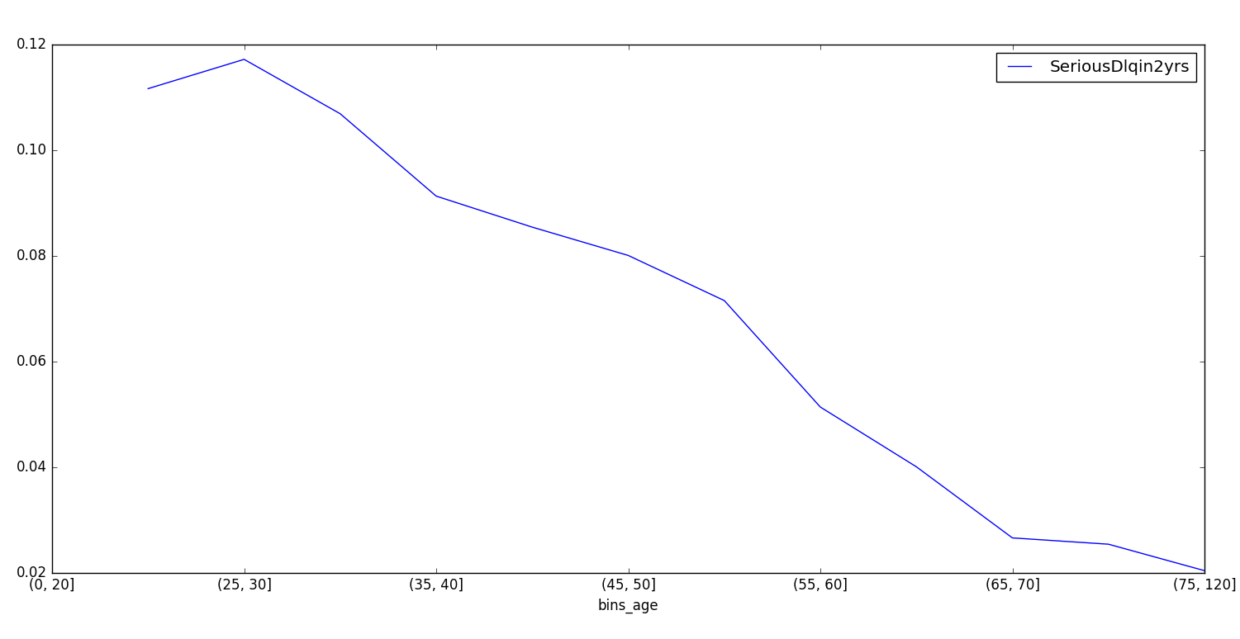
I

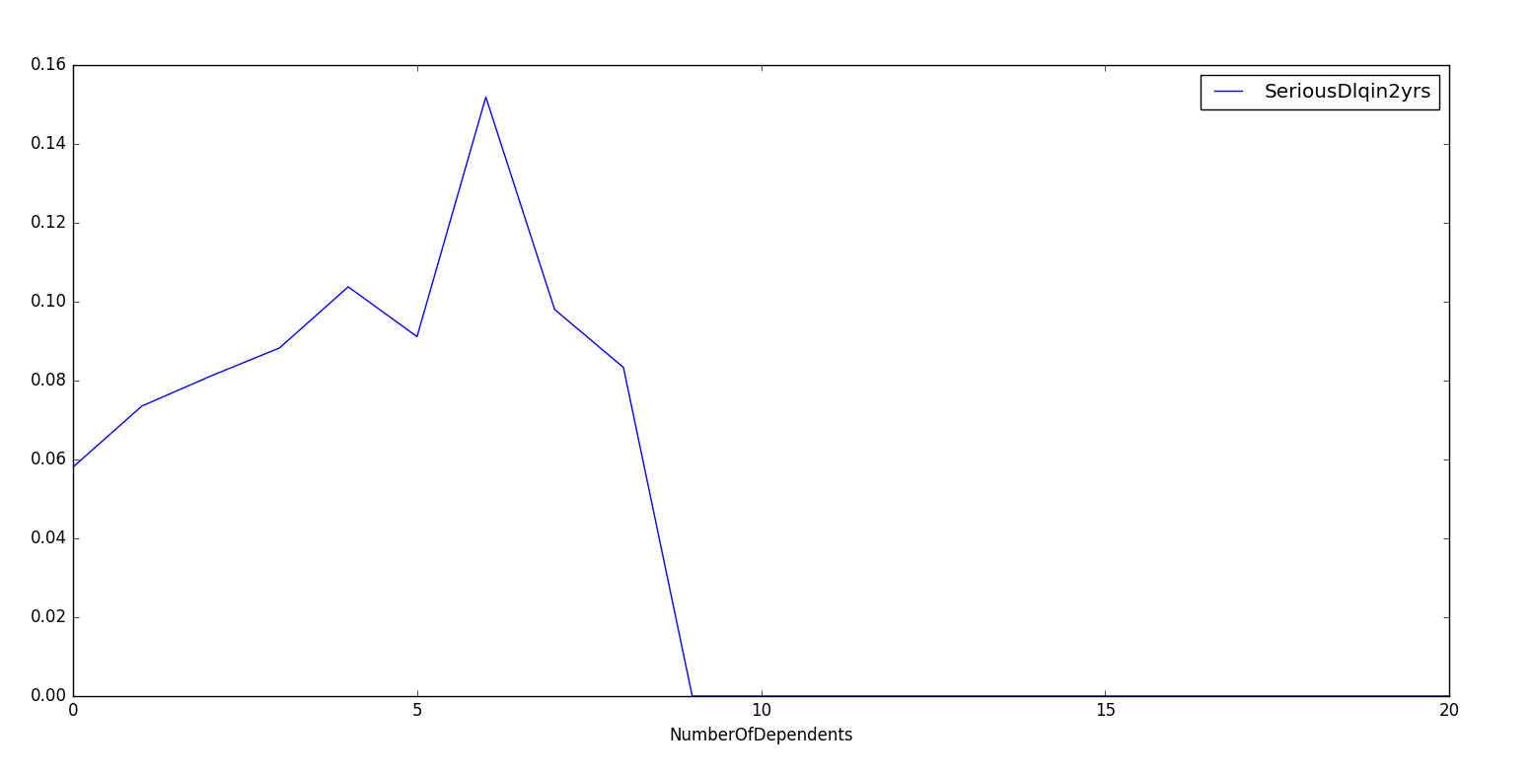
The following graph shows mean SeriousDlqin2yrs for number of dependents. I see that the more dependents an individual has, the more trouble she has repaying debt, as we would suspect. The large drop in the data after 9 dependents could be a data anomaly, but it most likely reflects the fact that most people in our dataset did not have many, if any, dependents.
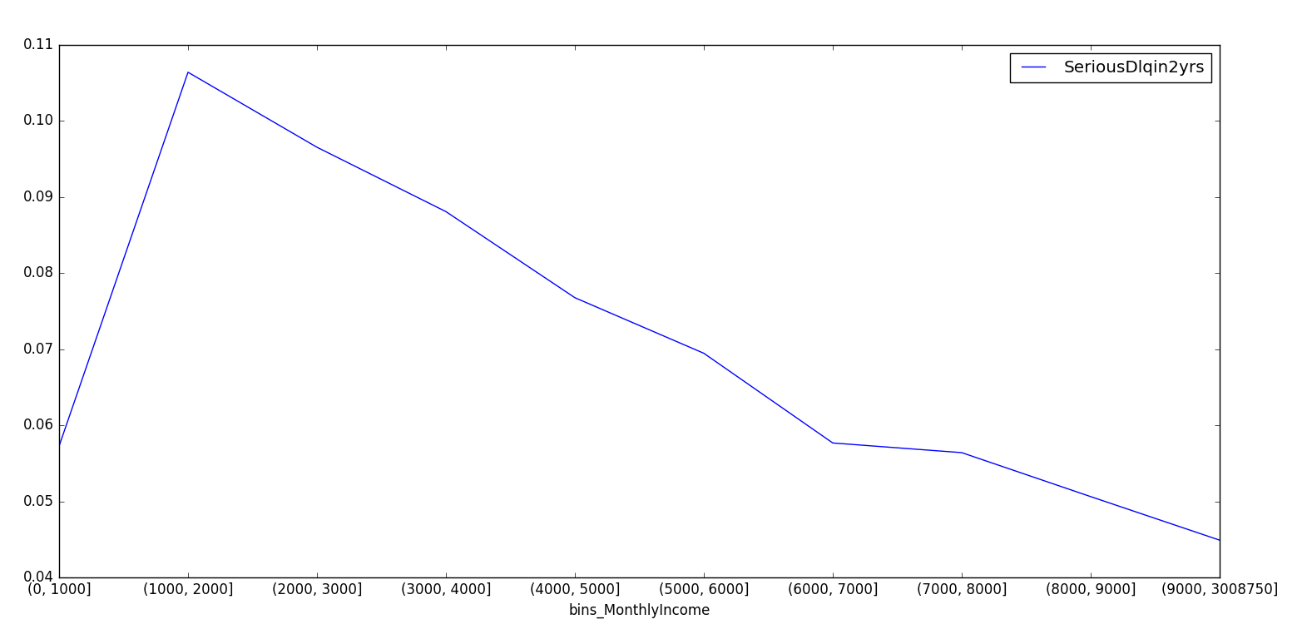
I also created category bins for income, such as income [0, 1000], [1000, 2000] … with the last bin containing most of the outliers. This graph of mean SeriousDlqin2yrs for income shows a very clear relationship. It appears that people with income around $2000 a month have a tough time paying back loan, and more monthly income steadily declines in rates of SeriousDlqin2yrs.

Creating and Evaluating a Model to predict loan default

To predict which individuals would be more likely to default on debt, I created a logistic regression model which will give category values of 0 or 1 for SeriousDlqin2yrs for new data. In general, the logistic regression model estimates the probability of an outcome (in our case SeriousDlqin2yrs ) being 1.

I built the model using 80% of the data, and left 20% to test the model's predictions. 80-20 is a very common split of data, but a more robust approach could include creating multiple “folds”, or splits, of the data and repeatedly creating and testing a model.

To give the model the best chance of predicting accurately, I created additional features. These include the age and income bins, the log of monthly income, and a scaled monthly income.

I evaluated my model's predictions with accuracy score, which compares the true value of SeriousDlqin2yrs to my model's prediction. This is certainly not the best evaluation model because most of the data has SeriousDlqin2yrs = 0, so even if I randomly assigned 0 to every prediction, I would get a very high accuracy score.
It is very common to test

While we have many features to work with, there is often a best group of features that does a better job of predicting. It is very common to manually test what group of features predicts best. I decided to use an approach called recursive feature elimination, which recursively considers smaller sets of features. There are many other approaches to do this kind of task, but I found this approach to be effective in increasing the accuracy score, albeit by 0.001 points.

If I used all features, including the ones I created, my accuracy score is:
0.931566666667

While using the recursive feature elimination method, which created the best model with the following features:

'NumberOfTime30-59DaysPastDueNotWorse', 'NumberOfTimes90DaysLate',
'NumberOfTime60-89DaysPastDueNotWorse', 'NumberOfDependents',
'log_MonthlyIncome',
'bins_age',
'bins_MonthlyIncome'

Returned an accuracy score of: 0.931866666667

Overall, the logistic regression model is a simple way to predict loan default, but there can be more appropriate models and evaluation metrics for this type of data and task.

