Felex: a local livestock ration decision-support platform
for Russian small farms and animal businesses
Danil D. Kotelnikov and Olga V. Demkina*
Far Eastern State Agrarian University, 86 Politekhnicheskaya Str., Blagoveshchensk, 675005, Russia
*Corresponding author: demkina1976@gmail.com

Abstract
Background and objectives: Mathematical ration formulation remains a core decision-support task in livestock production. For Russian small farms and animal businesses, software choice is constrained by regional feed data, mixed normative practice, intermittent connectivity, and limited tolerance for opaque cloud dependence. Felex was developed as a hybrid desktop application (Rust–React–Tauri) that implements transparent linear-programming workflows for ration calculation together with a local agent layer for bounded result interpretation.
Data collection: The raw normalized feed export contained 2,723 records. The benchmark-ready catalog contained 1,342 priced feed items assembled from 151 direct price anchors and 1,191 inferred benchmark prices.
Research methods: The optimization benchmark executed 23 livestock scenarios across three workflows (build_from_library, complete_from_library, selected_only), yielding 69 total runs. Two Qwen 3.5 configurations (4B/4096 and 9B/2048) were tested as bounded consultants on 12 tasks with web search disabled; benchmark telemetry recorded effective model/context and fallback status.
Results: Across all optimization runs, mean runtime was 246.6 ms, mean hard-constraint pass rate was 64.8%, and mean norm coverage index was 81.8/100. The complete_from_library workflow achieved the highest coverage (85.0), while selected_only was fastest (0.41 ms). Both agent configurations scored identically (overall applicability 34.2/100) with no hidden fallback.
Conclusions: Felex demonstrates that a locally deployable livestock ration platform can combine transparent optimization, mixed normative support, and a practical desktop runtime without relying on cloud-first architecture.
Contributions: Main strengths are local deployment and explicit workflows; current limits are database coverage, linear-model assumptions, and insufficient agent reliability for dependable consultation.

Highlights
- Local ration DSS for Russian small farms and animal businesses
- Three workflows were benchmarked across 23 scenarios and 69 total runs
- complete_from_library delivered the strongest mean norm coverage (85.0)
- Mean optimization runtime remained low at 246.6 ms across all workflows
- Local 4B and 9B agent variants were inadequate for dependable consultation
Keywords: livestock feeding; ration formulation; decision support; linear programming; desktop software; Russia

1. Introduction
Mathematical ration formulation remains a core decision-support task in livestock production because biological requirements, feed availability, and ration cost must be balanced simultaneously (NASEM 2021; Dantzig 1963; Zhai et al. 2020; Tedeschi et al. 2021). In practice, software for this task already spans enterprise formulation suites, consultant-oriented desktop tools, and farm-management platforms (Datacor 2026; MIXIT 2026; WinFeed 2026; KORALL 2026; DeltaKorm 2026; 1Cow 2026; WinMix 2026). The field is therefore not empty; the practical problem is heterogeneity. US/EN products show stronger commercial and enterprise maturity, whereas Russian products are more localized to domestic workflows but are predominantly closed and vendor-specific.
For Russian small farms and animal businesses, software choice is additionally constrained by regional feed data, mixed normative practice, intermittent connectivity, and limited tolerance for opaque cloud dependence (Kalashnikov et al. 2003; Fisinin et al. 2020; Aquilani et al. 2022; Selvaggi et al. 2024). In this setting, a useful instrument does not need to replace enterprise suites. It needs to provide transparent local optimization, practical norm handling, and reproducible workflow support while remaining usable by specialists outside large integrated software stacks.
Felex was developed in response to that narrower use case. It is a hybrid desktop application (Rust–React–Tauri) that implements linear programming workflows for ration calculation and includes a local agent layer for result interpretation. The objective of this paper is to describe the current executable architecture, report benchmarked optimizer performance, and assess whether the present local-agent layer is suitable for supportive interpretation of calculated rations in a practical livestock workflow.

2. Materials and Methods

2.1. System architecture
Felex utilizes a multi-tiered modular architecture separating the user interface, optimization runtime, and data layer. The frontend is implemented in React 18 and TypeScript with Zustand-based state management. The optimization backend is written in Rust (Rust Foundation 2023) and uses good_lp (good_lp Contributors 2023) for linear programming. Desktop packaging is provided by Tauri (Tauri Programme 2023), but the runtime is not pure Tauri IPC: the desktop shell launches an embedded local HTTP backend, and the frontend communicates with the optimizer through the same API surface used in local-browser development. The local data layer relies on SQLite supplemented by generated JSON artifacts.
The agent layer defaults to Ollama in the current repository configuration but also supports OpenAI-compatible endpoints. In the present benchmark, the agent was treated as a bounded consultant rather than as an autonomous formulation module, and all agent tests were executed with web search disabled.
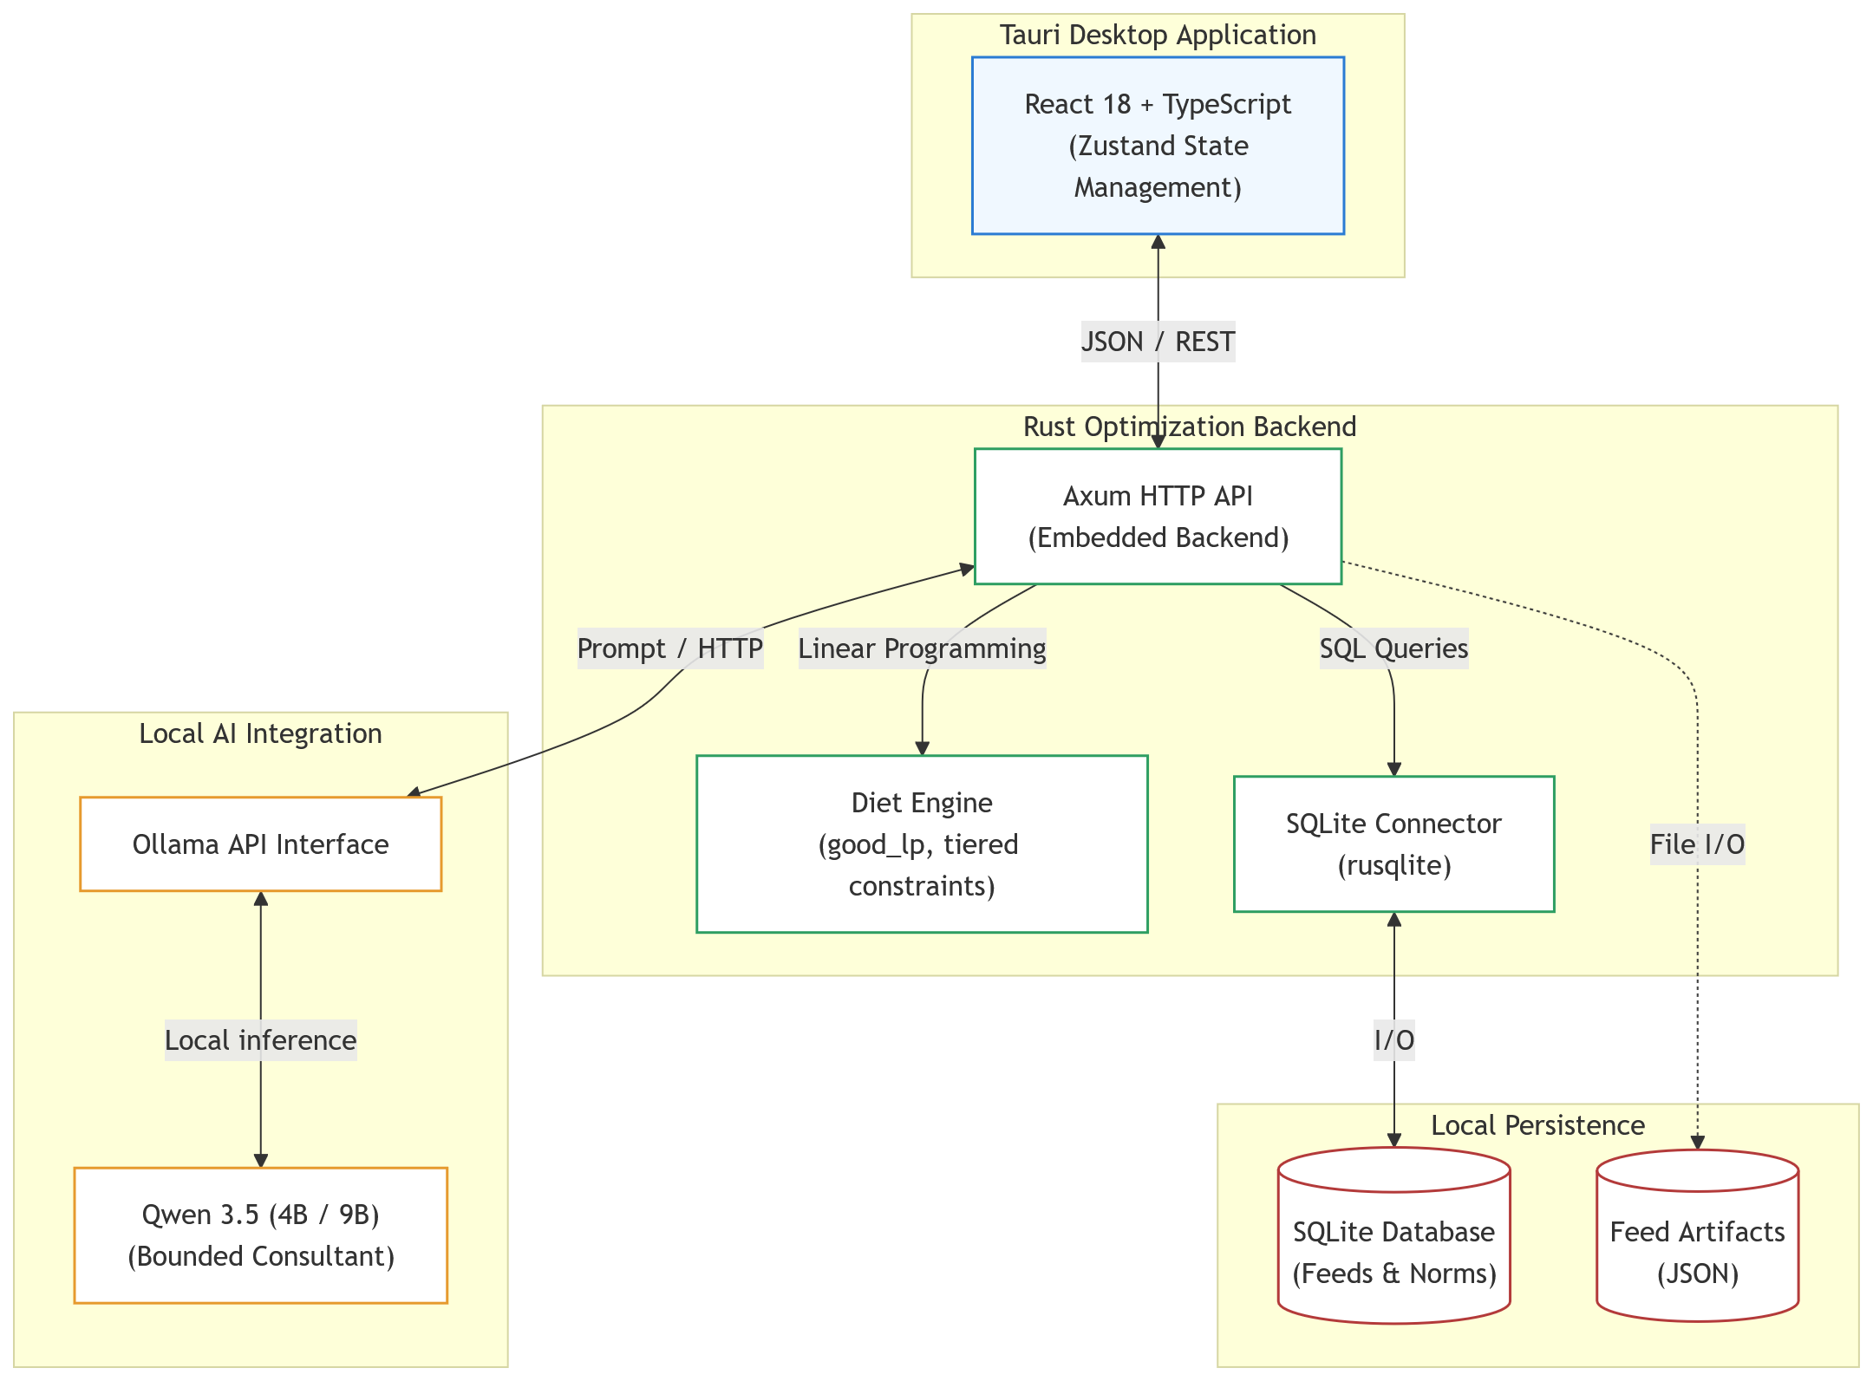
Figure. Felex system architecture, illustrating the interaction between the React user interface, the embedded Rust HTTP backend, the local database, and the local agent layer.

2.2. Feed database and nutrient system
The foundation of the algorithm is a feed database obtained through automated extraction and systematization of information from the open directory vidkormov.narod.ru. A custom Python pipeline handles data collection, translation, and normalization, compiling a local SQLite database. The raw normalized export currently contains 2,723 feed records. The benchmark-ready priced catalog used in the present publication artifact contains 1,342 feed items, assembled from 151 direct price anchors and 1,191 benchmark-priced records after fallback matching. The library spans roughage, succulents, concentrates, protein supplements, minerals, premixes, industrial by-products, animal-origin feeds, and non-protein nitrogen (NPN) sources.
Prices in the benchmark catalog are synthetic and used for workflow evaluation purposes only; they do not represent real-time market data. The raw normalized export (2,723 records) serves as reference data without price information.
The embedded database schema (feeds) supports a core contour of 31 nutrient and related feed-composition fields used by the ration engine. These include dry matter, three species-specific metabolizable energy indicators (energy_oe_cattle, energy_oe_pig, energy_oe_poultry), crude and digestible protein (dig_protein_cattle, dig_protein_pig, dig_protein_poultry), amino acids (lysine, methionine + cystine), crude fat, crude fiber, starch, sugar, macro- and microelements (Ca, P, Mg, K, Na, S, Fe, Cu, Zn, Mn, Co, I), and vitamins/precursors (carotene, vitamins D3 and E). Derived ratios and percentage constraints are then formed inside the optimizer from these stored fields.
The use of species-specific energy metrics is dictated by fundamental differences in digestion. For ruminants (cattle), the energy value of feed is evaluated based on metabolizable energy (energy_oe_cattle) accounting for rumen fermentation processes, which conceptually aligns with modern nutritional evaluation models (Sauvant and Noziere 2018; NASEM 2021). For monogastric animals, the metrics energy_oe_pig and energy_oe_poultry are used. The units of measurement for norms also depend on the animal species: for cattle, absolute daily values (e.g., MJ and grams per day) are predominantly used, whereas for swine and poultry, relative concentrations (g/kg of feed or percentages of the ration) are applied.
An important feature of the system for monogastric animals is digestibility-aware handling of amino-acid constraints. The current implementation interprets standardized ileal digestibility (SID) and true ileal digestibility (TID) requirements through the norm and optimizer layer, with alias/fallback handling where fully separated feed-profile fields are unavailable. The transition from evaluating total amino acid content to ileal-digestible forms remains a global standard (Stein et al. 2007; NRC 2012; NRC 1994), because it allows a more accurate assessment of biological protein availability and reduces excess nitrogen excretion (Pomar et al. 2021; de Lange et al. 2012; van Milgen and Dourmad 2015).
For benchmark cost evaluation, the engine first imports the latest non-inferred price anchors from the working Felex database and then fills the remaining benchmark catalog through an explicit fallback pipeline based on subcategory, category, family, and global medians. This produces a fully priced benchmark catalog while preserving provenance labels for direct versus inferred prices.

2.3. Feeding norms and their derivation
The system implements a multi-level process for calculating zootechnical norms: ranging from base values in database tables to species-specific dynamic models and factorial calculations. To ensure maximum accuracy, contextual scaling mechanisms are applied to the norms depending on the animal’s physiological state (live weight, productivity, age, sex).
For lactating cows, a dynamic model is applied to estimate dry matter intake (DMI) and net energy for lactation (NEL). Energy requirements consist of maintenance metabolism, depending on metabolic body weight (BW⁰·⁷⁵), and lactation costs, calculated based on 4% fat-corrected milk (FCM). Base equations and breed correction factors are adapted from classical methodologies (NRC 2001; Kalashnikov et al. 2003).
For finishing pigs, bilinear interpolation of normative tables by live weight and average daily gain is used. The model dynamically calculates requirements for metabolizable energy, protein, and standardized ileal-digestible amino acids, scaling them based on the expected growth intensity (NRC 2012).
Poultry nutrition accounting considers phase feeding. For broilers, amino acid requirements (TID lysine, TID methionine+cystine) are specified as strict percentages of the ration depending on the rearing period (starter, grower, finisher) (VNITIP 2017; NRC 1994). For laying hens, a factorial approach is used to calculate calcium, summing maintenance requirements for life and shell formation costs depending on egg production.
The computational core is based on a software factorial framework (NutrientCalculator), which sums requirement components (maintenance, growth, production, lactation, gestation) considering absorption coefficients.

2.4. Feed structural matrix
To ensure the biological adequacy of the ration, in addition to nutrient balance, it is necessary to adhere to structural proportions. For this purpose, a feed matrix is integrated into the optimizer, specifying allowable boundaries (minimum, optimum, maximum as a percentage of dry matter) for various feed categories.
The system automatically classifies each ingredient (classify_feed), assigning it to one of the functional groups: roughage, concentrate, succulent, mineral, premixes, animal-origin feeds, or non-protein nitrogen (NPN) sources. Based on these categories, species-specific structural constraints are imposed.

2.5. Optimization core mathematical model and workflows
The Felex engine formulates the ration construction task as a linear programming problem with hierarchical constraints (tiered constraints). Let x ∈ ℝⁿ denote the vector of feed quantities used. The objective function seeks to minimize the total cost of the ration: min z = cᵀx.
The model constraints are defined by the nutrient composition matrix A and the vectors of minimum and maximum requirements: b_min ≤ Ax ≤ b_max, x ≥ 0.
Absolute limits (e.g., maximum dry matter intake, feed structural matrix) are applied as non-relaxable LP constraints outside the tier system. The nutrient constraints are divided into three tiers:
- Tier 1: Essential (hard) nutrients (metabolizable energy, crude protein, calcium, phosphorus).
- Tier 2: Standard nutrients (lysine, methionine, crude fiber) with fallback mechanisms.
- Tier 3: Soft constraints, such as trace elements and vitamins.
The optimizer implements three conceptual workflows:
- build_from_library: Automatic construction with unbounded search and structural feed matrix.
- complete_from_library: Balancing a user-defined ration “skeleton.”
- selected_only: Bounded search restricted exclusively to user-selected feeds.
The optimizer uses an additive constraint-building method (Algorithm 1), locking the achieved target levels from the previous tier. In case of infeasibility, a goal programming mechanism with penalty functions is applied.

2.6. Computational experiment methodology and artifact generation
To evaluate practical performance, computational testing was conducted using the canonical benchmark artifact generated by the current Felex benchmark pipeline. The executable benchmark runs 23 implemented livestock scenarios. The benchmark-ready catalog contained 1,342 priced feed items. For each executed scenario, optimization was run under three workflows, yielding 69 total runs. Results were exported programmatically to JSON and then converted into derived CSV tables and figure assets.
All graphs, tables, and statistical summaries were programmatically generated from the benchmark JSON. The Norm Coverage Index (scale 0–100) was computed using tier-weighted penalty scores with Felex priority weights (Tier 1 = 3, Tier 2 = 2, Tier 3 = 1). Quality Delta was computed as the coverage difference between complete_from_library and build_from_library workflows.
The local agent layer was evaluated as a bounded consultation assistant. Two local configurations were tested: Qwen 3.5 4B at 4096 context tokens and Qwen 3.5 9B at 2048 context tokens (Alibaba Cloud 2023; Ollama 2023). The benchmark included six ration-diagnosis tasks and six feed-lookup tasks. Metrics included limiting-nutrient recall@3, recommendation overlap@3, grounded recommendation rate@3, lookup accuracy, and overall applicability.

3. Results

3.1. Computational performance
Analysis of the 69 runs revealed clear structural differences in performance among the workflows. The mean optimization time across all tests was 246.6 ms. The build_from_library workflow was computationally the most expensive, averaging 617.5 ms, because it searches the broadest ingredient space under matrix and norm constraints. The complete_from_library workflow averaged 121.8 ms, whereas the strictly bounded selected_only workflow averaged only 0.41 ms. Under the current benchmark, all three workflows therefore remain operationally interactive.
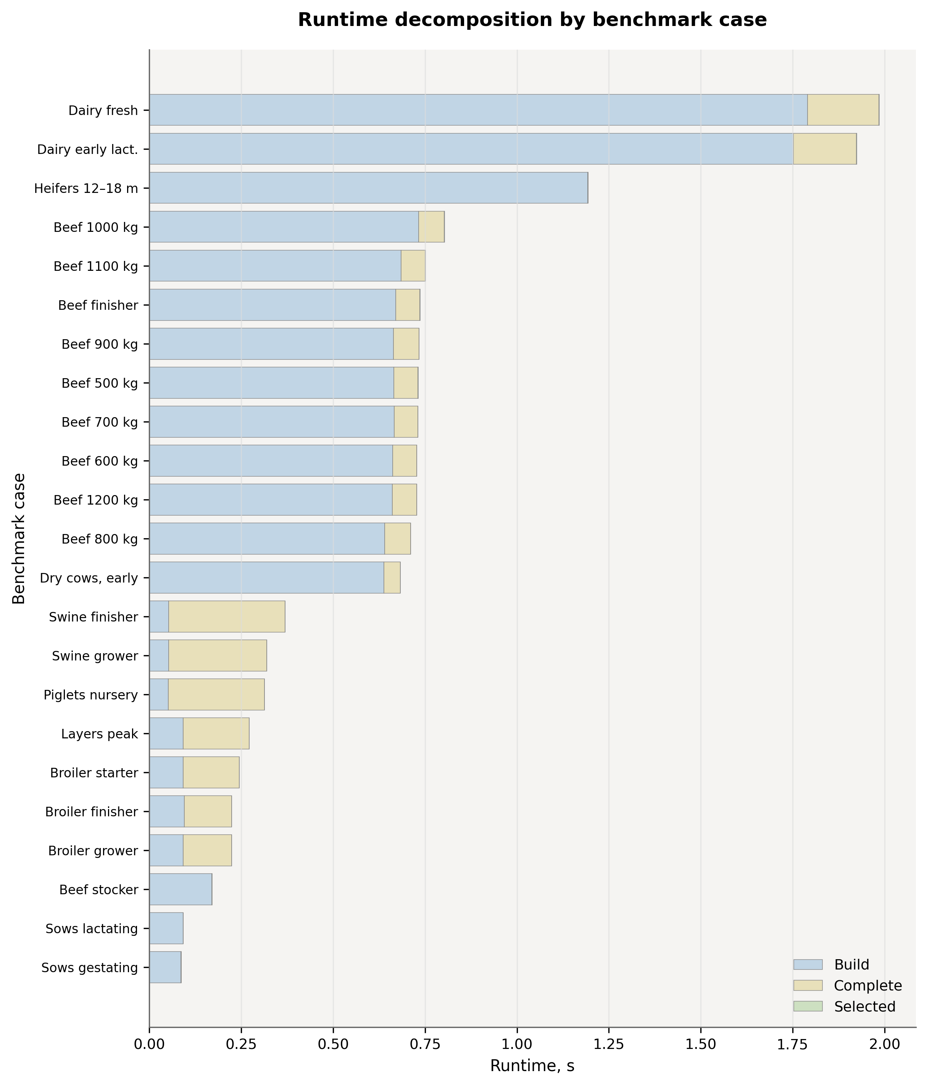
Figure. Comparison of execution times (Runtime) across workflows and scenarios.

3.2. Norm coverage quality and deficiency structure
The mean pass rate for hard constraints was 64.8%, and the average Norm Coverage Index across the entire sample was 81.8 out of 100.
The complete_from_library mode (coverage 85.0) systematically improved ration quality compared to automatic building from scratch (coverage 83.2), highlighting the value of an expert-defined “skeleton.” The Quality Delta was most pronounced in cattle scenarios. The selected_only mode exhibited the lowest coverage (77.1) due to the artificially narrowed ingredient list.
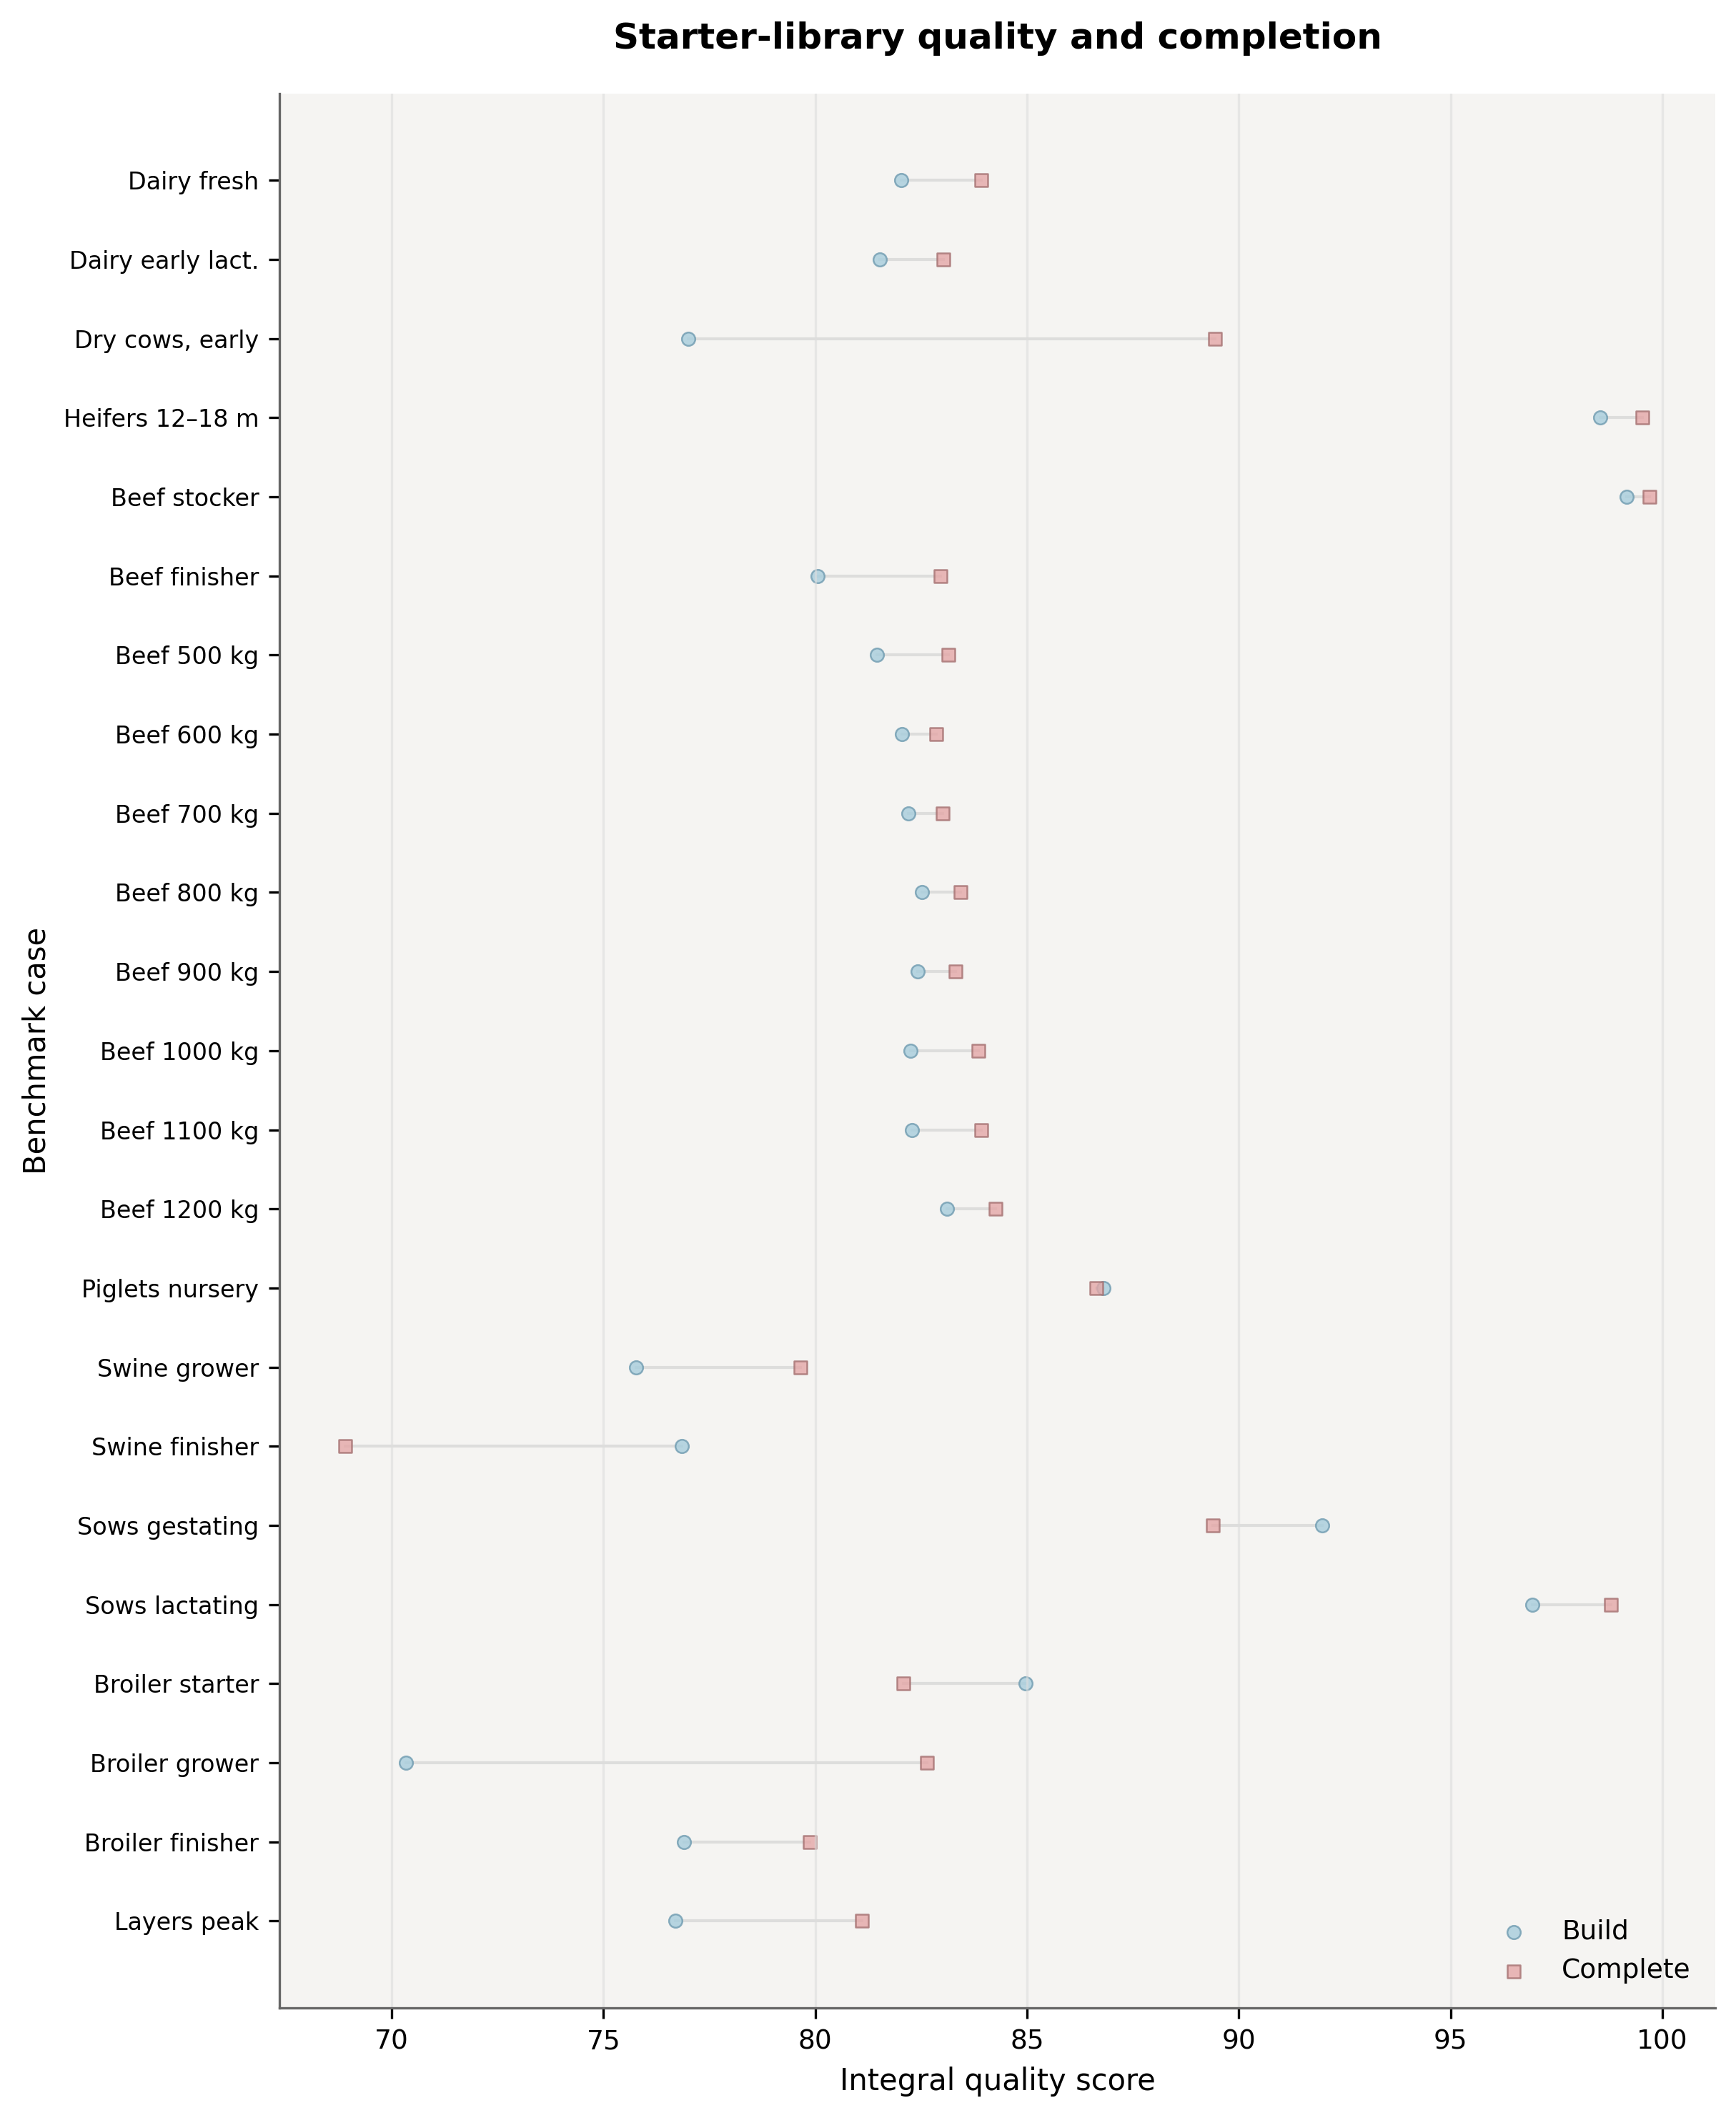
Figure. Comparison of the Norm Coverage index between the build_from_library and complete_from_library modes.
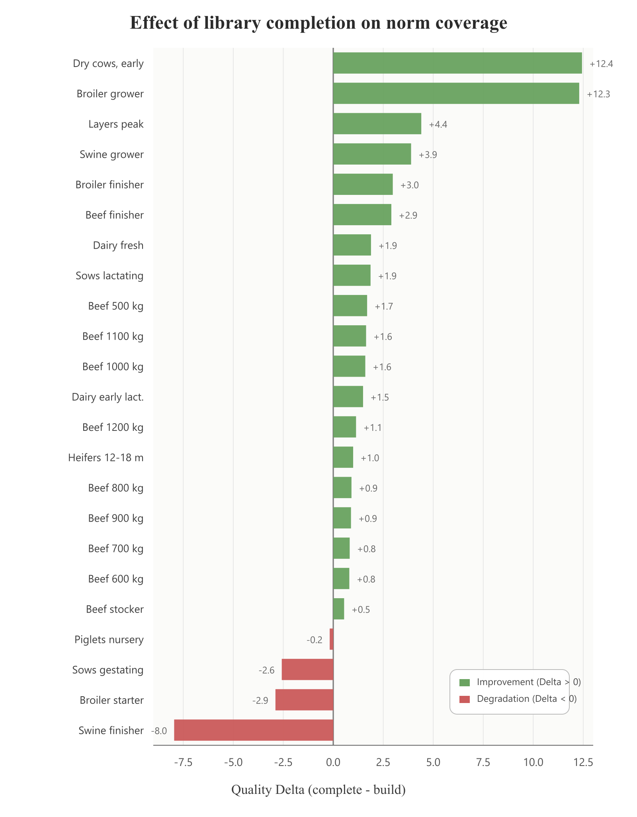
Figure. Quality Delta (difference in coverage indices) resulting from transitioning from automated construction to balancing a user-defined ration skeleton.
An in-depth analysis of systematic deficiencies was conducted for monogastric animals (swine and poultry). The primary limiting factors remained phosphorus, calcium density, vitamin D3, sodium, lysine or lysine-proxy constraints, and the sum of methionine and cystine depending on species and stage.
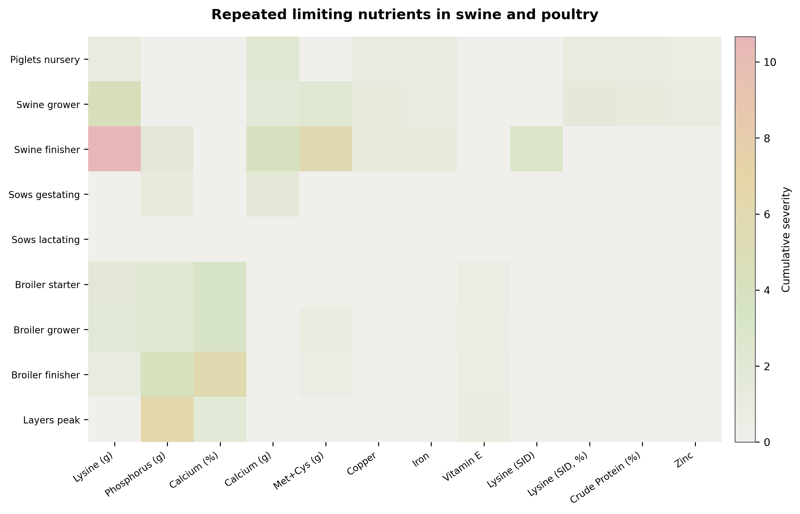
Figure. Cumulative severity of nutrient deficiencies in completed rations for swine and poultry scenarios.

3.3. Economic analysis and LLM evaluation
The average cost of a ration was 183.0 RUB/day.
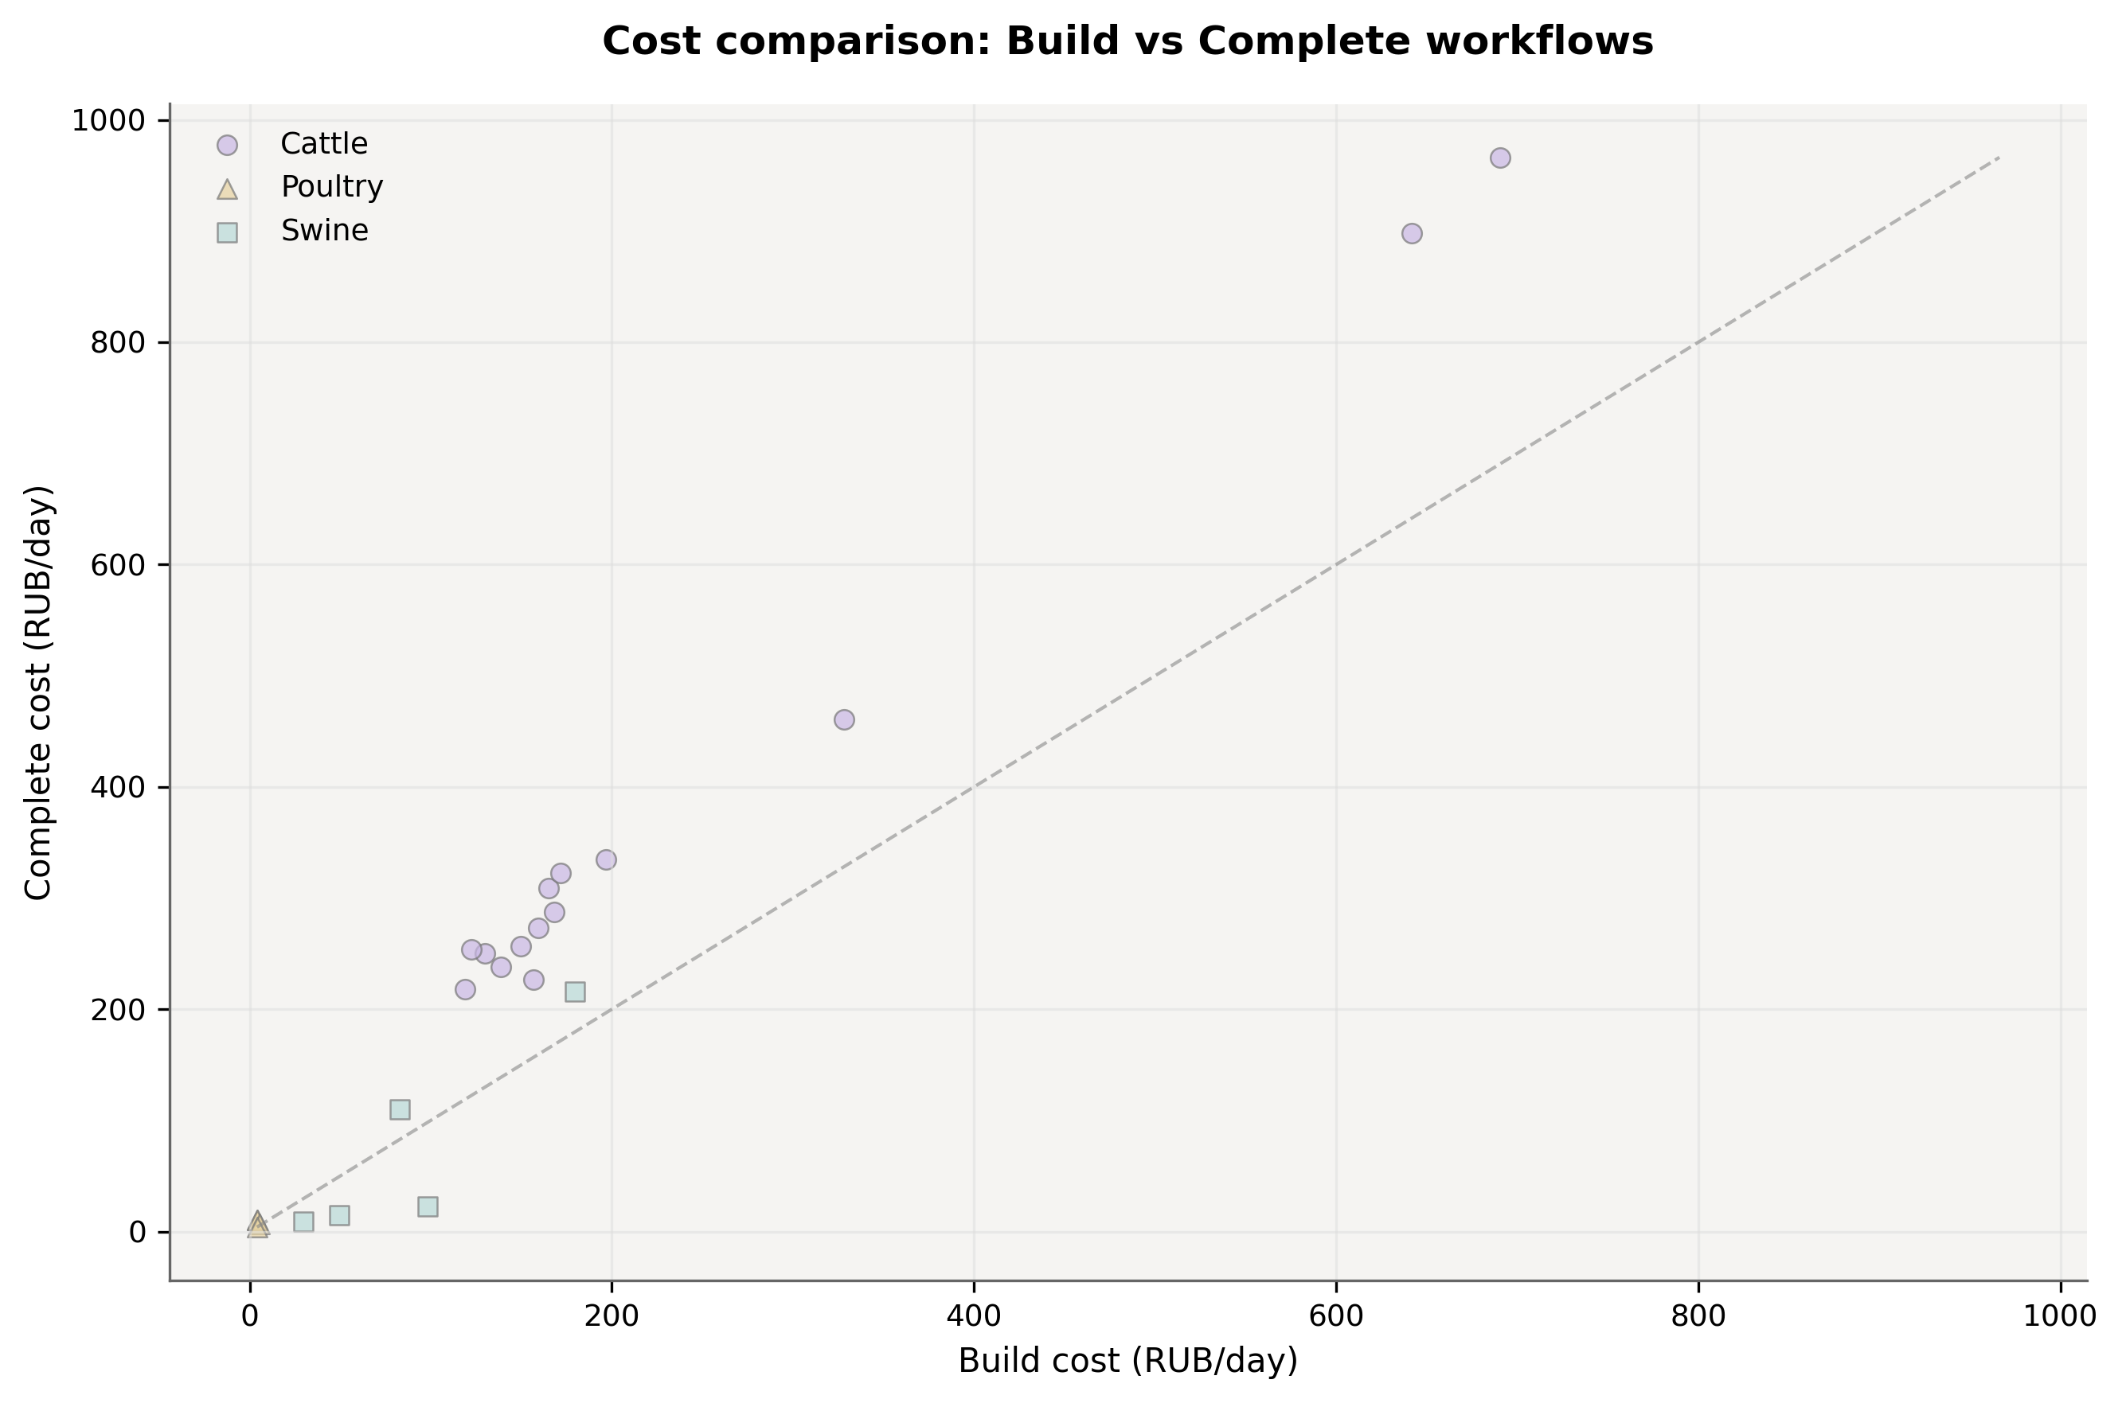
Figure. Dependence of ration cost on the applied optimization mode, with clustering by animal species.
Evaluation of the local consultant agent across both tested Qwen configurations showed limited usefulness. Both the 4B/4096 and 9B/2048 settings produced limiting-nutrient recall@3 of 0.17, grounded recommendation rate@3 of 0.67, lookup accuracy of 0.50, and overall applicability of 34.2/100. The benchmark telemetry showed that these results were obtained without hidden model or context fallback.
Configuration | Recall@3 | Grounded@3 | Lookup acc. | Applicability | Interpretation
Qwen 3.5 4B @ 4096 | 0.17 | 0.67 | 0.50 | 34.2/100 | Inadequate for dependable consultation
Qwen 3.5 9B @ 2048 | 0.17 | 0.67 | 0.50 | 34.2/100 | No aggregate gain under constrained context
Table 1. Bounded in-application consultation benchmark of local Qwen 3.5 configurations across 12 tasks.

4. Discussion
The benchmark confirms that the three Felex workflows should be interpreted as different practical operating modes rather than as equivalent solver settings. selected_only is extremely fast but structurally limited by the user-provided feed set. build_from_library offers the broadest search, but even this mode remained sub-second on average. complete_from_library provided the best balance, combining materially better norm coverage with runtime short enough for routine specialist use. For an applied livestock audience, this is the most relevant result: Felex performs best when it extends an expert-defined ration skeleton rather than when it is asked to replace expert input entirely.
This positioning also fits the current software field. Felex is not a replacement for enterprise formulation suites or integrated farm-management platforms (Datacor 2026; KORALL 2026; 1Cow 2026). Its more defensible niche is a local, transparent instrument for specialists who need explicit workflows, mixed normative support, and reduced dependence on proprietary cloud stacks. That niche is particularly relevant in Russian operating conditions, where localized tools exist (DeltaKorm 2026; WinMix 2026) but open, benchmarked, locally deployable options remain limited.
The nutritional behavior of the current engine is consistent with practical formulation logic. For cattle, metabolizable-energy accounting remains a pragmatic compromise for a cross-species tool (INRA 2018; Volden 2011; Kalashnikov et al. 2003). For monogastric animals, the recurrent pressure around digestibility-aware amino-acid constraints and phosphorus supports the continued importance of digestibility-aware formulation (Stein et al. 2007; NRC 2012; Pomar et al. 2021; de Lange et al. 2012; van Milgen and Dourmad 2015). The observed hard-constraint pass rate near 65% should therefore not be read as simple algorithmic failure; it also reflects imperfect feed data, sparse price anchors, and the biological difficulty of satisfying all tiers simultaneously from a constrained library. The hierarchical LP strategy and fallback soft-goal step remain reasonable for practical ration construction under those conditions (Rehman and Romero 1987).
The local agent results require a more cautious interpretation. Under a bounded in-application consultation benchmark, both tested Qwen configurations reached the same low aggregate adequacy score, and the larger 9B model did not improve on the 4B model when constrained to a smaller context window. These weak results are attributable to task performance rather than to silent infrastructure degradation.
Several limitations follow directly from the repository state and benchmark evidence. First, the optimization core remains linear, whereas nonlinear, multi-objective, stochastic, and evolutionary approaches may better represent some biological trade-offs (Li et al. 2022; Uyeh et al. 2018, 2019; Das et al. 2023; Agrawal et al. 2025; Kumar et al. 2025). Second, the regional feed database should be expanded. Third, the norm engine should be extended with richer factorial derivatives. Fourth, the local agent layer should not be expanded by model scaling alone. Future work should combine improved regional feed data, richer norm derivation, uncertainty analysis, explainable recommendation traces, and better task grounding and domain adaptation.

5. Conclusion
Felex demonstrates that a locally deployable livestock ration platform can combine transparent optimization workflows, mixed normative support, and a practical desktop runtime without relying on a cloud-first architecture. In its current state, the strongest use case is supportive ration building for specialists in small farms and animal businesses, especially where regional adaptation and operational autonomy matter. The present benchmark supports that practical positioning, while also showing clear limits in database coverage, uncertainty handling, and the adequacy of the local agent for dependable consultation. Those limits define the next development agenda more clearly than any claim of automation maturity.

Declaration of Competing Interest
The authors declare that they have no known competing financial interests or personal relationships that could have appeared to influence the work reported in this paper.

Funding
This research received no external funding.

Data Availability Statement
The Felex source code is available at https://github.com/danilkotelnikov/Felex. The canonical optimization benchmark artifact is stored at https://github.com/danilkotelnikov/Felex/tree/main/.claude/benchmarks. The bounded local-agent benchmark artifacts are stored at https://github.com/danilkotelnikov/Felex/tree/main/deliverables/agent_publication_benchmark_2026-04-03_qwen4b_4096 and https://github.com/danilkotelnikov/Felex/tree/main/deliverables/agent_publication_benchmark_2026-04-03_qwen9b_2048. The raw normalized feed export is available at https://github.com/danilkotelnikov/Felex/blob/main/database/output/feeds_database.json. Additional data and scripts are available from the corresponding author upon reasonable request.

Acknowledgments
The authors thank the developers of the good_lp library, the Ollama ecosystem, and the maintainers of open agricultural standards and reference resources that made this work possible.

Declaration of generative AI and AI-assisted technologies
During the preparation of this work the authors used Anthropic Claude (Claude Opus 4.6 and Claude Sonnet variants, https://www.anthropic.com/claude) and OpenAI Codex (https://openai.com/index/openai-codex/) in order to assist with literature synthesis, code documentation review, manuscript language editing, LaTeX formatting, and benchmark-audit documentation. After using these tools, the authors reviewed and edited the content as needed and take full responsibility for the content of the published article.

CRediT author statement
Danil D. Kotelnikov: Methodology, Software, Data curation, Formal analysis, Investigation, Writing – review & editing, Visualization, Validation, Resources, Supervision, Project administration.
Olga V. Demkina: Conceptualization, Writing – original draft preparation.

