How to Have Great Ideas

by Danilo Lapegna

Method, techniques, neuroscience

of an “effective creativity”

**

New GEM Edition

# How to Have Fantastic Ideas



In 1944, Mexico was a country heavily reliant on wheat imports. Plant diseases, particularly wheat rust, devastated crops every year, leaving farmers in poverty and the country in a constant food crisis. At the time, traditional agronomists were mostly trying to combat wheat rust with “conventional” methods, such as using pesticides and crop rotation, but none of these solutions seemed to have much success. However, this is where history was changed by the impact of a man named Norman Borlaug. Borlaug indeed attempted a different, unconventional approach: instead of trying to fight the disease, he decided to “change the wheat itself.” Through a process of selective breeding, Borlaug developed a new rust-resistant variety of wheat, but he didn’t stop there. He knew that to resolve the food crisis, Mexico needed not only disease-resistant wheat but also wheat that could produce more food. Therefore, Borlaug started developing semi-dwarf wheat varieties, shorter and sturdier plants that could bear heavier loads of grain without bending or breaking and channel more “energy” into production itself, rather than vertical growth.

The result of Borlaug’s approach was absolutely astonishing. By 1963, just two decades after Borlaug’s arrival, Mexico had become completely self-sufficient in wheat production. Most importantly, Borlaug’s impact did not stop at Mexico: his wheat varieties were introduced in countries like India and Pakistan, where they helped prevent famine and improve food security.

This short story, like that of so many other individuals who have literally (and here forgive the rhetoric) “changed the world” thanks to their creative solutions, leaves us, in my opinion, with a very powerful lesson: whether we find ourselves in a historical era of crisis or abundance, things can be profoundly revolutionized for the better thanks to the emergence of challenging ideas, unprecedented innovations, and new creative forces. If, after all, this primordial drive to “create”, not simply accepting what already exists but rather conceiving the “new”, were not naturally etched into the DNA of our species, we might still be living in caves, feeding on seeds and raw meat, and resigning ourselves to a life expectancy of 20-30 years; that is, assuming everything goes well and we don’t have an unfortunate encounter with a wild tiger long before that time.

And yes, it is likely that some historical researcher out there might have something to say about the accuracy of what has just been stated; however, I don’t think one can deny how the art of creative innovation has always allowed every individual and organization to push beyond their limits, establish new standards, and reach new levels of impact and significance in any field, no matter how challenging or critical. Even when considering things on a somewhat smaller scale, today, whether it’s a university student wanting to organize their study plans, a company trying to understand how to enter a tough market, or an individual embarking on a journey of self-improvement, a deep understanding and conscious use of the creative process can truly make the difference between an impactful outcome and one that gets lost in the “noise of the contemporary world.”

For this reason, whether you want to fulfill a long-held dream or solve a problem that has been troubling you for too long, I’m confident that you will find in this book an extraordinary “kit” of practical, technical, strategic, and neuroscientific tools to help you achieve your goal; a collection, which I believe is one of the most comprehensive you can find, of research, studies, techniques, and methods that will help you create value for yourself and those around you, act effectively and mindfully, and make a difference, regardless of the context you wish to tackle. And, why not, perhaps thanks to what you learn in this volume, you might even manage to create that “fantastic idea” that redefines every previous paradigm. Your unique, surprising creation that can set a precedent in beauty, functionality, and even the ability to generate wealth and value for you and those around you.

I also believe that discovering one’s “creative self” is a fundamental part of each of our inner journeys, something that goes far beyond the “practical results” of our possible ideas. Rediscovering ourselves as creative individuals can indeed help us “express” who we are and what we represent in the fullest and deepest sense of the term. This can be profoundly therapeutic for us, both in the short and long term, allowing us to create true “privileged windows” into ourselves, our emotions, and even our highest states of serenity and harmony. As Erich Fromm said in his art of loving, “Whether a carpenter builds a table, a jeweler crafts a piece of jewelry, a farmer grows grain, or a painter paints a picture, in every type of creative work, the maker and the object become one: the individual unites with the world in the process of creation.”



Before you begin, I would recommend grabbing a notebook, a tablet, or your favorite writing tool; anything is fine as long as you can use it to jot down notes and experiment with all the techniques you will encounter in the book. What I encourage with this volume is indeed a deeply active reading, one that requires you to get involved, to become an active participant in the creative process. This book is a bit like a prism, a lens through which to learn how to observe reality from new and astonishing angles; but ultimately, it will be up to you to shape it, to play with it, and in doing so, to learn how to express your uniqueness. That said, all that’s left is to wish you happy reading, happy writing, but above all, my warmest “good luck”! And remember:



At the “Kintsugi Project”, we promote and encourage the love of reading every day. Do the same by taking a photo of this book and tagging our Instagram account, @danilolapegna.kintsugi, with the hashtag #ioleggo. You will receive a special thank you from us.

If you have any feedback for us, proposals, requests, or suggestions, feel free to write to us at info@kintsugiproject.it. We will always be happy to hear from you!

Danilo Lapegna

**

If you’re reading a book with this badge on the cover, you’re reading one of our prestigious GEM editions. GEM stands for Guarantee, Excellence, and Method, embodying the essential core of the “Kintsugi Project” contents and products: Guarantee for your purchase, always protected by our refund policies. Pursuit of absolute Excellence in our content. But above all, a Method of writing and research developed to adhere to principles of “absolute quality.” A creation process based on a rigorous selection of everything that is most scientific, relevant, and impactful in human philosophy and culture. An approach fueled by our relentless desire to provide only the finest tools for personal well-being, continuous learning, and the elevation of all those qualities that can make the human spirit unique and wonderful. When you choose a GEM book, you choose a companion for everyday life, nourishment for your curiosity, and a one-way ticket to a journey of “never-ending discovery.” And the beauty of it all is that “this is just the beginning...”

# I - Creative Neural Training

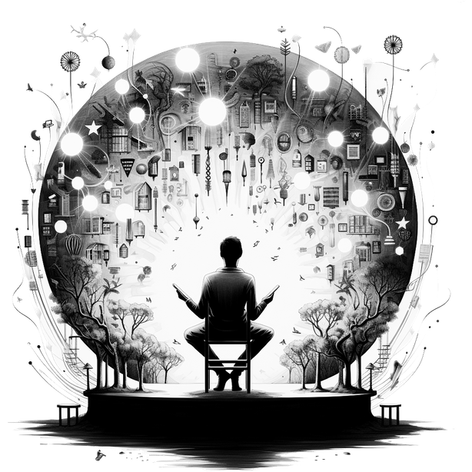

“True creativity, the sudden vision of a novel combination that forms new utility or meaning, creates a reaction such that our neural circuits suddenly change their behavior. Various neuromodulators, including dopamine, are secreted, and a sense of excitement, of future anticipation, arises because such a combination might appear to us again.”  
(Andrew Huberman)

Just as an athlete’s muscles require the right training before facing a competition, it is likely that a mind seeking to make its “quantum leap” into the world of creativity must first be adequately trained to think “freely.” Although this might sound like a pretentious activity for intellectuals at a bar, it actually involves the fundamental process of “unlearning what is known” and evolving one’s thoughts beyond everyday biases, influences, and prejudices. In essence, it’s a true “partial rewriting of one’s cognitive processes”, which may sound extremely difficult to achieve; yet, quite simply, like any training, it requires no more than the willingness to make an effort and to repeat that effort over time with consistency and dedication. After all, the physiology of our brain does not shy away from this principle, considering the way its natural plasticity allows neurons to establish new synaptic connections over time, depending on experiences and deliberate actions. This, and this might be one of the most valuable truths consolidated by recent neuroscientific research, is not only true for children or adolescents but also persists into advanced adulthood (defying, perhaps, the notion that people never change; a rhetoric I find extremely dangerous, as it is too often used to justify any abandonment of the effort required to become “slightly better” human beings).

Let us therefore begin by introducing some indispensable “mental gym” techniques to develop all our best “muscles” of creative and independent thinking. Read them, reread them, learn them, and try to understand over time which might be most suitable for you and your way of reasoning. You’ll probably start noticing changes much sooner than you might have expected.

## Visualise it all

The human brain remains an inexhaustible field of discovery, and the stories of great creative minds of the past inevitably carry an aura of fascination between reality and legend. However, despite the fact that we cannot (yet?) use a time machine to go back and monitor some of the great creative minds of the past through neuroimaging practices (also because what constitutes a “great creative mind” would first need to be defined; for simplicity’s sake, we will leave the complexity of this debate for another time), some scientific research is nevertheless attempting to shed light on the neural mechanisms that might represent an added value in terms of creative abilities—chief among them, the capacity for visualization and the formation of mental images.

Let’s take, for example, a study by Kosslyn, Ganis, and Thompson in 2001; in research published in the “American Psychologist”, these researchers hypothesized that the ability to mentally visualize images could have a significant impact on cognitive areas such as memory, problem-solving, and, yes, creativity. But another piece of the puzzle might also come from the work of Pearson, Logie, and Green in 1996. In their study in the “Journal of Experimental Psychology: General”, they reported that the use of mental imagery can notably boost memory skills, which are essential for establishing creative relationships between different concepts.

But let’s also try to think for a moment about the truths, albeit anecdotal, regarding the ability to think in images of some of the greatest geniuses of the past: it seems that Einstein, while describing the thought process behind the development of the theory of relativity, said he imagined himself riding a beam of light. Similarly, Leonardo Da Vinci’s thought process, based on his writings and sketches, is often cited as an emblematic case of “visual-spatial thinking”, a type of reasoning that involves the mental manipulation of images and three-dimensional objects.

Certainly, the complexity of the creative phenomenon often places us in a position where it is truly difficult to extract unique and absolute truths from scientific research, or even less so from anecdotal evidence. However, as long as we avoid foolishness, in my opinion, it can be fascinating to act as explorers, pioneers, and experimenters with the patterns that seem to emerge from the truths available to us. In this case, it boils down to a simple “try to train your ability to visualize creatively and see what benefits arise from it.” Of course, many of us may already possess a natural ability to visually process our thoughts, for whom this section might seem rather unnecessary. But for everyone else? My advice is simple: adopt a daily practice to develop this skill. Take a few minutes each day, perhaps five minutes upon waking or during an afternoon break, and try to give shape, size, and color to things that otherwise wouldn’t have them. For example, how would you visualize music played on the piano? Music played well? Music played poorly? How do you imagine the inspiration of a musician who, expressing their full potential, projects a wonderful melody onto the keys?

How would you visualize a generic relationship between two numbers? What about the uncertainty of a mathematician who must uncover this relationship? And the idea that emerges when that uncertainty is resolved?

Now take five different spices. What shape and color would you give to their aroma? What distinguishes one aroma from another? And now, continue on your own. Seek out abstract elements and try to understand how to visualize them. And in creating these forms, remember that your visual imagination has no limits and should have none: in your mind, you have absolute freedom to create, build, visualize, and imagine anything you want, and it is