Personal assignment:

- Pick your own client, import/clone the project

- Add a file (C, HTML, PHP, …) named with your net id prefix

- Make changes to the file, check in

- Undo the previous changes, check in

- Make different changes to the file, check in

Turn in write-up including

- Instruction to setup the repository

- Instruction to import/clone the repository

- Screen shot of your client (GUI or console)

- File history dump (screen shot) showing file was added, changed, reverted

- Screen shot of file diff for one of the check-ins

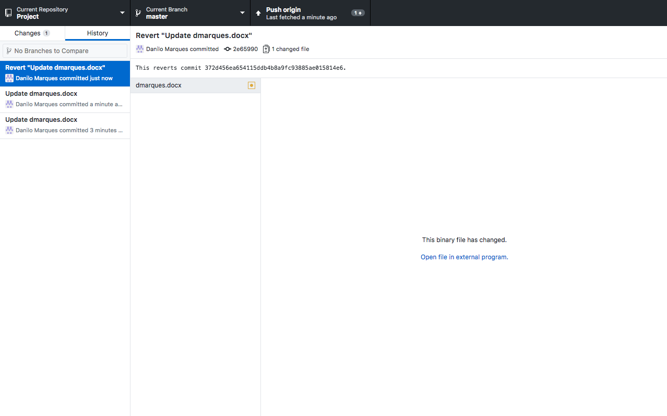

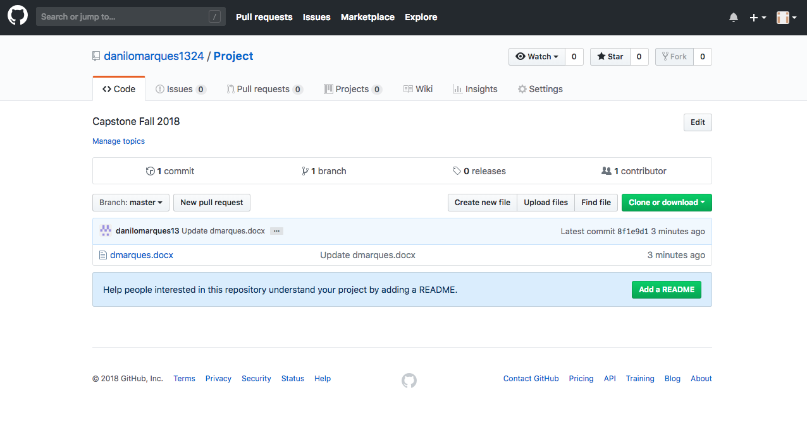

I want to see all the diff