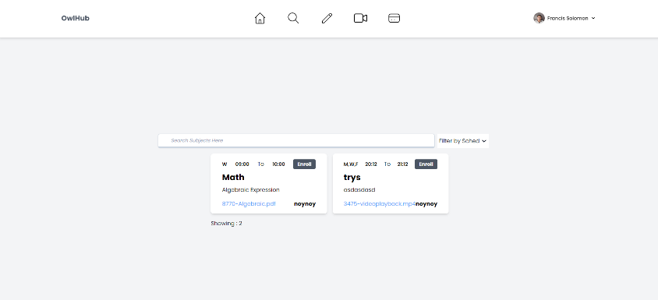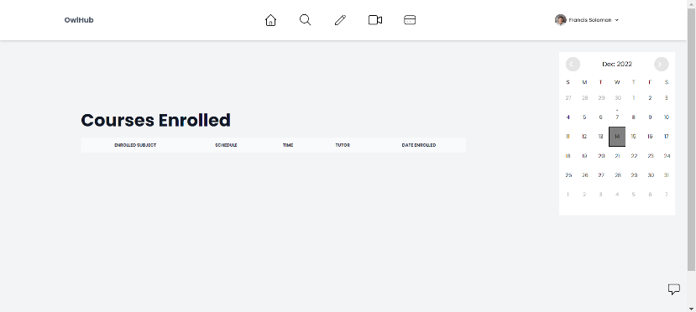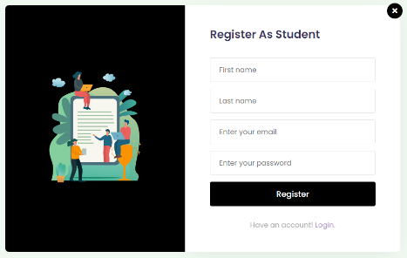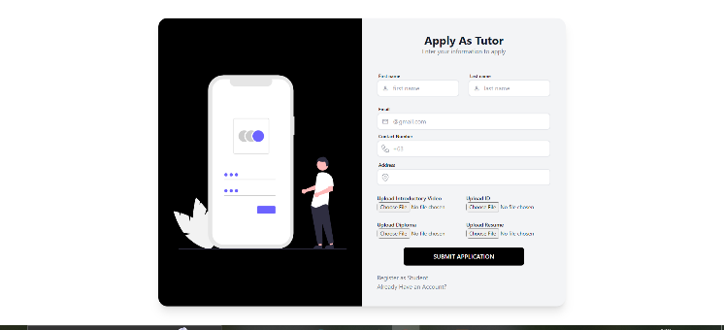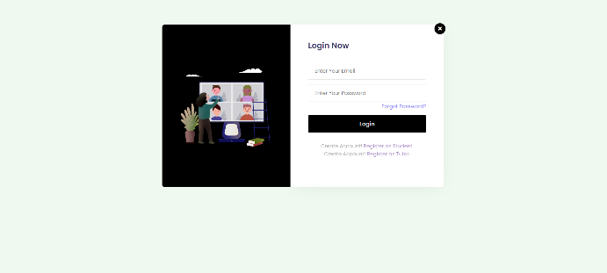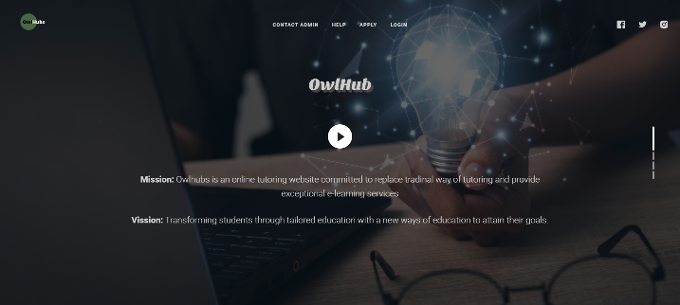 V

This is the Student Dashboard

This is the OwlHub Homepage

This is the searching module

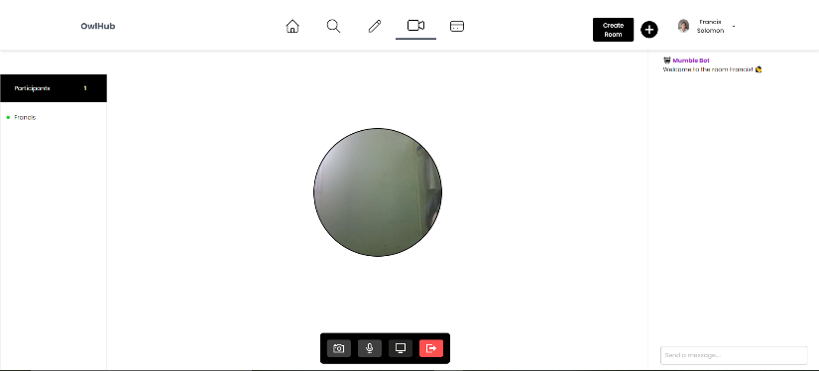

This is the E-Wallet

This is the Assessment Features

This is the Video Conferencing

This is the User Setting

**Tutor Features**

Tutor Dashboard

Add Lessons

Add Assessment

User Setting

Video Conferencing

**Admin**

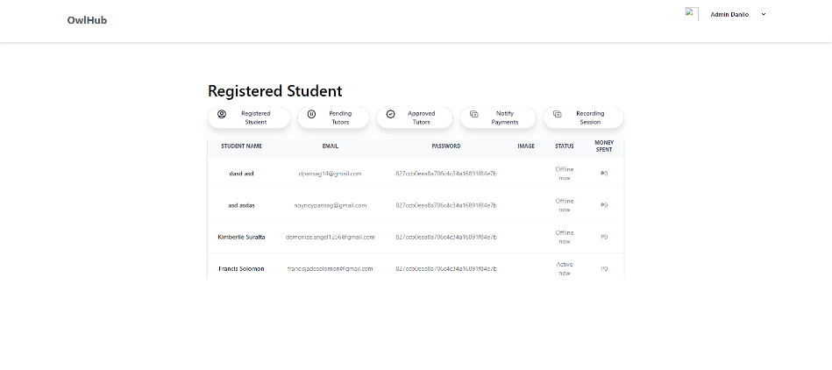

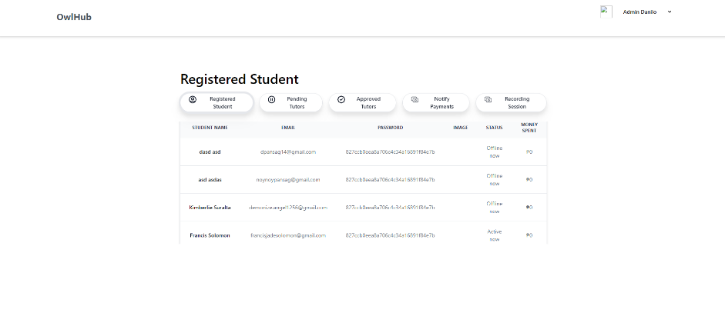

Registered Student

Admin Dashboard

Registered Student

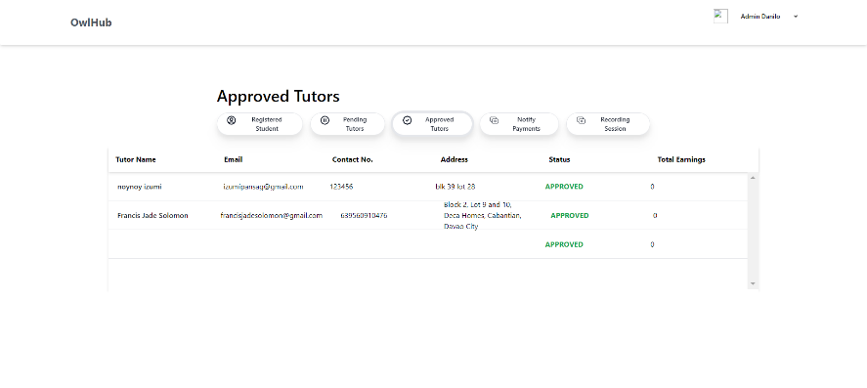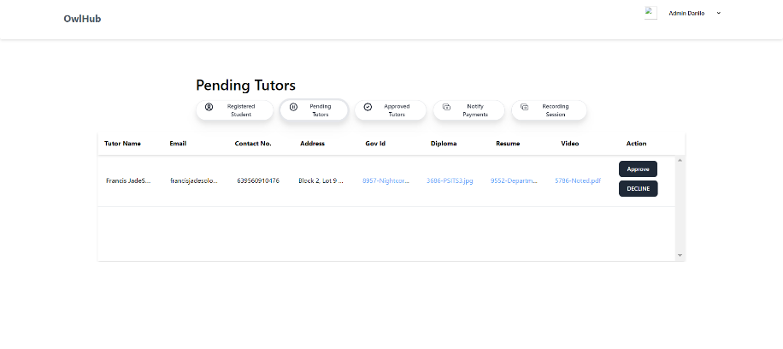

Approved Tutors

Payments Notification

Recording Session