Name: Andre Dan Dayaganon Course/Section: BSIT-601

Subject: Web Systems & Technologies

02 Task Performance 1/Prelim Exam – ARG

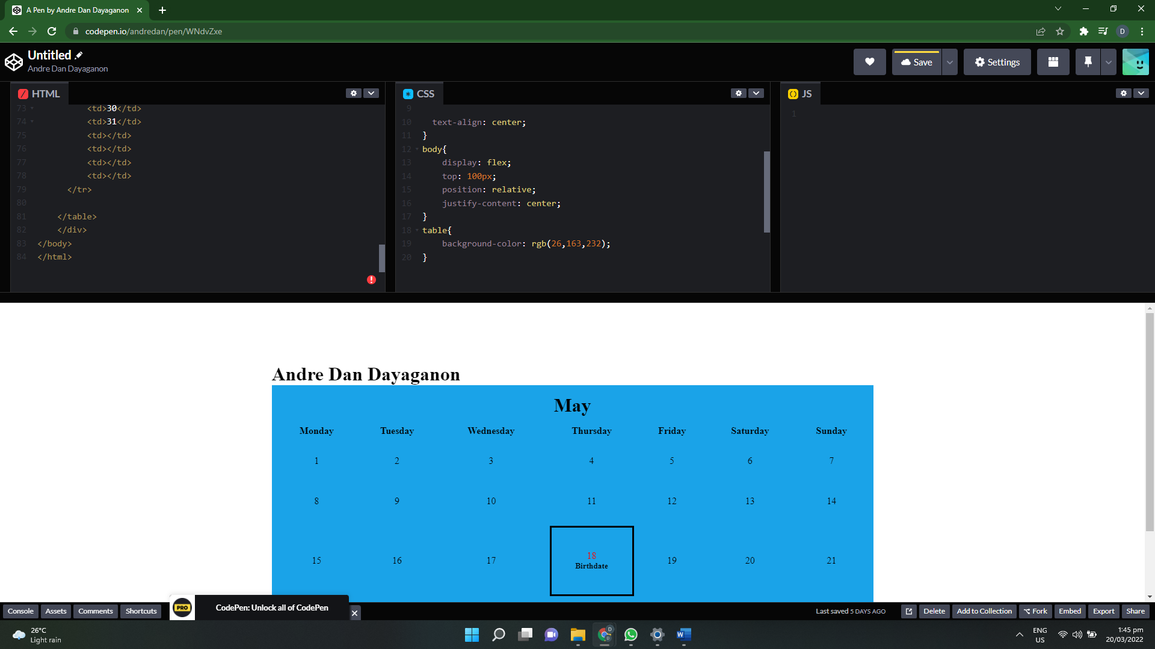

https://codepen.io/andredan/pen/WNdvZxe