# **Approval Sheet**

This capstone project proposal titled: **Online Tutoring Web Services: OwlHub** prepared and submitted by **Kimberlie Suralta, Dolmer Pansag, Andre Dan Dayaganon, and Francis Jade Solomon** in partial fulfillment of the requirements for the degree of Bachelor of Science in Information Technology, has been examined and is recommended for acceptance and approval.

**Clyde Anthony Migue**

Capstone Project Adviser

Accepted and approved by the Capstone Project Review Panel

in partial fulfillment of the requirements for the degree of

Bachelor of Science in Information Technology

**Maam Charish Bandayanon**

**Sir Joseph Limbaroc**

**Panel Member Panel Member**

**Sir Vincent Bryan Calija**

**Lead Panelist**

**Noted:**

Engr. Elvie Lito E. Ubas, MEE

**Capstone Project Coordinator**

**January 2023**

# **Acknowledgment**

First and foremost, we offer our sincerest praises and gratitude to the God Almighty for all blessing and guidance in everyday planning and conducting this project.

To our adviser **Mr. Clyde Anthony C. Migue,** our project coordinator, **Engr. Elvi Lito Ubas, MEE,** we express our deepest gratitude for your continued support and supervision toward achieving the feasibility of this project. We have learned so much from the advice and comment, which helped us to make the project on the right track.

To our caring parents and guardians, we cannot thank you enough for your hard work and support in everything that we do. Your sacrifices brought us here and we are grateful for your continued love and understanding.

**Table of Contents**

**Approval Sheet** i

**Acknowledgment** ii

**Introduction** 2

Project Context 2

Purpose and Description of the Project 3

Objectives of the Study 4

Scope and Limitation of the Study 5

**REVIEW OF RELATED LITERATURE** 7

Synthesis 11

Technical Background 12

Overview of Current Technologies Used in the Current System 12

Calendar of Activities 13

Resources 13

**Methodology, Result, Discussion** 14

Research Design 14

**CONCLUSIONS AND RECOMMENDATIONS** 42

Conclusion 42

Recommendations 42

**Appendices** 43

**REFERENCES** 54

Evaluation Tool/Test Documents 55

# **Introduction**

## Project Context

The traditional approach to education requires a place to learn where it can be done face-to-face in an exchange of information for students to learn, but some students prefer the comfort of their homes. However, as mentioned by UNICEF (2021), the Philippine government made some restrictions on face-to-face classes. The government is transitioning to a new normal of adapting online education where students use third-party apps for communication like Google Meet, Microsoft Teams, and other video conferencing platforms.

Websites have been more accessible to individuals since the inception of the internet, including its everyday improvements. Websites are primarily used for distributing information, but their scope has expanded since the introduction of social media in 1997. It advanced quickly and quickly reached many people all over the world. It came to a stage when technology and social media were integrated into people's daily lives since they greatly aided them in completing their jobs.

Based on the data that has been gathered, some students who are looking for tutors prefer online learning because it is fast, efficient to find tutors, and health risk free. Out of 30 student respondents, sixty percent (60%) prefer online tutoring while the other respondents prefer face-to-face tutoring (figure 1). On the other hand, tutors and students will save time on travel efforts and can easily access online tutoring web services in just a few minutes. Based on the data gathered, out of 30 student respondents, ninety point three (93.3%) are concerned about their health (figure 2). These are some of the reasons that they won’t go through face-to-face class sessions because of health risk. Aside from health risks, the cost of travel is a concern for some students, with eighty (80%) of 30 respondents agreeing that traveling to find tutors is costly (figure 3).

Owlhub proposed these studies to develop an online tutoring web service or tutors who have the right skillset for teaching specific lessons and for students that are looking for tutors. The online tutoring web services are for the two main target users: students and tutors who have completed college degrees and those who have graduated from college. The teaching method will heavily rely on the internet and can be done online between the student and the tutor, but prior to that, both users must undergo registration. The tutor must require a completed course for the college degree for the applying websites full-time, the tutor must fill in the requirements that they need for websites such as personal information, email, submitted legitimate credentials like Identification Cards, Diplomas, Resumes, and other credentials. For the students they will register themselves through fill-in the personal information and emails. Admin will verify the submitted credentials to determine their legitimacy, process for the verification for validation is done in 3 days and let the tutors know through sending email an information if they are accepted or not. Once the tutor is accepted into the system, they will have a badge near their profile picture that indicates picture which indicates they have been validated and accepted into online tutoring services. But if the tutor will be denied for the application, the tutor can still reapply in 6 months duration. This will help the student understand and find the right tutor.

## Purpose and Description of the Project

The purpose of this project is to create an online tutoring web services for those who want to apply as tutors and have completed their college degree, and for students who want to learn from the comfort of their home. This would benefit both tutors and students through fast payment, ease, and legit professions. The web content of the online tutoring web system is presented in an organized and simple-to-grasp manner, so tutors and students will be able to register easily. They will no longer use a third-party video conference when in a class session since the video conference will be done inside the website. Students can identify the tutors is verification by knowing the verified icon badge beside their profile picture. This will be a good indicator for students who are looking for verified tutors.

Students can find tutors or match the chosen course after they log in. The web content of this website includes a video conference, find tutor, admin, and e-wallet. The tutor and student will no longer need to use third-party video conferencing services by having their own video conference. Finding a tutor will be used by student to specify their chosen subject/course. There will be an admin facility that can verify the tutor’s submitted necessary papers to be identified as a verified tutor on the website. Before students can leave the class session, there will be an automatic payment deduction which will then be received by tutors using the e-wallet. E-wallet will be used as a payment term for both tutor and student, E-wallet can be recharged using PayPal. Tutors can withdraw their earnings from their e-wallet which will be sent to their chosen payment terms.

## Objectives of the Study

The main objective of this project is to develop an online platform which is an online session tutoring web for tutors and students that helps for allowing an online session. Specifically, the project aims:

* To develop a module for online registration for students and tutor.
  + Allow them to create their own account.
* To develop a tutor’s dashboard.
  + The tutor will be able to view the enrolled students.
  + The tutor can post lesson.
* To develop student’s dashboard.
  + The student will be able to view tutors, can enroll on the selected lesson and set schedules.
* To develop admin dashboard.
  + The admin can view the user register list in the system.
  + The admin allows to validate and verify the credentials required for the tutors.
* To develop an online session.
  + Tutors and Student can do a live video conferencing.

## Scope and Limitation of the Study

The general purpose of this project is to create an online tutoring web services for those who want to apply as tutors and have completed their college degree, and for students who want to learn from the comfort of their home. This project proposal covers only for the Video Online Tutoring.

**The Scope of the Web-Based System is the following:**

* **Tutor Registration Module**
  + This module allows tutors to register for their account using email link with their PayPal account and password, personal information and provide credentials such as Resume, Diploma, ID, Introductory Video, academic background, and work experience. Upon registration, Admin will be able to validate the credentials maximum of 3 days before they will confirm and message the tutor. And if their credentials are denied or failed, they’ll have to reapply 40 days after.
* **Student Registration Module**
  + This module allows students to register for their account using email and password. The students will provide their personal details and a pdf of their id.
* **Tutor Dashboard Module**
  + These modules allow the tutor to view and edit their account by changing profile, and personal information.
  + The tutor set their desired schedule for an online session, and it will be reflected to the students’ dashboards.
  + Tutor can post their lessons in dashboards.
* **Student Dashboard Module**
  + These modules allow the student to view and edit their profile, personal information, and setting up E-Wallet payments.
  + Students can view the tutor schedule and their enrolled course.
* **Admin Dashboard Module**
  + Admin will be able to view the list of users and validate tutors’ credentials such as Resume, Diploma, ID, Introductory Video, academic background, and work experience.
  + Admin will be able to view and evaluate the recorded session between tutor and students.
* **Class Session Module**
  + Video Conferencing allow them to virtual contact during one-on-one sessions, that allow them to communicate via audio and video calls.
  + These sessions will record automatically, and it will be uploaded to the system.
  + The admin will review the video recorded of their sessions.
  + The class duration will depend on the discussion and answering of questions during the session.

**This project will be beneficial to the following:**

* Students
  + Through the web application it can helps to register their required account as an identification for the students.
  + Through the web application it can help the students access the online video tutoring that can privately communicate session about the topics.
* Tutors
  + Through the web application it can helps to register or apply as a tutor in these websites through submitting required documents such as Diploma that represents a 4 years-degree graduate, a Resume, Identification Cards, and other credentials.
  + Through this web application it can help tutor show their skillset on how they will teach the students in any subjects that they had.
* Admin
  + Through this web application, the owner will have a more organized and efficient workflow in terms monitoring the sessions of video conferencing, manage the payments of the students, and monitoring the users and validate the personal account that required in registration.

# **REVIEW OF RELATED LITERATURE**

**Importance and benefits of online tutoring**

Online tutoring gives extra help with schoolwork outside of school hours. Professionals with lots of experience teach, answer any questions students might have, and help kids with their classwork or homework. Online tutoring is different because it takes place in a virtual world over the internet. This method of teaching can help almost every student, whether they are in regular school, special school, or need therapy services. Online tutoring is helpful because it helps students learn and remember what they have learned. It is also helpful because it allows students to set their own schedules. Most chances for traditional tutoring happen within a couple of hours after school is over. Tutors need to drive to a place that has been agreed upon, set up their materials, and then start working with the student. Now, though, services begin as soon as a tutor and a student set up an online virtual connection. Online tutoring works well, is easy to use, and can be tailored to any student's learning needs. Classrooms are always full of people doing things. Some students do well in these situations, but many get sidetracked or lose interest in the assignment. Tutoring can help to make up for these gaps. Universal Design for Learning is a method that has been shown to work in education (UDL). At its most basic level, UDL means making sure that all students have the same rights and opportunities and that the needs of children with different learning styles and cognitive levels are met. Teachers are often told to use UDL principles when planning lessons and teaching them. But even with well-thought-out lesson plans, it can be hard to meet the goals and objectives of each student. Even the most experienced teachers can find it hard to teach when there are a lot of distractions, and they must change their lessons to meet the needs of state tests. Tutoring can help with all these problems. No two kids in a classroom learn the same thing, and the easiest way to meet the goals and objectives of each student is to give them individualized instruction. Any student can benefit from one-on-one interactions. Students in general education can ask questions that they might not have been able to ask in class. They can get help with their homework or spend more time on their writing or math skills. Some students find that bouncing ideas from one person is much less stressful and helps them improve their ability to think and reason. We help students in all grades and in all subjects and content areas (VocoVision 2020).

**Toward Video-Conferencing Tools for Hands-On Activities in Online Teaching**

Many instructors in computing and HCI disciplines use hands-on activities for teaching and training new skills. Beyond simply teaching hands-on skills like sketching and programming, instructors also use these activities so students can acquire tacit skills. Yet, current video-conferencing technologies may not effectively support hands-on activities in online teaching contexts. To develop an understanding of the inadequacies of current video-conferencing technologies for hands-on activities, Labrie and other researchers conducted 15 interviews with university-level instructors who had quickly pivoted their use of hands-on activities to an online context during the early part of the COVID-19 pandemic. Based on their analysis, they uncovered four pedagogical goals that instructors have when using hands-on activities online and how instructors were unable to adequately address them due to the technological limitations of current video-conferencing tools. Our work provides empirical data about the challenges that many instructors experienced, and in so doing, the pedagogical goals they identify provide new requirements for video-conferencing systems to better support hands-on activities. (Labrie, et al., January 2022)

**Understanding Distributed Tutorship in Online Language Tutoring**

With the rise of the gig economy, online language tutoring platforms are becoming increasingly popular. They provide temporary and flexible jobs for native speakers as tutors and allow language learners to have one-on-one speaking practices on demand. However, the lack of stable relationships hinders tutors and learners from building long-term trust. “Distributed tutorship”—a temporally discontinuous learning experience with different tutors—has been underexplored yet has many implications for modern learning platforms. In this paper, Xio and other researchers analyzed tutorship sequences of 15,959 learners and found that around 40% of learners change to new tutors every session; 44% of learners change to new tutors while reverting to previous tutors sometimes; only 16% of learners change to new tutors and then fix on one tutor. They also found suggestive evidence that higher diversity and lower continuity in tutorship—is correlated to slower improvements in speaking performance scores with a similar number of sessions. The researchers surveyed 519 and interviewed 40 learners and found that more learners preferred fixed tutorship while some do not have it due to various reasons. Finally, they conducted semi-structured interviews with three tutors and one product manager to discuss the implications for improving the continuity in learning under distributed tutorship. (Xia, Zhao, Erol, Hong, & Kim, 21 March 2022)

With the significance of information technology literacy in the 21st century, the university requires all students to have specific knowledge of this topic before graduation by taking the exit exam. The university has encountered the problem with the meager rate of students who passed this exam. Since they learned this topic in the freshmen year, their understanding of this topic may be lost and limited consequently. Therefore, the students need a tutoring system that can help them to review the content effectively before taking the exam. In this study, an online web-based adaptive tutoring system has been developed by adopting the context of exit exam on information technology literacy. The developed system embedded an adaptive structure on questions, assessment and learning profile that can help students to better prepare and refresh their knowledge before taking the exit exam. The system has been tested for the system performance before use. To find the effectiveness of this system, the data analysis has been conducted. The results show that the students who learning and practicing on this system have higher achievements on the exam, while the university has a higher rate of students who passed this exam accordingly. The findings of this study shed light on the significance of preparing students to be ready before graduation by the competent, meaningful support of online learning systems. (Wongwangkit, 2019)

**Comparison of the Effectiveness of Online Tutoring to Traditional Tutoring**

Parents used to hire tutors to help their kids get better at subjects where they were struggling. So, when people hear the word "tutor," they think of a one-on-one session with someone who helps them with something (P. Carter, 2013). Dictionary.com says that a tutor is a private teacher who usually works with just one student or a very small group. Now that times are changing and technology is getting better, tutoring has moved into the same area of using media and technology. Online academic support services are becoming more and more important to schools. (2012). Parents are becoming more interested in online tutoring because they want their kids to be able to get as much help as they need, whenever they want. One of the hardest parts of traditional tutoring is sticking to a set schedule. Face-to-face tutoring requires thinking about things like time, location, and travel cost (P. Carter, 2013).

As the developers wants to adhere these problems in traditional tutoring, the developers’ proposed study is to develop an online tutoring web services called OwlHub. The tutors who have the right skillset for teaching specific lessons and for students that are looking for tutors. The students won't have to worry about the place because they can do it at home.

## Synthesis

In this paper, the developers present their contribution to the development of adaptive and intelligent online tutoring web services that consider individual student learning requirements. The first step when adapting a course to e-learning is to re-define the educational or learning model. Cooperative learning and tutoring are the two key concepts. This means that traditional lecture notes, books, and exercises are no longer effective. Teaching students need to have lots of opportunities to be more interactive and be made with the help of live video conferencing.

The developers proposed project, which is Online Tutoring Web Services: OwlHub, likewise bears those objectives mentioned in the project of student and tutor live online learning. However, the developers proposed project also has its distinctive feature. The online tutoring web services focus on education and can have 1 on 1 live video conferencing with the students online.

Therefore, the proposed project of the developers in this study is necessary and relevant since it will help students match with the certain skills of the tutors. It will help tutors to find prospects easily based on the skillset they've had and will not make a job application for any client.

## Technical Background

## Overview of Current Technologies Used in the Current System

As a result of the pandemic, many schools and universities now use apps from third parties to help with online education. The online tutoring web services: OwlHub helps the tutor and the student or learner share what they know by adapting to the new online tutoring services. In this paper's approach, a learner's level of knowledge and personal characteristics are used as valuable pieces of information to show where they are now and to personalize the learning system to help them reach their own learning goals and objectives.

In current system schools now adopt the new way of communication online by using third party apps like google meet, Microsoft teams and other video conferencing platform. Online platform is widely used in terms of

The front-end of the website will be developed using Hypertext Markup Language (HTML), Cascading Style Sheets (CSS), and JavaScript (JS). The HTML will serve as the website's structure. CSS will support the HTML structure visually, particularly in terms of style or design. JS will ensure the website's interactivity, which will engage the users.

For the back end of the website, My Structured Query Language (SQL) and PHP: Hypertext Preprocessor will be used for server-side website development. MySQL will provide a structured language for querying the database. In contrast, the PHP scripting language will interact with the data sets.

## Calendar of Activities

The Gantt chart presents the summary of activities. Listed are the activities and the opposite are their duration or period of execution. The blue means done, and the yellow is the revision, ongoing, and planning. See this Gantt Chart in the appendices.

## Resources

* **Hardware**

To be able to develop the proposed project, the developers will use laptops, and printer. The laptop is basically the most essential hardware tool that the proponents will use for programming, and it will also be used for the future testing of the web-based system, therefore the laptops should at least possess:

* 1.6 GHz or faster processor
* 2 GB of RAM
* Minimum of 480p quality of camera
* **Software**

For the laptop operating systems, developers will utilize either Windows or Linux. The proposed website's prototype will be designed with:

* Figma
* Visual Studio Code
* phpMyAdmin
* MySQL
* PowerPoint presentation
* Hostinger
* Agora

# **Methodology, Result, Discussion**

## Research Design

All through the development process of Online Tutoring Web Services: OwlHub, the developers used the Agile method to significantly improve the quality of the website when there is an error/bug. Not only that, but it also allows the developers to adapt to change quickly. The chosen method is based on the skillset of the developers. The developers may iterate at the beginning of the model to get the highest precision of every problem that the developers may encounter in developing the system. The agile method will be a great help for the developer’s project since the developer’s skillset is not high and will undergo an iterative process of developing a system. It will enable the proponents to respond quickly to problems that arise and to constantly improve the system's development process.

The software development process follows the agile model, which involves requirements gathering, analyzing them after the data is gathered, designing them, writing code based on the design, testing them once coding is done, and delivering them in pieces while waiting for user feedback. Throughout the whole process, user satisfaction is the most important thing.

Agile Model

**Requirement Gathering**

Developers started gathering the requirements first by creating Google Form online survey for students asking the students “Do you want to learn through online tutoring?”, “Are you concern of your health attending face to face classes?”, and “Does travelling to your school expensive?”. After creating online survey, the proponents proceed to chapter 1 creating introduction, purpose and description of the project, objectives of the study, and scope and limitations of the study. After chapter 1, the proponents proceed to chapter 2 creating review of related literature, technical background, calendar of activities, and resources. After chapter 2, the proponents proceed to chapter 3 methodology, proponents have chosen agile model.

The developers gather the required information for the tutor registration. The developers search for some different registration forms on Google and combine all the different styles and functions. On the other hand, student registration will have some similarities to gathering information, but the student will only need to register their personal details and email. The proponents also brainstormed on how the tutors would register on the system.

On the tutor dashboard module, the developers search on the online freelancing website, which is Upwork. The proponents use Upwork style as a reference for the tutors & student dashboard module.

For the design of the admin dashboard module, the developers search on Google for how the admin manages the system. They search for the design and different styles of the admin dashboard.

For the class session module, the developers searched for video conferencing styles and functions on YouTube and GitHub.

**Requirements Analysis**

Developers analyzed the finished documentation of chapter 1 to chapter 3, after analyzing developers ask the adviser to check the finished documentation for revision. After the adviser had checked the finished documentation developers brainstormed and carefully analyzed the parts where it needed to be revise. The developers analyzed the gathered requirements of all modules by reading the analyzed information and place it in the documentation.

Tutors typically must go through a lengthy process to find students to instruct. On the online tutoring platform, there will be qualified teachers who have the required skill set to match the requirements of the students. The online tutoring web services will be established to make the learning process effective and efficient, particularly in terms of qualified tutors and matching with students desired lesson they want to learn. This was done with the goal of minimizing or eliminating the inconveniences associated with traditional methods of education.

1. **Student**

|  |
| --- |
| **User Account Management** |
| Create user accounts as student. |
| Upload an image for their profile. |
| Modify their profile information (name, subjects, email, and contact number). |
| Could view tutor’s profile. |
| Find tutor based on their matched keywords |
| View their enrolled courses |
| **Class Session** |
| View class calendar. |
| Video conferencing |
| Assessment test |
| **Payment** |
| Could choose the desired payment method (Paypal). |
| Top up to E-wallet inside the proposed project. |
| Set up e-wallet |

1. **Administrator**

|  |
| --- |
| **User Account Management** |
| Validate tutors’ credential |
| Evaluate tutor and student class session |
|  |
| Verify payments/transaction |
| Can view the status of tutor and student class session |
| View list of users |

1. **Tutor**

|  |
| --- |
| **User Account Management** |
| Create user account as tutor. |
| Upload an image for their profile. |
| Upload credentials |
| Upload topic outline |
| Modify their profile information (name, subjects, email, and contact number). |
| Could view their registered account. |
| **Class Session** |
| View class calendar. |
| Set a schedule. |
| Video Conferencing |
| Give assessment test |
| **Payment** |
| Could choose the desired payment method (Paypal) |
| After the session the students balance will be deducted. |
|  |

**Requirements Documentation**

This section shows the features of the website, including its detailed description, based on the objectives specified by the developers.

This page will appear when the user clicks login on the homepage. The page contains information that must be filled in after verifying your email.

This page will appear when the user clicks Register in the homepage. The page contains information that needs to fill in when registering as a student.

This page will appear when the user clicks Apply in the homepage. The page contains information that needs to fill in when applying/registering as a tutor.

This is the OwlHub Homepage that will appear when the website is opened. The homepage contains the OwlHubs’ vision, mission, and the systems’ features.

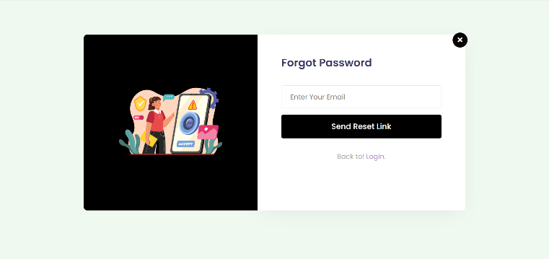

When the user forgets his/her password, the user will enter their email. And in their email, there is a verification link sent for them to add new password.

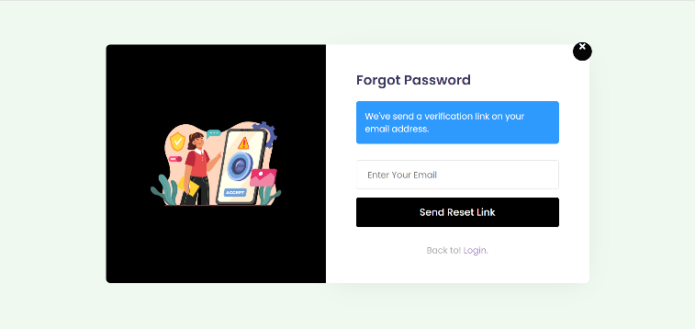

On this page, you will find the student’s dashboard. This allows the student to view the enrolled subjects and their total sessions.

Student can search their desired subject in the search bar and filter hourly rate to their desired and availability of budgets.

Students can view the information on the subjects. Student can set desired schedules for his/her availability time. It will show the session history after the session between the tutor and the student. And it can proceed to the room that automatically generated the room ID after they enrolled the subject.

This e-wallet section is where the students track their transaction history, billing details, and deposit use their PayPal account.

This is the student’s settings where the student can change and edit their personal information.

In this page, you find the tutors dashboard. This allows the tutor to view and edit his/her profile, and personal information. The tutor can also view assessment and add lesson.

In this section, the tutor can manage to view and add subjects. A tutor can set desired hourly rate, add assessments for the students, and it can proceed to the room by the automated generated room ID.

These sections allow the tutor to add lessons. And set desired hourly rate.

This section is where the tutor can change/edit their profile and information’s.

**Design of Software**

This section shows the diagrams that present the flow of information and process involving the website and its user.

Developers created diagrams using apps diagram and will use this in the future as well (refer to appendices figure 10-12).

For use-case diagram (Student Registration) see this in Figure 4, which explains the students registering in the system after clicking the sign-up button it will require the students email and personal details to register.

For use-case diagram (Tutor Registration) see this in Figure 5, which explains the tutors registering in the system after clicking the sign-up button it will require the tutor’s email, personal details, introductory video which has 1 minute of minimum video and 2 minutes of maximum video, and credentials that will notify the tutor in 72 hours if approved or denied after registering.

For use-case diagram (Student Dashboard) see this in Figure 6, which explains what students can do after logging in. The student will be able to update account, update profile, and set e-wallet. Student will also be able to find tutor in the dashboard through skillset.

For use-case diagram (Tutor Dashboard) see this in Figure 7, which explains what tutors could do after logging in, tutors will not be able to log in if the admin denied the credentials. Tutors will be able to update account, set skillsets, and upload demo video. Tutors will also be able to set topic outline through the form template in the dashboard.

For use-case diagram (Admin Dashboard) see this in Figure 8, which explains what admins can do in the system. Admins will be able to view credentials and will be able to approve or deny the credentials, admins will be able to view the list of users, and admins will also be able to validate payment when tutor or student withdraw funds and validate payment when student has negative feedback about the tutor.

For use-case diagram (Class Session) see this in Figure 9, which explains what will be done in class session. If the tutor and student matched, the tutor will be able to set schedule of the class session, the student will be able to view the schedule in the room, and when the class session starts student and tutor will begin the video conference. After the class session ends student will have feedback and an option to pay or not, and if the student’s feedback is negative and decide to not pay, the feedback will be directed to admin to validate whether it is valid or not.

For activity diagram see this in Figure 10, which explains the flow of the system when student and tutor will log in in the system.

For class diagram see this in Figure 11, which explains what classes will be in the system. Under role is users who will be able to log in the system which are admin, tutor, and student. And under tutor and student will have a room class where video conference is done.

For database diagram see this in Figure 12, which explains what database will be stored in, which are users, details of each user, requirements details, and room details.

**Development and Testing**

**Registration as Student Test Case**

|  |  |  |  |  |
| --- | --- | --- | --- | --- |
| **Test Case** | **Test Steps** | **Expected Result** | **Actual Result** | **Remarks** |
| Registration as Student functionality with correct credentials. | 1. Click Register as Student. 2. Enter First Name: <First Name> 3. Enter Last Name: < Last Name> 4. Enter Email: < Email > 5. Enter Password: < Password > 6. Enter Mobile Number: <Mobile Number> 7. Click choose file uploading valid ID. 8. Checked Terms and Conditions. 9. Click on Register. | 1. User navigates to a student registration form. 2. User enters the first name. 3. User enters the last name. 4. User enters email. 5. User enters the password. 6. User enters a mobile number. 7. Users upload a valid ID. 8. Verification link Submit in Email. 9. Back to the log-in page. | 1. User navigates to a student registration form. 2. User enters the first name. 3. User enters the last name. 4. User enters email. 5. User enters the password. 6. Users enter a mobile number. 7. Users upload a valid ID 8. Verification link Submit in Email. 9. Back to log in page. | The test was successfully done. |
| **Test Case** | **Scenario** | **Expected Result** | **Actual Result** | **Remarks** |
| Unfilled first name | Unfilled Enter First Name: <First Name> | Alert Message <Please fill out this field> | Alert Message <Please fill out this field> | Must provide the first name to proceed. |
| Unfilled last name | Unfilled Enter Last Name: <Last Name> | Alert Message <Please fill out this field> | Alert Message <Please fill out this field> | Must provide the last name to proceed. |
| Unfilled email | Unfilled Enter Email: < Email > | Alert Message <Please fill out this field> | Alert Message <Please fill out this field> | Must provide an existing email to proceed. |
| Unfilled Mobile Number | Unfilled Enter Mobile No.: < Mobile No.> | Alert Message <Please fill out this field> | Alert Message <Please fill out this field> | Must provide Mobile No. to proceed. |
| Unfilled Password | Unfilled Enter Password: <Password> | Alert Message <Please fill out this field> | Alert Message <Please fill out this field> | Must provide a password to proceed. |
| Not Uploading Valid Id | Not Uploading a valid ID | Alert Message <Please select a file> | Alert Message <Please fill out this field> | Must provide Upload a Valid ID to proceed. |
| Unchecked Terms and Conditions | Unchecked Terms and Conditions. | Alert Message <Please check the box if you want to proceed> | Alert Message <Please check the box if you want to proceed> | Must check the Terms and Conditions to proceed. |

**Registration as Tutor Test Case**

|  |  |  |  |  |
| --- | --- | --- | --- | --- |
| **Test Case** | **Test Steps** | **Expected Result** | **Test Results** | **Remarks** |
| Registration as Tutor functionality with correct credentials. | 1. Click Apply as Tutor on the landing page. 2. Enter First Name: <First Name> 3. Enter Last Name: < Last Name> 4. Enter Email: < Email > 5. Enter Contact Number: < Contact Number > 6. Enter Address: < Address > 7. Click choose file uploading introductory video 8. Click choose file for uploading the diploma 9. Click choose file for uploading the ID 10. Click choose file for uploading the resume 11. Click choose file for uploading academic background. 12. Click choose file for uploading work experience. 13. Click on Submit Application. | 1. User navigates to the tutor registration form. 2. User enters the first name. 3. User enters the last name. 4. User enters email. 5. User enters Contact Number. 6. User enters Address. 7. User uploads the introductory video. 8. User uploads diploma 9. User uploads ID 10. User uploads resume. 11. User uploads file academic background. 12. User upload files work experience. 13. Login page opens. | 1. User navigates to the tutor registration form. 2. User enters the first name. 3. User enters the last name. 4. User enters email. 5. User enters Contact Number. 6. User enters Address. 7. User uploads the introductory video. 8. User uploads diploma 9. User uploads ID 10. User uploads resume. 11. User uploads file academic background. 12. User upload files work experience. 13. Login page opens. | The test was successfully done. |
| **Test Case** | **Scenario** | **Expected Result** | **Actual Result** | **Remarks** |
| Unfilled first name | Unfilled Enter First Name: <First Name> | Alert Message <Please fill out this field>. | Alert Message <Please fill out this field> | Must provide the first name to proceed. |
| Unfilled last name | Unfilled Enter Last Name: <Last Name> | Alert Message <Please fill out this field> | Alert Message <Please fill out this field> | Must provide the last name to proceed. |
| Unfilled Email | Unfilled Email: <Email> | Alert Message <Please fill out this field> | Alert Message <Please fill out this field> | Must provide an existing email to proceed. |
| Unfilled Contact Number | Unfilled Contact Number: <Contact Number> | Alert Message <Please fill out this field> | Alert Message <Please fill out this field> | Must provide the contact number to proceed. |
| Unfilled Address | Unfilled Address: <Address> | Alert Message <Please fill out this field> | Alert Message <Please fill out this field> | Must provide the address to proceed. |
| The user does not Upload an Introductory Video | Not Upload introductory video | Alert Message <Please Select a file> | Alert Message <Please Select a file> | Must provide to upload the introductory video file to proceed. |
| The user does not Upload an ID | Not Upload ID | Alert Message <Please Select a file> | Alert Message <Please Select a file> | Must provide to upload ID to proceed. |
| The user does not Upload a Diploma | Not uploading the Diploma | Alert Message <Please Select a file> | Alert Message <Please Select a file> | Must provide to upload Diploma to proceed. |
| The user does not Upload a Resume | Not uploading resume | Alert Message <Please Select a file> | Alert Message <Please Select a file> | Must provide to upload resume. |
| The user does not Upload Academic Background | Not Upload Academic Background. | Alert Message <Please Select a file> | Alert Message <Please Select a file> | Must provide to upload academic background. |
| The user does not Upload Work Experience | Not Upload Work Experience | Alert Message <Please Select a file> | Alert Message <Please Select a file> | Must provide to upload work experience. |
| Unchecked Terms and Conditions | Unchecked Terms and Conditions. | Alert Message <Please check the box if you want to proceed> | Alert Message <Please check the box if you want to proceed> | Must check the Terms and Conditions to proceed. |

**Log in as Student and Tutor Test Case**

|  |  |  |  |  |
| --- | --- | --- | --- | --- |
| **Test Case** | **Test Steps** | **Expected Result** | **Actual Result** | **Remarks** |
| Login with the correct information. | 1. Click Login on the landing page. 2. Enter Email: < Email > 3. Enter Password: < Password > 4. Click on Login. | 1. User navigates to Login Page. 2. User enters email. 3. User enters a password. 4. Student and tutor home page opens. | 1. User navigates to Login Page. 2. User enters email. 3. User enters a password. 4. Student and tutor home page opens. | The test was successfully done. |
| Enter with incorrect email and password. | 1. Enter Incorrect Email: < Email > 2. Enter Incorrect Password: <Password> 3. Click on Login. | Alert message display <Email or password does not match> | Alert message display <Email or password does not match> | Must enter the correct registered email. |
| Login when not all the fields are not filled. | 1. Not Provide Email. 2. Not Providing a Password | Alert Message Display <Please fill out this field> | Alert Message Display <Please fill out this field> | The user must fill in both the email and password. |
| Login with an unverified email. | 1. Enter Unverified Email: < Email > 2. Enter Password: < Password > 3. Click on Login. | Alert Message Display <First Verify your account and try again> | Alert Message Display <Please fill out this field> | Students and tutors must click the message sent to their email by the admin for them to verify. |
| Forgot Password | 1. Click forgot Password. 2. Enter Email: <Email> 3. Click the reset link button. 4. Check your Email for the link. 5. Change the Password 6. Enter New Password: <Password> 7. Enter your confirm password: <Confirm Password | Can reset the password by clicking the reset link button. | Can reset the password by clicking the reset link button. | Users must click the message sent to their email by the admin for them to reset their password. |
| Change password do not match | 1. Enter Password: <Password> 2. Enter unmatched confirm password: <Confirm Password> | Alert Message Display <Password and Confirm Password does not match> | Alert Message Display <Password and Confirm Password does not match> | Must enter the same password. |

**Student Dashboard**

|  |  |  |  |  |
| --- | --- | --- | --- | --- |
| **Test Case** | **Scenario** | **Expected Result** | **Actual Result** | **Remarks** |
| Search for Subject | Click the icon to search. | It will display information such as the subject offer of tutor and filter by hourly rate | It will display information such as the subject offer of tutor and filter by hourly rate | This test was a success |
| Enroll Subject | Click the Enroll of the subjects  Click <OK> to proceed | Alert Message <Do You Want to Enroll>  Alert Message <Successfully Enrolled> | Alert Message <Do You Want to Enroll>  Alert Message <Successfully Enrolled> | The Enroll works smoothly |
| View Subject | Click the icon for Viewing Subject | It will display information about the subjects enrolled | It will display information about the subjects enrolled | This test was a success |
| View Assessment | Click the view button of the assessment | It will display information for take and result assessments given by the tutor | It will display information for take and result assessments given by the tutor | The take assessment works smoothly |
| Start Assessment | Click the start button for taking the assessment | It will display the assessment through answer essay or send a file | It will display the assessment through answer essay or send a file | The test was a success |
| Set Schedule | Click the Set button for setting the schedule and submit | It will show the dialog box for setting the schedule (Date and Time)  It will show an alert message <Successfully added assessment> | It will show the dialog box for setting the schedule (Date and Time)  It will show an alert message <Successfully added assessment> | The setting scheduled works smoothly |
| View Session History | Click the view button for the session history | It will display the session history from tutor names, times started the session, the hourly rate, and the total the payment | It will display the session history from tutor names, times started the session, the hourly rate, and the total the payment | The test was a successful |
| Payment | Click Payment button | Display the message if they want to pay this exact amount  Alert Message <Successful Pay> | Display the message if they want to pay this exact amount  Alert Message <Successful Pay> | The test was a successful |
| Room for student | Click <Go to Room>  Click <share> for screen shares  Click <Join Stream> | It will display a Message that can join in room  Alert Message <Starts for Recording> | It will display a Message that can join in room  Alert Message <Starts for Recording> | The Room works smoothly |
| End Session | Click the end-call button  Click stop sharing | Alert message <Recorded Saved>  Alert Message  <recorded videos send to admin> | Alert message <Recorded Saved>  Alert Message  <recorded videos send to admin> | The End session works smoothly |
| E-Wallet | Click the icon of the E-Wallet | It will display information about deposit and transaction history | It will display information about deposit and transaction history | The test was a successful |
| Deposit | Click deposit button  Enter the amount to deposit  Login PayPal Account | It will display PayPal information | It will display PayPal information | The Deposit works smoothly |

**Tutor Dashboard**

|  |  |  |  |  |
| --- | --- | --- | --- | --- |
| **Test Case** | **Scenario** | **Expected Result** | **Actual Result** | **Remarks** |
| View Subject | Click the icon for Viewing Subject | It will display information about the subjects | It will display information about the subjects | This test was a success |
| View Enrolled Student | Click the view button of the enrolled student | It will display information about the enrolled student, schedule, assessment, and room | It will display information about the enrolled student, schedule, assessment, and room | The test was a success |
| View Assessment | Click the view button for the assessment | It will display the assessment  It can view the answer of students and it can delete the assessment | It will display the assessment  It can view the answer of students and it can delete the assessment | The test was a success |
| Add Assessment | Click the Add Assessment button  Choose A File  Submit the Assessment | It will display the assessment by creating questions for essays.  It can send a file if is a task performance/Activities  It will show an alert message < Successfully added Assessment> | It will display the assessment by creating questions for essays.  It can send a file if is a task performance/Activities  It will show an alert message < Successfully added Assessment> | The test was a success |
| Add Subject | Click add subject  Click submit button | It will display the information for creating a subject, setting the desired rate, adding lesson descriptions, and choosing a file for the lessons or course outline  It will show an alert message after submitting <Success> | It will display the information for creating a subject, setting the desired rate, adding lesson descriptions, and choosing a file for the lessons or course outline  It will show an alert message after submitting <Success> | The test was a successful |
| Room for tutor | Click <Go to Room>  Copy the room ID and paste it into the blank filled  Click <Join Room>  Click <share> for the screenshare  Click start, stop, and reset for the tutor rating. | It will display the information of the Join Stream  Matched for the students  It will use the screen share  It will use the start, stop, and reset for the time. | It will display the information of the Join Stream  Matched for the students  It will use the screen share  It will use the start, stop, and reset for the time. | The test was a successful |

**Admin Dashboard**

|  |  |  |  |  |
| --- | --- | --- | --- | --- |
| **Test Case** | **Scenario** | **Expected Result** | **Actual Result** | **Remarks** |
| Enrolled Student | Click the enrolled student button | It will display information about Students, Subjects, Tutors, and Hourly Rate | It will display information about Students, Subjects, Tutors, and Hourly Rate | This test was a success |
| Registered Student | Click the registered student button | It will display information about the students | It will display information about the students | This test was a success |
| Subject | Click the subject button | It will display the information of the tutor subject, description, and file | It will display the information of the tutor subject, description, and file | The test was a success |
| Delete Subject | Click delete button | It will delete the subject’s information | It will delete the subject’s information | The Delete works smoothly |
| Pending Tutors | Click the pending tutor’s button | It will display the information on the tutor that submitted the requirements | It will display the information on the tutor that submitted the requirements | The test was a success |
| Approve Tutors | Click approve button | Alert Message <Approve and will be notified> in Email | Alert Message <Approve and will be notified> in Email | The approval works smoothly |
| Decline Tutors | Click Decline button | Alert Message <tutor Decline has been notified> in email | Alert Message <tutor Decline has been notified> in email | The decline works smoothly |
| Approved Tutors | Click the approved tutor’s button | It will display the information of tutors approved. | It will display the information of tutors approved. | The test was a success |
| Notify Payments | Click the Notify Payments Button | It will display information about the tutors and Payment notify | It will display information about the tutors and Payment notify | The test was a success |
| Notify Payments | Click Notify button | Alert Message <Tutor has been paid and notified> in email | Alert Message <Tutor has been paid and notified> in email | The notification works smoothly |
| Recording Session | Click the Recording Session button | It will display the recorded video | It will display the recorded video | The test was a success |

**Description of Prototype**

This section presents the system requirements, initial interface, testing and evaluation methodology, and descriptions of modules.

* **System Requirements**

The published website can run on laptops and personal computers. The required random-access memory (RAM) to access OwlHub is with a minimum of one gigabyte (1GB). To fully access website, the user must have a verified account.

* **Testing and Evaluation Methodology**

When testing and analyzing websites functionality, developers used black box testing and requirements, and specifications are looked at in relation to creating and running test cases. To determine whether the website processes input correctly during the test, legitimate inputs are utilized, and invalid inputs are used to determine whether the website can identify incorrect inputs. On the other side, the test case's expected and actual outputs are then compared.

**Description of Modules**

These are the following modules in the system with their corresponding description.

* **Tutor Registration Module**

This module displays the registration form for the tutor. To apply as a tutor, the applicant must fill in and provide all the information given.

* Graphical user interface, website

  Description automatically generated**Student Registration Modules**

This module displays the registration form for the student. To register as a student, the student must fill in and provide all the information given

* **Tutor Dashboard Module**

This module allows the tutor to view and edit their account by changing profiles, and personal information. Tutor can post their lessons and assessment in the dashboard. Tutors can be able to view their earnings, current balance, subjects, and enrolled students. Tutors can be able to set their desired for the hourly rate.

* Graphical user interface, application

  Description automatically generated**Student Dashboard Module**

This module allows the student to view and edit their profile, and personal information and set up E-Wallet payments. Students can view and set their desired schedule. They can be able to view the subjects, session history, and the E-Wallet transaction history.

* Graphical user interface, text, application

  Description automatically generated**Admin Dashboard Module**

Admin will be able to view the list of users and validate tutors’ credentials such as Resume, Diploma, ID, work experience, academic background, and Introductory Video. Admin can be able to view the subjects. Admin will be able to view and evaluate the recorded session between the tutor and students.

* **Class Session Module**

Video Conferencing module allows tutor and student to virtual contact during one-on-one sessions, that allow them to communicate via audio and video calls. These sessions will record automatically, and it will be uploaded to the system. The admin will review the video recorded of their sessions. The class duration will depend on the discussion and answering of questions during the session.

**Implementation Plan**

The main objective of this project is to develop an online platform which is an online session tutoring web for tutors and students that helps for allowing an online session. Developers start gathering essential information and the needed requirements for the implementation of the Owlhub. Developers then created and conduct an online survey for students. The website's features are subdivided based on the design for a step-by-step implementation to follow to the deadline and allocate tasks to each developer. In the process of coding, Developer uses visual studio code as a source code editor, and in the frontend development HTML and Tailwind CSS are used and organizes the content of the system, and in the backend, development PHP has been used, which interacts with databases to retrieve, store, and modify the information. Developers use phpMyAdmin for the management of the database. Developers use Agora for Video Conferencing for the sessions. Developers used Hostinger as a host for the website and developers used the GitHub student developer pack to use the free domains for the website.

**Implementation Result**

The results general during implementation were based on the implementation plan. During the early stages of research, the developers are able to gather the information through the online survey that can help to implement the OwlHub based on the needed requirements. During coding practices, developers can learn the basics of Tailwind CSS, which became the foundation to continuously expand knowledge for the website to be developed in its entirety. Developers organize the content of the system for development in the XAMPP server and phpMyAdmin can manage the database in the back end. Developers learn the basics of Agora that can be used in video conferencing for the sessions. Developers successfully used the Hostinger as host of the websites created by the student developers that use the free domains for the website OwlHub.

# **CONCLUSIONS AND RECOMMENDATIONS**

## Conclusion

OwlHub is an online tutoring web services for those who want to apply as tutors and have completed their college degree, and for students who want to learn from the comfort of their home. Due to the rapid increase of corona virus victim and the strictions of the government on face-to-face class, students who are looking for tutors prefer online learning because it is fast, efficient to find tutors, and health risk free. In conclusion, is built to replace the traditional way of tutoring. Transitioning to a new normal in adapting of online education, Owlhub makes it easier for tutor and students to have a one-on-one session where they no longer need to use third party apps for their online session. Owlhub has a fast-paying method, a user-friendly system, and has a legitimate professional who will guide and teach every student to meet their needs.

## Recommendations

The developers of this project proposal should recommend the system to improve for the next IT Capstone to innovate and improve the system done by the developers. The developers would like to recommend the following:

1. Adding more information about the proposed project.
2. Make the proposal projects improve and innovative more for developing the system.
3. Improve some of the parts of the modules in the systems development.
4. Use Framework to make the development faster.
5. Use Chat API to allow fast automation sending of sending and receiving message.
6. Find more references for the documentations.
7. Analyze and Improve the Documents done by the developers.

# **Appendices**

*Figure 1*

*Figure 2*

Figure 3

Figure 4 Student Registration Module

Figure 5 Tutor Registration Module

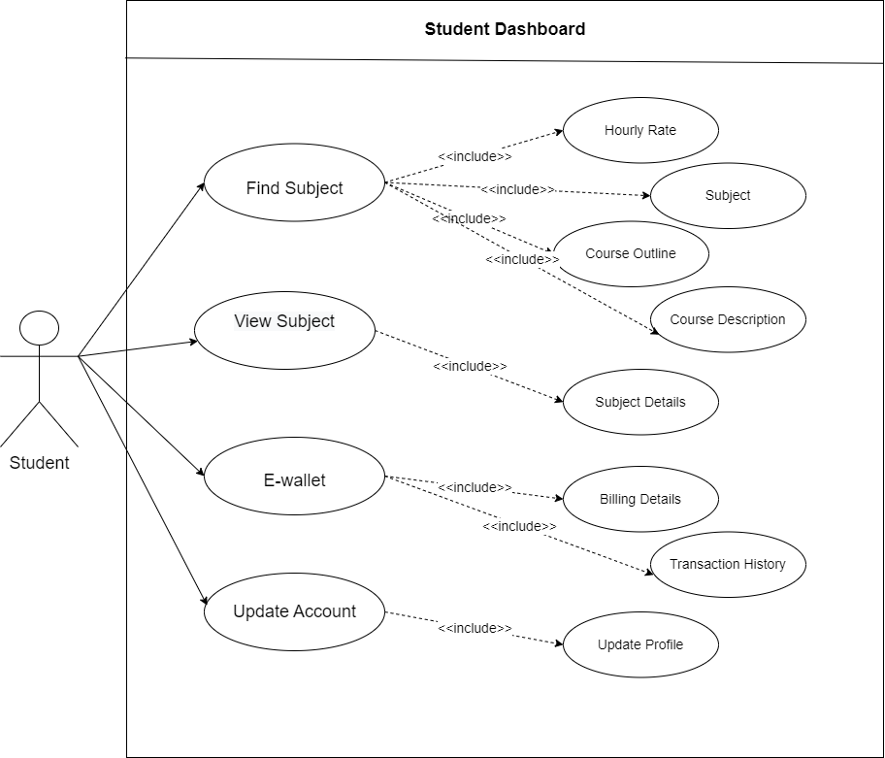

Figure 6 Student Dashboard Module

Figure 7 Tutor Dashboard Module



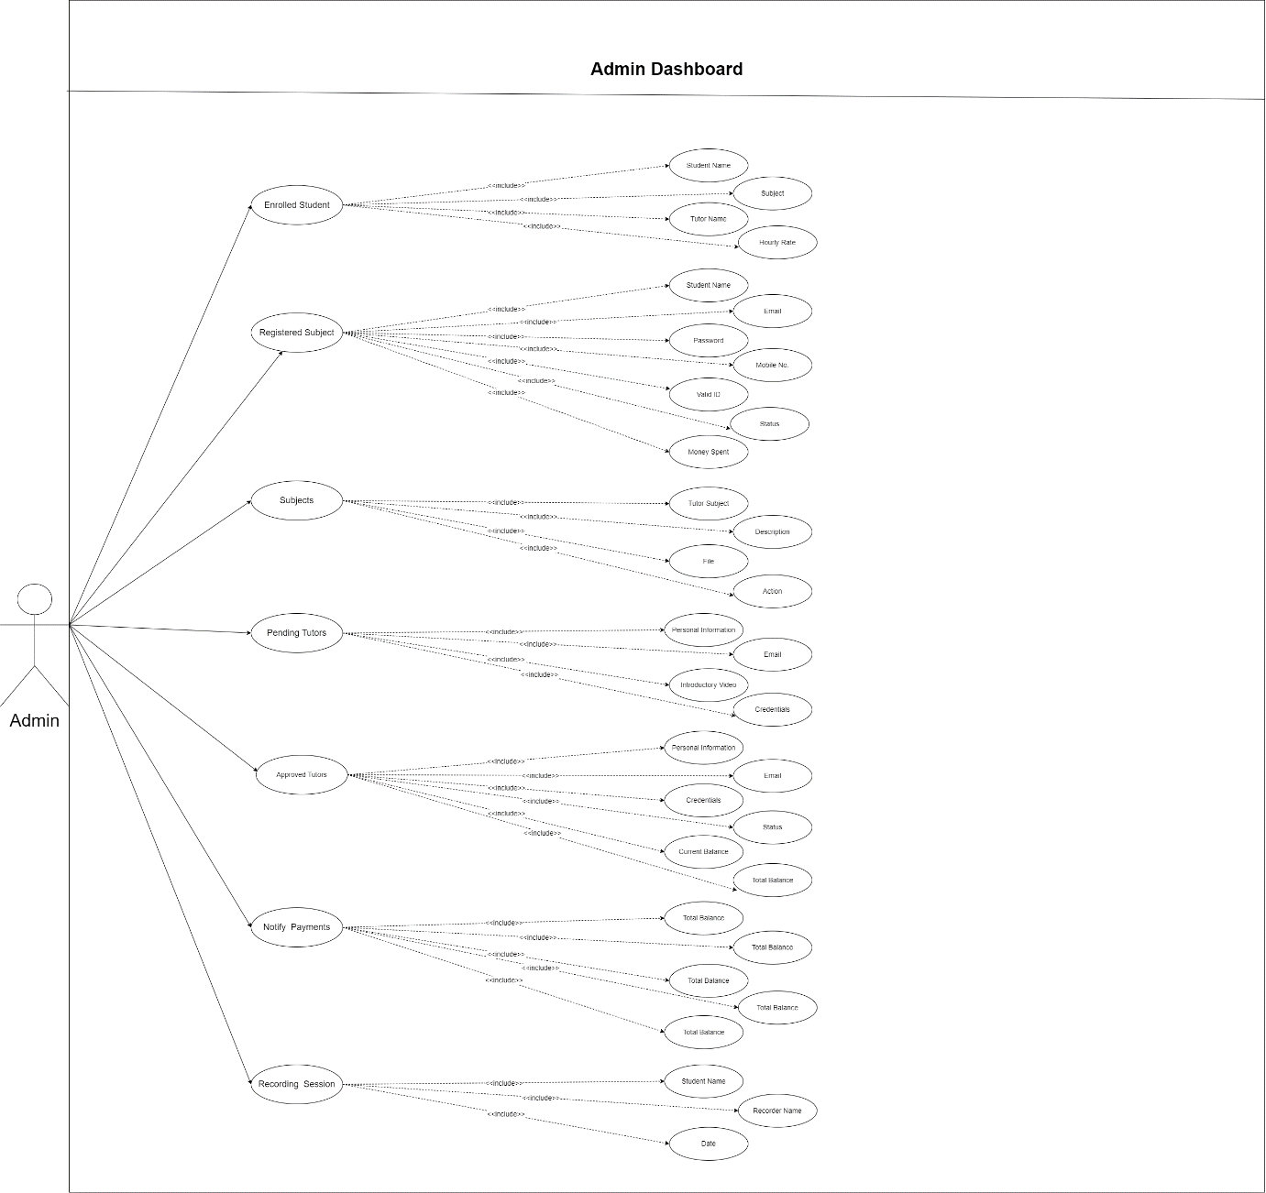

Figure 8 Admin Dashboard Module

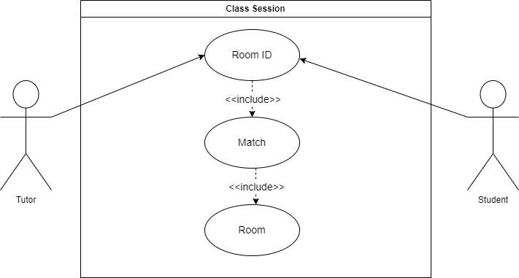

Figure 9 Class Session Module

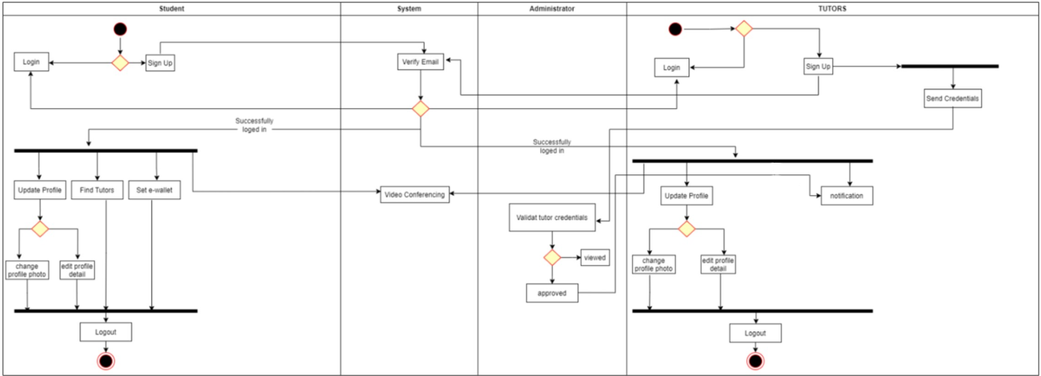

Figure 10 Activity Diagram.

Figure 11 Class Diagram.

Figure 12 Database Diagram.

|  |  |  |  |  |  |  |  |  |  |  |  |  |  |  |
| --- | --- | --- | --- | --- | --- | --- | --- | --- | --- | --- | --- | --- | --- | --- |
| **MONTH ACTIVITY** | **April** | | | | | **May** | | | | | **June** | | | |
| Requirements Gathering |  |  | |  |  |  |  | |  |  |  |  |  |  |
| Introduction |  | |  |  |  |  | |  |  |  |  |  |  |  |
| Purpose & Description |  | |  |  |  |  | |  |  |  |  |  |  |  |
| Objective of the study |  | |  |  |  |  | |  |  |  |  |  |  |  |
| Scope & Limitation |  | |  |  |  |  | |  |  |  |  |  |  |  |
| Review of Related Literature |  | |  |  |  |  | |  |  |  |  |  |  |  |
| Synthesis |  | |  |  |  |  | |  |  |  |  |  |  |  |
| Technical Background |  | |  |  |  |  | |  |  |  |  |  |  |  |
| Overview of Current Technologies Used in the Current System |  | |  |  |  |  | |  |  |  |  |  |  |  |
| Resources |  | |  |  |  |  | |  |  |  |  |  |  |  |
| Appendix |  | |  |  |  |  | |  |  |  |  |  |  |  |
| Requirements Analysis |  | |  |  |  |  | |  |  |  |  |  |  |  |
| Prototype |  | |  |  |  |  | |  |  |  |  |  |  |  |
| Reference |  | |  |  |  |  | |  |  |  |  |  |  |  |

**Planning Completed**

Figure 22 Gantt Chart 1.

|  |  |  |  |  |  |  |  |  |  |  |  |  |  |  |  |  |  |  |  |  |  |  |  |  |  |  |  |  |  |  |  |  |  |  |  |  |  |
| --- | --- | --- | --- | --- | --- | --- | --- | --- | --- | --- | --- | --- | --- | --- | --- | --- | --- | --- | --- | --- | --- | --- | --- | --- | --- | --- | --- | --- | --- | --- | --- | --- | --- | --- | --- | --- | --- |
| MONTH | May | | | | June | | | | July | | | | August | | | | September | | | | October | | | | November | | | | December | | | | January | | | | |
| Activity |  | | | |  | | | |  | | | |  | | | |  | | | |  | | | |  | | | |  | | | |  | | | | |
|  |  |  |  |  | 1 | 2 | 3 | 4 | 1 | 2 | 3 | 4 | 1 | 2 | 3 | 4 | 1 | 2 | 3 | 4 | 1 | 2 | 3 | 4 | 1 | 2 | 3 | 4 | 1 | 2 | 3 | 4 | 1 | 2 | 3 | 4 |
| Requirement  gathering |  |  |  |  |  |  |  |  |  |  |  |  |  |  |  |  |  |  |  |  |  |  |  |  |  |  |  |  |  |  |  |  |  |  |  |  |
| Analysis |  |  |  |  |  |  |  |  |  |  |  |  |  |  |  |  |  |  |  |  |  |  |  |  |  |  |  |  |  |  |  |  |  |  |  |  |
| Design |  |  |  |  |  |  |  |  |  |  |  |  |  |  |  |  |  |  |  |  |  |  |  |  |  |  |  |  |  |  |  |  |  |  |  |  |
| Coding |  |  |  |  |  |  |  |  |  |  |  |  |  |  |  |  |  |  |  |  |  |  |  |  |  |  |  |  |  |  |  |  |  |  |  |  |
| Testing |  |  |  |  |  |  |  |  |  |  |  |  |  |  |  |  |  |  |  |  |  |  |  |  |  |  |  |  |  |  |  |  |  |  |  |  |
| Implementation |  |  |  |  |  |  |  |  |  |  |  |  |  |  |  |  |  |  |  |  |  |  |  |  |  |  |  |  |  |  |  |  |  |  |  |  |
| Feedback |  |  |  |  |  |  |  |  |  |  |  |  |  |  |  |  |  |  |  |  |  |  |  |  |  |  |  |  |  |  |  |  |  |  |  |  |

**Planning Completed Revision**

Figure 23 Gantt Chart

# **REFERENCES**

Carter, P. (2013). Comparison of the Effectiveness of Online Tutoring to Traditional Tutoring | Patricia Carter - Academia.edu. www.academia.edu. Retrieved June 29, 2022, from <https://www.academia.edu/8423364/Comparison_of_the_Effectiveness_of_Online_Tutoring_to_Traditional_Tutoring>

Dimitrios, B., Labros, S., Nikolaos, K., Koutiva, M., & Athanasios, K. (2013). Traditional teaching methods vs. teaching through the application of information and communication technologies in the accounting field: Quo Vadis?. *European Scientific Journal*, *9*(28).

Labrie, A., Mok, T., Tang, A., Lui, M., Oehlberg, L., & Poretski, L. (January 2022). Toward Video-Conferencing Tools for Hands-On Activities in Online Teaching. Proceedings of the ACM on Human-Computer Interaction, 6, 1-22. doi:https://doi.org/10.1145/3492829

VocoVision. (2020, July 9). WHY TUTORING IS IMPORTANT & BENEFITS OF ONLINE TUTORING. <https://www.vocovision.com/blog/why-tutoring-is-important-and-the-benefits-of-online-tutoring/>

Wongwangkit, C. (2019). An Online Web-based Adaptive Tutoring System for University Exit Exam on IT Literacy. 2019 21st International Conference on Advanced Communication Technology (ICACT). doi:10.23919/ICACT.2019.8701994

Xia, M., Zhao, Y., Erol, M., Hong, J., & Kim, J. (21 March 2022). Understanding Distributed Tutorship in Online Language Tutoring. LAK22: LAK22: 12th International Learning Analytics and Knowledge Conference, 164-174. doi:https://doi.org/10.1145/3506860.3506883

Yusuf, N. (2021). The Effect of Online Tutoring Applications on Student Learning Outcomes during the COVID-19 Pandemic. Retrieved from <http://www.italienisch.nl/index.php/VerlagSauerlander/article/view/100>

## Evaluation Tool/Test Documents

Name (optional): ___________________________________________

Date: ______________________________

**Survey Questionnaire (Students Side)**

Good day! We, the developers of OwlHub, an online one-on-one video conference, would like your participation to improve the functions of our system. Just indicate if a certain condition meets your user experience. Your answer will be treated confidentially and will only be used in educational and testing purposes. Thank you for your time answering this questionnaire.

**Legend:**

**SD –** strongly disagree **U –** uncertain **A –** agree

**D –** disagree **SA –** strongly agree

|  |  |  |  |  |  |
| --- | --- | --- | --- | --- | --- |
| **Condition** | **SD** | **D** | **U** | **A** | **SA** |
| OwlHub is easy to use and navigate. |  |  |  |  |  |
| I created my account with no issues. |  |  |  |  |  |
| I logged in my account with no issues. |  |  |  |  |  |
| I was able to pay in Paypal Application. |  |  |  |  |  |
| I was able to search, view, and filter the subjects. |  |  |  |  |  |
| I can enter the room in video conference with no issues. |  |  |  |  |  |
| E-Wallet can deposit in Paypal account and view the balance of account. |  |  |  |  |  |
| I was able to change my profile information with ease. |  |  |  |  |  |

**Final Thoughts:**

**____________________________________________________________________________________________________________________________________________________________________________________________________________________________________________________________________________________________________________________________________________________________________________________________________________________________________________________________________________________________________________________________________________________________________________________________________________________**

**Evaluation Tool/Test Documents**

Name (optional):­­­­­­­_______________________________________________

Date: __________________________

**Survey Questionnaire (Tutor Side)**

Good day! We, the developers of OwlHub, an online one-on-one video conference, would like your participation to improve the functions of our system. Just indicate if a certain condition meets your user experience. Your answer will be treated confidentially and will only be used in educational and testing purposes. Thank you for your time answering this questionnaire.

**Legend:**

**SD –** strongly disagree **U –** uncertain **A –** agree

**D –** disagree **SA –** strongly agree

|  |  |  |  |  |  |
| --- | --- | --- | --- | --- | --- |
| **Condition** | **SD** | **D** | **U** | **A** | **SA** |
| OwlHub is easy to use and navigate. |  |  |  |  |  |
| I created my account with no issues. |  |  |  |  |  |
| I logged in my account with no issues. |  |  |  |  |  |
| I can create and view an assessment with no issues |  |  |  |  |  |
| I can create and view a lesson with no issues |  |  |  |  |  |
| I can join the video conference with no errors or issues. |  |  |  |  |  |
| I was able to change my profile information with ease. |  |  |  |  |  |

**Final Thoughts:**

_________________________________________________________________________________________________________________________________________________________________________________________________________________________________________________________________________________________________________________________________________________________________________________________________________________________________________________________________

**Evaluation Tool/Test Documents**

Name (optional):­­­­­­­_______________________________________________

Date: __________________________

**Survey Questionnaire (Admin Side)**

Good day! We, the developers of OwlHub, an online one-on-one video conference, would like your participation to improve the functions of our system. Just indicate if a certain condition meets your user experience. Your answer will be treated confidentially and will only be used in educational and testing purposes. Thank you for your time answering this questionnaire.

**Legend:**

**SD –** strongly disagree **U –** uncertain **A –** agree

**D –** disagree **SA –** strongly agree

|  |  |  |  |  |  |
| --- | --- | --- | --- | --- | --- |
| **Condition** | **SD** | **D** | **U** | **A** | **SA** |
| OwlHub is easy to use and navigate. |  |  |  |  |  |
| I logged in my account with no issues. |  |  |  |  |  |
| I can view the enrolled student in the subjects with no issues. |  |  |  |  |  |
| I can view the information of the registered student with no issues |  |  |  |  |  |
| I can view the information on the subjects |  |  |  |  |  |
| I can approve and decline the applying tutor’s ease. |  |  |  |  |  |
| I can view the information of the approved tutors with no issues. |  |  |  |  |  |
| I can notify the tutor for their payday with no issues. |  |  |  |  |  |
| I can be able to view the recorded session of the student and tutor. |  |  |  |  |  |

**Final Thoughts:**

_________________________________________________________________________________________________________________________________________________________________________________________________________________________________________________________________________________________________________________________________________________________________________________________________________________________________________________________________

**Sample Input/Output/Reports**

* **Registration of Student and Tutor**

* **Login Student and Tutor**

* **Student Input and Output**
  + **Dashboard**

* + Graphical user interface, application

    Description automatically generated**Search**
  + **Enrolled**

* + **View Subject**

* + 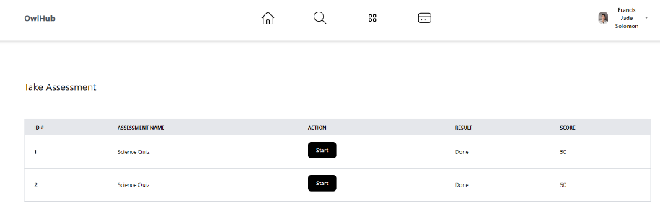**View and Take Assessments**

* + **Set Schedule**

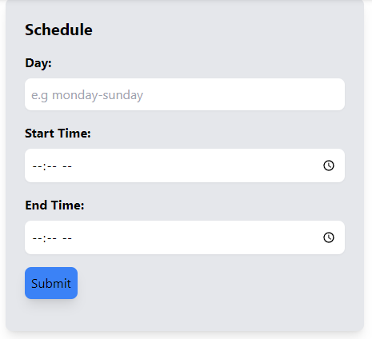

* + 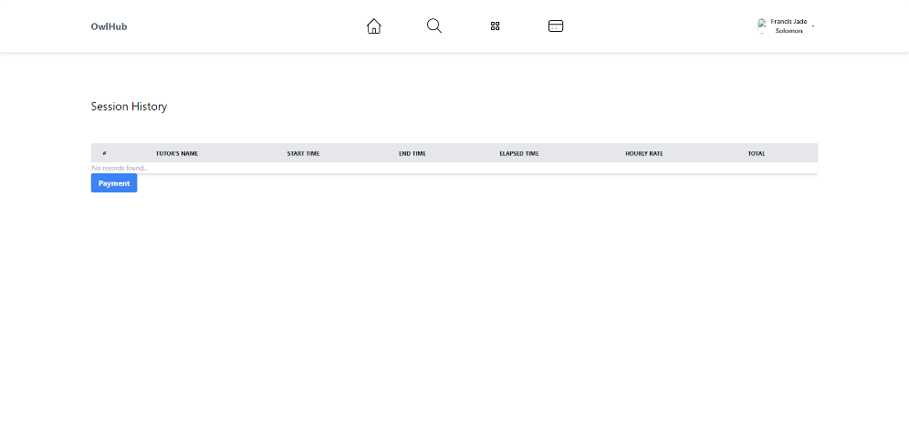**Session History**
  + **Payment**

* + 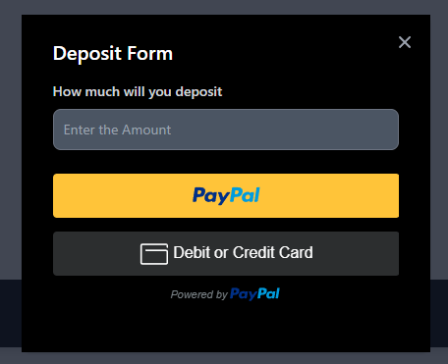**E-Wallet Deposit**
  + **Transaction History**

* **Tutor Input and Output**
  + **Dashboard**

* + **View Subject**

* + **View Enrolled Students**

* + **View and Add Assessment**

* + **Add Subject**

* **Session**
  + Graphical user interface, text, application

    Description automatically generated**Room for Student**
  + **Room for Tutor**

* + **Video Conference**

