Name: Andre Dan Dayaganon Course/Section: BSIT-601

Subject: Web Systems & Technology

EMAIL REGISTRATION FORM

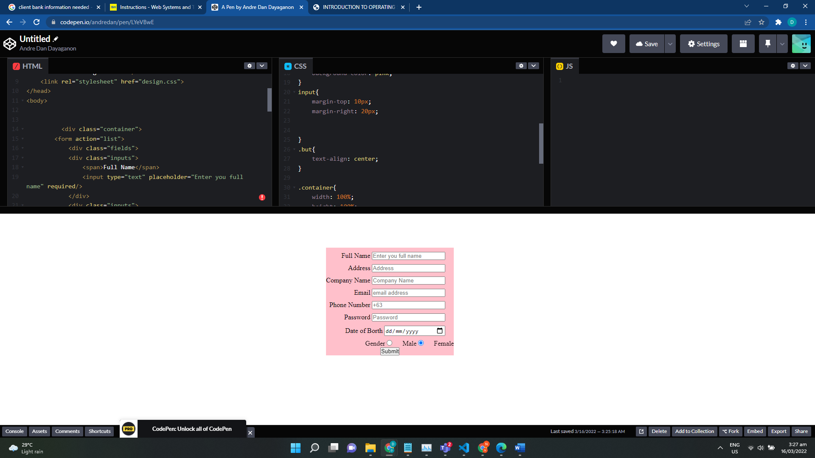

TABLE CLASS SCHEDULE