Integration of Interpretable Machine Learning and JULES-crop systems facilitates the understanding of variable importance and interactions

Amauri Cassio Prudente Juniorª, Roberto Fray da Silvaª, Fabio R. Marin^{a,b}, Danilo Augusto Sartiª
ª University of São Paulo - “Luiz de Queiroz” College of Agriculture, Piracicaba, São Paulo, Brazil
^{b} Center for Carbon Research in Tropical Agriculture (CCARBON), University of São Paulo, Piracicaba, São Paulo, Brazil

Abstract
Process-based models such as JULES-crop simulate crop development with mechanistic fidelity, but their many inputs and strong non-linearities make it difficult to identify which factors dominate the simulated outputs. The main objective of this work was to couple a multi-output feedforward neural network with the VIVID framework to emulate JULES-crop and expose the structure of its predictions, presenting as variable importance and pairwise interactions. Using daily JULES-crop maize simulations previously calibrated for Brazilian conditions (three sites and six growing seasons, 2014–2020; 747 daily records from nine site–cultivar–season–water-regime cycles), we trained a network with three hidden layers (256, 128 and 64 neurons) to approximate grain (GDM), leaf (LDM) and shoot (SDM) dry matter from phenological and agroclimatic predictors. It was selected as predictor: accumulated thermal time, mean and maximum air temperature, incoming and diffuse solar radiation, specific humidity, cultivar, site and water regime. Model-agnostic importance and interaction measures obtained with VIVID were summarized as heatmaps and interaction networks to improve results interpretation. Once the crop's developmental axis (accumulated thermal time) was included as a predictor, the emulator reproduced the three outputs with high precision on held-out data (test R² = 0.96, 0.93 and 0.89, and RMSE = 0.45, 0.62 and 0.41 t ha⁻¹ for SDM, GDM and LDM, respectively). Across the three outputs, accumulated thermal time was the dominant driver, followed by cultivar and site, with solar radiation and air temperature contributing secondarily. The strongest interactions coupled thermal time with cultivar and with site, indicating that genotype- and location-specific responses unfold along the developmental trajectory. Coupling neural networks with model-agnostic interpretability offers a scalable route to sensitivity analysis, mechanistic-model auditing, and support for breeding and climate-planning programs.
Keywords: Process-based models; Maize crop; Neural networks

1. Introduction

Maize (Zea mays L.) is central to global food security and to Brazilian agriculture. Brazil is currently the third-largest producer and the leading exporter worldwide, with output close to 116 million tonnes in the 2023/2024 season, of which roughly 80% is harvested in the so-called second season ("safrinha"), grown in succession to soybean (Souza et al., 2019; Prudente Junior et al., 2024; Antolin et al., 2025; Dias et al., 2025). The combination of the crop's economic relevance, the strong climatic dependence of the safrinha — sown when rainfall declines and temperatures rise — and the projected warming and shifting precipitation patterns over the coming decades make a quantitative understanding of how maize responds to environmental and management drivers a strategic research priority (Souza et al., 2019; Marin et al., 2022; Dias et al., 2025).
Process-based crop models have long been used for representing this response in mechanistic terms. In Brazil, models such as CERES-Maize, Hybrid-Maize and, more recently, JULES-crop have been applied to simulate maize growth, development and yield under contrasting management, soil and climate conditions (Souza et al., 2019; Prudente Junior et al., 2022, 2024; Antolin et al., 2025; Dias et al., 2025). JULES-crop is particularly attractive because it embeds an annual-crop parameterisation within the Joint UK Land Environment Simulator, thereby coupling the carbon, water and energy fluxes between the biosphere and the atmosphere with crop-specific phenology and carbon allocation (Osborne et al., 2015; Williams et al., 2017). Once calibrated for Brazilian genotypes and environments, JULES-crop reproduces leaf area index, canopy height, above-ground biomass and grain yield with acceptable accuracy across the country's main producing regions, supporting its use for large-scale assessments organized around homogeneous climate zones (Prudente Junior et al., 2022, 2024; Gasparotto et al., 2024).
Despite their descriptive power, process-based models share a practical limitation: the multiplicity of inputs — genotype, climate, soil, management — and the nonlinear ways in which they interact make it difficult to identify which factors actually dominate the variation of model outputs and in which combinations. Variance-based global sensitivity analyses, such as those derived from Sobol' indices (Sobol', 1993), often coupled with Morris-type screening (Confalonieri et al., 2013; Specka et al., 2015), are standard tools for this task. However, they tend to focus on internal model parameters rather than on the management and environmental variables that matter to end users. They are also computationally demanding, particularly for land-surface models such as JULES, which motivates the use of statistical emulators.
Against this background, interpretable machine-learning (IML) techniques have emerged as a valuable complementary approach. Neural networks, random forest and gradient-boosting models can approximate the response surfaces of process-based models with high precision at a fraction of the computational cost, acting as emulators or meta-models (Shahhosseini et al., 2021; Han et al., 2025). When combined with post-hoc tools such as SHAP (Lundberg & Lee, 2017), Sobol decompositions or Friedman's H-statistic, they enable predictions to be decomposed into contributions of individual variables and pairwise interactions, exposing patterns that drive the model´s behavior (Inglis et al., 2024; Smith et al., 2026). Recent applications have shown that this strategy recovers, for U.S. maize, the well-known dominance of radiation, temperature and precipitation over interannual yield variability (Smith et al., 2026). Additionally at regional scales, it identifies hybrid breeding value and key hydro-radiative variables as the leading predictors of maize yield in mixed genotype–environment trials (Jeong et al., 2016; Khaki & Wang, 2019).
In Brazil, initial efforts in this direction have combined JULES-crop (Joint UK Land Environment Simulator, Best et al., 2011) outputs with agrometeorological indicators in multiple linear regressions to forecast safrinha yield, showing that the joint use of mechanistic outputs and climatic variables substantially reduces prediction error along the cycle, particularly from the grain-filling stage onwards (Prudente Junior et al., 2024). Nonetheless, the tools used so far — stepwise regression and marginal variable importance from linear models — capture only part of the nonlinearities and little of the higher-order interactions known to matter for maize, such as those between genotype, year and water regime (Souza et al., 2019; Antolin et al., 2025; Dias et al., 2025).
To bridge this gap, we integrate a multi-output deep neural network with the VIVID framework (Inglis et al., 2024), which provides model-agnostic measures of variable importance and pairwise interaction and organizes them into heatmaps and interaction networks. The network jointly approximates the response surfaces of shoot (SDM), leaf (LDM) and grain (GDM) dry matter simulated by JULES-crop as functions of phenological and agroclimatic predictors — accumulated thermal time, air temperature, solar radiation and specific humidity — together with categorical descriptors of genotype, site and water regime (cultivar, county and treatment). VIVID then yields a quantitative, model-agnostic readout of which predictors and which predictor pairs shape each prediction output.
This approach is meant to complement, not replace, the process-based model. Rather than treating JULES-crop as a black box, we explored to make explicit what best explains the model´s outputs, opening up possibilities for model benchmarking, sensitivity analysis and scenario exploration at a much lower computational cost than running hundreds of mechanistic simulations. The resulting insights are directly relevant to breeding programmes, climate-impact assessment and precision agriculture (Antolin et al., 2025; Gasparotto et al., 2024; Smith et al., 2026).
The remainder of the paper is organised as follows. Section 2 describes the JULES-crop simulation data, the neural network architecture and the VIVID procedure. Section 3 presents the model-fitting results and the variable-importance and interaction analyses for sdm, ldm and gdm. Section 4 discusses the implications for agroclimatic modelling and potential applications. Section 5 concludes and outlines directions for future research.

2 Methods
The methodology is divided into three main components: (i) the generation of a synthetic dataset from the JULES-crop model calibrated for maize; (ii) training of a multi-output feedforward deep neural network as a statistical emulator of JULES-crop able to predict GDM, LDM and SDM from phenological and agroclimatic predictors (accumulated thermal time, air temperature, solar radiation and specific humidity), together with categorical descriptors (cultivar, site and water regime); and (iii) the application of the VIVID framework, which decomposes the emulator's predictions into main effects and bivariate interactions, synthesized into symmetric matrices subsequently represented as heatmaps and interaction networks. The sequence is detailed in the following order: JULES-crop model structure (2.1), simulation setup (2.2), problem formulation (2.3), data normalization and encoding (2.4), neural network architecture (2.5), loss function and optimization (2.6), model capacity and regularization (2.7), prediction and inverse transformation (2.8), variable importance and interaction analysis (2.9) and visual representation of variable effects (2.10).

2.1 JULES-crop model structure
The Joint UK Land Environment Simulator with crop parametrization (JULES-crop) is a process-based land-surface model that simulates crop growth under varying environmental conditions. Crop development in JULES-crop is represented by a development index (DVI), which varies continuously from $-2$ (before sowing) to $2$ (harvest). DVI progression is driven by accumulated thermal time and photoperiod sensitivity.
The effective temperature ($T_{\text{eff}}$), or thermal time, is calculated as (Osborne et al., 2015) (Equation 1):
$T_{\text{eff}}=\frac{(T_{\text{m}}-T_{\text{b}})(T_{\text{o}}-T_{\text{b}})}{(T_{\text{o}}-T_{\text{b}})+(T_{\text{m}}-T_{\text{o}})}$ (1)

where $T_{\text{m}}$ is the mean daily temperature, $T_{\text{o}}$ is the optimal temperature for growth, and $T_{\text{b}}$ is the base temperature below which development does not progress.
The photoperiod response is incorporated using a relative photoperiod effect (RPE) as demonstrated by Conor and Loomis (1992) (Equation 2):
$\text{RPE}=max\left[0,min\left(1,1-P_{\text{sens}}⋅(P_{\text{crit}}-P)\right)\right]$ (2)
where $P$ is the day length, $P_{\text{crit}}$ is the critical photoperiod, and $P_{\text{sens}}$ is the photoperiod sensitivity parameter.
The rate of DVI progression ($r_{\text{DVI}}$) is then expressed in the Equation 3:
$r_{\text{DVI}}=\frac{1}{TT_{\text{veg}}}⋅T_{\text{eff}}⋅\text{RPE}$ (3)
with $TT_{\text{veg}}$ representing the thermal time requirement for the vegetative phase.
JULES-crop allocates assimilated carbon (${\text{NPP}}_{\text{acc}}$) to plant organs (leaf, stem, root, harvestable organs) according to phenology-dependent partitioning functions (Clark et al., 2011) (Equation 4):
pj(DVI)=αjDVI+βji​(αiDVI+βi) (4)
where $p_{j}$ is the partitioning fraction to component $j$, and $α_{j}$, $β_{j}$ are user-calibrated coefficients based on empirical data.
Leaf senescence is triggered when $DVI>DVI_{\text{sen}}=0.4$, and leaf carbon ($C_{\text{leaf}}$) is decreased accordingly Equation 5:
$\frac{ dC_{\text{leaf}}}{dt}=-νC_{\text{leaf}} \text{if} DVI>0.4$ (5)
where $ν$ is an allometric coefficient governing the senescence rate.
Specific Leaf Area (SLA) is a function of DVI (Equation 6):
$\text{SLA}(DVI)=δ⋅e^{-γ⋅DVI}$ (6)
where $δ$ and $γ$ are empirical parameters derived from calibration.
Green leaf area index (LAI) is then estimated from SLA and carbon in leaves (Equation 7):
$\text{LAI}=\text{SLA}⋅\frac{C_{\text{leaf}}}{f_{c,\text{leaf}}}$ (7)
with $f_{c,\text{leaf}}$ being the carbon fraction in leaf dry matter.
Plant height ($h$) is derived from stem carbon pool ($C_{\text{stem}}$) (Equation 8):
$h=k⋅{\left(\frac{C_{\text{stem}}}{f_{c,\text{stem}}}\right)}^{λ}$ (8)
where $k$ and $λ$ are allometric constants and $f_{c,\text{stem}}$ is the stem carbon fraction.

2.2 Simulation setup

JULES-crop was calibrated and evaluated for maize across representative Brazilian producing environments using sub-daily meteorological forcing, with dominant soil types and locally grown cultivars, and a leave-one-out cross-validation strategy to ensure robustness (Prudente Junior et al., 2022, 2024). For the present study we used the daily simulation output for three sites (Chapadinha, Piracicaba, and Selvíria) and six growing seasons (Table 1), comprising nine independent cycles with distinct sites, cultivar, season and water-regime, totalizing 747 daily records after pairing each simulated day with its corresponding meteorological drivers.

Table 1: Description of the experimental database utilized to simulate JULES-crop in different regions of Brazil.
site | cultivar | season | water regime
Piracicaba | DKB363 | summer season | irrigated
Piracicaba | P4285YH | off-season | irrigated
Piracicaba | P4285YH | off-season | rainfed
Piracicaba | LG36790 | summer season | rainfed
Chapadinha | AG1051 | summer season | rainfed
Selviria | DKB393 | summer season | rainfed

Outputs included GDM, LDM and SDM, leaf area index, crop height, and water-related variables such as soil water content and the soil moisture stress factor. From the sub-daily meteorological forcing we derived, for each crop day, agroclimatic indicators used here as predictors: mean and maximum air temperature, incoming shortwave and diffuse radiation, and specific humidity. Daily values were accumulated into thermal time (growing-degree days, base temperature 8 °C) as a proxy for the JULES-crop DVI.

2.3 Problem Formulation

Let X denote the design matrix of n observations and p predictors, combining continuous phenological and agroclimatic inputs (accumulated thermal time, mean and maximum air temperature, incoming and diffuse solar radiation, specific humidity) with categorical descriptors (cultivar, site and water regime). Let Y be the matrix of response variables, representing the simulated values of shoot (sdm), leaf (ldm) and grain (gdm) dry matter from the JULES-crop model. Each daily record is treated as one observation, so that the developmental trajectory of every cycle is represented explicitly along the thermal-time axis.
The objective is to approximate a nonlinear function $f:R^{p}→R^{3}$ such that the equation 9
$Y≈f(X)+ε, ε∼N(0,Σ),$ (9)
where $f(⋅)$ is parameterized by a deep neural network and $Σ$ denotes the covariance matrix of the residuals.

2.4 Data Normalization and Encoding

Prior to modeling, each column $y_{j}$ of $Y$ was normalized to the unit interval using min-max scaling (Equation 10):
$y_{ij}^{*}=\frac{y_{ij}-min(y_{j})}{max(y_{j})-min(y_{j})}, ∀i∈\{1,…,n\}, j∈\{1,2,3\}.$ (10)
Categorical variables in $X$ were transformed using one-hot encoding to yield a purely numerical feature representation, allowing the neural network to process discrete and continuous predictors uniformly.

2.5 Neural Network Architecture

We define a multi-output multi-layer perceptron (MLP) as a composite function (Equation 11)
$f(x)=ϕ^{(L)}∘ϕ^{(L-1)}∘…∘ϕ^{(1)}(x),$ (11)
where each $ϕ^{(l)}:R^{d_{l-1}}→R^{d_{l}}$ is an affine transformation followed by a nonlinear activation (Equation 12):
$ϕ^{(l)}(z)=σ\left(W^{(l)}z+b^{(l)}\right).$ (12)
Here, $W^{(l)}∈R^{d_{l}×d_{l-1}}$ and $b^{(l)}∈R^{d_{l}}$ are learnable weights and biases, and $σ(⋅)$ denotes the activation function, chosen as the rectified linear unit (ReLU) for all hidden layers (Equation 13):
$\text{ReLU}(z)=max(0,z).$ (13)
The output layer uses a sigmoid activation function to map the network outputs to the $[0,1]$ interval (Equation 14):
$σ_{\text{sigmoid}}(z)=\frac{1}{1+e^{-z}},$ (14)
ensuring consistency with the normalized responses.
Let $L$ be the total number of layers. In this work, we use $L=4$: three hidden layers of dimensions $256$, $128$, and $64$, followed by a final output layer with three neurons corresponding to the normalized predictions ${\hat{y}}_{1}$, ${\hat{y}}_{2}$, and ${\hat{y}}_{3}$.

2.6 Loss Function and Optimization

The model parameters $Θ=\{W^{(l)},b^{(l)}\}_{l=1}^{L}$ are estimated by minimizing the mean squared error (MSE) over all outputs (Equation 15):
$L(Θ)=\frac{1}{n}\sum_{i=1}^{n}{{∥y_{i}^{*}-f(x_{i};Θ)∥}_{2}^{2}},$ (15)
where $y_{i}^{*}∈R^{3}$ is the vector of normalized targets and $f(x_{i};Θ)∈R^{3}$ is the vector of predicted values.
Optimization was performed using the Adam algorithm (Kingma and Ba, 2015), a stochastic gradient-based optimizer that adapts learning rates individually for each parameter using estimates of first and second moments (Equation 16):
${ θ}_{t+1}=θ_{t}-α\frac{{\hat{m}}_{t}}{\sqrt{{\hat{v}}_{t}}+ϵ},$ (16)
where ${\hat{m}}_{t}$ and ${\hat{v}}_{t}$ are bias-corrected estimates of the first and second moments of the gradient.

2.7 Model Capacity and Regularization
To reduce overfitting and improve generalization, dropout regularization was applied after each hidden layer. Dropout randomly deactivates a proportion $p$ of the units during training, modifying the forward pass as described in Equation 17:
${\tilde{h}}_{j}^{(l)}=r_{j}^{(l)}h_{j}^{(l)}, r_{j}^{(l)}∼\text{Bernoulli}(1-p),$ (17)
where $h_{j}^{(l)}$ is the $j$-th activation in layer $l$ and $p$ is the dropout rate.
In this study, dropout rates of 0.5, 0.4, and 0.3 were applied to the first, second, and third hidden layers, respectively.

2.8 Prediction and Inverse Transformation

Let ${\hat{y}}_{i}^{*}$ denote the normalized predictions for observation $i$. The denormalized predictions ${\hat{y}}_{ij}$ are recovered as described in Equation 18:
${ \hat{y}}_{ij}={\hat{y}}_{ij}^{*}⋅(max(y_{j})-min(y_{j}))+min(y_{j}), j∈\{1,2,3\}.$ (18)
Performance was evaluated using the root mean squared error (RMSE) for each response (Equation 19):
${\text{RMSE}}_{j}=\sqrt{\frac{1}{n_{\text{test}}}\sum_{i=1}^{n_{\text{test}}}{(}y_{ij}-{\hat{y}}_{ij})^{2}},$ (19)
where $y_{ij}$ and ${\hat{y}}_{ij}$ are the true and predicted (denormalized) values for response $j$ in the test set.

2.9 Variable Importance and Interaction Analysis

To interpret the internal structure of the trained neural network and identify the most influential input variables in predicting the agroclimatic outcomes, we employed the vivid package (Inglis et al., 2024), which provides a model-agnostic framework for estimating both main effects and two-way interaction strengths. This method is particularly suitable for complex nonlinear models such as deep neural networks and produces visual and quantitative summaries of variable importance and interactions. In practice, importance and interaction measures were obtained with the vivid approach applied to the trained network through a custom prediction wrapper. Univariate importance was estimated by permutation (averaging the increase in prediction error over repeated random permutations of each predictor), and pairwise interactions were estimated from two-way partial-dependence functions following Friedman's H formulation, on a discretized grid of predictor values (Friedman and Popescu, 2008). Crucially, importance and interactions were computed at the level of the original predictors — categorical variables were treated as single grouped features rather than as separate one-hot levels — so that the reported effects refer to interpretable agronomic variables (e.g., cultivar, site, water regime) rather than to individual dummy columns. Matrices were computed independently for each response variable.

2.10 Visual Representations of Variable Effects
To facilitate interpretation of the importance and interaction structures learned by the neural network, we employed two graphical representations derived from the $M^{(j)}$ matrices generated by vivid: heatmaps and interaction networks. These are model-agnostic diagnostic tools for visualizing both univariate effects and bivariate interaction terms.

2.10.1 Heatmap of Variable Importance and Interactions
For each response variable $j∈\{1,2,3\}$, we define a square matrix $M^{(j)}∈R^{p×p}$, where each diagonal element $M_{kk}^{(j)}$ corresponds to the main effect of predictor $x_{k}$, and each off-diagonal element $M_{kl}^{(j)}$ (with $k≠l$) represents the estimated strength of the two-way interaction between $x_{k}$ and $x_{l}$. These matrices are symmetric, i.e., $M_{kl}^{(j)}=M_{lk}^{(j)}$.
To enhance interpretability, variables were re-ordered according to decreasing main effect magnitude (i.e., ordering the diagonal entries of $M^{(j)}$). The reordered matrix ${\tilde{M}}^{(j)}$ was then visualized as a color-coded heatmap where:
- The color intensity on the diagonal reflects the importance of each variable.
- The off-diagonal values reflect the interaction magnitude between variable pairs.
- Axes are labeled with predictor names and rotated to improve readability.
These heatmaps allow the identification of dominant predictors as well as variable pairs with synergistic effects on the neural network outputs. High off-diagonal values suggest strong interactions that may indicate nonlinear or conditional relationships.

2.10.2 Interaction Network Diagrams

In addition to the heatmaps, the ${\tilde{M}}^{(j)}$ matrices were used to generate network graphs where nodes represent predictors and edges indicate non-negligible pairwise interactions. The edge weight between nodes $x_{k}$ and $x_{l}$ is proportional to $M_{kl}^{(j)}$, subject to a threshold $τ$ (Equation 22)
${ w}_{kl}^{(j)}=\left\{\begin{matrix}M_{kl}^{(j)}, & \text{if }M_{kl}^{(j)}>τ, \\ 0, & \text{otherwise}.\end{matrix}\right.$ (20)
To improve clarity, variables with negligible main or interaction effects were omitted from the graph, and only the strongest edges (interactions) were retained. The layout of the graph was determined by a force-directed algorithm, which spatially separates highly connected nodes from weakly interacting ones. These networks provide a sparse, interpretable representation of complex interaction patterns captured by the network and help highlight clusters of co-influential variables or modular structures in the predictive mechanism. The procedures were presented in a flowchart that can represent each step of the methodology applied (Figure 1)

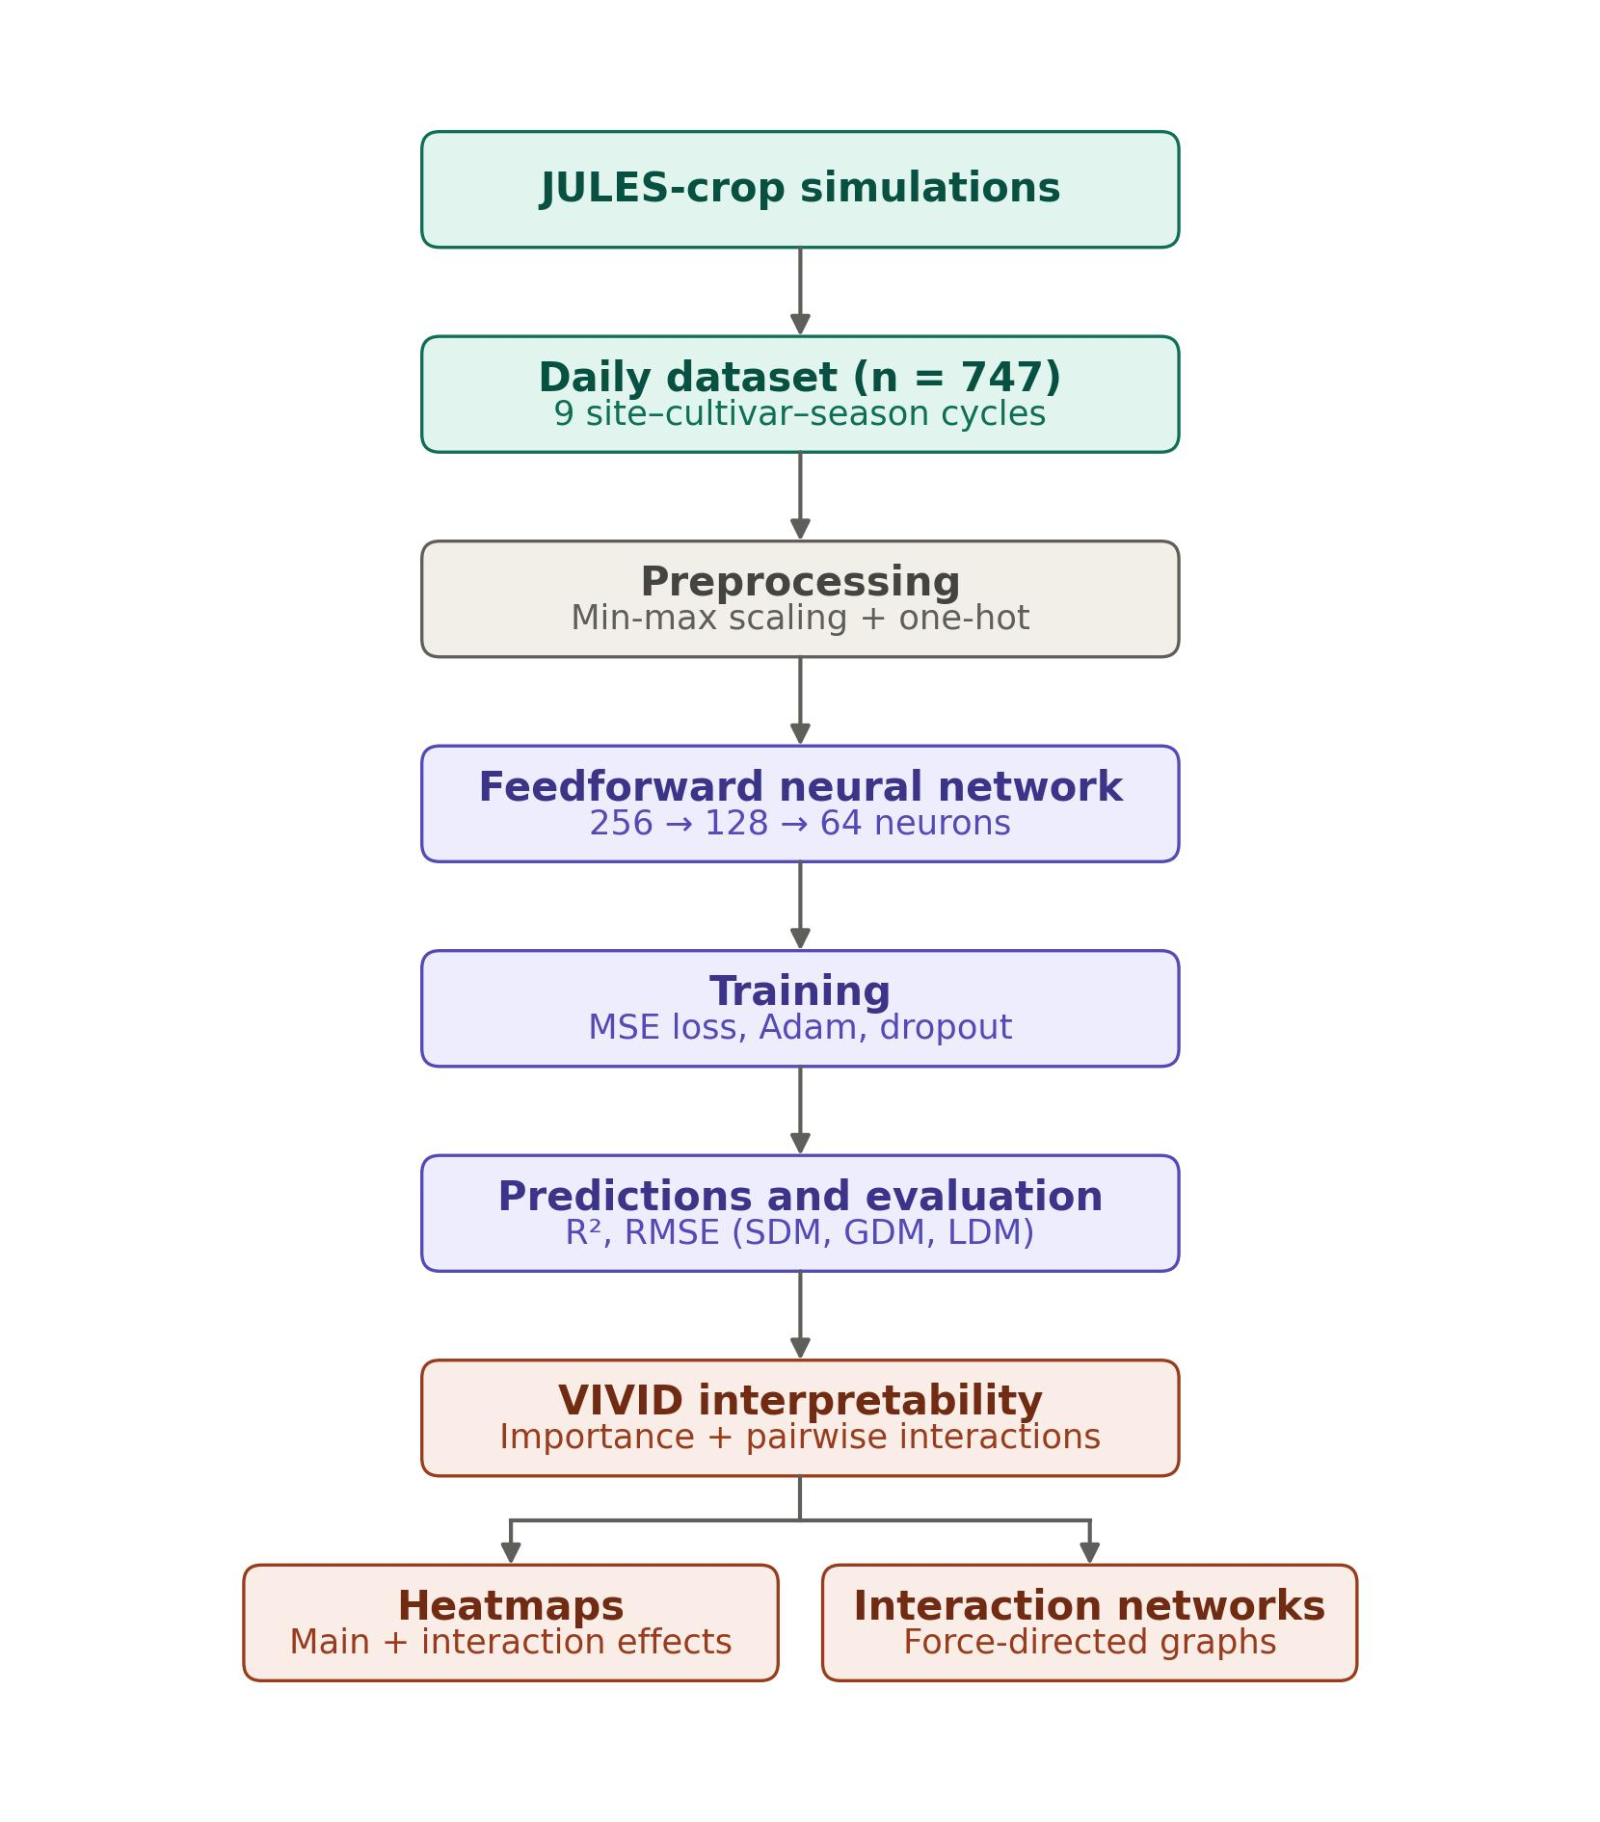
Figure 1: Workflow of the JULES-crop + Neural-Network methodology described in Section 2, from crop simulation to deep-learning surrogate and variable-importance analysis (vivid)

3 Results

3.1 Predictive Accuracy of the Neural Network Model
Figure 2 relates the values simulated by JULES-crop to those predicted by the emulator for the three outputs on the held-out test set; the red dashed line is the 1:1 identity. Once accumulated thermal time was included as a predictor — giving the network the developmental axis along which biomass accumulates — the emulator reproduced the simulated response surfaces closely. The test coefficient of determination was R² = 0.96 for shoot dry matter, 0.93 for grain dry matter and 0.89 for leaf dry matter, with corresponding RMSE of 0.45, 0.62 and 0.41 t ha⁻¹. Predicted values track the identity line across the full range of each variable, from near-zero at emergence to the seasonal maxima, without the flattening that arises when only categorical descriptors are used. A modest tendency to over-predict the smallest values and under-predict the largest remains, most visibly for LDM, but the overall agreement indicates that the network captures the joint dependence of dry-matter accumulation on development, genotype, site and climate, providing a reliable basis for the interpretability analysis that follows.
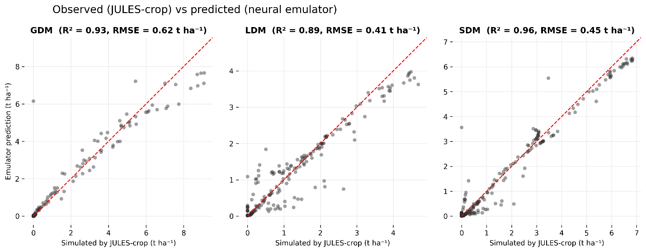
Figure 2: Values simulated by JULES-crop versus values predicted by the neural emulator for GDM, LDM and SDM dry matter on the test set, in t ha⁻¹. The red dashed line is the 1:1 identity. The coefficient of determination (R²) and the root-mean-square error (RMSE) are reported for each output.

3.2.Variable Importance and Interaction Structure for GDM

Figure 3 presents the importance–interaction heatmap for grain dry matter (gdm) obtained with the vivid framework, with predictors ordered by decreasing main effect. Importance and interaction were computed at the level of the original agronomic variables rather than one-hot levels. The diagonal entries quantify each predictor's main effect and the off-diagonal entries the strength of pairwise interactions. Accumulated thermal time is by far the most important predictor of gdm, reflecting the developmental control of grain filling, followed by cultivar and site (county); incoming water regime (treatment), air temperature and solar radiation contribute secondarily. This pattern is agronomically coherent: grain biomass is governed primarily by the progression of phenology, modulated by genotype and by location-specific water regime, temperature conditions and radiation. The interaction structure is dominated by the coupling of accumulated thermal time with cultivar and with site, indicating that genotype- and location-specific responses are expressed as the crop develops. The corresponding network (Figure 6) shows accumulated thermal time as the central hub, connected most strongly to cultivar and site.
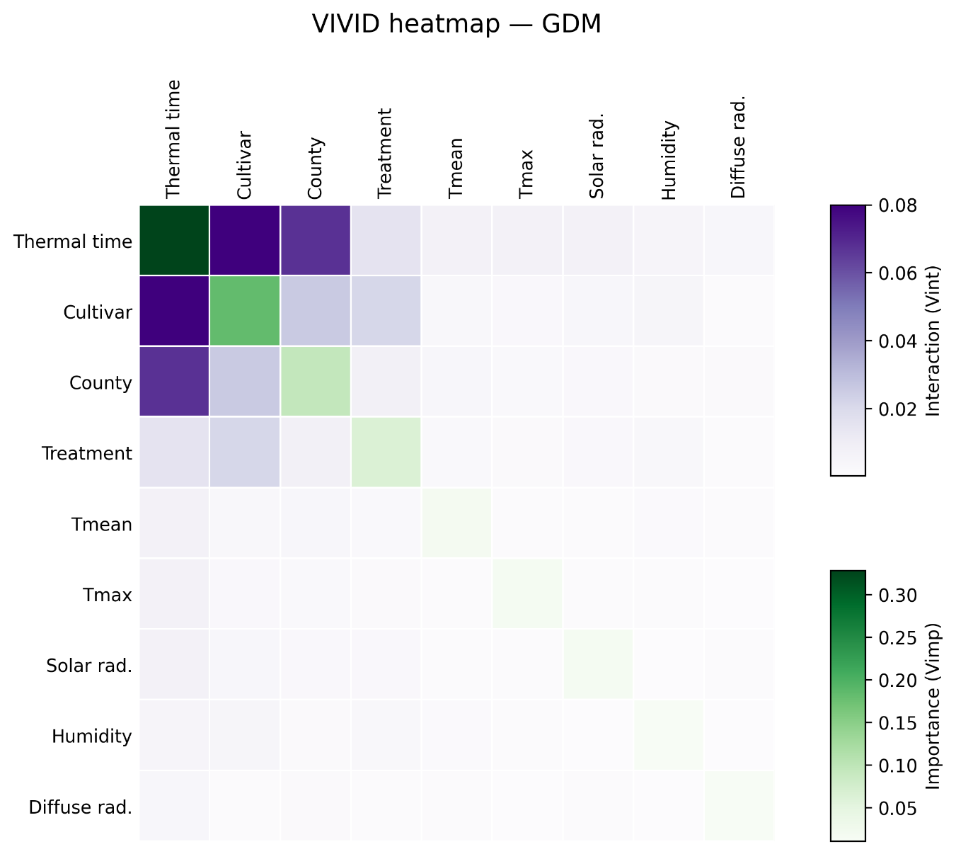
Figure 3: Variable importance and interaction heatmap for GDM. Diagonal values indicate individual variable importance, and off-diagonal values represent pairwise interaction strength as estimated by the VIVID framework.

3.3.Variable Importance and Interaction Structure for LDM

Figure 4 shows the importance–interaction heatmap for LDM. As for the other outputs, accumulated thermal time is the leading predictor, followed by cultivar and site. Among the instantaneous climate drivers, incoming solar radiation makes the largest contribution to ldm, consistent with the role of radiation in canopy expansion and leaf growth during the vegetative phase.
The strongest interaction again couples accumulated thermal time with cultivar, but additional, weaker interactions involving site and radiation are also present, pointing to genotype-by-environment responses that modulate leaf-area development. The network for ldm (Figure 7) accordingly centres on accumulated thermal time and cultivar, with site attached more loosely, reflecting the sensitivity of vegetative biomass to combined developmental, genotypic and radiative conditions.

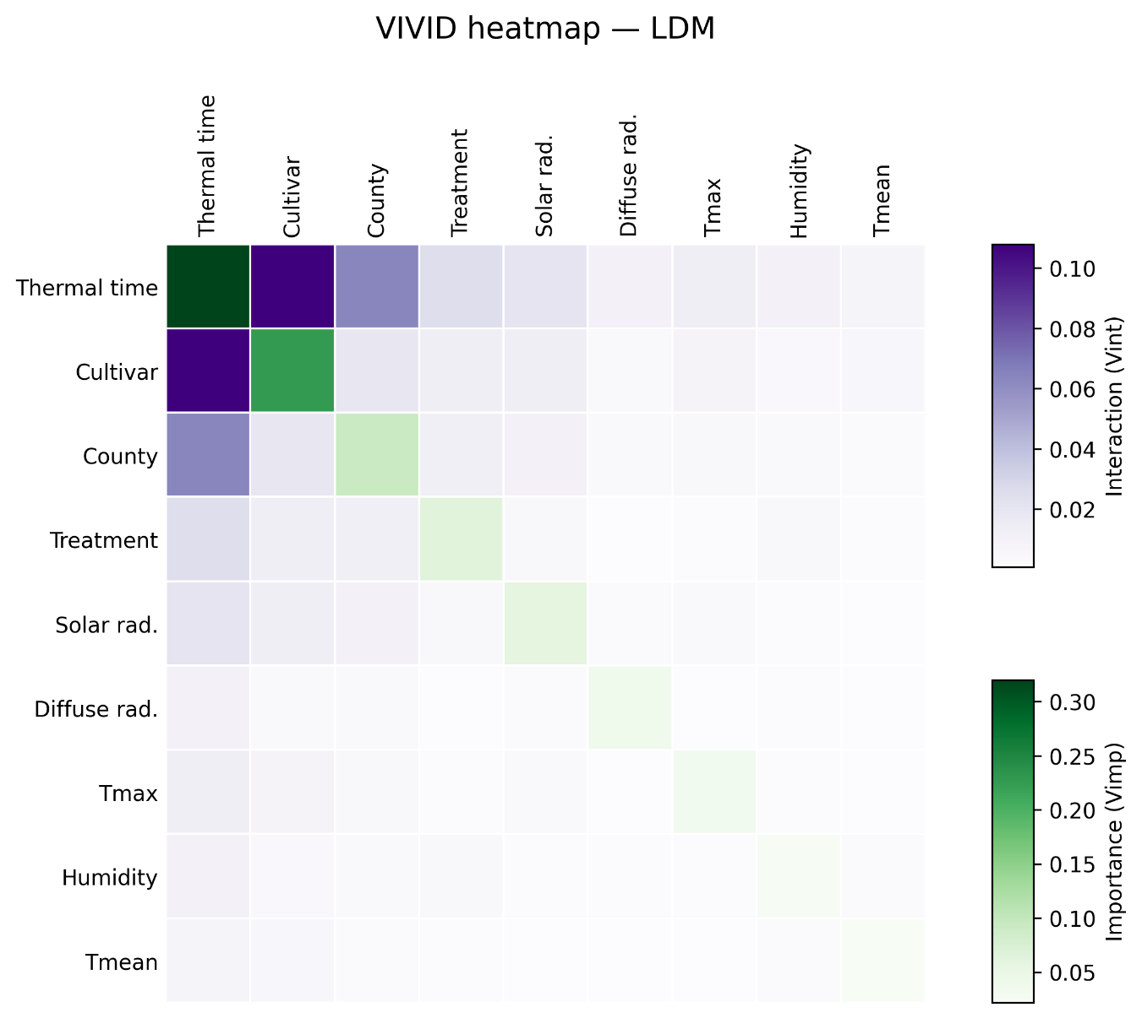
Figure 4: Variable importance and interaction heatmap for LDM. Most important predictors are located along the diagonal. Strong interactions are visualized by darker off-diagonal cells.

3.4.Variable Importance and Interaction Structure for SDM
Figure 5 presents the importance–interaction heatmap for SDM. Accumulated thermal time is the dominant predictor — more so than for the other outputs — followed by cultivar and site, with solar radiation the leading instantaneous climate driver. Because shoot dry matter integrates leaf and stem growth over the whole cycle, its accumulation is tightly tied to the developmental axis.
Interactions are concentrated on the pairing of accumulated thermal time with cultivar and, to a lesser extent, with site; interactions among the remaining variables are weak. The interaction network for sdm (Figure 8) is therefore sparse, with accumulated thermal time as the central node linked mainly to cultivar and site, indicating that shoot biomass is governed chiefly by development and genotype with limited higher-order modulation.
Together, the heatmap and network for sdm show that shoot biomass in the JULES-crop simulations responds primarily to the developmental trajectory and to genotype, with site and radiation as secondary drivers and only limited interaction beyond the thermal-time–cultivar coupling.
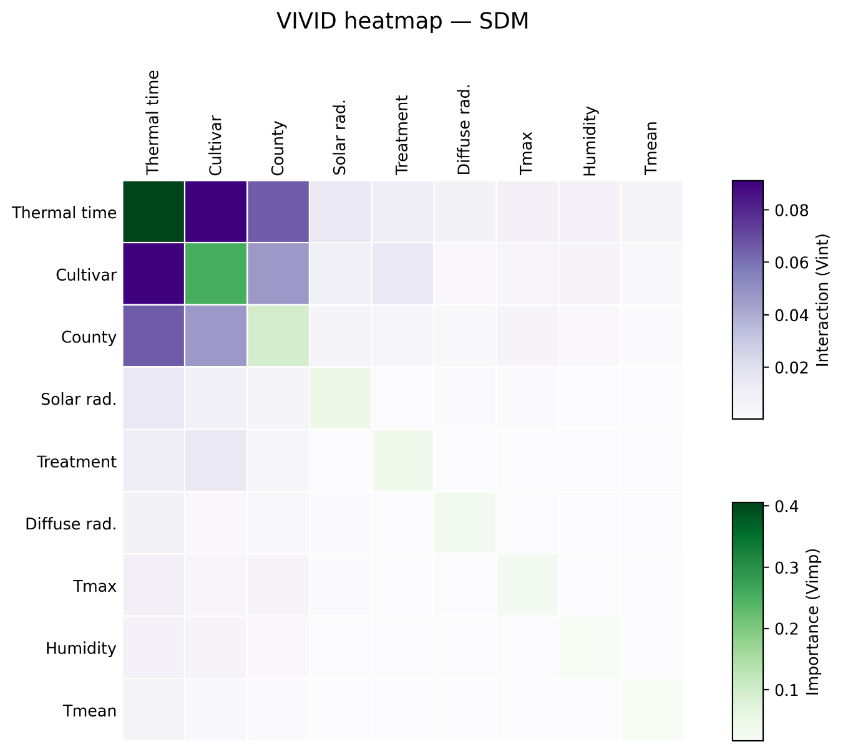
Figure 5: Variable importance and interaction heatmap for shoot dry matter (sdm). The reordering of rows and columns enhances interpretability of main and synergistic effects.
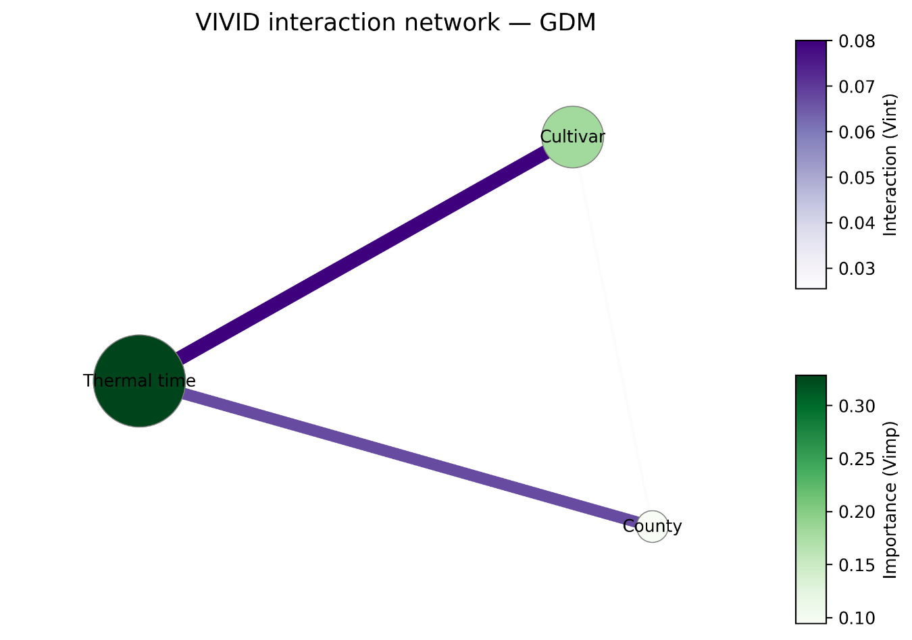

Figure 6: Network representation of predictor interactions for grain dry matter (gdm). Nodes represent variables and edges encode the strength of interactions above a threshold.
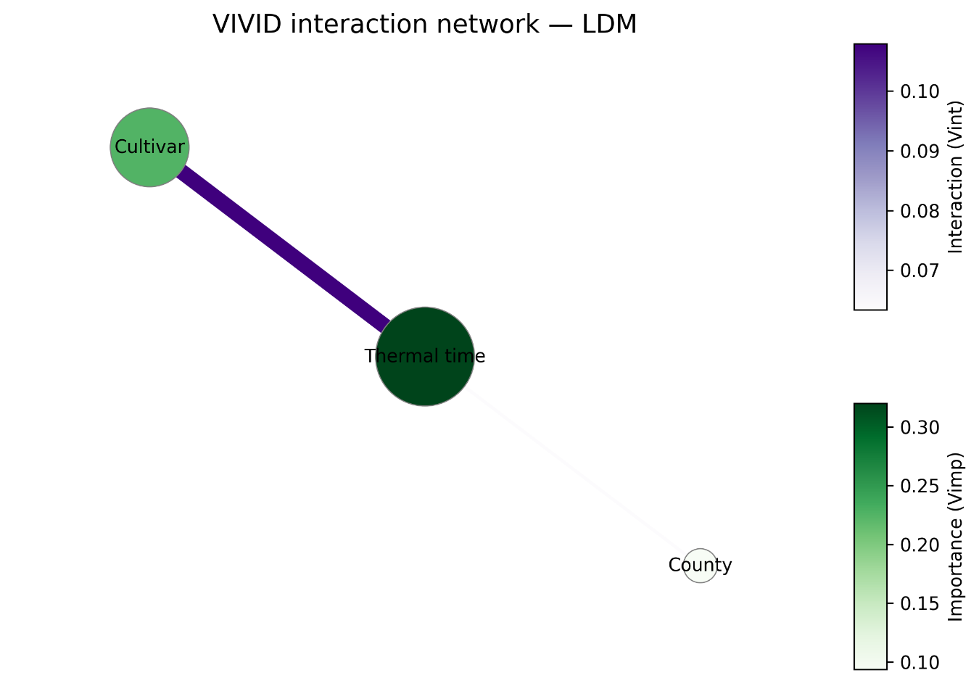

Figure 7: Network graph for leaf dry matter (ldm) showing the most relevant variable interactions. The size and connectivity of nodes reflect their marginal and joint effects.
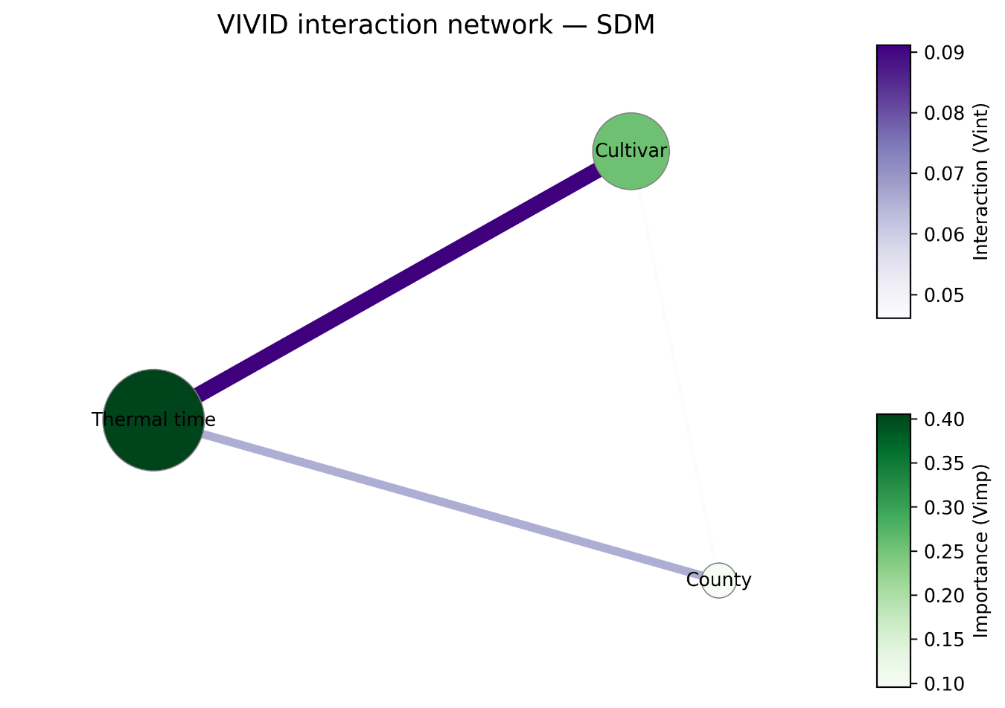

Figure 8: Interaction network for shoot dry matter (sdm). Only variable pairs with interaction strength above the visualization threshold are displayed.

3.5. Comparison Across Target Variables
A comparison across the three outputs reveals a consistent hierarchy of drivers. In every case accumulated thermal time is the dominant predictor, followed by cultivar and site, with incoming solar radiation and air temperature as secondary contributors and the water regime playing a smaller role. This shared structure underscores that, in the JULES-crop simulations, biomass accumulation is organized primarily along the crop's developmental trajectory, modulated by genotype and by location-specific climate.
The outputs differ mainly in their interaction richness. GDM and LDM show broader interaction structures — chiefly thermal time with cultivar and with site — whereas SDM is more strongly dominated by main effects, with fewer interactions exceeding the visualization threshold. In all three networks accumulated thermal time acts as the central hub, confirming that genotypic and environmental effects are expressed as the crop develops rather than as isolated, time-independent contributions.
Leaf dry matter interaction´s structure, can be explained by the developmental axis interacting with cultivar, site and radiation. This suggests that vegetative biomass is more sensitive to joint genotype–environment responses than grain or shoot biomass, plausibly because leaf-area development integrates canopy expansion and radiation capture during the vegetative phase.
Overall, these results show that although the three biomass components share the same dominant drivers, each responds through a distinct balance of main effects and interactions. Coupling the deep-learning emulator with vivid-based interpretability provides a transparent decomposition of these influences and recovers physiologically coherent sensitivities — development, genotype, radiation and temperature — directly from the simulated data.

4. Discussion

This study demonstrates the value of integrating interpretable machine learning with process-based crop modelling to explore how environmental, genetic and management drivers shape biomass allocation in simulated maize systems. By training a multi-output deep neural network on JULES-crop simulations and applying the VIVID framework (Inglis et al., 2024), we approximated the joint response surfaces of grain (gdm), leaf (ldm) and shoot (sdm) dry matter and decomposed model behaviour into individual variable importance and pairwise interaction effects. This combination provides a quantitative, model-agnostic readout of what the process-based model has effectively learned, complementing the mechanistic interpretation traditionally associated with JULES-crop (Osborne et al., 2015; Williams et al., 2017; Prudente Junior et al., 2022).
A central finding is that a small set of predictors governs all three biomass components: accumulated thermal time is consistently dominant, followed by cultivar and site, with solar radiation and air temperature as secondary drivers. The primacy of thermal time is physiologically expected, since dry-matter accumulation in JULES-crop is organized along the development index, which is itself driven by accumulated thermal time (Osborne et al., 2015; Williams et al., 2017). The prominence of cultivar reflects the well-documented role of genotype in canopy development and grain filling across Brazilian environments (Prudente Junior et al., 2022; Dias et al., 2025), while the contribution of site and of incoming radiation and temperature is consistent with the radiation- and temperature-driven nature of maize growth (Souza et al., 2019; Antolin et al., 2025). That these agronomically meaningful sensitivities emerge from a purely data-driven decomposition supports the interpretation that JULES-crop internally encodes them and that VIVID can recover them without explicit mechanistic supervision.
The interaction analyses add insights rarely accessible from process-based models directly. Across outputs, the strongest interactions couple accumulated thermal time with cultivar and with site, indicating that genotype, and location-specific responses are expressed progressively as the crop develops, rather than as time-independent effects. Computing importance and interactions at the level of the original predictors — treating cultivar, site and water regime as grouped features rather than as separate one-hot levels — avoids the structural inflation that individual dummy variables can introduce into global importance, following good practice with grouped-feature attribution (Lundberg & Lee, 2017; Inglis et al., 2024).
The contrast between outputs is itself informative. Leaf dry matter (LDM) showed the richest interaction structure, with the developmental axis interacting with cultivar, site and radiation, consistent with leaf-area development integrating canopy expansion and radiation capture during the vegetative phase (Williams et al., 2017; Prudente Junior et al., 2022). Grain dry matter (GDM) exhibited a more concentrated pattern centred on thermal time and cultivar, in line with the sensitivity of grain set and filling to phenology and genotype (Souza et al., 2019; Lobell et al., 2014). Shoot dry matter (SDM), which integrates leaf and stem contributions over the cycle, was dominated by main effects with weaker interactions. This trait-by-trait decomposition offers a finer-grained view than aggregate yield analyses and could help target breeding and management to the component most affected by a given driver (Antolin et al., 2025; Gasparotto et al., 2024).
From a methodological standpoint, the combination of a deep neural emulator with variance-based interpretability offers a flexible and computationally efficient alternative to running large ensembles of mechanistic simulations for sensitivity and scenario analysis. Once trained, the emulator can be queried orders of magnitude faster than the underlying land-surface model, which is particularly attractive for JULES-crop given its computational footprint (Osborne et al., 2015; Williams et al., 2017). This is conceptually aligned with the broader move towards hybrid process–machine-learning frameworks in agricultural modelling, in which data-driven components are used to emulate, correct or extend process-based predictions (Shahhosseini et al., 2021; Han et al., 2025). Compared with permutation-based importance and Friedman's H-statistic — used, for instance, in random-forest analyses of maize yield (Jeong et al., 2016) — the variance-based decomposition implemented in VIVID has the advantage of jointly producing main effects and pairwise interactions in a unified matrix, which is well suited to the structured visualizations we report here.
However, several limitations exits. First, although the emulator reproduces the simulated response surfaces with high accuracy (test R² between 0.89 and 0.96), performance was assessed with a random train–test split. With 747 daily records from only nine cycles, this typically places day 46 of a cycle in training and day 47 in test. Because JULES-crop biomass trajectories are smooth and strongly autocorrelated, predicting the next day from the previous one is a near-trivial interpolation, and these R² values should be read as an upper bound on out-of-cycle performance. A leave-one-cycle-out evaluation, together with bootstrap or repeated-permutation intervals on the VIVID importance and interaction indices, is the appropriate protocol for measuring generalization to unseen sites, seasons or genotypes. Second, the dominance of accumulated thermal time in the VIVID rankings is partly structural: the JULES-crop development index DVI, which mediates carbon partitioning through Equations (3)–(7), is itself driven by accumulated thermal time, so any faithful emulator offered thermal time as an input will place it at the top of its causal chain. The genuinely informative results are therefore the secondary rankings — cultivar, site, radiation and temperature — and, especially, the interaction structure among them. Third, water regime (treatment) was nearly constant across the analysed dry-season (safrinha) window and was therefore uninformative here, so the apparent secondary role of the water regime should not be read as a general statement about water limitation; datasets spanning wetter cycles and irrigation contrasts are needed to probe that effect. Finally, our analysis interprets what JULES-crop has learned, not the underlying biophysical reality directly, so conclusions about mechanisms must be cross-checked against field observations and independent process knowledge (Williams et al., 2017; Prudente Junior et al., 2022), and by relying on simulated outputs we inherit any biases of the underlying model, including its known difficulties with extreme heat and drought (Souza et al., 2019; Dias et al., 2025).
Despite these caveats, the framework has important practical implications. By identifying which combinations of cultivar, location, and water regime (treatment) drive each biomass component, the approach can support targeted decisions in breeding programmes, climate-impact assessment and irrigation planning, particularly when paired with the regional zoning and yield-gap analyses that have been developed for Brazilian maize (Antolin et al., 2025; Gasparotto et al., 2024). It also provides a reusable pipeline for auditing other process-based models — within or beyond JULES — and for accelerating sensitivity and scenario studies that would be prohibitive to run mechanistically at scale. Future work should extend the framework to hybrid datasets that combine simulations with field measurements, incorporate uncertainty quantification both in the emulator and in the VIVID indices, and explore whether the interpretability gains shown here for maize transfer to other crops and to other land-surface modelling platforms (Han et al., 2025; Smith et al., 2026).

5. Conclusions and future works

In this study, we proposed a framework that integrates deep learning and model-agnostic interpretability to clarify process-based crop simulations. By training a multi-output neural network on daily JULES-crop maize simulations and applying the vivid interpretability toolkit, we identified the factors driving biomass accumulation (GDM, LDM AND SDM) and the interactions among development, genotype, site and climate. A key methodological point is that the crop's developmental axis, represented by accumulated thermal time, must be available to the emulator: once included, the network reproduced the simulated outputs with high fidelity (test R² of 0.89–0.96).
Our results show that a compact set of drivers — accumulated thermal time, cultivar and site, with solar radiation and temperature as secondary contributors — governs the simulated biomass components, and that their effects are expressed jointly along the developmental trajectory. The combination of heatmaps and network visualizations made it possible to decompose both marginal and interaction contributions in an interpretable and actionable way.
This integrated approach offers a scalable and flexible solution to a common limitation of process-based models: the lack of tools for transparent interpretation. Beyond predictive accuracy, our method provides explanatory power and diagnostic insight that can inform breeding strategies, model evaluation, and climate resilience planning.
Future work may extend this framework to hybrid datasets combining simulations and field observations, incorporate uncertainty quantification, and explore broader applications across different crops, environments, and modeling platforms. Ultimately, the convergence of interpretable AI and biophysical simulation has the potential to bridge the gap between model complexity and real-world decision-making.

Data and code availability
The data and code supporting the findings of this study are openly available in the GitHub repository https://github.com/danilosarti/jules-crop-vivid, which includes the JULES-crop simulation outputs and the meteorological forcing used as model inputs, the reproducible Python pipeline (data preparation, the multi-output neural-network emulator, and the VIVID analysis), the R script that runs the vivid package, and the figures reported here. A permanently archived version is deposited on Zenodo (DOI: XXXX/zenodo.XXXXXXX).
Acknowledgements
This work was supported by Universidade Presbiteriana Mackenzie (UPM) [grant/process no. XXXX]. The authors also acknowledge the Center for Carbon Research in Tropical Agriculture (CCARBON) and the “Luiz de Queiroz” College of Agriculture, University of São Paulo (ESALQ/USP), for institutional support.
References

Antolin, L. A. S., Silva, E. H. F. M. da, Zanon, A. J., Ribeiro, B. S. M. R., & Marin, F. R. (2025). How much would irrigation increase maize production in Brazil? Scientia Agricola, 82, e20240083. https://doi.org/10.1590/1678-992X-2024-0083
Clark, D. B., Mercado, L. M., Sitch, S., Jones, C. D., Gedney, N., Best, M. J., Pryor, M., Rooney, G. G., Essery, R. L. H., Blyth, E., Boucher, O., Harding, R. J., Huntingford, C., & Cox, P. M. (2011). The Joint UK Land Environment Simulator (JULES), model description – Part 2: Carbon fluxes and vegetation dynamics. Geoscientific Model Development, 4, 701–722. https://doi.org/10.5194/gmd-4-701-2011
Confalonieri, R., Bregaglio, S., & Acutis, M. (2013). Quantifying uncertainty in crop model predictions due to the uncertainty in the observations used for calibration. Ecological Modelling, 258, 39–46.
Connor, D. J., & Loomis, R. S. (1992). Crop ecology: productivity and management in agricultural systems. Cambridge University Press.
Dias, T. S. dos S., Fattori Jr., I. M., de Melo, M. L. A., Brunetti, H. B., Sandoval, L. B., Bonaldi, I. de O., & Marin, F. R. (2025). Mitigating agricultural risk under future climate: assessing maize cycle and yield in Brazil. Theoretical and Applied Climatology, 156, 509. https://doi.org/10.1007/s00704-025-05732-4
Friedman, J. H., & Popescu, B. E. (2008). Predictive learning via rule ensembles. The Annals of Applied Statistics, 2(3), 916–954. https://doi.org/10.1214/07-AOAS148
Gasparotto, L. G., Gonçalves, I. Z., & Marin, F. R. (2024). The Brazilian case as a beacon to increase crop production in sub-Saharan Africa. The Journal of Agricultural Science, 1–10. https://doi.org/10.1017/S0021859624000431
Han, L., et al. (2025). Deep learning meets process-based models: a hybrid approach to agricultural challenges. arXiv preprint, arXiv:2504.16141.
Inglis, A., Parnell, A., & Hurley, C. B. (2024). vivid: An R package for variable importance and variable interactions displays for machine learning models. The R Journal, RJ-2023-054. https://journal.r-project.org/articles/RJ-2023-054/
Jeong, J. H., Resop, J. P., Mueller, N. D., Fleisher, D. H., Yun, K., Butler, E. E., Timlin, D. J., Shim, K.-M., Gerber, J. S., Reddy, V. R., & Kim, S.-H. (2016). Random forests for global and regional crop yield predictions. PLoS ONE, 11(6), e0156571.
Khaki, S., & Wang, L. (2019). Crop yield prediction using deep neural networks. Frontiers in Plant Science, 10, 621. https://doi.org/10.3389/fpls.2019.00621
Kingma, D. P., & Ba, J. (2015). Adam: A method for stochastic optimization. 3rd International Conference on Learning Representations (ICLR). https://arxiv.org/abs/1412.6980
Lobell, D. B., Hammer, G. L., McLean, G., Messina, C., Roberts, M. J., & Schlenker, W. (2014). Greater sensitivity to drought accompanies maize yield increase in the U.S. Midwest. Science, 344(6183), 516–519. https://doi.org/10.1126/science.1251423
Lundberg, S. M., & Lee, S.-I. (2017). A unified approach to interpreting model predictions. Advances in Neural Information Processing Systems, 30, 4765–4774.
Marin, F. R., Zanon, A. J., Monzon, J. P., Andrade, J. F., Silva, E. H. F. M., Richter, G. L., Antolin, L. A. S., Ribeiro, B. S. M. R., Ribas, G. G., Battisti, R., Heinemann, A. B., & Grassini, P. (2022). Protecting the Amazon forest and reducing global warming via agricultural intensification. Nature Sustainability, 5(12), 1018–1026. https://doi.org/10.1038/s41893-022-00968-8
Osborne, T., Gornall, J., Hooker, J., Williams, K., Wiltshire, A., Betts, R., & Wheeler, T. (2015). JULES-crop: a parametrisation of crops in the Joint UK Land Environment Simulator. Geoscientific Model Development, 8(4), 1139–1155. https://doi.org/10.5194/gmd-8-1139-2015
Prudente Junior, A. C., Vianna, M. S., Williams, K., Galdos, M. V., & Marin, F. R. (2022). Calibration and evaluation of JULES-crop for maize in Brazil. Agronomy Journal, 114, 3110–3124. https://doi.org/10.1002/agj2.21066
Prudente Junior, A. C., Vianna, M. S., Williams, K., Galdos, M. V., & Marin, F. R. (2024). Application of the JULES-crop model and agrometeorological indicators for forecasting off-season maize yield in Brazil. Heliyon, 10, e29555. https://doi.org/10.1016/j.heliyon.2024.e29555
Shahhosseini, M., Hu, G., Huber, I., & Archontoulis, S. V. (2021). Coupling machine learning and crop modeling improves crop yield prediction in the US Corn Belt. Scientific Reports, 11, 1606.
Smith, H. W., Heffernan, C. J., Ashworth, A. J., Nalley, L. L., Bullock, D. S., et al. (2026). Harvesting insights: interpretable machine learning to understand environmental drivers of U.S. maize and soybean yield. Scientific Reports, 16, 8994. https://doi.org/10.1038/s41598-026-38724-z
Sobol', I. M. (1993). Sensitivity analysis for non-linear mathematical models. Mathematical Modelling and Computational Experiment, 1, 407–414.
Souza, T. T. de, Antolin, L. A. S., Bianchini, V. de J. M., Pereira, R. A. de A., Silva, E. H. F. M., & Marin, F. R. (2019). Longer crop cycle lengths could offset the negative effects of climate change on Brazilian maize. Bragantia, 78(4), 622–631. https://doi.org/10.1590/1678-4499.20190085
Specka, X., Nendel, C., & Wieland, R. (2015). Analysing the parameter sensitivity of the agro-ecosystem model MONICA for different crops. European Journal of Agronomy, 71, 73–87.
Williams, K., Gornall, J., Harper, A., Wiltshire, A., Hemming, D., Quaife, T., Arkebauer, T., & Scoby, D. (2017). Evaluation of JULES-crop performance against site observations of irrigated maize from Mead, Nebraska. Geoscientific Model Development, 10, 1291–1320. https://doi.org/10.5194/gmd-10-1291-2017

