**Productivity and labor market dynamics in the supermultiplier model**

Önder Nomaler; Danilo Spinola; Bart Verspagen

Abstract

**Keywords: Economic Growth, Productivity Dynamics, Supermultiplier**

**JEL Codes: E11, E12, O41**

1. Introduction

The main motivation behind this article is to develop a model with a stable growth path in which employment rate and capacity utilization do not go out of bounds. Moreover, we are also interested in a model that is able to reproduce a Keynesian multiplier to the long-run. Models with this characteristic are scarce in the literature. In this spirit, we propose an expansion of the Freitas & Serrano (2015) version of the Sraffian Supermultiplier (SSM), a framework in which the autonomous component of expenditure that does not generate capacity defines the long-run growth pattern. Our model expansion includes a productivity and employment dynamics to the system, resulting in a 4-dymensional system in which the expanded variables interact with investment rate and capacity utilization.

We are focused on the basic idea of demand-based growth models, and how such a model can be consistent with Schumpeterian technical change. We established in the Supermultiplier model that the equilibrium needs that the growth of demand that does not create capacity ($g_{z}$) should be equal to productivity growth (*ρ*), which we cannot take as an exogenous restriction. We must therefore model a process in which $g_{z}$ and *ρ* adjust one to the other.

1. Literature Review
2. SSR, recent models
3. Cycles.
4. Inclusion of productivity and employment

Allain, O., 2019. Demographic growth, Harrodian (in) stability and the supermultiplier. Cambridge Journal of Economics, 43(1), pp.85-106.

Brochier, L. and Silva, A.C.M.E., 2019. A supermultiplier Stock-Flow Consistent model: the “return” of the paradoxes of thrift and costs in the long run?. *Cambridge Journal of Economics*, *43*(2), pp.413-442.

Caminati, M. and Sordi, S., 2019. Demand‐led growth with endogenous innovation. *Metroeconomica*, *70*(3), pp.405-422.

Deleidi, M. and Mazzucato, M., 2019. Putting austerity to bed: Technical progress, aggregate demand and the supermultiplier. *Review of Political Economy*, pp.1-21.

Deleidi, M., Pariboni, R. and Passarella, M.V., 2019. Supermultiplier, innovation and the ecosystem: a stock-flow dynamic model. *Institute for Innovation and Public Purpose, UCL, Working Paper*, (2019-01).

Dejuán, Ó. and Dejuán-Bitriá, D., 2018. A predator–prey model to explain cycles in credit-led economies. *Review of Keynesian Economics*, *6*(2), pp.159-179.

Dutt, A.K., 2017. Heterodox theories of economic growth and income distribution: a partial survey. *Journal of Economic Surveys*, *31*(5), pp.1240-1271.

Dutt, A.K., 2019. Some observations on models of growth and distribution with autonomous demand growth. *Metroeconomica*, *70*(2), pp.288-301.

Freitas, F. and Serrano, F., 2015. Growth rate and level effects, the stability of the adjustment of capacity to demand and the Sraffian supermultiplier. *Review of Political Economy*, *27*(3), pp.258-281.

Girardi, D. and Pariboni, R., 2016. Long-run effective demand in the US economy: An empirical test of the sraffian supermultiplier model. *Review of Political Economy*, *28*(4), pp.523-544.

Lavoie, M., 2016. Convergence Towards the Normal Rate of Capacity Utilization in Neo‐K aleckian Models: The Role of Non‐Capacity Creating Autonomous Expenditures. *Metroeconomica*, *67*(1), pp.172-201.

Nikiforos, M., 2018. Some comments on the Sraffian Supermultiplier approach to growth and distribution. *Journal of Post Keynesian Economics*, *41*(4), pp.659-675.

Oreiro, J.L., da Silva, G.J.C. and Santos, J.F.C., 2019. The Debate About Sraffian Supermultiplier Model and The Future of Heterodox Growth Models.

Pariboni, R., 2016. Household consumer debt, endogenous money and growth: A supermultiplier-based analysis. *PSL Quarterly Review*, *69*(278).

Palley, T.I., 2013. AK aldor–H icks–G oodwin–T obin–K alecki model of growth and distribution. *Metroeconomica*, *64*(2), pp.319-345.

Palley, T., 2019. The economics of the super‐multiplier: A comprehensive treatment with labor markets. *Metroeconomica*, *70*(2), pp.325-340.

Pérez-Montiel, J.A. and Erbina, C.M., 2020. Autonomous expenditures and induced investment: a panel test of the Sraffian supermultiplier model in European countries. Review of Keynesian Economics, 8(2), pp.220-239.

Serrano, F., Freitas, F. and Bhering, G., 2019. The Trouble with Harrod: The fundamental instability of the warranted rate in the light of the Sraffian Supermultiplier. *Metroeconomica*, *70*(2), pp.263-287.

Serrano, F. and Freitas, F., 2017. The Sraffian supermultiplier as an alternative closure for heterodox growth theory. European Journal of Economics and Economic Policies: Intervention, 14(1), pp.70-91.

Skott, P., 2019. Autonomous demand, Harrodian instability and the supply side. *Metroeconomica*, *70*(2), pp.233-246.

1. Sraffian Supermultiplier baseline model
2. Expansion of Freitas & Serrano

The expanded model maintains the original dynamic relationship between investment rate and capacity utilization, so all the assumptions and conditions of the original model are valid. The original SSM model from Freitas & Serrano (2015), in which investment and utilization capacity dynamically interact is defined by:

$$\dot{h}=hγ\left(u-μ\right)$$

$$\dot{u}=u\left(g-g_{K}\right)$$

In which the growth pattern is given by:

$$g=g_{Z}+\frac{\dot{h}}{s-h}$$

$$g_{k}=\frac{hu}{v}-δ$$

Our model expansions of the SSM consists in: (1) The inclusion of a labor productivity growth dynamics, adding the Kaldor-Verdoon effect, which links capital accumulation to rise in productivity through learning opportunities (Verdoorn, 2002);

$$ρ=ξg_{k}$$

(2) Including to the labor productivity growth an adjustment mechanism of current employment to a long-run exogenous level;

$$\dot{ρ}=ξ\dot{g_{k}}+ρλ\left(E-\overline{E}\right)$$

(3) Developing an employment dynamics, in which employment adjusts the gap between output growth and labor productivity growth.

$$\dot{E}=E\left(g-\hat{a}\right)$$

$$\dot{E}=E\left(g_{Z}+\frac{hγ\left(u-μ\right)}{s-h}-ρ\right)$$

Complete system

$$\dot{h}=hγ\left(u-μ\right)$$

$$\dot{u}=u\left(g_{Z}+\frac{hγ\left(u-μ\right)}{s-h}-\frac{hu}{v}+δ\right)$$

$$\dot{E}=E\left(g_{Z}+\frac{hγ\left(u-μ\right)}{s-h}-ρ\right)$$

$$\dot{ρ}=\frac{ξ}{v}\left[hγu\left(u-μ\right)+hu\left(g_{Z}+\frac{hγ\left(u-μ\right)}{s-h}-\frac{hu}{v}+δ\right)\right]+ρλ\left(E-\overline{E}\right)$$

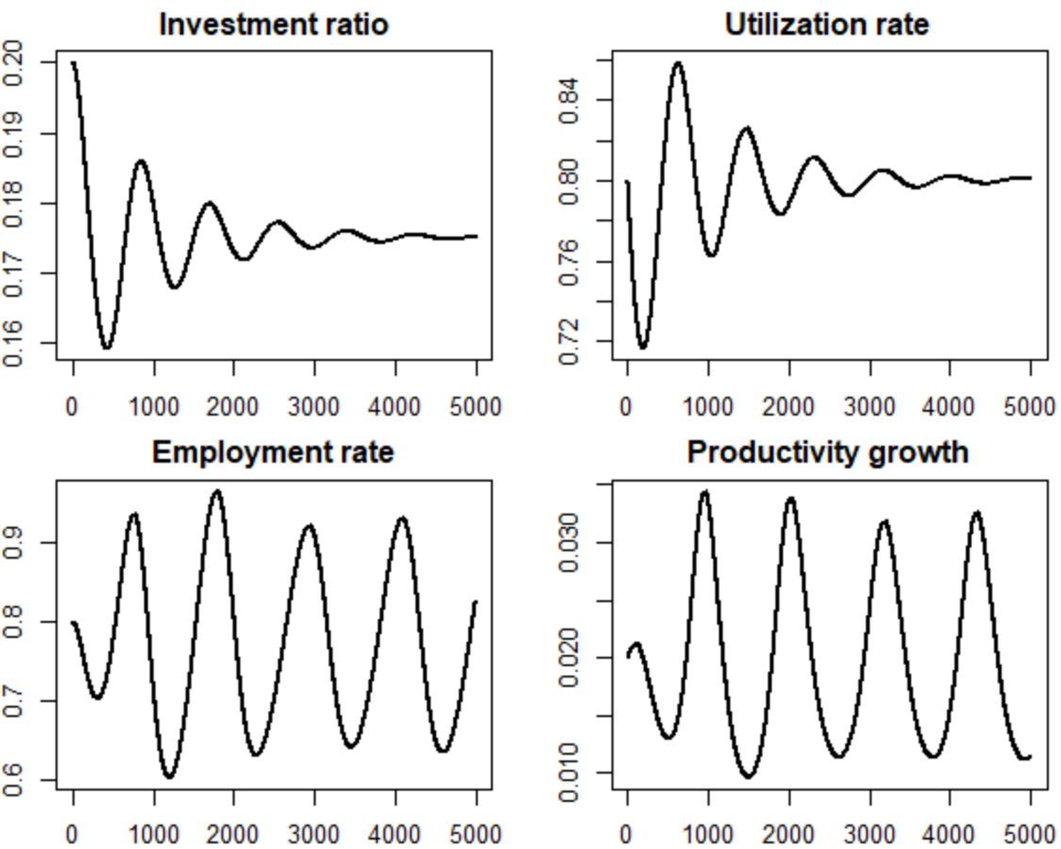

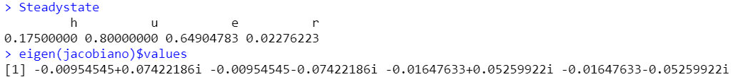

Use only this model? Do some other changes to that?

USING ONDER’S MODIFICTION BASED ON PALLEY 2013

Being $ζ$ the autonomous component of the productivity growth:

$$\dot{ρ}=ρ(ζ+ξg_{K}+ρλ(E-\overline{E}))$$

Then

$$\dot{ρ}=ρ(ζ+ξ\frac{hu}{v}-δ+ρλ(E-\overline{E}))$$

The system will be:





$$\dot{h}=hγ\left(u-μ\right)$$

$$\dot{u}=u\left(g_{Z}+\frac{hγ\left(u-μ\right)}{s-h}-\frac{hu}{v}+δ\right)$$

$$\dot{E}=E\left(g_{Z}+\frac{hγ\left(u-μ\right)}{s-h}-ρ\right)$$

$$\dot{ρ}=ρ(ζ+ξ\frac{hu}{v}-δ+λ(E-\overline{E}))$$

Differences in the system ($ρ,h,u,E,$)

$$\dot{ρ}=\frac{ξ}{v}\left[hγu\left(u-μ\right)+hu\left(g_{Z}+\frac{hγ\left(u-μ\right)}{s-h}-\frac{hu}{v}+δ\right)\right]+ρλ\left(E-\overline{E}\right)$$

$$\dot{ρ}=ρ(ζ+ξ\frac{hu}{v}-δ+ρλ(E-\overline{E}))$$

CONSIDERING $E=K_{1}$ AND $ρ=K_{2}$:

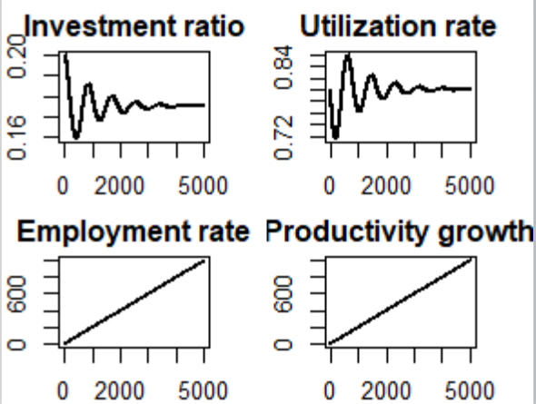

1. Study the characteristics of the model
2. Simulations/Policy recommendations

Our model expansion results in a dynamic model that shows and interesting trajectory between the short-run and the long-run. After studying the steady state and stability condition, we observe that the model shows a stable pattern. Preliminary results show that a calibration of this economy generates dampened cycles in a Goodwin relationship between employment and economic activity.

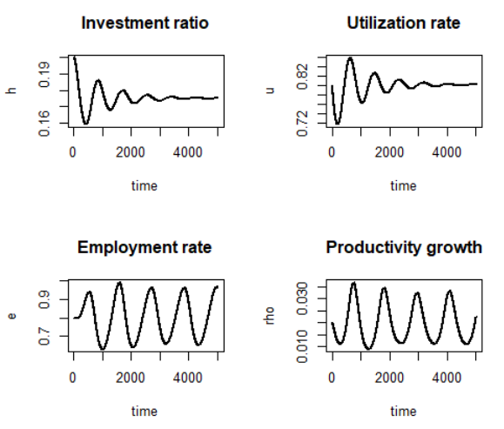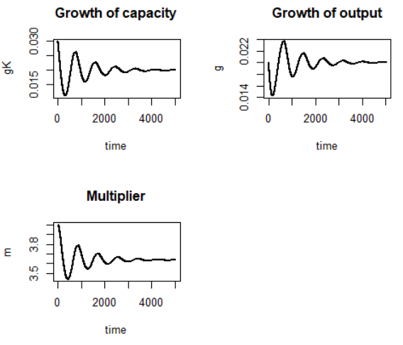

**Simulations**

List of Parameters of the Model:

Desired utilization rate: $μ=0.8$

Adjustment speed of investment with respect to u: $γ=0.1$

Growth of exogenous spending: $g_{z}=0.02$

Propensity to save: $s=0.45$

Desired capital-output ratio: $v=2$

Depreciation rate of capital: $δ=0.05$

Labour productivity growth rate: $ρ=0.02$

Endogenous part of productivity growth: $ξ=0.5$

Long-run employment rate: $\overline{E}=0.8$

Adjustment speed of employment: $λ=0.2$