 |  |  |  | 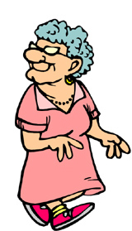 |  |  | 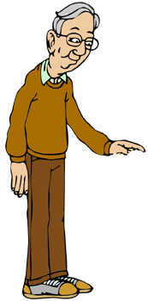 |  | 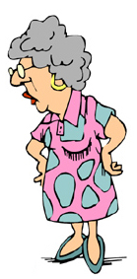 |  | Jack’s  Family  (A Sheet) |  |  |  |  | Here is Jack’s family tree. Fill in the names of the people on the family tree and what they do.  (1) Frank is Jack’s grandfather (on his father’s side). He is an artist.  (2) Rona is Jack’s grandmother (on his mother's side). She is a librarian.  (3) Harriet is Jack’s aunt. She is a housewife.  (4) Brad is Jack’s father. He is an engineer.  (5) Mary is Jack’s mother-in-law. She is a teacher.  (6) Sue is Jack’s cousin. She is a professional bowler.  (7) Stan is Jack’s brother. He is a chef.  (8)Brenda is Jack’s wife. She is a lawyer.  (9) Matt is Jack’s nephew. He is in pre-school.  (10) Erin is Jack’s daughter. She is in kindergarten.
 |  |  |  |  |  |  |  |  |  |  |  |  | 
 |  |  |  |  |  |  |  |  |  |  |  |  |  | 
 |  |  |  |  |  |  |  |  |  |  |  |  |  |  |  | Ask your partner about the following family members.
 |  |  |  |  |  |  |  |  |  |  |  |  |  |  |  | Sara, Dan, Myra, Melissa, George, Rose, Jeremy, John, Mike, Vicky,  Who is _______?  What does he/she do?

 |  |  |  |  |  |  |  |  |  |  | Jack’s  Family  (B Sheet) |  |  |  |  | Here is Jack’s family tree. Fill in the names of the people on the family tree and what they do.  (1) Rose is Jack’s grandmother (on his father’s side). She is retired.  (2) George is Jack’s grandfather (on his mother’s side). He is retired.  (3) Mike is Jack’s uncle. He is unemployed.  (4) Sara is Jack’s mom. She is a dance instructor.  (5) Dan is Jack’s father-in-law. He works at a bank.  (6) Vicky is Jack’s sister-in-law. She is a model.  (7) Myra is Jack’s sister. She is a high school student.  (8) John is Jack’s brother-in-law. He is a university student.  (9) Melissa is Jack’s baby niece. She is only two years old.  (10) Jeremy is Jack’s son. He is in the third grade of elementary school
 |  |  |  |  |  |  |  |  |  |  |  |  |  |  |  | Ask your partner about the following family members.
Brenda, Matt, Erin, Frank, Rona, Harriet, Mary, Sue, Brad, Stan

Who is _______?
What does he/she do?

