Binary Tree.  
- 0 1 or 2 children.  
- 1 root  
- 1 path b/w root and any node  
  
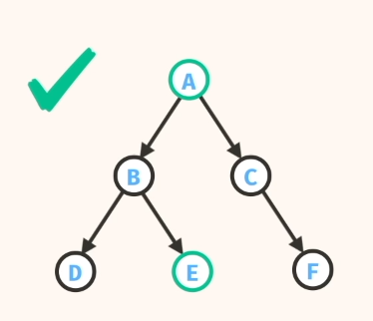  
  
Node has left and right nodes or null.  
And data.