Graph = nodes + edges.  
  
Directed and undirected.  
  
Adjacency List – representation of graph.  
  
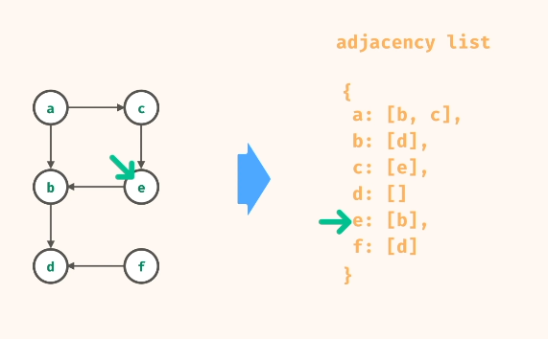  
  
DFS and BFS.  
  
